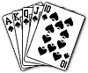 | Royal Flush  The five highest cards, the 10 through the Ace, all five of the same suit. A royal flush is actually an ace-high straight flush. Which suit it is doesn't matter in poker. Two people with royal flushes would tie.
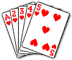 | Straight Flush  Any five cards of the same suit in consecutive numerical order. Our example shows a five-high straight flush.
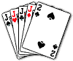 | Four of a Kind  Four cards of the same denomination. Our example shows four jacks with a deuce kicker.
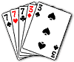 | Full House  Any three cards of the same denomination, plus any pair of a different denomination. Ties are broken first by the three of a kind, then the pair. Our example shows sevens full of threes.
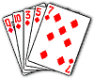 | Flush  Any five non-consecutive cards of the same suit. Our example shows a queen-high diamond flush.
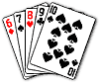 | Straight  Any five consecutive cards of mixed suits. Ace can be high or low. Our example shows a six-to-ten straight.
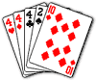 | Three of a Kind  Three cards of the same denomination.Our example displays three of a kind, fours.
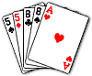 | Two Pair  Any two cards of the same denomination, plus any other two cards of the same denomination. If both hands have the same high pair, the second pair wins. If both pairs tie, the high card wins. Our example shows two pair, eights and fives.
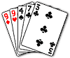 | Pair  Any two cards of the same denomination. Our example displays a pair of nines. In a tie, the high card wins.
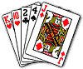 | High Card  If no other hand is achieved, the highest card held wins. In our example, the king of hearts is the high card.  Note: The ranking of hands differ in 2 and 3 card manila.
Draw Poker
To begin, two players at the table make a small bet, or blind wager, before receiving any cards. Each player seated in the game takes a turn at placing such a wager.
Players first receive five cards dealt face down. Players pick up the cards and look at them and then decide if they wish to stay in the game. If so, a bet must now be placed.
Once all bets are called the first round of betting is complete.
Players may now choose to exchange with the dealer any number of cards from their hand. This is known as 'the draw'.
Once the draw is complete a second round of betting takes place.
If all bets are called there is a showdown.
The winner is the player with the highest ranking hand.
If only one player remains (ie. no showdown) they will win the pot without having to expose their cards.

