

**Advanced Topics in Programming**

Dejan Mišić, Merisa Kasumović, Berin Sadiković, Omer Karasalihović,  
 Robert Stefanišin

Date: 27.01.2019

Contents

School system 3

# School System Application

Our Group Project is to make a School System Application. We have done it in C#. In this application you can input all information about employees in a school. We put some operations where you can separate employees through their jobs and students degrees. You can add student and all information about them (degree, program, class, courses and etc.), professors, administration, as you can see in a screenshots put here. For every field you can add also all information about. ID, date of birth, course information, and all other needed information.

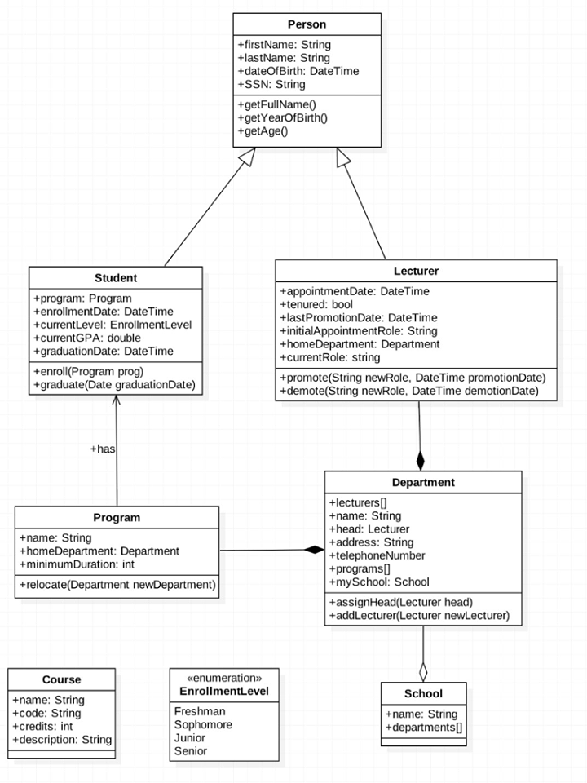

Add Record (Photo 1)

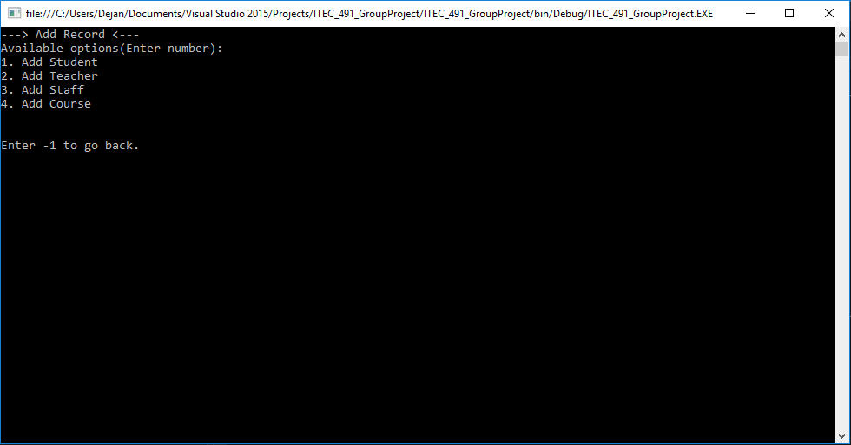

Edit Teacher (Photo 2)

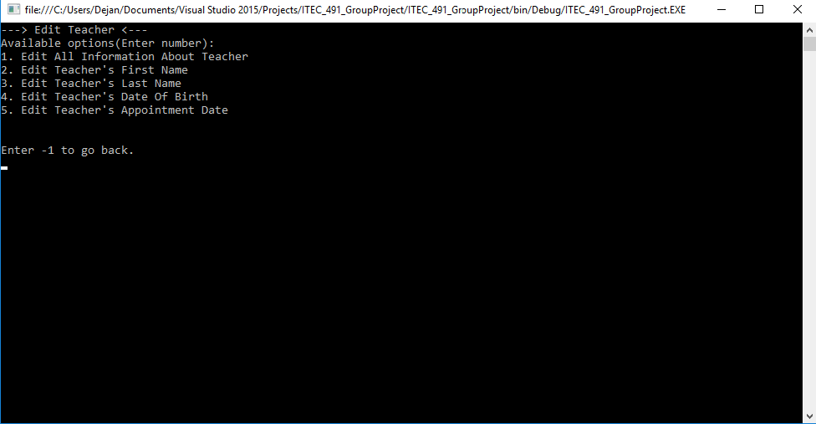

Edit Record (Photo 3)

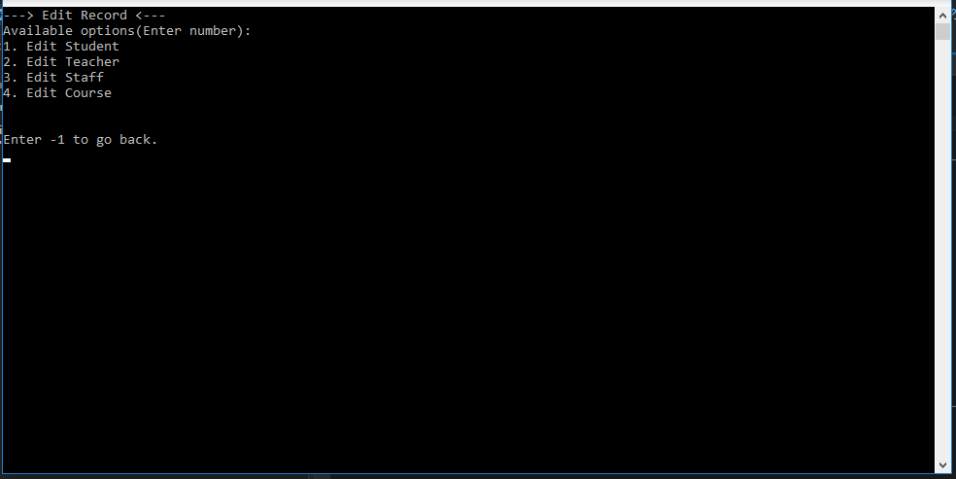

Edit Course (Photo 4)

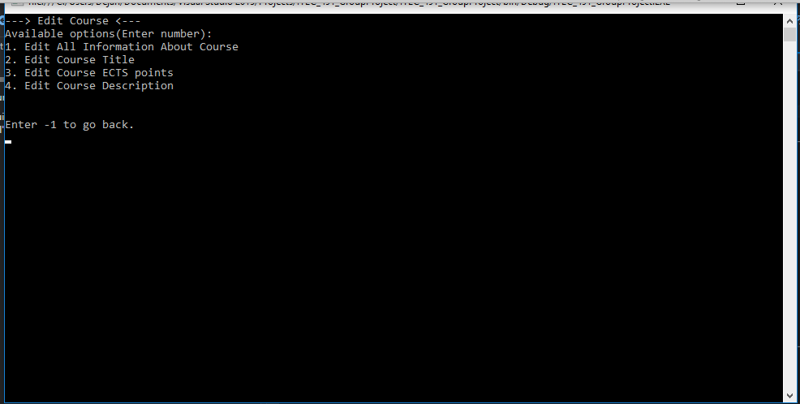

School System (Photo 5)

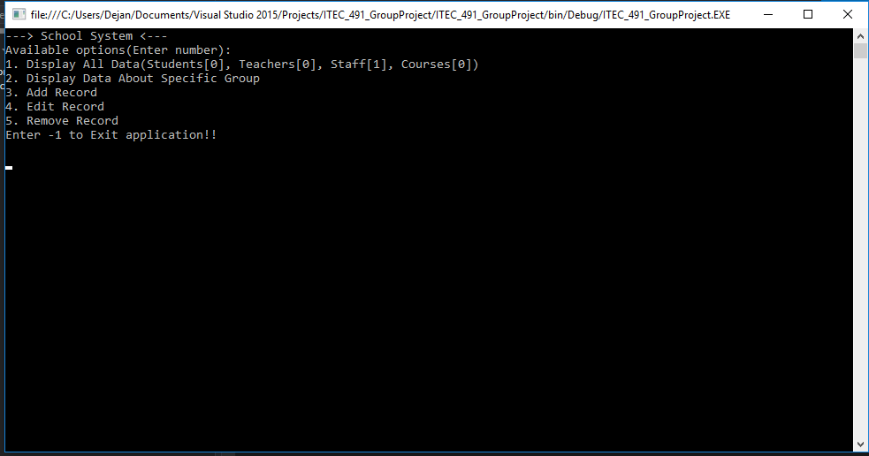

Display Information About Specific Group (Photo 6)

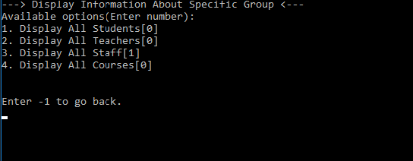

Staff Information (Photo 7)

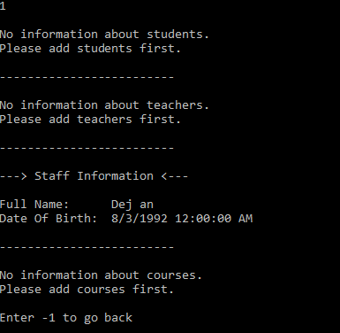

Remove Record (Photo 8)

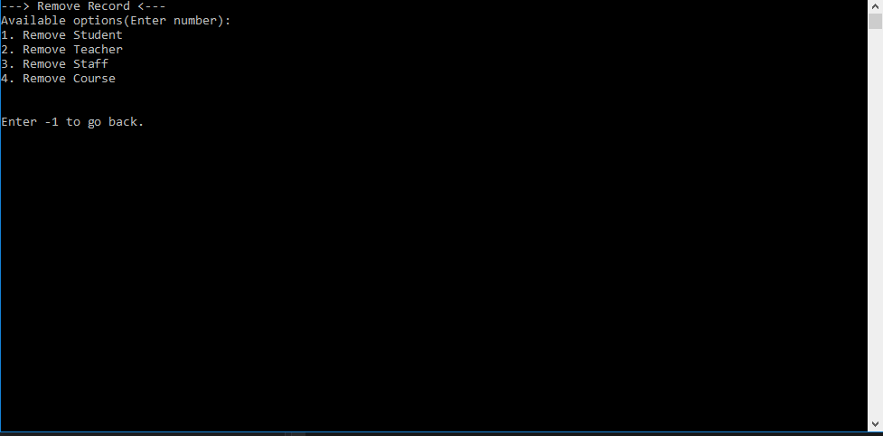

Edit Staff (Photo 9)

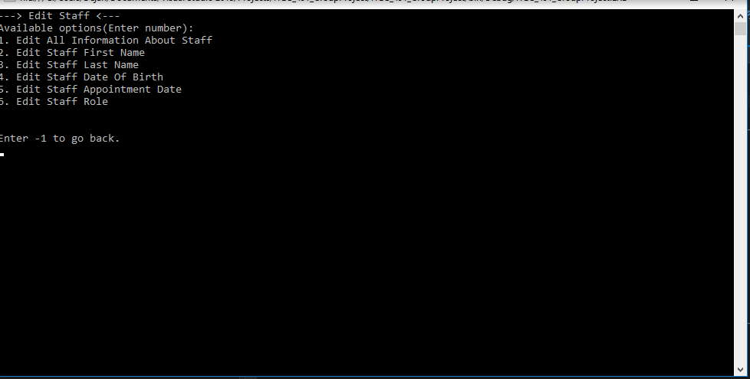

Edit Student (Photo 10)

