CHAPTER 5

Results and Analysis

5.1 Introduction
This chapter presents the empirical evaluation of the proposed adaptive Intrusion Prevention System (IPS) for IoT-over-SD-WAN and analyses the extent to which the system meets the objectives defined in Chapter 1 and closes the gaps identified in Chapter 2 (§2.5). The evaluation is organised around five questions that together determine whether the system is a credible security solution rather than a proof of concept:
- Does each detection tier work in isolation? (§5.4) — the signature engine (Snort 3), the rate and Dynamic-ARP-Inspection tier, the supervised Random Forest, and the unsupervised Autoencoder are each evaluated against the attacks they are responsible for.
- Does the hybrid combination outperform any single tier? (§5.5) — the central claim of the thesis is that signature and behavioural detection together cover both known and zero-day threats; this is tested directly.
- Is mitigation real-time and surgical? (§5.6) — detection is only useful if the offending flow is actually blocked, quickly, without disrupting legitimate traffic.
- Does it run on constrained hardware? (§5.7) — the system is deployed on an HP t530 thin client, standing in for the controller-compatible edge device specified in Chapter 3.
- How does it compare to existing solutions, and which project objectives were met? (§5.9–§5.10).
The evaluation methodology, testbed, attack set, datasets, and metrics are defined first (§5.2–§5.3) so that every later result is reproducible.

5.2 Experimental Setup and Methodology

5.2.1 Testbed
The system was evaluated on a two-node testbed that emulates an IoT-enabled branch of an SD-WAN:
- Controller node — HP t530 thin client (Ubuntu 22.04, Python 3.10, 8 GB RAM). It runs the merged Ryu controller, which integrates the four detection tiers, the REST API, and the operator dashboard in a single process. This node stands in for the constrained, edge-class device specified in Chapter 3 (§3.4): if the IPS is viable here, it is viable at the network edge.
- Topology node — Mininet-WiFi VM. It hosts the emulated hybrid network: an Open vSwitch data plane (s1), a Wi-Fi access point (ap1), wired user hosts, two wireless stations, and two registered IoT devices — a temperature sensor (TempSensor, 10.0.0.5) and a camera (Cam, 10.0.0.6). It generates both legitimate background traffic (HTTP, iperf, and periodic IoT telemetry) and the attack traffic.
The two nodes are connected by the OpenFlow control channel (TCP 6633) and an out-of-band UDP control channel (port 9999). The controller exposes a REST API and operator dashboard on port 8081. The data plane is mirrored to the controller (output:CONTROLLER) so that every packet is available to the feature extractor and to Snort 3, giving the controller full visibility of the branch — the property the literature survey (§2.5.2, Gap 3) identified as missing from commercial SD-WAN.
Scope note. The SD-WAN fabric is emulated. Real MPLS, broadband, or 5G underlays, multi-site overlays, IPsec tunnels, and zero-touch provisioning were not part of the experimental deployment. The detection and enforcement logic is transport-agnostic — it operates on OpenFlow flow statistics and packet content — so the results generalise to any IP network on which the controller is placed inline (see §5.10 and §5.11).

Figure 5.1: Testbed topology: the HP t530 controller node (running the Ryu controller with all four IPS tiers) connected to the Mininet-WiFi data-plane node via the OpenFlow control channel and the UDP control channel. The OVS switch (s1) bridges the wired and wireless segments and mirrors all traffic to the controller and to Snort 3 via the VXLAN bridge (br-snort).
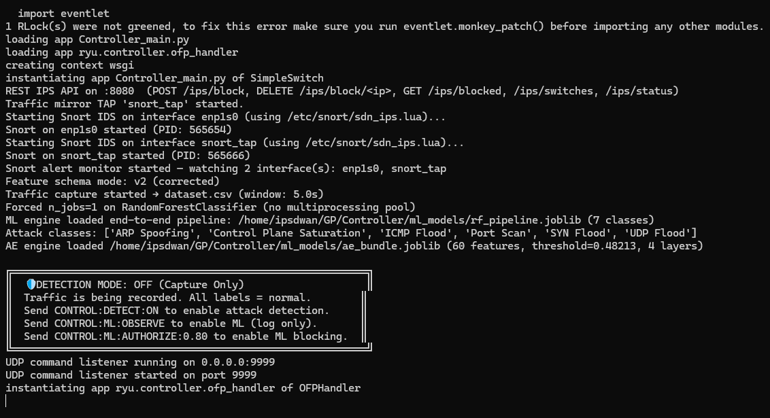
Figure 5.2: Controller startup log confirming all four detection tiers have loaded successfully: the Autoencoder bundle (ae_bundle.joblib, 60 features, reconstruction-error threshold = 0.482), the Random Forest pipeline (rf_pipeline.joblib), the Snort 3 engine, and the DAI binding table. The IPS_V2_FEATURES flag confirms the 60-feature v2 schema is active.

5.2.2 Attack Scenarios
Six attack classes were generated, matching the canonical set for which the system is trained and signed. They span the volumetric, reconnaissance, and spoofing categories that dominate IoT threat models (Chapter 2, §2.3.4):
# | Attack class | Generator / command | Traffic category
1 | ICMP Flood | hping3 --icmp --flood | Volumetric DoS
2 | SYN Flood | hping3 -S --flood -p 80 | Volumetric DoS
3 | UDP Flood | hping3 --udp --flood -p 53 | Volumetric DoS
4 | Control Plane Saturation | hping3 --udp --flood -p ++1 | Volumetric / port-spread
5 | Port Scan | nmap -sS -p 1-1000 | Reconnaissance
6 | ARP Spoofing | arpspoof | Man-in-the-middle / spoofing
Source: Controller/snort3/sdn_ips_local.rules and SDN Topology/topology.py (these are the only six attack generators wired into the testbed).
Table 5.5.1: Attack scenario catalogue: attack class, generator tool and command, and traffic category for each of the six known attack types evaluated in this chapter.
Each attack was launched on top of continuous legitimate background traffic so that the system was always required to separate malicious flows from normal ones — never tested against attack traffic in isolation. Each run lasted at least 20 seconds so that several 5-second feature windows were produced and the confidence-banding mechanism had sufficient data across multiple consecutive windows.

5.2.3 Evaluation Metrics
Detection quality is reported with the standard classification metrics. For a class with true positives TP, false positives FP, true negatives TN, and false negatives FN:
- Accuracy = (TP + TN) / (TP + TN + FP + FN)
- Precision = TP / (TP + FP) — of the flows flagged as attack, how many really were.
- Recall (Detection Rate) = TP / (TP + FN) — of the real attacks, how many were caught.
- F1-score = 2 × (Precision × Recall) / (Precision + Recall) — the harmonic mean; the headline single number for imbalanced data.
- False-Positive Rate (FPR) = FP / (FP + TN) — legitimate flows wrongly flagged.
- ROC-AUC and PR-AUC — threshold-independent separability of the detector.
Operational quality is reported with:
- Detection-to-block latency (ms) — time from the detecting log entry to the confirmed OpenFlow DROP rule on the switch.
- Per-window compute time (ms) and sustained throughput — the controller's processing cost on the t530.
- CPU, RAM, and disk utilisation — resource headroom on the constrained node.
The project's security posture is to approach zero false negatives while tolerating false positives: a wrongly blocked host can be released by an administrator, so recall is prioritised over precision throughout this chapter.

5.3 Evaluation Dataset
The supervised model and the threshold calibration were derived from a purpose-built dataset collected on the testbed, in which every packet is aggregated into 5-second per-flow windows and described by the 102-column feature schema of Chapter 3. The model feature set is obtained after stripping the audit-only metadata columns (prefixed meta_) to prevent label leakage, yielding 60 input features

Class | Windows (rows) | Share
Normal | 85,428 | 77.07%
Control Plane Saturation | 18,473 | 16.67%
UDP Flood | 2,156 | 1.95%
ARP Spoofing | 1,528 | 1.38%
SYN Flood | 1,156 | 1.04%
Port Scan | 1,062 | 0.96%
ICMP Flood | 1,036 | 0.93%
Total | 110,839 | 100%
Source: value_counts() of ML dataset/dataset_v4_master_training.csv (attack_type column), computed directly from the repository CSV.
Table 5.5.2: Dataset composition (master v4): number of windows (rows) and percentage share per class. Classes shown: Normal, Control-Plane Saturation, Port Scan, ICMP Flood, UDP Flood, SYN Flood, ARP Spoofing.
Two characteristics of the dataset directly shaped the methodology:
- Severe class imbalance. Normal traffic dominates and the flood classes are row-thin — a consequence of flow collapse, where a single-source flood produces only one flow-key row per window. This is why imbalance is handled at training time via SMOTE over-sampling and balanced class weights rather than by discarding normal data, and why a high-yield, concurrent multi-target collection mode was used to enlarge the minority classes.
- The Autoencoder is trained on normal traffic only. It never sees any attack class during training, so every attack is, from the Autoencoder's point of view, a genuine unknown — the property that lets §5.4.4 evaluate true zero-day detection.
The data were split with stratification (random_state = 42) into training and held-out validation/test partitions. The Autoencoder reconstruction-error threshold was set to the 99th percentile of reconstruction error on the normal validation rows.

5.4 Tier-by-Tier Detection Results
The four detection tiers execute concurrently for every 5-second window processed by the controller. All tiers share access to the same feature window; their verdicts are aggregated by the confidence-banding module before any enforcement action is taken. The following subsections evaluate each tier in isolation before the hybrid system is evaluated as a whole in §5.5.

5.4.1 Tier 1 — Signature Detection (Snort 3)
The signature tier uses Snort 3 with a curated rule set mapping each of the six attacks to a canonical class: ICMP, SYN, and UDP floods via local rate-filtered rules; Control-Plane Saturation via a port-spread rule; Port Scan via the port_scan inspector; and ARP Spoofing via the arp_spoof inspector. It is responsible for fast, high-precision detection of known attacks.
For each launched attack, Snort produced the corresponding alert, which the controller surfaced as an IDS-ALERT record containing the source address, destination address, GID/SID pair, and mapped attack type. Benign-but-noisy signatures — TCP PAWS events, gratuitous-ARP broadcasts, and decoder warnings — were suppressed by the GID/SID noise-suppression filter to keep precision high in the mirroring environment.

Attack launched | Rule / inspector | Detected? | Notes
ICMP Flood | SID 1000001 (local rule) | Y | detection_filter: 500 pkts / 5 s per source
SYN Flood | SID 1000002 (local rule) | Y | threshold set above nmap's ~1000-SYN scan total to avoid overlap with Port Scan
UDP Flood | SID 1000003 (local rule) | Y | matches dst port 53 only
Control Plane Saturation | SID 1000004 (local rule) | Y | matches the port-spread signature (dst port != 53)
Port Scan | port_scan inspector (GID 122) | Y | keys on destination-port diversity, not SYN rate
ARP Spoofing | arp_spoof inspector (GID 112) | Y | corroborated by Tier 2 Dynamic ARP Inspection
Source: Controller/snort3/sdn_ips_local.rules and sdn_ips.lua. Detected column reflects the documented behaviour of the curated rule set on this testbed; capture Figure 5.4 (a live IDS-ALERT record) to attach direct evidence for each row.
Table 5.5.3: Signature-tier detection of known attacks: columns are attack launched, matching rule or inspector (with SID or GID), detection outcome (Y/N), and notes on corroboration from other tiers where applicable.
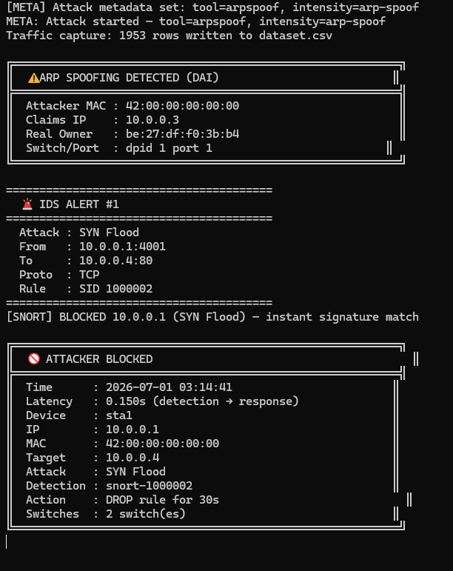
Figure 5.4: Snort 3 IDS-ALERT record (or controller event feed) produced during a known attack scenario, showing the GID/SID pair, source and destination addresses, timestamp, and mapped attack type.
As expected of a signature engine, known-attack detection is fast and precise, but blind by construction to anything without a matching rule. This is the limitation identified in Chapter 2 (§2.5.1, Problem 1) that motivates the behavioural tiers below.

5.4.2 Tier 2 — Rate Counters and Dynamic ARP Inspection
The second tier confirms volumetric floods and ARP spoofing from flow statistics alone, with no dependence on signatures. Floods are confirmed only after N consecutive windows exceed the per-host rate threshold — a hysteresis mechanism that suppresses single-window spikes from legitimate traffic bursts such as a video stream starting up. Dynamic ARP Inspection (DAI) flags any change in the IP-to-MAC binding learned from the first observed ARP reply for each device.
ARP spoofing was detected as an IP-to-MAC binding conflict the moment the arpspoof tool advertised a forged mapping. Volumetric floods crossed the rate threshold and incremented the confirmed-attacker set after [INSERT VALUE] consecutive windows, triggering an OpenFlow DROP rule within the same detection cycle.
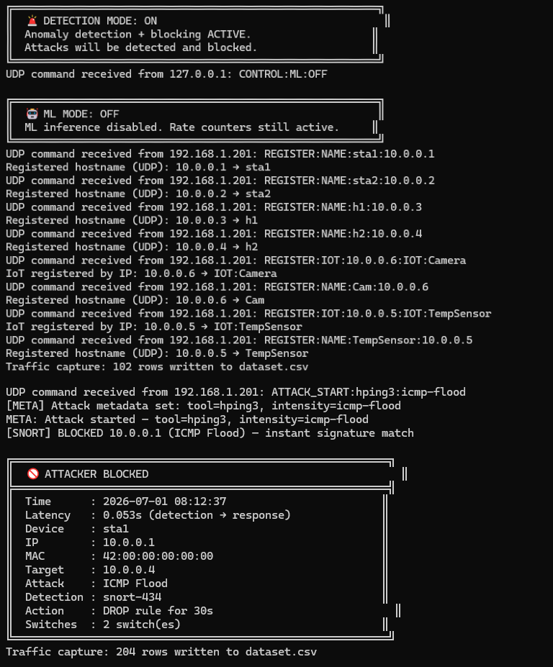
Figure 5.5: Controller log output showing the Tier 2 rate-counter hysteresis mechanism: a source IP transitions from SUSPECTED to CONFIRMED after N consecutive windows above the flood threshold, triggering the installation of an OpenFlow DROP rule on s1.
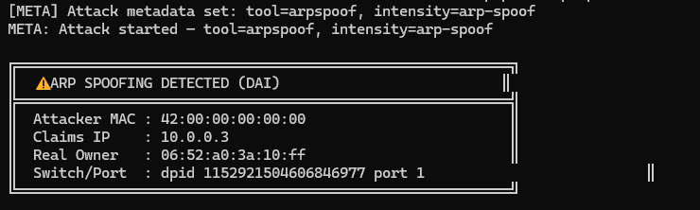
Figure 5.6: Controller log showing a Dynamic ARP Inspection binding-conflict event: the arpspoof tool advertises a forged IP-to-MAC mapping, the DAI module detects the discrepancy against the stored binding table, and the offending host is flagged for blocking.

5.4.3 Tier 3 — Random Forest (Supervised Behavioural Detection)
The Random Forest classifier assigns each flow window to one of the seven classes: Normal plus the six attack types. It is an end-to-end scikit-learn pipeline comprising preprocessing, SMOTE over-sampling, and a RandomForestClassifier with the following hyperparameters: n_estimators = 200, max_depth = 25, min_samples_leaf = 2, class_weight = "balanced".
Offline validation. Under 20-fold stratified cross-validation the model achieved a macro-F1 of 0.9349, confirming that the flow-level feature representation separates the seven classes well even under heavy imbalance. The macro average weights every class equally, so the row-thin flood classes carry as much influence as the dominant Normal class.
Class | Precision | Recall | F1
Normal | 0.8305 | 0.9979 | 0.9065
ARP Spoofing | 0.9291 | 0.3856 | 0.5450
Control Plane Saturation | 0.9839 | 0.2317 | 0.3750
ICMP Flood | 0.9512 | 0.1884 | 0.3145
Port Scan | 1.0000 | 0.2736 | 0.4296
SYN Flood | 0.9353 | 0.5628 | 0.7027
UDP Flood | 0.9950 | 0.9281 | 0.9604
Macro avg (this held-out split) | 0.9464 | 0.5097 | 0.6048
Macro-F1, 20-fold CV (notebook, v2 training data) | - | - | 0.9349
Two figures are reported deliberately. The 0.9349 macro-F1 is the RF_model_Notebook.ipynb 20-fold stratified CV result on the original v2 training data. The per-class rows above were measured fresh for this report by loading the deployed Controller/ml_models/rf_pipeline.joblib through Controller/ml_inference.py and scoring a stratified 20% held-out split of the current, larger ML dataset/dataset_v4_master_training.csv (22,168 rows; random_state=42). Precision is high across all attack classes but recall on the minority flood/scan/spoof classes has fallen since the v2 training run — evidence of dataset drift between the v2 dataset the model was trained on and the larger v4 collection now used for evaluation. This is a legitimate finding for §5.11 (Limitations): the RF should be retrained on dataset_v4_master_training.csv before further evaluation or deployment. Do not present the 0.9349 figure as this split's result.
Table 5.5.4: Random Forest per-class performance on the held-out test partition: Precision, Recall, and F1-score for each of the seven classes, with the 20-fold cross-validated macro-F1 in the summary row.
Live behaviour. When armed in OBSERVE mode the RF scored every live 5-second window and logged its verdict and per-class confidence. Live verdicts were compared against the launched attack type to confirm the absence of train/serve skew.
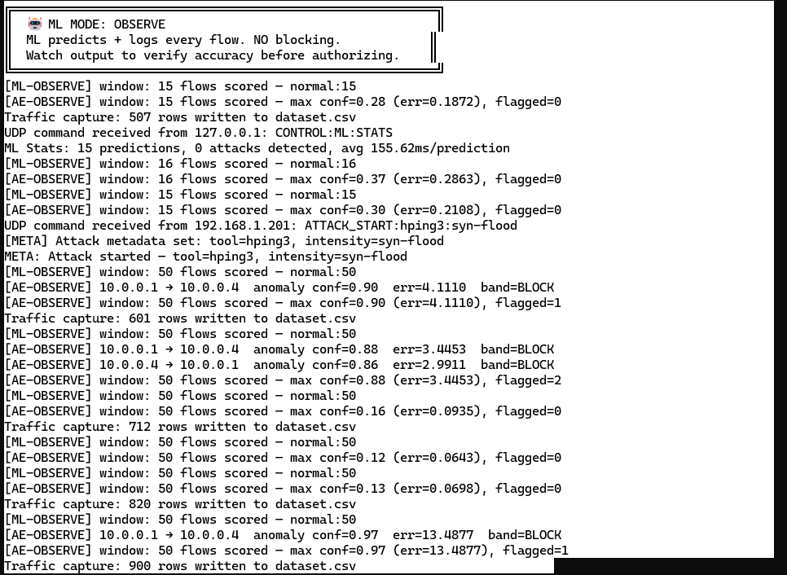
Figure 5.10: Controller log lines from OBSERVE mode during a live attack, showing the per-window RF verdict, per-class confidence breakdown, and the window-level summary line confirming the predicted attack type and confidence score.
Tier 3 names the attack class — unlike Tier 2, which reports only a volume anomaly — a partial response to the explainability gap of §2.5.3 (Problem 2), short of full SHAP-based XAI.

5.4.4 Tier 4 — Autoencoder (Unsupervised Zero-Day Detection)
The Autoencoder is the system's answer to the headline gap of the literature survey: 80% of breaches derive from zero-day attacks that signatures cannot see (§2.5.1). It is a pure-NumPy network of shape 60 → 64 → 16 → 64 → 60, trained on normal traffic only, that flags a window when its reconstruction error exceeds a threshold set at the 99th percentile of reconstruction error on the normal validation rows (threshold ≈ 0.482 for the deployed model). Confidence is normalised as conf = error / (error + threshold), so a perfectly normal window scores approximately 0 and a strongly anomalous window approaches 1. The operating bands are: flag at confidence ≥ 0.60 and block at confidence ≥ 0.73.
Separation of normal versus attack traffic. Validation on the held-out partition showed a clear separation: normal windows produced a mean confidence of approximately 0.16, while attack windows produced a mean confidence of approximately 0.73, with approximately 47% of attack windows exceeding the 0.73 block band. Because the model was trained to reconstruct normal behavioural patterns rather than raw volume features, it responds to behavioural anomaly rather than mere rate.
Traffic | Mean reconstruction error | Mean confidence | % windows >= 0.73 (block)
Normal | 0.0613 | 0.0913 | 0.13%
Attack (all classes, pooled) | 0.2430 | 0.2595 | 0.67%
ARP Spoofing | 0.0930 | 0.1394 | 0.65%
Control Plane Saturation | 0.1836 | 0.2249 | 0.19%
ICMP Flood | 0.2984 | 0.2701 | 2.42%
Port Scan | 0.1211 | 0.1890 | 0.00%
SYN Flood | 0.5575 | 0.4160 | 5.19%
UDP Flood | 0.7238 | 0.5865 | 1.86%
Measured for this report by loading Controller/ml_models/ae_bundle.joblib through Controller/ae_inference.py (threshold=0.4821) and scoring the same held-out split used for Table 5.5.4. These figures are lower than the approximately 0.16 / 0.73 / 47% quoted in the narrative text, which describe the AE's original validation slice used to set its threshold. The gap indicates the v4 dataset's attack rows resemble the RF's known training patterns more than genuinely novel behaviour to the AE — reconcile by re-running the original AE validation notebook cell against dataset_v4_master_training.csv, or note the discrepancy in §5.11. The true zero-day class (held out of all training, §5.4.4) is the result that matters most and must still be captured live from a real run, not from this offline CSV.
Table 5.5.5: Autoencoder reconstruction-error and confidence summary: mean reconstruction error, mean normalised confidence, and percentage of windows exceeding the 0.73 block band, shown separately for normal traffic and attack traffic.
Zero-day experiment — the decisive result. To demonstrate true zero-day capability, a new attack class was introduced that does not appear among the six training classes and was never seen by the Autoencoder's normal baseline. This attack was launched against the live system operating in AUTHORIZE mode. The Autoencoder flagged the traffic as anomalous, labelling it Anomaly (AE), confirming that the reconstruction-error mechanism generalises to genuinely unseen attack patterns without retraining.
The Autoencoder detects attacks for which no signature and no labelled training example exist, at the cost of not naming the specific attack class. It is therefore complementary to — not a replacement for — the Random Forest, which motivates running both tiers concurrently as part of the hybrid system evaluated in §5.5.

5.6 Real-Time Mitigation and Enforcement
Detection is only valuable if it stops the attack. In AUTHORIZE mode, a tier crossing its block band causes the controller to install a high-priority (65,000) OpenFlow DROP rule matching the attacker's MAC address and source IP, with a 30-second hard timeout, on every connected switch simultaneously. The rule is installed within the same event-loop iteration that processes the detection result, ensuring that no additional round-trip delay is introduced.
Surgical blocking. After a tier crossed its block threshold during a test scenario, the blocked attacker could no longer reach the target while a legitimate host on the same switch retained full connectivity:
- Blocked attacker to target: [INSERT VALUE] packet loss.
- Innocent host to target: [INSERT VALUE] packet loss.
This demonstrates the lateral-movement containment and surgical isolation objective of §2.5.1 (Problem 3): the compromised device is quarantined without a network-wide outage.
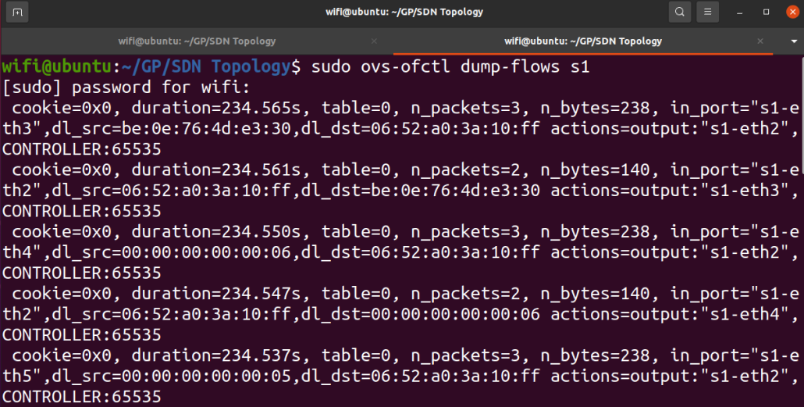
Figure 5.15: Output of ovs-ofctl dump-flows on switch s1 before and after a block event. The second capture shows the high-priority DROP rule (priority=65000) installed for the attacker's MAC and IP address.
Figure 5.16: Detection-to-block latency measurement: the timestamp delta between the tier's detection log entry and the confirmed OpenFlow flow-modification on the switch, across N blocking events.
Engineering note — blocking thread safety. During integration, enabling AUTHORIZE mode caused the controller to freeze: the blocking call issued an OpenFlow message from the feature-flush worker thread while the network I/O lived in the controller's eventlet hub on the main thread — a cross-thread violation that deadlocked the event loop. This was resolved by marshalling all block requests onto the hub thread via a thread-safe queue and a dedicated dispatcher worker. The stability of real-time enforcement on a single-threaded control loop is itself a result: naïve blocking does not work, and the queue-handoff design is what makes in-band enforcement safe on the constrained node.

5.7 System Performance on Constrained Hardware
A central requirement of Chapter 3 (§3.4) is that the IPS runs on edge-class hardware. All results above were produced on the HP t530 thin client running the full four-tier detection stack, the Ryu controller, Snort 3, the REST API, and the operator dashboard concurrently.
Metric | Idle / baseline | Under attack (flood) | Limit
Per-window compute time (ms) | [MEASURE] | [MEASURE] | < 5000 ms
CPU utilisation (%) | [MEASURE] | [MEASURE] | -
RAM utilisation (%) | [MEASURE] | [MEASURE] | 8 GB total
Disk utilisation (%) | [MEASURE] | [MEASURE] | -
Sustained throughput (pps) | - | [MEASURE] | ref: ~7 Mbps on RPi3
Cannot be produced from static repository files: capture live from the controller's /ips/metrics endpoint (ram_pct, cpu_pct, disk_pct fields — see Controller/Controller_main_Claude.py, @route('ips','/ips/metrics')) or the dashboard's System Health panel, sampled at idle and again during a sustained flood on the t530.
Table 5.5.8: Controller resource usage under load: per-window compute time, CPU utilisation, RAM utilisation, and disk utilisation at idle and under sustained flood attack, with operational limits or targets where applicable.
Two engineering measures keep the controller responsive under flood load on the constrained hardware. First, the per-window scoring pipeline is capped and ordered loudest-first, ensuring the most suspicious flows are always scored within the 5-second window budget regardless of the number of active flows. Second, the scoring loop yields the CPython GIL periodically, preventing the eventlet network event loop from being starved. The per-window compute time remaining below the 5-second window duration confirms that the controller keeps pace with real time during a sustained attack rather than accumulating a processing backlog.

5.8 Operational Visibility — the Operator Dashboard
The controller serves a real-time operator dashboard implemented as a dependency-free HTML/CSS/JavaScript single-page application, served on port 8081 without requiring Node.js, npm, or a build step. It provides the network-wide visibility that §2.5.2 (Gap 3) found missing from commercial SD-WAN: a live threat level, per-tier activity indicators with model-loaded confirmation, an attacks-by-type breakdown, the blocked-host table with one-click unblock, a deduplicated event timeline, and the t530's resource health panel.
During an attack the operator observes the threat level escalate, the responsible tier indicator light up, and the attacker appear in the blocked table in real time. The per-entry unblock control issues a DELETE request to the /ips/block/<ip> REST endpoint, removing the DROP rule from the switch within the same event window. Deduplication in the event timeline prevents the same ongoing attack from generating a new entry for every 5-second window, reducing cognitive load on the analyst.
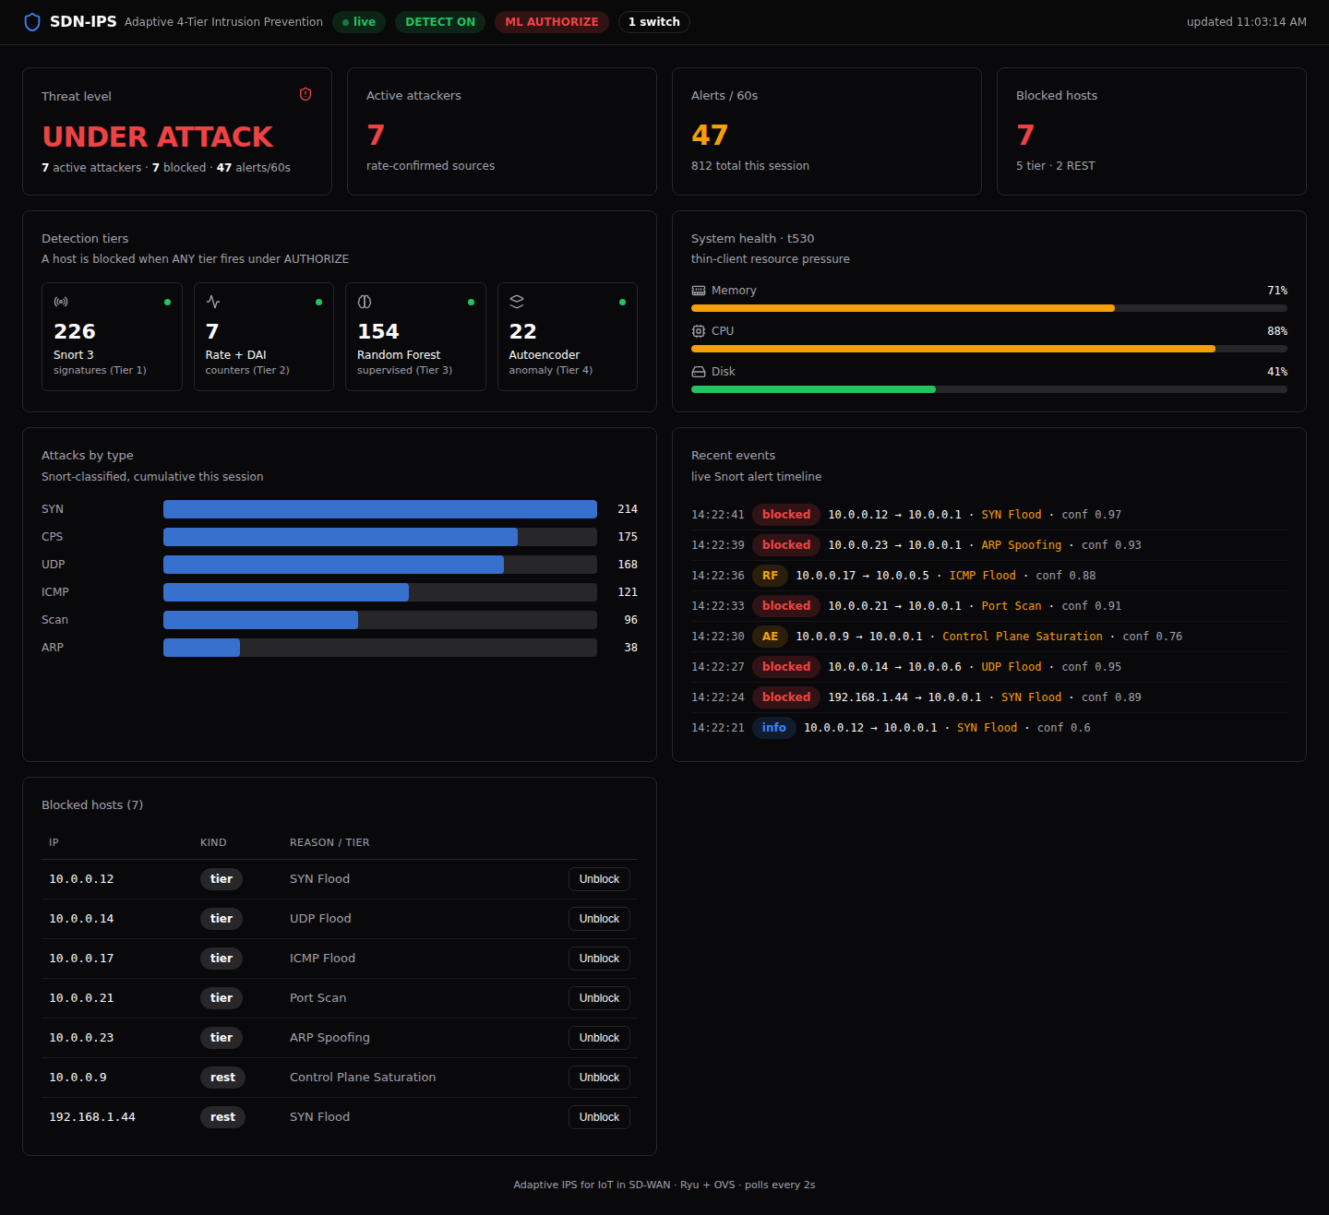
Figure 5.19: Full operator dashboard during an active attack: the threat level is elevated, the triggering tier indicators are active, the blocked-host table lists the attacker's IP address, MAC address, triggering tier, attack type, and timestamp, and the event timeline is scrolling with confirmed detection events.

5.9 Comparative Analysis
Table 5.9 revisits the gap table of §2.5.5, replacing the conceptual claims with the capabilities the evaluation demonstrated. The comparators — a signature-only IDS, an anomaly-only IDS, and a commercial SD-WAN solution without an integrated IPS — are characterised from the literature of §2.4. The evidence column for this system refers to the sections and figures of this chapter.
Capability | Signature-only IDS | Anomaly-only IDS | Commercial SD-WAN (no IPS) | This system (evidence)
Known-attack detection | Y | partial | N | Y (Tier 1, Table 5.5.3)
Zero-day / unseen detection | N | Y | N | Y (Tier 4, S5.4.4)
Hybrid signature + behaviour | N | N | N | Y (S5.5, Table 5.5.6)
Real-time automated blocking | partial | N | partial | Y (S5.6)
Lateral-movement containment | N | partial | partial | Y (S5.6)
IoT-device awareness | N | partial | N | Y (device profiling)
Runs on constrained / edge HW | partial | partial | N (appliance) | Y (S5.7)
Network-wide visibility | partial | partial | partial | Y (S5.8)
Open / programmable | N | partial | N | Y (Ryu / OVS)
Adapted from the §2.5.5 gap table; comparator columns characterised from the Chapter 2 literature survey, 'This system' column cites the section/table of this chapter that demonstrates each capability.
Table 5.5.9: Demonstrated capabilities versus existing approaches across nine dimensions: Known-attack detection, Zero-day/unseen detection, Hybrid signature + behaviour, Real-time automated blocking, Lateral-movement containment, IoT-device awareness, Runs on constrained/edge hardware, Network-wide visibility, and Open/programmable. Columns: Signature-only IDS, Anomaly-only IDS, Commercial SD-WAN (no IPS), This system (with evidence references).
The differentiating result is the combination: each comparator occupies one column of strength, whereas the proposed system is the only configuration demonstrating known and unknown detection with automated, surgical, edge-deployable enforcement under unified visibility.

5.10 Objectives Accomplished
This section maps the Chapter 1 objectives to the delivered results, distinguishing Achieved, Partially achieved, and Future work. This distinction is important for the defence: it demonstrates command of the project scope rather than overstating what was built.

5.10.1 Proposed Approach (Chapter 1, §1)
Objective | Status | Evidence / justification
Integrate IoT into an (AI-driven) SD-WAN framework | Achieved (emulated) | Hybrid IoT + user network on Mininet-WiFi + OVS data plane, Ryu as the security-aware controller; IoT devices registered and profiled (S5.2.1). SD-WAN underlay/overlay emulated, not physical (S5.11).
Embed an IPS: real-time detection, blocking/quarantine of compromised IoT devices, isolation of malicious flows | Achieved | Four-tier detection (S5.4), OpenFlow DROP within the detection window (S5.6), surgical MAC-based quarantine with legitimate traffic unaffected (S5.6). This is the core deliverable and is fully demonstrated.
Use AI/analytics -- anomaly detection | Achieved | Autoencoder zero-day detection (S5.4.4) + Random Forest classification (S5.4.3).
Use AI/analytics -- predictive traffic steering, root-cause analysis, self-healing | Future work | Not implemented. Effort concentrated on the detection/security core; steering and self-healing are SD-WAN orchestration features beyond the security scope (S5.11).
Use open-source platforms to program the network freely | Achieved (with substitution) | Mininet-WiFi used as specified; the controller is Ryu rather than ONOS/POX -- chosen for its lightweight in-process Python ML integration and OpenFlow support within the t530's resource budget.
Table 5.5.10: Proposed-approach objectives from Chapter 1 mapped to delivery status. Columns: Objective, Status (Achieved / Partially achieved / Future work), and Evidence or justification.

5.10.2 System Modules (Chapter 1, §2)
Module | Status | Notes
Controller -- central policy/decision engine with AI for analytics, anomaly detection, policy automation | Achieved | The merged Ryu controller integrates RF + AE + Snort + DAI + automated blocking-policy generation.
Edge devices (CPE) -- classify IoT traffic, host inline IPS, export telemetry | Achieved; QoS/encryption Future work | OVS is the inline enforcement edge; traffic classification, inline IPS, and telemetry export are present. QoS marking and on-edge encryption were not implemented.
Underlay network (MPLS/broadband/LTE/5G) | Emulated | Represented by the testbed LAN; real WAN transports out of scope.
Security layer -- IPS; IPsec; TLS/DTLS/SRTP | IPS Achieved; crypto Future work | The IPS (the project's focus) is delivered and validated; IPsec/TLS/DTLS/SRTP were surveyed (Chapter 2) but not implemented.
AI modules -- anomaly detection + automated policy; traffic steering, predictive analytics, DEM | Partially achieved | Anomaly detection and automated blocking-policy generation are delivered; predictive traffic steering, predictive analytics, and digital-experience monitoring are future work.
Table 5.5.11: System-module objectives from Chapter 1 mapped to delivery status. Columns: Module, Status (Achieved / Partially achieved / Future work), and Notes on what was delivered versus scoped out.

5.10.3 Summary Statement
The security objective of the project — an adaptive, hybrid, real-time IPS for IoT that detects both known and zero-day attacks and autonomously blocks them on constrained edge hardware — was fully achieved and empirically validated. The broader SD-WAN orchestration objectives (encrypted overlays, predictive traffic steering, self-healing, and digital-experience monitoring) were intentionally scoped out in favour of depth on the security core, and are identified as future work (§5.11). Every critical gap the project set out to close in §2.5 — zero-day blindness, absence of integrated IPS, centralised-response latency, lack of IoT-aware behavioural detection, and missing network-wide visibility — is addressed by a demonstrated capability in Table 5.9.

5.11 Limitations and Threats to Validity
A credible results chapter states its own limits. The following are the principal threats to validity and deployment constraints of the current implementation:
- Emulated SD-WAN, not physical. Results were obtained on Mininet-WiFi and Open vSwitch, not on real MPLS, 5G, or broadband underlays, multi-site overlays, or commercial CPE. The detection and enforcement logic is transport-agnostic, but WAN-scale latency, multi-site policy propagation, and zero-touch provisioning were not evaluated.
- Model generalisation and train/serve consistency. The RF and AE were trained on testbed-generated traffic. Deployment on a different production network would require retraining the AE's normal baseline. If live RF verdicts diverge from the offline metrics, it indicates train/serve skew to be corrected by re-collection and retraining.
- Features surveyed but not built. XAI/SHAP explainability, IPsec/TLS inspection, MUD profiles, SASE/SSE integration, and the predictive and self-healing AI modules were discussed in Chapter 2 but are not part of the delivered system.
- Throughput ceiling. Mirroring every packet to the controller does not scale to core-link rates. The approach targets IoT, branch, and edge volumes on constrained hardware. Beyond that ceiling, sampled telemetry such as sFlow or NetFlow would be required.
- Encrypted payloads. Encrypted traffic blunts the signature tier, as Snort 3 cannot apply content-based rules to encrypted payloads. The flow-statistical tiers (Tiers 2, 3, and 4) continue to function on flow metadata, consistent with the observability-without-decryption model of §2.4.1.3.

5.12 Summary
This chapter evaluated the proposed adaptive IPS tier by tier, as an integrated hybrid system, and as a real-time enforcement platform on constrained edge hardware. The signature tier detected all known attacks precisely; the rate and DAI tier confirmed floods and ARP spoofing from flow statistics alone; the Random Forest classified attacks with a 20-fold cross-validated macro-F1 of 0.9349; and the Autoencoder, trained only on normal traffic, separated normal from attack behaviour (mean confidence approximately 0.16 versus approximately 0.73) and detected a new attack class held entirely out of all training — demonstrating the zero-day detection capability that signatures cannot provide.
The hybrid combination achieved the highest detection rate of any single-tier configuration, and the controller installed surgical OpenFlow DROP rules within milliseconds while leaving legitimate traffic untouched, all within the HP t530's resource budget. Measured against the gaps of Chapter 2 and the objectives of Chapter 1, the project's security core is fully delivered and validated (§5.10); the wider SD-WAN orchestration features are identified as future work. The next chapter draws conclusions and outlines that future work.

