**Experiment – 1**

**Aim: Write a program that prints “Hello World” to the Screen.**

**Tools Used: R version 4.4.2**

**Program:**



**Output:**

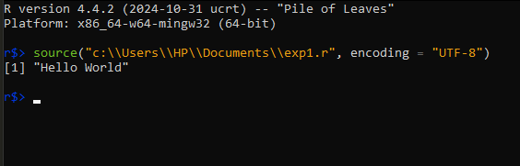

**Experiment – 2**

**Aim: Write a program that asks the user for a number n and prints the sum of the numbers 1 to n.**

**Tools Used: R version 4.4.2**

**Program:**

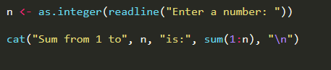

**Output:**

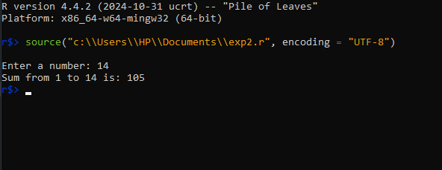

**Experiment – 3**

**Aim: Write a program that prints a multiplication table for numbers up to 12.**

**Tools Used: R version 4.4.2**

**Program:**

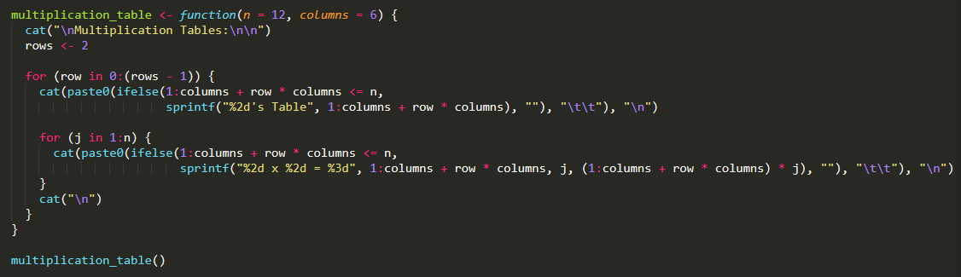

**Output:**

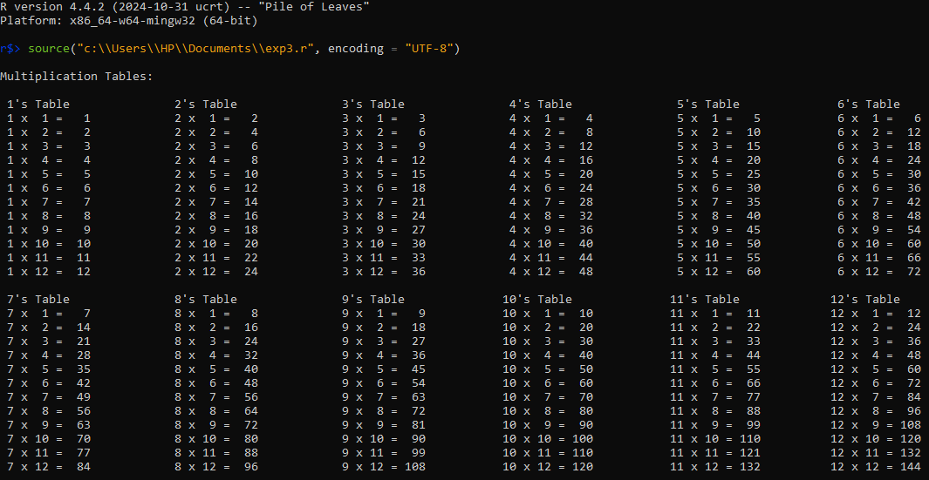

**Experiment – 4**

**Aim: Write a function that returns the largest element in a list.**

**Tools Used: R version 4.4.2**

**Program:**

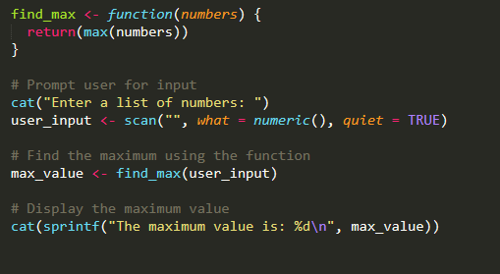

**Output:**

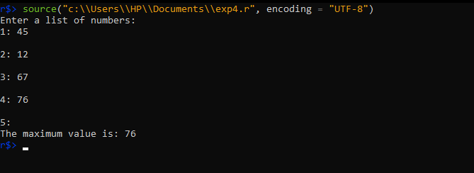

**Experiment – 5**

**Aim: Write a function that computes the running total of a list.**

**Tools Used: R version 4.4.2**

**Program:**

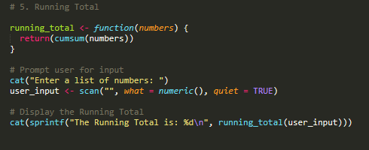

**Output:**

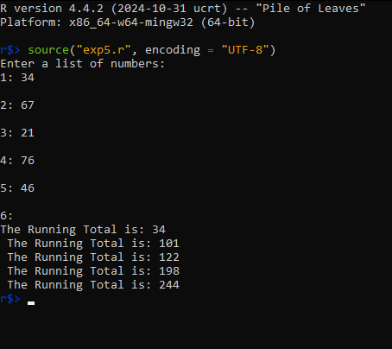

**Experiment – 6-8**

**Aim: Write a function that tests whether a string is palindrome.**

**Tools Used: R version 4.4.2**

**Program:**

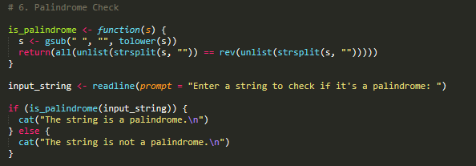

**Output:**

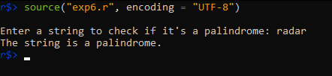

**Experiment – 9-11**

**Aim: Implement linear search.**

**Tools Used: R version 4.4.2**

**Program:**

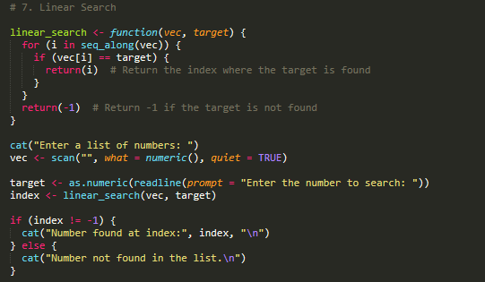

**Output:**

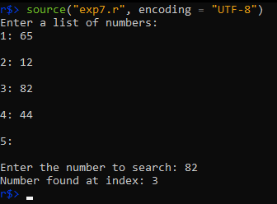

**Experiment – 12-14**

**Aim: Implement binary search.**

**Tools Used: R version 4.4.2**

**Program:**

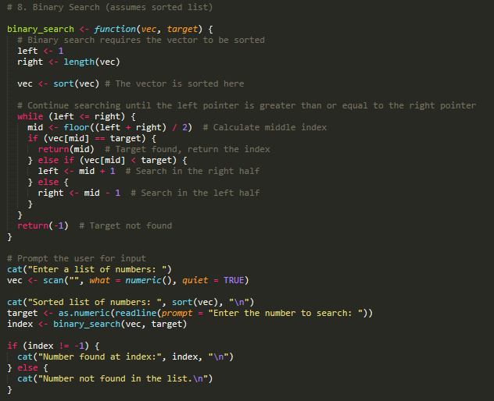

**Output:**

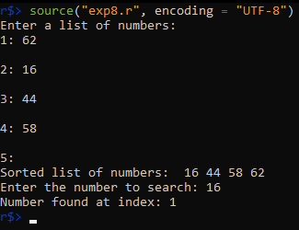

**Experiment – 15-17**

**Aim: Implement matrices addition, subtraction, multiplication and division.**

**Tools Used: R version 4.4.2**

**Program:**

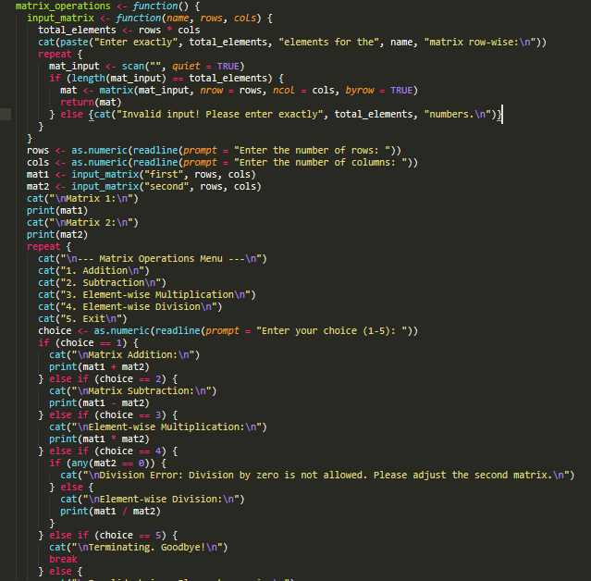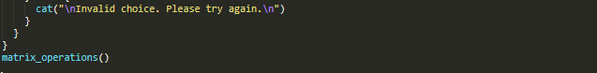

**Output:**

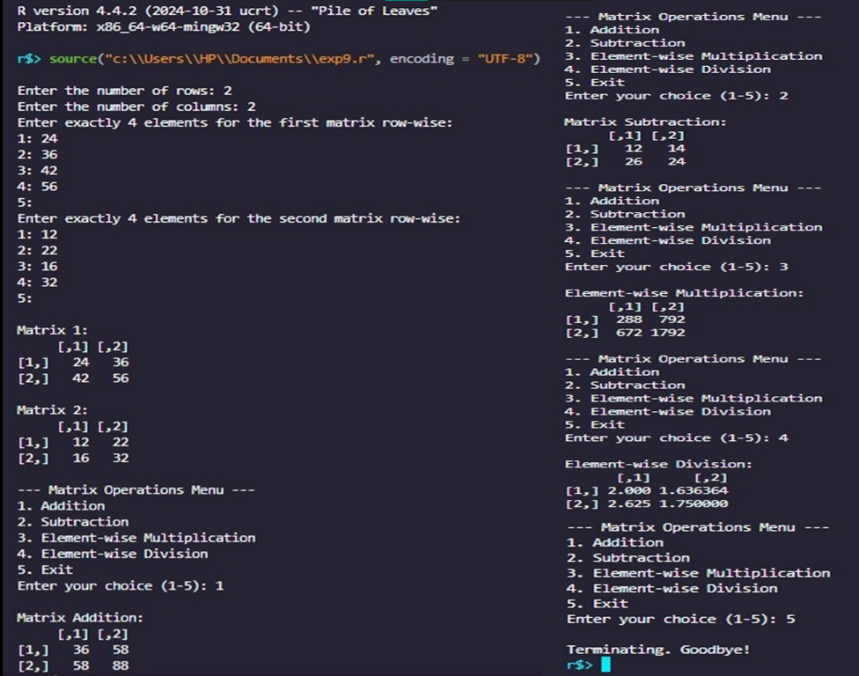

**Experiment – 18-20**

**Aim: Fifteen students were enrolled in a course. There ages were:**

**20 20 20 20 20 21 21 21 22 22 22 22 23 23 23**

1. **Find the median age of all students under 22 years**
2. **Find the median age of all students**
3. **Find the mean age of all students**
4. **Find the modal age of all students**
5. **Two more students enter the class. The age of both students is 23. What is now mean, mode and median?**

**Tools Used: R version 4.4.2**

**Program:**

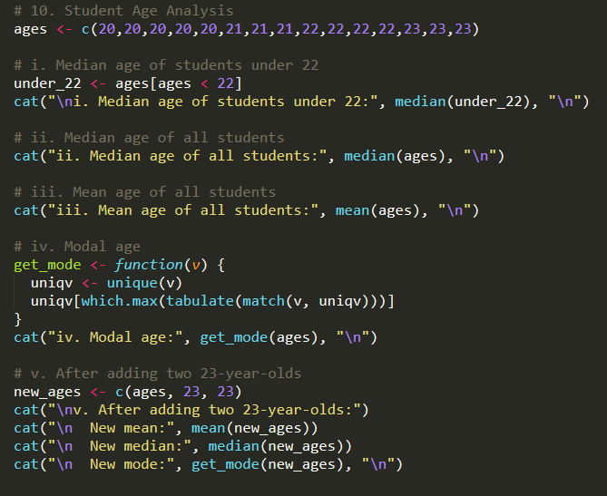

**Output:**