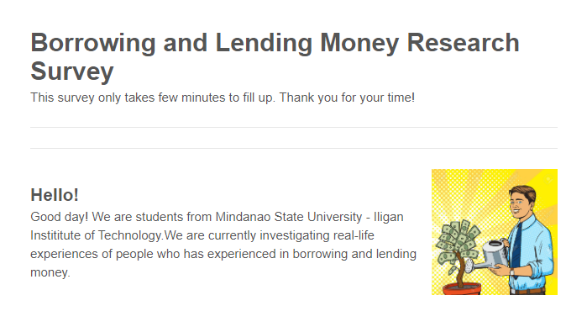ddas

Borrowing money means that you are committing to pay the money back within a certain time frame and at a certain interest rate (0%-100%)

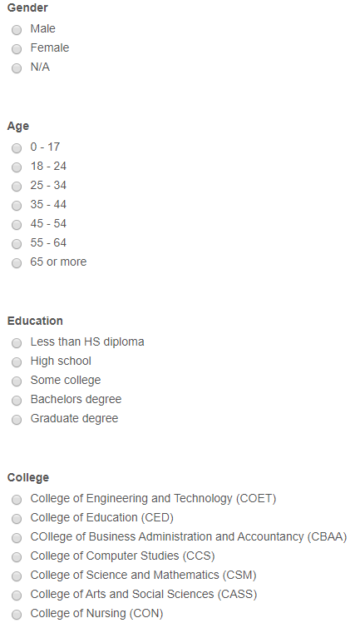

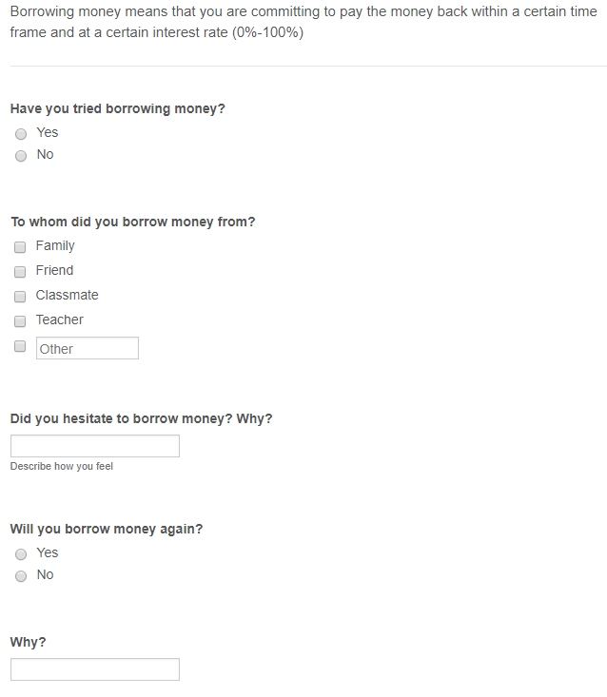

dasdsada

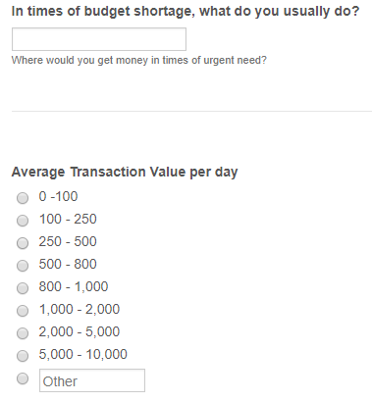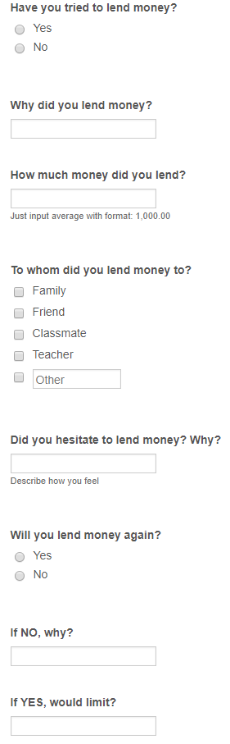

Lending in its most general sense is the temporary giving of money or property to another person with the expectation that it will be repaid. The recipient incurs a debt and is usually liable to pay interest on that debt until it is repaid as well as to repay the amount borrowed.