Oracle Red Labs Website Progress Report
Milestone 1 | September 30, 2026
Progress summary
The Oracle Red Labs project has a multi-page website foundation for presenting its services, security methodology, target audiences, and research resources. It also includes contact and engagement inquiry flows, account demonstration pages, and client dashboard and administration interfaces, built with static HTML, CSS, and JavaScript.

Current implementation
The pages share a responsive black-and-red visual system and use browser-side scripts for navigation, form interactions, resource filtering, and sample operational views. The project is build-free and can be opened from a basic static file server.

Current challenge
The website is not yet connected to a backend. The backend folder contains planning documentation but no server implementation, so account, inquiry, engagement, and administration features remain demonstrations and their data is not stored by a live service.

Next milestone
Implement the planned API and persistent data layer, then connect the inquiry and engagement forms, authentication flows, service and resource data, and dashboard status updates to those endpoints.

Website page screenshots
The appendix contains one desktop screenshot for each of the 11 website pages. Each image is labeled with the page name and source filename.

01 Home Page
index.html | Screenshot captured September 30, 2026
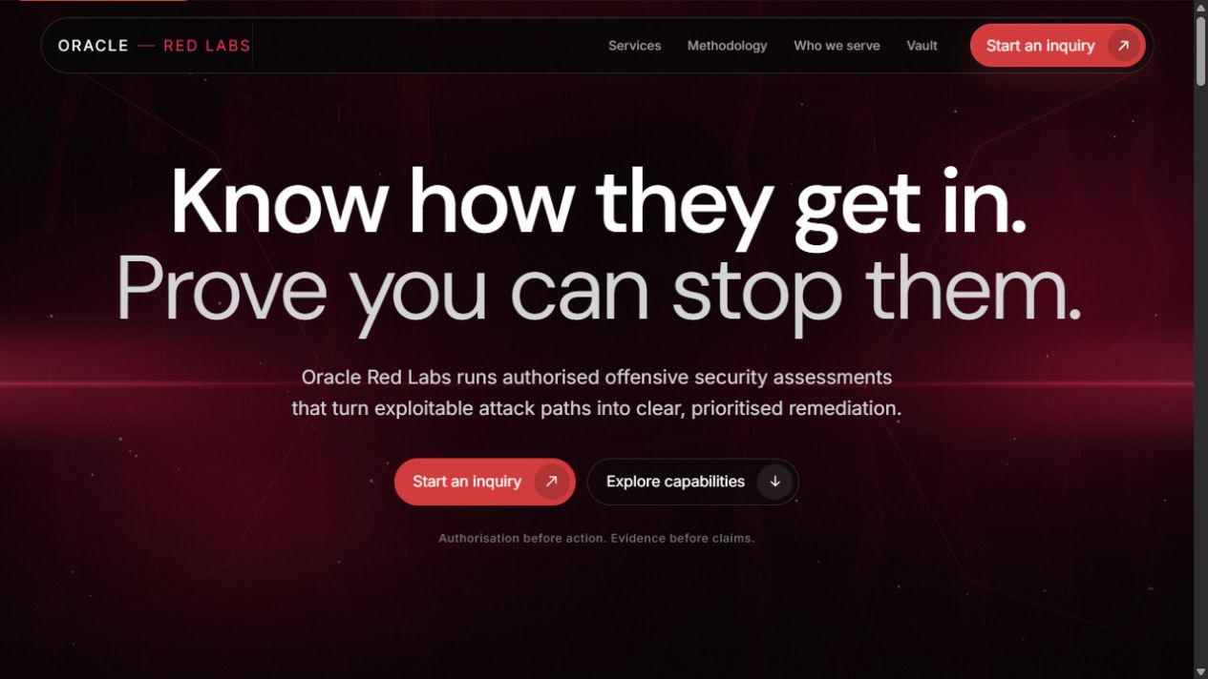

02 Services Page
services.html | Screenshot captured September 30, 2026
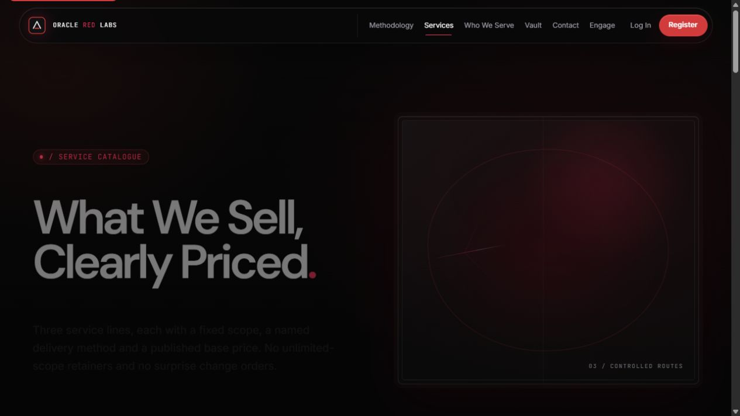

03 Methodology Page
methodology.html | Screenshot captured September 30, 2026
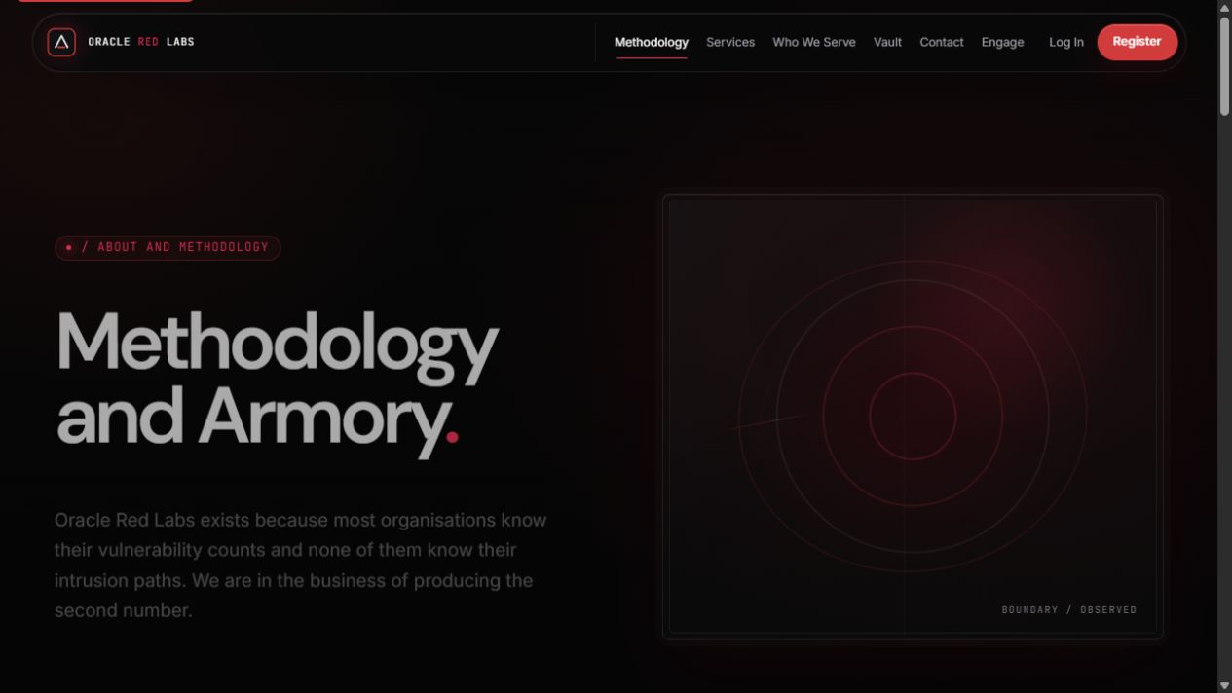

04 Who We Serve Page
who-we-serve.html | Screenshot captured September 30, 2026
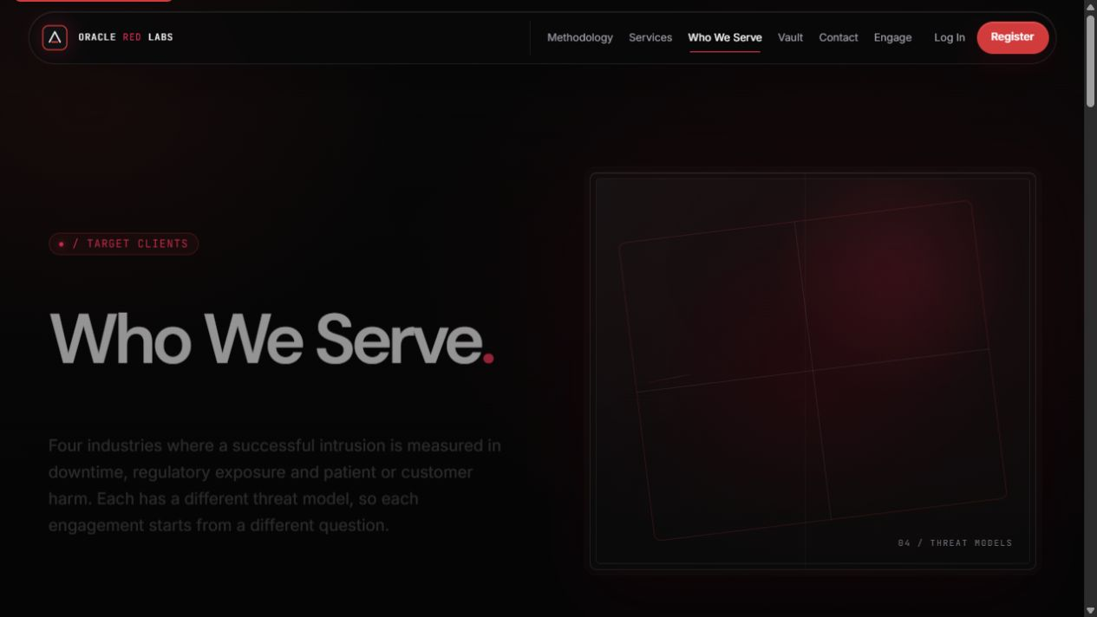

05 Vault Page
vault.html | Screenshot captured September 30, 2026
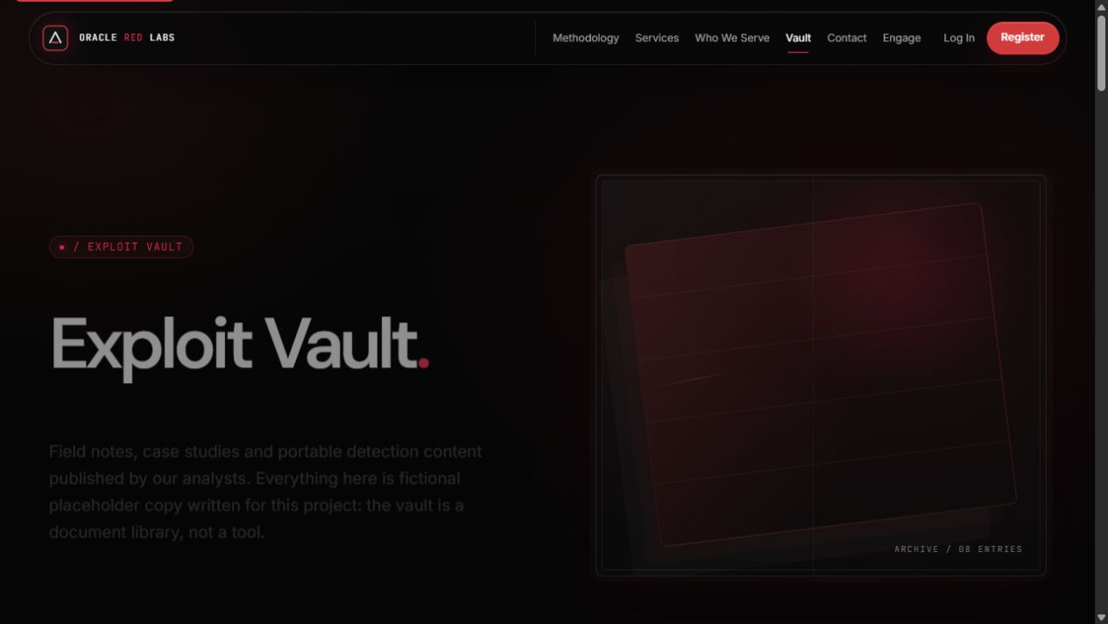

06 Contact Page
contact.html | Screenshot captured September 30, 2026
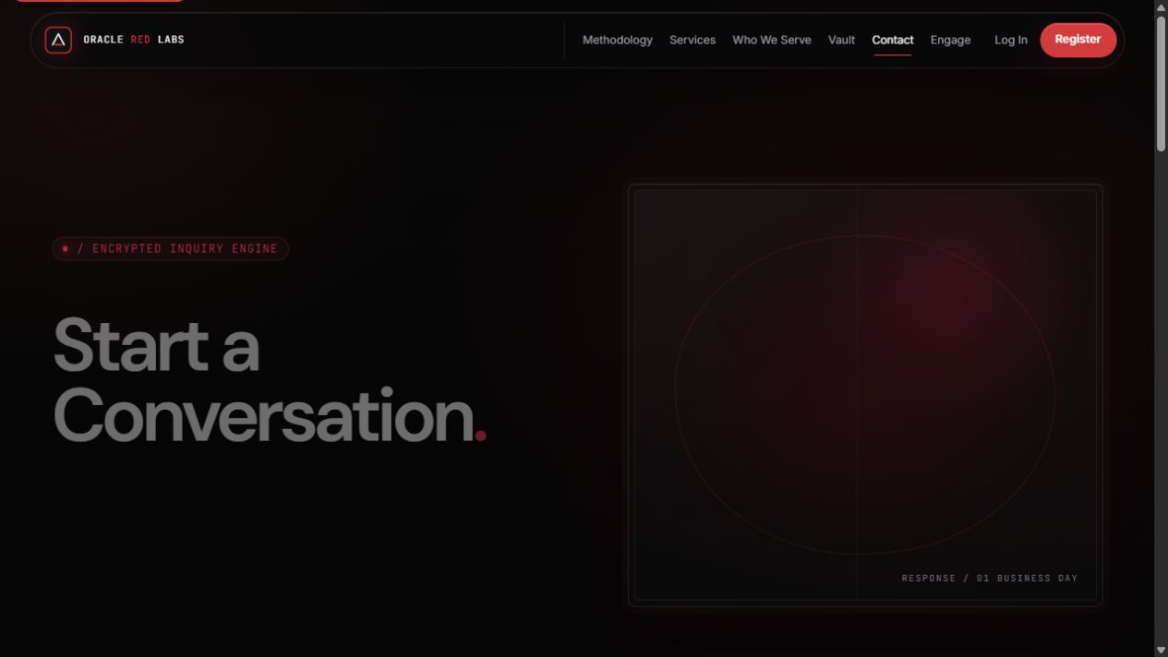

07 Engagement Booking Page
engage.html | Screenshot captured September 30, 2026
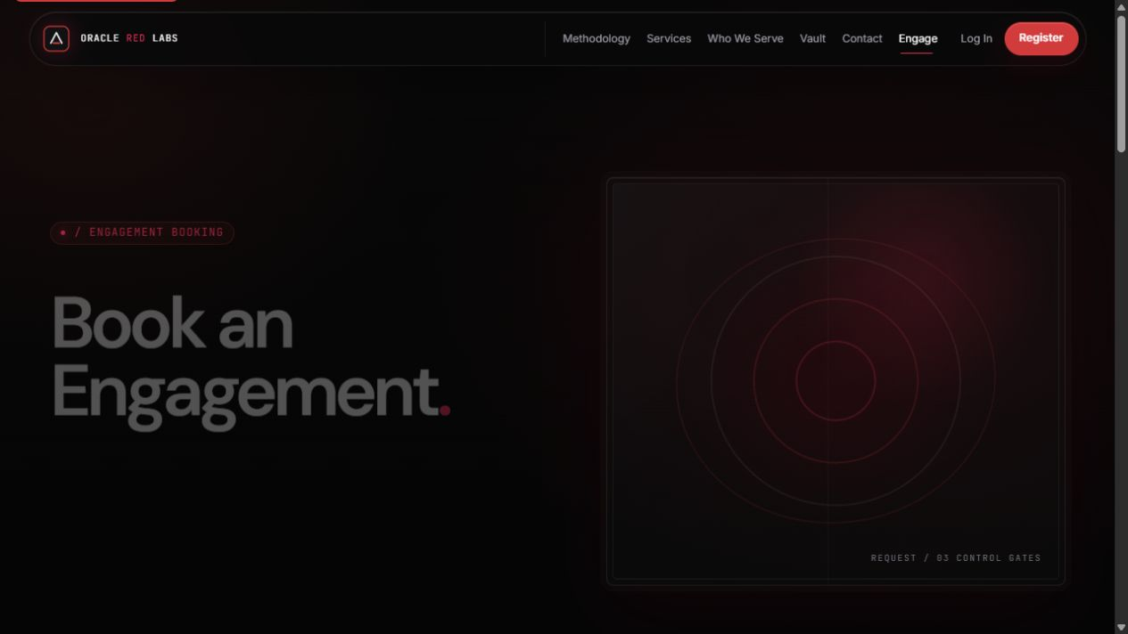

08 Client Login Page
login.html | Screenshot captured September 30, 2026
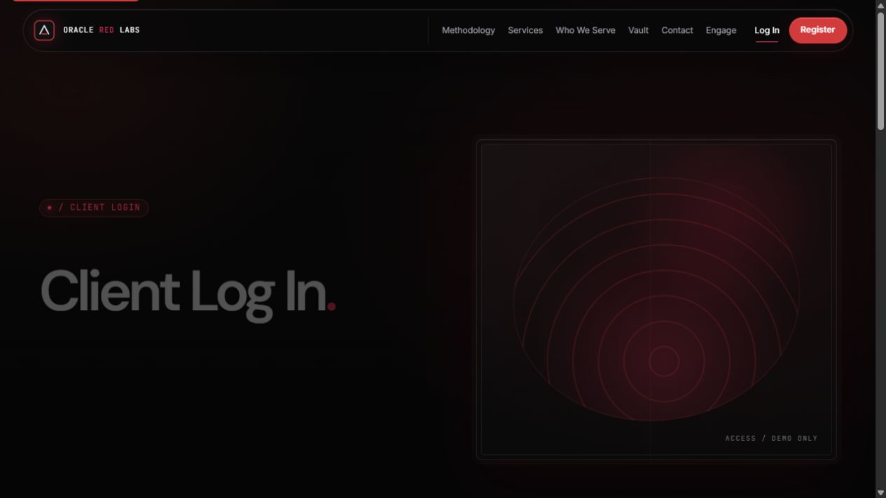

09 Client Registration Page
register.html | Screenshot captured September 30, 2026
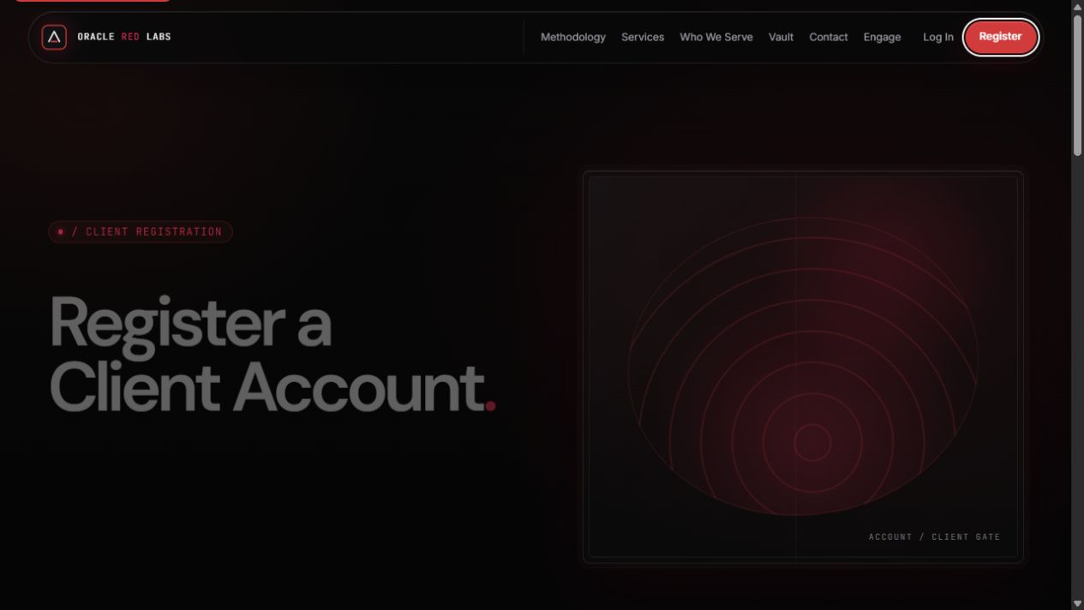

10 Client Dashboard Page
dashboard.html | Screenshot captured September 30, 2026
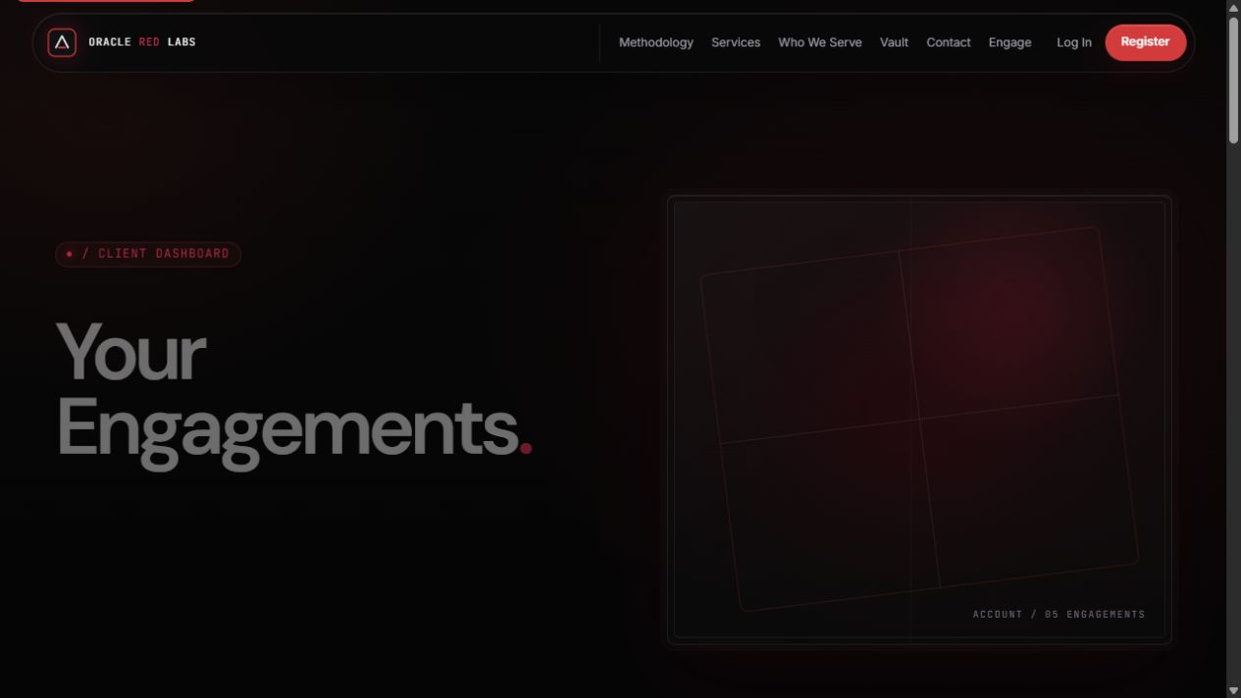

11 Administrator Console Page
admin.html | Screenshot captured September 30, 2026
