Assignement – 6

Using Special Operators in Conditions.

1) Write two different queries that would produce
all orders taken on October 3rd or 4th, 1990.

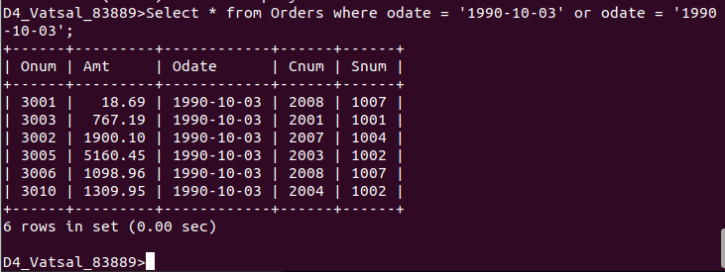

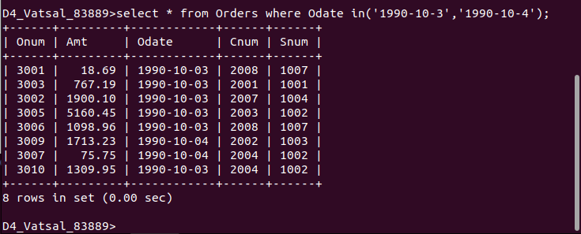

2)Write a query that selects all of the customers
serviced by Peel or Motika. (Hint: the snum field
relates the two tables to one another).
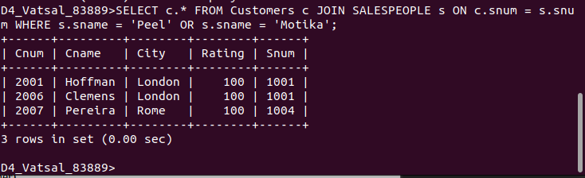

3)Write a query that will produce all the
customers whose names begin with a letter from ‘A’
to ‘G’.

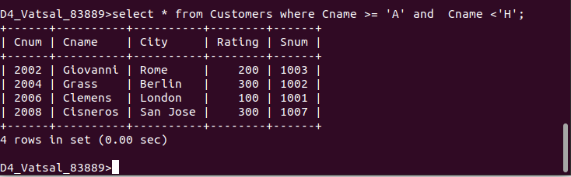

4)Write a query that selects all customers whose
names begin with the letter ‘C’.

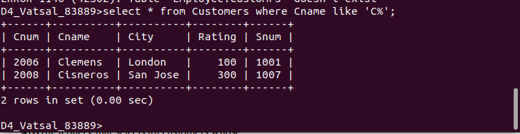

5) Write a query that selects all orders except
those with zeroes or NULLs in the amt field.

