Basic Linux Commands
- Man
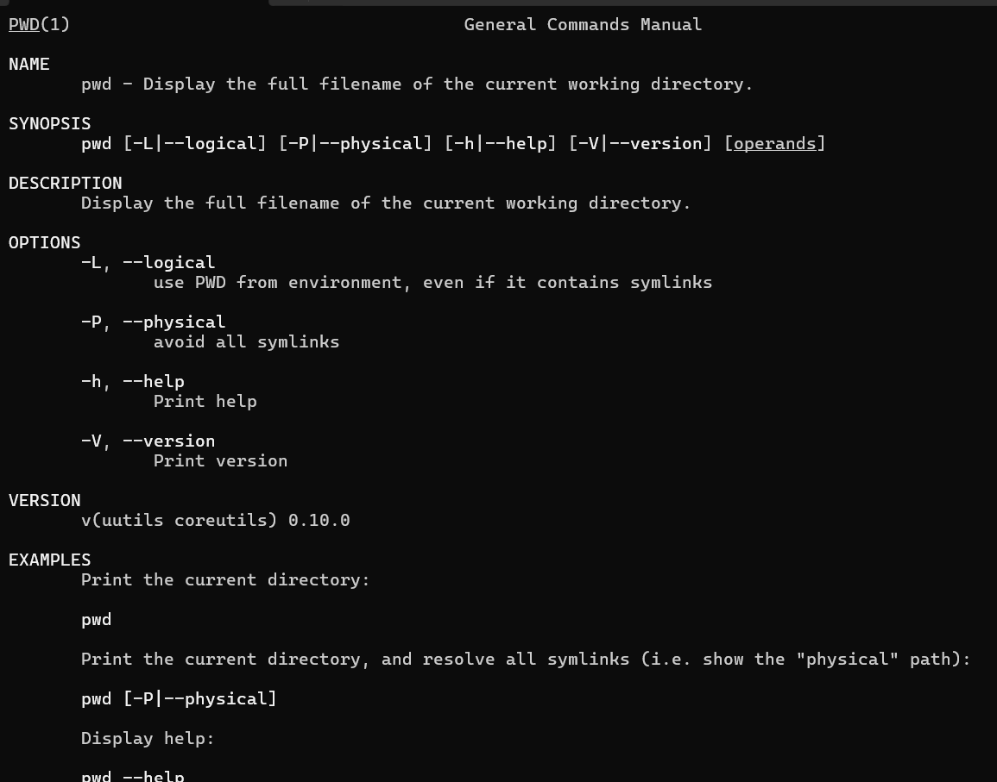

- Uname
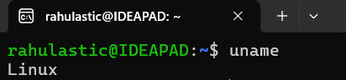

- PWD
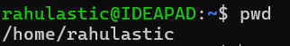

- Hostname


- Date
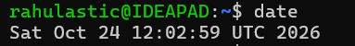

- Cal
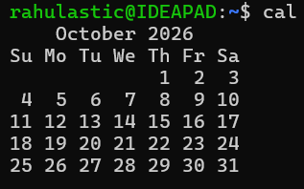

- Ls and Dir

- Cat
rahulastic@IDEAPAD:~$ cat > file1.txt
Hello Linux
This is my first file
rahulastic@IDEAPAD:~$ cat file1.txt
Hello Linux
This is my first file

- Cat >>
rahulastic@IDEAPAD:~$ cat >> file1.txt
Learning Linux commands
rahulastic@IDEAPAD:~$ cat file1.txt
Hello Linux
This is my first file
Learning Linux commands

- Cp
rahulastic@IDEAPAD:~$ cp file1.txt file2.txt
rahulastic@IDEAPAD:~$ cp -r new_directory backup_dir
rahulastic@IDEAPAD:~$ ls
backup_dir demo01.txt editor file1.txt file2.txt filename.txt hello.txt new_directory test.txt vim

- Mv (move)
rahulastic@IDEAPAD:~$ mv file2.txt new_directory/
rahulastic@IDEAPAD:~$ ls new_directory
file2.txt
rahulastic@IDEAPAD:~$ ls
backup_dir demo01.txt editor file1.txt filename.txt hello.txt new_directory test.txt vim

- Mv (rename)
rahulastic@IDEAPAD:~$ mv file1.txt myfile.txt
rahulastic@IDEAPAD:~$ ls
backup_dir demo01.txt editor filename.txt hello.txt myfile.txt new_directory test.txt vim

- Tac and Rev
rahulastic@IDEAPAD:~$ tac myfile.txt
Learning Linux commands
This is my first file
Hello Linux
rahulastic@IDEAPAD:~$ rev myfile.txt
xuniL olleH
elif tsrif ym si sihT
sdnammoc xuniL gninraeL

- Wc
rahulastic@IDEAPAD:~$ wc myfile.txt
3 10 58 myfile.txt
rahulastic@IDEAPAD:~$ wc -l myfile.txt
3 myfile.txt
rahulastic@IDEAPAD:~$ wc -w myfile.txt
10 myfile.txt
rahulastic@IDEAPAD:~$ wc -c myfile.txt
58 myfile.txt

- Mkdir
rahulastic@IDEAPAD:~$ mkdir mydir
rahulastic@IDEAPAD:~$ mkdir -p dir1/dir2/dir3
rahulastic@IDEAPAD:~$ ls
backup_dir demo01.txt dir1 editor filename.txt hello.txt mydir myfile.txt new_directory test.txt vim
rahulastic@IDEAPAD:~$ ls dir1
dir2

- Cd
rahulastic@IDEAPAD:~$ cd mydir
rahulastic@IDEAPAD:~/mydir$ pwd
/home/rahulastic/mydir
rahulastic@IDEAPAD:~/mydir$ cd ..
rahulastic@IDEAPAD:~$ pwd
/home/rahulastic

- Rm
rahulastic@IDEAPAD:~$ rm new_directory/file2.txt
rahulastic@IDEAPAD:~$ ls new_directory
rahulastic@IDEAPAD:~$ rm -R dir1
rahulastic@IDEAPAD:~$ ls
backup_dir demo01.txt editor filename.txt hello.txt mydir myfile.txt new_directory test.txt vim

- Rmdir
rahulastic@IDEAPAD:~$ rmdir mydir
rahulastic@IDEAPAD:~$ ls
backup_dir demo01.txt editor filename.txt hello.txt myfile.txt new_directory test.txt vim

- Touch
rahulastic@IDEAPAD:~$ ls -l myfile.txt
-rw-r--r-- 1 rahulastic rahulastic 58 Oct 28 10:12 myfile.txt
rahulastic@IDEAPAD:~$ touch myfile.txt
rahulastic@IDEAPAD:~$ ls -l myfile.txt
-rw-r--r-- 1 rahulastic rahulastic 58 Oct 28 10:30 myfile.txt
rahulastic@IDEAPAD:~$ touch a.txt b.txt c.txt
rahulastic@IDEAPAD:~$ ls a.txt b.txt c.txt
a.txt b.txt c.txt

- Sort
rahulastic@IDEAPAD:~$ cat > fruits.txt
banana
apple
mango
apple
banana
cherry
rahulastic@IDEAPAD:~$ sort fruits.txt
apple
apple
banana
banana
cherry
mango
rahulastic@IDEAPAD:~$ sort -r fruits.txt
mango
cherry
banana
banana
apple
apple

- Uniq
rahulastic@IDEAPAD:~$ sort fruits.txt | uniq
apple
banana
cherry
mango
rahulastic@IDEAPAD:~$ sort fruits.txt | uniq -c
2 apple
2 banana
1 cherry
1 mango

- Head
rahulastic@IDEAPAD:~$ seq 1 10 > numbers.txt
rahulastic@IDEAPAD:~$ head -n 3 numbers.txt
1
2
3
rahulastic@IDEAPAD:~$ head -n 5 numbers.txt
1
2
3
4
5

- Tail
rahulastic@IDEAPAD:~$ tail -n 3 numbers.txt
8
9
10
rahulastic@IDEAPAD:~$ tail -n 5 numbers.txt
6
7
8
9
10

- Factor
rahulastic@IDEAPAD:~$ factor 60
60: 2 2 3 5
rahulastic@IDEAPAD:~$ factor 84
84: 2 2 3 7
rahulastic@IDEAPAD:~$ factor 100
100: 2 2 5 5

- Alias
rahulastic@IDEAPAD:~$ alias hi='echo Hello Rahul'
rahulastic@IDEAPAD:~$ hi
Hello Rahul

- Unalias
rahulastic@IDEAPAD:~$ unalias hi
rahulastic@IDEAPAD:~$ hi
hi: command not found

- Echo
rahulastic@IDEAPAD:~$ echo $HOME
/home/rahulastic
rahulastic@IDEAPAD:~$ echo $USER
rahulastic
rahulastic@IDEAPAD:~$ echo $SHELL
/bin/bash
rahulastic@IDEAPAD:~$ echo $PWD
/home/rahulastic
rahulastic@IDEAPAD:~$ echo $HOSTNAME
IDEAPAD

- Ps
rahulastic@IDEAPAD:~$ ps
PID TTY TIME CMD
312 pts/0 00:00:00 bash
520 pts/0 00:00:00 ps
rahulastic@IDEAPAD:~$ ps -f
UID PID PPID C STIME TTY TIME CMD
rahulas+ 312 301 0 10:05 pts/0 00:00:00 -bash
rahulas+ 524 312 0 10:41 pts/0 00:00:00 ps -f

- Kill
rahulastic@IDEAPAD:~$ sleep 300 &
[1] 601
rahulastic@IDEAPAD:~$ ps
PID TTY TIME CMD
312 pts/0 00:00:00 bash
601 pts/0 00:00:00 sleep
602 pts/0 00:00:00 ps
rahulastic@IDEAPAD:~$ kill 601
[1]+ Terminated sleep 300
rahulastic@IDEAPAD:~$ sleep 400 &
[1] 640
rahulastic@IDEAPAD:~$ kill -9 640
[1]+ Killed sleep 400

- Env
rahulastic@IDEAPAD:~$ env
SHELL=/bin/bash
PWD=/home/rahulastic
LOGNAME=rahulastic
HOME=/home/rahulastic
LANG=C.UTF-8
USER=rahulastic
TERM=xterm-256color
HOSTNAME=IDEAPAD
PATH=/usr/local/sbin:/usr/local/bin:/usr/sbin:/usr/bin:/sbin:/bin

