Arduino is the opensource developed board microprecessor for project making. The arduino is like AVR, but the IDE is different. Arduino is simple board, we just connect the board by USB cable, and instal the IDE and driver for arduino. We don’t need the USB ASP, downloader, or others to use, its very simple. Many kinds of the arduino version, UNO, MEGA, TINY, LILLIPAD, Nano, Mini, etc. In other sides the arduino family has many sheilds for support the developing some projects. Like ethernet sheild, LCD sheild, keypad sheild, GSM sheild, motor sheild, and etc.

Bellow the spesification of the arduino UNO :

|  |  |
| --- | --- |
| Microcontroller | ATMega328P |
| Operating Voltage | 5V |
| Input Voltage (recommended) | 7-12V |
| Input Voltage (limit) | 6-20V |
| Digital I/O Pins | 14 (of which 6 provide PWM output) |
| PWM Digital I/O Pins | 6 |
| Analog Input Pins | 6 |
| DC Current per I/O Pin | 20 mA |
| DC Current for 3.3V Pin | 50 mA |
| Flash Memory | 32 KB (ATmega328P) of which 0.5 KB used by bootloader |
| SRAM | 2 KB (ATmega328P) |
| EEPROM | 1 KB (ATmega328P) |
| Clock Speed | 16 MHz |
| Length | 68.6 mm |
| Width | 53.4 mm |
| Weight | 25 g |

Then we have communication, the Uno has a number of facilities for communicating with a computer, another Uno board, or other microcontrollers. The ATmega328 provides UART TTL (5V) serial communication, which is available on digital pins 0 (RX) and 1 (TX). An ATmega16U2 on the board channels this serial communication over USB and appears as a virtual com port to software on the computer. The 16U2 firmware uses the standard USB COM drivers, and no external driver is needed. However, on Windows, a .inf file is required. The Arduino Software (IDE) includes a serial monitor which allows simple textual data to be sent to and from the board. The RX and TX LEDs on the board will flash when data is being transmitted via the USB-to-serial chip and USB connection to the computer (but not for serial communication on pins 0 and 1).

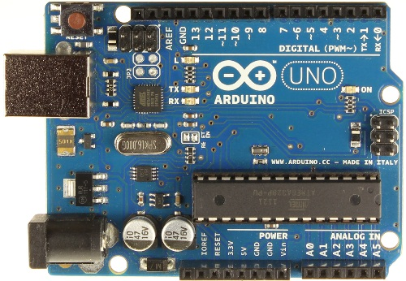Pic of arduino uno board

Pic of arduino sheild

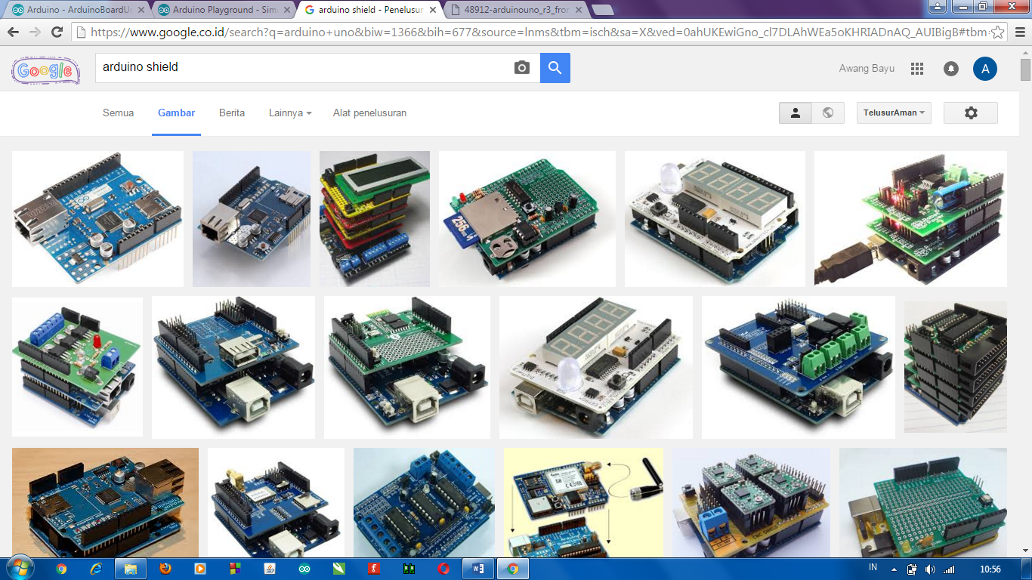

Source :

<https://www.arduino.cc/en/Main/ArduinoBoardUno>

<https://www.google.co.id/search?q=arduino+uno&biw=1366&bih=677&source=lnms&tbm=isch&sa=X&ved=0ahUKEwiGno_cl7DLAhWEa5oKHRIADnAQ_AUIBigB#tbm=isch&q=arduino+shield>

<https://www.google.co.id/?gws_rd=cr,ssl&ei=90veVuTsIonI6ATpkYL4Cw#q=arduino+uno>