Teams recording screenshots
Screenshot 1 at 00:00:15.000
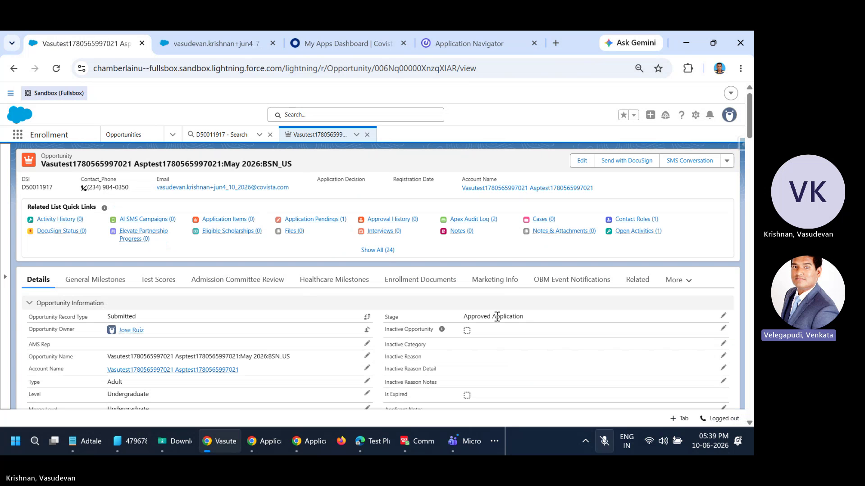
Screenshot 2 at 00:00:15.000

Screenshot 3 at 00:00:15.000

Screenshot 4 at 00:00:15.000

Screenshot 5 at 00:00:15.000

Screenshot 6 at 00:00:15.000

Screenshot 7 at 00:00:15.000

Screenshot 8 at 00:00:15.000

Screenshot 9 at 00:00:15.000

Screenshot 10 at 00:00:15.000

Screenshot 11 at 00:00:15.000

Screenshot 12 at 00:00:15.000

Screenshot 13 at 00:00:15.000

Screenshot 14 at 00:00:15.000

Screenshot 15 at 00:00:15.000

Screenshot 16 at 00:00:15.000

Screenshot 17 at 00:00:15.000

Screenshot 18 at 00:00:15.000

Screenshot 19 at 00:00:15.000

Screenshot 20 at 00:00:15.000

Screenshot 21 at 00:00:15.000

Screenshot 22 at 00:00:15.000

Screenshot 23 at 00:00:15.000

Screenshot 24 at 00:00:15.000

Screenshot 25 at 00:00:15.000

Screenshot 26 at 00:00:15.000

Screenshot 27 at 00:00:15.000

Screenshot 28 at 00:00:15.000

Screenshot 29 at 00:00:15.000

Screenshot 30 at 00:00:15.000

Screenshot 31 at 00:00:15.000

Screenshot 32 at 00:00:15.000

Screenshot 33 at 00:18:01.000
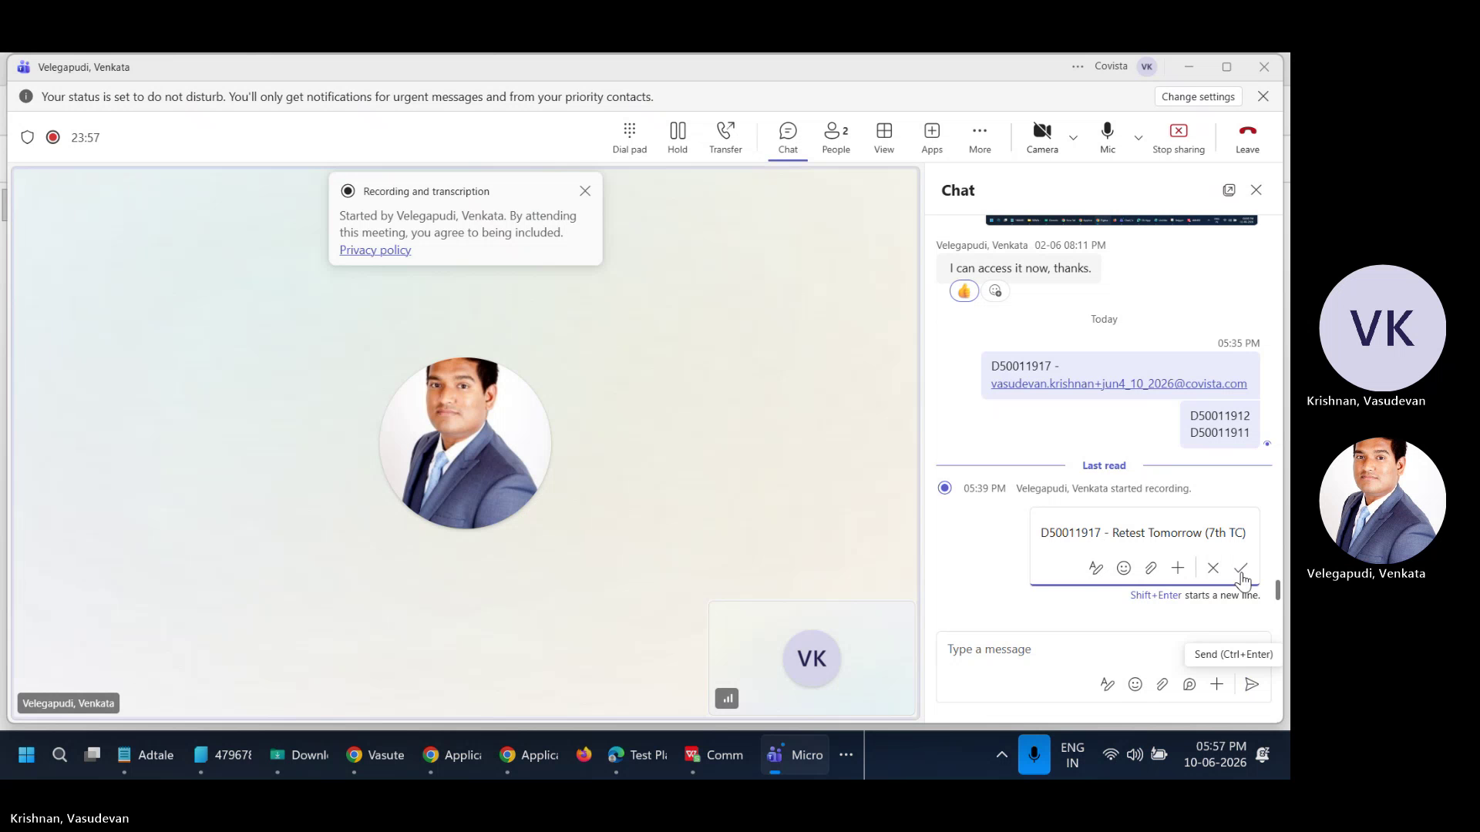
Screenshot 34 at 00:18:01.000

Screenshot 35 at 00:18:01.000

Screenshot 36 at 00:18:01.000

Screenshot 37 at 00:18:01.000

Screenshot 38 at 00:18:01.000

Screenshot 39 at 00:18:01.000

Screenshot 40 at 00:18:01.000

Screenshot 41 at 00:18:01.000

Screenshot 42 at 00:18:01.000

Screenshot 43 at 00:18:01.000

Screenshot 44 at 00:18:01.000

Screenshot 45 at 00:18:01.000

Screenshot 46 at 00:18:01.000

Screenshot 47 at 00:18:01.000

Screenshot 48 at 00:18:01.000

Screenshot 49 at 00:18:01.000

Screenshot 50 at 00:18:01.000

Screenshot 51 at 00:18:01.000

Screenshot 52 at 00:18:01.000


