1. Project Initialization & DB First
- Create a Blank Solution: NorthwindCatalog.
- Add three projects:
  - NorthwindCatalog.Services (Class Library)
  - NorthwindCatalog.Web (ASP.NET Core MVC)
  - NorthwindCatalog.Tests (xUnit Test Project)
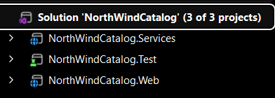
- Install NuGet packages in Services: Microsoft.EntityFrameworkCore.SqlServer, Microsoft.EntityFrameworkCore.Tools, AutoMapper.Extensions.Microsoft.DependencyInjection.
- Scaffold the database:
Bash
dotnet ef dbcontext scaffold "YourConnectionString" Microsoft.EntityFrameworkCore.SqlServer -o Models
Insert Screenshot: Database connection success/scaffolded models.
2. Configure Fluent API
In your NorthwindContext.cs, override OnModelCreating to configure entity relationships and precision constraints. Insert Screenshot: OnModelCreating code snippet.
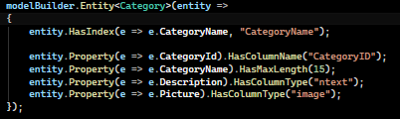
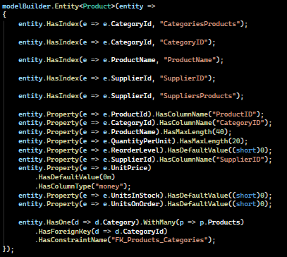
3. Data Transfer Objects (DTOs)
Create a DTOs folder in the Services project. Define CategoryDto, ProductDto, and CategorySummaryDto as specified in the requirements. Ensure the InventoryValue property is calculated in the ProductDto.
4. AutoMapper Configuration
Create a MappingProfile.cs class inheriting from Profile. Configure mappings for Category to CategoryDto (with ImageUrl logic) and Product to ProductDto. Insert Screenshot: MappingProfile code.
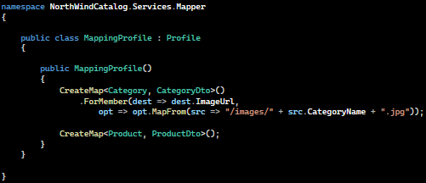
5. Repository Pattern Implementation
- Create ICategoryRepository and IProductRepository in the Services project.
- Implement the repositories, ensuring GetCategorySummariesAsync uses LINQ projections for efficiency. Insert Screenshot: Repository implementation logic.
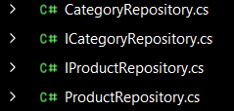
6. Web API Layer
- Add controllers in the Services or Web project (depending on your preference).
- Inject IProductRepository and IMapper.
- Create Endpoints:
  - GET api/categories
  - GET api/products/by-category/{id}
  - GET api/products/summary Insert Screenshot: Postman/Swagger test result for API endpoints.
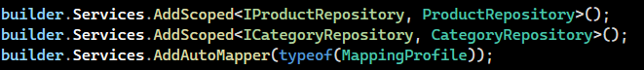
7. MVC Consumption
- Register IHttpClientFactory in Program.cs.
- Implement Controllers (CategoriesController, ProductsController) using HttpClient to consume the APIs created in Step 6. Insert Screenshot: MVC Controller code.
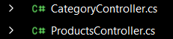
8. UI Implementation
- Develop Bootstrap Cards for Index (Categories) and ByCategory (Products).
- Create a Table view for the Summary page. Insert Screenshot: Final UI of the Category page. Insert Screenshot: Final UI of the Product page (showing Inventory Value).
