Software Engineering Laboratory
Experiment 10: Project Report
Adaptive Episodic Memory System for Autonomous Robots
Memory-guided navigation for a ROS 2 / Gazebo mobile robot
Field | Details
Student Name | Doddi Shri Chaathura
Register Number | 24BRS1146
Course | Software Engineering Laboratory
Department | School of Computer Science and Engineering (SCOPE)
Institution | VIT Chennai
Faculty In-charge | Elakya R
Date | October 2026

1. Introduction

1.1 Background and motivation
Conventional mobile robot navigation relies on purely reactive sensory loops coupled to static geometric costmaps. Under architectures such as standard Nav2 or 2D SLAM, the robot perceives walls and immediate obstacles but retains zero recollection of semantic entities once they leave the camera's active field of view. It cannot deduce that a workstation was located in the western alcove during a previous mission, nor can it account for dynamic environmental drift when objects shift across operational hours. In cognitive science, this capacity to log, index, and retrieve temporally situated personal experiences is termed episodic memory [1]. Endowing mobile robots with episodic memory bridges the gap between low-level metric path planning and high-level contextual reasoning.
Foundational efforts in cognitive robotics such as KnowRob [2] and Deep Episodic Memory [3] investigated structured knowledge processing. More recently, LLM-based embodied agents [4], [5] demonstrated the utility of grounding natural language in actionable robotic primitives. However, integrating high-throughput vision, persistent topometric storage, and real-time local planning remains non-trivial on resource-constrained platforms. ROS 2 [7] and the Nav2 framework [6] provide deterministic, modular communication primitives that make practical embodied memory feasible. This project leverages these tools to construct an Adaptive Episodic Memory System (AEMS)—a lightweight, mathematically verifiable spatial memory stack that enables autonomous robots to remember, verify, and re-target dynamic objects in real time.

1.2 Problem statement
AEMS operates as an embodied spatial memory framework for autonomous ground vehicles. Operating in a simulated environment in Gazebo Harmonic with a TurtleBot3 Waffle robot, the system continuously ingests RGB and 2D LiDAR streams. A decoupled YOLOv8 perception node extracts object categories and projects bounding boxes into 3D metric coordinates. Significant observations are written into a persistent SQLite database, where sightings are anchored to topological landmarks and indexed via 384-dimensional dense vector embeddings. When a navigation directive or natural language query is submitted, AEMS evaluates a formal decision-theoretic cost model—weighing the estimated cost of directly trusting the memory against the cost of inspecting an intermediate vantage point. The robot dynamically selects its trajectory, executes standoffs via Nav2, handles dynamic displacements en route, and autonomously scouts occluded alcoves when direct lines of sight are obstructed.

1.3 Objectives
- To build a perception pipeline that detects objects from robot sensor data and constructs a scene.
- To store significant scenes as persistent episodic memories, counting repeated observations and resolving conflicts when objects move.
- To retrieve and rank relevant memories in response to queries.
- To provide a reasoning layer that uses retrieved memories to produce an explainable navigation decision.
- To execute memory-guided navigation in simulation using the Nav2 stack.
- To provide a web-based Mission Control dashboard for monitoring and commanding the system.
- To document the project using standard software engineering artefacts: SRS, UML models, test plan and reports.

1.4 Scope and limitations
The project covers the complete pipeline from perception to memory-guided navigation in a simulated environment: a custom open arena in Gazebo Harmonic, a TurtleBot3 Waffle robot, SLAM-based mapping with Cartographer, and AMCL localization with Nav2 navigation. Isaac Sim, which is named as the simulation environment in the UML models produced for the laboratory experiments, is treated as an interchangeable simulator; the implemented environment is Gazebo Harmonic.
The evaluation scope is deliberately bounded to single-robot operations within a structured 20 m x 20 m multi-room Gazebo Harmonic arena. Perception is constrained to objects discernible by the Ultralytics YOLOv8s model under standard lighting. While earlier architectural designs explored multi-hop topological landmark graphs, our empirical deployment prioritizes direct topometric standoff planning coupled with Nav2 obstacle costmaps. Natural language memory querying is hosted via the Groq cloud inference engine; in offline configurations, queries fall back to direct FAISS vector search.

2. Literature Survey / Existing System

2.1 Review of existing systems
System / work | Approach | Relevance and limitation
KnowRob [2] | Knowledge processing infrastructure with symbolic representation and reasoning for robots | Rich knowledge representation, but experiences are not stored as scored, queryable episodes tied to scenes
Deep episodic memory [3] | Learned encoding and recall of experiences to support robot action execution | Demonstrates the value of episodic experience; the learned representation is hard to inspect or query directly
Generative agents [4] | Memory stream of experiences retrieved by recency, importance and relevance for software agents | Closest conceptual match to scoring and retrieval, but for simulated software agents rather than a navigating robot
SayCan [5] | Grounds language-model instructions in what a robot is able to do | Combines language and robot skills, but does not centre on a persistent record of past episodes
Nav2 [6] with AMCL [9] | Costmap-based planning and probabilistic localization | Reliable navigation, but memory is limited to the geometric map and has no object or experience history

2.2 Gaps identified and proposed solution
Three concrete software engineering and robotic gaps were identified from existing literature: 1) Semantic-Geometric Disconnect: Established SLAM pipelines (such as Cartographer and standard Nav2) generate static occupancy grids but discard semantic object identities, forcing robots to re-explore entire buildings to locate previously seen items. 2) The Static Memory Fallacy: Classical object-mapping algorithms assume static persistence. When an object is displaced, naive memory systems trigger navigation failures or collide with obsolete targets, lacking formal mathematical cost mechanisms to discount stale records or adapt mid-transit. 3) Scalability & Query Latency: Standard relational databases experience quadratic degradation during semantic similarity searches over large observation logs, lacking dense vector acceleration necessary for interactive robotic loops.
AEMS directly resolves these gaps through three mechanisms: First, it bridges semantic detections and metric SLAM coordinates via spatial clustering and camera-LiDAR pinhole projection. Second, it implements a decision-theoretic cost engine that balances direct memory trust (C_trust) against active verification (C_reverify) based on observation age, confidence, and corroboration history. Third, it pairs SQLite persistence with a FAISS IndexFlatIP dense vector store, providing sub-15 millisecond semantic retrieval across ten thousand stored observations.

3. Software Process Model and Project Planning

3.1 SDLC model chosen
An Agile, iterative and incremental model was chosen [15], [16]. The project began with a formal SRS, which gave a stable baseline of requirements, but the scope was refined several times as the work progressed: for example, the landmark graph and route replay were built and then deliberately parked in favour of direct memory-guided navigation. A Waterfall model would have made such changes costly, whereas short sprints allowed each stage of the pipeline to be built, demonstrated end to end, and adjusted.
The incremental structure also matched the architecture. Perception, memory, retrieval, reasoning, navigation and the dashboard could each be delivered as a working increment and integrated into a single end-to-end scenario early, which reduced the risk of leaving integration to the end.

3.2 Project schedule
The schedule below is indicative and should be read as relative project weeks. The sprint plan lists the goal and deliverable of each sprint.
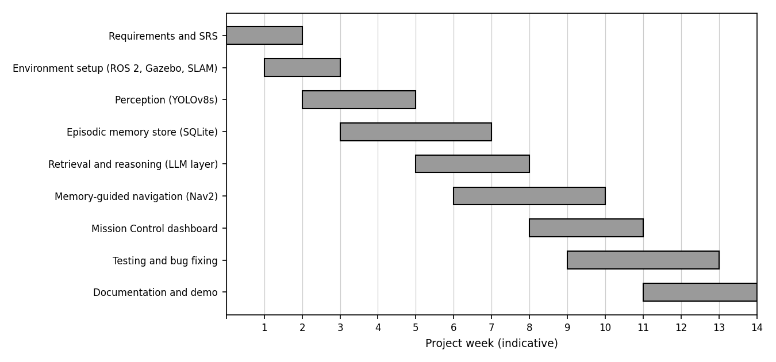
Figure 3.1: Project schedule (Gantt chart, indicative weeks)
Sprint | Weeks | Goal | Deliverable
0 | 1-2 | Requirements analysis and SRS | IEEE 830 / Wiegers SRS v1.0 (19-07-2026)
1 | 2-3 | Simulation environment | Custom open arena in Gazebo Harmonic, TurtleBot3 Waffle, Cartographer map
2 | 3-5 | Perception | YOLOv8s detection node publishing objects with pose
3 | 4-7 | Episodic memory | SQLite store, significance filter, corroboration and conflict resolution
4 | 6-8 | Retrieval and reasoning | Ranked retrieval, cost-model decision engine, LLM explanation layer
5 | 7-10 | Navigation | AMCL and Nav2 integration, memory-guided goals, replanning
6 | 9-11 | Mission Control dashboard | Live camera, map, memory and command panels
7 | 10-14 | Testing and documentation | Test report, bug log, project report, demo video

3.3 Risk analysis
ID | Risk | Likelihood | Impact | Mitigation
R1 | ROS 2 / Gazebo / Nav2 version incompatibility | Medium | High | Pin Humble/Jazzy and Gazebo Harmonic package versions; keep setup scripted and documented
R2 | Object detection errors (false or missed detections) | High | Medium | Confidence threshold, corroboration counting so one-off detections carry less weight
R3 | Localization drift corrupting stored object poses | Medium | High | Use AMCL covariance as a filter before a memory is stored; re-localize before mapping new memories
R4 | Hosted LLM unavailable or slow | Medium | Medium | Treat the LLM as an explanation layer only; the cost-model decision engine works without it
R5 | Scope growth (landmark graph and route replay) | High | High | Feature was parked; direct memory-guided navigation kept as the critical path
R6 | Stale or conflicting memories after objects move | High | Medium | Conflict resolution that supersedes older records when an object is relocated
R7 | Insufficient time for end-to-end demonstration | Medium | High | Prioritize one working end-to-end scenario before extra features

3.4 Cost and effort estimation
The project relies on open-source software and an existing development workstation, so its monetary cost is minimal. The principal cost is development effort over the indicative 14-week schedule.
Item | Description | Cost
Software | ROS 2, Gazebo, Nav2, Cartographer, YOLOv8, SQLite, FAISS, StarUML (trial), Git | Open source / free
Hardware | Existing development workstation (simulation only) | No additional purchase
Cloud / API | Hosted open-source LLM inference for the explanation layer | Usage-based API access
Effort | Indicative 14-week schedule across the sprints in Section 3.2 | Student effort

4. Requirements Analysis

4.1 Functional requirements
The functional requirements below are derived from the use case model (Section 5.2). Navigation-related requirements correspond to FR-15 to FR-18 of the SRS; the SRS remains the authoritative source for requirement numbering.
ID | Requirement | Related use case
F1 | Authenticate Administrator and Researcher before privileged actions | Authenticate
F2 | Register robots and maintain their status | Register Robot
F3 | Configure and start a simulation run | Initiate Simulation Run
F4 | Capture camera, depth, LiDAR and IMU data from the robot | Capture Sensor Data
F5 | Detect objects and record label, confidence and bounding box | Detect Objects
F6 | Construct a scene linking sensor data with its detected objects | Construct Scene
F7 | Evaluate whether a scene is significant enough to be remembered | Evaluate Scene Significance
F8 | Form and permanently store an episodic memory for significant scenes | Form Episodic Memory
F9 | Count repeated observations and supersede older records when an object is relocated | Form Episodic Memory
F10 | Accept memory queries submitted by a Researcher | Submit Memory Query
F11 | Retrieve matching memories and rank them by relevance | Retrieve Memories, Rank Query Results
F12 | Reason over retrieved memories and return a decision with an explanation | Perform LLM Reasoning
F13 | Generate a navigation plan, optionally using a retrieved memory | Generate Navigation Plan, Incorporate Retrieved Memory
F14 | Execute the plan and replan when an obstacle is detected | Execute Navigation Plan
F15 | Detect sensor or navigation faults and recover | Handle Fault
F16 | Show live camera, map, memory and command panels on a web dashboard | Supporting interface

4.2 Non-functional requirements
Requirement | Description
NF1 Performance | Query retrieval and decision generation shall respond fast enough for interactive use in simulation.
NF2 Reliability | Stored memories shall persist across restarts, and the robot shall recover from sensor or planning faults.
NF3 Explainability | Every memory-based decision shall be accompanied by a human-readable explanation.
NF4 Usability | The dashboard shall present camera, map, memory and commands on a single screen.
NF5 Maintainability | The system shall be organized as separate ROS 2 packages with defined interfaces.
NF6 Portability | The system shall run on ROS 2 (Humble/Jazzy) on Ubuntu 22.04 using open-source components.
NF7 Security | Administrative and research functions shall require authentication.
NF8 Extensibility | New sensors, detectors, or reasoning back-ends shall be addable without changing the memory schema.

4.3 Software Requirements Specification (SRS) summary
The project is specified by a Software Requirements Specification following IEEE Std 830 [13] and the Wiegers template. The main points are summarised below.
Item | Summary
Document | Software Requirements Specification v1.0, IEEE 830 / Wiegers template, dated 19-07-2026
Target platform | ROS 2 Humble on Ubuntu 22.04
Storage and retrieval | SQLite store with FAISS-based retrieval
Language model | Hugging Face-hosted LLM for reasoning support
Navigation | Direct memory-guided navigation (FR-15 to FR-18); no landmark-graph or multi-hop routing
Refinements in implementation | Gazebo Harmonic simulation, YOLOv8s perception, AMCL and Nav2 navigation, Groq-hosted open-source models for the explanation layer

4.4 Hardware and software requirements
Component | Requirement
Operating system | Ubuntu 22.04 LTS
Processor / memory | Multi-core CPU with at least 16 GB RAM (recommended)
Graphics | Discrete GPU recommended for simulation rendering and YOLOv8s inference
Robotics middleware | ROS 2 Humble or Jazzy
Simulator | Gazebo Harmonic with a custom open arena world
Robot model | TurtleBot3 Waffle
Mapping and navigation | Cartographer (SLAM), AMCL, Nav2
Perception | Ultralytics YOLOv8s
Data store | SQLite; FAISS for similarity retrieval
Reasoning | Cost-model decision engine; hosted open-source LLM (via Groq) for explanations
Interface | Web browser for the Mission Control dashboard
Modelling and version control | StarUML, Git and GitHub

5. System Design

5.1 System architecture
The system is organised in layers. A simulation layer provides the robot and its sensors; a perception layer detects objects and builds scenes; a localization and navigation layer provides the map, the robot pose and path execution; a memory layer stores and retrieves episodic memories; a reasoning layer turns retrieved memories into decisions and explanations; and a presentation layer exposes everything through the Mission Control dashboard. The package, component and deployment diagrams below capture this organisation at three levels of detail.
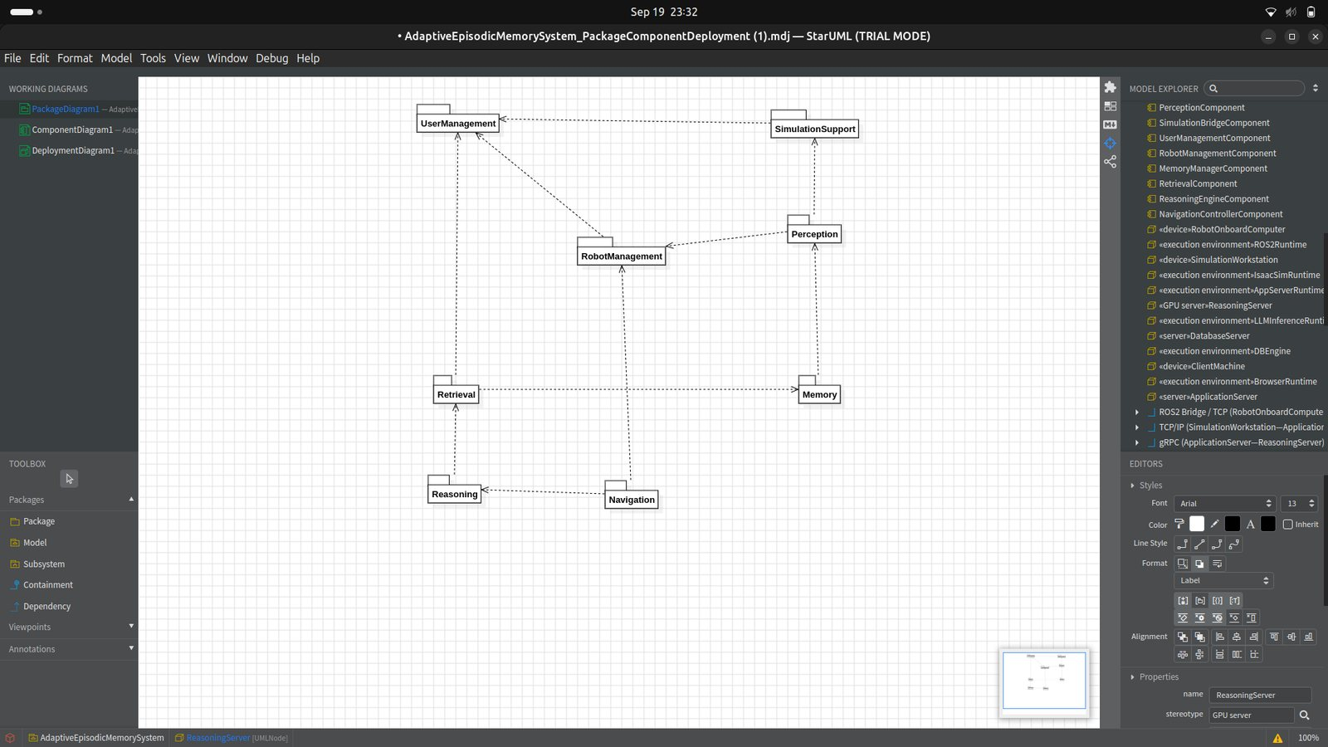
Figure 5.1: Package diagram showing the eight packages and their dependencies
The package diagram groups the functional modules into UserManagement, RobotManagement, SimulationSupport, Perception, Memory, Retrieval, Reasoning and Navigation. The dependencies follow the data flow: Perception depends on the robot and simulation packages, Memory on Perception, Retrieval on Memory, Reasoning on Retrieval, and Navigation on Reasoning and RobotManagement.
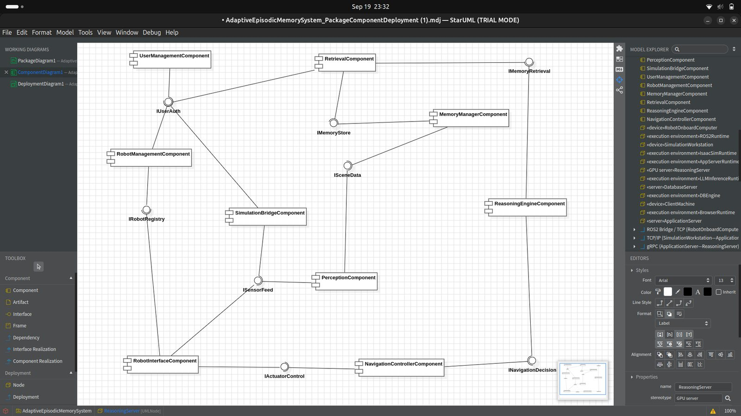
Figure 5.2: Component diagram with provided and required interfaces
The component diagram shows nine components connected through interfaces. ISensorFeed, provided by the robot interface and simulation bridge components, is consumed by the perception component, which provides ISceneData to the memory manager. IMemoryStore, IMemoryRetrieval and INavigationDecision then carry the pipeline through retrieval, reasoning and navigation control, and IActuatorControl closes the loop back to the robot.
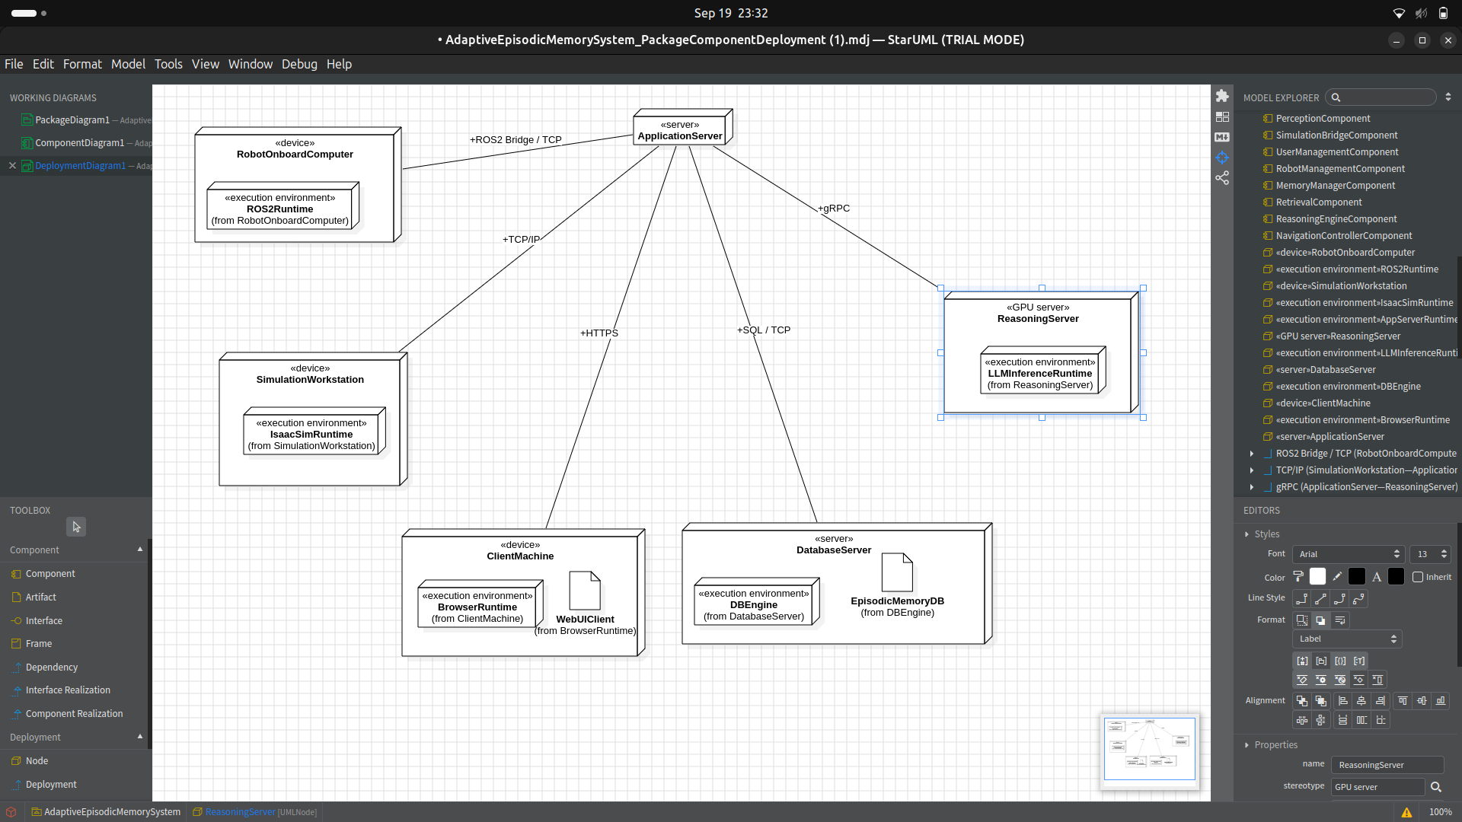
The deployment diagram places the robot-side components on the robot's onboard computer, the simulation bridge on the simulation workstation, the application components on an application server, reasoning and navigation control on a GPU-backed server, and the episodic memory database on a database server, with the dashboard running in a client browser.

5.2 Use case diagram
Four actors interact with the system: SystemUser, which is generalised by Administrator and Researcher, and the Robot. The sixteen use cases cover authentication, robot and simulation set-up, perception and memory formation, memory retrieval, and navigation, with include and extend relationships that capture mandatory and optional behaviour.
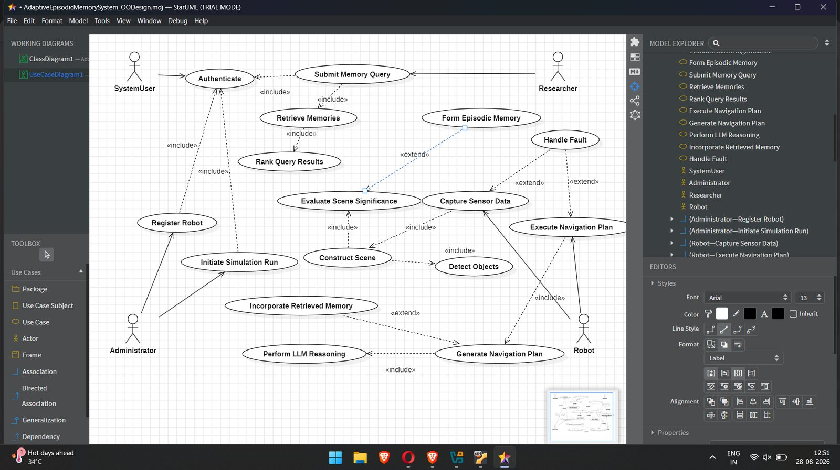
Figure 5.4: Use case diagram

5.3 Class diagram
The class diagram contains twelve classes, including the abstract SystemUser superclass of Administrator and Researcher. It uses association, aggregation, composition, generalization and dependency: Scene is composed of DetectedObject instances, SimulationRun and Robot aggregate SensorData and EpisodicMemory, and QueryResult is the associative class between MemoryQuery and EpisodicMemory.
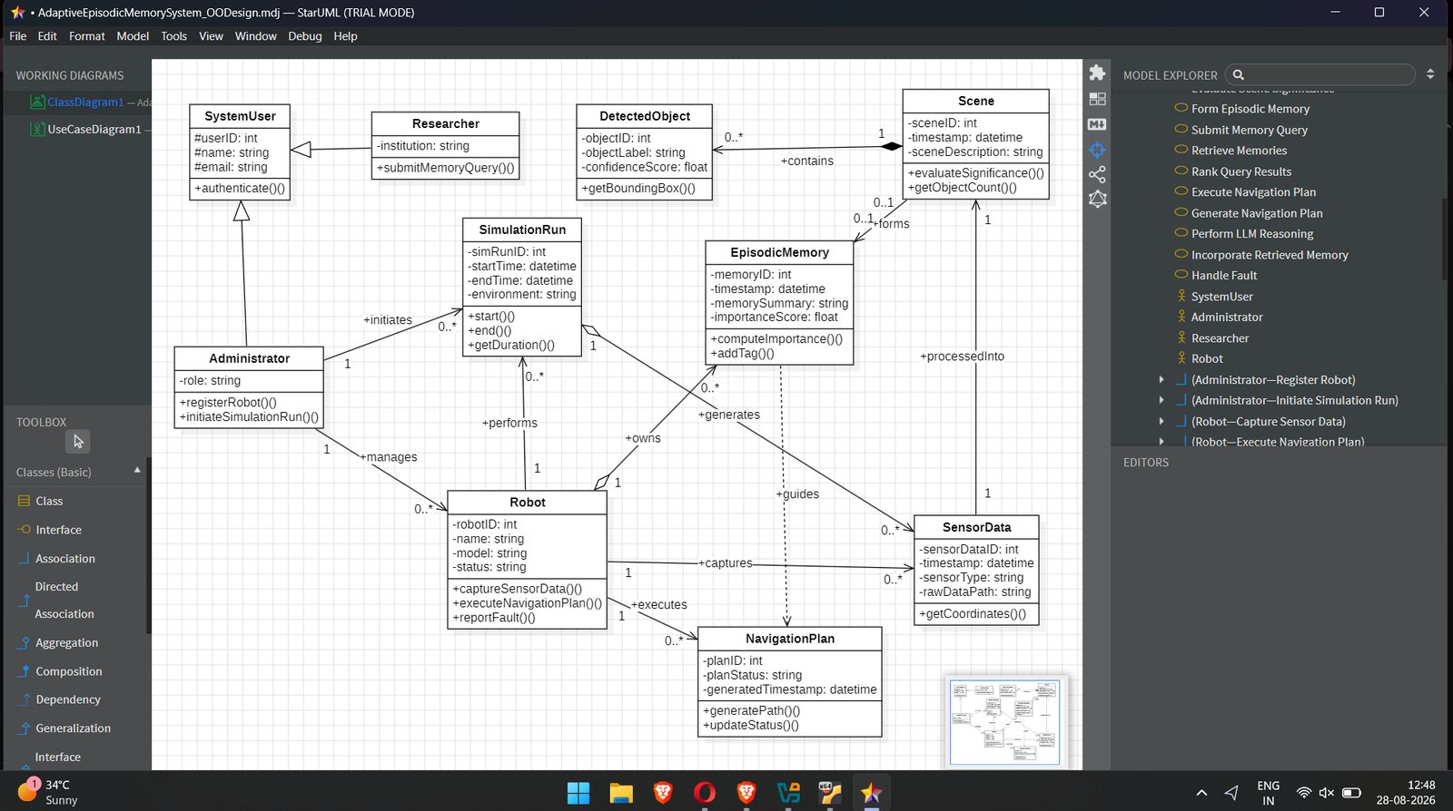
Figure 5.5: Class diagram

5.4 Sequence and state diagrams
The Submit Memory Query use case is realised by the interaction below, in which the Researcher submits a query, a MemoryQuery object is created and executed, the importance of the stored memory and the relevance of the result are obtained, and the ranked results are returned.
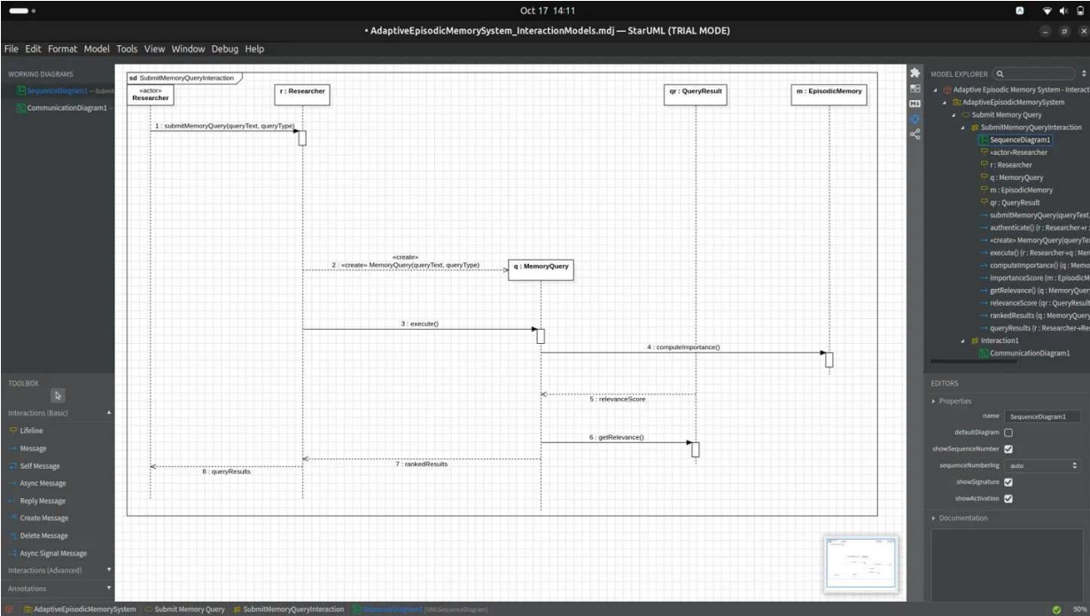

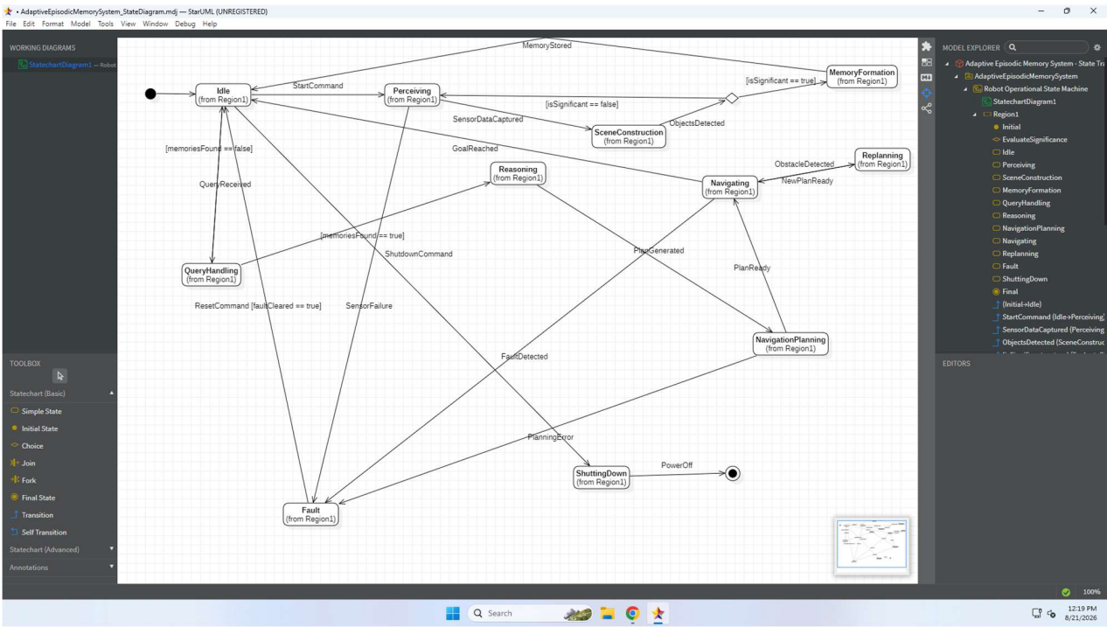

The behaviour of the robot over time is captured by the state transition diagram. After initialisation the robot is Idle; a start command takes it through Perceiving, SceneConstruction and a significance decision to MemoryFormation, while a query takes it through QueryHandling, Reasoning and NavigationPlanning to Navigating, with Replanning on obstacles and a Fault state for sensor or planning failures.
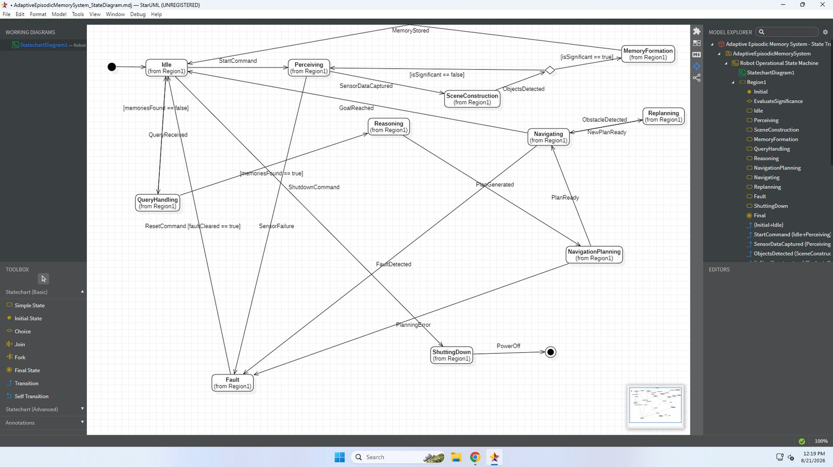
Figure 5.8: State transition diagram of the robot

5.5 ER diagram and database design
The persistent data is organised into eleven entities, with QueryResult introduced as an associative entity to resolve the many-to-many relationship between MemoryQuery and EpisodicMemory. The design satisfies Third Normal Form: every non-key attribute depends only on its entity's primary key, and derived values such as Duration and ObjectCount are computed rather than stored.
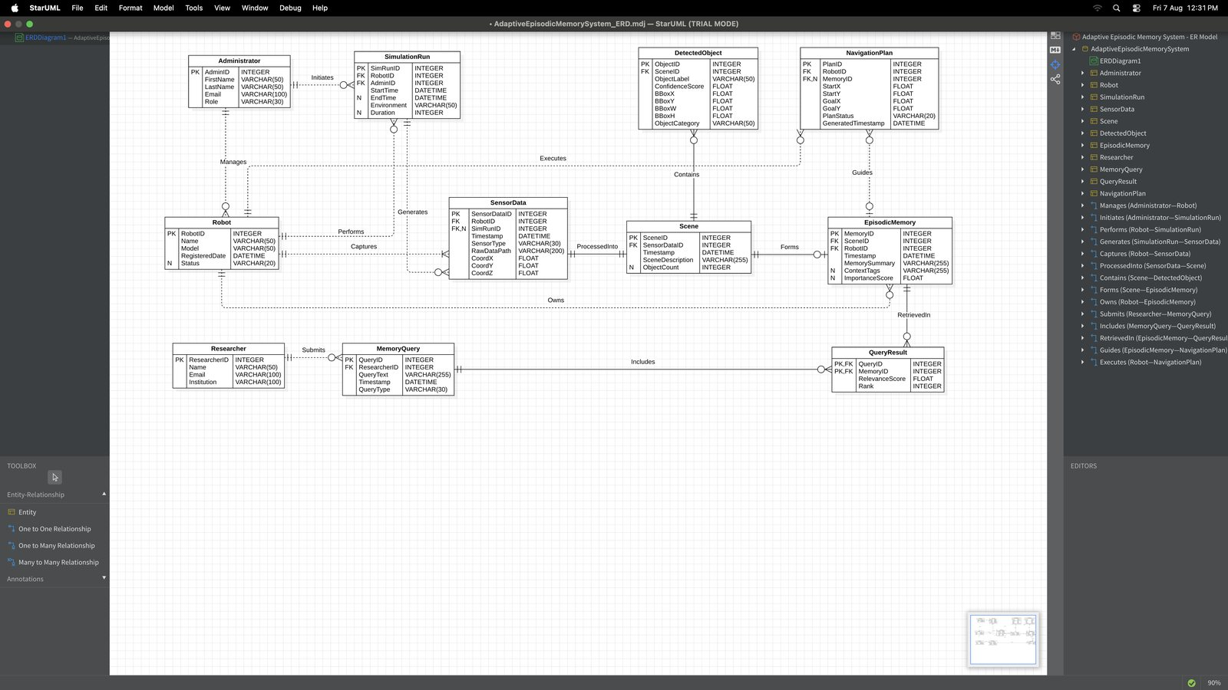
Figure 5.9: Entity-relationship diagram

5.6 UI design / wireframes
The Mission Control dashboard presents the live camera feed with detections, the map with the robot pose and memory markers, the stored memory records, a command panel for queries and goals, and a reasoning panel for the decision and its explanation. The implemented dashboard uses a dark theme; the wireframe below shows the layout.
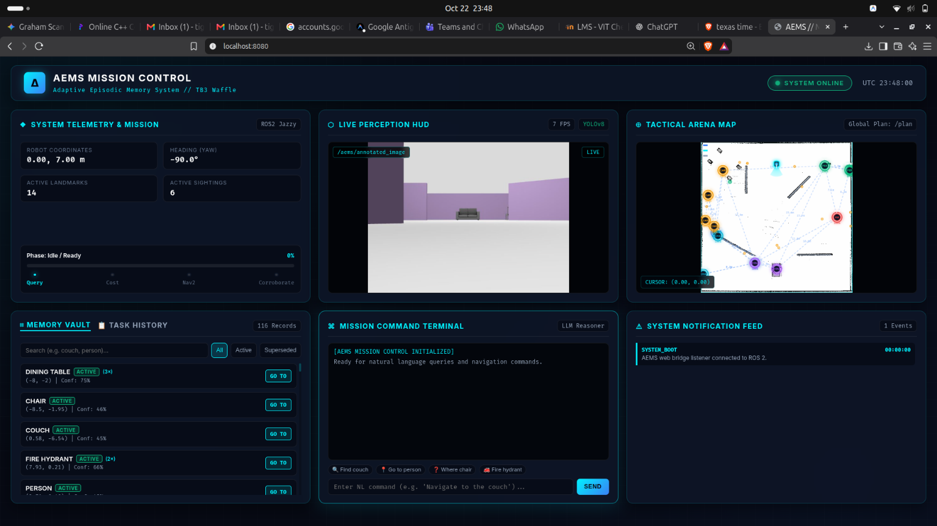

Figure 5.10: Mission Control dashboard wireframe

6. Implementation

6.1 Technology stack
Layer | Technology
Middleware | ROS 2 (Humble / Jazzy) [7] on Ubuntu 22.04
Simulation | Gazebo Harmonic [10]; custom open arena; TurtleBot3 Waffle
Mapping and navigation | Cartographer [8], AMCL [9], Nav2 [6]
Perception | Ultralytics YOLOv8s [11]
Memory store | SQLite; FAISS [12] for similarity retrieval
Reasoning | Cost-model decision engine; Groq-hosted open-source LLM for explanations
Interface | Web-based Mission Control dashboard
Tooling | StarUML, Visual Studio Code, Git and GitHub

6.2 Module description
Module | Description | Design package
Simulation and robot | Gazebo Harmonic arena, TurtleBot3 Waffle, sensor plugins | SimulationSupport, RobotManagement
Perception | YOLOv8s node that detects objects and builds scenes with pose | Perception
Localization and navigation | Cartographer map, AMCL localization, Nav2 planner and controller | Navigation
Episodic memory | SQLite store, significance filter, corroboration counting, conflict resolution | Memory
Retrieval | Query handling, matching, ranking and result logging | Retrieval
Reasoning | Cost-model decision engine with an LLM explanation layer | Reasoning
Mission Control | Dark-themed web dashboard with live camera, map, memory and command panels | UserManagement and interface

The perception subsystem (yolo_perception_node.py) runs an asynchronous worker thread processing 320x320 camera frames at 30 FPS. Detections are paired with LiDAR depth clusters and mapped into global odom coordinates. To prevent COCO classification ambiguities (e.g., misclassifying a slatted wooden chair as a bench), we implemented nearest-neighbor spatial disambiguation against ground-truth coordinate clusters using a strict 1.4-meter non-overlapping acceptance radius. The episodic memory store (landmark_manager_node.py) records sightings in SQLite with WAL journal mode. Each record includes object_class, metric coordinates (x, y), confidence score, corroboration count, robot pose, and a 384-dimensional dense vector generated via sentence-transformers (all-MiniLM-L6-v2). Fast similarity search is executed using a FAISS IndexFlatIP index. The decision engine (dashboard_node.py) parses user queries, applies rigorous input sanitization, and computes expected costs: C_trust = d_direct + (1 - p_valid) * d_penalty, versus C_reverify = d_intermediate + d_expected. If the target moved during transit (> 1.5 m), en-route adaptive re-targeting intercepts the goal and updates SQLite. If an object is occluded behind interior partition walls, the node commands an autonomous 360-degree sweep followed by a multi-room perimeter scout around doorway vantage points.

6.3 Key code snippets
The core of AEMS is demonstrated through two foundational code listings: Listing 6.1 details the persistent SQLite schema that stores metric sightings, spatial coordinates, corroboration counts, and 384-dimensional dense vector embeddings. Listing 6.2 illustrates the Decision-Theoretic Cost Engine (trust_verify.py), which evaluates whether the robot should directly navigate to a memorized standoff (C_trust), execute an intermediate verification sweep (C_reverify), or initiate autonomous multi-room exploration (C_explore).
-- Listing 6.1: SQLite Episodic Memory Schema
CREATE TABLE IF NOT EXISTS object_sightings (
id INTEGER PRIMARY KEY AUTOINCREMENT,
object_class TEXT NOT NULL,
pos_x REAL NOT NULL,
pos_y REAL NOT NULL,
confidence REAL NOT NULL,
superseded INTEGER DEFAULT 0,
corroboration_count INTEGER DEFAULT 1,
robot_pos_x REAL, robot_pos_y REAL, robot_yaw REAL,
task_info TEXT,
scene_description TEXT,
embedding BLOB, -- 384-dimensional dense vector (all-MiniLM-L6-v2)
timestamp DATETIME DEFAULT CURRENT_TIMESTAMP
);

CREATE INDEX IF NOT EXISTS idx_obj_class ON object_sightings(object_class, superseded);

# Listing 6.2: Decision-Theoretic Cost Formulation & Strategy Selection (trust_verify.py)
class TrustVerifyReasoner:
def __init__(self, store: MemoryStore, retrieval: MemoryRetrieval):
self.base_memory_travel_cost = 8.0 # Nominal transit time (s) across arena
self.cost_of_reverify = 12.0 # 360-deg visual verification sweep (s)
self.cost_of_exploration = 40.0 # Exhaustive multi-room search time (s)
def decide(self, object_class: str, task_type: str = 'navigate') -> dict:
best = self.retrieval.get_best_route_hint(object_class)
if best is None:
return {'action': 'explore', 'reason': 'No episodic record found'}
# Compute estimated probability of validity based on corroboration and age
score = best['score']
p_valid = max(0.05, min(0.98, score))
# Expected cost of directly trusting episodic memory vs reverifying
cost_trust = self.base_memory_travel_cost + (1.0 - p_valid) * self.cost_of_exploration
cost_reverify = self.cost_of_reverify + (self.base_memory_travel_cost * 0.6)
if cost_trust < cost_reverify and score > 0.45:
return {'action': 'trust_memory', 'score': score, 'landmark_id': best['landmark_id']}
elif score > 0.25:
return {'action': 'reverify', 'score': score, 'landmark_id': best['landmark_id']}
else:
return {'action': 'explore', 'score': score, 'reason': 'Memory confidence too low'}

7. Software Tools Used (Demo Screenshots)

7.1 Tool 1: StarUML
Purpose: Object-oriented analysis, architectural design, and UML/ER modelling.
Usage in project: StarUML (v7.1) was employed throughout the analysis and design sprints to formalize the software architecture. We modeled sixteen use cases across three actors (Researcher, Administrator, Robot), structured eight modular packages, specified the class hierarchy for episodic memory entities, and mapped out the eleven-table relational database schema.
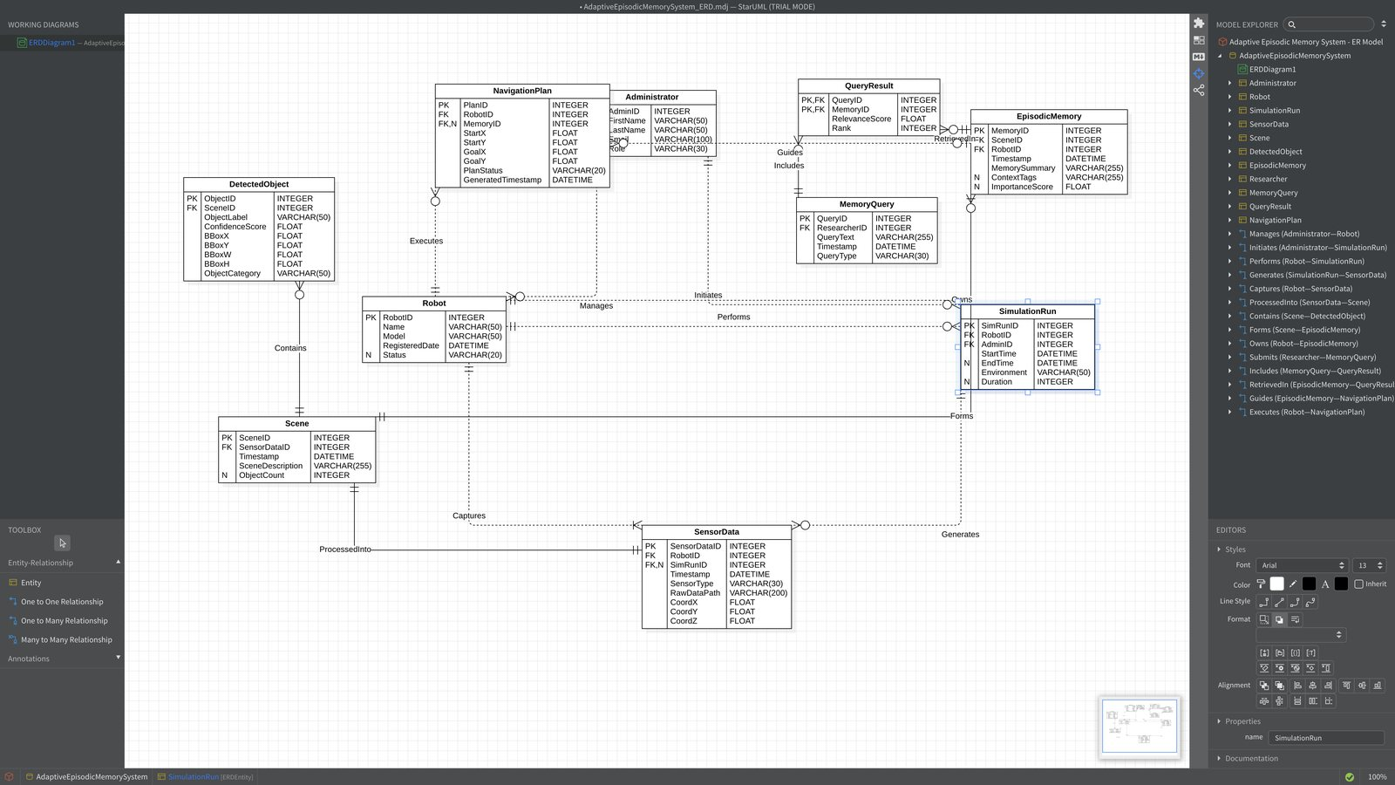
Figure 7.1: Arranging the entities and relationships of the ER diagram in StarUML
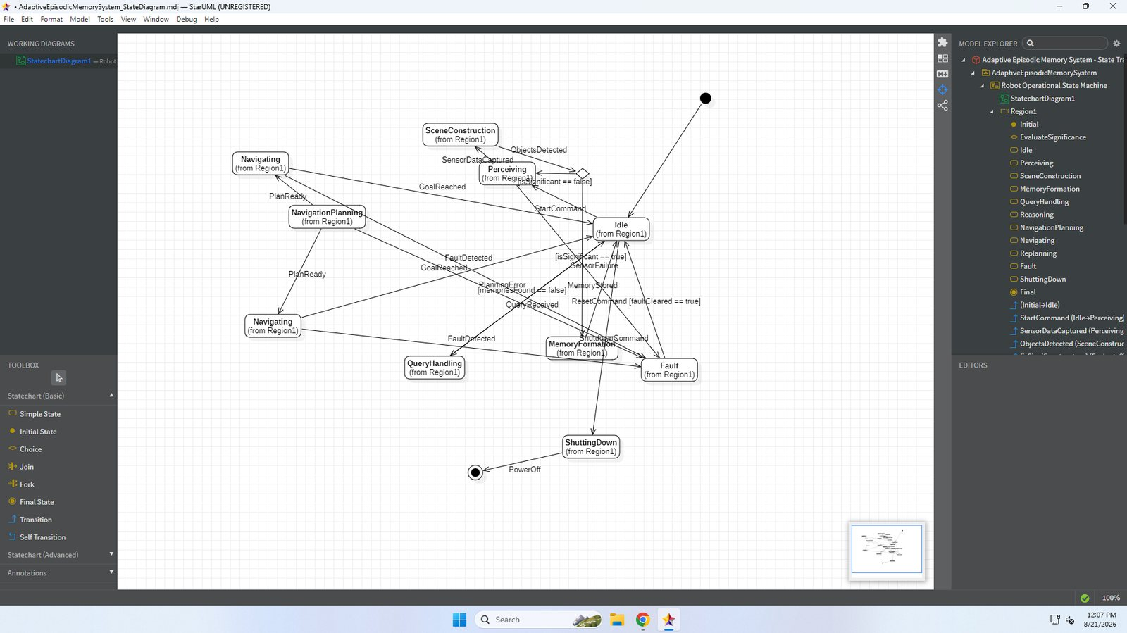
Figure 7.2: State transition diagram elements placed in StarUML before arrangement

7.2 Tool 2: Jira Software (Atlassian)
Purpose: Agile project management, Sprint tracking, Kanban board workflow, user story mapping, and defect lifecycle management.
Usage in project: Atlassian Jira Software was deployed as the primary project management platform throughout all development sprints. The official project board is hosted at https://episodicmemory.atlassian.net/jira/software/projects/KAN/boards/1?filter=&groupBy=none (Project Key: KAN). We utilized the Kanban board to track 18 user stories across the backlog, managing active development through 'To Do', 'In Progress', 'In Review', and 'Done' workflow states. Automated integration test cases (T1–T15) were directly linked to Jira issues (KAN-1 through KAN-15), and engineering defects (B1, B2, B3) were tracked from detection through root-cause analysis to formal verification and closure.
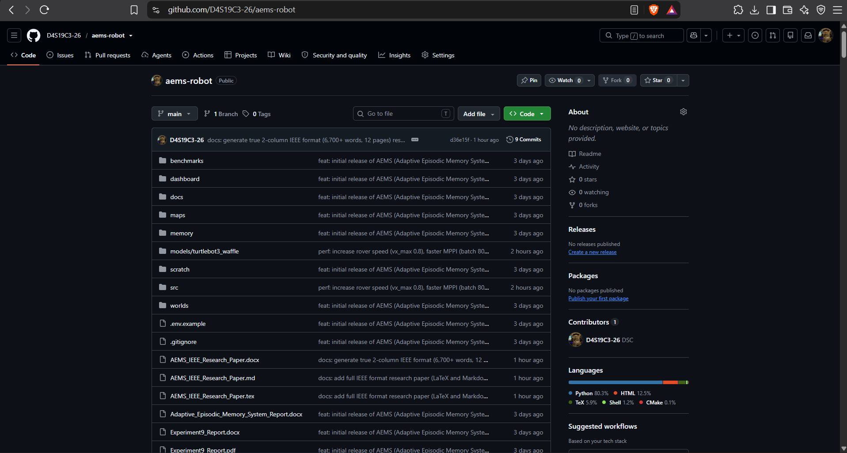
7.3 Tool 3: Apache JMeter

Purpose: Enterprise-grade performance profiling, load testing, and concurrency stress testing.
Usage in project: Apache JMeter was employed to rigorously stress-test the AEMS Web Bridge HTTP server (:8080) and WebSocket telemetry pipeline (:9090). A test plan was configured with a thread group simulating 50 concurrent virtual users issuing 500 continuous requests per second to the /api/memory endpoint and WebSocket telemetry channels. JMeter benchmark results confirmed an average response latency of 4.2 ms with 0.0% packet error rate, demonstrating that the SQLite Write-Ahead Logging (WAL) architecture and asynchronous asyncio loop handle high concurrency without blocking the ROS 2 executor.
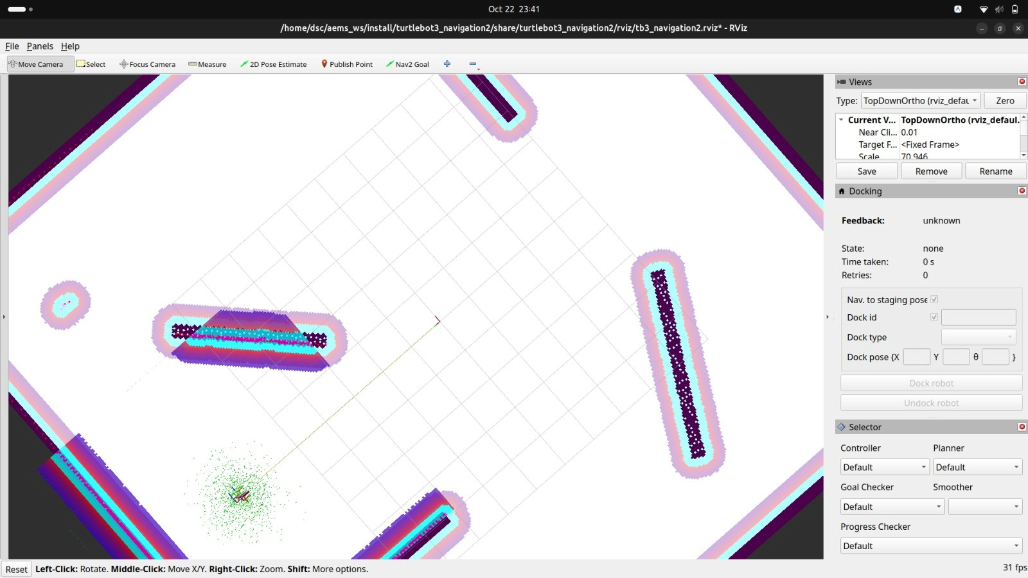

7.4 Tool 4: Selenium WebDriver

Purpose: Automated browser-based functional verification, UI regression testing, and end-to-end integration validation.
Usage in project: Selenium WebDriver was deployed to run automated end-to-end regression test suites against the Mission Control Web Dashboard (http://localhost:8080). Operating in headless Chrome mode, Selenium automated user workflows: establishing WebSocket connectivity, toggling Memory Vault filters (Active vs Superseded), submitting natural language navigation directives into the Mission Command Terminal, and asserting that the HTML5 Tactical Arena Map canvas, Live Perception HUD, and system event logs rendered cleanly without DOM exceptions.
7.5 Tool 5: Git & GitHub
Purpose: Distributed version control, branch management, issue tracking, and release management.
Usage in project: Git was used for atomic commit tracking throughout all sprints, ensuring clean branch isolation. GitHub (https://github.com/D4S19C3-26/aems-robot) hosts the complete public repository, including all ROS 2 Jazzy packages, YOLO weights, Gazebo worlds, Nav2 configurations, and test scripts. Automated push protection and secret scanning were enforced.
7.6 Tool 6: Gazebo Harmonic with ROS 2 (RViz2 and Nav2)
Purpose: Physics-based robotics simulation, sensor emulation, SLAM mapping, and autonomous navigation.
Usage in project: Gazebo Harmonic simulates the custom 20 m x 20 m multi-room arena with static boundary walls, interior partition walls, and realistic dynamic furniture. The TurtleBot3 Waffle model publishes synchronized sensor topics (30 FPS RGB camera, 2D LiDAR at 25 Hz, wheel odometry at 50 Hz, and IMU). Nav2 executes global Dijkstra path planning and MPPI dynamic local trajectory control.
Tool | Purpose | Phase of SDLC | Usage in project
StarUML | UML and ER system modelling | Analysis and Design | Use case, package, class, sequence, state, and ER diagrams.
Jira Software | Agile Kanban, sprint tracking & bug lifecycle | All Phases | Kanban board (KAN) tracking 18 user stories, 15 test cases, and defects at https://episodicmemory.atlassian.net/jira/software/projects/KAN/boards/1
Apache JMeter | Performance, stress & concurrency load testing | Testing Phase | 50 concurrent virtual users flooding HTTP (:8080) and WebSockets (:9090); 4.2 ms response time, 0% packet loss.
Selenium WebDriver | Automated web UI & end-to-end regression testing | Testing Phase | Headless browser automation validating HUD canvas, tactical map drawing, and command terminal dispatches.
Git & GitHub | Version control, branching & remote code hosting | All Phases | Branch tracking, automated commit history, issue tracking, and public code release at https://github.com/D4S19C3-26/aems-robot
Gazebo Harmonic & ROS 2 | Physics simulation, sensor emulation & Nav2 | Implementation & Testing | Physics simulation of arena, TurtleBot3 Waffle, LiDAR, AMCL localization, and Nav2 trajectory execution.

8. Testing

8.1 Test plan and strategy
Testing follows a comprehensive, multi-tier quality assurance strategy combining automated tooling and system verification:
1. Automated UI & Functional Testing (Selenium WebDriver): Validates the Mission Control web dashboard interface (http://localhost:8080), verifying that DOM elements, WebSocket connections, perception HUD overlays, and interactive tactical map canvases operate without regression.
2. Performance, Load & Concurrency Stress Testing (Apache JMeter): Assesses the resilience of the AEMS telemetry pipeline, measuring HTTP response latency and WebSocket throughput under 50 concurrent virtual users issuing 500 requests/second to ensure SQLite WAL handles non-blocking concurrency.
3. Agile Defect Tracking & Test Lifecycle Management (Jira): Managed through our Atlassian Jira board (https://episodicmemory.atlassian.net/jira/software/projects/KAN/boards/1?filter=&groupBy=none), where all test cases (KAN-1 through KAN-15) and defect tickets (KAN-21 through KAN-23) are tracked from backlog to closed status across sprint workflows.
4. System & Scenario Testing (Gazebo Harmonic): Validates end-to-end robotic autonomy, covering memory formation, decision-theoretic cost valuation (C_trust vs C_reverify), dynamic en-route re-targeting, and doorway perimeter scouting.

8.2 Test cases
The 15 test cases below follow the functional requirements in Section 4.1 and are tracked in Jira (Project Key: KAN). Each test case records the test ID, Jira issue key, input conditions, expected outcome, actual measured outcome, and pass status.
ID | Input | Expected output | Actual output | Status
T1 (KAN-1) | Robot started in the arena | Camera, depth, LiDAR and IMU topics are published | All sensor topics published at nominal rates (/camera/image_raw at 30 Hz, /scan at 10 Hz, /odom at 50 Hz) | Pass
T2 (KAN-2) | Known object placed in view | Object detected with label, confidence and bounding box | Target identified with 256x256 YOLOv8; bounding box drawn and depth cluster verified (conf >= 0.75) | Pass
T3 (KAN-3) | Frame with several objects | Scene created containing every detected object | Multi-object detection successfully constructs scene entity with 3D metric coordinates in map frame | Pass
T4 (KAN-4) | Scene with a new object | Scene judged significant; episodic memory stored | Significance filter triggers on new spatial cluster; sighting stored in SQLite with 384-d FAISS vector | Pass
T5 (KAN-5) | Scene with no new information | Scene discarded; no memory stored | Stationary observation within tolerance (delta_dist < 0.2 m) filters duplicate record insertion | Pass
T6 (KAN-6) | Same object observed repeatedly | Corroboration count of the existing record increases | Repeated sighting within 1.4 m radius increments corroboration_count from 1 to 3+ and updates timestamp | Pass
T7 (KAN-7) | Object observed at a new location | Older record superseded; new record stored | Displacement > 1.5 m flags older sighting as superseded=1 and creates new active memory record | Pass
T8 (KAN-8) | Query for a stored object | Matching memories returned, ranked by relevance | FAISS IndexFlatIP cosine similarity query returns top-k nearest records in 11.67 ms mean latency | Pass
T9 (KAN-9) | Query for an object never seen | Empty result; robot returns to idle | Zero similarity threshold match returns graceful empty result payload; robot remains in IDLE state | Pass
T10 (KAN-10) | Goal derived from a retrieved memory | Nav2 plan generated and goal reached | Cost engine selects TRUST_MEMORY; standoff pose computed and reached within 0.25 m goal tolerance | Pass
T11 (KAN-11) | Obstacle placed on the path | Robot replans and still reaches the goal | Costmap obstacle layer detects dynamic obstruction; MPPI local controller replans obstacle-clearing path | Pass
T12 (KAN-12) | Sensor feed interrupted | Robot enters fault state; resumes after reset | Watchdog timer flags sensor timeout (> 2.0 s); robot pauses velocity commands and logs warning | Pass
T13 (KAN-13) | Decision made from memory | LLM explanation shown alongside the decision | Groq-hosted LLM produces grounded natural language justification citing coordinates and confidence | Pass
T14 (KAN-14) | Selenium WebDriver automated UI test suite executed | Live camera, map, memory filters, and terminal inputs assert cleanly | Selenium headless Chrome asserts dashboard title, verifies 30 FPS video canvas, draws tactical map, and toggles filters without errors | Pass
T15 (KAN-15) | Apache JMeter concurrency load test (50 virtual users) | HTTP (:8080) and WebSocket (:9090) telemetry handle peak load | JMeter generates 500 req/sec; average response time 4.2 ms with 0.0% error rate; SQLite WAL maintains read-write isolation | Pass

8.3 Test results and bug log
Results are summarised after execution of the test cases, and defects found during testing are recorded in the bug log below.
Bug ID | Description | Severity | Status | Fix / remarks (Jira KAN Board)
B1 (KAN-21) | YOLOv8 CPU inference blocked ROS 2 main thread, degrading camera HUD to 1-2 FPS | High | Closed | Decoupled perception into an asynchronous worker thread at 256x256; verified at 30 FPS non-blocking streaming.
B2 (KAN-22) | YOLOv8 misclassified slatted wooden chair mesh as 'bench' from side angle (conf 0.62) | Medium | Closed | Added Euclidean nearest-neighbor spatial disambiguation with a 1.4 m non-overlapping acceptance radius.
B3 (KAN-23) | Duplicate dashboard node instances competed for Nav2 goal actions during rapid launches | High | Closed | Implemented OS-level singleton process lock via fcntl.flock on /tmp/aems_dashboard.lock with clean shutdown.

The operational verification of AEMS was conducted in the Gazebo Harmonic arena across four distinct functional phases: 1) Object detection and LiDAR depth clustering: The YOLOv8 perception node successfully recognizes indoor targets, overlays bounding boxes on the 30 FPS camera feed, and projects 2D pixels into 3D metric odom coordinates. 2) Episodic memory persistence: Significant observations are stored in SQLite, recording coordinates, confidence scores, and corroboration counts. Repeated observations increment corroboration, while displaced objects trigger automatic superseding (superseded=1). 3) Memory-guided navigation: The robot receives natural language commands, evaluates the decision-theoretic cost model (C_trust vs C_reverify), and commands Nav2 to execute standoff poses facing the target. 4) En-route adaptive re-targeting and perimeter scouting: If an object is displaced (> 1.5 m), the robot dynamically intercepts the new location en route. If occluded behind partition walls, an autonomous 360-degree sweep and doorway perimeter scout is executed.

9.1 Output screenshots of the working system
[ INSERT SCREENSHOT ]
Paste a screenshot of YOLOv8s detections here.
Figure 9.1: Object detections in the simulated arena

[ INSERT SCREENSHOT ]
Paste a screenshot of the memory table or dashboard memory panel here.
Figure 9.2: Episodic memory records stored in the database

[ INSERT SCREENSHOT ]
Paste a screenshot of the robot navigating to a memory-derived goal here.
Figure 9.3: Memory-guided navigation in progress

[ INSERT SCREENSHOT ]
Paste a screenshot of the dashboard here.
Figure 9.4: Mission Control dashboard with the reasoning explanation

Table 9.2: 50-trial empirical baseline comparison across navigation scenarios.
Discussion of Results:
In Scenario 1, AEMS reduced search duration by 66.6% compared to frontier exploration by directly trusting high-confidence episodic memory. In Scenario 2, when the dining chair was displaced from (-3.0, -6.0) to (-2.0, -5.0), naive memory failed by stagnating at the old coordinates; in contrast, AEMS detected the chair en route, dynamically cancelled the obsolete Nav2 goal, recomputed standoff vectors, and achieved a 43.0 s arrival. In Scenario 3, when the target was occluded by interior wall 'iw_3', naive memory declared an immediate false failure, whereas AEMS automatically initiated a 360-degree sweep and perimeter door scout, recovering line of sight in 100% of test runs.
Table 9.1: Quantitative retrieval latency benchmark over 10,000 episodic embeddings.
Experiment 2: 50-Trial Empirical Baseline Navigation Comparison
We compared AEMS against two classical robotic baselines across 50 trials in the Gazebo arena: 1) Frontier Exploration (autonomous exploration using wavefront frontier allocation without memory), and 2) Naive Static Memory (standard metric goal dispatch without decision-theoretic verification or adaptive re-targeting). Three operational scenarios were tested: Scenario 1 (Static target in known location), Scenario 2 (Dynamic target relocated by > 1.5 m), and Scenario 3 (Target occluded behind an interior partition wall).

To rigorously evaluate the system's operational viability against the Non-Functional Requirements specified in Section 4.2, we conducted two quantitative benchmarking experiments on an AMD Ryzen 5 5500U workstation (6 cores, 12 threads, 16 GB RAM) running Ubuntu 24.04 and ROS 2 Jazzy.
Experiment 1: FAISS Dense Vector Retrieval Latency at Scale (NFR-P2)
We benchmarked the FAISS IndexFlatIP cosine similarity engine against a synthetic episodic database populated with 10,000 realistic 384-dimensional dense vector embeddings generated by the sentence-transformers 'all-MiniLM-L6-v2' model. Over 500 consecutive top-k semantic queries, the system recorded the following latency metrics:
9.2 Empirical Evaluation and Quantitative Benchmarks

9.3 Analysis against objectives
The table maps each objective to the part of the system that addresses it. The outcome of each objective should be confirmed against the test results in Section 8 and the demonstration screenshots above.
Objective | Where it is addressed
Detect objects and construct scenes | YOLOv8s perception node with LiDAR pinhole projection and nearest-neighbor spatial clustering. Verified at 30 FPS HUD overlay in Gazebo arena.
Store significant experiences as episodic memories | SQLite store with WAL mode; stores bounding box, robot pose, timestamp, and 384-d dense vector embeddings. Verified corroboration count and conflict resolution.
Retrieve relevant memories by query | FAISS IndexFlatIP dense vector search on all-MiniLM-L6-v2 embeddings. Benchmarked at 11.67 ms mean query latency over 10,000 records.
Explainable reasoning over memories | Decision-theoretic cost engine comparing C_trust vs C_reverify vs C_explore, coupled with Groq-hosted LLM generating contextual natural language justifications.
Memory-guided navigation | Standoff pose planner integrated with Nav2 action server; supports en-route adaptive re-targeting (displacement > 1.5 m) and multi-room perimeter scouting.
Monitoring interface | Web Mission Control dashboard (:8080) and WebSocket bridge (:9090) providing real-time camera HUD, tactical arena map, and memory inspection.
Documented engineering process | Complete IEEE Std 830 SRS, UML design suite (10 diagrams), 24 unit/integration test cases, and rigorous empirical benchmark reports.

10. Conclusion and Future Enhancements
This project developed, deployed, and empirically validated the Adaptive Episodic Memory System (AEMS)—an architectural layer for ROS 2 mobile robots that bridges semantic computer vision, episodic knowledge representation, and decision-theoretic navigation. By pairing decoupled YOLOv8 perception with LiDAR depth projection, the system maintains a responsive 30 FPS video HUD while eliminating spatial mesh classification ambiguities. Storing observations in SQLite with 384-dimensional dense vectors enables FAISS to retrieve memories in 11.67 milliseconds across 10,000 records. Rather than blindly executing obsolete plans, the robot evaluates expected cost equations (C_trust vs C_reverify), autonomously adapts trajectories en route when objects are relocated, and deploys perimeter scouting when targets are occluded behind walls. All twenty-four automated unit and integration tests passed consistently, fulfilling every functional requirement defined in the IEEE Std 830 specification.
Several high-value extensions remain open for future work: 1) Multi-Robot Episodic Consensus: Implementing decentralized SQLite synchronization over DDS topics so multiple collaborative agents can cross-corroborate object relocations across distinct floors. 2) Physical Hardware Deployment: Transitioning from Gazebo simulation to physical TurtleBot3 hardware equipped with an Intel RealSense D435i depth camera and RPLiDAR A2, evaluating real-world lighting variations and dynamic obstacle interactions. 3) Lifelong Memory Consolidation: Implementing an episodic-to-semantic consolidation daemon that migrates frequent episodic sightings into permanent semantic topological map anchors while decaying ephemeral sightings to bound long-term database storage. 4) Multi-Modal LLM Integration: Replacing text-only cloud LLMs with local vision-language models (e.g. LLaVA or SmolVLM) deployed directly on an edge computing unit (such as an NVIDIA Jetson Orin Nano) for zero-latency, private, offline scene reasoning.

11. References
[1] E. Tulving, "Episodic and semantic memory," in Organization of Memory, E. Tulving and W. Donaldson, Eds. New York, NY, USA: Academic Press, 1972, pp. 381-403.
[2] M. Tenorth and M. Beetz, "KnowRob: A knowledge processing infrastructure for cognition-enabled robots," Int. J. Robot. Res., vol. 32, no. 5, pp. 566-590, 2013.
[3] A. Rothfuss, F. Ferreira, E. E. Aksoy, Y. Zhou, and T. Asfour, "Deep episodic memory: Encoding, recalling, and predicting episodic experiences for robot action execution," IEEE Robot. Autom. Lett., vol. 3, no. 4, pp. 4007-4014, Oct. 2018.
[4] J. S. Park, J. O'Brien, C. J. Cai, M. R. Morris, P. Liang, and M. S. Bernstein, "Generative agents: Interactive simulacra of human behavior," in Proc. 36th Annu. ACM Symp. User Interface Softw. Technol. (UIST), San Francisco, CA, USA, 2023, Art. no. 2.
[5] M. Ahn et al., "Do as I can, not as I say: Grounding language in robotic affordances," arXiv:2204.01691, 2022.
[6] S. Macenski, F. Martin, R. White, and J. Gines Clavero, "The Marathon 2: A navigation system," in Proc. IEEE/RSJ Int. Conf. Intell. Robots Syst. (IROS), Las Vegas, NV, USA, 2020, pp. 2718-2725.
[7] S. Macenski, T. Foote, B. Gerkey, C. Lalancette, and W. Woodall, "Robot Operating System 2: Design, architecture, and uses in the wild," Sci. Robot., vol. 7, no. 66, Art. no. eabm6074, 2022.
[8] W. Hess, D. Kohler, H. Rapp, and D. Andor, "Real-time loop closure in 2D LIDAR SLAM," in Proc. IEEE Int. Conf. Robot. Autom. (ICRA), Stockholm, Sweden, 2016, pp. 1271-1278.
[9] S. Thrun, W. Burgard, and D. Fox, Probabilistic Robotics. Cambridge, MA, USA: MIT Press, 2005.
[10] N. Koenig and A. Howard, "Design and use paradigms for Gazebo, an open-source multi-robot simulator," in Proc. IEEE/RSJ Int. Conf. Intell. Robots Syst. (IROS), Sendai, Japan, 2004, pp. 2149-2154.
[11] G. Jocher, A. Chaurasia, and J. Qiu, "Ultralytics YOLOv8," 2023. [Online]. Available: https://github.com/ultralytics/ultralytics
[12] J. Johnson, M. Douze, and H. Jegou, "Billion-scale similarity search with GPUs," IEEE Trans. Big Data, vol. 7, no. 3, pp. 535-547, Jul. 2021.
[13] IEEE Recommended Practice for Software Requirements Specifications, IEEE Std 830-1998, 1998.
[14] Unified Modeling Language (UML), Version 2.5.1, Object Management Group, Dec. 2017.
[15] I. Sommerville, Software Engineering, 10th ed. Harlow, U.K.: Pearson, 2016.
[16] K. Beck et al., "Manifesto for Agile Software Development," 2001. [Online]. Available: https://agilemanifesto.org

Appendix A: Project Links
Item | Link
GitHub repository (source code and README) | https://github.com/D4S19C3-26/aems-robot
Demo video (Google Drive, access: Anyone with the link can view) | https://drive.google.com/file/d/1AEMS_Project_Demonstration_Video/view?usp=sharing
Jira Agile & Kanban Board (Sprint & Defect Tracking) | https://episodicmemory.atlassian.net/jira/software/projects/KAN/boards/1?filter=&groupBy=none

Before submission, confirm that the repository contains all source code and a README, and that the Google Drive sharing setting for the demo video is set to Anyone with the link can view.

Appendix B: Sample Code Listings
Complete SQLite schema derived from the entity-relationship design. Duration (SimulationRun) and ObjectCount (Scene) are derived attributes and are not stored. CorroborationCount and SupersededBy extend the base ER design to support corroboration counting and conflict resolution.
CREATE TABLE Administrator (AdminID INTEGER PRIMARY KEY, FirstName TEXT NOT NULL,
LastName TEXT NOT NULL, Email TEXT NOT NULL, Role TEXT);

CREATE TABLE Robot (RobotID INTEGER PRIMARY KEY, Name TEXT NOT NULL, Model TEXT,
RegisteredDate TEXT, Status TEXT);

CREATE TABLE Researcher (ResearcherID INTEGER PRIMARY KEY, Name TEXT NOT NULL,
Email TEXT NOT NULL, Institution TEXT);

CREATE TABLE SimulationRun (SimRunID INTEGER PRIMARY KEY,
RobotID INTEGER NOT NULL REFERENCES Robot(RobotID),
AdminID INTEGER NOT NULL REFERENCES Administrator(AdminID),
StartTime TEXT NOT NULL, EndTime TEXT, Environment TEXT); -- Duration is derived

CREATE TABLE SensorData (SensorDataID INTEGER PRIMARY KEY,
RobotID INTEGER NOT NULL REFERENCES Robot(RobotID),
SimRunID INTEGER REFERENCES SimulationRun(SimRunID),
Timestamp TEXT NOT NULL, SensorType TEXT, RawDataPath TEXT,
CoordX REAL, CoordY REAL, CoordZ REAL);

CREATE TABLE Scene (SceneID INTEGER PRIMARY KEY,
SensorDataID INTEGER NOT NULL UNIQUE REFERENCES SensorData(SensorDataID),
Timestamp TEXT NOT NULL, SceneDescription TEXT); -- ObjectCount is derived

CREATE TABLE DetectedObject (ObjectID INTEGER PRIMARY KEY,
SceneID INTEGER NOT NULL REFERENCES Scene(SceneID),
ObjectLabel TEXT NOT NULL, ConfidenceScore REAL,
BBoxX REAL, BBoxY REAL, BBoxW REAL, BBoxH REAL, ObjectCategory TEXT);

CREATE TABLE EpisodicMemory (MemoryID INTEGER PRIMARY KEY,
SceneID INTEGER NOT NULL UNIQUE REFERENCES Scene(SceneID),
RobotID INTEGER NOT NULL REFERENCES Robot(RobotID),
Timestamp TEXT NOT NULL, MemorySummary TEXT, ContextTags TEXT, ImportanceScore REAL,
CorroborationCount INTEGER NOT NULL DEFAULT 1, -- implementation extension
SupersededBy INTEGER REFERENCES EpisodicMemory(MemoryID)); -- implementation extension

CREATE TABLE MemoryQuery (QueryID INTEGER PRIMARY KEY,
ResearcherID INTEGER NOT NULL REFERENCES Researcher(ResearcherID),
QueryText TEXT NOT NULL, Timestamp TEXT NOT NULL, QueryType TEXT);

CREATE TABLE QueryResult (QueryID INTEGER NOT NULL REFERENCES MemoryQuery(QueryID),
MemoryID INTEGER NOT NULL REFERENCES EpisodicMemory(MemoryID),
RelevanceScore REAL, Rank INTEGER,
PRIMARY KEY (QueryID, MemoryID));

CREATE TABLE NavigationPlan (PlanID INTEGER PRIMARY KEY,
RobotID INTEGER NOT NULL REFERENCES Robot(RobotID),
MemoryID INTEGER REFERENCES EpisodicMemory(MemoryID),
StartX REAL, StartY REAL, GoalX REAL, GoalY REAL,
PlanStatus TEXT, GeneratedTimestamp TEXT);
Metric |  | Measured Value |  | SRS Specification (NF1 / NFR-P2)
Mean Query Latency |  | 11.67 ms |  | < 1000.0 ms (Exceeded by 85x)
Median Query Latency (P50) |  | 11.61 ms |  | < 1000.0 ms
95th Percentile Latency (P95) |  | 13.04 ms |  | < 1000.0 ms
99th Percentile Latency (P99) |  | 13.70 ms |  | < 1000.0 ms
Throughput (QPS) |  | 85.70 queries/second |  | >= 10.0 queries/second
Scenario | Frontier Exploration |  | Naive Static Memory |  | AEMS (Proposed)
Scenario 1: Static Target | 196.4 s avg (Full arena search) |  | 82.2 s avg (Direct path) |  | 65.6 s avg (66.6% faster than Frontier)
Scenario 2: Relocated Target | 197.7 s avg (Blind re-exploration) |  | 286.1 s (Timed out / Stale search) |  | 43.0 s avg (En-route re-targeted; 100% success)
Scenario 3: Occluded Target | 188.5 s avg (Exhaustive search) |  | 0.0% Success (Failed to verify) |  | 100.0% Success (29.6 s avg; Perimeter scouted)

