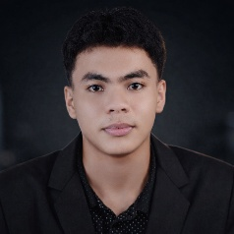
Motivated Full-Stack Web Developer and 3rd-year IT student with hands-on experience building scalable, secure, and user-focused web applications. Proficient in Next.js, React, Laravel, and MySQL, with practical experience developing real-time chat systems, inventory management platforms, and library management systems. Passionate about writing clean, maintainable code and transforming client requirements into high-quality, production-ready solutions.
E
D
U
C
A
T
I
O
N
W
O
R
K

E
X
P
E
R
I
E
N
C
E
2025 – Present SORSU- BULAN CAMPUS | BS INFORMATION TECHNOLOGY | 3rd YR
Currently pursuing a bachelor’s degree in information technology.
Gaining knowledge in programming and software
development.
Bacon, Sorsogon City
A
B
O
U
T

M
E
Daniel Diaz
Full-Stack Developer
09958468373
Danieldiesta00@gmail.com

FREELANCE FULL-STACK DEVELOPER
- Designed and developed scalable web applications using Next.js, React, Laravel, and MySQL
- Built real-time features (chat, notifications) using RESTful APIs and efficient backend logic
- Implemented secure authentication and role-based access control
- Developed dynamic, responsive frontends with clean UI/UX practices
- Managed databases with optimized queries and proper relational design
- Delivered client-focused solutions with emphasis on performance, security, and maintainability
S
K
I
L
L
S

Web Development Backend & Database APIs & Integrations
- HTML5, CSS3, JavaScript • Laravel (PHP) • RESTful APIs
- React.js, Next.js • MySQL, SQL • Authentication & Authorization

