**Note:** I started the assignment in pycharm but due to some error pylab is not working in my Pycharm, so I have attached  **images for code** in both jupyter notebook and pycharm in part 1. (pycharm to show the success anad also the results appear different). Which is why I had to do part 2 in Jupyter notebook.

**#Assignment code**

**from PIL import Image**

**from pylab import \***

**##image manipulation**

**from os import walk**

**import os**

**import numpy**

**dirpath="C:\\Users\\dee Jay\\Documents\\BAIM\\Unstructured\\Assignment 2\\image"**

**images=[]**

**image_files=os.listdir(dirpath)**

**for image in image_files:**

**im = Image.open(dirpath+"\\"+image)**

**im_rs = im.resize((100, 100)) ## part 1 resize**

**images.append(im_rs)**

**imshow(im_rs)**

**for image in images:**

**figure()**

**imshow(image)**

**image_array=[]**

**for image in images:**

**##math representation**

**im_m = array(image)**

**im_grey_m =array(image.convert('L')) ## part 2 grayscale 2D**

**figure()**

**imshow(im_grey_m)**

**im_v = im_grey_m.flatten()**

**print(im_m)**

**print(im_grey_m)**

**print(im_v)**

**figure()**

**hist(im_v,256, normed =True) ## part 3 histogram- flatten**

**image_array.append(im_grey_m)**

**##normalization**

**for image in image_array:**

**imhist, bins = histogram(image.flatten(), 256, normed=True)**

**cdf = imhist.cumsum()**

**cdf = 255 * cdf / cdf[-1]**

**im2 = interp(image.flatten(), bins[:-1], cdf) ## part 4 normalize**

**im_norm = im2.reshape(image.shape)**

**##display**

**figure(figsize=(30,8))**

**subplot(1,4,1)**

**imshow(image)**

**subplot(1,4,2)**

**imshow(im_norm)**

**subplot(1,4,3)**

**hist(im_grey_m.flatten(),256)**

**subplot(1,4,4)**

**hist(im2.flatten(),256)**

Image Normalization:

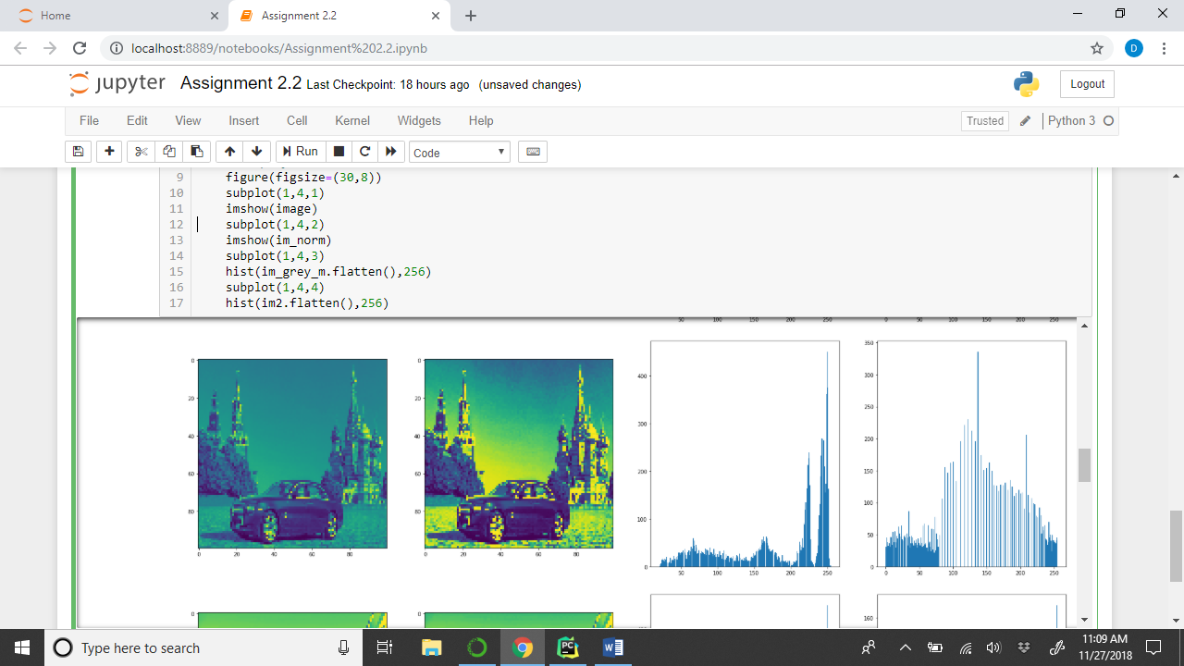

Histogram equalization is a method in image processing of contrast adjustment using the image's histogram. The first histogram has cumulative distribution frequencies for a smaller range and the intensities are spread to a minimum of 0 and max range of 255 after histogram equalization also called as image normalization.

In image processing, normalization is a process that changes the range of pixel intensity values. Applications include photographs with poor contrast due to glare, for example. ... with intensity values in the range (Min, Max), into a new image with intensity values in the range (newMin, newMax).

Since applications include photographs with poor contrast due to glare or some other reasons, so normalization is done to bring the image, or other type of signal, into a range that is more familiar or normal to the senses. We might have used interchangeably terms like contrast stretching, histogram stretching, dynamic range expansion etc which is basically normalization forma. The normalized image has mean =0 and variance =1 (To make it Normal distributed as far as possible).

PART 1:

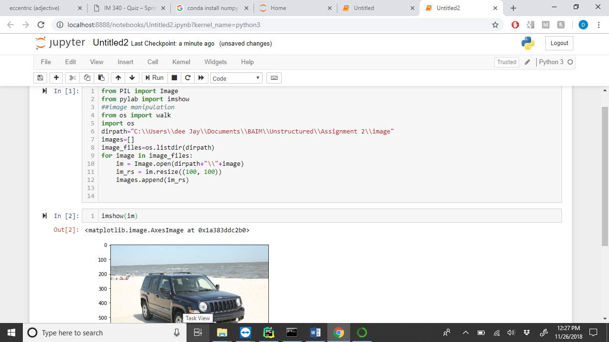

PART 2:

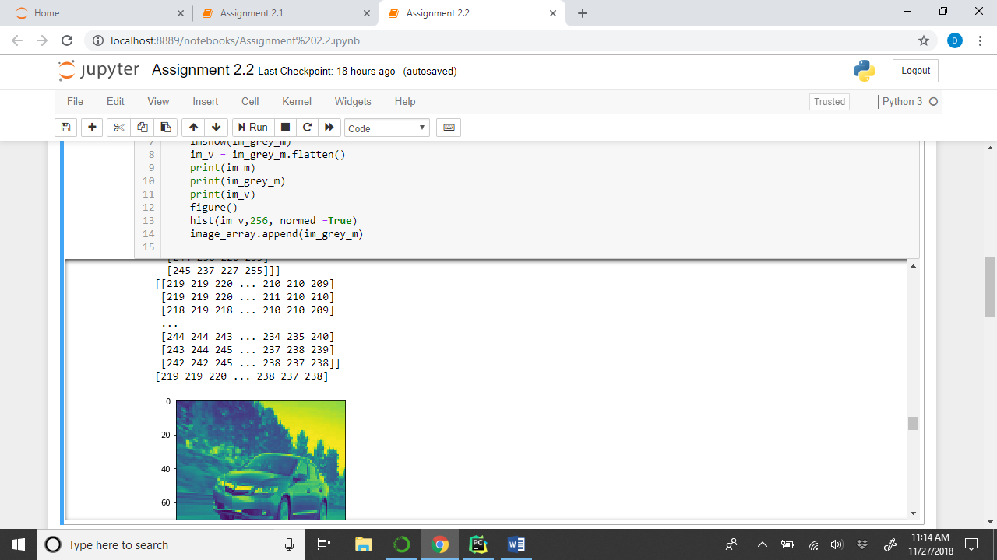

PART 3:

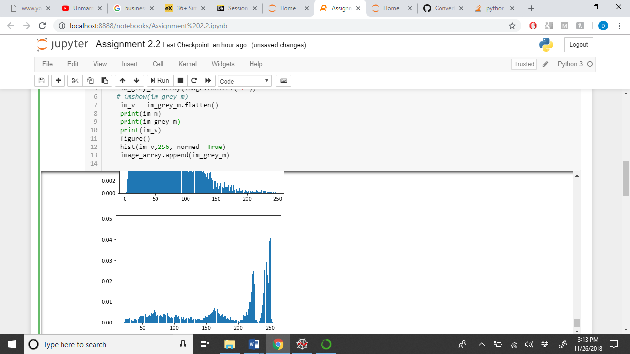

PART 4:

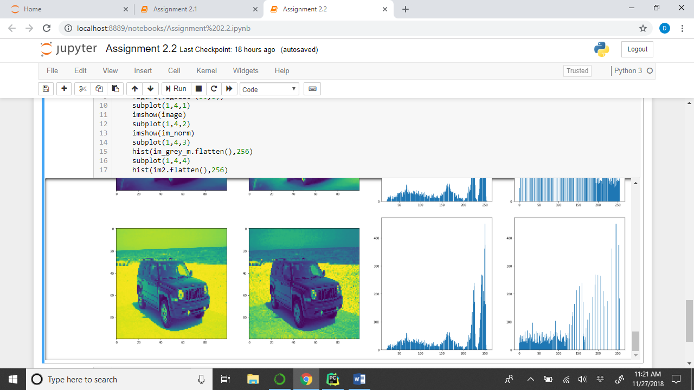

Part 5 Explanation image:

