1 Hello Admin (Authorization Admin)

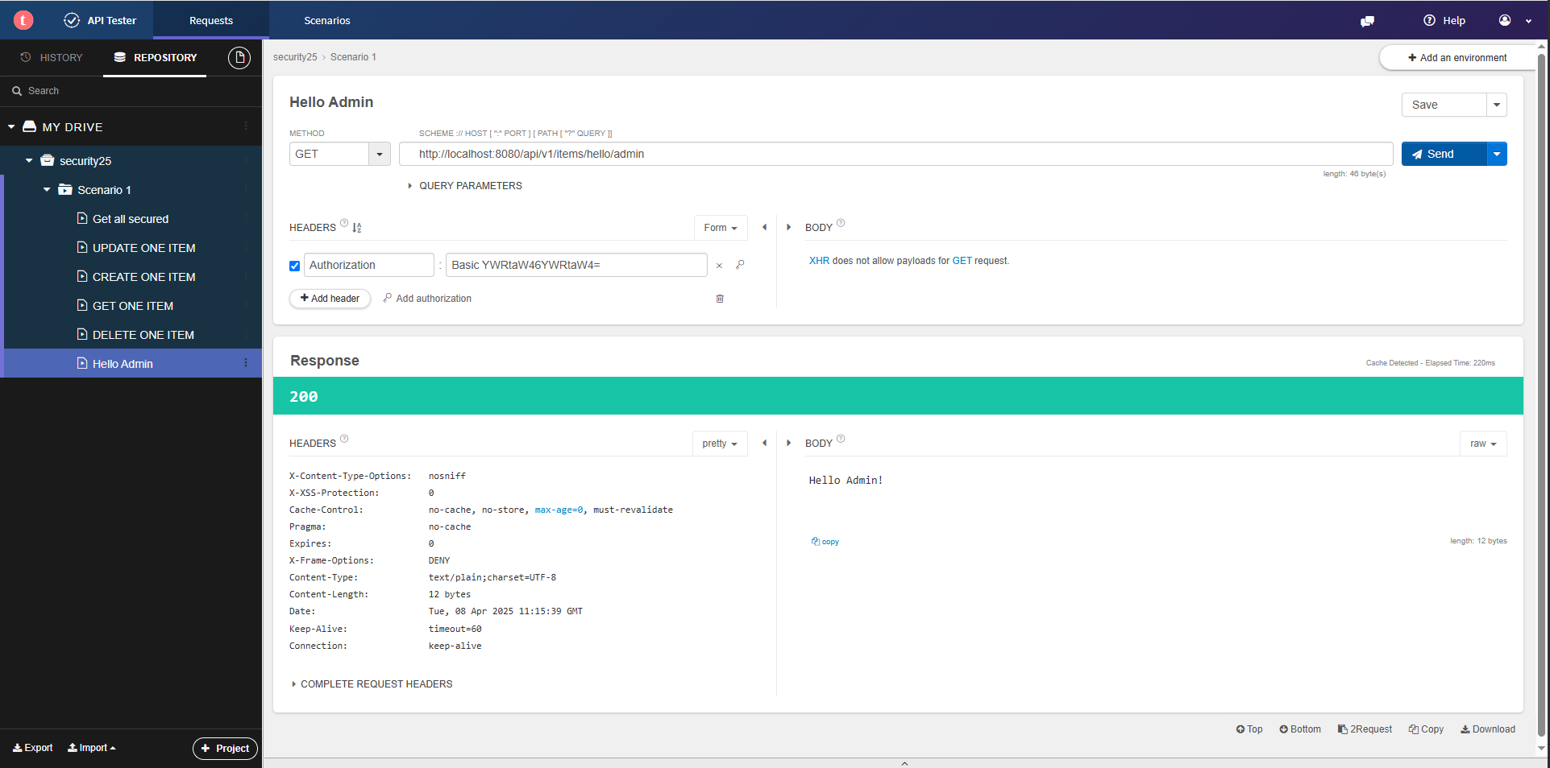

2 Hello Admin (Authorization User)

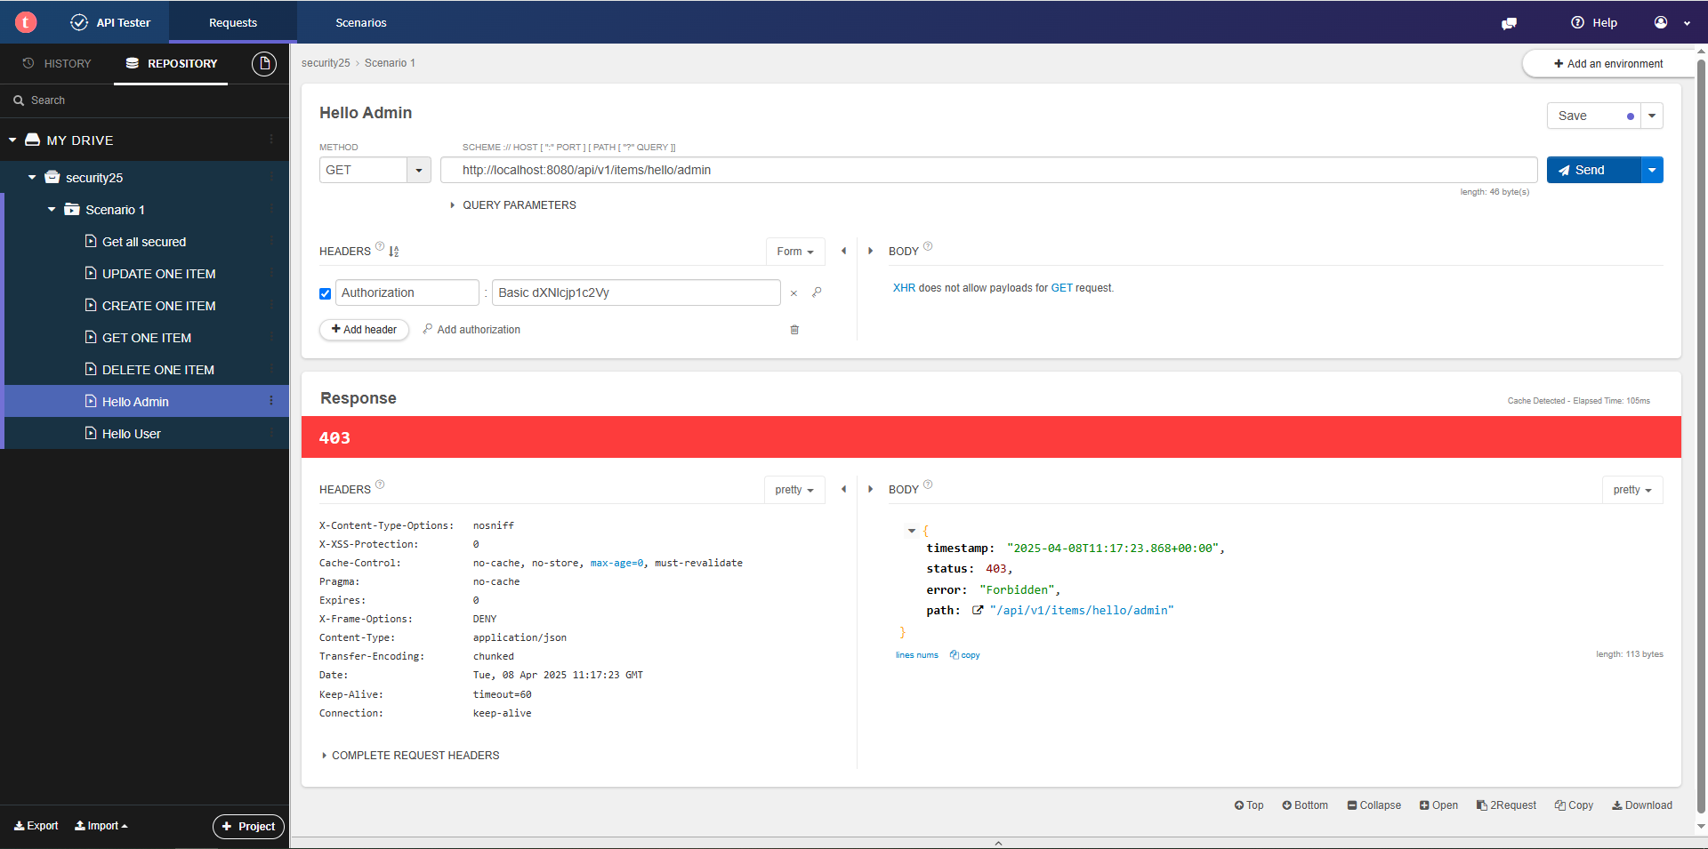

3 Hello Admin (Authorization SuperAdmin)

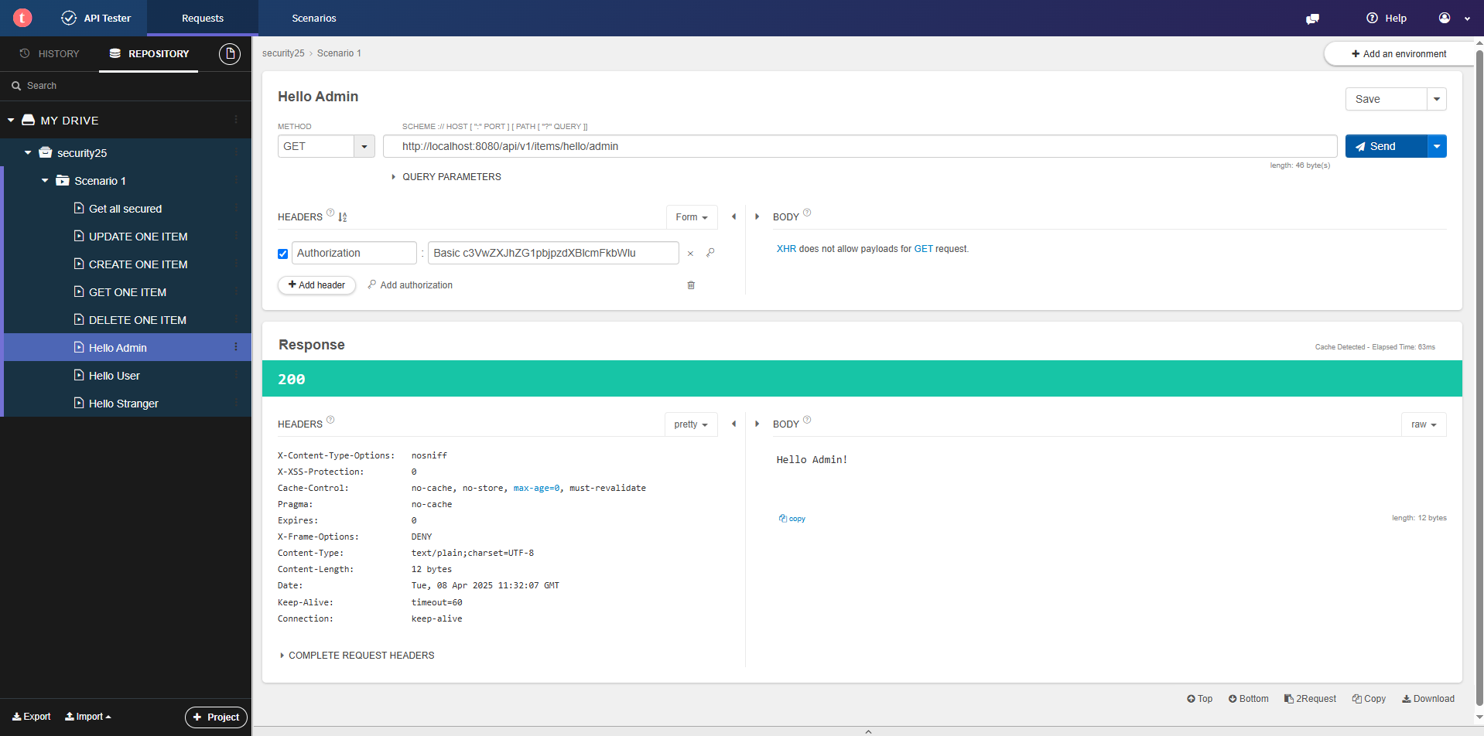

4 Hello User (Authorization Admin)

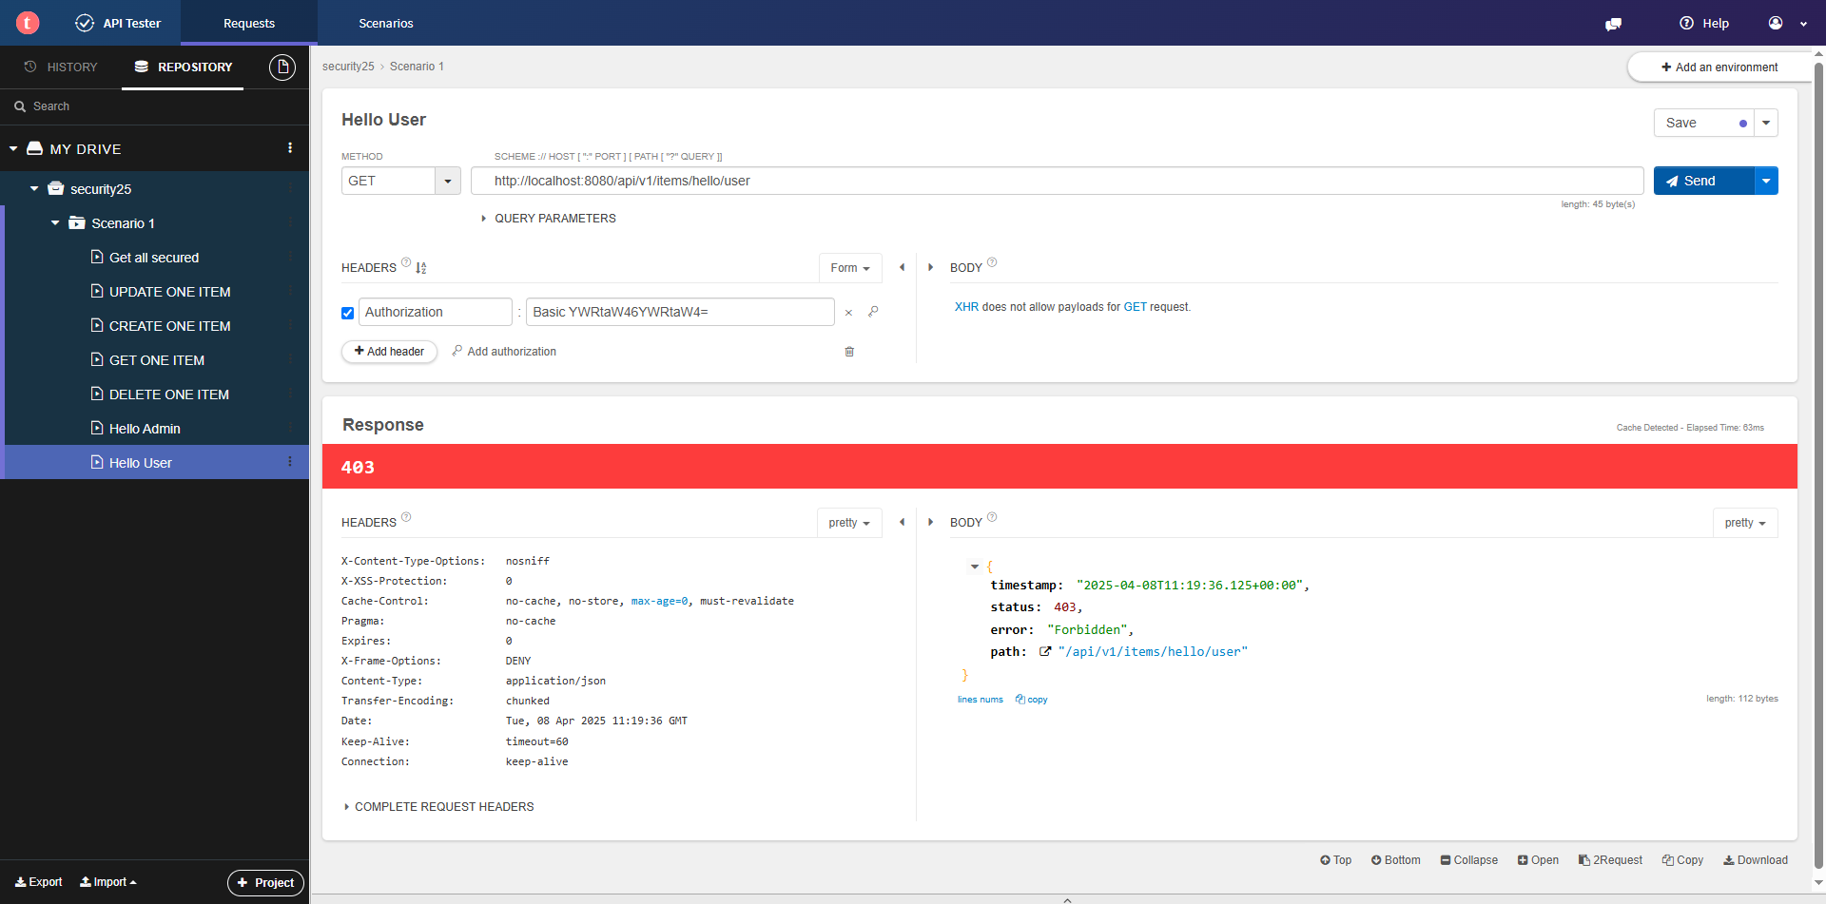

5 Hello User (Authorization User)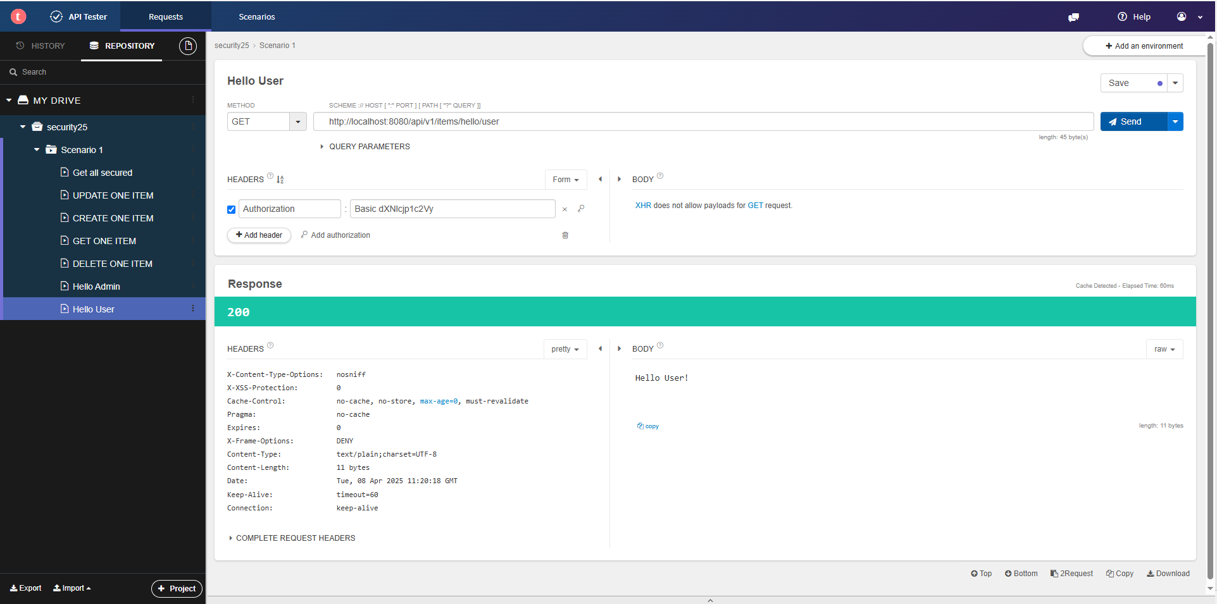

6 Hello User (Authorization SuperAdmin)

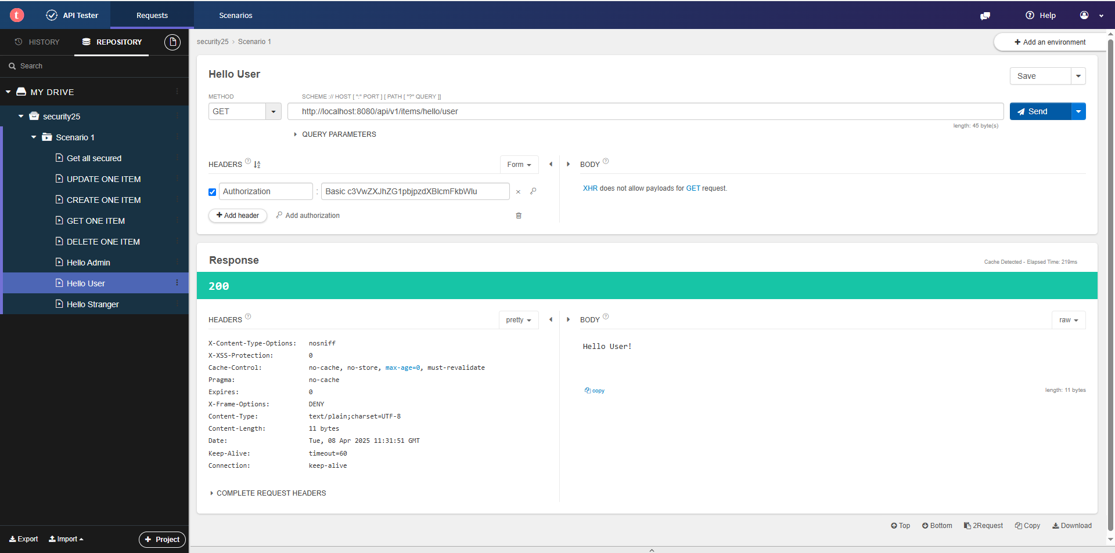

7 Hello Stranger (Authorization Admin)

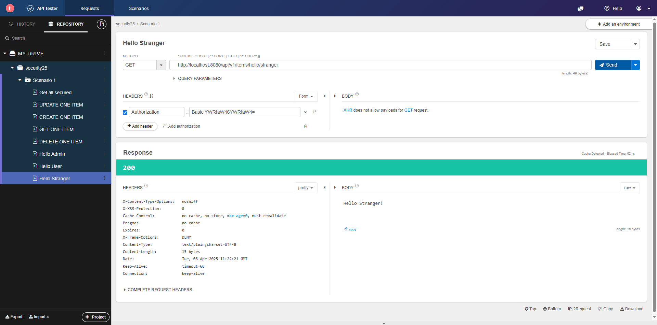

8 Hello Stranger (Authorization User)

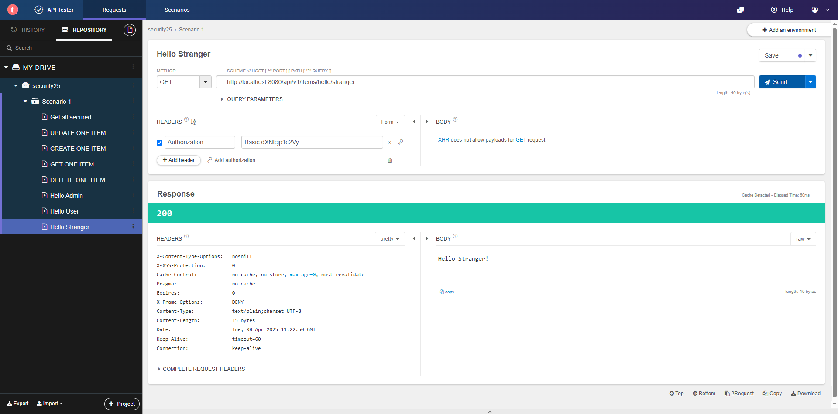

9 Hello Stranger (Authorization SuperAdmin)

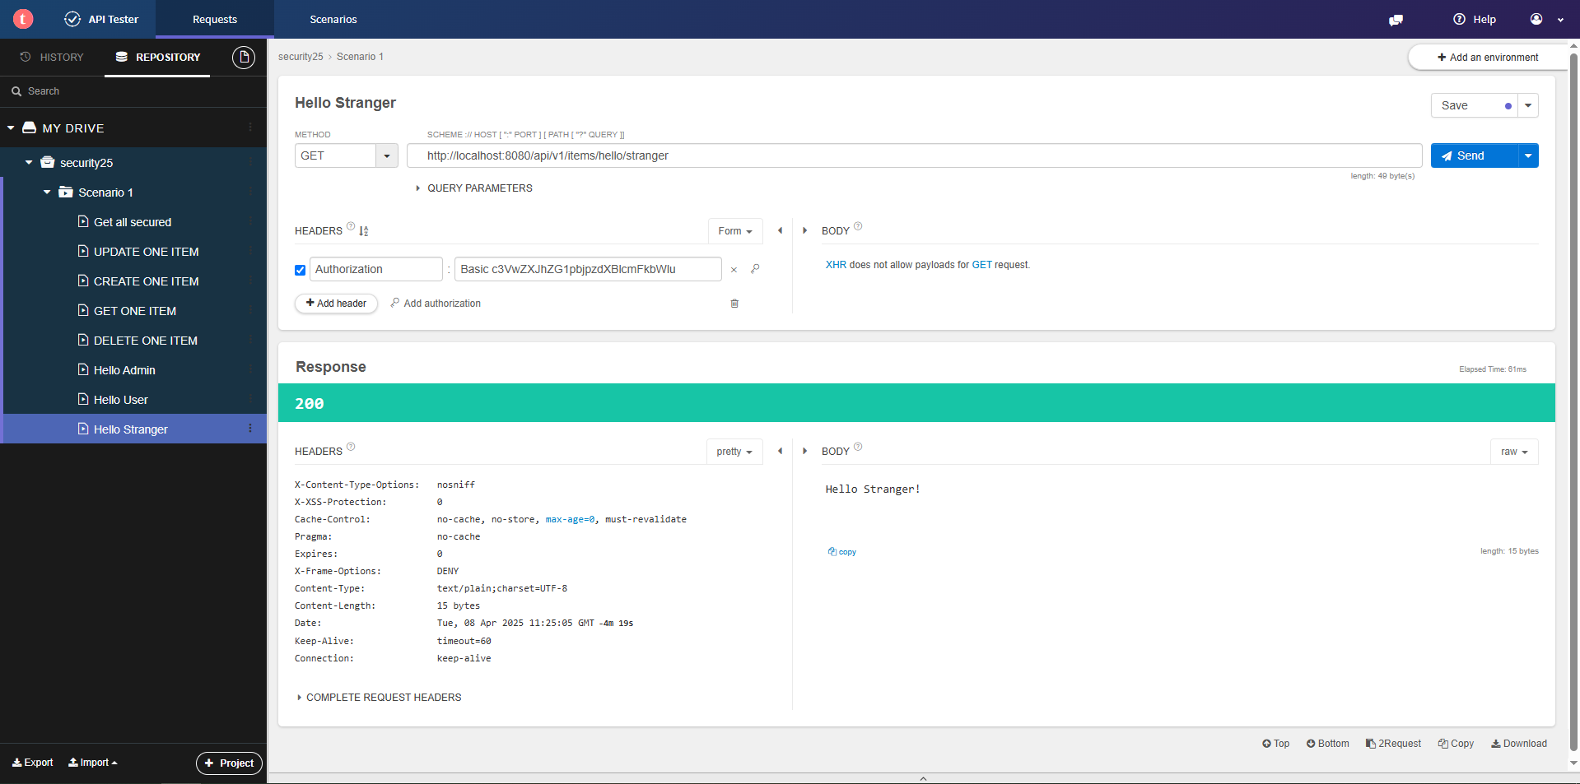

10 Hello Unknown (Authorization Admin)

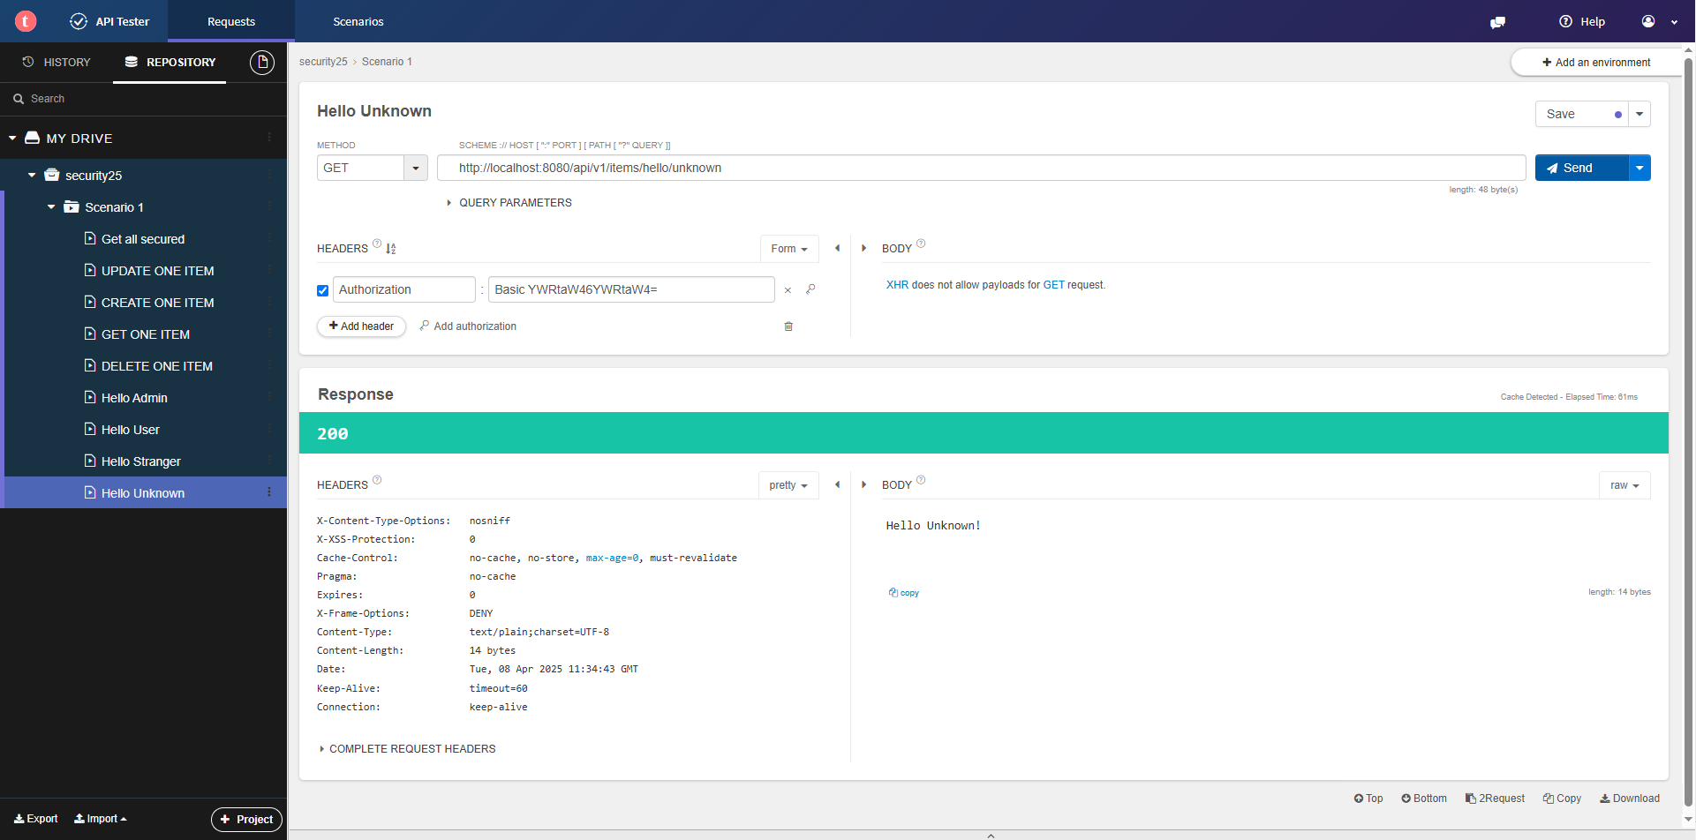

11 Hello Unknown (Authorization User)

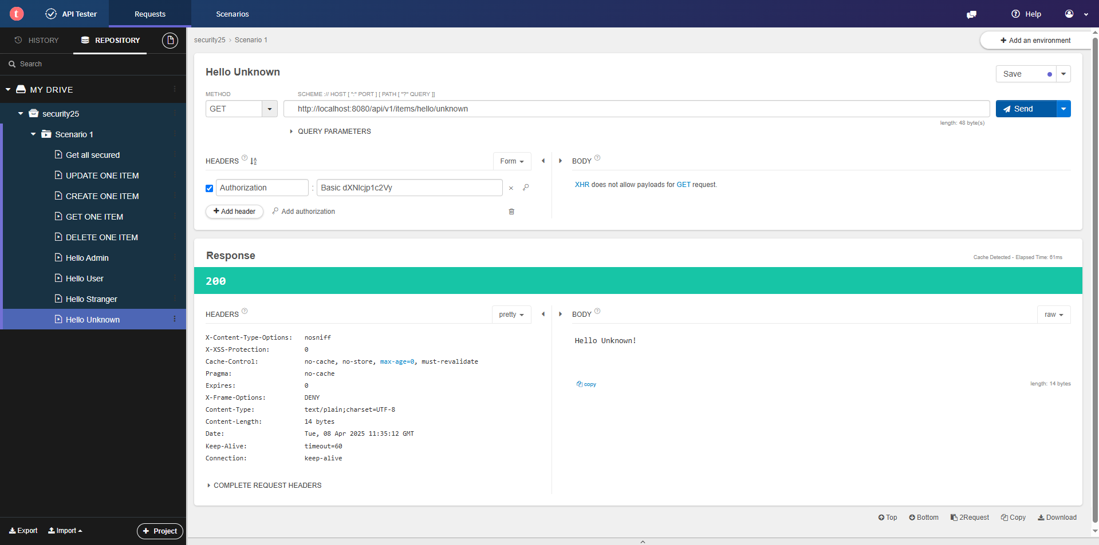

12 Hello Unknown (Authorization SuperAdmin)

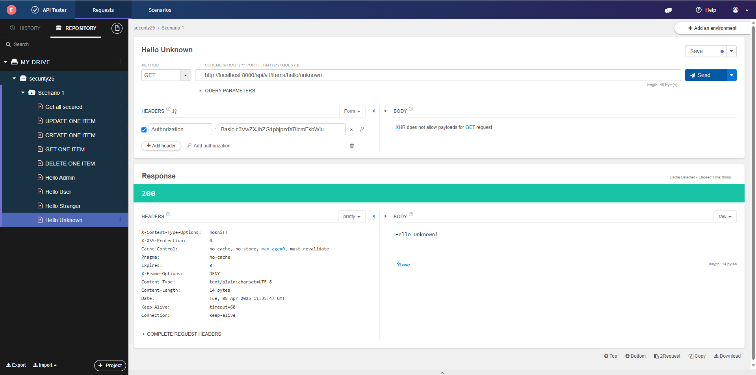

13 Hello SuperAdmin (Authorization Admin)

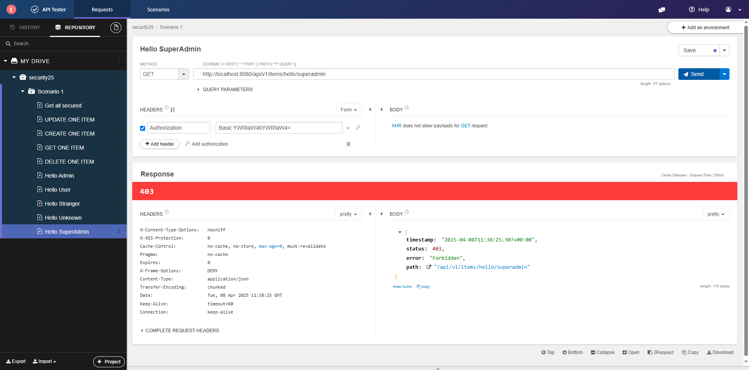

14 Hello SuperAdmin (Authorization User)

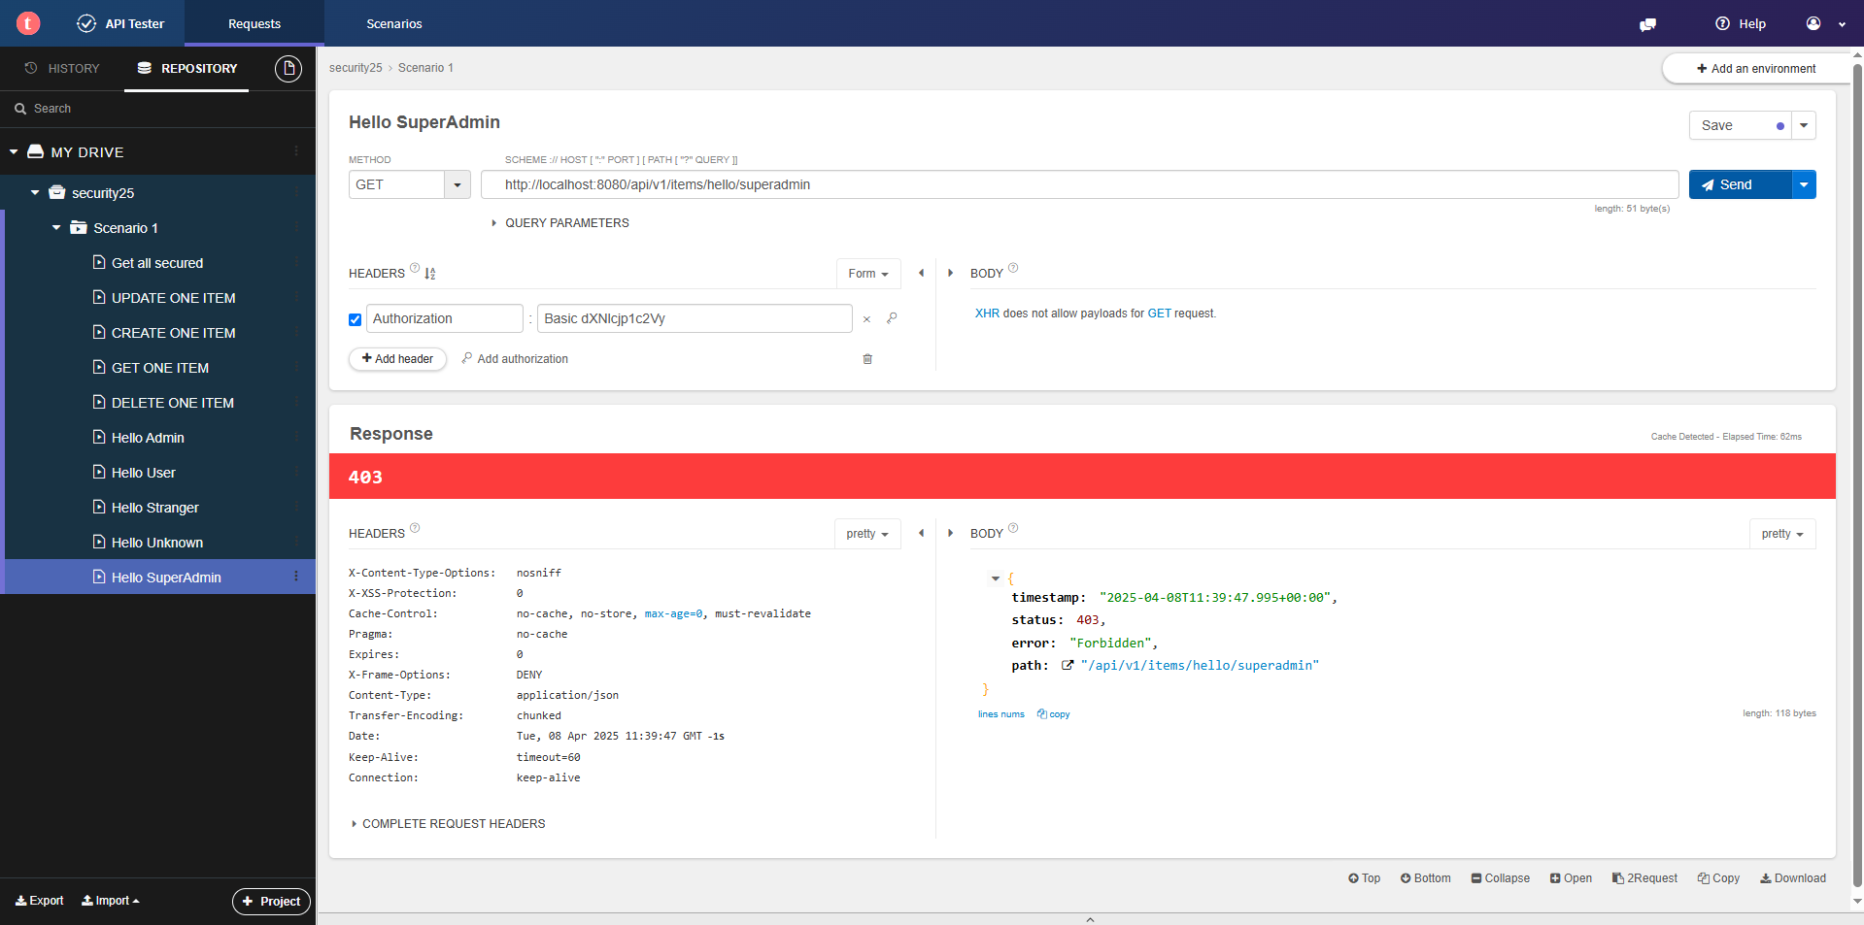

15 Hello SuperAdmin (Authorization SuperAdmin)

