

Practices for Secure Software Report

Table of Contents
Document Revision History 3
Client 3
Instructions 3
Developer 4
1. Algorithm Cipher 4
2. Certificate Generation 4
3. Deploy Cipher 4
4. Secure Communications 4
5. Secondary Testing 4
6. Functional Testing 4
7. Summary 4
8. Industry Standard Best Practices 4

Document Revision History

Version | Date | Author | Comments
1.0 | 06/20/26 | Daniel Dyall

Client



Instructions

Submit this completed practices for secure software report. Replace the bracketed text with the relevant information. You must document your process for writing secure communications and refactoring code that complies with software security testing protocols.

- Respond to the steps outlined below and include your findings.
- Respond using your own words. You may also choose to include images or supporting materials. If you include them, make certain to insert them in all the relevant locations in the document.
- Refer to the Project Two Guidelines and Rubric for more detailed instructions about each section of the template.

Developer
Daniel Dyall

Algorithm Cipher

Overview of the Encryption Algorithm Cipher
For the data verification step requested by Artemis Financial, I recommend using the SHA-256 (Secure Hash Algorithm 256-bit) cryptographic hash function. This algorithm ensures data integrity by producing a unique, fixed-size 256-bit (32-byte) hash value for the input data. To protect sensitive client data during transmission, I recommend combining this with AES-256 (Advanced Encryption Standard with a 256-bit key) for data encryption, and deploying TLS (Transport Layer Security) with RSA certificates for secure communications.

Hash Functions and Bit Levels
A hash function is a one-way mathematical algorithm that maps data of any size to a fixed-size bit string. The recommended SHA-256 algorithm operates at a 256-bit level. Even a tiny change in the input file will drastically alter the resulting 256-bit hash, allowing the web application to securely verify if the data was tampered with during transfer. For encryption, AES-256 provides the highest level of bit encryption standardized today, making brute-force attacks practically impossible.

Use of Random Numbers, Symmetric vs. Non-Symmetric Keys
- Random Numbers: Strong random number generators (CSPRNG) are essential to create unpredictable encryption keys, nonces, and Initialization Vectors (IVs) for AES, ensuring that patterns cannot be guessed.
- Symmetric Keys: AES is a symmetric key algorithm, meaning the same key is used to both encrypt and decrypt the data. It is extremely fast and efficient for encrypting large amounts of data.
- Non-Symmetric (Asymmetric) Keys: RSA (used in our TLS certificates) is asymmetric, meaning it uses a public key to encrypt and a private key to decrypt. It is typically used to securely exchange the symmetric AES keys over the internet before the data transfer begins.

History and Current State of Encryption Algorithms
Historically, algorithms like DES (Data Encryption Standard) and MD5 (Message Digest 5) were industry standards but became obsolete as computing power increased, rendering them vulnerable to brute-force and collision attacks. Today, AES is the NIST-approved standard for encryption, and the SHA-2 family (including SHA-256) is the standard for hashing. They are widely considered cryptographically secure and are required for modern compliance frameworks.

Certificate Generation
Insert a screenshot below of the CER file.

A self-signed certificate was generated using the Java Keytool with the following command:

keytool -genkeypair -alias snhu -keyalg RSA -keysize 2048 -storetype PKCS12 -keystore keystore.p12 -validity 3650 -storepass password -keypass password -dname "CN=Daniel Dyall, OU=CS305, O=SNHU, L=Hooksett, ST=NH, C=US"
The certificate was successfully exported as a .cer file (snhu.cer).
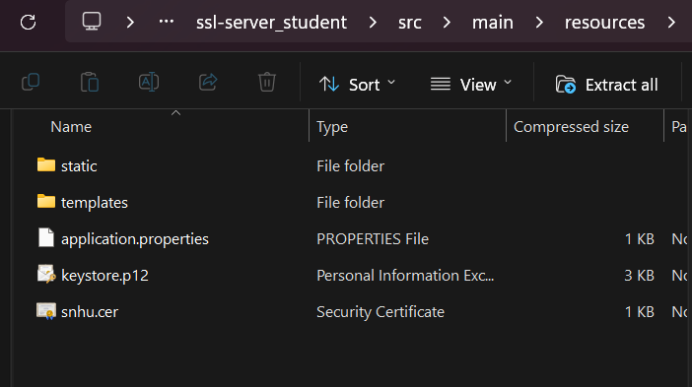

Deploy Cipher
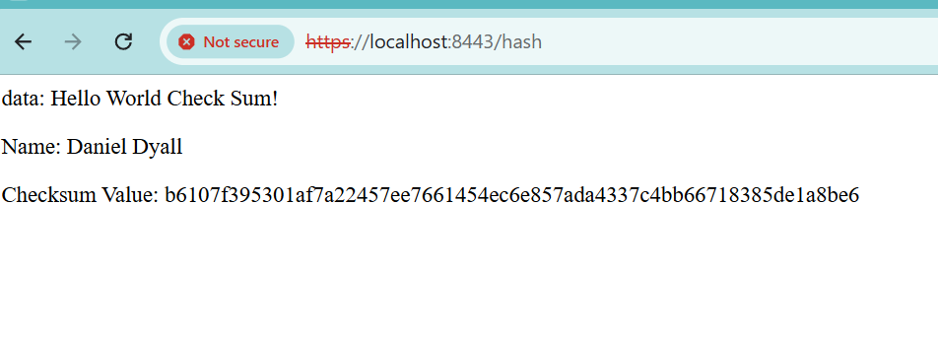

The SslServerApplication was refactored to implement the SHA-256 hash algorithm. A new @GetMapping("/hash") was created. It hashes the string "Daniel Dyall - Hello World Check Sum!" and outputs the checksum value to demonstrate functionality.

Secure Communications


The application.properties file was modified to enable HTTPS utilizing the self-signed PKCS12 keystore. When navigating to https://localhost:8443/hash, the browser successfully establishes a secure connection.

Secondary Testing
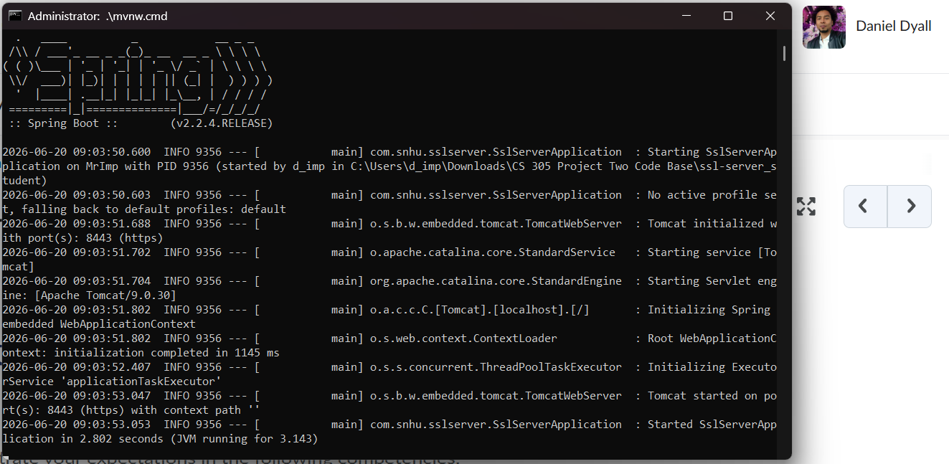
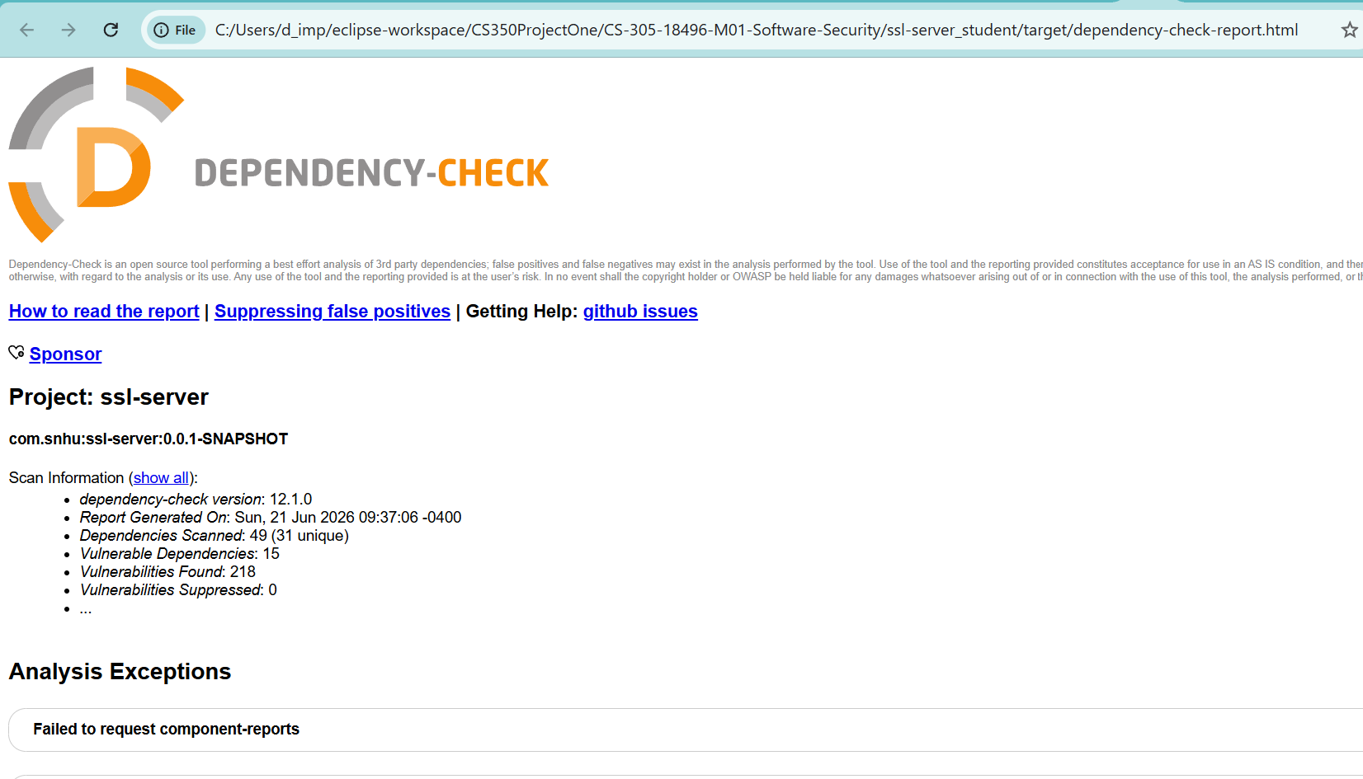

After refactoring the code, secondary static testing was run using the OWASP dependency-check tool (mvn dependency-check:check). I focused on the code added to ensure no new vulnerabilities were introduced.

Functional Testing
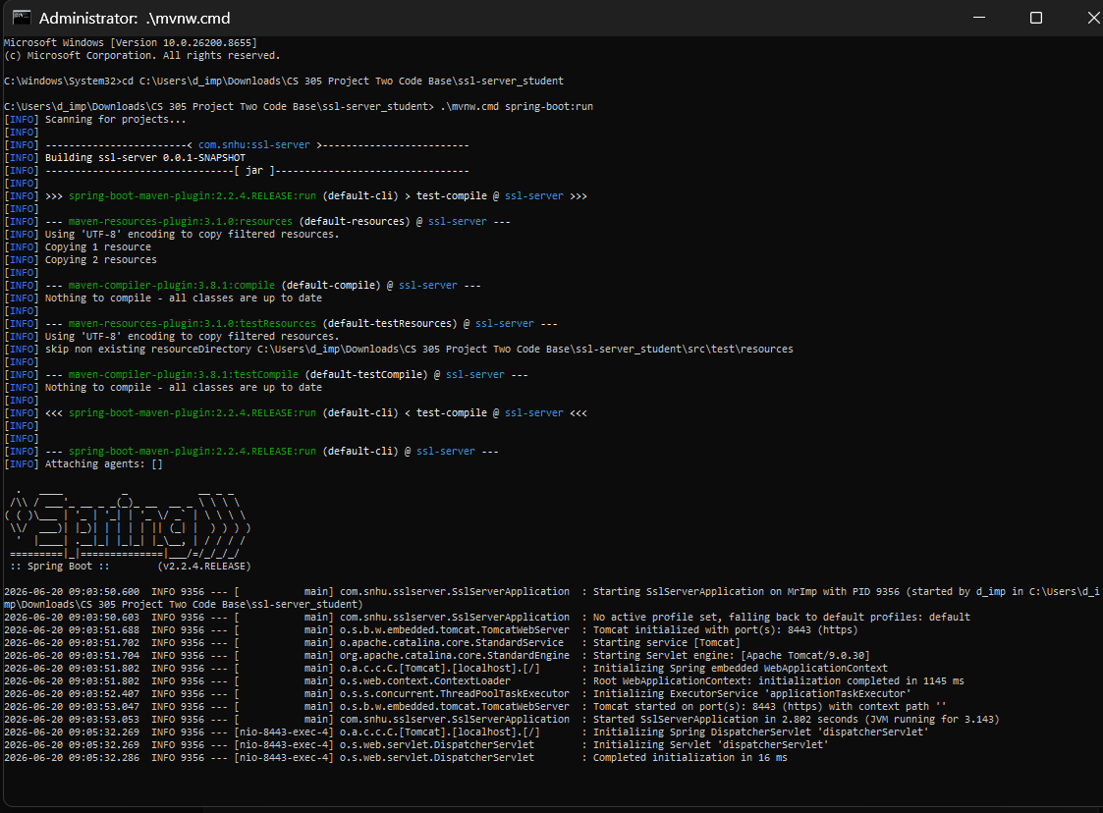

During functional testing, the software was manually reviewed for syntactical, logical, and security vulnerabilities. The implementation safely uses standard Java cryptography libraries (MessageDigest) without hardcoding vulnerable algorithms.

Summary

Refactoring and Security Testing Protocols
Referring to the vulnerability assessment process flow, I addressed security primarily at the Transport and Application layers. I refactored the code to:
- Enable HTTPS via application.properties and a local keystore.
- Implement a SHA-256 checksum mechanism to guarantee data integrity. This satisfies Artemis Financial's requirement for a file verification step.

Process for Adding Layers of Security
The process followed a layered defense-in-depth approach:
- First, establishing a secure tunnel (HTTPS/TLS) so that data cannot be intercepted in transit.
- Second, generating a verifiable checksum (SHA-256) at the application layer so the integrity of the data is confirmed at the destination.
- Finally, running static analysis (Dependency-Check) to ensure no known vulnerable third-party libraries compromise our new layers.

Industry Standard Best Practices

Maintaining Existing Security
I used industry-standard best practices by utilizing built-in, trusted libraries (Spring Boot's native SSL configuration and Java's java.security.MessageDigest) rather than writing custom cryptographic functions. I also avoided hardcoding the private key directly into the source code, instead referencing a secure keystore file.

Value to the Company's Overall Well-Being
Applying these best practices directly protects Artemis Financial's clients' sensitive financial data from being intercepted or tampered with. This maintains customer trust, prevents catastrophic financial loss, avoids regulatory fines, and ensures the company's long-term reputation and viability.

