**Multimedia:** Multimedia refers to the use of different types of content such as text, audio, images, animations, video, and interactive content together. For example, a webpage that has text, images, and a video is a multimedia webpage.

**Browser Support:** Different web browsers (like Chrome, Firefox, Safari, etc.) have different capabilities and support for various multimedia formats. For example, some browsers might not support a specific video format, but others might.

**Multimedia Formats:** These are the different types of file formats used to store multimedia content. For example, JPEG for images, MP3 for audio, MP4 for video, etc.

**Common Video Formats:** Some of the common video formats include MPEG, AVI, WMV, and QuickTime. These formats differ in terms of compression, quality, and compatibility.

1. MPEG: It stands for Moving Picture Experts Group. It’s like a set of standards for audio and video compression. For example, when you download a movie online, it’s often in MPEG format.
2. AVI: Audio Video Interleave (AVI) is a multimedia container format introduced by Microsoft. It’s like a file box that contains both audio and video data. For example, some old home videos might be in AVI format.
3. WMV: Windows Media Video (WMV) is a series of video codecs and their corresponding video coding formats developed by Microsoft. It’s like a specific way of encoding video, specifically for Windows systems.
4. QuickTime: This is a multimedia framework developed by Apple that is capable of handling various formats of digital video, picture, sound, panoramic images, and interactivity.

**HTML Video:** HTML5 introduced the <video> element for embedding videos. Here’s an example:

**HTML Audio:** Similarly, HTML5 introduced the <audio> element for embedding audio files. Here’s an example:

**HTML Plug-ins:** Plug-ins are software components that add specific capabilities to a larger software application. Browsers have plug-ins to display or play certain file types. For example, Adobe Flash Player was a popular plug-in used to play multimedia content.

**HTML YouTube Videos:** You can embed YouTube videos in your webpage using the <iframe> tag. Here’s an example:

In below code it is just shown how we can use multimedia in our html file.

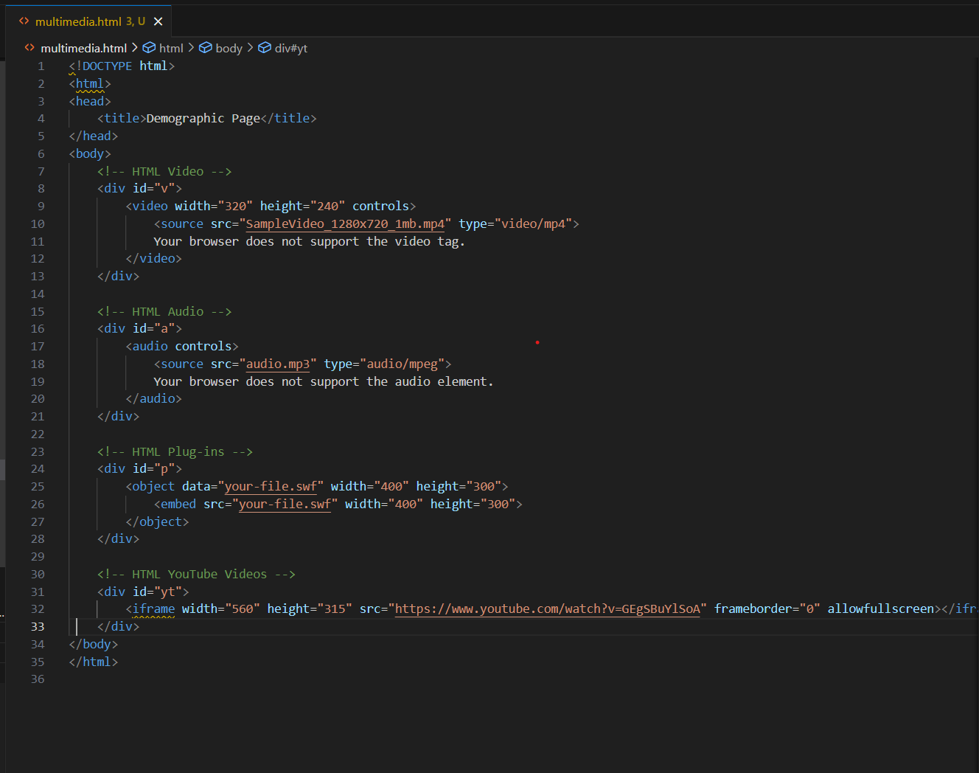

HTML Geolocation API

The Geolocation API allows the user to provide their location to web applications if they so desire. For privacy reasons, the user is asked for permission to report location information.

Locate the User’s Position: You can get the user’s position by using the getCurrentPosition() method:

**Browser Support:** Most modern browsers support the Geolocation API.

Using HTML Geolocation: You can use the Geolocation API in conjunction with the Google Maps API to show the user’s location on a map:

**Location-specific Information:** Once you have the user’s location, you can provide information tailored to their location, such as showing nearby restaurants or weather information.

**HTML Drag and Drop API**

HTML Drag and Drop interfaces enable applications to use drag and drop features in browsers.

Drag and Drop: You can make an element draggable by setting the draggable attribute to true:

**Make an Element Draggable:** The ondragstart attribute calls a function, drag(event), which specifies what data to be dragged:

Where to Drop - ondragover: The ondragover event specifies where the dragged data can be dropped. By default, data/elements cannot be dropped in other elements. To allow a drop, we must prevent the default handling of the element:

Do the Drop - ondrop: When the dragged data is dropped, a drop event occurs. In the example below, the ondrop attribute calls a function, drop(event):

HTML Web Storage API

The Web Storage API provides mechanisms by which browsers can store key/value pairs, in a much more intuitive fashion than using cookies.

What is HTML Web Storage: Web storage can be viewed simplistically as an improvement on cookies, providing much greater storage capacity (5MB per domain in Mozilla Firefox, Google Chrome, and Opera; 10MB per storage area in Internet Explorer) and better programmatic interfaces.

HTML Web Storage Objects: The two storage objects are localStorage and sessionStorage.

The localStorage Object: The localStorage object stores the data with no expiration date. The data will not be deleted when the browser is closed, and will be available the next day, week, or year:

The sessionStorage Object: The sessionStorage object is equal to the localStorage object, except that it stores the data for only one session. The data is deleted when the user closes the specific browser tab:

HTML Web Workers API

A web worker is a JavaScript that runs in the background, independently of other scripts, without affecting the performance of the page. You can continue to do whatever you want: clicking, selecting things, etc., while the web worker runs in the background.