Self Learning
Mohd Mudassir Azmi –96272
MySQL Lab Exercises
1. Explain EXISTS vs IN performance comparison with an example.
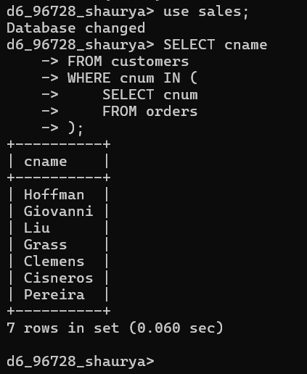

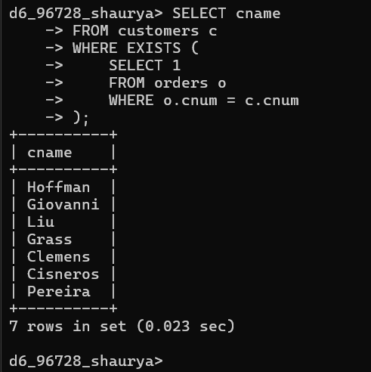

2. Implement a trigger to update the product price in cart, when price is updated in products table

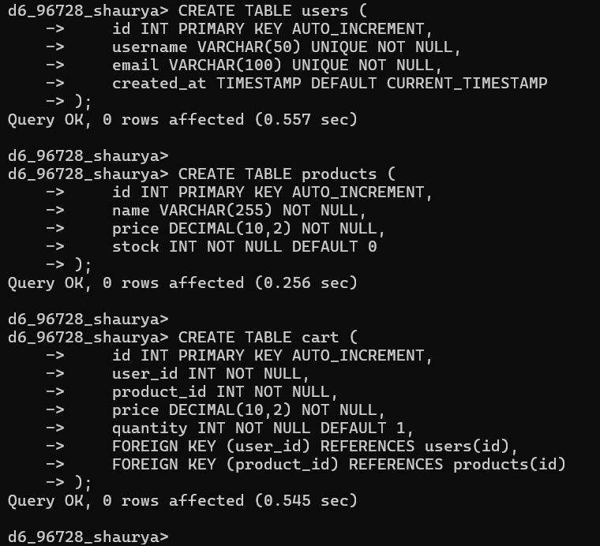

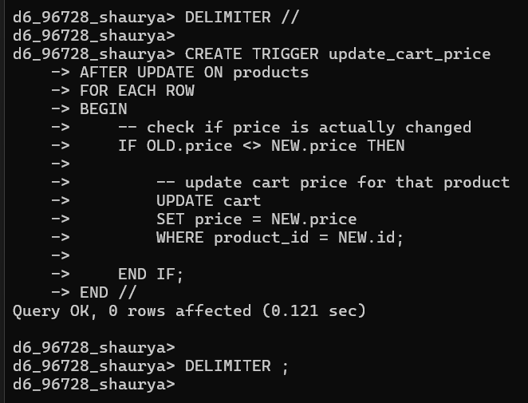

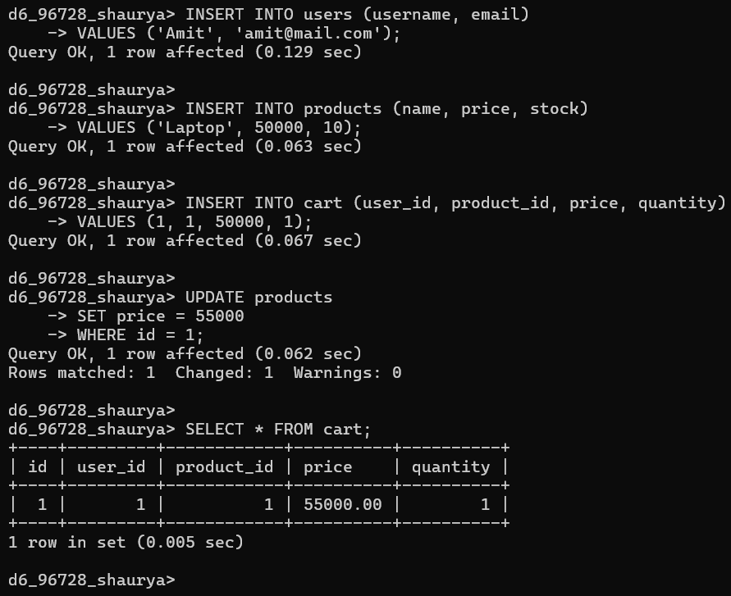

3. Understand ON DELETE CASCADE, ON UPDATE CASCADE. Write emp, dept CREATE TABLE statements and apply CASCADE for all foreign keys.

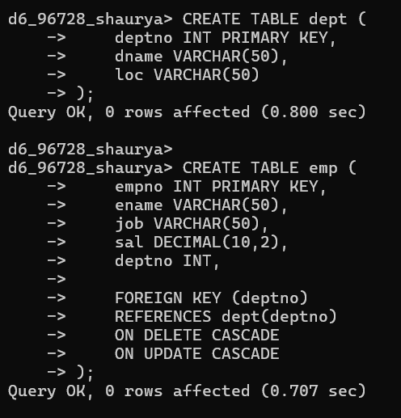
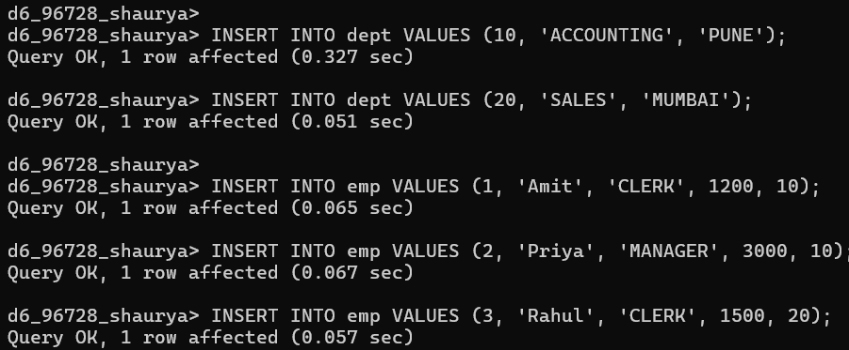
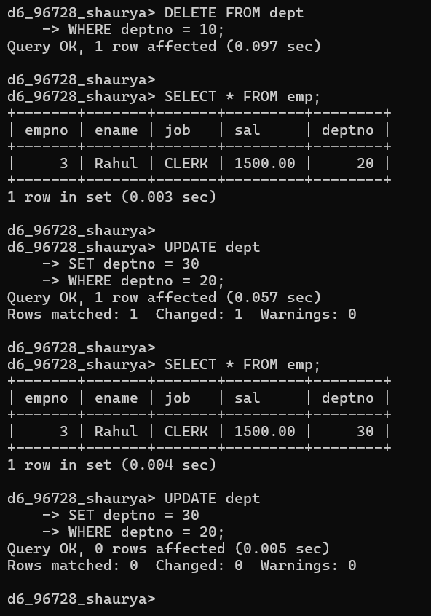

MongoDb Lab
Exercises 1. Practice CRUD operations on Mongo.
1. Create two collections -- emp and dept.
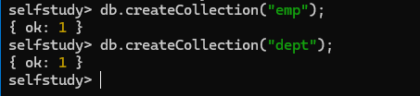
2. Insert the emp and dept records.
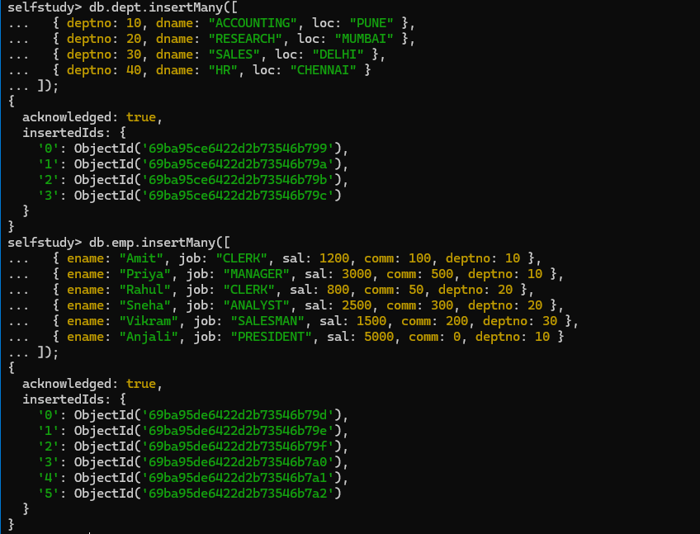

3. Increase salary of dept 10 emps by 100.
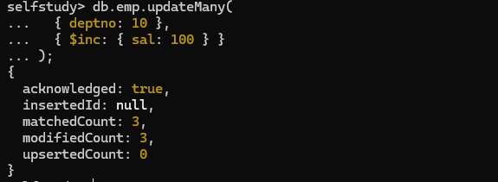
4. Display emp name, job, deptno, sal in sorted order of deptno, job, sal (desc) for all emps whose sal more than 1000.
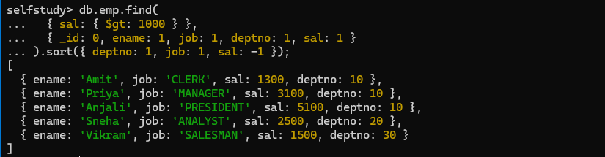
5. Delete the dept with id 40.

2. Learn grouping operations using Mongo aggregation pipeline
1. Display job wise total sal, max sal, min sal, and avg sal for all jobs other than PRESIDENT.
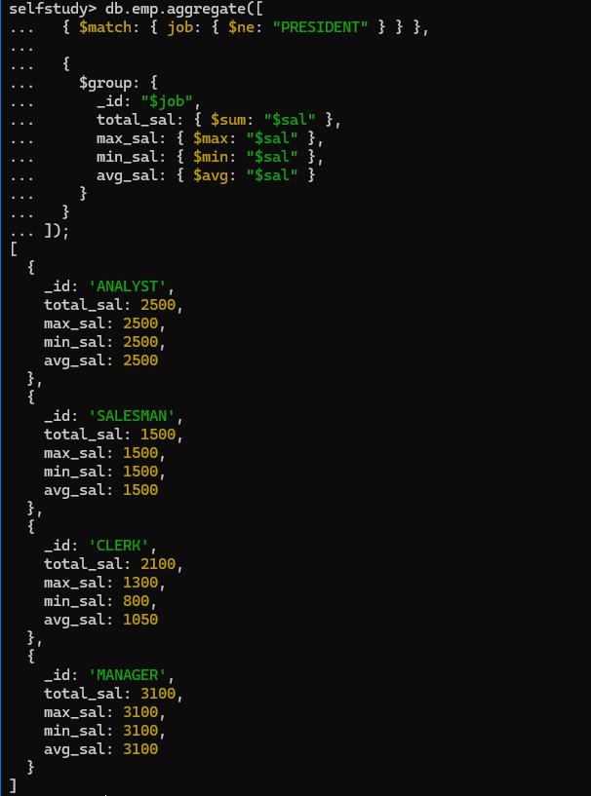

2. Display emp name, dept name, income (sal + comm) in sorted order of their income.
