NCI BPA - FDA Recall Impact Manual Assessment Report

Provided by NCI

CONFIDENTIAL   
June 25, 2015

**Table of Contents**

Version History 3

Executive Summary 4

Notes on Manual Testing 4

Assessment Scope 4

Technology Used 4

Assumption 4

Table Header Explanation 5

Issues and Recommendations 6

Site-wide Issues 6

1. FDA Recall Impact – Home page 7

Conclusion 13

# Version History

| **Number** | **Date** | **Author/Tester** | **Comments** |
| --- | --- | --- | --- |
| V1.0 | 6/24/2015 | Jules Trapp | Initial prototype review. |
| V2.0 | 6/25/2015 | Jules Trapp | Review of development application. |

Manual Report Format V1.7.8

# Executive Summary

This document summarizes the issues found from a manual assessment of FDA Impact Recall **[**<http://bpa-app-dev.elasticbeanstalk.com/>] performed by NCI. To make this assessment the pages were manually tested using a variety of browsers and screen readers. This document lists all of the issues encountered with recommendations based on Section 508 and WCAG 2.0 Level AA guidelines.

## Notes on Manual Testing

As websites regularly evolve, NCI. recommends that the following report be revisited with regularity to continuously monitor the findings for the scope provided and determine if new accessibility issues have arisen since this testing was last performed.

## Assessment Scope

The Scope was to test the pages from the Application Test URLs on [<http://bpa-app-dev.elasticbeanstalk.com/>], at the request of the client. This site was reviewed based on:

* Adherence to Section 508 and WCAG Level AA Guidelines

| **#** | **Feature** | **Details** | **Accessible** |
| --- | --- | --- | --- |
| 1 | FDA Recall Impact | Public facing functionality | No |

## Technology Used

VoiceOver, Chrome 43, Firefox 19.0.2 / 32.0.1, Firebug 1.10.6, WAVE, Mac OSX 10.9.1

## Assumption

1. Reviewed only landing pages.

# Table Header Explanation

| **Column** | **Terminology** | **Explanation** |
| --- | --- | --- |
| **1.** | **ID #** | Unique item identifier. |
| **2.** | **Sec 508** | **The letters in this column** refer to theSection 508 §1194.22 standards (<http://www.access-board.gov/sec508/guide/1194.22.htm>). For example (a) refers to 1194.22(a), the first provision of the Section 508 Web Accessibility Standards which deals text alternatives for non-text content (alt-text). When a 21 prefaces the letter, that refers to the Section 508 Software Standards, §1194.21 (<http://www.access-board.gov/sec508/guide/1194.21.htm>). |
| **3.** | **WCAG level** | The WCAG SC (Success Criteria) level, column indicates the applicable accessibility standard WCAG 2.0 Guidelines Success Criteria. An issue can relate to more than one SC, if applicable.   * **The three part numbers (e.g. 1.1.1)** refers to the WCAG 2.0 checkpoints (<http://www.w3.org/TR/WCAG20/>). * **The letters in this column** refer to theWCAG 2.0 Level of the issue.   + **Level A**   + **Level AA** |
| **4.** | **Issue** | Description of where the page is not consistent with the specified accessibility standards. Includes details that identify the specific problem(s). |
| **5.** | **Remediation Recommendation** | Presents information for fixing the accessibility error. |
| **6.** | **Impact (optional)** | * **Critical** - This type of accessibility error is a brick wall. Until this is fixed, there are significant barriers for a person with a disability to use this page. It is a red-hot emergency to fix this error. It should have been fixed yesterday! * **Serious** - This is a very important accessibility error. It would be very frustrating to encounter this error and it might prevent some people with disabilities from using the page. It should be fixed as soon as possible (today or this week). * **Moderate** - This is an accessibility error. It would be frustrating to encounter, but it would not prevent a person with a disability from using the key elements of the page. This needs to be fixed for the page to be fully WCAG 2.0 AA compliant. * **Minor** – This is an accessibility error that yields less impact for the user than a moderate error. Though it still needs to be fixed for the page to be fully WCAG 2.0 AA compliant, this type of accessibility error could be dealt with last. |

# Issues and Recommendations

## Site-wide Issues

Header Template Issues

See item # 1.1 for skip navigation.

Footer Template Issues

NA

Other Relevant Template Issues

NA

## 1. FDA Recall Impact – Home page

<http://bpa-app-dev.elasticbeanstalk.com/>

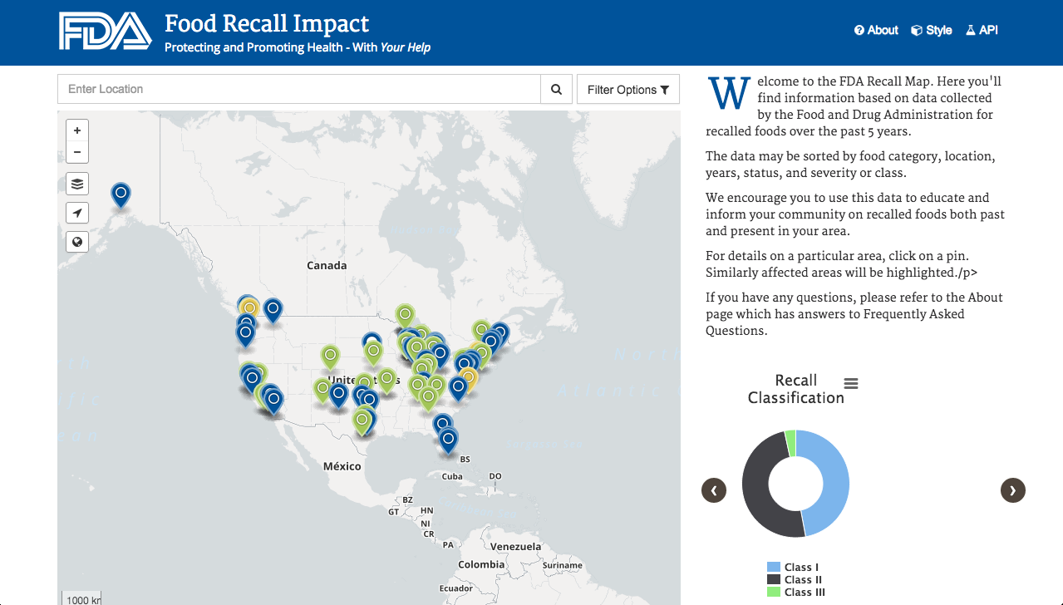

| **ID#** | **Section 508** | **SC level** | **Issue** | **Remediation Recommendation** | **Impact** |
| --- | --- | --- | --- | --- | --- |
| 1.1 | [1194.22](http://www.access-board.gov/guidelines-and-standards/communications-and-it/about-the-section-508-standards/guide-to-the-section-508-standards/web-based-intranet-and-internet-information-and-applications-1194-22)  para(o) | [2.4.1](http://www.w3.org/TR/UNDERSTANDING-WCAG20/navigation-mechanisms-skip.html)A | **Skip Navigation/Bypass Content Blocks:** The page needs to incorporate jump header links or ARIA roles to bypass standard header navigation links and jump to the main content area and footer. | Implement standard skip navigation mechanisms.  **Option 1:** Add a skip navigation link in the header area.  <h1><img src=”/image/nciinc_logo_large.png”>  NCI ATS BPA –FDA Recall Impact</h1>  <a href=”#main” class=”offscreen”>Skip Navigation</a>  ….  <main class=”container” **id=”main”**>  **Option 2:** Add ARIA roles on the main content block and footer. (Supports identification in non-HTML5 browsers.)  Code example:  <main class=”container” **role=”main”**>  And…  <footer **role=”contentinfo”**>  **Note:** This update is neded on each page of the application. | Critical |
| 1.2 | [1194.22](http://www.access-board.gov/guidelines-and-standards/communications-and-it/about-the-section-508-standards/guide-to-the-section-508-standards/web-based-intranet-and-internet-information-and-applications-1194-22)  para(n) | [3.3.2](http://www.w3.org/TR/UNDERSTANDING-WCAG20/minimize-error-cues.html)A | Labels / Instructions: The select boxes for All Food, All States, and All Years need explicit labels.  Untitled 1:Users:julestrapp:Desktop:Screen Shot 2015-06-25 at 9.34.37 AM.png | Incorporate HTML labels or aria-label attributes that can be read by assistive technology.  Code examples:  **Option 1:** Match Label FOR tags to each select ID. (The <label> may be offscreen if required.)  <label for=”**select_food**”>Food</label>  <select id=”select_food”>  **Option 2:** ARIA label  <select id=”select_food” **aria-label=”Food”**> | Critical |
| 1.3 | [1194.22](http://www.access-board.gov/guidelines-and-standards/communications-and-it/about-the-section-508-standards/guide-to-the-section-508-standards/web-based-intranet-and-internet-information-and-applications-1194-22)  para(n) | [3.3.2](http://www.w3.org/TR/UNDERSTANDING-WCAG20/minimize-error-cues.html)A | **Labels / Instructions:** The **Enter Location** search field needs an explcit label. (An explicit label is needed to supplement the placeholder text.)  Untitled 1:Users:julestrapp:Desktop:Screen Shot 2015-06-25 at 9.33.36 AM.png | Incorporate HTML labels or aria-label attributes that can be read by assistive technology.  Code examples:  **Option 1:** Match Label FOR tags to each select ID. (The <label> may be offscreen if required.)  <label for=”**input-geo-location**”>Location</label>  <input id="input-geo-location" class="form-control" type="search" placeholder="Enter Location" style="display: block">  **Option 2:** ARIA label  <input id="input-geo-location" **aria-label=”Location”** class="form-control" type="search" placeholder="Enter Location" style="display: block"> | Crtical |
| 1.4 | [1194.22](http://www.access-board.gov/guidelines-and-standards/communications-and-it/about-the-section-508-standards/guide-to-the-section-508-standards/web-based-intranet-and-internet-information-and-applications-1194-22)  para(n) | [3.3.2](http://www.w3.org/TR/UNDERSTANDING-WCAG20/minimize-error-cues.html)A | Labels / Instructions: The submit search button (magnifying glass) needs an explcit label.  Untitled 1:Users:julestrapp:Desktop:Screen Shot 2015-06-25 at 9.36.40 AM.png | Replace the title attribute on the button with an aria-label attribute that can be read reliably by assistive technology and mobile devices.  Code example:  <button class="btn-search btn btn-default" type="submit" id="input-geo-search" **aria-label="**Submit Search"><span><i class="fa fa-search"></i></span></button> | Critical |
| 1.5 | [1194.21](http://www.access-board.gov/guidelines-and-standards/communications-and-it/about-the-section-508-standards/guide-to-the-section-508-standards/software-applications-and-operating-systems-1194-21)  para(a) | [2.1.1](http://www.w3.org/TR/UNDERSTANDING-WCAG20/keyboard-operation-keyboard-operable.html)A | **Keyboard Navigation/Access to Responsive Content:** The menu/hamburger icons are not directly keyboard accessible.  Untitled 1:Users:julestrapp:Desktop:Screen Shot 2015-06-25 at 10.09.16 AM.png | Provide redundant links to download data via keyboard.  Code example:  <h3>Download Data (PDF) :</h3>  <a href=”status.pdf”>Recall Status</a>  <a href=”dates.pdf”>Recall Datess</a>  <a href=”status.pdf”>Recall Classification</a> | Critical |

# Conclusion

**The FDA Recall Impact website requires the above updates in order to meet NCI’s guidelines of Section 508 and WCAG 2.0 (Level AA) for Accessible Electronic and Information Technology Design.**