King Saud University

**Department of Computer Science**

**CSC227:Operating Systems**

## Tutorial No. 6

**Exercise 1**

Below is a table of four CPU-bound processes P1, P2, P3, and P4 and their associated arrival times and CPU burst times.

1. Draw Gantt charts illustrating the execution of these processes using SRTF scheduling.
2. What is the average turnaround time
3. What is the average waiting time

|  |  |  |
| --- | --- | --- |
| Process | Arrival | Burst Time |
| P1 | 0 | 8 |
| P2 | 1 | 4 |
| P3 | 2 | 9 |
| P4 | 3 | 5 |

Gantt chart:   
  
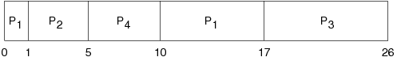

|  |  |  |  |  |  |  |
| --- | --- | --- | --- | --- | --- | --- |
| Process | Arrival | Burst Time | Start | Wait | Finish | TA |
| 1 | 0 | 8 | 0 | 9 | 17 | 17 |
| 2 | 1 | 4 | 1 | 0 | 5 | 4 |
| 3 | 2 | 9 | 17 | 15 | 26 | 24 |
| 4 | 3 | 5 | 5 | 2 | 10 | 7 |

Average waiting time: (9+0+15+2)/4 = 6.5

Average turnaround time: (17+4+24+7)/4 = 13

**Exercise 2**

Below is a table of four CPU-bound processes P1, P2, P3, and P4 and their associated arrival times and CPU burst times.

|  |  |  |
| --- | --- | --- |
| Process | Arrival | Burst Time |
| P1 | 0 | 7 |
| P2 | 2 | 4 |
| P3 | 4 | 1 |
| P4 | 5 | 4 |

1. Draw Gantt charts illustrating the execution of these processes using SRTF scheduling.
2. What is the average turnaround time
3. What is the average waiting time

* Gantt chart:   
    
  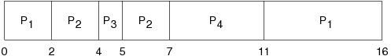

|  |  |  |  |  |  |  |
| --- | --- | --- | --- | --- | --- | --- |
| Process | Arrival | Burst Time | Start | Wait | Finish | TA |
| 1 | 0 | 7 | 0 | 9 | 16 | 16 |
| 2 | 2 | 4 | 2 | 1 | 7 | 5 |
| 3 | 4 | 1 | 4 | 0 | 5 | 1 |
| 4 | 5 | 4 | 7 | 2 | 11 | 6 |

* Average waiting time: (9+1+0+2)/4 = 3
* Average turnaround time: (16+5+1+6)/4 = 7

**Exercise 3**

Below is a table of five CPU-bound processes P1, P2, P3, P4, and P5 and their associated arrival times and CPU burst times.

|  |  |  |
| --- | --- | --- |
| Process | Arrival | Burst Time |
| P1 | 0 | 10 |
| P2 | 0 | 29 |
| P3 | 0 | 3 |
| P4 | 0 | 7 |
| P5 | 0 | 12 |

1. Draw Gantt charts illustrating the execution of these processes using RR (quantum=10) scheduling.
2. What is the average turnaround time
3. What is the average waiting time

* Gantt chart:   
    
  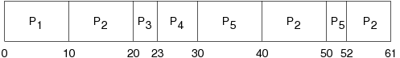

|  |  |  |  |  |  |  |
| --- | --- | --- | --- | --- | --- | --- |
| Process | Arrival | Burst Time | Start | Wait | Finish | TA |
| 1 | 0 | 10 | 0 | 0 | 10 | 10 |
| 2 | 0 | 29 | 10 | 32 | 61 | 61 |
| 3 | 0 | 3 | 20 | 20 | 23 | 23 |
| 4 | 0 | 7 | 23 | 23 | 30 | 30 |
| 5 | 0 | 12 | 30 | 40 | 52 | 52 |

* Average waiting time: (0+32+20+23+40)/5 = 23
* Average turnaround time: (10+39+42+49+61)/5 = 35.2