Game Design Document
Fill up the following document

- Write the title of your project.
Stock Frenzy

- What is the goal of the game?
To get the most money before you reach the finish line

- Write a brief story of your game.
You have to start the game and you press to go down, and then press again to go up. You have to collect the multipliers and avoid the dividers to get the highest score

- Which are the playing characters of this game?
- Playing characters are the ones who respond to the user based on the input from the user.
- Cars, monkeys, dinos, wizards, etc., are the playing characters in the game.

Number | Character Name | What can this character do?
1 | player | Move forward, up and down
2
3
4
5
6
7
8

- Which are the Non-Playing Characters of this game?
- Non-Playing characters are the ones that don't have an action or behavior when the user interacts with the game.
- Hurdles, stones, bananas, coins, etc., are non-playing characters in the game.

Number | Character Name | What can this character do?
1 | multipliers | Multiply player score
2 | Dividers | Divide player score
3
4
5
6
7
8

Draw your imagination of this game. What does this game look like?
- Draw the game either on your computer or on paper.
- Add images of the game scenes to show each of the playing and non-playing characters at least once.
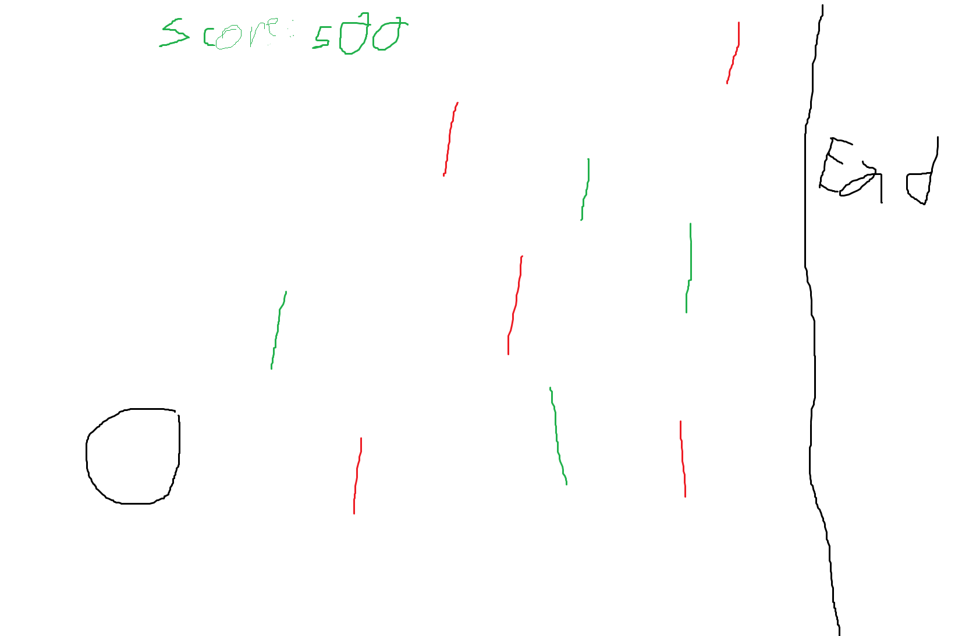

How do you plan to make your game engaging?
By making people want to get the highest score

