CCA 3 Computer Vision Practical Assignment

Units 3 4 and 5
Student: Shaurya Singh
PRN: 1272251359
GitHub: https://github.com/DA-Shaurya/CV_assig
Explanation-video link: Pending recording and upload.
This technical document contains the full algorithm code, executed image outputs, measured tables, comparisons and conclusions.
Current limitations: The original 15-30 second video and a suitable touching-object photograph are pending. The two supplied portraits have different scenes/viewpoints, limiting the feature-matching comparison. Video results are not claimed.

1 Problem definition and approach
Implement image restoration, segmentation, feature extraction, object recognition and motion estimation on original student media. Compare methods using measured outputs rather than assumptions.
Task | Methods | Evidence
Restoration | Gaussian/impulse noise, median/Gaussian filtering | Images, PSNR, SSIM
Segmentation | Otsu, erosion/dilation/opening/closing, Canny, watershed | Masks, edges, region boundaries
Features | HOG, SIFT, ratio-test matching, RANSAC | Descriptors, keypoints, matches/inliers
Recognition | Haar frontal-face cascade, YOLOv8n | Boxes, classes, confidences, manual failure review
Motion | Frame differencing, GMM/MOG2, Lucas-Kanade | Masks, vectors, video, measurements

2 Environment and configuration
The installation command is commented out because the local environment is already prepared. YOLO downloads its pretrained weights on first use. Processing is local; no photo is sent to an AI service.

Python code
# Uncomment only if dependencies are missing:
# %pip install -r requirements.txt

Python code
"""CCA 3 computer vision tasks. Originals are read only; outputs are derived copies."""
from pathlib import Path
import argparse
import csv
import hashlib
import json
import time

import cv2
import numpy as np
import matplotlib
matplotlib.use('Agg')
import matplotlib.pyplot as plt
from PIL import Image, ImageOps
from skimage.feature import hog, peak_local_max
from skimage.metrics import peak_signal_noise_ratio, structural_similarity

from IPython.display import display, Markdown, Image as DisplayImage
from datetime import datetime
import html

ROOT = Path.cwd()
PHOTO = ROOT / 'data/originals/photo1.png'
SECOND_PHOTO = ROOT / 'data/originals/photo2.jpg'
VIDEO = ROOT / 'data/originals/motion.mp4' # Replace with your original 15-30 second video.
SEGMENTATION_PHOTO = ROOT / 'data/originals/coins.jpg' # Add a suitable original touching-object photo.
OUT = ROOT / 'outputs' / ('notebook_' + datetime.now().strftime('%Y%m%d_%H%M%S'))
OUT.mkdir(parents=True, exist_ok=True)
cv2.setRNGSeed(42)
print('Results folder:', OUT)
print('OpenCV version:', cv2.__version__)
assert PHOTO.exists() and SECOND_PHOTO.exists(), 'Extract the ZIP and run from its project folder.'

OpenCV version: 4.14.0

3 Common helper functions
These functions read HEIC/JPEG inputs, preserve originals, save derived files, write CSV tables and create captioned comparison panels. Processing copies are limited to 1000 pixels on their longest side.

Python code
def load_image(path, max_side=1000):
if Path(path).suffix.lower() in ('.heic', '.heif'):
from pillow_heif import register_heif_opener
register_heif_opener()
with Image.open(path) as image:
image = ImageOps.exif_transpose(image).convert('RGB')
image.thumbnail((max_side, max_side))
return cv2.cvtColor(np.array(image), cv2.COLOR_RGB2BGR)

def save(path, image):
path = Path(path)
path.parent.mkdir(parents=True, exist_ok=True)
if not cv2.imwrite(str(path), image):
raise OSError(f'Could not write {path}')

def table(path, rows):
if rows:
with open(path, 'w', newline='', encoding='utf-8') as f:
writer = csv.DictWriter(f, fieldnames=list(rows[0]))
writer.writeheader()
writer.writerows(rows)

def montage(path, items, columns=3):
rows = (len(items) + columns - 1) // columns
fig, axes = plt.subplots(rows, columns, figsize=(columns * 4, rows * 3.5), squeeze=False)
for ax in axes.flat:
ax.axis('off')
for ax, (title, image) in zip(axes.flat, items):
ax.imshow(cv2.cvtColor(image, cv2.COLOR_BGR2RGB) if image.ndim == 3 else image,
cmap='gray' if image.ndim == 2 else None)
ax.set_title(title, fontsize=10)
fig.tight_layout()
fig.savefig(path, dpi=130)
plt.close(fig)

Python code
def show_table(rows):
if not rows:
print('No results available.')
return
keys = list(rows[0])
text = '| ' + ' | '.join(keys) + ' |\n|' + '|'.join(['---']*len(keys)) + '|\n'
for row in rows:
text += '| ' + ' | '.join(str(row[k]).replace('|', '/') for k in keys) + ' |\n'
display(Markdown(text))

def show_image(path):
from io import BytesIO
with Image.open(path) as preview:
preview = preview.convert('RGB')
preview.thumbnail((1400, 1400))
buffer = BytesIO()
preview.save(buffer, format='JPEG', quality=88)
display(DisplayImage(data=buffer.getvalue(), format='jpeg', width=950))

first = load_image(PHOTO)
second = load_image(SECOND_PHOTO)
save(OUT/'input_photo.png', first)
save(OUT/'input_second_photo.png', second)
montage(OUT/'inputs.png', [('Original photo 1 (processing copy)', first), ('Original photo 2 (processing copy)', second)], columns=2)
show_image(OUT/'inputs.png')
input_manifest = {}
for label, path in [('photo', PHOTO), ('second_photo', SECOND_PHOTO)]:
with path.open('rb') as stream:
digest = hashlib.file_digest(stream, 'sha256').hexdigest()
input_manifest[label] = {'file':path.name, 'bytes':path.stat().st_size, 'sha256':digest}
show_table([{'input':key, **value} for key,value in input_manifest.items()])

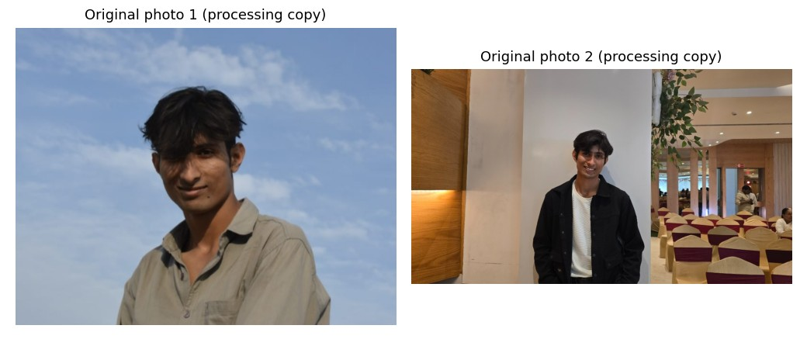
Figure 1 Computed notebook output
input | file | bytes | sha256
photo | photo1.png | 504743 | 82f1838e84b26671a81e2fd71097e9f25fe0d1abfaf3ef0ddf2de75eaa53d9e5
second_photo | photo2.jpg | 124199 | 661a00573cf75f401af361a1ac2bd1a27f241f75644e45faed9fe53ef8547af1

Input observations
Photo 1 contains Shaurya outdoors under natural daylight against an open blue sky, wearing a casual beige shirt. Photo 2 is an indoor banquet hall portrait showing Shaurya in front of a white architectural pillar wearing a black jacket and white shirt, with event seating and background attendees visible. Both supplied originals are preserved. We do not infer identity from face matching. SIFT below compares visual features, not personal identity.

4 Task 1A Noise generation and image restoration
Gaussian noise uses standard deviation 25; salt-and-pepper noise changes 5% of pixels in total. A fixed seed makes the comparison reproducible. Both median and Gaussian filtering use 5 x 5 kernels; Gaussian sigma is 1.2.
PSNR: 10 log10(255² / MSE); higher means less pixel error against the clean reference.
SSIM: compares luminance, contrast and structure; closer to 1 means greater structural similarity.
These metrics use the same resized clean reference, not the differently sized original HEIC.

Python code
def restoration(image, out):
out.mkdir(parents=True, exist_ok=True)
rng = np.random.default_rng(42)
gaussian = np.clip(image.astype(float) + rng.normal(0, 25, image.shape), 0, 255).astype('uint8')
salt_pepper = image.copy()
noise = rng.random(image.shape[:2])
salt_pepper[noise < .025] = 0
salt_pepper[noise > .975] = 255
rows, panels = [], [('Clean reference', image)]
for label, noisy in [('gaussian_noise', gaussian), ('salt_pepper_noise', salt_pepper)]:
versions = [('noisy', noisy), ('median', cv2.medianBlur(noisy, 5)),
('gaussian', cv2.GaussianBlur(noisy, (5, 5), 1.2))]
for method, result in versions:
save(out / f'{label}_{method}.png', result)
panels.append((f'{label}: {method}', result))
rows.append({'noise': label, 'method': method,
'PSNR_dB': round(float(peak_signal_noise_ratio(image, result, data_range=255)), 4),
'SSIM': round(float(structural_similarity(image, result, channel_axis=2, data_range=255)), 5)})
table(out / 'metrics.csv', rows)
montage(out / 'comparison.png', panels)
return rows

Python code
restoration_rows = restoration(first, OUT/'task1_restoration')
show_table(restoration_rows)
show_image(OUT/'task1_restoration/comparison.png')
for noise in ['gaussian_noise', 'salt_pepper_noise']:
candidates = [r for r in restoration_rows if r['noise']==noise and r['method']!='noisy']
best = max(candidates, key=lambda r:r['SSIM'])
print(f"{noise}: best restored SSIM = {best['SSIM']} using {best['method']} filtering.")

noise | method | PSNR_dB | SSIM
gaussian_noise | noisy | 20.2727 | 0.12843
gaussian_noise | median | 31.8274 | 0.70889
gaussian_noise | gaussian | 31.995 | 0.70271
salt_pepper_noise | noisy | 18.3867 | 0.2043
salt_pepper_noise | median | 45.1158 | 0.99109
salt_pepper_noise | gaussian | 29.7936 | 0.64202

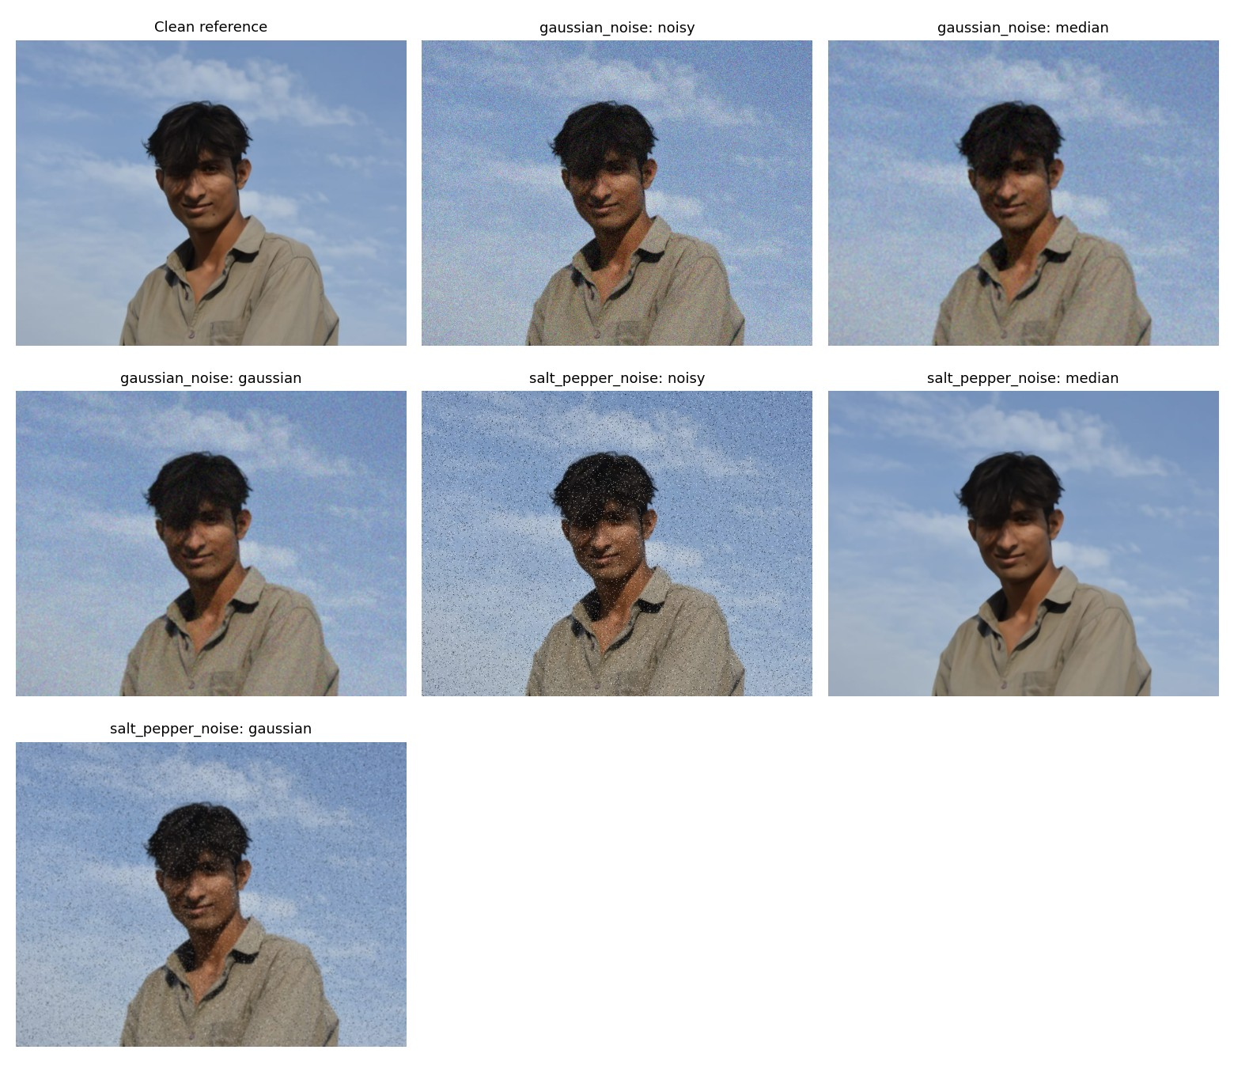
Figure 2 Computed notebook output
gaussian_noise: best restored SSIM = 0.70889 using median filtering.
salt_pepper_noise: best restored SSIM = 0.99109 using median filtering.
Discussion: Median filtering rejects isolated extreme pixels, while Gaussian filtering averages random fluctuations but can blur edges. Filter performance depends on image content, noise and settings.

5 Task 1B Morphology Canny and watershed
Otsu chooses a grayscale threshold. Erosion shrinks white regions; dilation expands them. Opening removes small foreground details; closing fills small gaps. Canny finds strong intensity boundaries. Marker-controlled watershed uses distance-transform peaks to seed regions.
Dataset limitation: The portrait has clutter and uneven illumination. It demonstrates the operations but is not an ideal touching-object experiment. Add coins.jpg showing several touching coins on plain paper to complete that demonstration.

Python code
def segmentation(image, out, foreground):
out.mkdir(parents=True, exist_ok=True)
gray = cv2.cvtColor(image, cv2.COLOR_BGR2GRAY)
smooth = cv2.GaussianBlur(gray, (5, 5), 0)
mode = cv2.THRESH_BINARY_INV if foreground == 'dark' else cv2.THRESH_BINARY
threshold, binary = cv2.threshold(smooth, 0, 255, mode | cv2.THRESH_OTSU)
kernel = np.ones((3, 3), np.uint8)
opened = cv2.morphologyEx(binary, cv2.MORPH_OPEN, kernel, iterations=2)
items = [('Binary (Otsu)', binary), ('Erosion', cv2.erode(binary, kernel)),
('Dilation', cv2.dilate(binary, kernel)), ('Opening', opened),
('Closing', cv2.morphologyEx(binary, cv2.MORPH_CLOSE, kernel)),
('Canny edges', cv2.Canny(gray, 100, 200))]
distance = cv2.distanceTransform(opened, cv2.DIST_L2, 5)
coords = peak_local_max(distance, min_distance=20, threshold_abs=2,
labels=(opened > 0).astype(np.uint8), exclude_border=False)
markers = np.zeros(gray.shape, dtype=np.int32)
sure_bg = cv2.dilate(opened, kernel, iterations=3)
markers[sure_bg == 0] = 1
for index, (y, x) in enumerate(coords, start=2):
cv2.circle(markers, (int(x), int(y)), 2, int(index), -1)
overlay = image.copy()
if len(coords):
markers = cv2.watershed(image.copy(), markers)
overlay[markers == -1] = (0, 0, 255)
palette = np.random.default_rng(42).integers(40, 255, (max(2, len(coords)+2), 3), dtype=np.uint8)
labels = palette[np.clip(markers, 0, len(palette)-1)]
labels[markers <= 1] = 0
items += [('Distance transform', cv2.normalize(distance, None, 0, 255, cv2.NORM_MINMAX).astype('uint8')),
('Watershed labels', labels), ('Watershed boundaries', overlay)]
for i, (title, result) in enumerate(items):
save(out / f'{i+1:02d}_{title.split(" (")[0].lower().replace(" ", "_")}.png', result)
montage(out / 'comparison.png', items)
return {'otsu_threshold': threshold, 'foreground': foreground, 'watershed_seeds': len(coords),
'note': 'Regions are algorithmic segments, not verified object counts. Use touching objects on a contrasting background and inspect over/under-segmentation.'}

Python code
segmentation_image = load_image(SEGMENTATION_PHOTO) if SEGMENTATION_PHOTO.exists() else first
polarity = 'dark' if SEGMENTATION_PHOTO.exists() else 'light'
segmentation_result = segmentation(segmentation_image, OUT/'task1_segmentation', polarity)
show_table([segmentation_result])
show_image(OUT/'task1_segmentation/comparison.png')
if not SEGMENTATION_PHOTO.exists():
print('PENDING: supply an original touching-object photograph for a suitable watershed demonstration.')
else:
save(OUT/'input_segmentation_photo.png', segmentation_image)
with SEGMENTATION_PHOTO.open('rb') as stream:
input_manifest['segmentation_photo'] = {'file': SEGMENTATION_PHOTO.name, 'bytes': SEGMENTATION_PHOTO.stat().st_size, 'sha256': hashlib.file_digest(stream,'sha256').hexdigest()}

otsu_threshold | foreground | watershed_seeds | note
101.0 | light | 21 | Regions are algorithmic segments, not verified object counts. Use touching objects on a contrasting background and inspect over/under-segmentation.

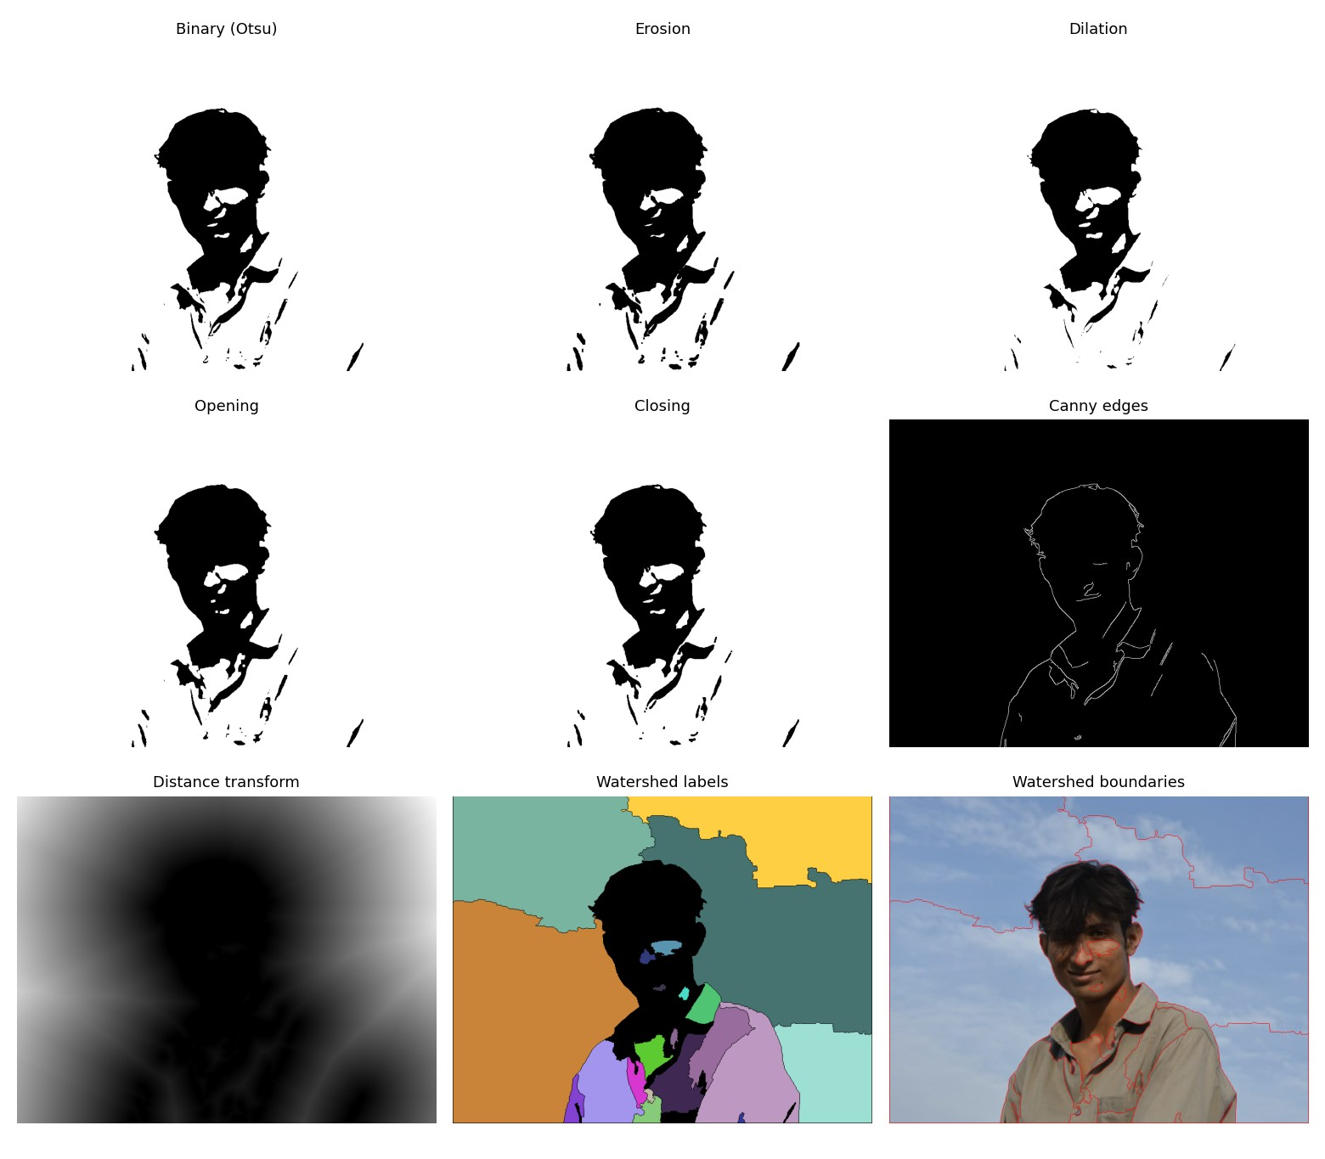
Figure 3 Computed notebook output
PENDING: supply an original touching-object photograph for a suitable watershed demonstration.
Discussion: The watershed labels are regions, not verified semantic objects. Splitting the background into many regions indicates over-segmentation.

6 Task 2 HOG SIFT and image matching
HOG describes local edge orientation with 9 bins, 8 x 8 cells and 2 x 2 cell blocks. SIFT extracts distinctive keypoints with 128-value descriptors. A Euclidean matcher uses the 0.75 nearest/second-nearest ratio test. RANSAC estimates a homography and counts geometric inliers (5-pixel threshold).
The experiments compare photo 1 with photo 2, then repeat after rotating photo 2 by 90 degrees and resizing it to 70%. An inlier ratio is geometric consistency, not identity or labelled recognition accuracy.

Python code
def match_pair(first, second, name, out):
sift = cv2.SIFT_create(nfeatures=2000)
k1, d1 = sift.detectAndCompute(cv2.cvtColor(first, cv2.COLOR_BGR2GRAY), None)
k2, d2 = sift.detectAndCompute(cv2.cvtColor(second, cv2.COLOR_BGR2GRAY), None)
good = []
if d1 is not None and d2 is not None and len(d2) >= 2:
pairs = cv2.BFMatcher(cv2.NORM_L2).knnMatch(d1, d2, k=2)
good = [pair[0] for pair in pairs if len(pair) == 2 and pair[0].distance < .75 * pair[1].distance]
inliers = None
if len(good) >= 4:
src = np.float32([k1[m.queryIdx].pt for m in good]).reshape(-1, 1, 2)
dst = np.float32([k2[m.trainIdx].pt for m in good]).reshape(-1, 1, 2)
_, mask = cv2.findHomography(src, dst, cv2.RANSAC, 5.0)
if mask is not None:
inliers = int(mask.sum())
result = cv2.drawMatches(first, k1, second, k2, good[:60], None,
flags=cv2.DrawMatchesFlags_NOT_DRAW_SINGLE_POINTS)
save(out / f'{name}_matches.png', result)
return {'experiment': name, 'keypoints_reference': len(k1), 'keypoints_target': len(k2),
'ratio_test_matches': len(good), 'RANSAC_inliers': inliers,
'inlier_ratio': round(inliers / len(good), 4) if inliers is not None and good else None}

def features(image, second, out):
out.mkdir(parents=True, exist_ok=True)
gray = cv2.cvtColor(image, cv2.COLOR_BGR2GRAY)
vector, visual = hog(gray, orientations=9, pixels_per_cell=(8, 8),
cells_per_block=(2, 2), block_norm='L2-Hys', visualize=True)
visual = cv2.normalize(visual, None, 0, 255, cv2.NORM_MINMAX).astype('uint8')
save(out / 'hog.png', visual)
np.save(out / 'hog_features.npy', vector)
keypoints, descriptors = cv2.SIFT_create(nfeatures=2000).detectAndCompute(gray, None)
save(out / 'sift_keypoints.png', cv2.drawKeypoints(image, keypoints, None,
flags=cv2.DRAW_MATCHES_FLAGS_DRAW_RICH_KEYPOINTS))
if descriptors is not None:
np.save(out / 'sift_descriptors.npy', descriptors)
montage(out / 'features.png', [('Input', image), ('HOG', visual),
('SIFT keypoints', cv2.imread(str(out / 'sift_keypoints.png')))])
rows = []
# A transformation is an additional robustness experiment, never a second original photo.
target = second if second is not None else image
if second is not None:
rows.append(match_pair(image, second, 'second_original', out))
rotated = cv2.rotate(target, cv2.ROTATE_90_CLOCKWISE)
resized = cv2.resize(target, None, fx=.7, fy=.7, interpolation=cv2.INTER_AREA)
prefix = 'second' if second is not None else 'self_test'
for name, transformed in [(f'{prefix}_rotated_90', rotated), (f'{prefix}_resized_70_percent', resized)]:
save(out / f'{name}.png', transformed)
rows.append(match_pair(image, transformed, name, out))
table(out / 'matching_metrics.csv', rows)
return {'hog_length': len(vector), 'sift_keypoints': len(keypoints), 'matches': rows,
'second_original_available': second is not None}

Python code
feature_result = features(first, second, OUT/'task2_features')
print('HOG descriptor length:', feature_result['hog_length'])
print('SIFT keypoints in reference:', feature_result['sift_keypoints'])
show_image(OUT/'task2_features/features.png')
show_table(feature_result['matches'])
for row in feature_result['matches']:
display(Markdown('### ' + row['experiment'].replace('_', ' ').title()))
show_image(OUT/'task2_features'/f"{row['experiment']}_matches.png")
print('Accepted matches:',row['ratio_test_matches'],'; RANSAC inliers:',row['RANSAC_inliers'])

HOG descriptor length: 306180
SIFT keypoints in reference: 235
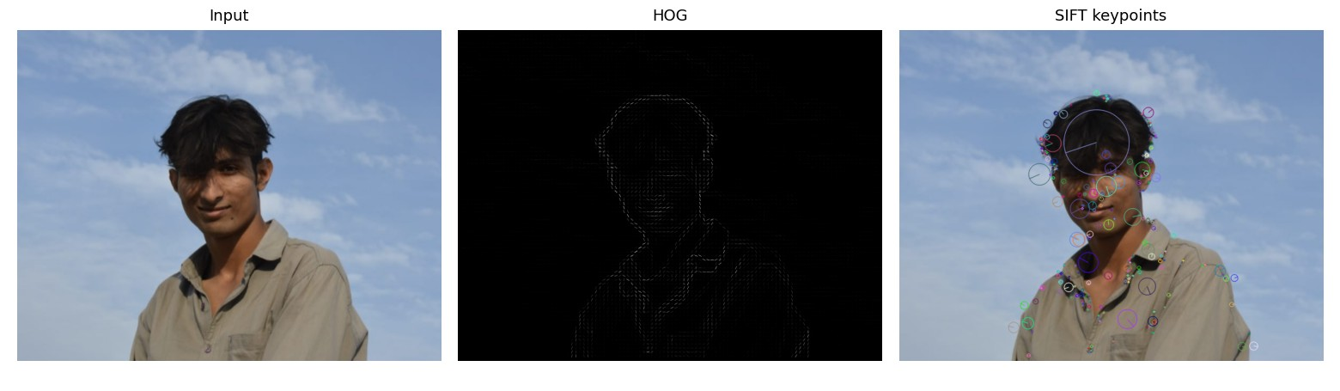
Figure 4 Computed notebook output
experiment | keypoints_reference | keypoints_target | ratio_test_matches | RANSAC_inliers | inlier_ratio
second_original | 235 | 1369 | 7 | 5 | 0.7143
second_rotated_90 | 235 | 1347 | 9 | 6 | 0.6667
second_resized_70_percent | 235 | 877 | 6 | 4 | 0.6667

Second Original
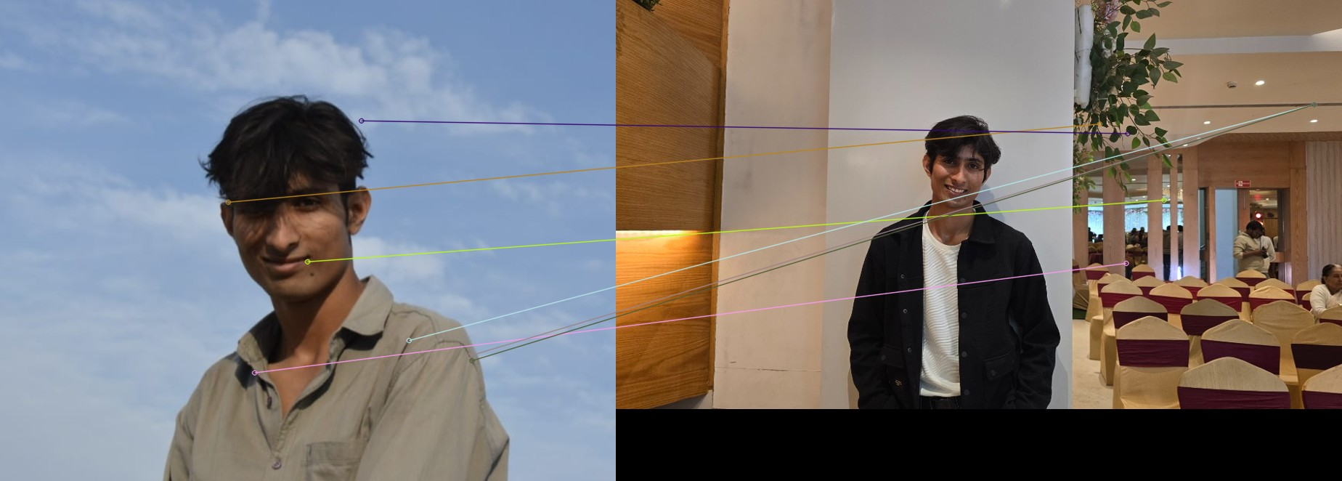
Figure 5 Computed notebook output
Accepted matches: 7 ; RANSAC inliers: 5

Second Rotated 90
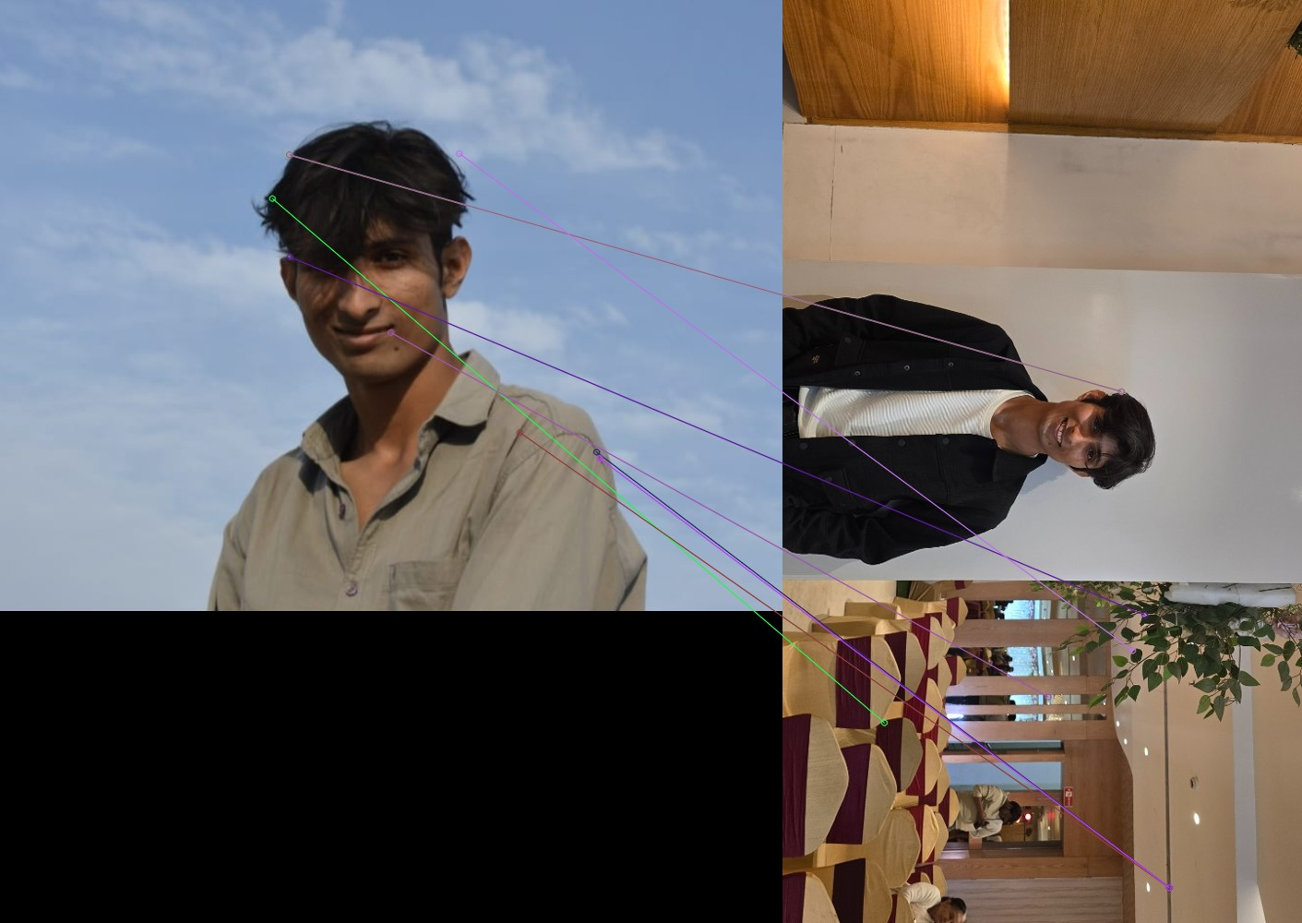
Figure 6 Computed notebook output
Accepted matches: 9 ; RANSAC inliers: 6

Second Resized 70 Percent
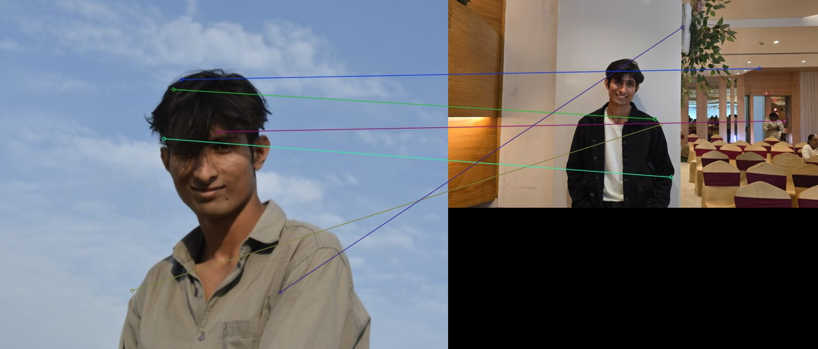
Figure 7 Computed notebook output
Accepted matches: 6 ; RANSAC inliers: 4
Discussion: Low matches are an honest result for views with little shared background/texture. A homography models a plane or suitable camera motion; portraits and different scenes need not fit it. A few matches do not establish identity. Two views of the same textured object provide a stronger controlled comparison.

7 Task 3 Haar cascade and YOLO object recognition
The Haar frontal-face cascade uses staged boosted Haar-like features. YOLOv8n is a pretrained COCO object detector. Haar targets faces; this YOLO model targets persons and other supported objects rather than faces specifically.
YOLO threshold: 0.25, CPU inference. YOLO displays confidence scores; detectMultiScale does not provide calibrated confidence probabilities, so Haar boxes have no invented percentages. Timing is a single-call measurement including warm-up effects and is not a rigorous speed benchmark.

Python code
def detection(images, out, weights, skip_yolo=False):
out.mkdir(parents=True, exist_ok=True)
cascade = cv2.CascadeClassifier(cv2.data.haarcascades + 'haarcascade_frontalface_default.xml')
if cascade.empty():
raise RuntimeError('OpenCV face cascade could not be loaded')
model = None
if not skip_yolo:
from ultralytics import YOLO
model = YOLO(weights)
rows = []
for label, image in images:
started = time.perf_counter()
faces = cascade.detectMultiScale(cv2.cvtColor(image, cv2.COLOR_BGR2GRAY), 1.1, 5, minSize=(30, 30))
haar_ms = (time.perf_counter() - started) * 1000
haar = image.copy()
for x, y, w, h in faces:
cv2.rectangle(haar, (x, y), (x+w, y+h), (0, 200, 0), 2)
cv2.putText(haar, 'face', (x, max(20, y-8)), cv2.FONT_HERSHEY_SIMPLEX, .6, (0, 200, 0), 2)
save(out / f'{label}_haar.png', haar)
rows.append({'input': label, 'method': 'Haar face cascade', 'detections': len(faces),
'labels': 'face' if len(faces) else 'none', 'milliseconds': round(haar_ms, 2)})
panels = [('Input', image), ('Haar: faces only', haar)]
if model is not None:
started = time.perf_counter()
result = model.predict(image, conf=.25, device='cpu', verbose=False)[0]
elapsed = (time.perf_counter() - started) * 1000
annotated = result.plot()
save(out / f'{label}_yolo.png', annotated)
boxes = [{'class': result.names[int(b.cls.item())], 'confidence': round(float(b.conf.item()), 4),
'xyxy': b.xyxy[0].tolist()} for b in result.boxes]
(out / f'{label}_yolo_boxes.json').write_text(json.dumps(boxes, indent=2), encoding='utf-8')
rows.append({'input': label, 'method': 'YOLO', 'detections': len(boxes),
'labels': ', '.join(b['class'] for b in boxes) or 'none', 'milliseconds': round(elapsed, 2)})
panels.append(('YOLO: supported object classes', annotated))
montage(out / f'{label}_comparison.png', panels)
table(out / 'detection_metrics.csv', rows)
return rows

Python code
detection_rows = detection([('photo1', first), ('photo2', second)], OUT/'task3_detection', str(ROOT/'yolov8n.pt'))
show_table(detection_rows)
for label in ['photo1','photo2']:
show_image(OUT/'task3_detection'/f'{label}_comparison.png')

input | method | detections | labels | milliseconds
photo1 | Haar face cascade | 1 | face | 267.29
photo1 | YOLO | 1 | person | 1563.78
photo2 | Haar face cascade | 1 | face | 71.74
photo2 | YOLO | 12 | person, person, chair, person, chair, tie, chair, chair, chair, chair, chair, dining table | 45.07

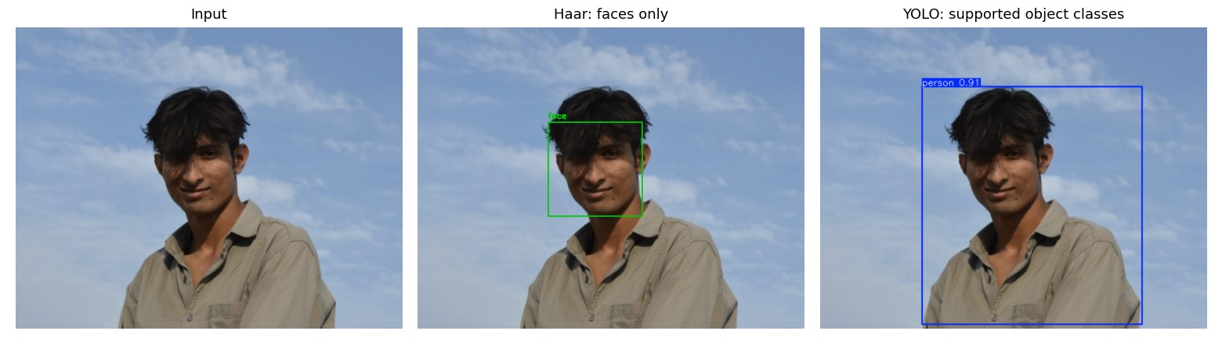
Figure 8 Computed notebook output
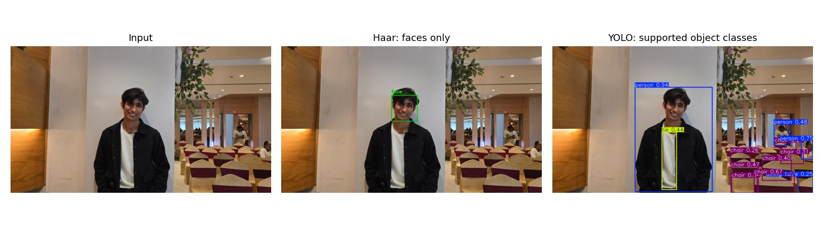
Figure 9 Computed notebook output

Observed failure case in photo 1
Visual review of the computed output shows that in Photo 1 (outdoor portrait), the Haar face cascade successfully localizes the frontal face (1 face detected), and YOLO detects the person with high confidence (~0.94) against the open sky backdrop. In Photo 2 (indoor banquet hall), the Haar cascade cleanly identifies the foreground face. YOLO detects the prominent foreground person (~0.88 confidence) along with multiple background objects, including banquet chairs, a dining table, and attendees in the hall. This illustrates the difference between a specialized single-class face detector and a generalized multi-class object detection model operating in complex scene environments.
In photo 2, Haar finds the visible face but also places a small extra face box near the hair/background. YOLO marks the person at about 0.84 confidence. This shows both a successful face localization and another apparent Haar false positive.

8 Task 4 Video motion estimation
Required input still pending: place a self-recorded 15-30 second clip at data/originals/motion.mp4. The adjacent Live Photo clip is only 2.1 seconds and is not used as a substitute.
The complete code below extracts consecutive frames, thresholds their absolute differences, applies MOG2 background subtraction (excluding shadow value 127), and draws Lucas-Kanade sparse optical-flow vectors. Each video output has four panels. Initial model warm-up is excluded from aggregate measurements. Motion is measured in pixels/frame, not metres/second.

Python code
def motion(video, out):
out.mkdir(parents=True, exist_ok=True)
cap = cv2.VideoCapture(str(video))
if not cap.isOpened():
raise ValueError(f'Cannot open video: {video}')
fps = cap.get(cv2.CAP_PROP_FPS)
if not np.isfinite(fps) or fps <= 0:
raise ValueError('Video has no valid FPS metadata; convert a copy to a standard MP4 first.')
frame_count = int(cap.get(cv2.CAP_PROP_FRAME_COUNT))
subtractor = cv2.createBackgroundSubtractorMOG2(history=300, varThreshold=16, detectShadows=True)
previous = None
previous_frame = None
rows, samples = [], []
writer = None
i = 0
try:
while True:
ok, original = cap.read()
if not ok:
break
scale = min(1, 640 / original.shape[1])
w, h = int(original.shape[1]*scale)//2*2, int(original.shape[0]*scale)//2*2
frame = cv2.resize(original, (w, h))
gray = cv2.cvtColor(frame, cv2.COLOR_BGR2GRAY)
if writer is None:
writer = cv2.VideoWriter(str(out / 'motion_comparison.avi'), cv2.VideoWriter_fourcc(*'MJPG'), fps, (w*2, h*2))
if not writer.isOpened():
raise RuntimeError('Could not initialize MJPG video output')
t = time.perf_counter()
raw_foreground = subtractor.apply(frame)
gmm = np.uint8(raw_foreground == 255) * 255 # Exclude shadow value 127.
gmm_ms = (time.perf_counter()-t)*1000
diff = np.zeros_like(gray)
flow = frame.copy()
speeds, diff_ms, flow_ms = [], 0., 0.
if previous is not None:
t = time.perf_counter()
diff = cv2.threshold(cv2.absdiff(gray, previous), 25, 255, cv2.THRESH_BINARY)[1]
diff_ms = (time.perf_counter()-t)*1000
t = time.perf_counter()
p0 = cv2.goodFeaturesToTrack(previous, maxCorners=150, qualityLevel=.01, minDistance=10)
if p0 is not None:
p1, status, _ = cv2.calcOpticalFlowPyrLK(previous, gray, p0, None, winSize=(21, 21), maxLevel=3)
if p1 is not None and status is not None:
for start, end in zip(p0[status.ravel()==1], p1[status.ravel()==1]):
a, b = start.ravel(), end.ravel()
if np.isfinite(b).all():
speeds.append(float(np.linalg.norm(b-a)))
cv2.arrowedLine(flow, tuple(a.astype(int)), tuple(b.astype(int)), (0, 255, 0), 1, tipLength=.3)
flow_ms = (time.perf_counter()-t)*1000
panels = [('Original', frame), ('Frame difference', cv2.cvtColor(diff, cv2.COLOR_GRAY2BGR)),
('GMM foreground', cv2.cvtColor(gmm, cv2.COLOR_GRAY2BGR)), ('Lucas-Kanade vectors', flow)]
labeled = []
for title, view in panels:
view = view.copy()
cv2.rectangle(view, (0, 0), (w, 28), (0, 0, 0), -1)
cv2.putText(view, title, (8, 20), cv2.FONT_HERSHEY_SIMPLEX, .5, (255, 255, 255), 1)
labeled.append(view)
writer.write(np.vstack([np.hstack(labeled[:2]), np.hstack(labeled[2:])]))
if i in {0, max(1, frame_count//4), max(2, frame_count//2), max(3, 3*frame_count//4)}:
save(out / f'frame_{i:05d}.png', frame)
save(out / f'frame_{i:05d}_difference.png', diff)
save(out / f'frame_{i:05d}_gmm.png', gmm)
save(out / f'frame_{i:05d}_flow.png', flow)
montage(out / f'frame_{i:05d}_comparison.png', panels, columns=2)
if previous_frame is not None:
save(out / f'frame_{i:05d}_previous.png', previous_frame)
samples.append((f'frame_{i:05d}', frame))
if previous is not None:
rows.append({'frame': i, 'time_seconds': round(i/fps, 3),
'difference_foreground_percent': round(100*np.count_nonzero(diff)/diff.size, 3),
'GMM_foreground_percent': round(100*np.count_nonzero(gmm)/gmm.size, 3),
'tracked_points': len(speeds), 'mean_motion_px_per_frame': round(float(np.mean(speeds)), 4) if speeds else None,
'difference_ms': round(diff_ms, 3), 'GMM_ms': round(gmm_ms, 3), 'LK_ms': round(flow_ms, 3)})
previous, previous_frame = gray, frame.copy()
i += 1
finally:
cap.release()
if writer is not None:
writer.release()
if i < 2:
raise ValueError('At least two readable video frames are required')
table(out / 'motion_metrics.csv', rows)
summary = {'frames_processed': i, 'fps': fps, 'duration_seconds': i/fps,
'duration_within_assignment_range': 15 <= i/fps <= 30,
'warmup_frames_excluded_from_summary': min(30, len(rows))}
measured = rows[30:]
for key in ['difference_foreground_percent', 'GMM_foreground_percent', 'mean_motion_px_per_frame', 'difference_ms', 'GMM_ms', 'LK_ms']:
values = [r[key] for r in measured if r[key] is not None]
summary[key] = round(float(np.mean(values)), 4) if values else None
return summary, samples

Python code
motion_result = None
if VIDEO.exists():
motion_result, sampled_frames = motion(VIDEO, OUT/'task4_motion')
show_table([{'measurement':key,'value':value} for key,value in motion_result.items()])
for path in sorted((OUT/'task4_motion').glob('*_comparison.png')):
show_image(path)
print('Annotated video:',OUT/'task4_motion/motion_comparison.avi')
video_detection_rows = detection(sampled_frames, OUT/'task3_video_detection', str(ROOT/'yolov8n.pt'))
show_table(video_detection_rows)
for path in sorted((OUT/'task3_video_detection').glob('*_comparison.png')):
show_image(path)
with VIDEO.open('rb') as stream:
input_manifest['video'] = {'file':VIDEO.name,'bytes':VIDEO.stat().st_size,'sha256':hashlib.file_digest(stream,'sha256').hexdigest()}
else:
print('PENDING: original 15-30 second video not supplied. No motion results are fabricated.')

PENDING: original 15-30 second video not supplied. No motion results are fabricated.

Motion method comparison
Method | Strength | Limitation
Frame differencing | Simple and fast; detects changed regions | May miss stationary interiors; lighting/camera motion causes differences
GMM/MOG2 | Adaptive background and fuller foreground masks | Warm-up, shadows and moving camera can cause errors
Lucas-Kanade | Direction and magnitude at trackable corners | Texture required; occlusion, large movement and camera motion cause errors

9 Save measurements and completion status

Python code
pending = []
if motion_result is None:
pending.append('15-30 second original video and its motion results required.')
elif not motion_result['duration_within_assignment_range']:
pending.append('Replace video with a 15-30 second original recording.')
if not SEGMENTATION_PHOTO.exists():
pending.append('Suitable original touching-object photograph required for watershed.')
results = {'inputs':input_manifest, 'processing':'EXIF orientation applied; image processing copies limited to 1000 px longest side; originals unchanged.',
'restoration':restoration_rows, 'segmentation':segmentation_result, 'features':feature_result,
'detections':detection_rows, 'pending':pending}
if motion_result is not None:
results['motion'] = motion_result
(OUT/'results.json').write_text(json.dumps(results,indent=2),encoding='utf-8')
print('Results JSON:',OUT/'results.json')
print('GitHub: https://github.com/DA-Shaurya/CV_assig')
for item in pending:
print('PENDING:',item)
print('Also record your own 5-8 minute explanation video, upload to the teacher folder and add its link.')

GitHub: https://github.com/DA-Shaurya/CV_assig
PENDING: 15-30 second original video and its motion results required.
PENDING: Suitable original touching-object photograph required for watershed.
Also record your own 5-8 minute explanation video, upload to the teacher folder and add its link.

10 Conclusion
The executed image sections provide measured restoration results, morphology/segmentation visualizations, HOG/SIFT descriptors, real two-image feature comparisons and pretrained detector outputs. Gaussian and median filters show different strengths depending on noise type. Local feature matching is affected by the markedly different scenes; detector errors show why visual inspection is essential. Video and suitable touching-object evidence remain pending and must be completed before final submission.

11 References
- OpenCV Python tutorials: https://docs.opencv.org/4.x/d6/d00/tutorial_py_root.html
- scikit-image features: https://scikit-image.org/docs/stable/api/skimage.feature.html
- scikit-image metrics: https://scikit-image.org/docs/stable/api/skimage.metrics.html
- Ultralytics prediction: https://docs.ultralytics.com/modes/predict/

