TRIP EXPENSE SETTLEMENT
DAA Activity – Algorithm Design & Optimization
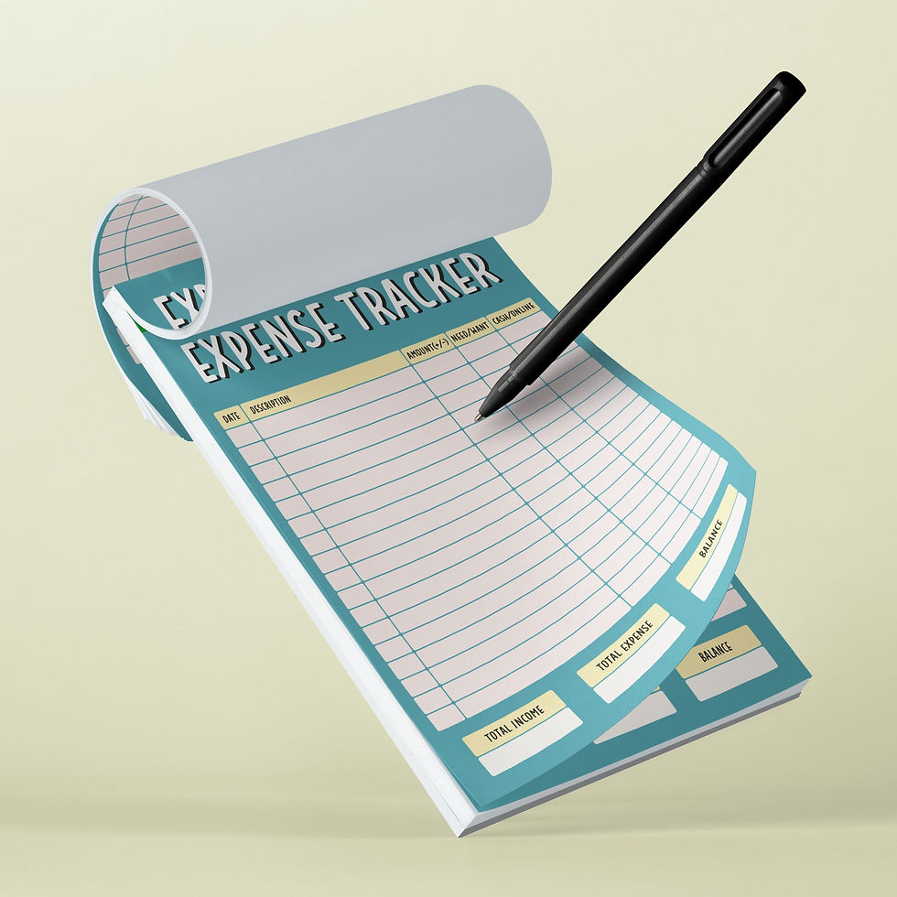

1. Activity Scenario
A group of 20 students went on a 3-day trip. During the trip, different students paid for travel, accommodation, food, tickets, transport and other expenses. Some expenses were shared by everyone, while others were shared only by a subset of students. Some students paid much more than their own final share, while others paid less.
Your task is to design an algorithm that determines the final amount each student should pay or receive and produces a settlement plan. The objective is to settle the entire trip with as few money-transfer transactions as possible.

2. Learning Objectives
- Model a real-world problem using an algorithmic representation.
- Process raw expense data and derive individual obligations.
- Calculate total paid, total share and net balance for every student.
- Separate debtors from creditors.
- Design a settlement algorithm using suitable data structures.
- Validate that all balances become zero after settlement.

3. Input Provided
The Excel file contains three sheets: Trip Expenses, Student List and Activity Brief. The Trip Expenses sheet contains 32 expenses. For each expense, the file gives the payer, amount and the exact set of participants.
- Do not assume every expense is shared by all 20 students.
- Do not assume the payer's contribution equals their final share.
- A student may pay several expenses.
- A student may participate in an expense without being the payer.
- Some expenses involve only a subset of students.

4. Problem Statement
Given the trip-expense data, design an algorithm that generates the settlement transactions required to make every student's final balance zero. Your algorithm should aim to minimize the number of transactions rather than simply listing every individual reimbursement.

5. Think Before You Code
- How will you represent a student's net balance?
- How will you calculate a share when only some students participated?
- Once net balances are known, do you still need the original expense rows for settlement?
- Can debtors and creditors be maintained separately?
- What happens if the largest debtor is matched with the largest creditor?
- What happens when one of them becomes zero?
- Can the same process be repeated until all balances are settled?
- Can you justify why your choice is reasonable?

6. Expected Output
Develop an algorithm to track the expense , and share the amount among all 20 students.

⭐⭐Think in Steps⭐⭐

