Is yours a data-intensive use case?

An application is data intensive if the **amount of data** that it generates/uses increases quickly or if the **complexity of data** that it generates/uses increases quickly or if the **speed of changes data** increases quickly.

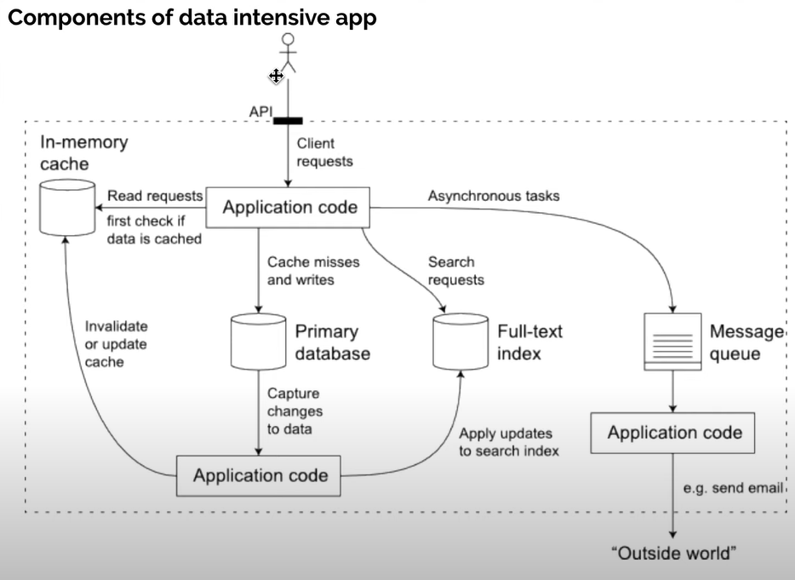

**Main Components in a data-intensive app:**

Databases: for sources of truth for any consumer. Example -> Oracle/MySQL

Cache: for temporarily storing an expensive operation to speed up reads. Example -> Memcache/Redis

Full-text Index: for quickly searching data by keyword or filter. Example -> Apache Lucene

Message queues: for messaging passing between process. Example Apache Kafka

Stream processing: Example -> Apache samza, Apache spark

Batch processing for crunching large amount of data. Example -> Apache Spark/Hadoop

Application code: which acts as the connective tissue between the above components.