Weekly Project Meeting Minutes
The main purpose of the document is to capture all the work that has been done by the group over the course of one week and not to write down what was discussed in a single meeting. You should be meeting and/or working throughout the week.

Time group spent on project: 5 hours .

Group Number: 7

Group members present (Name, ID):
- Delta Joseph(0735816)
- Amith John Varkey(0735036)
- Abdul Hannan Mansoor(0735818)

Specific Activities from prior week:
  - In this week we have selected the dataset for the project “Price Prediction For The Used Cars” from the Kaggle and the real time data from the Automax.
  - Our dataset has “1444” rows and “27” columns.
  - We have emailed couple of companies to get the real time dataset but it didn’t work out due to confidential data.

Specific Output from prior week:
- In our dataset we have train and the test data in which we have 1235 rows, 12 columns for test data and 6020 rows,13 columns for the train data.

- Test Data:

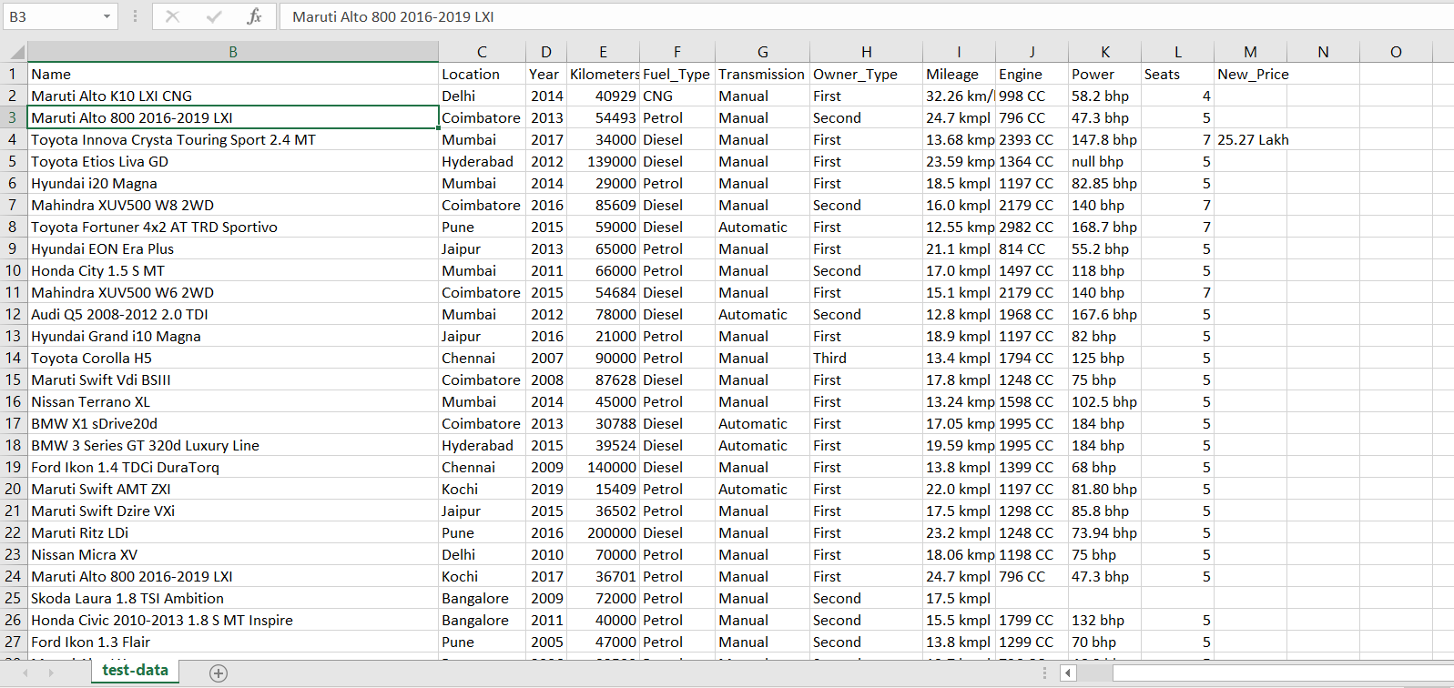
- Train Data:

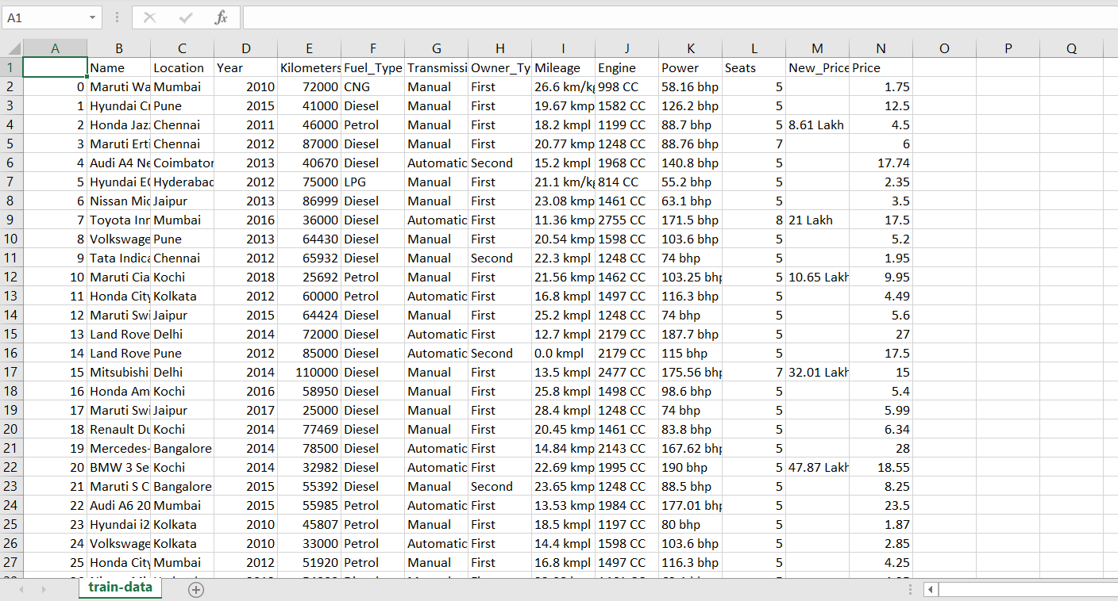

- Automax Dataset :

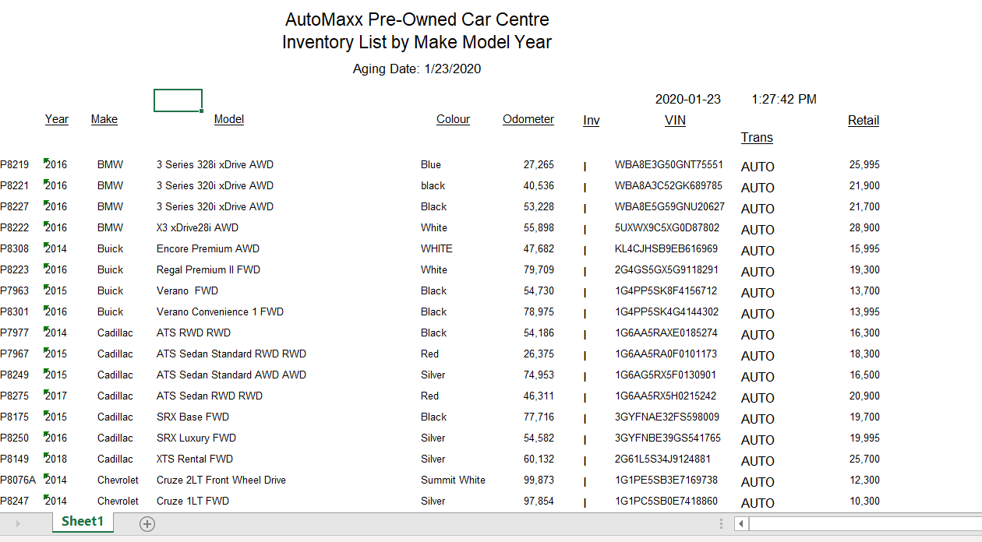

Python Output :

Train Data :

- 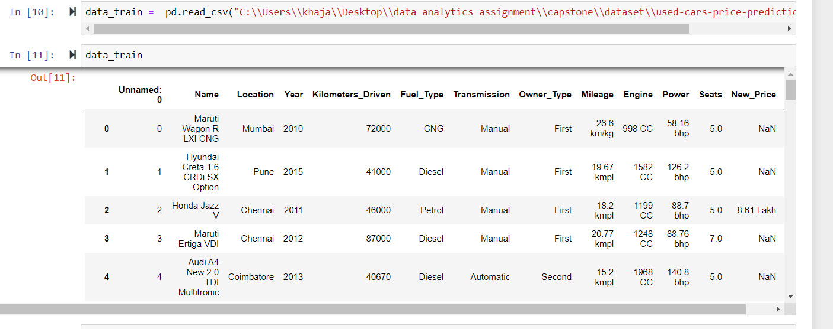
- Null values in Train Data:

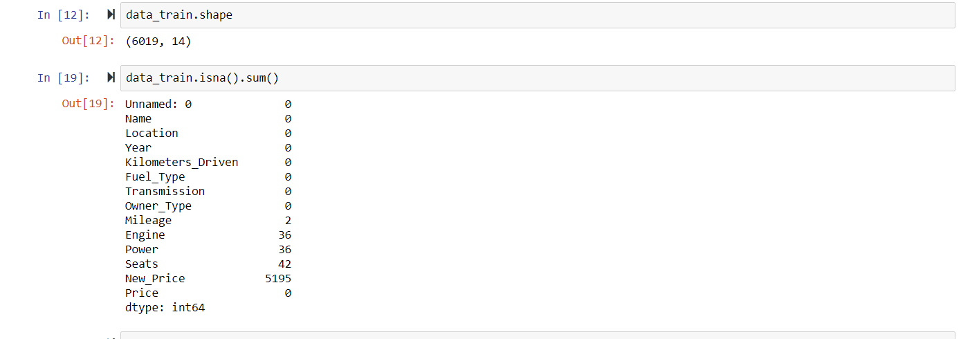

Test data :

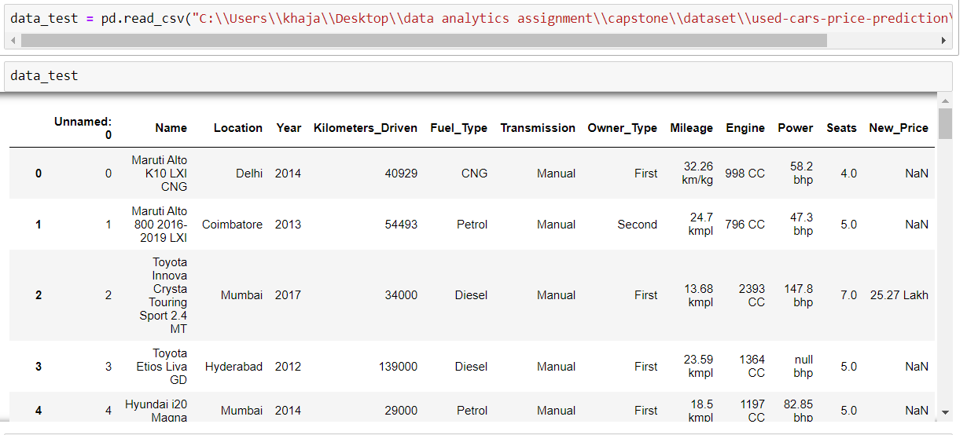

Test Data Null Values:

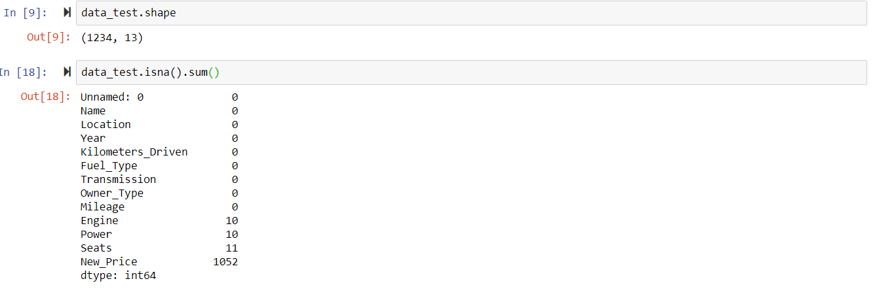

Refrence for the dataset::

- https://www.kaggle.com/avikasliwal/used-cars-price-prediction/data
- https://www.automaxxwindsor.com/used-cars-windsor

On Target:

- Indicate the current status of your project
  - _____ green: everything on track for completion by due date
  - _____ yellow: a small number of tasks are off track and completion by due date is at risk
  - _____ red: many tasks are off track and project will not be completed by due date

Challenges/Disagreements:
- The real time dataset we got from the “Automax “ was really helpful but unfortunately, we didn’t have enough amount of rows and columns to work on the models.
- We decided to get the dataset from the Kaggle
- We have huge amount of null values in both train and the test data.
Planned Activities for coming week:
- We are still waiting for the responses from the clients we mailed. Meanwhile, we decided to work on the dataset we have.
- Working on preprocessing ,cleaning of the data and models .

