|  |
| --- |
| BLOCKCHAIN |

What is Blockchain?

A blockchain is a constantly growing ledger which keeps a permanent record of all the transactions that have taken place in a secure, chronological, and immutable way.

* **Ledger:** It is a file that is constantly growing.
* **Permanent:** It means once the transaction goes inside a blockchain, you can put up it permanently in the ledger.
* **Secure:** Blockchain placed information in a secure way. It uses very advanced cryptography to make sure that the information is locked inside the blockchain.
* **Chronological:** Chronological means every transaction happens after the previous one.
* **Immutable:** It means as you build all the transaction onto the blockchain, this ledger can never be changed.

A blockchain is a chain of blocks which contain information. Each block records all of the recent transactions, and once completed goes into the blockchain as a permanent database. Each time a block gets completed, a new block is generated.

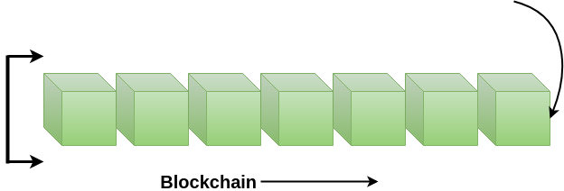

**Note:** A blockchain can be used for the secure transfer of money, property, contracts, etc. without requiring a third-party intermediary like bank or government. Blockchain is a software protocol, but it could not be run without the Internet (like SMTP used in email).

Who uses the blockchain?

Blockchain technology can be integrated into multiple areas. The primary use of blockchains is as a distributed ledger for cryptocurrencies. It shows great promise across a wide range of business applications like Banking, Finance, Government, Healthcare, Insurance, Media and Entertainment, Retail, etc.

Need of Blockchain

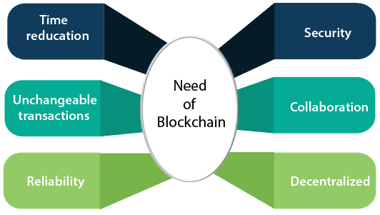

Blockchain technology has become popular because of the following.

* **Time reduction:** In the financial industry, blockchain can allow the quicker settlement of trades. It does not take a lengthy process for verification, settlement, and clearance. It is because of a single version of agreed-upon data available between all stakeholders.
* **Unchangeable transactions:** Blockchain register transactions in a chronological order which certifies the unalterability of all operations, means when a new block is added to the chain of ledgers, it cannot be removed or modified.
* **Reliability:** Blockchain certifies and verifies the identities of each interested parties. This removes double records, reducing rates and accelerates transactions.
* **Security:** Blockchain uses very advanced cryptography to make sure that the information is locked inside the blockchain. It uses Distributed Ledger Technology where each party holds a copy of the original chain, so the system remains operative, even the large number of other nodes fall.
* **Collaboration:** It allows each party to transact directly with each other without requiring a third-party intermediary.
* **Decentralized:** It is decentralized because there is no central authority supervising anything. There are standards rules on how every node exchanges the blockchain information. This method ensures that all transactions are validated, and all valid transactions are added one by one.

History of Blockchain

The blockchain technology was described in **1991** by the research scientist **Stuart Haber** and **W. Scott Stornetta**. They wanted to introduce a computationally practical solution for time-stamping digital documents so that they could not be backdated or tampered. They develop a system using the concept of **cryptographically** secured chain of blocks to store the time-stamped documents.

In **1992**, Merkle Trees were incorporated into the design, which makes [blockchain](https://www.javatpoint.com/blockchain-tutorial) more efficient by allowing several documents to be collected into one block. **Merkle Trees** are used to create a 'secured chain of blocks.' It stored a series of data records, and each data records connected to the one before it. The newest record in this chain contains the history of the entire chain. However, this technology went unused, and the patent lapsed in 2004.

In **2004**, computer scientist and cryptographic activist **Hal Finney** introduced a system called **Reusable Proof Of Work(RPoW)** as a prototype for digital cash. It was a significant early step in the history of cryptocurrencies. The RPoW system worked by receiving a non-exchangeable or a non-fungible Hashcash based proof of work token in return, created an **RSA-signed** token that further could be transferred from person to person.

RPoW solved the double-spending problem by keeping the ownership of tokens registered on a trusted server. This server was designed to allow users throughout the world to verify its correctness and integrity in real-time.

Further, in **2008**, **Satoshi Nakamoto** conceptualized the theory of **distributed blockchains**. He improves the design in a unique way to add blocks to the initial chain without requiring them to be signed by trusted parties. The modified trees would contain a secure history of data exchanges. It utilizes a peer-to-peer network for timestamping and verifying each exchange. It could be managed autonomously without requiring a central authority. These improvements were so beneficial that makes blockchains as the backbone of cryptocurrencies. Today, the design serves as the public ledger for all transactions in the [cryptocurrency](https://www.javatpoint.com/blockchain-cryptocurrency) space.

The evolution of blockchains has been steady and promising. The words block and chain were used separately in Satoshi Nakamoto's original paper but were eventually popularized as a single word, the Blockchain, by **2016**. In recent time, the file size of cryptocurrency blockchain containing records of all transactions occurred on the network has grown from **20 GB** to **100 GB**.

What is Bitcoin?

**Satoshi Nakamoto** introduced the bitcoin in the year 2008. Bitcoin is a cryptocurrency(virtual currency), or a **digital currency** that uses rules of cryptography for regulation and generation of units of currency. A Bitcoin fell under the scope of [cryptocurrency](https://www.javatpoint.com/blockchain-cryptocurrency) and became the first and most valuable among them. It is commonly called **decentralized digital currency**.

A bitcoin is a type of digital assets which can be bought, sold, and transfer between the two parties securely over the internet. Bitcoin can be used to store values much like fine gold, silver, and some other type of investments. We can also use bitcoin to buy products and services as well as make payments and exchange values electronically.

A bitcoin is different from other traditional currencies such as **Dollar**, **Pound**, and **Euro**, which can also be used to buy things and exchange values electronically. There are no physical coins for bitcoins or paper bills. When you send bitcoin to someone or used bitcoin to buy anything, you don?t need to use a bank, a credit card, or any other third-party. Instead, you can simply send bitcoin directly to another party over the internet with securely and almost instantly.

## **How Bitcoin Works?**

When you send an email to another person, you just type an email address and can communicate directly to that person. It is the same thing when you send an instant message. This type of communication between two parties is commonly known as Peer-to-Peer communication.

Whenever you want to transfer money to someone over the internet, you need to use a service of third-party such as banks, a credit card, a PayPal, or some other type of money transfer services. The reason for using third-party is to ensure that you are transferring that money. In other words, you need to be able to verify that both parties have done what they need to do in real exchange.

**For example**, Suppose you click on a photo that you want to send it to another person, so you can simply attach that photo to an email, type the receiver email address and send it. The other person will receive the photo, and you think it would end, but it is not. Now, we have two copies of photo, one is a simple email, and another is an original file which is still on my computer. Here, we send the copy of the file of the photo, not the original file. This issue is commonly known as the double-spend problem.

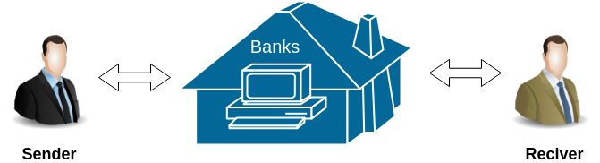

The double-spend problem provides a challenge to determine whether a transaction is real or not. How you can send a bitcoin to someone over the internet without needing a bank or some other institution to certify the transfer took place. The answer arises in a global network of thousands of computers called a Bitcoin Network and a special type of decentralized laser technology called **blockchain**.

In Bitcoin, all the information related to the transaction is captured securely by using maths, protected cryptographically, and the data is stored and verified across the entire network of computers. In other words, instead of having a centralized database of the third-party such as banks to certify the transaction took place. Bitcoin uses [blockchain](https://www.javatpoint.com/blockchain-tutorial) technology across a decentralized network of computers to securely verify, confirm and record each transaction. Since data is stored in a decentralized manner across a wide network, there is no single point of failure. This makes blockchain more secure and less prone to fraud, tampering or general system failure than keeping them in a single centralized location.

# **Blockchain Version**

The brief description of the evolution of blockchain technology and its **versioning** from 1.0 to 3.0 are explained below.

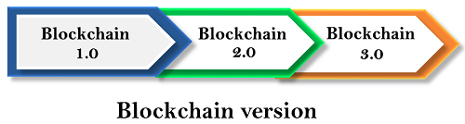

## **Blockchain 1.0: Currency**

The idea of creating money through solving computational puzzles was first introduced in **2005** by **Hal Finney**, who created the first concept for cryptocurrencies (The implementation of distributed ledger technology). This ledger allows financial transactions based on blockchain technology or DLT to be executed with [Bitcoin](https://www.javatpoint.com/bitcoin). Bitcoin is the most prominent example in this segment. It is being used as **cash for the Internet** and seen as the enabler of an **Internet of Money**.

## **Blockchain 2.0: Smart Contracts**

The main issues that came with Bitcoin are wasteful mining and lack of network scalability. To overcome these issues, this version extends the concept of Bitcoin beyond currency. The new key concepts are Smart Contracts. It is small computer programs that **"live"** in the [blockchain](https://www.javatpoint.com/blockchain-tutorial). They are free computer programs which executed automatically and checked conditions which are defined earlier like facilitation, verification or enforcement. The big advantage of this technology that blockchain offers, making it impossible to tamper or hack Smart Contracts. A most prominent example is the Ethereum Blockchain, which provides a platform where the developer community can build distributed applications for the Blockchain network.

Quickly, the blockchain 2.0 version is successfully processing a high number of daily transactions on a public network, where millions were raised through **ICO** (Initial Coin Offerings), and the market cap increased rapidly.

## **Blockchain 3.0: DApps**

DApps is also known as a decentralized application. It uses decentralized storage and communication. Its backend code is running on a decentralized peer-to-peer network. A DApp can have **frontend code** hosted on decentralized storages such as Ethereum Swarm and **user interfaces** written in any language that can make a call to its backend like a traditional Apps.

# **Role of Bitcoin Miners**

To understand the role of bitcoin miners, let us first understand Bitcoin Mining.

## **Bitcoin Mining**

Bitcoin mining is the process of adding transaction records to Bitcoin's public ledger of past transactions. This ledger of past transactions is called the blockchain as it is a chain of blocks. Bitcoin mining is used to secure and verify transactions to the rest of the network.

## **Role of Bitcoin Miners**

Within the bitcoin networks, there are a group of people known as Miners. In miners, there was a process and confirm transactions. Anybody can apply for a minor, and you could run the client yourself. However, these minors use very powerful computers that are specifically designed to mine [bitcoin](https://www.javatpoint.com/bitcoin) transaction. They do this by actually solving math problems and resolving cryptographic issues because every transaction needs to be cryptographically encoded and secured. These mathematical problems ensure that nobody is tampering with that data.

Additionally, for this task, the minors are paid in bitcoins, which is the key component in bitcoin. In Bitcoin, you cannot create money as like you create regular fiat currencies such as Dollar, Euro, and Yuan. The bitcoin is created by rewarding these minors for their work in solving the mathematical and cryptographical problems.

## **How is the Bitcoin Blockchain built?**

The role of a minor is to build the blockchain of records that forms the bitcoin ledger. These ledgers are called blocks, and each block contains all the different transactions that have taken place. A new block is added in every 10 minutes as a new Bitcoin Transaction takes place. So, as the minors process these different transactions, they build the block, and when a block is confirmed, it gets added to the blockchain. The bitcoin blockchain provides a permanent record of all bitcoin transactions to the beginning.

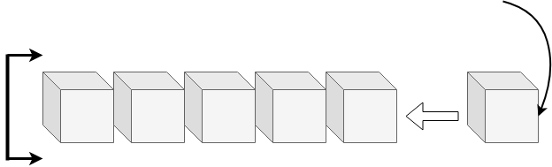

# **Blockchain Hash Function**

A hash function takes an input string (numbers, alphabets, media files) of any length and transforms it into a fixed length. The fixed bit length can vary (like 32-bit or 64-bit or 128-bit or 256-bit) depending on the hash function which is being used. The fixed-length output is called a hash. This hash is also the cryptographic byproduct of a hash algorithm. We can understand it from the following diagram.

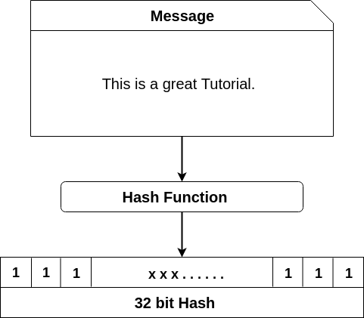

**The hash algorithm has certain unique properties:**

1. It produces a unique output (or hash).
2. It is a one-way function.

In the context of cryptocurrencies like [Bitcoin](https://www.javatpoint.com/bitcoin), the blockchain uses this cryptographic hash function's properties in its consensus mechanism. A cryptographic hash is a digest or digital fingerprints of a certain amount of data. In cryptographic hash functions, the transactions are taken as an input and run through a hashing algorithm which gives an output of a fixed size.

## **SHA-256**

A Bitcoin's blockchain uses SHA-256 (Secure Hash Algorithm) hashing algorithm. In 2001, SHA-256 Hashing algorithm was developed by the National Security Agency (NSA) in the USA.

## **How does the hashing process works?**

For this hash function, we are going to use a program developed by Anders Brownworth. This program can be found in the below link.

**Anders Brownworth Hash Program:** <https://anders.com/blockchain/hash.html>

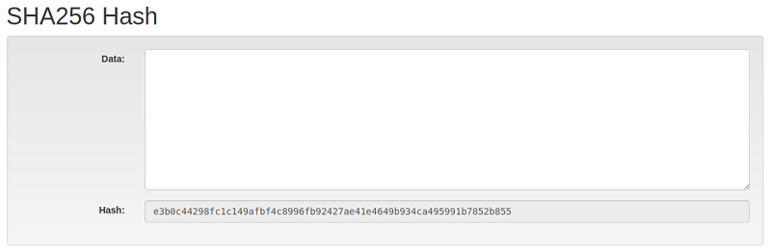

If we type any character in the data section, we will observe its corresponding cryptographic hash in the hash section.

**For example:** We have type in data section: **This is a great tutorial**.

It will generate the corresponding Hash:

1. 759831720aa978c890b11f62ae49d2417f600f26aaa51b3291a8d21a4216582a

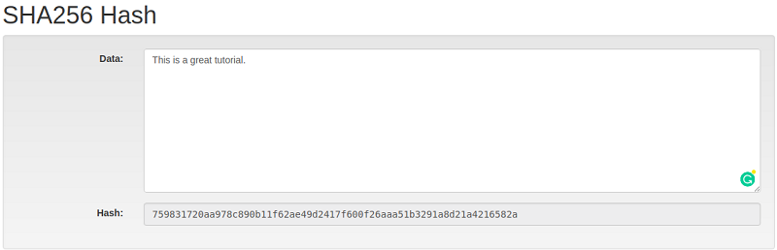

Now if we change the text: "**This is a great tutorial**." To "**this is a great tutorial**."

You will find the corresponding Hash:

1. 4bc35380792eb7884df411ade1fa5fc3e82ab2da76f76dc83e1baecf48d60018

In the above, you can see that we have changed only the first character case sentence from capital "T" to small "t" and it will change the whole Hash value.

#### Note:**If we write the same text again in a data section, it will always give the same output. It is because you are creating a message digest of that one's specific amount of data.**

Since the Hash function is a one-way function, there is no way to get back entire text from the generated hash. This is different from traditional cryptographic functions like encryption where you can encrypt something using the key and by using decryption, you can decrypt the message to its original form.

# **Blockchain Block Hashing**

In this section, we are going to learn how SHA-256 applies to build a block within a blockchain. We will discuss here in the context of the Bitcoin blockchain and understand how this ties into the role of miners. The minors are actually in the process of building blocks, and these blocks are added to a blockchain to build out what the Bitcoin blockchain will be.

In the below image, you can see that this block is composed of a block number, data field, cryptographic hash associated with it and a Nonce.

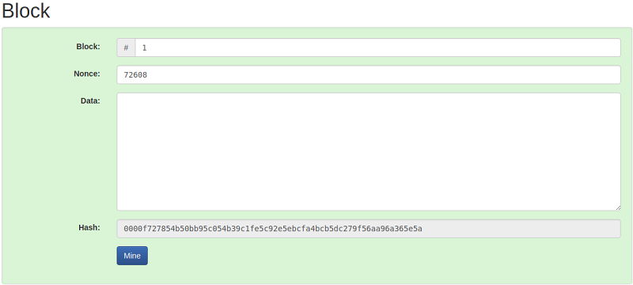

In the above image, the generated hash would look like 00001acbm010gfh1010xxx. I'd like to point out that this hash has four leading zeros. The four leading zero's describes whether the block is valid or not. For practical purposes, you will see that this hash is corresponding to the nonce, and the block number is corresponding to the available data. Since the hash has four leading zeroes, therefore, it is a valid block.

If we make any change in the data section, it will give the completely different hash that can be shown in the below image.

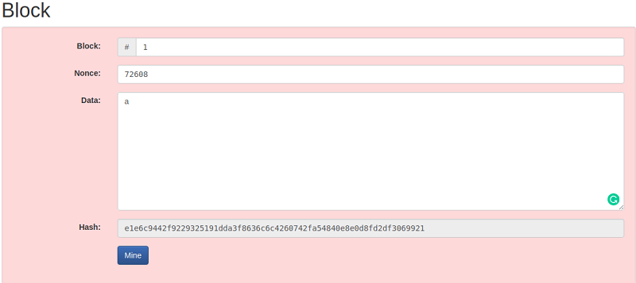

If the newly generating hash does not have four leading zeroes, then it will not a valid block. To make the block valid, we will do it by using the field called **nonce**.

Nonce stands for **a Number Used Once** in a cryptographic communication such that the block's hash meets a certain criterion. This criterion could be generated a hash that must have its leading four digits to be zero. Thus, the generated hash would look like 00001acbm010gfh1010xxx.

A nonce is basically a random number which figures out how you can actually make this specific block provide you with a valid hash. The way you can do this is by changing the nonce manually. Generally, the miner starts with a Nonce value of 1 and keeps on incrementing it until the generated hash meets the specified criterion. Thus, it may take several iterations until the desired hash with four leading zeros is generated. The expected time for generating a block in the [bitcoin](https://www.javatpoint.com/bitcoin) system is 10 minutes. Once the miner successfully mines the block, he releases that block in the system and making it the last block in the chain.

In Anders Brownworth Hash Program, when we click mine button as shown in the image, it will give the valid block. This block has a unique nonce with hash leading four zeroes in the beginning.

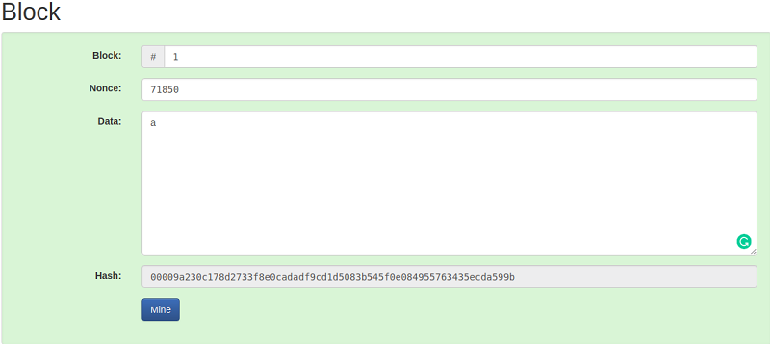

# **How Block Hashes Work in Blockchain?**

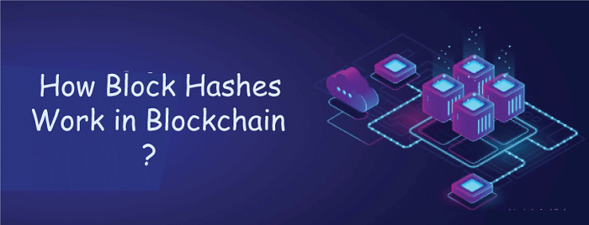

Blockchain is a breakthrough technology that has changed the way we think about digital security and trust. It is a distributed and decentralized ledger that enables the safe and transparent exchange of information and currency. Block hashes are at the foundation of blockchain technology, and they play a critical role in preserving the blockchain's integrity and immutability.

In this post, we will look at what block hashes are, how they operate, and why they are important in the blockchain.

## **What are Block Hashes?**

A block hash may be thought of as a special identification number that is given to each block on the blockchain. It is a cryptographic hash function that outputs a fixed-size block of data after taking in a block of data. This output is a distinct string of characters that acts as the block's digital fingerprint.

Block hashes are created by applying sophisticated mathematical methods that consider the block's data as well as a nonce value, a random integer that is added to the block to make sure the hash is generated only once.

## **How do Block Hashes Work?**

A cryptographic hash function is used to create the block hash whenever a new block is added to the blockchain. This function generates a fixed-size output after taking in the block's contents, including the transaction data, timestamp, and preceding block hash.

The block header is then updated to include this output in addition to other details like the nonce value and the current blockchain protocol version. A final block hash is then generated by performing another hash on the block header.

The block hash is then sent out to the network to be confirmed by other blockchain nodes. This verification procedure comprises determining if the block hash satisfies a set of predetermined standards, such as the degree of difficulty of the employed proof-of-work algorithm.

The block is uploaded to the blockchain when the block hash has been confirmed. The new block also contains the prior block's hash, resulting in a chain of blocks that are connected by their individual block hashes.

## **Significance of Block Hashes in Blockchain**

Block hashes are essential for maintaining the immutability and integrity of the blockchain. Every attempt to edit a block will cause the block hash to change since every block in the blockchain contains the hash of the preceding block. It will be nearly hard to tamper with the blockchain since other nodes in the network will instantly notice this change.

In the blockchain, consensus is also achieved via block hashes. The process of creating a block hash is computationally demanding and needs a substantial amount of processing power since the block hash is produced using a proof-of-work method. By doing so, the blockchain is protected against assaults from bad actors who could try to change it by adding or removing blocks.

## **Various advantages in Blockchain Technology**

In the blockchain, block hashes especially offer various advantages, including:

1. **Security:** Blockchain security is quite good thanks to block hashes. It becomes challenging for an attacker to modify a block without being noticed since each block is connected to the one before it using its hash. If a block is altered, the network will reject the change because the hash of the changed block differs from the hash of the original block.
2. **Immutability:** The immutability of the data contained in the blockchain is ensured through the use of block hashes. A block cannot be modified or removed from the blockchain once it has been added since doing so would invalidate the hash of all future blocks.
3. **Verification:** In the blockchain, block hashes are used for verification. A block's validity may be confirmed by nodes in the network by comparing its hash to the hash of the preceding block. The block is regarded as legitimate if the hash matches.
4. **Consensus:** The creation of a block hash needs a considerable amount of processing power. This ensures that the blockchain is decentralized and democratic by making it difficult for any single entity to dominate it.

Block hashes are a vital part of blockchain technology, to sum up. They offer a safe and open method for transferring and storing data in the digital world. Block hashes have the potential to completely change how we communicate and conduct business online by guaranteeing the immutability and security of the blockchain.

# **Blockchain Distributed ledger**

A distributed ledger is a type of database that is consensually **shared**, **replicated**, and **synchronized among** the members of a decentralized network. All the information on this ledger is securely and accurately stored using **cryptography**. This information can be accessed by using keys and cryptographic signatures. The distributed ledger allows transactions to have public **witnesses**, which makes cyberattack more difficult. It records the transactions such as the exchange of assets or data, among the participants in the network.

All the participants in the network govern and agreed-upon consensus on the updates to the records in the ledger. There is no **central authority**, or third-party mediators such as a financial institution or government agencies are involved. Every record in the distributed ledger has a **timestamp** and **unique** cryptographic signature. It makes the ledger an auditable, and immutable history of all transactions in the network.

Further, if any alterations made to the ledger, they are reflected and copied to all participants in seconds or minutes. In other words, when any modifications or updates happen in the ledger, each node constructs the new transaction, and then the nodes **vote by consensus algorithm** on which copy is correct. Once a consensus algorithm has been determined, all the other nodes update themselves with the new and correct copy of the ledger.

The primary advantage of the distributed ledger is the lack of central authority. As we know that centralized ledgers are prone to cyber-attack, distributed ledgers are inherently very hard to attack. It is because all the distributed copies need to be attacked simultaneously for an attack to be successful.

# **Basic Components of Bitcoin**

In this section, we are going to learn about the four basic components of bitcoin. These four elements will help us to understand the bitcoin blockchain in a more clear way.

Here, we are going to put up every object that we have learned previously in a single SCENE. As we know that a block is made up of hash and complex cryptography environment, but this is only the one side of the coin. The bitcoin blockchain is more interesting than we thought.

We can see the basic components of bitcoin in the following image:

1. Software
2. Cryptography
3. Hardware
4. Miners(Gaming Theory)

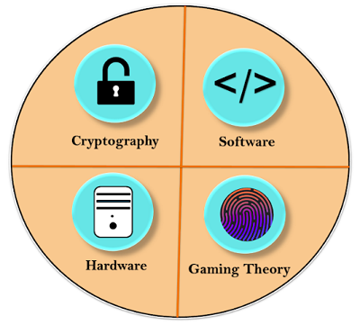

## **First Component: Software**

[Bitcoin](https://www.javatpoint.com/bitcoin) is basically a software at the core that defines what a bitcoin is, as well as how a bitcoin gets transferred. It identifies what the rules of a valid bitcoin, who can be inside bitcoin, who cannot be inside bitcoin, what is valid, what is not, etc. Everything is based on software, which is the bitcoin software. The bitcoin software is always operated in 24*7.

## **Second component: Cryptography**

The software, at its core, uses cryptography and bitcoin as a cryptocurrency. Bitcoin uses cryptography to regulate the transfer of bitcoin between parties, as well as the creation of new units of bitcoin. Without cryptography, Bitcoin would simply not be possible. So, we've got that this software uses cryptography to control the transfer of bitcoin over the internet.

Cryptography is a mathematical approach which is solvable by computers and not by humans. So all the stuff that protects your data is served by the cryptography.

## **Third Component: Hardware**

To run and solve cryptography, it needs HARDWARE. This hardware is composed of those thousands of miners around the world running their computers. So there are thousands of computers around the world that are basically running the Bitcoin software or the Bitcoin client. This hardware is specially designed for finding Nonce to validate block and hash. It requires a lot of CPU power to complete a simple task on the bitcoin blockchain.

If you try to mine bitcoin right now with your smartphone or home computer, then you will End up losing your computer along with a hefty electric bill.

## **Fourth Component: Mining(Gaming Theory)**

Miners are users who involved in a gaming theory because bitcoin is truly a game which is run by these miners around the world. In the above, we have seen that the first component is **software for bitcoin** that issues a cryptography challenge in every 10 minutes. The cryptography challenge involves in trying to find a Nonce which will make the hash for a specific block valid. All the hashes and validations are done by these miners. After successful creation of the block, the new block is added to the blockchain.

**Let's see how gaming theory works!**

* Bitcoin software creates a challenge. Now, there is a game begins, and there is a race that goes off. The race involves all these miners competing against each other to solve the challenges.
* This task or challenge will take approximately 10 minutes to be completed.
* Every single miner starts trying to find the solution to that one Nonce that will satisfy the hash for the block.
* At some specific point, one of those miners in the global community with higher speed and great hardware specs will solve the cryptography challenge and be the winner of that race.
* Now, the rest of the community will start verifying that block which is mined by the winner. This makes Bitcoin so strong, because in one stage of this cycle, the miners are competing against each other, and in the next stage of the cycle, the rest of the community rallies together to ensure that that solution is correct.
* If the Nonce is correct, it will end up with the new block which will be added to the blockchain.
* For this task or challenge, the winner will earn a reward. That reward is currently 12.5 bitcoins.

# **Blockchain Proof of work**

Proof of Work(PoW) is the **original consensus algorithm** in a blockchain network. The algorithm is used to confirm the transaction and creates a new block to the chain. In this algorithm, **minors** (a group of people) compete against each other to complete the transaction on the network. The process of competing against each other is called **mining**. As soon as miners successfully created a valid block, he gets **rewarded**. The most famous application of Proof of Work(PoW) is Bitcoin.

Producing proof of work can be a random process with low probability. In this, a lot of **trial and error** is required before a valid proof of work is generated. The main working principle of proof of work is a mathematical puzzle which can easily prove the solution. Proof of work can be implemented in a [blockchain](https://www.javatpoint.com/blockchain-tutorial) by the Hashcash proof of work system.

In the below image, you can see that this block is composed of a block number, data field, cryptographic hash associated with it and a nonce. The nonce is responsible for making the block valid.

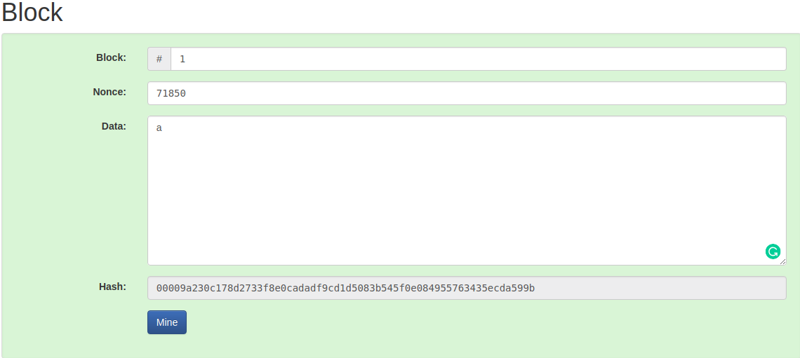

In the puzzle game, [bitcoin](https://www.javatpoint.com/bitcoin) software creates a challenge, and there is a game begins. This game involves all miners competing against each other to solve the challenges, and this challenge will take approximately 10 minutes to be completed. Every single miner starts trying to find the solution to that one Nonce that will satisfy the hash for the block. At some specific point, one of those miners in the global community with higher speed and great hardware specs will solve the cryptography challenge and be the winner of the game. Now, the rest of the community will start verifying that block which is mined by the winner. If the nonce is correct, it will end up with the new block that will be added to the blockchain. The concept of generating a block provides a clear explanation of proof of work(PoW).

# **Coinbase Transaction**

A coinbase transaction is the **first** transaction in a block. It is a **unique** type of bitcoin transaction that can be created by a miner. The miners use it to collect the block reward for their work and any other transaction fees collected by the miner are also sent in this transaction.

## **Explanation**

Each transaction executed on the [bitcoin](https://www.javatpoint.com/bitcoin) network are combined together to form a block. When a block is formed, immediately, it will be added in the blockchain. Now, these blocks are immutable and tamper-proof for all transactions that are made on the bitcoin network. Each block must contain one or more transactions, and the first transaction in the block is called the **coinbase transaction**.

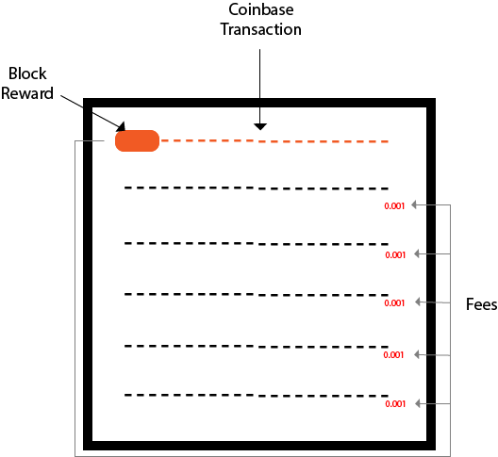

The miners are always responsible for creating a block. When a block is successfully created, he will be rewarded from bitcoin for their work. The bitcoin block reward is always dependent on the number of blocks from the **genesis block** and the number of fees included in the transactions of the block. The total amount of rewards that a miner will collect is the sum of the block reward and the transaction fees taken from all the transactions that have been included in the block.

In the start of the bitcoin, the block reward is 50 bitcoin per block. The block reward is reduced by half after every 210, 000 blocks, i.e. approximately in every four years. The current reward for successfully creating a block is 12.5 bitcoin. It will be going to get reduced 6.25 bitcoin per block in the year 2020.

There is one important feature of a coinbase transaction is that bitcoins involved in the transaction cannot be spent until they have received at least 100 block confirmations in the blockchain.

# **Key Concepts of Bitcoin**

There are four key concepts that you need to aware in Bitcoin. These are:

* Disintermediated
* Distributed
* Decentralized
* Trustless

## **Disintermediated**

When you send money to someone over the Internet, you need a third party like banks which manages all your transactions. But in [Bitcoin](https://www.javatpoint.com/bitcoin), you are doing transactions directly to another party over the Internet. This transaction takes place in the Bitcoin network. This network takes care of confirming and verifying that there was a true transfer of value between the two parties. This concept is called Disintermediated.

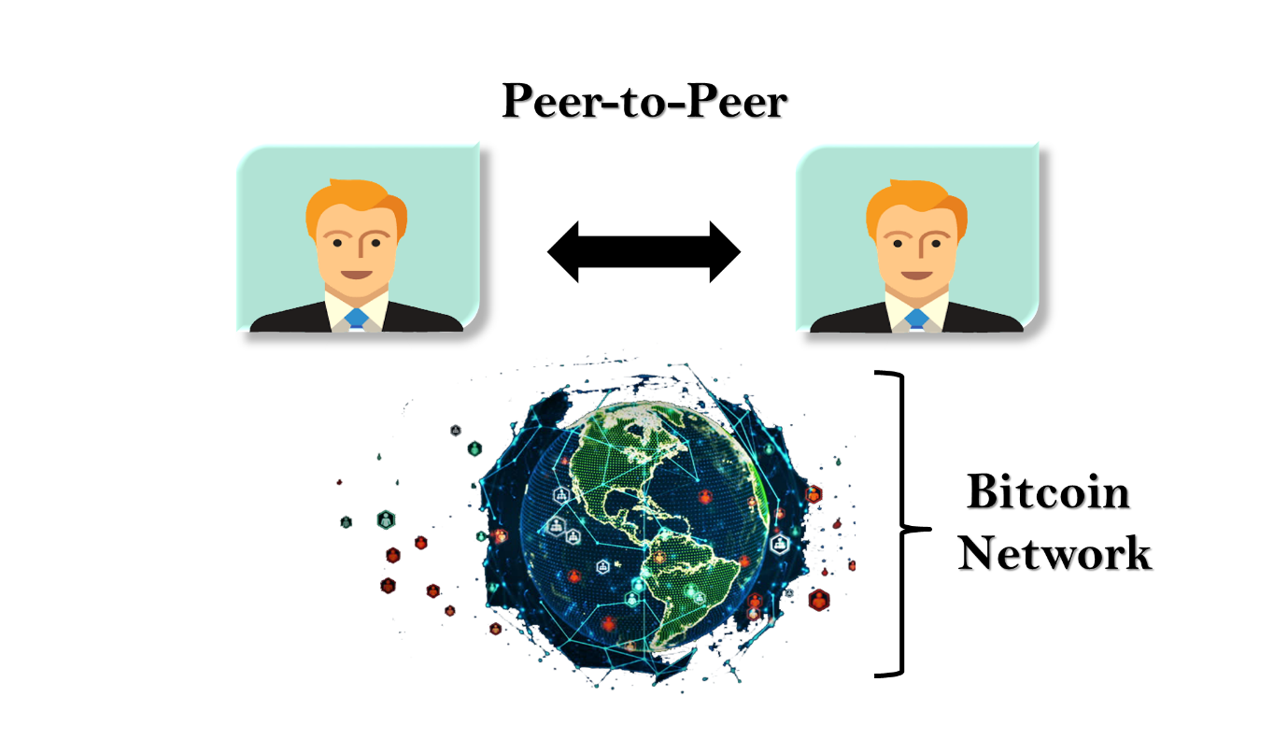

The Disintermediated is the act of removing the middleman. It is one of the key components that makes [blockchain](https://www.javatpoint.com/blockchain-tutorial) so valuable because it eliminates the unnecessary inefficiency that's involved when we are using a third-party during the transfer of value between parties.

## **Distributed**

The entire bitcoin network runs on a network of thousands of distributed computers which shares the work. So, instead of having one centralized computer which handles the workload, you are distributing it across multiple computers. The distributed network is more reliable because there is no single point of failure. Here, the work is shared across thousands of computers which are all running and sharing the workload.

## **Decentralized**

Bitcoin is decentralized. It means that there is no central control, no central repository of data and no management in the middle that overseeing what Bitcoin does. As a result, there is no central point of failure.

## **Trustless**

Bitcoin is Trustless because there is no need to have a third-party, such as a bank to certify and bring trust to the entire process of transactions. Instead, the blockchain and how Bitcoin process the transactions enable the trust is done by Distributed Trustless Consensus in which all the nodes agree that a transaction took place.

# **Blockchain Key Areas**

In the blockchain technology, bitcoin is the best-known implementation of the blockchain. There is a lot of development and the direction is based on the premise of what blockchain does to enable Bitcoin to happen. We can learn and expand how it can spread into so many different areas.

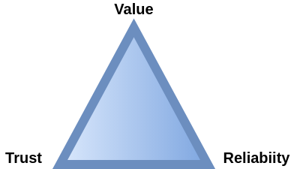

The blockchain technology fixes **three** things that the Internet was not designed to do. These three things are:

1. Value
2. Trust
3. Reliability

## **Value**

With blockchain, you can actually create value on a digital asset. The value can be controlled by that person who owns it. It enables a unique asset to be transferred over the internet without a middle centralized agent.

## **Trust**

Blockchain enables to securely assign ownership of a specific digital asset and be able to track who actually controls that asset at a time. In other words, blockchain creates a permanent, secure, unalterable record of who owns what. It uses advanced hash cryptography to preserve the integrity of the information.

## **Reliability**

Blockchain distributes their workload among thousands of different computers worldwide. It provides reliability because if you have everything localized in one location, it becomes a single point of failure. But, its decentralized network structure ensures that there is no single point of failure which could bring the entire system down.

# **Blockchain Cryptocurrency**

Cryptocurrency is a type of **digital asset** which is used to exchange value between parties. It uses strong **cryptography** to secure financial transactions and control the creation of new units of that currency and verify the transfer of assets. Cryptocurrency does not exist physically.

We know that the government prints the government currencies like fiat currency such as Dollar, Yen or Yuan itself. It means there is a centralized institution exists which can create thousands or millions or billions more of that currency. Unlike government currencies like bitcoin, these type of currencies is created by the same mathematical formulas that make the cryptocurrency work. Thus, cryptocurrencies use decentralized control, which works through distributed ledger technology that serves as a public financial transaction database.

Today, many different types of cryptocurrencies are available. Some of them are given below.

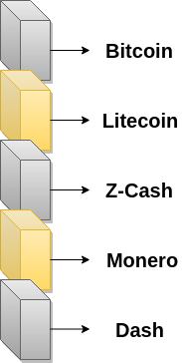

## **Bitcoin**



Bitcoin is generally known as the first decentralized cryptocurrencies. It is created by the network of thousands of specific nodes called **miners**. The miners can process the bitcoin transactions in the blockchain network. Since the release of bitcoin, more than **4000** alternative variants of bitcoin are available now.

## **Litecoin**



Litecoin cryptocurrency worked very similar to Bitcoin. We know that bitcoin wait **ten minutes** for a transaction block to be processed, but Litecoin can do this in maximum **two and a half minutes**. Litecoin doesn't have a big market cap. The price of Litecoin is lower than Bitcoin, but it's a very effective process and also has some variations from Bitcoin.

## **Z-Cash**

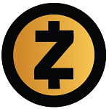

Z-Cash is a **privacy-protecting** digital currency which is built-on strong science in cryptography. It provides enhanced privacy for its users as compared to other cryptocurrencies such as bitcoin. Here, transaction data is kept confidential, which is made possible through **zero-knowledge proofs**. It allows transactions to be verified without any information about the sender, receiver, and the amount transacted.

Z-Cash features known as **viewing keys** and **payment disclosure** makes it possible to disclose some of the user's transaction data. It makes the transactions on Z-Cash auditable and regulation-compliant.

## **Monero**



Monero is an open-source cryptocurrency which focuses on **untraceable**, **privacy** and **decentralization**. It is fast, private, and secure digital cash, which is operated by a network of users. We can use it to buy and sell things and can exchange for other coins or tokens.

It uses a special kind of cryptography which ensures that the transactions remain 100% untraceable. It focuses on anonymity, which is harder to track, whereas Bitcoin is pseudonymous, which transactions are still traceable.

## **Dash**



Dash is a short form of **Digital Cash**. It is an open-source cryptocurrency and is a form of a decentralized autonomous organization which is run by a subset of users, called master nodes. It is one of the most promising alternative coins to bitcoin. It permits very fast transactions, which are untraceable.

# **Blockchain DAO**

The DAO stands for **Decentralized Autonomous Organization**. As the name implies, it is an organization which is both autonomous and decentralized. Sometimes, it is also known as **Decentralized Autonomous Corporation** (DAC), but the term DAO is more often used because not all organizations are corporations.

A DAO is an organization which is represented by rules encoded as a computer program that is transparent, controlled by shareholders, and not influenced by the central government. A DAO is the most complex form of a **smart contract**. A smart contract is a computer program that autonomously exists on the internet, but at the same time, it needs people to perform a task that it can't do by itself.

A DAO's financial transaction record and program rules are maintained on a blockchain. Since DAO runs on a blockchain, and it's running on a distributed network, you can have multiple combinations of different parties exchanging value and reaching agreements. It means that, to a Decentralized Autonomous Organization, it doesn't matter that you are a human being or you are a robot. You can actually have devices communicating with devices, or devices communicating with people, or people communicating with people.

## **How does DAO work?**

Decentralized Autonomous Organization runs through rules encoded as a computer program called Smart Contracts. A Smart Contract is an entity that lives on the internet and exists autonomously. It also has individuals to perform a certain task that the automation program itself cannot do.

**Let us take an example of Uber to understand the working of DAO**. Uber is an organization that allows you to call a car for yourself using a mobile app. Once you place your call, a driver will come up in a car, will pick you up and drive you to your destination. The app will take care of processing the payment, and the driver will be set off to go to the next rider. A mobile app runs the entire process. However, there is a human component, which is the driver that drives over and drives off.

Now, if you tie-in artificial intelligence, there is no reason to need a driver to come up and interact with you. You could have a self-driving car come over and pick you up. The whole thing is automated and self-executing so you can actually process the payment directly on the app and the car will interact with you directly, without requiring a human element. This type of process can be created into a Decentralized Autonomous Organization. Now, it doesn't necessarily mean that you need to be replaced by a computer. You could actually have multiple human beings on a distributed network, and those human beings will reach these agreements based on smart contracts between each other.

# **Limitation of Blockchain Technology**

Blockchain technology has enormous potential in creating trustless, decentralized applications. But it is not perfect. There are certain barriers which make the blockchain technology not the right choice and unusable for mainstream application. We can see the limitations of blockchain technology in the following image.

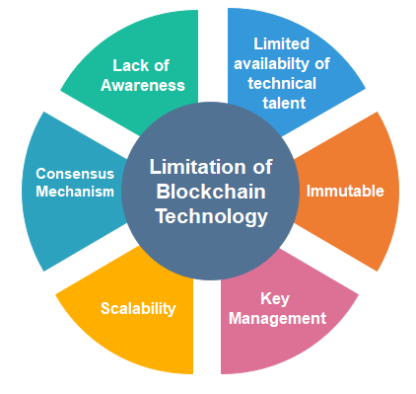

## **Lack of Awareness**

There is a lot of discussion about blockchain, but people do not know the true value of blockchain and how they could implement it in different situations.

## **Limited availability of technical talent**

Today, there are a lot of developers available who can do a lot of different things in every field. But in the blockchain technology, there are not so many developers available who have specialized expertise in blockchain technology. Hence, the lack of developers is a hindrance to developing anything on the blockchain.

## **Immutable**

In immutable, we cannot make any **modifications** to any of the records. It is very helpful if you want to keep the **integrity** of a record and make sure that nobody ever tampers with it. But immutability also has a drawback.

We can understand this, in the case, when you want to make any revisions, or want to go back and make any reversals. **For example**, you have processed payment and need to go back and make an amendment to change that payment.

## **Key Management**

As we know, blockchain is built on cryptography, which implies that there are different keys, such as public keys and private keys. When you are dealing with a private key, then you are also running the risk that somebody may lose access to your private key. It happens a lot in the early days when bitcoin wasn't worth that much. People would just collect a lot of bitcoin, and then suddenly forgot what the key was, and those may be worth millions of dollars today.

## **Scalability**

Blockchain like bitcoin has consensus mechanisms which require every participating node to verify the transaction. It limits the number of transactions a blockchain network can process. So bitcoin was not developed to do the large scale volumes of transactions that many of the other institutions are doing. Currently, bitcoin can process a maximum of **seven transactions per second**.

## **Consensus Mechanism**

In the blockchain, we know that a block can be created in every 10 minutes. It is because every transaction made must ensure that every block in the blockchain network must reach a common consensus. Depending on the network size and the number of blocks or nodes involved in a blockchain, the back-and-forth communications involved to attain a consensus can consume a considerable amount of time and resources.

# **Blockchain Double Spending**

Double spending means spending the same money twice. As we know, any transaction can be processed only in two ways. One is offline, and another is online.

**Offline:** A transaction which involves physical currency or cash is known as an offline transaction.

**Online:** A transaction which involves digital cash is known as an online transaction.

Let us consider this example:

You go to Restaurants and order a cappuccino worth $5. You pay in cash. The service provider at Restaurants instantly confirmed that you have paid, and you received your coffee in exchange for the money. Now is it possible to spend the same $5 somewhere else to make another purchase? The answer is **NO**. But what if the answer is **YES**? It means the same person can use the same cash more than one times. This type of problem is known as Double Spending Problem.

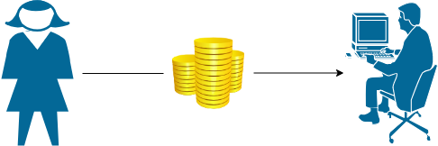

In a physical currency, the double-spending problem can never arise. But in digital cash-like bitcoin, the double-spending problem can arise. Hence, bitcoin transactions have a possibility of being copied and rebroadcasted. It opens up the possibility that the same BTC could be spent twice by its owner.

## **How Bitcoin handles the Double Spending Problem?**

Bitcoin handles the double-spending problem by implementing a confirmation mechanism and maintaining a universal ledger called blockchain.

Let us suppose you have 1 BTC and try to spend it twice. You made the 1 BTC transaction to Alice. Again, you sign and send the same 1 BTC transaction to Bob. Both transactions go into the pool of unconfirmed transactions where many unconfirmed transactions are stored already. The unconfirmed transactions are transactions which do not pick by anyone. Now, whichever transaction first got confirmations and was verified by miners, will be valid. Another transaction which could not get enough confirmations will be pulled out from the network. In this example, transaction T1 is valid, and Alice will receive the bitcoin.

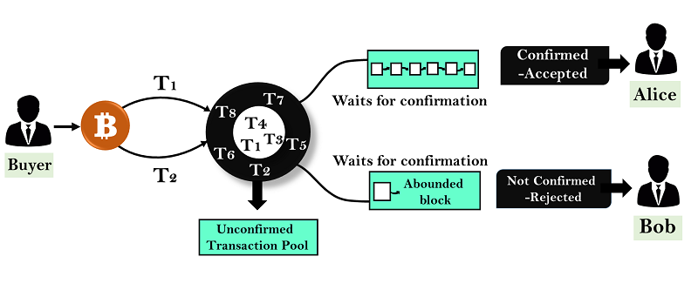

## **What happened if both the transactions are taken simultaneously by the miners?**

Suppose two different miners will pick both transactions at the same time and start creating a block. Now, when the block is confirmed, both Alice and Bob will wait for confirmation on their transaction. Whichever transaction first got confirmations will be validated first, and another transaction will be pulled out from the network.

Now suppose if both Alice and Bob received the first confirmation at the same time, then there is a race will be started between Alice and Bob. So, whichever transaction gets the maximum number of confirmations from the network will be included in the blockchain, and the other one will be discarded.

# **Blockchain Bitcoin Cash**

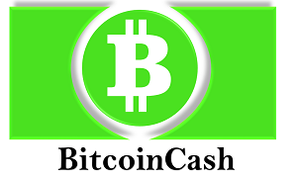

Bitcoin Cash is peer-to-peer **electronic cash** for the Internet. It is fully decentralized, with no central bank, and do not require any trusted third parties to operate.

Bitcoin Cash is a cryptocurrency developed from a **hard fork** of the bitcoin network. It came in existence from the mid of 2017. Bitcoin Cash is different from Bitcoin. It is the upgraded version of the bitcoin core software. It is **faster**, **cheaper** and **more reliable** to use. It increases the block size of bitcoin from 1 MB to 8 MB and allowing for around two million transactions to be processed per day.

## **How Bitcoin Cash came in existence?**

The Bitcoin blockchain is a constantly updated ledger, and all transactions that take place on the bitcoin network are listed there. In the bitcoin network, the first transaction block took place on **January 2009**, and each new blocks are added to this Bitcoin blockchain approximately every 10 minutes. The bitcoin protocol ensures that every single block which gets added to the blockchain is **valid** and conforms to the rules of bitcoin. Furthermore, each block that is added in the blockchain contains a cryptographic hash of the previous block.

On **August 1st, 2017**, at block number 478,558, there was a **split**. The ViaBTC pool produced a 1.9 MB block which is not valid on the legacy Bitcoin network because bitcoin has a 1 MB limit. This new block did not have the 1 MB limit, and instead, it included 1.9 MB. It causes a split which resulted in the creation of Bitcoin Cash. The computers that are mining Bitcoin Cash have a protocol that limits the block size at 8 MB rather than 1 MB.

## **What is a Bitcoin Hard Fork?**

A fork takes place when a blockchain splits into two different paths forward. In the case of bitcoin hard fork, to make transaction speeds faster on the network, one group(miners) within the bitcoin community wanted to increase the size of blocks on the bitcoin blockchain. As a result, the bitcoin blockchain may split into two different **versions**, resulting in two different chains with a separate coin in each one which gives birth of Bitcoin Cash.

As you can see in this diagram, there is a split that takes place on the network and essentially creates a new Blockchain with altered rules. The original and the forked version of the cryptocurrency had identical blockchains up to the block when the split occurred. After the split happened, everyone who held bitcoins before the hard fork, received the same amount of Bitcoin Cash tokens.

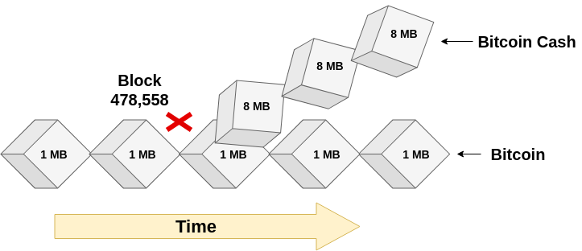

## **What differs Bitcoin Cash from other Cryptocurrencies?**

1. Bitcoin Cash is based on the Bitcoin original source code with the difference of bigger blocks (8MB) size.
2. In contrast to Bitcoin, bitcoin cash does not focus on becoming a store of value. Instead, its main aims are to be used for digital payments only.

# **Bitcoin Forks and SegWit**

In this section, we are going to learn about the bitcoin forks and Segregated Witness (SegWit). Let us first discuss what Bitcoin Forks is.

## **Bitcoin Forks**

A fork is a change to the digital currency software which creates two different paths of the blockchain with a shared history. The forks can be temporary, or lasting for a few minutes, or can be permanent.

There are many reasons why a fork happens. The changes made to the bitcoin software can require either a **Soft Fork** or **Hard Fork**.

### **Soft Fork**

A soft fork introduces a change which is **backwards compatible** with the previous version. It means there is no need to upgrade the older version of the bitcoin software necessarily. The users who are running the older version of the software will still recognize new blocks created by computers. It is called **soft** because both groups of users(old and new users) will continue to mine new blocks on the same blockchain. As they remain part of the same network, a soft fork will never result in the formation of a new digital currency.

A soft fork is considered complete when the majority of nodes in the bitcoin network have updated their software. If this doesn't happen, the minority group may eventually decide to abandon the proposed update or move to implement a hard fork instead.

### **Hard Fork**

A hard fork introduces a change that forces everyone to **upgrade** the software. The hard fork is not backwards compatible with older versions of the software. The users who are running the older version of the software in the Bitcoin network needs to upgrade their software to recognize new blocks.

As a result, hard forks lead to a **split** in the blockchain network with a group of users to form a cryptocurrency. The new network takes an exact copy of the blockchain as it was at the point of the split, and after that, both versions remain separate. Users who owned bitcoin at the time of the split can often claim new coins on the forked network.

## **Segregated Witness**

The concept of Segregated Witness is invented by **Pieter Wuille**, who is a part of the bitcoin core development team since **2011**. SegWit(Segregated Witness) is a **protocol upgrade** that changes the structure of bitcoin transaction data. It was activated on bitcoin on **23 August 2017** and characterized as a soft fork in the bitcoin chain, and then it has been widely accepted by bitcoin miners and users.

The segregated witness improves the scalability of bitcoin without increasing the block size. If it is **activated**, then it will fixed transaction malleability. It does this by allowing transaction-producing software to separate transaction signatures from the part of the data in a transaction that is covered by the transaction id and storing it outside the base transaction block.

The soft fork that was represented for segregated witness does not require upgrading to remain on the blockchain. It means that if miners have not upgraded the segregated witness can still remain on the blockchain. They won't have access all the functionality that segregated witness can provide and also being able to participate in segregated witness transaction. However, they would still be able to validate the block that does not include the segregated witness information in them.

Now, we analyze about the segregated witness. To do this, let us first understand the contents of the bitcoin transaction. There are **three** main components of the bitcoin transaction. They are

1. **Input:** Where the coin/funds are coming from.
2. **Amount:** How many bitcoins are coming from the source.
3. **Output:** Where that bitcoin are actually headed.

A transaction is very similar to a **bank check**, which contains inputs, amount, and output. For the transaction to happen, someone who has bitcoin needs to **sign** that transaction. The signature makes sure that your bitcoin cannot be used by someone who is not authorized. It is because you have the private keys that can be controlled by you only.

Now in SegWit transaction, the digital signature needs to be segregated from the transaction data. It would increase the 1 MB limit for block sizes. The digital signature freezes up about 60-65% of the space in a given transaction. SegWit transaction ignores the data attached to a signature by pulled out the signature from within the input and moving it to a structure towards the end of a transaction. It also solves the problem where a receiver could intercept and modify the sender's transaction ID to get more coins from the sender. Since the digital signature would be detached from the input, the unauthorized party would have no way of changing the transaction ID without also nullifying the digital signature.

# **Blockchain Merkle Tree**

Merkle tree is a fundamental part of blockchain technology. It is a mathematical **data structure** composed of hashes of different blocks of data, and which serves as a summary of all the transactions in a block. It also allows for efficient and secure verification of content in a large body of data. It also helps to verify the consistency and content of the data. Both Bitcoin and Ethereum use Merkle Trees structure. Merkle Tree is also known as **Hash Tree**.

The concept of Merkle Tree is named after **Ralph Merkle**, who patented the idea in **1979**. Fundamentally, it is a data structure tree in which every **leaf node** labelled with the hash of a data block, and the **non-leaf node** labelled with the cryptographic hash of the labels of its child nodes. The leaf nodes are the lowest node in the tree.

## **How do Merkle trees work?**

A Merkle tree stores all the transactions in a block by producing a digital fingerprint of the entire set of transactions. It allows the user to verify whether a transaction can be included in a block or not.

Merkle trees are created by repeatedly calculating hashing pairs of nodes until there is only one hash left. This hash is called the Merkle Root, or the Root Hash. The Merkle Trees are constructed in a bottom-up approach.

Every leaf node is a hash of transactional data, and the non-leaf node is a hash of its previous hashes. Merkle trees are in a binary tree, so it requires an even number of leaf nodes. If there is an odd number of transactions, the last hash will be duplicated once to create an even number of leaf nodes.

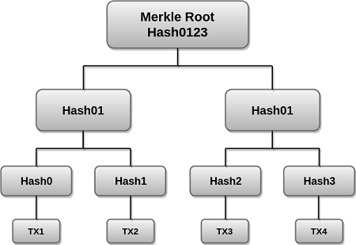

The above example is the most common and simple form of a Merkle tree, i.e., **Binary Merkle Tree**. There are four transactions in a block: **TX1**, **TX2**, **TX3**, and **TX4**. Here you can see, there is a top hash which is the hash of the entire tree, known as the **Root Hash**, or the **Merkle Root**. Each of these is repeatedly hashed, and stored in each leaf node, resulting in Hash 0, 1, 2, and 3. Consecutive pairs of leaf nodes are then summarized in a parent node by hashing **Hash0** and **Hash1**, resulting in **Hash01**, and separately hashing **Hash2** and **Hash3**, resulting in **Hash23**. The two hashes (**Hash01** and **Hash23**) are then hashed again to produce the Root Hash or the Merkle Root.

Merkle Root is stored in the **block header**. The block header is the part of the bitcoin block which gets hash in the process of mining. It contains the hash of the last block, a Nonce, and the Root Hash of all the transactions in the current block in a Merkle Tree. So having the Merkle root in block header makes the transaction **tamper-proof**. As this Root Hash includes the hashes of all the transactions within the block, these transactions may result in saving the disk space.

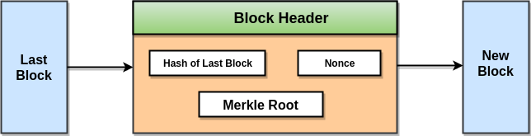

The Merkle Tree maintains the **integrity** of the data. If any single detail of transactions or order of the transaction's changes, then these changes reflected in the hash of that transaction. This change would cascade up the Merkle Tree to the Merkle Root, changing the value of the Merkle root and thus invalidating the block. So everyone can see that Merkle tree allows for a quick and simple test of whether a specific transaction is included in the set or not.

**Merkle trees have three benefits:**

* It provides a means to maintain the integrity and validity of data.
* It helps in saving the memory or disk space as the proofs, computationally easy and fast.
* Their proofs and management require tiny amounts of information to be transmitted across networks.

# **Difference between Blockchain and Database**

## **Blockchain**

A blockchain is a database or a ledger that stores information in a data structure called blocks. It is based on distributed ledger technology which can be used between parties that don't trust each other with data. It is because when you add anything onto the blockchain, it requires verification from all other users available on the network.

Blockchain keeps information permanently in uniformly sized blocks, where each block stores the hashed information from the previous block to provide cryptographic security. The blockchain hashing uses **SHA256** hashing algorithm, which is a one-way hash function. The hashed information is the data and a digital signature from the previous block. The hashes of previous blocks that go back to the very first block produced in the blockchain are known as the **genesis block**. A blockchain data structure is in the form of a Merkle Tree, which is used as an efficient way to verify data.

**Advantage of Blockchain**

Blockchain technology has become popular because of the following.

* **Time reduction:** In the financial industry, blockchain can allow the quicker settlement of trades. It does not take a lengthy process for verification, settlement, and clearance.
* **Unchangeable transactions:** Blockchain only allows insertion of data, which means when a new block is added to the chain of ledgers, it cannot be removed or modified.
* **Reliability:** Blockchain certifies and verifies the identities of each interested parties. This removes double records, reducing rates and accelerates transactions.
* **Security:** Blockchain uses very advanced cryptography to make sure that the information is locked inside the blockchain. It uses Distributed Ledger Technology where each party holds a copy of the original chain, so the system remains operative, even the large number of other nodes fall.
* **Decentralized:** It is because there is no central authority supervising anything. There are standards rules on how every node exchanges the blockchain information.

## **Databases**

A database is a kind of central ledger where the administrator manages everything. Here the administrator gives rights to read, write, update, or delete operation. Since it is centralized in nature, their maintenance is easy, and output is high. But it also has a drawback which, when corrupted, can compromise the entire data and can even change the ownership of digital records.

A database uses a client-server network architecture. Here database administrator has rights to make changes in any part of the data and its structure.

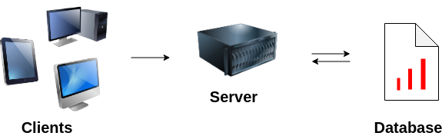

**Advantage of Database**

The database has become popular because of the following.

* **Controls database redundancy:** It is because it stores all the data in one single database file and that recorded data is placed in the database.
* **Data sharing:** In DBMS, the authorized users of an organization can share the data among multiple users.
* **Easily Maintenance:** It can be easily maintainable due to the centralized nature of the database system.
* **Reduce time:** It reduces development time and maintenance need.
* **Backup:** It provides backup and recovery subsystems which create an automatic backup of data from hardware and software failures and restores the data if required.
* **Multiple user interfaces:** It provides different types of user interfaces like graphical user interfaces, application program interfaces.

## **Blockchain vs Database**

We can see the difference between blockchain and database in the below table.

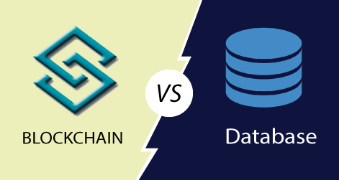

|  |  |  |
| --- | --- | --- |
| **SN** | **Blockchain** | **Database** |
| 1. | Blockchain is decentralized because there is no admin or in-charge. | The database is centralized because it has admins and in-charge. |
| 2. | Blockchain is permissionless because anyone can access it. | The database required permission because it can be accessed only by entities who have rights to access. |
| 3. | Blockchains are slow. | Databases are fast. |
| 4. | It has a history of records and ownership of digital records. | It has no history of records and ownership of records. |
| 5. | Blockchain is fully confidential. | The database is not fully confidential. |
| 6. | Blockchain has only Insert operation. | The database has Create, Read, Update, and Delete operation. |
| 7. | It is a fully robust technology. | It is not entirely robust technology. |
| 8. | Disintermediation is allowed with blockchain. | Disintermediation is not allowed with the database. |
| 9. | Anyone with the right proof of work can write on the blockchain. | Only entities entitled to read or write can do so. |
| 10. | Blockchain is not recursive. Here, we cannot go back to repeat a task on any record. | The database is recursive. Here, we can go back to repeat a task on a particular record. |

# **Bitcoin Mitigating Attacks**

Bitcoin is the most secure cryptocurrency, which provides security at multiple levels of the protocol. It is often rendering sustained sophisticated attacks. In this section, we are going to look at various types of probable attacks in the bitcoin system.

## **The Sybil Attack**

The Sybil attack happens in the peer-to-peer network. A malicious attacker wishes to carry out this attack on the bitcoin network. In this, a node in the network operates multiple identities at the same time and undermines the authority in the reputation system. Its main aim is to gain the majority of influence in the network to carry out illegal actions in the system.

The Sybil attack is difficult to detect and prevent, but the following measures can be useful:

ADVERTISEMENT

ADVERTISEMENT

* By increasing the cost of creating a new identity.
* Require validation of identities or trust for joining the network.
* Give different power to different members.

## **Race Attack**

The Race Attack requires the recipients to accept unconfirmed transactions as payment. As an attacker, you can send the same coin to different vendors by using the two different machines. If the vendors deliver the things without waiting for block confirmation, they will soon realize that the transaction was rejected during the mining process. The solution to this is that the vendor must wait for at least one block confirmation before sending things.

This attack is easier to pull off when the attacker has a direct connection to the victim's node. Therefore it is recommended to turn off incoming connections to nodes for receiving payments so that your node will identify their own peers. And it does not allow the payer to submit the payment to the payee directly.

## **Finney Attack**

The Finney attack is named after **Hal Finney**. The Finney attack is one of the types of double-spending problem. In this attack, the attacker is the miner who mines blocks normally. In the block, he includes a transaction which sends some of his coins back to himself without broadcasting the transaction. When he finds a pre-mined block, he sends the same coins in a second transaction. The second transaction would be rejected by other miners, but this will take some time. To prevent this attack, the seller should wait for at least six blocks confirmation before releasing the goods.

## **Vector76 Attack**

The Vector76 attack is a combination of the **Race attack** and the **Finney attack** such that a transaction that even has one confirmation can still be reversed. In this attack, a miner creates two nodes, one of which is connected to the exchange node, and the other is connected to well-connected peers in the blockchain network. Now, the miner creates two transactions, one high value, and one low value. Then, the attacker pre-mines a high-value transaction to an exchange service. When a block is announced, he quickly sends the pre-mined block directly to the exchange service. When exchange service confirms the high-value transaction, the corrupted attacker sends a low-value transaction to the blockchain network that finally rejects the high-value transaction. As a result, the corrupted attacker's account is deposited on the amount of the high-value transaction. This attack can be protected by disabling the incoming connections and only connecting to well-connected nodes.

## **The 51% Attack**

The 51% attack is a potential attack on the blockchain network. It refers to a single miner or group of miners who are trying to control more than 50% of a network's mining power, computing power or hash rate. In this attack, the attacker can block new transactions from taking place or being confirmed. They are also able to reverse the transactions that have already confirmed while they were in control of the network, leading to a double-spending problem.

When a miner forms a valid block of transactions, the individual will broadcast the block to other miners on the network. It can only be accepted if all transactions in a block are valid according to the existing record on a blockchain. However, a corrupt minor with more than 50% of a network's hash rate does not broadcast solutions to the rest of the network. It results in the formation of two versions of the blockchain. One is the public version of the blockchain, which is being followed by legitimate miners. And second is used by the corrupt miners who are not broadcasting it to the rest of the network.

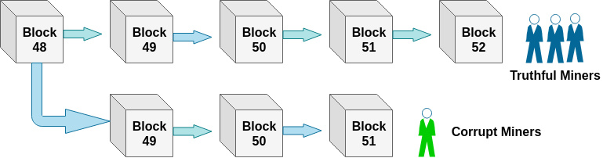

This type of attack is fictitious because it is costly to acquire computing power, which has more than 50% of the computing power of the entire network.

# **Who sets the Bitcoin Price**

Bitcoin is like a commodity. The price of bitcoin is determined by the market in which it trades. In other words, its price is determined by how much someone is willing to pay for that bitcoin. The market sets the price of bitcoin as same as Gold, Oil, Sugar, Grains, etc. is determined. Bitcoin, like any other market, is subject to the rules of supply and demand. i.e.

1. More Demand, Less Supply = Price Goes Up
2. More Supply, Less Demand = Price Goes Down

No one, in particular, sets the bitcoin's price nor we can trade it in one place. Each market/exchange determines its price based on supply and demand. Traders can buy and sell [bitcoin](https://www.javatpoint.com/bitcoin) on the **Luno Exchange**.

If you want to buy and selling bitcoin, you must have to choose a particular exchange. **For example**, the Luno exchange sets a specific price at a specific time for a specific market. Here, you have not confused that Luno exchange fixes the bitcoin price. Instead, the traders who are buying and selling on Luno exchange sets the price. The price of bitcoin can fluctuate at the moment, which is depending on who you talk to, and it is often different from country to country.

#### Note:**If a bitcoin owner sets the prices of their coin too high, no one will buy it. The owner will either have to reduce their price to a reasonable rate or just go without a sale. If the owner set the price too low, the coin will sell immediately and be taken off the market.**

## **Why does the price of bitcoin change so often?**

It is because the price of a bitcoin is very **volatile**. Since the number of bitcoins is limited in circulation, new bitcoins are created at a decreasing rate. It means that demand must follow this level of inflation to keep the price stable. The bitcoin market is still relatively small as compared to other industries. Therefore it does not take significant amounts of money to move the market price up or down. Thus, the price of a bitcoin is still very volatile.

It is not only the bitcoin exchange rate seems to change from day-to-day. There is also the price of many things, such as stocks, currencies, gold and many other products can be volatile. It can be moving up and down a lot against a base currency (such as the US dollar).

**Some of the factors behind bitcoin volatility are:**

* Bad news hurts adoption rate. The news that scare Bitcoin users include geopolitical events and statements by governments who are regulating the bitcoin.
* There is an uncertainty of future bitcoin's value.
* Large currency holder risks. It means the bitcoin investors who have holding a large currency is not much clear how they would liquidate it into fiat currency without severely moving the market.

# **Getting Started With Bitcoin**

The objective of this section is to show you a little bit about how you can get started with Bitcoin. The below image shows you how to start with bitcoin.

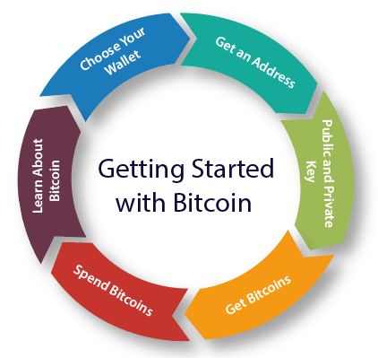

### **1. Learn About Bitcoin**

Bitcoin has some peculiar qualities. It behaves a lot like money, but it is different from money. **For example:** with [bitcoin](https://www.javatpoint.com/bitcoin), we cannot reverse any transactions after adding on the blockchain. Every transaction in the blockchain network is permanent. It makes the blockchain different from actually sending of money with a bank where you may issue a stop payment or reversal of it's a wrong payment. Bitcoin is also fast and efficient as compared to physical currency.

### **2. Choose Your Wallet**

After learning about Bitcoin, the first thing you need to do is to **install a wallet**. The wallet is a type of software that you install on your mobile device or your computer. It enables you to get into Bitcoin and create your own **addresses**.

### **3. Get an Address**

An address in Bitcoin is very similar to an **e-mail address**, which is used to receive bitcoin. As opposed to an e-mail address where you have one e-mail address, you can have multiple addresses in bitcoin. It's a good practice to have multiple addresses for different needs. You may use bitcoin address for every single transaction you use.

### **4. Public and Private Key**

When you open up your wallet, you will receive two valuable pieces of information. One of them is the **public key**, and another one is the **private key**. This information makes Bitcoin more interesting. With most businesses and different organizations, you need to have a **password** which you share with the people who are running the organization. So you can click on **Retrieve my password**, and you can get it back. But in the case of bitcoin, you will get keys instead of a password. The public key that you can share with everybody, and a private key which only you know. The private key is an alphanumeric sequence which knows only you, and with them, you can remain completely in control of all the funds that go into your wallet.

### **5. Get bitcoins**

Once you have your wallet, you can get bitcoins. There are different ways to get bitcoins. You can earn Bitcoins by doing a job or getting paid. You can also buy bitcoins it means you could go to an exchange and get bitcoin by put in dollars or whatever currency into bitcoin. You can also gift bitcoins and can receive them from others. So these are ways of getting bitcoin.

### **6. Spend bitcoins**

Here, we are going to know about how you can spend bitcoin. You can send bitcoin to anyone. You can use bitcoin over millions of businesses at this moment Worldwide. Many of the best-known brands like Microsoft and Dell take bitcoin as payment. You can also use bitcoin to send payments and paying bills. It works great if you are actually sending payments to people in different currencies globally. You don't have to worry about having to change into different currencies. You can just pay in Bitcoin, and it's universal around the world.

# **How to Choose Bitcoin Wallet**

In this section, we are going to learn the process of choosing the bitcoin wallet. If you want to involve in bitcoin, you need to have a wallet. A wallet allows you to receive bitcoins, send bitcoins, store bitcoins. Here, I will take an example of a page called **bitcoin.org** to choose the wallet.

Bitcoin.org is a website that was developed by **Satoshi Nakamoto** and **Martti Malmi**. Now, Martti's is no longer an active developer, but he maintains the Bitcoin.org websites. He is not involved in developing bitcoin. Bitcoin.org website is not tied into any specific core developers. It's an open-source project which is handled by a global community.

Bitcoin.org is a very good starting point to explain how to choose your wallet because there is a lot of options available. In this page, we will go to an option called **Choose your wallet**. We can see this in the below image.

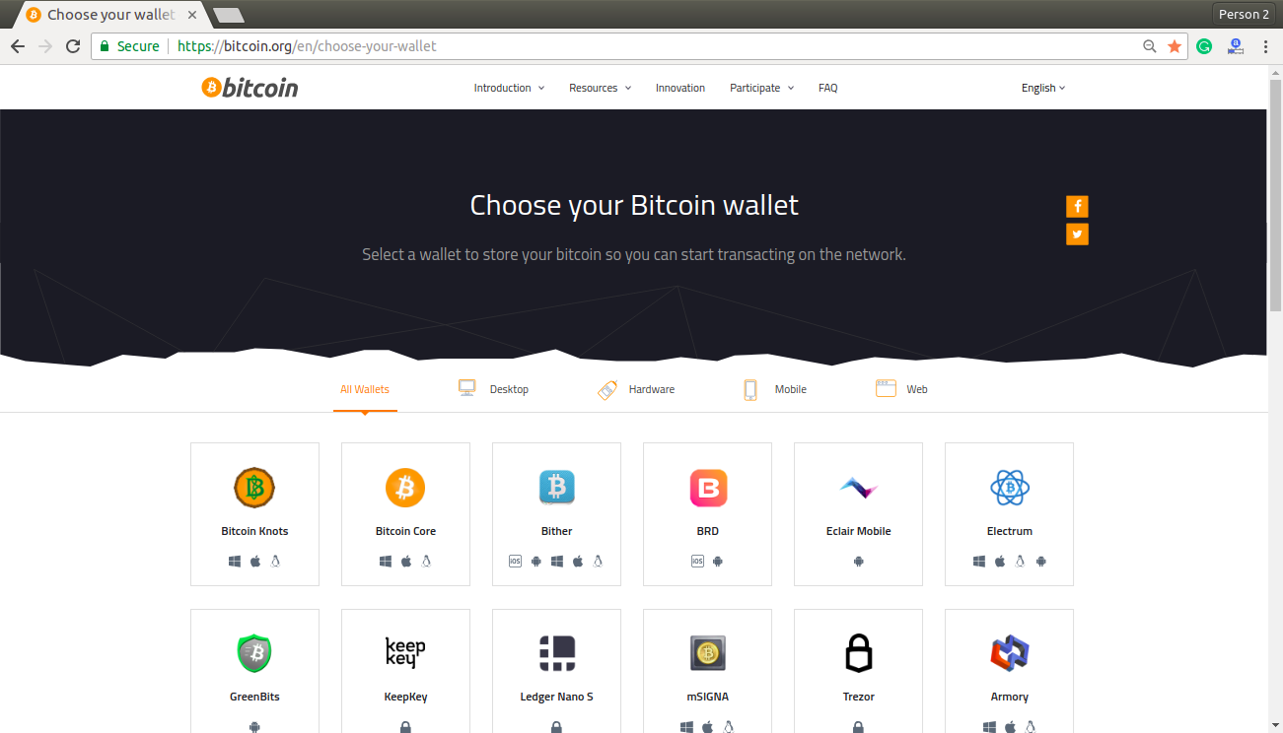

In the above image, we can see that there are different types of wallets that you can choose, like **Desktop wallet**, **Mobile wallet**, **Web wallet**, **Hardware wallet**, etc.

### **Mobile wallet**

In the mobile wallet, you can run any type of application, whether it is on Android, iOS, Windows, or even on Blackberry. They are significantly smaller and simpler and serve as a convenient on-the-go wallet for daily usage.

Popular Mobile wallets are Bitpay, BTC.com, Edge, Electrum, Mycelium, Bitcoin Wallet, etc.

### **Desktop wallet**

In the desktop wallet, you can run it on your desktop or laptop computer for Windows, Mac, and Linux. Generally, they are secure, but sometimes they are vulnerable to various malware and computer viruses.

Popular Desktop wallets are Bitcoin Core, Bitcoin Knots, mSIGNA, Armory, etc.

### **Hardware wallet**

In a hardware wallet, there are devices which contain your private keys. The hardware wallets are the most secure wallets, but it will also cost money.

Popular hardware wallets are BitBox, Keepkey, Trezor, Ledger Nano S, etc.

ADVERTISEMENT

### **Web wallet**

The web wallets are online wallets that are considered less secure than other types of wallets, yet they can be highly convenient.

Popular web wallets are Guarda, Coinbase, GreenAddress, Binance, etc.

There are multiple different wallet options available which you can have and install on your mobile device, or on your computer or a web one. There is not necessary to have only one wallet. You can have multiple wallets for different needs. It helps you to spread the risk by not keeping all of your personal crypto's in one location but across different locations(wallets). You can create a wallet in any of these options that you find. If you wish, you can open up another wallet elsewhere and can send coins to a different wallet.

If you want to get started fast, select one of the wallet options that are available here. I would recommend you to try one of the web wallet options that are presented here. In the wallet, open up an account and try to send bitcoin to someone, buy bitcoin from someone, and store bitcoin into your wallet.

**To select a reliable Bitcoin wallet, one should judge it based on the following criteria:**

* **Hot/Cold Wallet:** Whether a wallet is a hot(Online storage) or cold(offline storage).
* **Control private keys:** A wallet where you own and control your keys.
* **Backup & security features:** Here, you can seed backup keys and pin codes.
* **Developer community:** It is an active development community for maintenance.
* **Compatibility:** It can be compatible with different operating systems.
* **HD Wallet:** It is a wallet that generates new addresses itself.
* **KYC:** A wallet that doesn't require KYC.

# **Sending and Receiving Bitcoin**

Sending and receiving bitcoin is one of the core building blocks of any bitcoin application. Sending and receiving bitcoins securely over the internet gives you a bitcoin value. To send and receive bitcoin, you need to have a wallet where you need to put the public address of the sender and recipient. The process of sending and receiving bitcoin can differ between wallets to wallets, but the general steps are given below.

**Step-1** Log-in into your wallet.

**Step-2** Go to Send and Receive icon.

**Step-3** Choose whether you want to send or receive bitcoin.

**Step-4** **Send bitcoin:** Enter the public address of the recipient and choose the amount which you want to send. Once you decide the amount, confirm the amount to avoid mistakes, then click on send transaction, and verify the transaction one last time for confirming your public address and sender's public address.

**Step-5** **Receive bitcoin:** To receive bitcoin, you need to share your public wallet address with the sender. You can also do this by letting them scan a QR code.

### **For example:**

Alice wants to send five bitcoins to Ben. She is sending five bitcoins because she may have bought a product or paying him for services. For sending those five bitcoins, Alice needs to have five bitcoins in her wallet, and can also be able to receive bitcoins in her wallet. Now she could have bought bitcoins, or she could have received bitcoins as payment.

Here, we are assuming that Alice has 20 bitcoins in her wallet. When the wallet is created, it assigns two keys. One is the **public key** which is used to receive bitcoins. And second is the **private key** which is used to sign and authorize to send or spend those bitcoins to other people. We know that Alice has the private key to her wallet, so she is able to spend those bitcoins.

Ben can receive five bitcoins if he has a wallet of his own, which allows him to get bitcoins from anyone else. Ben also has a private key for his wallet that will enable him to spend those bitcoins that he has in his wallet. Ben's private key is completely different from Alice's private key. Now, if Ben wants to receive five bitcoins from Alice, he needs to provide his Bitcoin address to Alice. The [bitcoin](https://www.javatpoint.com/bitcoin) address is used for receiving money, which is a hashed version of the public key. Ben has the option to generate a new bitcoin address for every single transaction if he wants. Creating the new bitcoin address for every transaction is a good security recommendation in terms of privacy.

Ben can share his bitcoin address in two ways. He can share an **alphanumeric code** which starts with the number one and ends in the letter H, and another one is the **QR code**. The alphanumeric code is always different for every single bitcoin address, and these addresses are typically between 26 to 35 characters in length. The bitcoin address which you see numerically is the Ben address used to receive bitcoins from Alice.

Now, when Alice sends the five bitcoins to that address, she creates a transaction. She is able to do this transaction because she can access the private key and can authorize to transfer five bitcoins on Ben's bitcoin address. So, a new transaction shows that from Alice's wallet, five bitcoins are being sent to Ben's wallet. The transaction at that point gets sent out into the network, and the miners begin mining blocks. When the first block comes in and includes that transaction in it, then the transaction is said to be confirmed.

# **Converting Bitcoins to Fiat Currency**

In this section, we are going first to understand the meaning of **Fiat** or **Fiat Currency**.

Fiat currency is a currency which is issued by a government to be legal tender in the territories controlled by it. Fiat money that has value only because of government regulation or law is not backed by a physical commodity, such as gold or silver. The value of fiat money is derived from the relationship between **supply** and **demand** and the stability of the issuing government rather than the worth of a commodity backing it. It is based on the faith and credit of the economy. Most modern paper currencies are fiat currencies.

Every [cryptocurrency](https://www.javatpoint.com/blockchain-cryptocurrency) newcomers want to know how to cash out bitcoin or withdraw from bitcoins into fiat currency(USD, EUR, INR) which will be acceptable in their native countries. There are some easy ways to convert BTC into USD, INR, EUR or GBP, some of them are listed below. Before picking any of the listed methods, you need to find out how you want to receive your fiat currency. You can sell Bitcoins in person for cash or can sell it on exchanges and get the money directly into your bank account. You can also spend your [Bitcoin](https://www.javatpoint.com/bitcoin) to buy stuff from Amazon.



## **Cryptocurrency Exchange**

The first one is to use a cryptocurrency exchange. Whenever you want to go on a business trip or other countries, the first thing you need to do is that you have to go to a currency exchange centre. The exchange centre switches your local currency with the currency of that country where you are visiting. It's the same thing with bitcoin. There are cryptocurrency exchanges that will convert your cryptocurrency into your local currency such as US dollars, euros or yen. There are many options available to do the exchanges of your currencies, such as Coinbase. The Coinbase is available in over 30 different countries, which can easily convert your bitcoins into currency and deposit it directly into your bank account. There are other alternatives available such as Kraken, Gemini, BitStamp.

## **Bitcoin Debit Card**

It is also used to convert your bitcoin into fiat currency. The bitcoin debit cards allow their users to deposit their crypto coins via an online website which automatically converts them into a fiat currency such as Dollar or Euro. There are multiple options available for this. **For example,** Coinbase offers a Visa Bitcoin debit card. This card enables you to keep your holdings in bitcoin, and you can be paying anywhere that accepts Visa using your Bitcoin debit card.

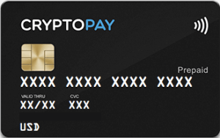

## **Selling Bitcoins**

The next option is to sell your bitcoins to someone else. As we know that, you can transfer bitcoin directly to another person without involving the services of a **third-party** such as a bank or a credit card. So you simply need to find out somebody who wants to buy your Bitcoins. When the buyer is available, you can transfer your bitcoins directly into their wallet and can get paid for that. In this type of transfer, there are some **security risks** involved because when you do a transfer of bitcoin to someone else, that transaction is **irreversible**. So if you send your bitcoins to someone else and that person does not pay you for the bitcoins, then there is no way to retrieve your bitcoins back. So whenever you are going to sell bitcoins to someone else whether it's a family member, a friend, or some other person, make sure that you can trust on this person, and you are going to get paid for the bitcoins that you send.

## **Bitcoin ATMs**

Bitcoin ATM is also known as **BTMs** or **Bitcoin Teller Machines**. It is a machine where you can buy bitcoins or can sell your bitcoins. Bitcoin ATMs are available in most major cities around the world. The bitcoin **ATMs** provides a relatively fast and easiest way to quickly withdraw funds in your local fiat currency against your bitcoin holdings. Many Bitcoin ATMs also allow users to buy Bitcoin with money in much the same way as someone deposit money into their bank account at a regular ATM.

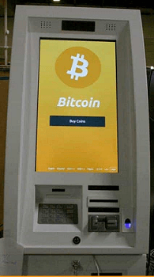

# **Ethereum 2.0**

## **What is Eth2?**

Eth2 pertains to a series of updates that will improve Ethereum's scalability, security, and long-term viability. Numerous teams from around the Ethereum network are working on these enhancements.

Ethereum 2.0 (ETH2) is a system update that attempts to enhance the safety and manageability of the Ethereum blockchain. A holding mechanism will replace Ethereum's existing mining process as part of this development.

## **What Exactly do You have to Accomplish?**

You do not have to do something if you're a digital asset customer or have ETH. If you're a programmer or would like to initiate mining, several options are available nowadays.

## **Difference between Ethereum (ETH) and Ethereum2 (ETH2)**

ETH2 denotes ETH that has been staked. Our users can earn incentives by staking their ETH with Coinbase. The ETH is converted to ETH2 when you stake it. The cost of ETH2 is the same as the cost of ETH. The ETH2 will regress to ETH that once Ethereum system advancement is comprehensive.

## **What is Staking Process?**

On a PoS (proof-of-stake) blockchain, staking is the act of intentionally engaging in purchasing guidelines (equivalent to extraction). Anyone with a minimum needed crypto value can conduct transactions and gain Protecting payments on these blockchain systems.

## **How does Staking Work on Coinbase?**

Stacking works on the coinbase in the following way:

* When a network node budget range is reached, it spends that currency in the chain like a security deposit.
* The probability of a node being selected to generate the next transaction is directly proportional to the volume of the stake.
* The validation earns a payment if the network properly generates a log, analogous to how a miner is compensated in proof-of-work networks.
* If super nodes dual or seek to assault the platform, they forfeit a portion of their investment.

## **What is Inflation?**

ALGO (Algorand) is a cryptocurrency that earns benefits through inflation and social benefits. Inflation occurs when new coins are connected to the system at a price fixed by the system, and those assets are then dispersed as incentives to owners.

## **Rewards of Staking Ethereum**

As an incentive to safeguard the infrastructure, you can receive an additional 5% APR on each ETH of your deposit. Staking payouts for ETH2 are calculated based on how much ETH confirms and what incentives the system is paying over the period.

When a small amount of ETH is pledged, the protocol payouts grow to encourage additional ETH to be staked. When a large amount of ETH has already been staked, however, the payout is lowered.

## **Risks of Ethereum Staking**

Terms of agreement and any amendments made when the stake applies to the ETH scoping facility may be proffered. Staking with ETH is investigational and comes with some risks, such as the possibility of the system failing. Whenever you decide to stake, be ensure you individually examine, comprehend, and embrace the associated risks.

The chance of sacrificing your staked resources (sometimes referred to as your "main money") owing to slicing is an obvious concern to be wary of. Slashing is a protocol-level punishment imposed in response to a connection or validator error.

Coinbase has taken precautions to reduce the possibility of a hack. On the other hand, slashing can be affected by things beyond our influence, leading to the loss of pledged ETH. If you have a slicing incident, Coinbase will instantly restore the cut principle at no further charge. If you began staking after August 30, 2021, Coinbase would only reimburse slicing fines if they are the consequence of an act or omission within our immediate control.

## **Is There an Initial and Final Staking Amount?**

On Coinbase, there are no minimal stakes. To help regulate system restrictions, each client can deposit a maximum amount of ETH. This max amount is subject to fluctuate over the period and is not unique to the account.

## **What are Prerequisites for Staking Ethereum?**

To be authorized to stake ETH, users must meet the following requirements:

1. Maintain an ETH balance in the Coinbase account.
2. Be a citizen of a nation that allows ETH staking.
3. Verify your identification completely.
4. Verify all of your identification documents.
5. Check the ETH staking terms of service and clarify them.

## **Which Countries are Allowed to Stake ETH?**

Below are the following countries that allow stacking ETH, such as:

* Europe
* Asia
* Africa
* South America
* North America
* Middle east

## **How can You Start Staking Ethereum on Coinbase?**

On the browser or the smartphone, go to the Ethereum asset section inside the Portfolio and follow the instructions. You may indeed be able to transfer the Ethereum to Ethereum2 and begin mining right away if you're clogged up and approved.

If you're on the queue, you'll have to wait for the name to be eliminated until you can begin staking Ethereum. We're trying to expand the availability of this option to more users, and it will let you know when you're no longer in the queue.

We're trying to expand the availability of this option to more users, and it will let you know when you're no longer in the queue.

#### **Important Note: The Coinbase Assistance is unable to confirm whether or whether you are in the queue. Where you are in a queue, or when you will be allowed access to the functionality.**

If you're having trouble investing, check to ensure you're running the most updated incarnation of the Coinbase mobile platform.

## **What are Prerequisites for Receiving Reward?**

It would help if you had the following prerequisites for receiving rewards, such as:

* Your identification must be confirmed.
* You must have the minimum threshold amount for that specific currency. You can either buy or keep the required minimum amount on Cryptocurrencies, or you can send the Bitcoin from another account or marketplace. You can also see the support page for more information on transferring cryptocurrency to Coinbase.
* On Coinbase.com, you must have the relevant bitcoin, but the reward points are not available on Coinbase Pro.

## **Is It Possible to Opt-Out?**

You can opt-out, but you won't get any benefits until you re-opt in. To opt-out of benefits, Follow the steps mentioned below:

**On the World Wide Web:** Click on Financial Services from the Settings menu. To opt-out, flip the Awards symbol off from there.

**On a mobile device:** Click on Financial Services in the iOS or Android application's Settings. To opt-out, flip the Awards symbol off from there.

## **Working of rewards**

The appropriate resource is used to determine benefits. Coinbase will accept the benefits from the platform on the side and send them to the cryptocurrency wallet instantly.

* Rewards are computed depending on the value of the crypto you have in that wallet-the higher you have, the more Coinbase can invest on your behalf and the higher the expected rewards.
* The regularity of transactions created by a cryptocurrency's system affects bonuses as well.

## **Will the benefit percentage always be the same? Is there any chance of an increment?**

The reward value is controlled by many elements, the most important of which is the platform's protocol. It's impacted by verifier efficiency, staked quantities or stakes, inflation expectations and/or investment returns established by the system, and so on. Depending on these conditions, the rate may rise or fall.

## **What is the Difference between Expected and Actual Rewards?**

The statistical activities under Incentive waiting are the best approximation of the rewards you could receive once the system distributes them. Coinbase's previous staking achievement for that crypto is the basis for the estimate.

## **Is It Taxed for Users to Receive Rewards?**

Staking bonuses gains must be reported by US clients who are liable to US income taxes. Coinbase will issue a 1099-MISC to United States users that gain more than $600 in Staking bonuses. The IRS's official site has more information about the 1099-MISC.

# **Blockchain Data Management**

As we are aware, Blockchains are distributed structures that follow peer-to-peer networks and inherit the advantages of a peer-to-peer network such as speed, avoidance of single-point failures, etc.

The below diagram gives an overview of the Peer-to-Peer networks.

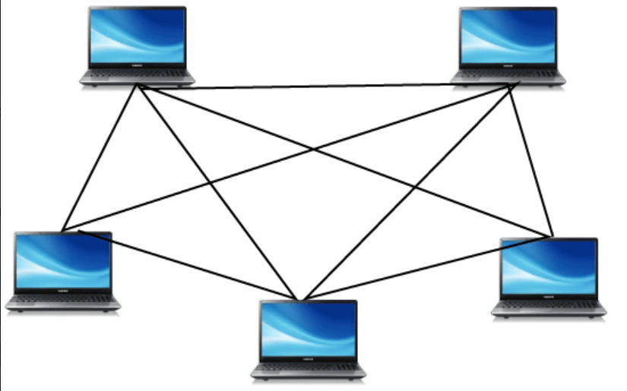

Each node is linked to each other and shares resources, meaning there is no dependence on central machines similar to the traditional client-server design.

## **Data Management on Chain:**

In this tutorial, we'll try to comprehend how data is stored on blockchains and the contents of every block on the blockchain. Each transaction is grouped into units, and each unit is called a **block**. We can refer to the following image:

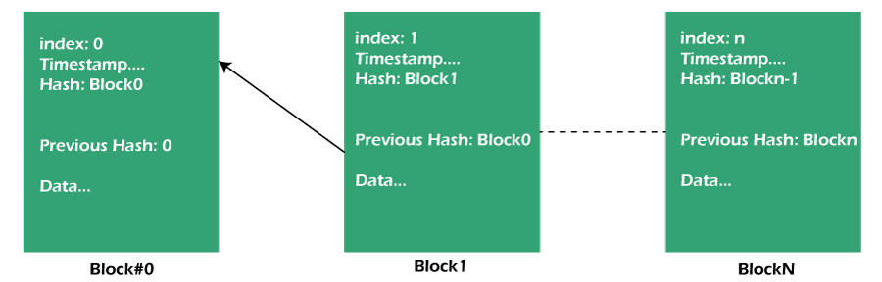

In the above picture, some blocks have actual transaction information on them. Apart from transaction data, there are other common characteristics of every block that are like this:

1. **Index:** The term "index" is nothing more than a number that is a sequential block number.
2. **Timestamp:** Date on the day that blocks the data was added.
3. **Hash:** It is a unique hash value used to identify the information. It is created using mathematical formulas. Each block contains different hash values that directly communicate via data changed (i.e., if data changes, then it will be reflected in the hash value as well).
4. **Previous hash:** It has values for the hash of previous blocks in order to gain references backward.

## **Immutability over Blockchain:**

We all know that databases. Traditional databases are designed for **CRUD** (Create, Read, Update, and Delete) operations. However, blockchain is only able to append and retrieve, meaning that the data once added can't be removed or changed.

In the blockchain, any node that has access to the ledgers can verify and check whether the ledger has been altered or if any transaction in any block has changed. This is typically performed by calculating the hash value of the block's data and then comparing it to the hash value of previous blocks in the next block.

**Example:**

Here is the Blockchain, which shows the latest block, Block#555.

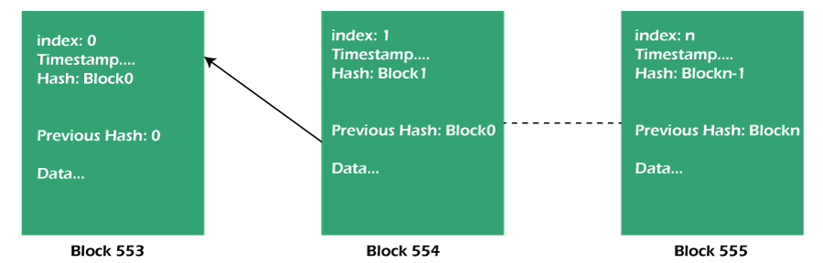

The peer or node here can determine the hash value of block#554 as well as determine whether the hash value for block#555 is the same as the value for block#554. If it's not, the block is declared compromised. The image below illustrates the verification process.

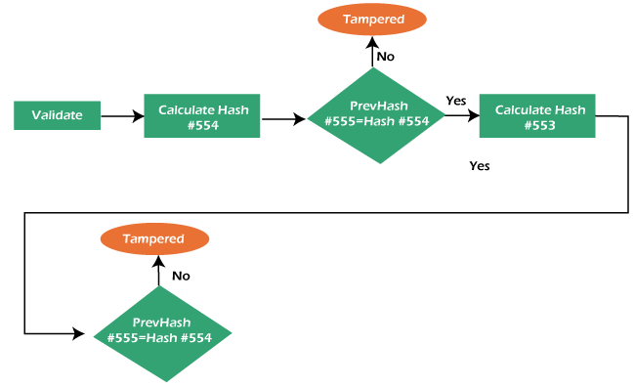

If the data is altered and invalid validation fails, rejection of a block will occur by all nodes.

Blockchain uses the consensus (general agreement) method to validate the transactions

## **Blockchain Consensus**

It's a method whereby peers agree to the current state of the ledger. It makes sure that all peers share the same copy of the ledger. Fraudulent transactions are kept off the ledger. It also ensures that it records transactions in chronological order.

Here is a brief description of the consensus protocols that are common to all.

## **Common Consensus Protocols:**

### **1. Proof of work:**

**Proof of Work** (PoW) as the name implies, it's the confirmation of the work done and the proof that it is accurate. This is the method of consensus to ensure that the chain's authenticity is valid.

The major drawback of PoW is that it demands more electrical power and high-end computing hardware, which can be expensive.

### **2. Proof of stake:**

The **Proof of Stake** (PoS) is a different method of confirming and verifying the block or transaction. PoS chooses the validator according to the stake that the validator holds and their age of stake. In PoS, the validated player earns the entire or a portion from the fee for transactions.

PoS eliminates the biggest issues with PoW and is believed to have an advantage since there's no need for expensive hardware. It is also energy efficient because it doesn't draw as much power as PoW.

### **3. Tendermint:**

The **Tendermint** is an open-source project designed to tackle scaling, speed as well as environmental issues of Bitcoin's Proof-of-Work consensus algorithm. It utilizes the BFT (Byzantine fault-tolerant consensus) algorithm.

The Bitcoin, as well as Ethereum blockchain networks, use Proof of Work.

# **How Blockchain Technology Can Accelerate the Potential of IoT?**

It is proved that the Internet of Things (IoT) links people, places, and things, and by doing so, it creates and captures opportunities for value. Physical objects now contain sophisticated electronics, sensors, and actuators that all relay data to the IoT network. The IoT's analytics capabilities employ this data to turn insights into actions that have an influence on company processes and inspire new ways of doing things. But there are still a few technical and security issues that need to be resolved.The Internet of Things (IoT), a revolutionary emergent technology, has advanced quickly, yet its privacy issues and security flaws continue to be major obstacles. Blockchain's distributed and decentralized architecture can meet the IoT's privacy and security needs. The new field of blockchain technology for IoT (BIoT) is therefore born. Numerous industries will undergo considerable change as a result of BIoT, opening the door for new business strategies. The goal of this study is to investigate research trends and collaboration in the area of BIoT utilizing the bibliometric technique, using the Science Citations Index Extended (SCIE) and the Social Sciences Citations Index (SSCI) datasets in the of Science, or WoS, Core Collection.

## **Introduction**

Applications for the Internet of Things (IoT) have been growing quickly in recent years and are now essential to the advancement of society. In fact, the Internet of Things (IoT) will make human living conditions more comfortable through a variety of applications coming from different industrial domains, such as smart homes, smart healthcare, farming, transportation, retail, and wearable technology.

IoT's widespread deployment has been hampered by a severe security problem. Because of their many security flaws, Internet of Things (IoT) devices are prime targets of Distributed Denial of Service, or DDoS, attacks. DDoS attacks cause a denial of service to users of the target system when numerous compromised computer systems flood a target-such as a central server-with a massive amount of simultaneous data requests. DDoS assaults have disrupted businesses and individuals over the past few years. Cybercriminals can easily target unprotected IoT devices and use their lax security to hack them so they can conduct DDoS attacks.

Scalability is another problem with current IoT networks. Current centralized solutions to authenticate, authorize, and link diverse nodes in a network will become a bottleneck when the amount of devices linked through an IoT network rises. The entire network could crash if the server goes down, which would need significant expenditures on computers that are capable of handling the volume of information transmission.

Blockchain, also known as distributed database technology (DLT), is another ground-breaking innovation that may be able to aid with some of the IoT's scalability and security issues. Due to its distinctive features and advantages, blockchain is a "game changer" in the information age. A blockchain system's fundamental component is a distributed digital record that is shared among system users and is located on the Internet. Transactions or events are verified and added to the ledger, after which they cannot be changed or deleted. It offers a method for a user community to gather and share information. Selected members of this community keep their own copies of the ledger, and any new transactions must be approved by the community as a whole through a process of consensus before being added to the ledger.

## **How can blockchain overcome the scalability and security issues with IoT?**

* In the event of a cyberattack by cybercriminals, it may be challenging to determine the reason for any data leaks because the IoT network might handle data transactions across numerous devices which are owned and managed by various businesses. In addition, the IoT produces an enormous quantity of data, and because there are many stakeholders, it is frequently not clear who is the owner of the data.IoT security and scalability challenges can be reduced by blockchain in the following ways: A blockchain system's distributed ledger is tamper-proof, eliminating the trust requirement between the parties. The massive amounts of data that IoT devices create are not under the authority of any one entity.
* By storing IoT data on the blockchain, additional security would be added, making it more difficult for hackers to access the network. Blockchain offers a significantly higher standard of encryption that virtually prohibits overwriting pre-existing data records.
* Transparency is provided by a blockchain, which enables anybody with authorization to get onto the network to view a history of all previous transactions. This can offer a trustworthy technique to pinpoint the origin of any data leaks and take prompt corrective action.
* Blockchain can help IoT organizations cut costs by removing processing overheads associated with IoT gateways (for example, conventional protocol, hardware, or communication-related costs). Blockchain does this by providing a means to enable trust among the stakeholders.

Smart contracts, a two-party agreement that is recorded in the distributed ledger, can also enable the implementation of contractual agreements among stakeholders subject to the fulfillment of certain requirements. Smart contracts, for instance, can automatically allow payments when the requirements for rendering the service have been met, requiring no human involvement.

## **Possibilities for Growth**

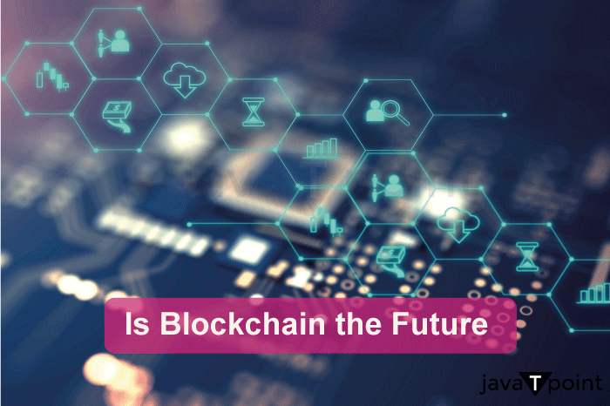

Four different sorts of initiatives should be taken by businesses to fortify the links between their suppliers, but they must be patient because it will take time to carry out these actions and see results.

* **Include tracking and IoT capabilities :** Businesses should give their supply chains IoT functionality to monitor finished goods inventory and trace individual components at the unit level. IoT is the ability of devices to employ sensors that gather data, such as pressure, temperature, GPS setting, and bar code scanning, and to upload this data on their own to a cloud server through the Internet.

IoT enables businesses to get novel forms of data from various points along their supply chain. These tools, for instance, can monitor the creation of a packaged food item from the sourcing of components through manufacture, transportation, and retail, as well as the state of the stock and operational conditions in the production and logistics facilities.

* **Note transactional information:** Blockchains, which are capable of capturing incredibly precise decentralized data and may be used to confirm the validity of transaction records, should be used by organizations to store information about transactions from IoT devices. This information can be used by a company to assure ethical sourcing, enhance the implementation of supply chain agreements, and secure better financing.

A system based on the blockchain can be implemented in a decentralized, piecemeal approach, which eliminates the need for significant IT system investments or expensive third-party certification.

* **Align and standardize data from many sources :** To leverage the information gathered from Internet of Things (IoT) gadgets in a supply chain, this is required.Consider a company that utilizes inventory scanners to monitor the flow of inventory into and out of a fulfillment center and temperature sensors to record the storage temperature every hour. To find out which inventory items were kept at a particular temperature for how long, the company must line up these data tables.
* **Create analytics that is predictive and prescriptive :** For instance, temperature information from fulfillment centers can be used to forecast when a food item will decay or ripen. The planning of inventories and the creation of marketing for food goods that will soon go bad can then be guided by this predictive model. This will increase revenue and decrease food waste.

An agri-tech company called Ripe.io used data on tomato production's traceability to link the flavor of ripened cherries to the growing environment. The company was able to develop various tomato varieties in accordance with the demands of various consumer segments thanks to predictive analytics.

## **IoT and blockchain adoption factors to take into account**

As previously explained, the security design of current IoT systems has a fundamental flaw. It uses a centralized client-server architecture that is controlled by a central authority, making it vulnerable to a single point of malfunction. Blockchain provides a solution to this issue by decentralized decision-making to a common network of devices that relies on consensus. However, there are three primary difficulties to take into account while building an infrastructure for IoT devices when combined with a blockchain ledger:

**Scalability:** How to manage the enormous amounts of data generated by an extensive system of devices and potentially slower processing of transactions speeds or latency is one of the key challenges that IoT is still facing. Setting up an easily understood data model in advance helps save time and avoid problems when implementing the solution.

**Secrecy of transactions:** and network privacy. On open blockchains, it is difficult to readily grant confidentiality of the history of transactions in the joint record for an ensemble of IoT devices. This is because transaction pattern evaluation can be used to draw conclusions about the users' or devices' identities hidden behind public keys. Organizations should examine their privacy needs to determine whether hybrid or exclusive blockchains would better meet those needs.

**Sensors:** By conflicting with the accurate measurement of the requirements that must be completed in order to conduct a transaction, it is possible to jeopardize the dependability of IoT sensors. Securing an appropriate setting for data collection and transactions requires steps to preserve the confidentiality of IoT devices so that external interventions cannot change them.

**Enhanced Transparency, Trust, and Privacy of Data Protection :** Many people are concerned about centralized governmental bodies or businesses gathering their data and private data, including footage of their daily lives at home. Blockchain operates on a decentralized network, where no organization or governing body has authority over and ownership of all the user's personal data. This helps to alleviate trust issues and worries about data privacy.Blockchain provides transparency by making it possible for anybody with access rights to the network to view a history of all previous transactions. This might offer a dependable technique to locate the exact location of any data leaks and initiate prompt corrective action.

IoT and blockchain are cutting-edge technologies with enormous potential, but they haven't been widely used because of technical and security issues. Since the two technologies can be used in use cases that minimize security risks and other business hazards, many companies in the marketplace are already developing such use cases.

## **Challenges in IoT and Blockchain Integration**

The limitations imposed by the short battery life of various IoT devices are one of the main problems with merging blockchain with IoT. Battery life may be a limiting concern for some IoT devices since they may only sometimes be linked to WiFi or power sources. Small devices with low battery life cannot be paired with a blockchain transaction system that requires high computing and bandwidth. As a result, either a server-based infrastructure or a separate gateway device must be developed. Multiple parties and players within the same environment also add complexity. For example, when companies from different sectors try to collaborate and connect their devices (for example, when intelligent refrigerators or home appliances try to connect to a chain of supermarkets, which in turn tries to connect to the telecommunications provider that offers the 5G wireless connection and the business that builds and oversees the network infrastructure).

## **Conclusion**

Although implementing blockchain technology in IoT ecosystems has its obstacles, these differ from the efficiency and productivity that may be achieved. The technology will need time to develop, as will the adoption of it. However, more individuals, organizations, and communities will wish to join as time goes on. The Internet of Things (IoT) offers a wealth of potential for value generation and capture by connecting people, locations, and things.

According to Cisco, there will be 14.7 billion machine-to-machine (M2M) connections by 2023, up from 33% in 2018. Connected home applications will account for nearly half of these connections, while linked car applications will experience the greatest growth at a CAGR of 30%. Currently, most IoT solutions use a centralized server-client architecture that entails establishing connections to cloud servers over the Internet.

Multiple goals must be met by supply chains, including a high level of customer satisfaction, profitability targets, and disruption resistance. By ensuring their manufacturing and distribution systems are secure and environmentally friendly, that raw materials are sourced from environmentally friendly sources, and that workers receive fair compensation, businesses are also starting to prepare their supply chains for a responsible future. Until recently, accomplishing these objectives would have been extremely expensive, requiring organizations to compromise. However, these goals are becoming more and more realistic thanks to analytics, the Internet of Things (IoT), and blockchain technologies.

# **Introduction to Blockchain Technology**

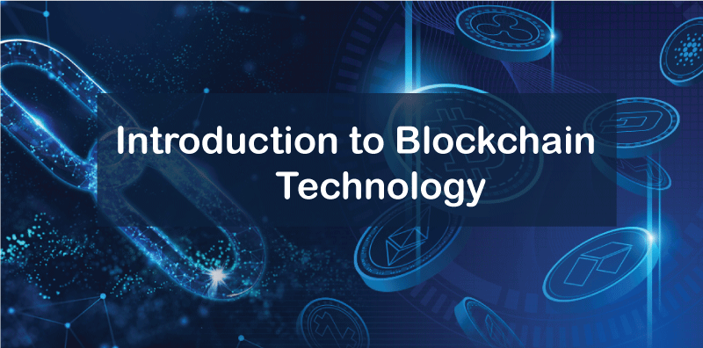

Blockchain technology is a ground-breaking innovation that has drawn a lot of interest in recent years because of its potential to upend established data storage and exchange methods. It is a distributed, decentralized digital ledger that securely and openly records transactions. Blockchain technology, which was first developed for Bitcoin, the first decentralized cryptocurrency, is now being used in a number of sectors, including banking, healthcare, and supply chain management.

A blockchain is essentially a database made up of a sequence of blocks. Once a block is included in the chain, it cannot be changed or removed. Each block comprises a series of transactions. A network of nodes that collaborate to validate transactions and add them to the blockchain maintains the chain. The blockchain is controlled by no central authority or middleman thanks to the decentralized nature of this network of nodes.

Security is one of the biggest benefits of blockchain technology. Blockchain data is spread throughout the network, making it impossible to alter with or hack. It is practically hard to modify the data since numerous network nodes verify each transaction. Also, the use of cryptographic techniques guarantees the encryption and security of the data.

The transparency of blockchain technology is another benefit. Every transaction is documented on the blockchain, making it accessible to everyone using the network. As a result, there is no requirement for a central authority or middleman to validate transactions. Instead, the network itself validates transactions, improving both the effectiveness and efficiency of the process.

The potential uses for blockchain technology are numerous and diverse. Blockchain technology is being utilized in the banking sector to develop new varieties of virtual currencies like Bitcoin and Ethereum. Also, it is utilized to simplify payment procedures and lower transaction fees. Blockchain technology is being utilized in the healthcare industry to securely store and exchange medical data. Blockchain technology is also being utilized in supply chain management to trace the movement of items and lower the risk of fraud and counterfeiting.

Although it is still in its infancy, blockchain technology has the power to completely alter the way that data is stored and exchanged. As it is decentralized and transparent, it has several advantages over conventional systems, and the fact that it has security features makes it a desirable alternative for sectors that deal with sensitive data. We can anticipate seeing blockchain technology used more widely across a range of businesses as it continues to develop and mature.

Blockchain technology relies on a consensus method to make sure that all network nodes concur on the blockchain's current state. Although there are many other kinds of consensus techniques, Proof of Work (PoW) and Proof of Stake are the most used ones (PoS). Whereas PoS needs nodes to stake a particular amount of bitcoin to participate in the validation process, PoW requires nodes to solve challenging mathematical problems in order to validate transactions and add them to the blockchain.

Smart contracts, which are self-executing contracts where the terms of the agreement between the buyer and seller are directly put into lines of code, may also be created using blockchain technology. This eliminates the need for middlemen and lowers transaction costs by enabling automated enforcement of the contract's terms.

Despite all of its benefits, blockchain technology is not without its drawbacks. Scalability is one of the main problems since it makes it harder to store and handle vast volumes of data because the blockchain's size increases with each transaction. Another issue is regulation, which can be challenging for governments to control and enforce due to the decentralized and anonymous nature of blockchain technology.

The immutability of blockchain technology is another significant feature. The data on the blockchain is impenetrable because once a transaction is recorded there, it cannot be changed or removed. This makes blockchain technology excellent for applications like identity management, voting systems, and intellectual property rights management that need for secure and tamper-proof data storage.

Decentralized autonomous organizations are a further area where blockchain technology may be used (DAOs). Organizations known as decentralized autonomous organizations (DAOs) operate on the tenets of transparency, democracy, and decentralization. Smart contracts may be used to establish DAOs that are regulated by blockchain technology, enabling automated and open decision-making.

Decentralized marketplaces, which allow buyers and sellers to conduct business directly with one another without the use of middlemen, are also being developed using blockchain technology. This can improve efficiency and lower transaction costs while also giving buyers and sellers more security and transparency.

In conclusion, blockchain technology is a ground-breaking innovation that has the potential to upend established data exchange and archiving methods. Compared to traditional systems, it has major benefits in terms of security, transparency, and decentralization, and it has a wide range of possible applications. Even if there are currently issues with blockchain technology, its continuous development and maturation will probably lead to greater acceptance and innovation across a range of sectors.

# **Blockchain and distributed ledger technology**

One of the biggest technological stories of the last ten years is Blockchain. Although it appears like everyone is talking about it, the actual meaning and operation of Blockchain are sometimes obscured under the surface of discussion. Although Blockchain has a reputation for impenetrable, its core concept is quite straightforward. Additionally, it has the power to completely transform entire sectors.

Blockchain is a system that makes it possible to share information securely. A database obviously contains data. A ledger is an account book where transactions are entered. The ability to update the Blockchain is shared among the nodes, or individuals, of a public or personal computer network. A blockchain is a sort of decentralised database or ledger, one of today's top technological developments. Distributed ledger technology, also known as or DLT, is what this is. Digital tokens or money are used as incentives to encourage nodes to update blockchains.

Three main features define a blockchain. A blockchain database must, first and foremost, be cryptographically secure. Therefore, two cryptographic keys are required in order to enter or contribute data to the database: a key that is publicly accessible, which is essentially the database address, and a secret key, which is a unique key that must be verified by the network.

## **Distributed ledger**

A sort of information that is shared, copied, and synchronised among the participants in a decentralised network is known as a distributed ledger. The distributed ledger keeps track of all interactions between network participants, such as trading goods or information.

The ledger's records are updated by consensus among network participants, who also regulate the system. There needs to be involvement from a centralised authority or a neutral third party, such a clearinghouse or financial institution. The distributed ledger is an auditable, immutable record of all network transactions since each record includes a date and distinctive cryptographic signature.

Users at every node in the network can evaluate distributed ledgers, and they can have an exact copy of the files that circulate across the network. If the ledger is modified or added to, the participants are notified and copied on the changes. The database is synchronised to ensure that it is accurate. Bitcoin and distributed ledgers both make use of the same technology.

Blockchain/DLT are the foundation of the "internet of value," allowing peer-to-peer "value" transfers and recording interactions without the need to establish a centrally coordinating body. The term "value" refers to every record of ownership of an asset, such as money, securities, or property titles, as well as ownership of certain information, such as an individual's identity, health information, or other personal data.

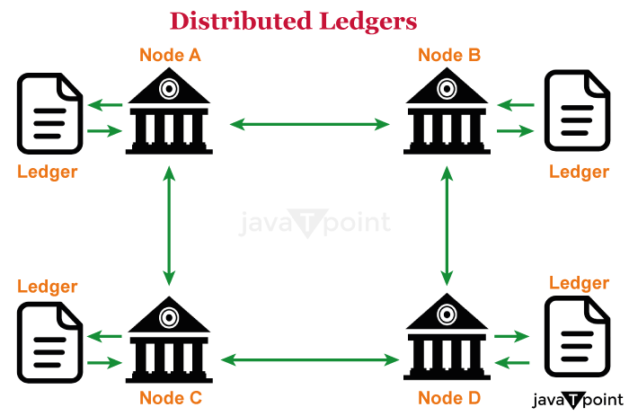

DLT has the potential to significantly improve the financial sector's efficiency, resiliency, and reliability.

* This may change the responsibilities of stakeholders in the financial system and address enduring problems. DLT offers the potential to revolutionise a number of different industries, including manufacturing, public financial administration, and clean energy.
* The International Monetary Fund does not have any broad advice regarding how to use this technology for global development because it is still in its infancy. We collaborate with standard-setting organisations, governments, central banks, and other parties to track, investigate, and test DLT and blockchain-based applications.
* Waiting for "perfect" DLT solutions, however, can mean passing up a chance to influence it. Research as well as practical implementations and pilots are necessary to comprehend how DLT might address issues in the banking sector.
* As a result of the introduction of new technology, it also necessitates addressing difficulties with consumer protection, financial integrity, transaction speed, environmental impact, and legal, regulatory, and technological issues.
* DLT applications are expected to be implemented gradually, replacing manual and ineffective processes and activities. (For example, maintaining reference data in settlement and payment systems, trade finance, loan syndicates, and tracing the provenance of agricultural goods or commodities, their future sale, or their use as collateral for financing.)
* DLT has the potential to improve access to money for unbanked communities that are now excluded from the traditional financial system, as well as increase efficiency and reduce remittance costs.

## **Workings of Distributed Ledgers**

Individuals known as nodes hold, manage, and alter distributed ledgers. Every node independently builds the database. Each node processes every transaction on the network, drawing conclusions about how the database develops.

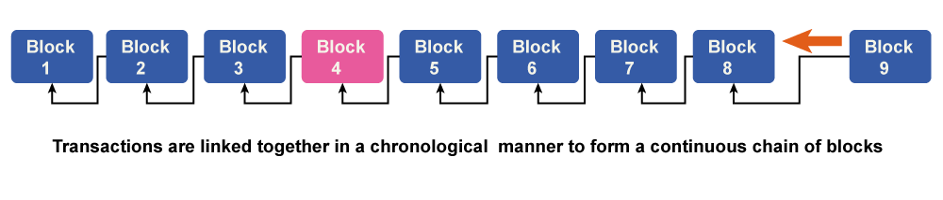

Voting is done on the database modifications that have been made based on the transaction. All nodes take part in the voting process, and a new transaction is approved on the database if a minimum of 51% of them concur. After that, all of the nodes refresh the database versions to ensure that every device or node is running the same version. The newly created transaction is added to a blockchain block.

In a Proof-of-Work blockchain, nodes are also known as miners. A miner is rewarded for successfully adding a new transaction to a block. It needs devoted computer power available constantly. Miners are in charge of calculating the digital signature for new blocks. The reward goes to the miner who correctly locates the hash first.

The success of miners who devote more computing power to finding the hash will increase. Finding new hash scales, however, gets more challenging as blocks continue to generate. The objective is to generate blocks at a steady rate.

## **Distributed ledger technology types**

**There are three different types of distributed ledgers:**

* Permissioned DLT: To access or alter the network in any way, nodes must first obtain permission from a centralized authority. These rights typically require identity verification.
* Permissionless DLT: there's no governing body to validate transactions; instead, all of the current nodes work together to do it. Transactions based on preset algorithms are validated using a variety of consensus techniques. The proof-of-work consensus process is applied in the instance of Bitcoin.
* Hybrid : Permissionless and permissioned distributed ledger technologies are merged to create a hybrid DLT that can reap the benefits of both.

## **Features of Distributed Ledgers**

* distributed ledgers, entries are made directly in the information system without the assistance of a third party. Records entered into distributed ledgers cannot be changed by any other person once they are there. As a result, documents cannot be altered until the accounting records are disseminated.
* There is no longer a need for an outside organisation While it is not always necessary, operating distributed databases without an outside organization can often result in significant cost and time savings. Results in the logistics sector can be directly written to the Blockchain by sensors, eliminating the need for a middleman. It helps you save a lot of money, time, and effort.
* Another degree of security is added by the distributed ledgers' inherently decentralised structure. The information within it is spread out internationally, making an attack challenging.
* A high degree of transparency is demonstrated by distributed ledgers. They make it possible to freely and conveniently view all the data that has been saved. It offers a considerable portion of the openness that many industries want.

## **Examples**

A very well-known instance of a distributed database is bitcoin. It is a form of digital currency that can be used to make purchases on a network that lets users to make irreversible purchases for less money than they would pay using more traditional online payment methods.

Ethereum is a well-known distributed ledger that lets programmers build custom apps. Since it introduced smart contracts, it is incredibly well-liked. The self-executing smart contracts are activated when specific real-world circumstances are met and pertinent data is added to the Blockchain.

Ripple is another instance of a distributed database that focuses on payments, particularly cross-border transactions. Ripple is an open-source ledger. It was designed with banks in mind initially.

## **How do decentralized finance, cryptocurrencies, and Blockchain relate to one another?**

Without the help of banks or other middlemen, buyers and sellers can trade cryptocurrencies online thanks to blockchain technology.

Cryptocurrencies and all other digital assets are built on the blockchain technology. A series of blockchain or cryptocurrency applications known as "decentralised finance" (DeFi) is intended to take the role of the present financial intermediaries with services based on smart contracts. Decentralized means that anybody with access to a program has control over whatever changes are made to it, just like Blockchain. Users may now have a more significant direct influence over their money as a result.

## **Conclusion**

DLT is marketed by experts in this field as a remedy for numerous online issues that will radically resolve all of these issues. "Internet of Value" is a concept used to describe distributed ledger technology. The Internet will be used to facilitate real-time transactions and processes. With its efficient solutions, the use of distributed ledgers has a chance to have a positive impact on issues in the finance or banking, online safety, healthcare, government, and data security sectors.

# **How Blockchain Technology is Revolutionizing Industries**

Blockchain constitutes a transparent and secure digital ledger that keeps track of transactions between many computers. It creates an immutable ledger using a series of linked transactions that cannot be altered or removed without network consent. It has more functionality than a typical database and has built-in safeguards against unauthorized transactions. Without go-betweens like banks, blockchain technology offers safe, transparent transactions that boost productivity and cut costs. Additionally, it can give underbanked or unbanked people access to financial and banking services and lower the risk of corruption and money laundering.

Supply chain management can benefit from the use of blockchain technology to boost efficiency, lower the risk of fraud, and promote transparency. Businesses may increase consumer trust, lower costs, and make better decisions by tracking a product from its point of origin to its final destination. In the supply chain, this future use of cryptocurrencies can be advantageous to both companies and customers.

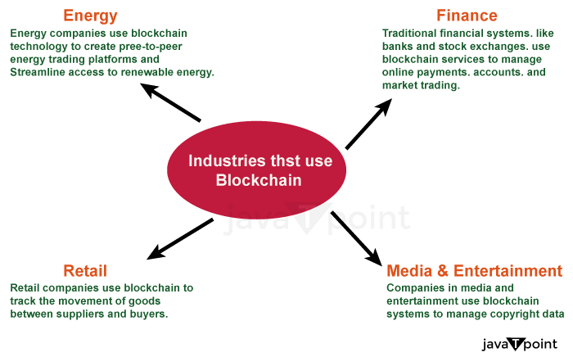

A block that has been added to the chain cannot be changed or removed, making blockchain technology extremely secure and tamper-proof. This qualifies it for applications like monetary transactions or voting systems, where confidence and security are crucial. The article's main discussion topic is how blockchain-based technology is transforming several businesses.

Although blockchain technology has many benefits, there are still particular challenges to its widespread implementation. These challenges include scalability constraints, regulatory hurdles, and security risks. Improved security measures are required to stop hacking and cyberattacks.

## **How is the Blockchain operate?**

The Blockchain comprises an interconnected set of nodes that validate transactions and add new blocks to the chain of blocks already in existence. Each block has a different hash code that serves as a means of identification and an allusion to the previous block's hash code. As a result, a series of blocks is formed that cannot be added to or eliminated, which renders the Blockchain an unchangeable and untouchable record of transactions. We'll look at how the blockchain system is altering how we view financial transactions and how it's being applied to upend a variety of sectors.

We provide a quick introduction to the underlying blockchain mechanisms in the following steps, notwithstanding their complexity. Most of these steps can be automated using blockchain software:

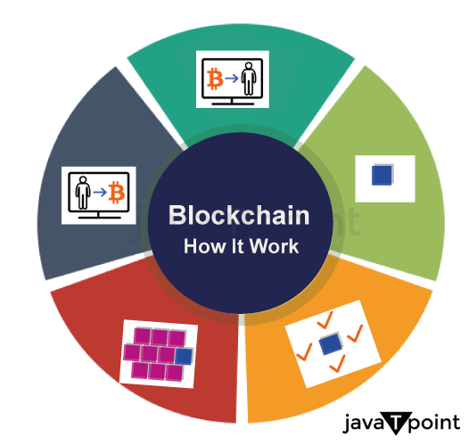

* **Please keep track of the transaction:** A blockchain transaction documents how assets are transferred between network parties, whether tangible or digital. It is stored as a data block and can include information such as "Who was involved in the transaction?" "What happened during the transaction?","When the transaction occurred?","Where the transaction occurred?" "Why did the transaction occur?" "How much of the asset was exchanged?" and "How many pre-conditions were met throughout the transaction?"
* **Gain Consensus:** The majority of users on the decentralized blockchain network must concur that the transaction recorded is legitimate. Rules for agreement can differ according to the network, but they are usually defined at the beginning of the network.
* **Write the Blocks:** After the participants have agreed, the blockchain transactions are put into blocks similar to the sections of a ledger book. A cryptographic hash is applied to the new block along with the transactions. The blocks are connected by a chain created by the hash. The value of the hash changes whenever the block's contents are altered, whether on purpose or accidentally, making it possible to spot data manipulation. As a result, the component parts and chains connect solidly and cannot be changed. Each new block reinforces the previous block's verification and, by extension, the Blockchain as a whole. This is similar to building a tower out of wooden blocks. Blocks can only be stacked on top of one another; removing an element from the center of a tower causes the tower to collapse.
* **Decentralized system:** A decentralized, secure record of personal data, such as proof of identity, can be made using Blockchain and used to authenticate a person's identity without the aid of a centralized authority.
* **Secure:** By offering a safe and impenetrable mechanism to record and trace digital transactions, blockchain technology is revolutionizing businesses all over the world.
* **New innovation:** It can challenge established business models and open up new chances for development and innovation. It will be fascinating to watch how technology changes our way of living and working as it advances.

Although digital currencies like Ethereum and Bitcoin are frequently mentioned when discussing blockchain technology, their potential uses go far more profound than digital assets. Blockchain technology is revolutionizing industries in previously unthinkable ways, from managing supply chains to healthcare. This article will examine the ways that blockchain technology is reshaping several businesses and the possible advantages it may have.

Let's look at some of the major sectors that blockchain technology is fundamentally reshaping and how they stand to gain.

**Data Retention**

Data distribution and storage have traditionally been handled by businesses using centralized servers, such as Cloud storage. While it has benefits like simple access, there are also disadvantages like a higher risk of hacking and just one point of failure. Blockchain-based decentralized data storage spreads information throughout an interconnected system of computers, addressing issues like data loss and breach through increased security and giving users greater authority over their data.

For instance, a decentralized storage network like BNB Greenfield offers a decentralized storage infrastructure that users and DApps can utilize to generate, store, and share data with full ownership and establish a new data economy. Website hosting, secure cloud and chain storage of information, publication, and social media are a few application cases for BNB Greenfield.

**Creation of Content :**

Because of centralized governing systems, content providers in the music, recreation, and arts sectors sometimes struggle to monetize their work. Blockchain technology facilitates royalty payments while lowering content piracy and duplication. In terms of operation, it also offers a less expensive choice.

**Entertainment :**

The media and entertainment sectors have previously adopted blockchain technology in various use cases, including NFT ticketing. This method of distributing tickets is gaining popularity since it can prevent bots and assist event organizers in establishing precise resell guidelines.As it involves fans purchasing and utilizing tickets, it also offers more security and convenience in operation. Additionally, NFT tickets frequently come with extra benefits like early admission to future events, which boosts fan engagement. They also serve as a commemorative gift that fans to take in after the event.

**Finance :** The majority of the financial sector's operations are controlled by regulatory organizations using centralized systems. As a result, there are fewer opportunities for customers to receive financial services and high entry barriers are created. Blockchain provides a substitute in the form of Decentralised Finance (DeFi), which anybody with a crypto wallet can use and which uses smart contract technology to authenticate and handle transactions.This is opening the way for the financial services sector to become more democratic as it transitions from an antiquated system to a cutting-edge one which relies on peer-to-peer exchanges.

**Healthcare:** The usage of blockchain technology is transforming the healthcare sector. Healthcare providers can guarantee that private information is secured but shared only with authorized parties by generating an encrypted and immutable copy of patient data.

**Smart Contracts:** Using smart contracts is another effective way to harness blockchain technology. When specific criteria are satisfied, these self-executing agreements autonomously execute the conditions of a contract, eliminating the need for go-betweens and facilitating quicker, less expensive, and more secure transactions. Industries like property management, coverage, and banking, which frequently require complicated legal agreements, might be completely transformed by smart contracts. One of the most popular blockchain platforms, Ethereum, was at the forefront of the creation of smart contracts and has drawn many companies and developers to its platform to create applications.

Blockchain technology can also help to lower expenses and streamline administrative procedures. Blockchain, for instance, may be utilized to automate the processing of claims and do away with middlemen like insurance firms. Industries could be completely transformed by blockchain technology, which offers a variety of advantages, including improved security, openness, and effectiveness, as well as prospects for decentralized decision-making, ownership of information, and monetization. Technology is positioned to fuel more innovation and accelerate acceptance on a global scale as it develops and becomes more widely available.

In order to achieve this, organizations should investigate how they might use blockchain technology to improve operations, and processes and create fresh possibilities while staying one step ahead of their rivals.

## **Here are a few concepts for how Blockchain is changing the supply chain sector.**

Everyone despises middlemen, but they actually serve a very vital purpose. The only way to get a lot of entities to agree on a shared, accurate set of data (like who owns how much money) was before the invention of cryptocurrency and blockchain technology.

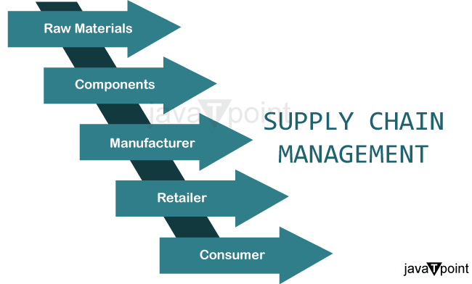

This was done in order to appoint a neutral go-between to handle & track all transactions. Blockchain enables networks of commercial partners to exchange and concur on crucial information. Blockchain technology is also utilized by Facebook's Libra.

Blockchains synchronize all information and transactions throughout the network without the need for a central middleman, and each user independently verifies each other's calculations and labor. The massive quantity of cross-checking and redundancy is what makes financial systems like Bitcoin so dependable and secure.

Even though they synchronize thousands of transactions every week amongst thousands of network nodes.

Most people are familiar with the statements "Blockchain is the most significant innovation since the Internet" and "Everything will be Bitcoin in a few years."People often become even more perplexed after hearing these expressions. Blockchain is a distributed, decentralized database that securely stores digital records. Additionally, even though all documents are open to the public and transparent, they are not changed, removed, or amended.

Every piece of data that is added to the Blockchain is permanently damaged. A new "Block" is registered on the chain for every transaction or record added to the Blockchain.

In essence, Blockchain offers a way to retain records that is more effective for organizations and individuals to use while still being more secure. The probable future of robotics is being shaped in various ways by BlockChain and AI.

Today, we enjoy the convenience of having high-quality, ready-made things at our doorstep. It's simple to walk into an outlet mall, buy an item of clothing, and not give the clothing's origin or manufacturing process any thought. The origin of that shirt is in the way it was made.

From the supplier of the raw ingredients to the merchant that is providing you the finished product, a lot of hands must be involved in order for that jersey or other goods to reach the store shelves.

The supply chain is the mechanism that connects all the parties engaged in delivering the finished good to you.

### **Provenance and traceability of the product**

Consumers want to be able to verify the authenticity of the goods they purchase, whether they are purchasing food, diamonds, or automobile parts. Customers can have faith that data wasn't modified along the process because it can be made public to all those who have been granted access to view it and generally cannot be changed by a single organization. Additionally, time-stamping can offer only one source of truth regarding the history of the product, from the gathering of the materials through the stocking in a store. Knowing a product's whole route has many advantages, including greater product safety, decreased fraud, improved forecasting, and industry-wide cooperative planning.

As an illustration, in 2018, the US saw its worst E. coli outbreak before 2006 when 210 individuals fell ill, and five of them passed away from eating romaine lettuce that was contaminated. Up until the Centres for Prevention and Control of Diseases were able to identify the source to a manufacturer in Yuma, Arizona, the panic led to a worldwide recall of stock. However, Blockchain would make it possible to fully understand each lettuce's history, so information from the earliest instances could be utilized to rapidly identify the outbreak's source. Only those with a risk of E. coli infection should have been removed from the shelves, as opposed to a general recall.

### **Immutable records that can be traced**

Immutable blockchain data and digital signatures are both necessary to verify information ownership. If several businesses collaborate, they can utilize blockchain technology to store information on the ownership and location of their raw materials and finished goods.

The information is kept on the Blockchain, which provides a complete history of every component in the supply chain. The movement of materials from one enterprise to another is visible to every participant in the supply chain. These data recordings are extremely traceable and cannot be changed.

When a product is faulty, the problem's root cause can be found more rapidly, which boosts the effectiveness of merchandise recalls and the resolution of disruptions between chain parties.

Businesses may make wiser judgments if their product flow inventory is visible and complete.

It increases the trust of customers and stakeholders in the quality of the products. A further strategy for battling fraud and counterfeiting is the increased transparency.

### **Protection of Intellectual Property (IP)**

In the digital age, defending rights to intellectual property has grown more difficult. By enabling artists to safely record and date their creations on a decentralized ledger, blockchain technology presents a potential solution. This electronic fingerprint can serve as unambiguous evidence of ownership and aid in preventing unauthorized dissemination or copying. Businesses like Give and Attached have begun providing blockchain-based IP protection services, focusing on sectors like the arts, music, and photography.

### **Voting and governance**

Lastly, blockchain technology can be used to improve voting procedures and government operations. Blockchain can assist in protecting the honesty and openness of elections by employing a decentralized and tamper-proof ledger, lowering the possibility of fraud and manipulation. Additionally, decision-making processes may be automated, transparency can be increased, and stakeholder participation can be increased with the help of blockchain-based governance systems. Blockchain-based voting technologies are being developed by businesses like Follow My Vote or Horizon State.

**Blockchain Participation in industries :** Blockchain technology can help supply chains handle some of their most pressing problems because it offers new methods for storing, transmitting, and sharing data.

A blockchain is essentially a special database system that users in a decentralized network construct and maintain. It provides a secure and dependable infrastructure for information and transactions that may be digitally documented, such as the interchange of data and assets across supply chain players.

Each stakeholder retains a copy of the distributed ledger since it is decentralized, preventing just one point of failure and data loss. This also means that blockchains are very hard to change or tamper with. Such precise and impenetrable records safeguard data integrity and are accessible to facilitate regulatory compliance.

In the end, Blockchain can improve supply chain transparency and efficiency, which will benefit everything from payment to delivery to warehousing.

### **Cost reduction**

Waste is produced in large amounts by supply chain inefficiencies. This is particularly common in sectors that produce perishable items, like the food sector. Blockchain's enhanced monitoring and data transparency can aid corporate identification. they can execute focused cost-saving efforts by eliminating these inefficient inefficiencies.

## **Conclusion**

Blockchain has the potential to revolutionize our consumption habits, from the clothes we dress to the foods we eat. Solutions must be implemented carefully as they emerge since, along with all these hopes come concerns about hype, data security, interoperability, and access.This doesn't happen by mistake like it does with other technologies. It is planned. For this reason, we're collaborating with over 95 people from around the globe to design tools for decision-making for the supply chain actors. The aim? shifting supply chains in the direction of solutions that are open to everybody, interoperable, and trustworthy.

# **How Block Hashes Work in Blockchain?**



Blockchain is a breakthrough technology that has changed the way we think about digital security and trust. It is a distributed and decentralized ledger that enables the safe and transparent exchange of information and currency. Block hashes are at the foundation of blockchain technology, and they play a critical role in preserving the blockchain's integrity and immutability.

In this post, we will look at what block hashes are, how they operate, and why they are important in the blockchain.

## **What are Block Hashes?**

A block hash may be thought of as a special identification number that is given to each block on the blockchain. It is a cryptographic hash function that outputs a fixed-size block of data after taking in a block of data. This output is a distinct string of characters that acts as the block's digital fingerprint.

Block hashes are created by applying sophisticated mathematical methods that consider the block's data as well as a nonce value, a random integer that is added to the block to make sure the hash is generated only once.

## **How do Block Hashes Work?**

A cryptographic hash function is used to create the block hash whenever a new block is added to the blockchain. This function generates a fixed-size output after taking in the block's contents, including the transaction data, timestamp, and preceding block hash.

The block header is then updated to include this output in addition to other details like the nonce value and the current blockchain protocol version. A final block hash is then generated by performing another hash on the block header.

The block hash is then sent out to the network to be confirmed by other blockchain nodes. This verification procedure comprises determining if the block hash satisfies a set of predetermined standards, such as the degree of difficulty of the employed proof-of-work algorithm.

The block is uploaded to the blockchain when the block hash has been confirmed. The new block also contains the prior block's hash, resulting in a chain of blocks that are connected by their individual block hashes.

## **Significance of Block Hashes in Blockchain**

Block hashes are essential for maintaining the immutability and integrity of the blockchain. Every attempt to edit a block will cause the block hash to change since every block in the blockchain contains the hash of the preceding block. It will be nearly hard to tamper with the blockchain since other nodes in the network will instantly notice this change.

In the blockchain, consensus is also achieved via block hashes. The process of creating a block hash is computationally demanding and needs a substantial amount of processing power since the block hash is produced using a proof-of-work method. By doing so, the blockchain is protected against assaults from bad actors who could try to change it by adding or removing blocks.

## **Various advantages in Blockchain Technology**

In the blockchain, block hashes especially offer various advantages, including:

1. **Security:** Blockchain security is quite good thanks to block hashes. It becomes challenging for an attacker to modify a block without being noticed since each block is connected to the one before it using its hash. If a block is altered, the network will reject the change because the hash of the changed block differs from the hash of the original block.
2. **Immutability:** The immutability of the data contained in the blockchain is ensured through the use of block hashes. A block cannot be modified or removed from the blockchain once it has been added since doing so would invalidate the hash of all future blocks.
3. **Verification:** In the blockchain, block hashes are used for verification. A block's validity may be confirmed by nodes in the network by comparing its hash to the hash of the preceding block. The block is regarded as legitimate if the hash matches.
4. **Consensus:** The creation of a block hash needs a considerable amount of processing power. This ensures that the blockchain is decentralized and democratic by making it difficult for any single entity to dominate it.

Block hashes are a vital part of blockchain technology, to sum up. They offer a safe and open method for transferring and storing data in the digital world. Block hashes have the potential to completely change how we communicate and conduct business online by guaranteeing the immutability and security of the blockchain.

# **Implementation of Blockchain in Java**

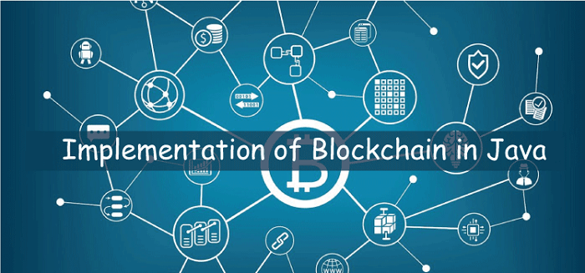

Blockchain is a cutting-edge technology that has the ability to completely change how we safely store and move data. With the use of distributed ledger technology, transactions are securely and impenetrably recorded. Although the technology is most frequently linked to digital currencies like Bitcoin, its potential uses go well beyond that.

Java is a well-liked programming language that is frequently employed in the creation of business applications. It has been more popular in recent years to use blockchain technology with Java-based apps. We shall examine how blockchain is implemented in Java in this post.

### **Describe a blockchain.**

Let's first define a blockchain before moving on to Java's implementation of the technology. A blockchain is simply a network of computers-based distributed digital ledger of transactions. Multiple transactions are recorded in each block of the chain, and once a block has been added to the chain, it cannot be changed or removed.

The decentralization of blockchain technology is a key characteristic. A blockchain is dispersed among a network of nodes, as opposed to traditional databases, which are often centralized and managed by a single company. Each node has a copy of the complete chain. Because there is no single point of failure or weakness, the blockchain is very safe.

### **Implementing Blockchain in Java**

Let's examine the Java implementation of blockchain now that we have a fundamental idea of what it is. The Hyperledger Fabric, Ethereum, and Corda blockchain frameworks are just a few of the ones that run on Java. The main emphasis of this paper will be Hyperledger Fabric, one of the most popular blockchain frameworks for business applications.

A permissioned blockchain architecture made specifically for business use cases is called Hyperledger Fabric. It has a flexible, modular architecture that enables customisation. Smart contracts, which are self-executing contracts that may automate corporate procedures, are also supported by Fabric.

To implement a blockchain in Java using Hyperledger Fabric, we need to follow these steps:

1. **Set up a development environment:** A development environment that contains the Hyperledger Fabric SDK for Java and the required dependencies must be set up.
2. **Define the network:** The network topology, including the nodes, channels, and smart contracts, must be specified.
3. **Develop the smart contracts:** Java must be used to create the smart contracts. The business logic that governs transactions and operates on the blockchain is known as a smart contract.
4. **Build the application:** We must create the software that communicates with the blockchain network. The Hyperledger Fabric SDK for Java may be used for this.
5. **Test and deploy:** The application has to be evaluated before being launched onto the blockchain network.

A collection of APIs offered by Hyperledger Fabric may be used to communicate with the blockchain network. These APIs include the Chaincode API, which enables us to create and deploy smart contracts, and the Fabric Gateway API, which offers a streamlined interface for communicating with the blockchain network.

Let's look at some of Hyperledger Fabric's important attributes and how they make it a good option for developing blockchain in Java.

1. **Modular architecture:** Because of its modular nature, Hyperledger Fabric is adaptable and customizable. We may select the consensus method that best fits our use case since it offers a pluggable consensus mechanism. Private data collectors may be implemented with Fabric, allowing for the selective sharing of data among network users.
2. **Permissioned blockchain:** Hyperledger Fabric is a permissioned blockchain, which means that only authorized parties may participate in the network. This makes it an excellent solution for corporate use cases where data privacy and security are critical.
3. **Smart contracts:** Smart contracts, which are self-executing contracts that may automate corporate activities, are supported by Hyperledger Fabric. Smart contracts are written in a programming language, and they may be written in Java in Fabric. This simplifies the integration of current Java-based apps onto the blockchain network.
4. **Performance and scalability:** Hyperledger Fabric is intended to be fast and scalable. It can handle thousands of transactions per second and can be horizontally expanded to handle bigger networks.
5. **Enterprise-grade security:** Identity management, access control, and encryption are among the enterprise-grade security capabilities provided by Hyperledger Fabric. This guarantees that the network is safe and secure.

The Linux Foundation maintains Hyperledger Fabric, an open-source blockchain platform. It has a huge and active developer and contributor community, which means it is always changing and improving.

Finally, integrating blockchain in Java with Hyperledger Fabric provides several advantages for commercial applications. It has a modular architecture, enables smart contracts, and is built for speed and scalability. We can construct safe and dependable blockchain apps for a range of use cases by using the strength of Java and the flexibility of Hyperledger Fabric.

# **Smart Contracts in Blockchain Technology**

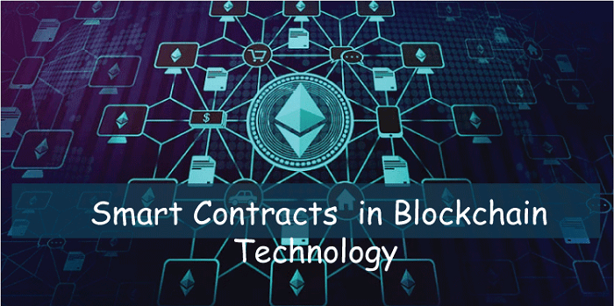

The way we understand and handle digital transactions has been revolutionized by blockchain technology. The possibilities of blockchain technology have been

further improved by the introduction of smart contracts, a self-executing piece of code. Digital contracts that are effective, transparent, and impenetrable have entered a new era thanks to smart contracts.

A blockchain-encoded digital contract between two or more parties is known as a smart contract. The conditions of the agreement between the buyer and seller are directly encoded into lines of code, making it a self-executing contract. The contract cannot be changed after it is deployed since both the code and the agreements it contains are on a decentralized blockchain network.

Smart contracts work by having a set of predetermined circumstances that, when satisfied, cause the contract's obligations to be automatically carried out. The time and expenses related to conventional contract administration are decreased since this automation removes the need for middlemen like attorneys, banks, or brokers.

The transparency of smart contracts is one of its most important benefits. A smart contract's execution results in its recording on the blockchain, where it is accessible to everybody on the network. This openness makes sure that everyone participating in the deal has the same information at their disposal and that the provisions of the contract are strictly adhered to.

The potential of smart contracts to automate complicated procedures is another important benefit. Smart contracts have the ability to be programmed to carry out a sequence of operations when certain criteria are satisfied. For instance, if a certain set of circumstances are satisfied, a smart contract may be set up to automatically transfer money from one party to another.

There are several applications for smart contracts, including supply chain management, real estate transactions, and digital identity verification. The banking sector is one area where smart contracts are becoming more and more popular. Banks and other financial institutions are investigating the use of smart contracts to automate many of their current procedures, including clearing and settlement, in order to cut down on time and expenses.

Despite all of its advantages, smart contracts are not without drawbacks. The absence of standards is one major problem. Since smart contracts are a relatively new kind of technology, they are not required to go by any particular set of norms or guidelines. Due to the absence of standardization, it may be challenging for various blockchains' smart contracts to communicate with one another.

The potential for bugs or other weaknesses in the code is another difficulty. Any flaws or weaknesses in the code might have serious repercussions because smart contracts are self-executing and cannot be changed once they are deployed. To reduce these risks, developers must make sure that the code is extensively tested and audited.

Blockchain technology, a distributed ledger that is maintained by a network of nodes, provides the foundation for smart contracts. Every node has a copy of the ledger, and any updates are added after being approved by the network. The blockchain's security and integrity are guaranteed by this verification procedure.

Traditional contract management procedures are significantly impacted by smart contracts. They do away with the necessity for middlemen, which lowers the price and time of contract administration. Furthermore, there is no doubt or misunderstanding regarding the contract's conditions because they are encoded in the code. This lessens the possibility of disagreements and legal conflicts.

Smart contracts may also be used to carry out intricate corporate procedures. A smart contract, for instance, may automate the tracking of items from the manufacturer to the customer in supply chain management. The smart contract updates the ledger each time the products are exchanged, guaranteeing that everyone in the supply chain has access to the same data.

Digital identity verification may also be accomplished with smart contracts. The blockchain may be used to store a person's identifying data in a smart contract. Anyone on the network may then access and verify this information. As a result, there is no longer a need for centralized identity verification agencies, and the likelihood of identity fraud is decreased.

Decentralized finance (DeFi) is another area where smart contracts may be used. DeFi is a term used to describe financial apps created using blockchain technology. Automating financial procedures like lending, borrowing, and trading is possible using smart contracts.

A smart contract may be used to carry out a loan arrangement between two parties, for instance. The code contains the conditions of the loan arrangement, such as the interest rate and payback timeline. The smart contract automatically distributes the money to the lender once the borrower pays back the loan.

To summarize, smart contracts are a powerful and transformational technology that has the ability to revolutionize the way we handle contracts and carry out business procedures. Their efficiency, transparency, and automation make them a popular choice in a variety of businesses. While there are certain hurdles to overcome, such as standardization and code vulnerabilities, the advantages of smart contracts are considerable and have the potential to revolutionize the way we do business for the better.

# **What is Blockchain Wallet ?**

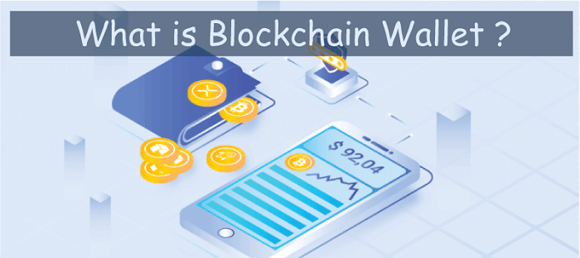

Blockchain technology has gained tremendous interest in recent years as a safe and dependable means of conducting online transactions. The Blockchain wallet, which functions as a digital wallet for holding cryptocurrency, is a key component of this technology. In this essay, we will define a Blockchain wallet and explain how it works.

A Blockchain wallet is a digital wallet that enables users to securely store, transmit, and receive cryptocurrency. It is a software programme that uses Blockchain technology to handle users' private and public keys, allowing them to transact with cryptocurrencies like Bitcoin and Ethereum. The wallet runs on a decentralized network, which means it does not rely on a centralized authority to function, making it extremely safe and transparent.

The operation of the wallet is centered on Blockchain technology, which is a distributed ledger system that records all bitcoin transactions. The Blockchain wallet operates by producing a digital signature for each transaction, which protects the transaction's legitimacy and integrity. Before the transaction is posted to the Blockchain, the network nodes verify the signature. The transaction is irreversible once it is recorded on the Blockchain, making the procedure extremely safe.

Desktop wallets, mobile wallets, online wallets, and hardware wallets are all examples of Blockchain wallets. Each wallet has its own set of features and perks. Desktop wallets are software apps that are installed on a desktop computer and provide the user complete control over their private keys.

Mobile wallets are smartphone applications that allow users to access cryptocurrencies while on the go. Web wallets, which can be accessed via a web browser, allow users to manage their bitcoins online. Hardware wallets, on the other hand, are actual devices that securely store the user's private keys offline.

One of the major benefits of Blockchain wallets is their high degree of security. Because the wallet runs on a decentralized network, there is no need for a central authority, making it nearly difficult for hackers to take cryptocurrency from the wallet. Furthermore, the combination of private and public keys guarantees that only the wallet owner has access to the contents of the wallet, adding an extra degree of protection.

To elaborate, Blockchain wallets enable users to handle their cryptocurrencies in an intuitive and easy manner. By simplifying the difficult process of bitcoin administration, they give consumers a smooth and hassle-free experience. The wallet's UI is intended to provide a straightforward and simple platform for users to manage their bitcoins.

The security of the Blockchain wallet is based on the usage of both public and private keys, which are utilized to authenticate transactions. The private key is a secret code that only the wallet owner knows about and is used to sign transactions. In contrast, the public key is accessible to everyone on the entire network and is used to accept cryptocurrency. Together, these keys maintain transaction security, making it nearly difficult for anybody to take cryptocurrency from the wallet.

Blockchain wallets enable transparency in addition to security. All transactions are recorded on the Blockchain, allowing users to easily follow and verify the validity of each transaction. Because of this transparency, there is no need for middlemen such as banks or financial institutions, lowering transaction costs and boosting transaction speed.

Another advantage of Blockchain wallets is that they are not geographically constrained. They may be accessible from anywhere in the globe as long as there is an internet connection. This characteristic makes them excellent for performing international transactions since it eliminates the need for costly foreign currency costs.

However, it is important to highlight that the security of Blockchain wallets is contingent on the user's adherence to security rules. To prevent unauthorized access to the wallet, users must follow suggested security precautions such as creating a strong password and enabling two-factor authentication.

Finally, Blockchain wallets are a game-changing technology that gives a safe and simple way to manage cryptocurrency. They provide high levels of security, transparency, and simplicity, making them suitable for cryptocurrency transactions by people and organizations. While they offer several benefits, it is important to follow prescribed security practices to ensure the protection of cryptocurrencies kept in the wallet.

### **Applications of Blockchain Wallet**

Blockchain wallets offer a variety of uses that make them a valuable resource for consumers and organizations wishing to conduct bitcoin transactions. Blockchain wallets may be used for a variety of purposes, including:

1. **Storing cryptocurrencies:** Blockchain wallets are mostly used to securely store bitcoins. Because the wallet employs private and public keys, only the wallet owner has access to and management of the cryptocurrency stored in the wallet.
2. **Sending and receiving cryptocurrencies:** Blockchain wallets allow users to quickly transfer and receive bitcoins. Users may transfer bitcoin to anybody having a cryptocurrency wallet address, no matter where they are in the globe.
3. **Online shopping:**Blockchain wallets may be used to perform cryptocurrency-based online purchases. This function eliminates the need for traditional payment methods and increases the security of online purchase.
4. **Investment:** Blockchain wallets can be used to invest in cryptocurrencies, allowing individuals to participate in a decentralized asset class that is not controlled by any central authority.
5. **Remittances:** Blockchain wallets enable international money transfers without the involvement of middlemen such as banks or financial organizations. This function avoids the need for costly foreign currency fees and lowers transaction expenses.
6. **Decentralized applications:** Blockchain wallets can be used to access the Blockchain network's decentralized apps (DApps). DApps are decentralized apps that are not controlled by a central authority and allow users to connect with digital services in a secure and transparent manner.

As a result, Blockchain wallets are a handy tool for both people and companies wanting to conduct bitcoin transactions. They have a variety of uses. For online transactions, investments, remittances, and access to decentralized apps, they offer a safe and practical means to store, transmit, and receive bitcoins. It is anticipated that as cryptocurrencies continue to be recognised as a genuine asset class, the use of Blockchain wallets will rise.

# **Demur-rage currencies in Blockchain**

The way we do financial transactions has been completely transformed by blockchain technology. It has produced an unchangeable, decentralized system that guarantees security and transparency. However, the use of demurrage currencies in blockchain technology has been underutilized. Alternatives to conventional currencies, demurrage currencies offer distinctive qualities that draw people in. In this post, we'll look into blockchain-based demurrage currencies and their possible advantages.

### **What are Demurrage Currencies?**

Demurrage currencies are those whose value depreciates over time. Demurrage currencies aim to increase consumption by discouraging hoarding. Demurrage currencies are not a novel idea; they have been applied in the past, notably during periods of economic unrest. The Wörgl money, which was used in Austria during the Great Depression, is the most well-known illustration of a demurrage currency. The local government utilized the Wörgl money to pay for public works projects, although it depreciated at a rate of 1% each month.

Currency issued under a demurrage has an expiration date, which sets it apart from conventional currencies. To accommodate the demands of the currency's users, this expiration date can be changed. A currency may, for instance, lose value at a rate of 1% per week or 1% per day. To promote spending and discourage hoarding, the expiration date was created.

### **How do Demurrage Currencies Work in Blockchain?**

Demurrage currencies may now be created that are safe and transparent thanks to blockchain technology. These currencies are based on blockchain networks and use smart contracts to function. Smart contracts are preprogrammed to automatically carry out the conditions of the parties' agreement. Smart contracts are employed in the case of demurrage currencies to control the currency's expiration date.

The smart contract includes a provision for the currency's expiry date. The smart contract subtracts a specific percentage from the value of the currency at predetermined intervals when a user gets demurrage cash. Depending on the demands of the currency's users, this deduction can be programmed to happen daily, weekly, or monthly. It is impossible to halt or change the automatic deduction.

### **Benefits of Demurrage Currencies in Blockchain**

There are several benefits to using demurrage currencies in blockchain, including:

1. **Encouraging Spending:** Demurrage currencies discourage hoarding and promote spending. This is because the currency loses value over time, so users are incentivized to spend it before it expires.
2. **Stability:** Demurrage currencies can provide stability in times of economic uncertainty. They can help prevent inflation and stabilize the value of a currency.
3. **Sustainability:** Demurrage currencies can promote sustainable practices by encouraging users to spend their currency on environmentally-friendly products and services.
4. **Decentralization:** Demurrage currencies are decentralized, meaning they are not controlled by a central authority. This makes them more resistant to manipulation and corruption.
5. **Community Building:** Demurrage currencies can be used to build communities around a shared set of values. For example, a demurrage currency could be used to fund local public works projects or support local businesses.

### **Specific Examples of Demurrage Currencies in Blockchain**

There are several demurrage currencies that are currently being developed or are already in use in blockchain. Some examples include:

1. **Freicoin:** Freicoin is a cryptocurrency that was launched in 2013. It is a demurrage currency that loses value at a rate of 5% per year. The purpose of Freicoin is to encourage spending and prevent hoarding. Freicoin operates on the Bitcoin blockchain.
2. **Circles:** Circles is a blockchain-based social currency that was launched in 2020. It is a demurrage currency that loses value at a rate of 5% per month. The purpose of Circles is to promote community building and social interactions. Circles operates on the xDai blockchain.
3. **Earth Dollar:** Earth Dollar is a blockchain-based currency that was launched in 2018. It is a demurrage currency that loses value at a rate of 3.5% per year. The purpose of Earth Dollar is to promote sustainable practices and fund environmental projects. Earth Dollar operates on the Ethereum blockchain.
4. **Mutual Credit:** Mutual Credit is a blockchain-based currency that was launched in 2016. It is a demurrage currency that loses value at a rate of 5% per month. The purpose of Mutual Credit is to promote community building and local economic development. Mutual Credit operates on the Open Credit Network blockchain.

### **Challenges of Demurrage Currencies in Blockchain**

Although demurrage currencies provide a number of advantages, they are not without drawbacks. The biggest obstacle is user acceptability. Users could be cautious to use demurrage currencies since they differ from conventional currencies. The difficulty of deploying demurrage currency on a big scale presents another difficulty. Governments and corporations must provide major technical infrastructure in order for this to be possible.

# **Blockchain to secure IOT data**

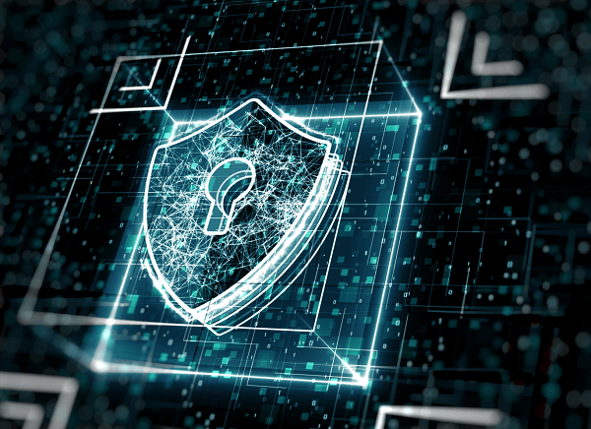

Blockchain is a game-changing technology that is altering how we store and transport data. It has the potential to change a wide range of businesses, including the Internet of Things (IoT). With billions of devices linked to the internet, the IoT market is expanding at an unprecedented rate. However, with this expansion comes the necessity for enhanced security measures to safeguard critical data. Blockchain technology has the potential to play a critical role in the security of IoT data.

The IoT sector confronts a number of security concerns, including device tampering, data breaches, and unauthorized device access. These issues come as a result of data centralization, which makes it simpler for hackers to obtain access to critical information. Blockchain technology can address these issues by establishing a decentralized and immutable ledger that securely and transparently records all transactions.

One of the most important characteristics of blockchain technology is its decentralized nature. Data is stored in a single area in a typical centralized system, making it easier for hackers to obtain access to important information. Data is kept across a network of nodes in a blockchain-based system, making it far more difficult for hackers to tamper with the data.

Immutability is another fundamental aspect of blockchain technology. Data that has been recorded on a blockchain cannot be changed or removed. This implies that any tampering with the data will be discovered instantly, making it far more difficult for hackers to infiltrate the system.

Encryption and smart contracts are two examples of how blockchain technology might improve security. Encryption guarantees that data is delivered securely, while smart contracts automate transaction verification and execution. These measures can guarantee that only authorized devices have access to the data and that any unauthorized access is identified as soon as possible.

The application of blockchain technology in the IoT market goes beyond data security. It can also make data exchange across devices and organizations easier. Blockchain-based platforms can make data exchange more safe and transparent, making it easier for organizations to cooperate and share insights.

Additionally, blockchain technology has the potential to increase the efficiency and cost-effectiveness of IoT data handling. To handle and validate transactions, traditional data management systems require centralized authority. This centralized strategy is both costly and time-consuming. By eliminating the need for centralized authority, blockchain technology can provide a more efficient and cost-effective alternative. The decentralized structure of blockchain enables automatic transaction verification and execution, removing the need for middlemen and lowering costs.

Increased transparency is another advantage of employing blockchain technology in the IoT market. Because blockchain technology is transparent, data transactions can be easily audited and accountable. This implies that any tampering or unauthorized access may be detected and tracked back to its source. Increased openness can also aid in the development of trust among various organizations and players in the IoT ecosystem.

Supply chain management is one of the possible uses of blockchain technology in the IoT business. Blockchain technology may be used to build a transparent and secure supply chain, allowing for easy tracking and monitoring of things from their origin to their destination. This can increase supply chain efficiency and lessen the possibility of counterfeit items entering the market.

However, it is crucial to highlight that blockchain technology adoption in the IoT industry is still in its early phases, and there are various hurdles that must be overcome. These issues include blockchain network scalability, blockchain platform interoperability, and blockchain technology integration with current IoT infrastructure.

One of the primary advantages of adopting blockchain technology to safeguard IoT data is that it allows consumers to have more control and ownership over their data. Data is frequently managed by centralized entities, such as governments or companies, in traditional data management systems. This might raise concerns about data privacy and ownership. Users may have more control over their data and select who they share it with thanks to blockchain technology.

Blockchain technology has the potential to drive increased innovation in the IoT business. Collaboration and the creation of new apps and services can be facilitated by the ability to safely and openly share data. IoT systems built on blockchain can potentially enable the formation of decentralized autonomous organizations (DAOs), in which devices can participate in decision-making and governance.

Following that, the use of blockchain technology to protect IoT data has the potential to revolutionize the IoT sector by offering a safe and transparent answer to the industry's security concerns. While there are still obstacles to overcome, the potential benefits of blockchain technology in the IoT business are enormous, including enhanced security, efficiency, transparency, and creativity. As blockchain technology becomes more widely used, we should expect to see more inventive applications of this technology in the IoT market.

# **How does Blockchain support Crowdfunding?**

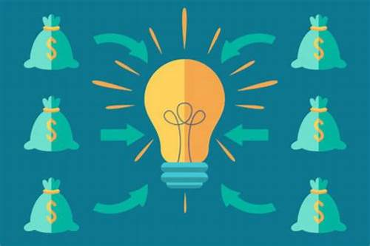

Crowdfunding is a way to get a lot of people to give modest sums of money to a project or business endeavor. It has grown in popularity in recent years as a means for business owners to obtain cash without using conventional channels like banks or venture capitalists. With the advent of blockchain technology, crowdfunding has evolved into a new model that provides a safer and more open method to raise money. In this post, we'll examine what crowdfunding is and how it functions in the context of blockchain technology.

## **What Does Blockchain Technology's Crowdfunding Mean?**

Using cryptocurrency or digital tokens, crowdfunding with blockchain technology entails raising money via a decentralized network. A distributed ledger using blockchain technology tracks each transaction and confirms it across several network nodes. A safe and open platform for crowdfunding is offered by this.

The entrepreneur develops a smart contract that specifies the parameters of the fundraising agreement in a blockchain-based crowdfunding campaign. This smart contract is then published on the blockchain so that interested investors may access it. The blockchain then records the donations made by investors, who may subsequently fund the campaign using cryptocurrency or digital tokens.

The smart contract automatically carries out the conditions of the agreement whenever the financing target is met, disbursing the money to the business owner. This makes it unnecessary to use middlemen and offers a more effective and open method of raising money.

A well-liked method for entrepreneurs to generate capital for their company endeavors is crowdfunding. The conventional crowdfunding strategy does, however, have several drawbacks, including expensive fees, regional constraints, and a lack of transparency. Blockchain technology can provide a safer and more effective method of crowdfunding in this situation.

A decentralized ledger powered by blockchain technology keeps a permanent and unchangeable record of all transactions. It has a number of features that make it the perfect crowdfunding platform. The following are some ways that blockchain helps in crowdfunding:

1. **Transparency:** Transparency is one of the main benefits of adopting blockchain technology for crowdfunding. Multiple network nodes record and confirm each transaction on the blockchain. This ensures that there is no fraudulent behavior by creating a clear and unchangeable record of all transactions.
2. **Reduced Fees:** Traditional crowdfunding sites have significant service costs, which might reduce the amount of money businesses are able to raise. On the other side, peer-to-peer networks are used by blockchain-based crowdfunding platforms, which do away with the necessity for middlemen. Because of the cheaper costs as a consequence, businesses may keep more of the money they raise.
3. **Global Reach:** Entrepreneurs find it challenging to reach a worldwide audience thanks to the geographical constraints that sometimes limit traditional crowdfunding platforms. However, blockchain-based crowdfunding platforms run on a decentralized network, enabling business owners to freely access a worldwide audience.
4. **Smart Contracts:** Smart contracts, which are self-executing contracts that automatically carry out the terms of an agreement when specific criteria are satisfied, are another feature of blockchain technology that may be used. Smart contracts may be used to automate the crowdfunding process, making sure that money is only paid to the business owner after reaching predetermined milestones.
5. **Tokenization:** Digital tokens may be created using blockchain technology to signify ownership in a business or project. Through an Initial Coin Offering (ICO), these tokens may be used to raise money. Using ICOs, business owners may generate money rapidly and effectively without the use of conventional middlemen.

## **Advantages:**

1. **Security:** Blockchain technology provides a high level of security, protecting against fraud and hacking, and ensuring the safe transfer of funds.
2. **Speed:** Blockchain-based crowdfunding campaigns can be launched quickly, enabling entrepreneurs to raise funds more efficiently.
3. **Diversity:** Crowdfunding in blockchain technology provides an opportunity for small investors to invest in projects they believe in, promoting a more diverse and inclusive investment ecosystem.
4. **Innovation:** Blockchain technology is constantly evolving, leading to the emergence of new and innovative crowdfunding platforms.
5. **Low minimum investment:** Blockchain-based crowdfunding platforms often have a low minimum investment requirement, allowing small investors to participate in investment opportunities that were previously out of reach.

## **Disadvantages:**

1. **Lack of regulation:** Crowdfunding in blockchain technology is relatively new and lacks regulatory oversight, which may expose investors to higher risks.
2. **Volatility:** Cryptocurrencies and digital tokens are often highly volatile, exposing investors to a higher level of risk than traditional investments.
3. **Lack of transparency:** While blockchain technology provides transparency, some crowdfunding campaigns may lack information about the underlying project or venture, exposing investors to the risk of investing in a poorly conceived or fraudulent project.
4. **Limited liquidity:** While tokenization provides investors with a more liquid asset, some digital tokens may be difficult to sell or trade, leading to a lack of liquidity.
5. **Crowding out:** Crowdfunding in blockchain technology may lead to the crowding out of traditional investment channels, limiting access to capital for entrepreneurs who are not familiar with or cannot access blockchain-based crowdfunding platforms.

Finally, blockchain technology has various benefits for crowdfunding, such as transparency, lower costs, global access, smart contracts, and tokenization. These advantages are fueling the development of new and creative crowdfunding platforms based on blockchain technology. As technology advances, we may anticipate more efficient and effective crowdfunding systems that will benefit both entrepreneurs and investors.

# **What are Crypto Assets in Blockchain?**

Cryptocurrencies are among the most well-known uses of blockchain technology, which has emerged as one of the most inventive technologies in recent years. Cryptography is used by cryptocurrencies, which are digital or virtual tokens, to safeguard and verify transactions and regulate the generation of new tokens. These tokens may be used for a variety of things, such as making investments as well as buying products and services.

A kind of digital asset based on blockchain technology is known as a crypto asset. In addition to cryptocurrencies, they also include non-fungible tokens (NFTs), utility tokens, and security tokens, which are all constructed on top of blockchain technology.

1. **Cryptocurrencies:-** Cryptography is used by cryptocurrencies, which are digital tokens, to safeguard and verify transactions as well as to regulate the generation of new tokens. Since its inception in 2009, Bitcoin has maintained its position as the most well-known and popular cryptocurrency. Ethereum, Ripple, Bitcoin Cash, Litecoin, and more well-known cryptocurrencies are also available.
2. **Utility Tokens:-** Digital tokens called "utility tokens" can be used to access or buy a certain service or product that a business is offering. They are often employed in Initial Coin Offerings (ICOs) as a means of funding for businesses. Utility tokens are designed to give users access to a particular service or product; they are not meant to be used as a medium of exchange or as an investment.
3. **Security Tokens:-** Securities regulations apply to security tokens, which are digital tokens that reflect ownership in an underlying asset or business. Security tokens can represent ownership in digital assets like cryptocurrencies and other crypto assets as well as traditional assets like stocks, bonds, and real estate.
4. **Non-Fungible Tokens (NFTs):-** A sort of digital asset known as a non-fungible token (NFT) denotes ownership of a certain good or piece of content. NFTs are not interchangeable like bitcoins and other digital assets since each one represents a different thing. Digital art, music, and other sorts of creative creations are frequently represented by NFTs.

The creation of crypto assets using blockchain technology has created new opportunities for generating and transferring digital assets in a safe and open way. Blockchain technology's decentralization enables more control over assets and transactions, eliminating the need for middlemen and boosting transaction efficiency and transparency.

In recent years, cryptocurrency assets have grown in popularity as more and more investors seek to profit on the possibility for huge returns. However, there are dangers associated with investing in crypto assets because the market is extremely volatile and the regulatory landscape is still hazy in many jurisdictions.

ADVERTISEMENT

Cryptoassets are redefining how we perceive ownership and value, and they have the ability to upend established financial structures. Cryptoassets' capacity to enable peer-to-peer transactions without the aid of middlemen like banks or payment processors is one of its main benefits. Transactions may become quicker, more affordable, and more effective as a consequence.

The accessibility of crypto assets worldwide is another benefit. Due to their digital nature and ease of cross-border trade, they enable greater financial inclusion for people and enterprises worldwide.

The utilization of crypto assets does, however, come with certain difficulties. Given that various countries have varied ways to regulate crypto assets, regulatory ambiguity is one of the main problems. For investors, companies, and regulators alike, this may lead to confusion and ambiguity.

The erratic nature of the market for crypto assets is another difficulty. Cryptoassets' value is solely based on supply and demand because they are not backed by any tangible assets. This makes them a high-risk investment since the price might fluctuate quickly and dramatically as a result.

Despite these difficulties, the usage of crypto assets is expanding. Bitcoin is already accepted as payment by well-known businesses like Tesla and PayPal, and many banks and financial institutions are looking at how to incorporate crypto assets into their services.

Finally,a subset of digital assets known as crypto assets is based on the blockchain technology. They consist of digital currencies, NFTs, utility tokens, and security tokens. While there are certain drawbacks to using crypto assets, there are also numerous benefits, including more widespread accessibility, quicker and more efficient transactions, and more financial inclusion. Although the future of crypto assets is still unclear, it is obvious that they have the power to completely alter the way we perceive value and ownership.

# **Blockchain and distributed ledger technology**

One of the biggest technological stories of the last ten years is Blockchain. Although it appears like everyone is talking about it, the actual meaning and operation of Blockchain are sometimes obscured under the surface of discussion. Although Blockchain has a reputation for impenetrable, its core concept is quite straightforward. Additionally, it has the power to completely transform entire sectors.

Blockchain is a system that makes it possible to share information securely. A database obviously contains data. A ledger is an account book where transactions are entered. The ability to update the Blockchain is shared among the nodes, or individuals, of a public or personal computer network. A blockchain is a sort of decentralised database or ledger, one of today's top technological developments. Distributed ledger technology, also known as or DLT, is what this is. Digital tokens or money are used as incentives to encourage nodes to update blockchains.

Three main features define a blockchain. A blockchain database must, first and foremost, be cryptographically secure. Therefore, two cryptographic keys are required in order to enter or contribute data to the database: a key that is publicly accessible, which is essentially the database address, and a secret key, which is a unique key that must be verified by the network.

## **Distributed ledger**

A sort of information that is shared, copied, and synchronised among the participants in a decentralised network is known as a distributed ledger. The distributed ledger keeps track of all interactions between network participants, such as trading goods or information.

The ledger's records are updated by consensus among network participants, who also regulate the system. There needs to be involvement from a centralised authority or a neutral third party, such a clearinghouse or financial institution. The distributed ledger is an auditable, immutable record of all network transactions since each record includes a date and distinctive cryptographic signature.

Users at every node in the network can evaluate distributed ledgers, and they can have an exact copy of the files that circulate across the network. If the ledger is modified or added to, the participants are notified and copied on the changes. The database is synchronised to ensure that it is accurate. Bitcoin and distributed ledgers both make use of the same technology.

Blockchain/DLT are the foundation of the "internet of value," allowing peer-to-peer "value" transfers and recording interactions without the need to establish a centrally coordinating body. The term "value" refers to every record of ownership of an asset, such as money, securities, or property titles, as well as ownership of certain information, such as an individual's identity, health information, or other personal data.



DLT has the potential to significantly improve the financial sector's efficiency, resiliency, and reliability.

ADVERTISEMENT

ADVERTISEMENT

* This may change the responsibilities of stakeholders in the financial system and address enduring problems. DLT offers the potential to revolutionise a number of different industries, including manufacturing, public financial administration, and clean energy.
* The International Monetary Fund does not have any broad advice regarding how to use this technology for global development because it is still in its infancy. We collaborate with standard-setting organisations, governments, central banks, and other parties to track, investigate, and test DLT and blockchain-based applications.
* Waiting for "perfect" DLT solutions, however, can mean passing up a chance to influence it. Research as well as practical implementations and pilots are necessary to comprehend how DLT might address issues in the banking sector.
* As a result of the introduction of new technology, it also necessitates addressing difficulties with consumer protection, financial integrity, transaction speed, environmental impact, and legal, regulatory, and technological issues.
* DLT applications are expected to be implemented gradually, replacing manual and ineffective processes and activities. (For example, maintaining reference data in settlement and payment systems, trade finance, loan syndicates, and tracing the provenance of agricultural goods or commodities, their future sale, or their use as collateral for financing.)
* DLT has the potential to improve access to money for unbanked communities that are now excluded from the traditional financial system, as well as increase efficiency and reduce remittance costs.

## **Workings of Distributed Ledgers**

Individuals known as nodes hold, manage, and alter distributed ledgers. Every node independently builds the database. Each node processes every transaction on the network, drawing conclusions about how the database develops.



Voting is done on the database modifications that have been made based on the transaction. All nodes take part in the voting process, and a new transaction is approved on the database if a minimum of 51% of them concur. After that, all of the nodes refresh the database versions to ensure that every device or node is running the same version. The newly created transaction is added to a blockchain block.

In a Proof-of-Work blockchain, nodes are also known as miners. A miner is rewarded for successfully adding a new transaction to a block. It needs devoted computer power available constantly. Miners are in charge of calculating the digital signature for new blocks. The reward goes to the miner who correctly locates the hash first.

The success of miners who devote more computing power to finding the hash will increase. Finding new hash scales, however, gets more challenging as blocks continue to generate. The objective is to generate blocks at a steady rate.

## **Distributed ledger technology types**

**There are three different types of distributed ledgers:**

* Permissioned DLT: To access or alter the network in any way, nodes must first obtain permission from a centralized authority. These rights typically require identity verification.
* Permissionless DLT: there's no governing body to validate transactions; instead, all of the current nodes work together to do it. Transactions based on preset algorithms are validated using a variety of consensus techniques. The proof-of-work consensus process is applied in the instance of Bitcoin.
* Hybrid : Permissionless and permissioned distributed ledger technologies are merged to create a hybrid DLT that can reap the benefits of both.

## **Features of Distributed Ledgers**

* distributed ledgers, entries are made directly in the information system without the assistance of a third party. Records entered into distributed ledgers cannot be changed by any other person once they are there. As a result, documents cannot be altered until the accounting records are disseminated.
* There is no longer a need for an outside organisation While it is not always necessary, operating distributed databases without an outside organization can often result in significant cost and time savings. Results in the logistics sector can be directly written to the Blockchain by sensors, eliminating the need for a middleman. It helps you save a lot of money, time, and effort.
* Another degree of security is added by the distributed ledgers' inherently decentralised structure. The information within it is spread out internationally, making an attack challenging.
* A high degree of transparency is demonstrated by distributed ledgers. They make it possible to freely and conveniently view all the data that has been saved. It offers a considerable portion of the openness that many industries want.

## **Examples**

A very well-known instance of a distributed database is bitcoin. It is a form of digital currency that can be used to make purchases on a network that lets users to make irreversible purchases for less money than they would pay using more traditional online payment methods.

Ethereum is a well-known distributed ledger that lets programmers build custom apps. Since it introduced smart contracts, it is incredibly well-liked. The self-executing smart contracts are activated when specific real-world circumstances are met and pertinent data is added to the Blockchain.

Ripple is another instance of a distributed database that focuses on payments, particularly cross-border transactions. Ripple is an open-source ledger. It was designed with banks in mind initially.

## **How do decentralized finance, cryptocurrencies, and Blockchain relate to one another?**

Without the help of banks or other middlemen, buyers and sellers can trade cryptocurrencies online thanks to blockchain technology.

Cryptocurrencies and all other digital assets are built on the blockchain technology. A series of blockchain or cryptocurrency applications known as "decentralised finance" (DeFi) is intended to take the role of the present financial intermediaries with services based on smart contracts. Decentralized means that anybody with access to a program has control over whatever changes are made to it, just like Blockchain. Users may now have a more significant direct influence over their money as a result.

## **Conclusion**

DLT is marketed by experts in this field as a remedy for numerous online issues that will radically resolve all of these issues. "Internet of Value" is a concept used to describe distributed ledger technology. The Internet will be used to facilitate real-time transactions and processes. With its efficient solutions, the use of distributed ledgers has a chance to have a positive impact on issues in the finance or banking, online safety, healthcare, government, and data security sectors.

# **How Blockchain Technology is Revolutionizing Industries**

Blockchain constitutes a transparent and secure digital ledger that keeps track of transactions between many computers. It creates an immutable ledger using a series of linked transactions that cannot be altered or removed without network consent. It has more functionality than a typical database and has built-in safeguards against unauthorized transactions. Without go-betweens like banks, blockchain technology offers safe, transparent transactions that boost productivity and cut costs. Additionally, it can give underbanked or unbanked people access to financial and banking services and lower the risk of corruption and money laundering.

Supply chain management can benefit from the use of blockchain technology to boost efficiency, lower the risk of fraud, and promote transparency. Businesses may increase consumer trust, lower costs, and make better decisions by tracking a product from its point of origin to its final destination. In the supply chain, this future use of cryptocurrencies can be advantageous to both companies and customers.



A block that has been added to the chain cannot be changed or removed, making blockchain technology extremely secure and tamper-proof. This qualifies it for applications like monetary transactions or voting systems, where confidence and security are crucial. The article's main discussion topic is how blockchain-based technology is transforming several businesses.

Although blockchain technology has many benefits, there are still particular challenges to its widespread implementation. These challenges include scalability constraints, regulatory hurdles, and security risks. Improved security measures are required to stop hacking and cyberattacks.

## **How is the Blockchain operate?**

The Blockchain comprises an interconnected set of nodes that validate transactions and add new blocks to the chain of blocks already in existence. Each block has a different hash code that serves as a means of identification and an allusion to the previous block's hash code. As a result, a series of blocks is formed that cannot be added to or eliminated, which renders the Blockchain an unchangeable and untouchable record of transactions. We'll look at how the blockchain system is altering how we view financial transactions and how it's being applied to upend a variety of sectors.

We provide a quick introduction to the underlying blockchain mechanisms in the following steps, notwithstanding their complexity. Most of these steps can be automated using blockchain software:



* **Please keep track of the transaction:** A blockchain transaction documents how assets are transferred between network parties, whether tangible or digital. It is stored as a data block and can include information such as "Who was involved in the transaction?" "What happened during the transaction?","When the transaction occurred?","Where the transaction occurred?" "Why did the transaction occur?" "How much of the asset was exchanged?" and "How many pre-conditions were met throughout the transaction?"
* **Gain Consensus:** The majority of users on the decentralized blockchain network must concur that the transaction recorded is legitimate. Rules for agreement can differ according to the network, but they are usually defined at the beginning of the network.
* **Write the Blocks:** After the participants have agreed, the blockchain transactions are put into blocks similar to the sections of a ledger book. A cryptographic hash is applied to the new block along with the transactions. The blocks are connected by a chain created by the hash. The value of the hash changes whenever the block's contents are altered, whether on purpose or accidentally, making it possible to spot data manipulation. As a result, the component parts and chains connect solidly and cannot be changed. Each new block reinforces the previous block's verification and, by extension, the Blockchain as a whole. This is similar to building a tower out of wooden blocks. Blocks can only be stacked on top of one another; removing an element from the center of a tower causes the tower to collapse.
* **Decentralized system:** A decentralized, secure record of personal data, such as proof of identity, can be made using Blockchain and used to authenticate a person's identity without the aid of a centralized authority.
* **Secure:** By offering a safe and impenetrable mechanism to record and trace digital transactions, blockchain technology is revolutionizing businesses all over the world.
* **New innovation:** It can challenge established business models and open up new chances for development and innovation. It will be fascinating to watch how technology changes our way of living and working as it advances.

Although digital currencies like Ethereum and Bitcoin are frequently mentioned when discussing blockchain technology, their potential uses go far more profound than digital assets. Blockchain technology is revolutionizing industries in previously unthinkable ways, from managing supply chains to healthcare. This article will examine the ways that blockchain technology is reshaping several businesses and the possible advantages it may have.

Let's look at some of the major sectors that blockchain technology is fundamentally reshaping and how they stand to gain.

**Data Retention**

Data distribution and storage have traditionally been handled by businesses using centralized servers, such as Cloud storage. While it has benefits like simple access, there are also disadvantages like a higher risk of hacking and just one point of failure. Blockchain-based decentralized data storage spreads information throughout an interconnected system of computers, addressing issues like data loss and breach through increased security and giving users greater authority over their data.

ADVERTISEMENT

For instance, a decentralized storage network like BNB Greenfield offers a decentralized storage infrastructure that users and DApps can utilize to generate, store, and share data with full ownership and establish a new data economy. Website hosting, secure cloud and chain storage of information, publication, and social media are a few application cases for BNB Greenfield.

**Creation of Content :**

Because of centralized governing systems, content providers in the music, recreation, and arts sectors sometimes struggle to monetize their work. Blockchain technology facilitates royalty payments while lowering content piracy and duplication. In terms of operation, it also offers a less expensive choice.

**Entertainment :**

The media and entertainment sectors have previously adopted blockchain technology in various use cases, including NFT ticketing. This method of distributing tickets is gaining popularity since it can prevent bots and assist event organizers in establishing precise resell guidelines.As it involves fans purchasing and utilizing tickets, it also offers more security and convenience in operation. Additionally, NFT tickets frequently come with extra benefits like early admission to future events, which boosts fan engagement. They also serve as a commemorative gift that fans to take in after the event.

**Finance :** The majority of the financial sector's operations are controlled by regulatory organizations using centralized systems. As a result, there are fewer opportunities for customers to receive financial services and high entry barriers are created. Blockchain provides a substitute in the form of Decentralised Finance (DeFi), which anybody with a crypto wallet can use and which uses smart contract technology to authenticate and handle transactions.This is opening the way for the financial services sector to become more democratic as it transitions from an antiquated system to a cutting-edge one which relies on peer-to-peer exchanges.

**Healthcare:** The usage of blockchain technology is transforming the healthcare sector. Healthcare providers can guarantee that private information is secured but shared only with authorized parties by generating an encrypted and immutable copy of patient data.

**Smart Contracts:** Using smart contracts is another effective way to harness blockchain technology. When specific criteria are satisfied, these self-executing agreements autonomously execute the conditions of a contract, eliminating the need for go-betweens and facilitating quicker, less expensive, and more secure transactions. Industries like property management, coverage, and banking, which frequently require complicated legal agreements, might be completely transformed by smart contracts. One of the most popular blockchain platforms, Ethereum, was at the forefront of the creation of smart contracts and has drawn many companies and developers to its platform to create applications.

Blockchain technology can also help to lower expenses and streamline administrative procedures. Blockchain, for instance, may be utilized to automate the processing of claims and do away with middlemen like insurance firms. Industries could be completely transformed by blockchain technology, which offers a variety of advantages, including improved security, openness, and effectiveness, as well as prospects for decentralized decision-making, ownership of information, and monetization. Technology is positioned to fuel more innovation and accelerate acceptance on a global scale as it develops and becomes more widely available.

In order to achieve this, organizations should investigate how they might use blockchain technology to improve operations, and processes and create fresh possibilities while staying one step ahead of their rivals.

## **Here are a few concepts for how Blockchain is changing the supply chain sector.**

Everyone despises middlemen, but they actually serve a very vital purpose. The only way to get a lot of entities to agree on a shared, accurate set of data (like who owns how much money) was before the invention of cryptocurrency and blockchain technology.



This was done in order to appoint a neutral go-between to handle & track all transactions. Blockchain enables networks of commercial partners to exchange and concur on crucial information. Blockchain technology is also utilized by Facebook's Libra.

Blockchains synchronize all information and transactions throughout the network without the need for a central middleman, and each user independently verifies each other's calculations and labor. The massive quantity of cross-checking and redundancy is what makes financial systems like Bitcoin so dependable and secure.

Even though they synchronize thousands of transactions every week amongst thousands of network nodes.

Most people are familiar with the statements "Blockchain is the most significant innovation since the Internet" and "Everything will be Bitcoin in a few years."People often become even more perplexed after hearing these expressions. Blockchain is a distributed, decentralized database that securely stores digital records. Additionally, even though all documents are open to the public and transparent, they are not changed, removed, or amended.

Every piece of data that is added to the Blockchain is permanently damaged. A new "Block" is registered on the chain for every transaction or record added to the Blockchain.

In essence, Blockchain offers a way to retain records that is more effective for organizations and individuals to use while still being more secure. The probable future of robotics is being shaped in various ways by BlockChain and AI.

Today, we enjoy the convenience of having high-quality, ready-made things at our doorstep. It's simple to walk into an outlet mall, buy an item of clothing, and not give the clothing's origin or manufacturing process any thought. The origin of that shirt is in the way it was made.

From the supplier of the raw ingredients to the merchant that is providing you the finished product, a lot of hands must be involved in order for that jersey or other goods to reach the store shelves.

The supply chain is the mechanism that connects all the parties engaged in delivering the finished good to you.

### **Provenance and traceability of the product**

Consumers want to be able to verify the authenticity of the goods they purchase, whether they are purchasing food, diamonds, or automobile parts. Customers can have faith that data wasn't modified along the process because it can be made public to all those who have been granted access to view it and generally cannot be changed by a single organization. Additionally, time-stamping can offer only one source of truth regarding the history of the product, from the gathering of the materials through the stocking in a store. Knowing a product's whole route has many advantages, including greater product safety, decreased fraud, improved forecasting, and industry-wide cooperative planning.

As an illustration, in 2018, the US saw its worst E. coli outbreak before 2006 when 210 individuals fell ill, and five of them passed away from eating romaine lettuce that was contaminated. Up until the Centres for Prevention and Control of Diseases were able to identify the source to a manufacturer in Yuma, Arizona, the panic led to a worldwide recall of stock. However, Blockchain would make it possible to fully understand each lettuce's history, so information from the earliest instances could be utilized to rapidly identify the outbreak's source. Only those with a risk of E. coli infection should have been removed from the shelves, as opposed to a general recall.

### **Immutable records that can be traced**

Immutable blockchain data and digital signatures are both necessary to verify information ownership. If several businesses collaborate, they can utilize blockchain technology to store information on the ownership and location of their raw materials and finished goods.

The information is kept on the Blockchain, which provides a complete history of every component in the supply chain. The movement of materials from one enterprise to another is visible to every participant in the supply chain. These data recordings are extremely traceable and cannot be changed.

When a product is faulty, the problem's root cause can be found more rapidly, which boosts the effectiveness of merchandise recalls and the resolution of disruptions between chain parties.

Businesses may make wiser judgments if their product flow inventory is visible and complete.

It increases the trust of customers and stakeholders in the quality of the products. A further strategy for battling fraud and counterfeiting is the increased transparency.

### **Protection of Intellectual Property (IP)**

In the digital age, defending rights to intellectual property has grown more difficult. By enabling artists to safely record and date their creations on a decentralized ledger, blockchain technology presents a potential solution. This electronic fingerprint can serve as unambiguous evidence of ownership and aid in preventing unauthorized dissemination or copying. Businesses like Give and Attached have begun providing blockchain-based IP protection services, focusing on sectors like the arts, music, and photography.

### **Voting and governance**

Lastly, blockchain technology can be used to improve voting procedures and government operations. Blockchain can assist in protecting the honesty and openness of elections by employing a decentralized and tamper-proof ledger, lowering the possibility of fraud and manipulation. Additionally, decision-making processes may be automated, transparency can be increased, and stakeholder participation can be increased with the help of blockchain-based governance systems. Blockchain-based voting technologies are being developed by businesses like Follow My Vote or Horizon State.

**Blockchain Participation in industries :** Blockchain technology can help supply chains handle some of their most pressing problems because it offers new methods for storing, transmitting, and sharing data.

A blockchain is essentially a special database system that users in a decentralized network construct and maintain. It provides a secure and dependable infrastructure for information and transactions that may be digitally documented, such as the interchange of data and assets across supply chain players.

Each stakeholder retains a copy of the distributed ledger since it is decentralized, preventing just one point of failure and data loss. This also means that blockchains are very hard to change or tamper with. Such precise and impenetrable records safeguard data integrity and are accessible to facilitate regulatory compliance.

In the end, Blockchain can improve supply chain transparency and efficiency, which will benefit everything from payment to delivery to warehousing.

### **Cost reduction**

Waste is produced in large amounts by supply chain inefficiencies. This is particularly common in sectors that produce perishable items, like the food sector. Blockchain's enhanced monitoring and data transparency can aid corporate identification. they can execute focused cost-saving efforts by eliminating these inefficient inefficiencies.

## **Conclusion**

Blockchain has the potential to revolutionize our consumption habits, from the clothes we dress to the foods we eat. Solutions must be implemented carefully as they emerge since, along with all these hopes come concerns about hype, data security, interoperability, and access.This doesn't happen by mistake like it does with other technologies. It is planned. For this reason, we're collaborating with over 95 people from around the globe to design tools for decision-making for the supply chain actors. The aim? shifting supply chains in the direction of solutions that are open to everybody, interoperable, and trustworthy.

# **10 Reasons Why Blockchain Technology Is the Future**

Blockchain for business employs an open, unchangeable ledger that only members with authorization can view. Members of the network have control over what data each organization or member may view, as well as the actions each member may take. Because business partners don't have to trust one another, blockchain is frequently referred to as a "trustless" network rather than because they don't have to.

This confidence is based on the increased security, increased transparency, and immediate traceability of blockchain technology. Beyond issues of trust, blockchain offers additional commercial advantages, such as cost savings via accelerated rapidity, effectiveness, and automation. Blockchain dramatically lowers overhead and transaction expenses by minimizing paperwork and errors and the requirement for intermediaries or third parties to validate transactions.

Recently, blockchain technology has drawn a lot of attention. It is referred to as the cryptocurrency, financial transactions, and computer future. But what exactly is a blockchain? Why should you care, then?

As a decentralized database structure, blockchain was developed to address the issue of trust in networks of peers. Bitcoin was the first program to be developed on top of it. Today, blockchain technology has a wide range of uses that are just now being discovered.

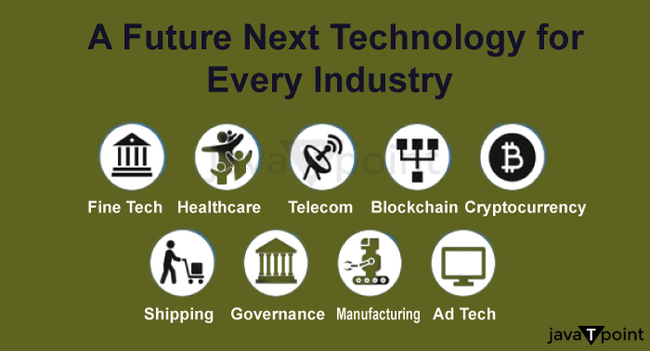

## **Introduction**

Blockchain innovation has the ability to drastically alter our way of life. Blockchain technology is currently making waves throughout industries, and over the next few years, it's likely to become increasingly common in financial services, medical facilities, governments, and other sectors.

The way we view money, business, law, and society is changing as a result of blockchain technology. After the internet, mobile, social, and AI/IoT waves, it has an opportunity to become the fourth disruptive wave. Despite their name, distributed ledgers-hence the term-used by several nodes (personal computers or people) rather than chains of individual blocks are what makeup blockchains.

## **How does blockchain technology work?**

The idea of blockchain technology is relatively new. It has been operating for the last eight years, and in that short time, it went from obscurity to prominence. It began as a way to use cryptocurrencies like Bitcoin for anonymous transactions. Currently, blockchain has been employed for a wide range of different purposes, including food traceability and supply chain management.

The forthcoming wave of technological progress is blockchain technology. It is at the forefront of the industrial revolution and will fundamentally alter how we conduct business. Blockchain technology has the potential to significantly alter a variety of industries, including finance, healthcare, governance, security, and voting.

Blockchain, put simply, is a cloud-based information storage system. The cryptocurrency's underlying network is called blockchain. The market is flooded with cryptocurrencies. The four most significant ones are XRP, Tether, Ethereum, and Bitcoin. Due to its benefits, this technology improves flexibility, security concerns, and even data transmission processing. Why the Blockchain is the Destiny of Digital Information is the topic of this article. To comprehend this, we need to have a thorough understanding of what Bitcoin is, how it operates, and how it is used.

Many issues that existed before the advent of blockchain technology have excellent solutions now. Additionally, it produces new issues that are difficult to resolve using techniques and ideas already in use. For instance, blockchain dramatically reduces transaction costs by doing away with middlemen in peer-to-peer transactions, but it also raises privacy issues since users are fictitious rather than anonymous.

Blockchain innovation has been a hot topic for the past two years. All of the big media outlets are covering it in their headlines. But how exactly does it operate? And why are there so large investments in it? How does blockchain technology work?

Financial transactions can be carried out without the use of a middleman or centralized authority thanks to blockchain technology. Online transactions are made through a global network of computers that verify and confirm them all at once. As a result, a decentralized ledger that continuously records these transactions is created, resulting in data blocks that cannot be retroactively changed by anyone who is not a part of the blockchain.

One of the most well-liked and intriguing technologies nowadays is blockchain technology. The number of cryptocurrency owners is growing quickly. Blockchain is being used by many companies to streamline commercial operations, and several governments are looking into using it to develop citizen service delivery systems that are more effective.On paper, all of this appears to be a fantastic idea, but in practice, it is difficult to comprehend. Let's make an effort to debunk the entire procedure and clarify what blockchain accomplishes in reality and why it's so crucial to our future.

Blockchain innovation has the power to transform a variety of markets and alter the way we view trust, transactions, and data security. Ten factors make blockchain the technology of the future, so the 10 reasons are listed below :

1. The fact that blockchain technology is decentralized-that is, not governed by a single entity-is one of its main characteristics. As a result of relying on a community of computers to confirm and record transactions, it is more resistant to surveillance and hacking.
2. An increase in security is provided by the use of encryption in blockchain technology, which makes it very difficult for hackers to edit or erase data. Decentralisation also makes it less susceptible to assaults on just one point of failure.
3. Due to the various middlemen engaged in each transaction, conventional financial and legal structures can be slow and inefficient. These procedures are streamlined by blockchain technology, which makes them quicker and more effective.
4. Transparency: Because every transaction is documented on a publicly accessible ledger using blockchain technology, everything is completely transparent. This can aid in fostering confidence as well as accountability in previously murky businesses.
5. Blockchain innovation has a chance to drastically lower prices for both enterprises and consumers by getting rid of middlemen and optimizing workflows.
6. Blockchain technology makes it possible to create smart contracts, self-executing contracts in which the conditions of the contract between the buyer and seller are directly encoded into lines of code. By doing so, the possibility of fraud can be decreased, and the proper execution of contracts can be guaranteed.
7. Identification confirmation: Blockchain innovation can be used to build trustworthy and secure identity verification systems, which may find utility in processes like voting and immigration.
8. Management of the supply chain: Blockchain-based technology is able to be used to trace the flow of commodities via a supply chain, thereby enhancing transparency and lowering the possibility of fraud.
9. Better data management: With the use of blockchain technology, enormous quantities of information, including personal information and medical records, may be stored and managed securely. This may aid in preserving privacy and lowering the danger of data breaches.
10. Increased adoption is likely to occur across a variety of industries as more companies and organizations start to recognize the potential of the technology known as the blockchain. New goods and services could be produced as a result, as well as new company strategies.

## **What will happen to blockchain technology next?**

The development of blockchain technology is ongoing. It is still being improved upon and put to use in several novel ways, which will result in a more modernized internet that is totally secure from hackers.

The future of technology is blockchain. It's what powers digital money like Bitcoin and Ethereum, and beyond that, it has the power to transform entire sectors of the economy. Although some businesses are already using this to their own advantage, blockchain is no longer just for them.

## **Blockchain is the way to the future of money!**

One of the most significant and groundbreaking innovations since the internet is blockchain technology. Peer-to-peer networks are made possible by this because it makes it possible to disseminate information to all participants without it being copied, eliminating middlemen from a variety of businesses.

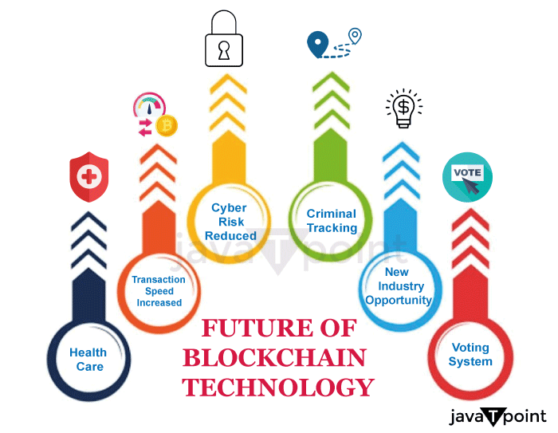

Simply put, a blockchain is an internet of computers that acts as a secure, private database for transactions. The distributed ledger database is not kept in one place or under the authority of one single organization. Instead, it is present on hard drives and servers anywhere in the world. Because of this decentralization, hackers can't attack a single point of failure, which results

The banking industry is embracing blockchain technology more and more. A revolutionary technology, the blockchain has the ability to change how money is transferred globally.

## **Conclusion**

**"The way sectors conduct business is already changing as a result of blockchain**."

The director of operations of Techstars Bitcoin in New York, Lisa Nestor, explains. It can also influence how governments are managed, but to do so, it will need to get through the current legal framework. Overall, blockchain technology has a wide range of possible uses and has the ability to profoundly alter how we connect with one another and the outside world. Therefore, it is probable that distributed ledger technology will have a significant impact on how the future is shaped.

# **How Blockchain Technology Can Accelerate the Potential of IoT?**

It is proved that the Internet of Things (IoT) links people, places, and things, and by doing so, it creates and captures opportunities for value. Physical objects now contain sophisticated electronics, sensors, and actuators that all relay data to the IoT network. The IoT's analytics capabilities employ this data to turn insights into actions that have an influence on company processes and inspire new ways of doing things. But there are still a few technical and security issues that need to be resolved.The Internet of Things (IoT), a revolutionary emergent technology, has advanced quickly, yet its privacy issues and security flaws continue to be major obstacles. Blockchain's distributed and decentralized architecture can meet the IoT's privacy and security needs. The new field of blockchain technology for IoT (BIoT) is therefore born. Numerous industries will undergo considerable change as a result of BIoT, opening the door for new business strategies. The goal of this study is to investigate research trends and collaboration in the area of BIoT utilizing the bibliometric technique, using the Science Citations Index Extended (SCIE) and the Social Sciences Citations Index (SSCI) datasets in the of Science, or WoS, Core Collection.

## **Introduction**

Applications for the Internet of Things (IoT) have been growing quickly in recent years and are now essential to the advancement of society. In fact, the Internet of Things (IoT) will make human living conditions more comfortable through a variety of applications coming from different industrial domains, such as smart homes, smart healthcare, farming, transportation, retail, and wearable technology.

IoT's widespread deployment has been hampered by a severe security problem. Because of their many security flaws, Internet of Things (IoT) devices are prime targets of Distributed Denial of Service, or DDoS, attacks. DDoS attacks cause a denial of service to users of the target system when numerous compromised computer systems flood a target-such as a central server-with a massive amount of simultaneous data requests. DDoS assaults have disrupted businesses and individuals over the past few years. Cybercriminals can easily target unprotected IoT devices and use their lax security to hack them so they can conduct DDoS attacks.

Scalability is another problem with current IoT networks. Current centralized solutions to authenticate, authorize, and link diverse nodes in a network will become a bottleneck when the amount of devices linked through an IoT network rises. The entire network could crash if the server goes down, which would need significant expenditures on computers that are capable of handling the volume of information transmission.

Blockchain, also known as distributed database technology (DLT), is another ground-breaking innovation that may be able to aid with some of the IoT's scalability and security issues. Due to its distinctive features and advantages, blockchain is a "game changer" in the information age. A blockchain system's fundamental component is a distributed digital record that is shared among system users and is located on the Internet. Transactions or events are verified and added to the ledger, after which they cannot be changed or deleted. It offers a method for a user community to gather and share information. Selected members of this community keep their own copies of the ledger, and any new transactions must be approved by the community as a whole through a process of consensus before being added to the ledger.

## **How can blockchain overcome the scalability and security issues with IoT?**

In the event of a cyberattack by cybercriminals, it may be challenging to determine the reason for any data leaks because the IoT network might handle data transactions across numerous devices which are owned and managed by various businesses. In addition, the IoT produces an enormous quantity of data, and because there are many stakeholders, it is frequently not clear who is the owner of the data.IoT security and scalability challenges can be reduced by blockchain in the following ways:

ADVERTISEMENT

ADVERTISEMENT

* A blockchain system's distributed ledger is tamper-proof, eliminating the trust requirement between the parties. The massive amounts of data that IoT devices create are not under the authority of any one entity.
* By storing IoT data on the blockchain, additional security would be added, making it more difficult for hackers to access the network. Blockchain offers a significantly higher standard of encryption that virtually prohibits overwriting pre-existing data records.
* Transparency is provided by a blockchain, which enables anybody with authorization to get onto the network to view a history of all previous transactions. This can offer a trustworthy technique to pinpoint the origin of any data leaks and take prompt corrective action.
* Blockchain can help IoT organizations cut costs by removing processing overheads associated with IoT gateways (for example, conventional protocol, hardware, or communication-related costs). Blockchain does this by providing a means to enable trust among the stakeholders.

Smart contracts, a two-party agreement that is recorded in the distributed ledger, can also enable the implementation of contractual agreements among stakeholders subject to the fulfillment of certain requirements. Smart contracts, for instance, can automatically allow payments when the requirements for rendering the service have been met, requiring no human involvement.

## **Possibilities for Growth**



Four different sorts of initiatives should be taken by businesses to fortify the links between their suppliers, but they must be patient because it will take time to carry out these actions and see results.

* **Include tracking and IoT capabilities :** Businesses should give their supply chains IoT functionality to monitor finished goods inventory and trace individual components at the unit level. IoT is the ability of devices to employ sensors that gather data, such as pressure, temperature, GPS setting, and bar code scanning, and to upload this data on their own to a cloud server through the Internet.

IoT enables businesses to get novel forms of data from various points along their supply chain. These tools, for instance, can monitor the creation of a packaged food item from the sourcing of components through manufacture, transportation, and retail, as well as the state of the stock and operational conditions in the production and logistics facilities.

* **Note transactional information:** Blockchains, which are capable of capturing incredibly precise decentralized data and may be used to confirm the validity of transaction records, should be used by organizations to store information about transactions from IoT devices. This information can be used by a company to assure ethical sourcing, enhance the implementation of supply chain agreements, and secure better financing.

A system based on the blockchain can be implemented in a decentralized, piecemeal approach, which eliminates the need for significant IT system investments or expensive third-party certification.

* **Align and standardize data from many sources :** To leverage the information gathered from Internet of Things (IoT) gadgets in a supply chain, this is required.Consider a company that utilizes inventory scanners to monitor the flow of inventory into and out of a fulfillment center and temperature sensors to record the storage temperature every hour. To find out which inventory items were kept at a particular temperature for how long, the company must line up these data tables.
* **Create analytics that is predictive and prescriptive :** For instance, temperature information from fulfillment centers can be used to forecast when a food item will decay or ripen. The planning of inventories and the creation of marketing for food goods that will soon go bad can then be guided by this predictive model. This will increase revenue and decrease food waste.

An agri-tech company called Ripe.io used data on tomato production's traceability to link the flavor of ripened cherries to the growing environment. The company was able to develop various tomato varieties in accordance with the demands of various consumer segments thanks to predictive analytics.

## **IoT and blockchain adoption factors to take into account**

As previously explained, the security design of current IoT systems has a fundamental flaw. It uses a centralized client-server architecture that is controlled by a central authority, making it vulnerable to a single point of malfunction. Blockchain provides a solution to this issue by decentralized decision-making to a common network of devices that relies on consensus. However, there are three primary difficulties to take into account while building an infrastructure for IoT devices when combined with a blockchain ledger:

**Scalability:** How to manage the enormous amounts of data generated by an extensive system of devices and potentially slower processing of transactions speeds or latency is one of the key challenges that IoT is still facing. Setting up an easily understood data model in advance helps save time and avoid problems when implementing the solution.

**Secrecy of transactions:** and network privacy. On open blockchains, it is difficult to readily grant confidentiality of the history of transactions in the joint record for an ensemble of IoT devices. This is because transaction pattern evaluation can be used to draw conclusions about the users' or devices' identities hidden behind public keys. Organizations should examine their privacy needs to determine whether hybrid or exclusive blockchains would better meet those needs.

**Sensors:** By conflicting with the accurate measurement of the requirements that must be completed in order to conduct a transaction, it is possible to jeopardize the dependability of IoT sensors. Securing an appropriate setting for data collection and transactions requires steps to preserve the confidentiality of IoT devices so that external interventions cannot change them.

**Enhanced Transparency, Trust, and Privacy of Data Protection :** Many people are concerned about centralized governmental bodies or businesses gathering their data and private data, including footage of their daily lives at home. Blockchain operates on a decentralized network, where no organization or governing body has authority over and ownership of all the user's personal data. This helps to alleviate trust issues and worries about data privacy.Blockchain provides transparency by making it possible for anybody with access rights to the network to view a history of all previous transactions. This might offer a dependable technique to locate the exact location of any data leaks and initiate prompt corrective action.

IoT and blockchain are cutting-edge technologies with enormous potential, but they haven't been widely used because of technical and security issues. Since the two technologies can be used in use cases that minimize security risks and other business hazards, many companies in the marketplace are already developing such use cases.

## **Challenges in IoT and Blockchain Integration**

The limitations imposed by the short battery life of various IoT devices are one of the main problems with merging blockchain with IoT. Battery life may be a limiting concern for some IoT devices since they may only sometimes be linked to WiFi or power sources. Small devices with low battery life cannot be paired with a blockchain transaction system that requires high computing and bandwidth. As a result, either a server-based infrastructure or a separate gateway device must be developed. Multiple parties and players within the same environment also add complexity. For example, when companies from different sectors try to collaborate and connect their devices (for example, when intelligent refrigerators or home appliances try to connect to a chain of supermarkets, which in turn tries to connect to the telecommunications provider that offers the 5G wireless connection and the business that builds and oversees the network infrastructure).

## **Conclusion**

Although implementing blockchain technology in IoT ecosystems has its obstacles, these differ from the efficiency and productivity that may be achieved. The technology will need time to develop, as will the adoption of it. However, more individuals, organizations, and communities will wish to join as time goes on. The Internet of Things (IoT) offers a wealth of potential for value generation and capture by connecting people, locations, and things.

According to Cisco, there will be 14.7 billion machine-to-machine (M2M) connections by 2023, up from 33% in 2018. Connected home applications will account for nearly half of these connections, while linked car applications will experience the greatest growth at a CAGR of 30%. Currently, most IoT solutions use a centralized server-client architecture that entails establishing connections to cloud servers over the Internet.

Multiple goals must be met by supply chains, including a high level of customer satisfaction, profitability targets, and disruption resistance. By ensuring their manufacturing and distribution systems are secure and environmentally friendly, that raw materials are sourced from environmentally friendly sources, and that workers receive fair compensation, businesses are also starting to prepare their supply chains for a responsible future. Until recently, accomplishing these objectives would have been extremely expensive, requiring organizations to compromise. However, these goals are becoming more and more realistic thanks to analytics, the Internet of Things (IoT), and blockchain technologies.

# **Smart contracts in blockchain**

The majority of commercial transactions involve the signing of documents that outline the terms and circumstances of the arrangement. Due to the handwriting, there is a potential that both parties will perceive these contacts differently. The likelihood of a dispute growing will increase as the contract's complexity does. As a result, having a neutral third party that can enact legislation and expedites the agreement process becomes increasingly important over time.

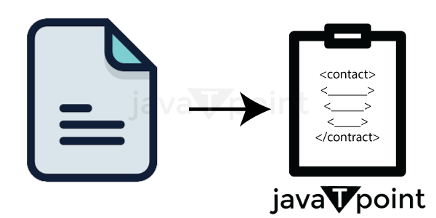

Intelligent contracts are short pieces of logic-based code that run when specific criteria are met. You should be conscious that smart contracts have been developed for secure blockchain. Smart contracts are used everywhere now, which increases their significance. To keep up with technology, people are learning about blockchain smart contracts.

## **What is a smart contract?**

The smart contract represents an authenticated contract with all the necessary information and has been agreed upon by both parties. Its reasoning includes conclusions for any scenario that could arise under an agreement. The agreement includes scenarios for both outcomes, making it more straightforward for you to settle disagreements whether it succeeds or fails. Typically connected to Ethereum, these contracts were explicitly created to support the use of smart contracts. However, you can easily apply this approach to any blockchain network or platform. The smart contract's code specifies how to guarantee agreement performance. Based on the particulars set on the contract, smart contracts are automatic and self-explanatory. The distributed ledger system (DLT) used by the blockchain, which enables data to be kept globally across several servers, mainly depends on those databases to validate a transaction. Smart contracts are enticing because they eliminate administrative burdens.

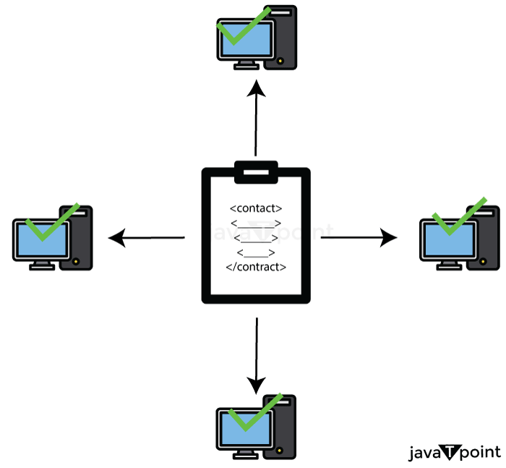

When the established conditions of a smart contract are satisfied, funds are automatically transferred from a single party to another. This is represented by the terms and constraints expressed in codes. For instance, if both parties agree to exchange a cryptocurrency, the exchange will be recorded on the blockchain using the smart contract's protocol.

Smart contracts are created using the Solidity and Go programming languages and are immutable and irrevocable. However, despite their name, smart contracts are not enforceable in court. Their main responsibility is to implement business logic through programming that executes different operations, processes, or transactions that are part of them depending on certain criteria.

## **Different kinds of smart contracts:**

* Decentralized Autonomous Organizations (DAO)
* Smart Legal Contracts
* Application Logic Contracts (ALC)

## **Smart Contract's History**

The smart contract was first introduced to the world by American technologist Nick Szabo in 1994. The main objectives of smart contracts, according to him, are to "satisfy common commercial conditions of use, minimize both nefarious and unintentional errors, and remove the need for trustworthy third parties." Smart contracts are a computerized transaction protocol that performs the terms of a contract.

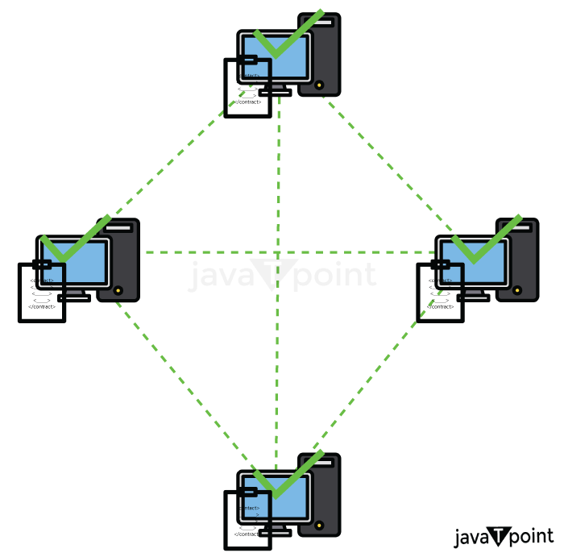

Smart contracts' foundation was laid by blockchain. The primary protocol, smart contracts, which define the requirements that must be met when transferring bitcoins between users of the network, such as having sufficient cash to make the transfer, is also supported by bitcoin. This reasoning is seen in food machines where a particular code releases a specific snack. Nick advocated replicating asset databases and executing contracts employing encrypted hash chains & Byzantine fault-tolerant mechanisms when he initially coined the term "Smart Contracts" in 1994. Additionally, he created BitGold, which was Bitcoin's direct forerunner. I stumbled discovered a video of Nick speaking on computer science as a branch of law in the early 1990s at a US university, noting the potential of smart contracts. This was much before the internet or the global web became widely used.

Multi-signature transactions were a brand-new smart contract that was introduced in 2012. For a transaction to be valid, a predetermined number of individuals must sign it using private keys. This is done to increase the funds' security, especially in the event that the private keys are stolen or misplaced.

Blockchains have introduced new programmed conditions (also known as operation codes, or opcodes) as they continue their experiment. Ethereum, a novel blockchain for programmable smart contracts, was introduced in 2015. Unlike blockchain technology, the Ether smart contract allows for simultaneous execution of numerous separate smart contracts.

## **What Function Do Blockchain Smart Contracts Serve?**

Customers would need to transmit transactions to the blockchain in order to launch smart contracts because the program operates on the blockchain. Only then can the program be performed when the codes have been established and the logic secured.

ADVERTISEMENT

Smart contracts often aim to stream commercial transactions among parties by doing away with the go-betweens present in conventional business processes. These agreements seek to lessen the complexity of typical contracts, the possibility of errors, and payment delays while maintaining their validity and reliability.

Its most characteristic benefit is that it makes it possible to conduct reliable transactions without the use of intermediaries.

## **How do Blockchain Smart Contracts are Created?**

A computer mechanism known as a "smart contract" is created to form, manage, and communicate details about the asset's owner. It is true that a program used to enable, confirm, or carry out reliable transactions autonomously operates on the Ethereum blockchain.

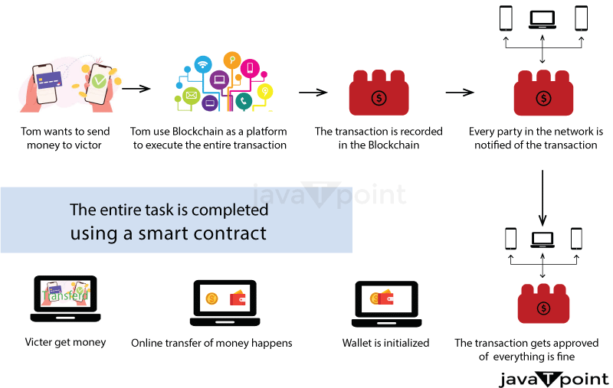

We first need to comprehend what makes up a smart contract in order to understand how it functions.

**Signatures:** To proceed with the suggested regulations and conditions, a minimum of two parties must give their approval.

**Identify the contract's topic critically :** The topic needs to fit in with the digital contract environment. When using the terms, be precise. The terminology must be clear and thoroughly defined. The agreement should be in precise mathematical terms consistent with the precise language, for instance, as Ethereum's smart contract system relies on Solidity, also known and Serpent programming language.

You can then enter the blockchain-based smart contract once these conditions have been established. Before the terms of the agreement are implemented in the blockchain, however, they are subject to negotiation.

On the basis of an understanding between two users that is maintained on the blockchain, smart contracts will often automatically initiate an action. Accordingly, a smart contract will control the transfers when a seller desires to sell a BTC until the BTC has been successfully transferred from one individual to another. The money will be released at that point, and nothing will change. In addition, a public database will list and keep all of the transaction's information.

## **Smart contracts' characteristics and traits**

Smart contracts are well-liked because of the following traits:

* **Self-enforcing:** It requires less human interaction and is hence enforceable. When a particular condition is satisfied, smart contracts that include logic are carried out.
* **Self-verify:** Smart contracts that self-verify are renowned for their integrity since they verify that both parties adhere to the rules. It is going to impose an obligation on the party who violated the rules in the event of a breach.
* **Tamper-proof:** Because the contract's terms and conditions cannot be changed, the possibility of manipulation is eliminated. If you want to change, you must create a separate block with the agreed-upon specifications.

## **How Are Smart Contracts Operated?**

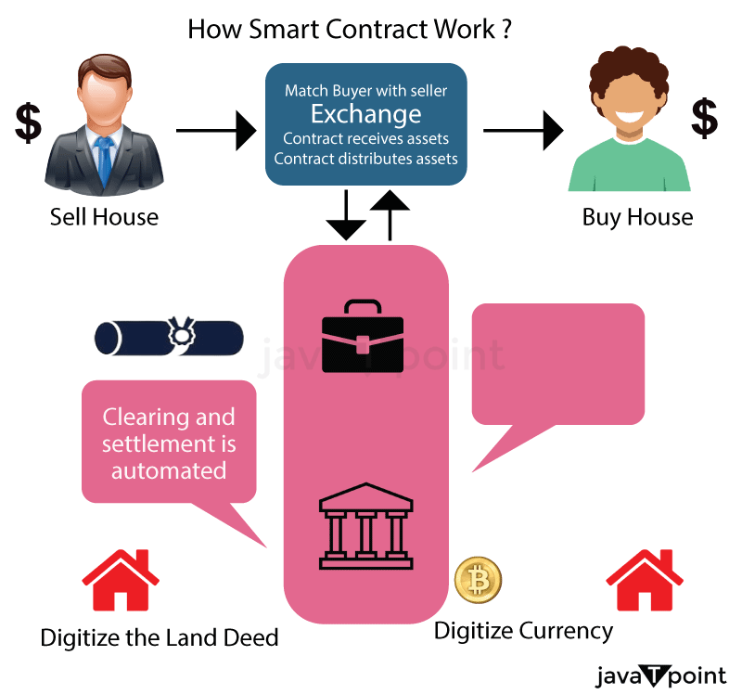

Smart contracts are just pieces of software that describe computer protocols or, to put it another way, a core component of technology. They serve to detail every agreement condition reached between blockchain transaction parties. When these prerequisites are met, a smart contract will immediately execute a transaction. As it depends on a publicly accessible ledger whereby anyone with interest can verify all transactions, a system built around the blockchain enables its members to remove intermediaries and wasteful paperwork. The paramount necessity here is to use appropriate programming languages and mathematical methods to specify all the agreement criteria.

ADVERTISEMENT

Each node in the blockchain's dispersed network of nodes stores the details of every transaction. One would need to take control of over fifty percent of these various nodes in order to reverse a transaction or double-spend money.

* The company works with blockchain engineers to specify what should be in the contract as well as all the rules and conditions in order to establish a smart contract. Smart contracts are used by businesses for a variety of purposes, from confirming payments to more complicated actions like determining the value of an investment, etc.
* Any criterion for success can be included by businesses in smart contracts. The transactions should be approved by each signing partner. The mechanism for addressing disputes, if any, must also be included in the contract.
* The logic is then specified by the smart contract programmer and tested to see if it functions correctly on smart contract ecosystems. The contract's security is then examined by internal experts. The contract is put into effect on the blockchain after verification. This guarantees the creation of smart contracts.
* Ethereum enables the development and deployment of smart contracts. A cryptographically secured streaming data source called "Oracle" is where the smart contract first begins to listen for event updates. Only when it receives the proper events via oracles does the smart contract actually go into action? On the Ethereum blockchain, smart contracts are often created using the Solidity language for programming.
* Like Javascript, Solidity is a specially designed scripting language that verifies and sticks to the contract's restrictions at compile time rather than during runtime.
* After processing, a smart contract is deployed to the network to carry out its function.

ADVERTISEMENT

## **Advantages of Smart Contracts**

Smart contracts are attractive for a number of reasons, including:

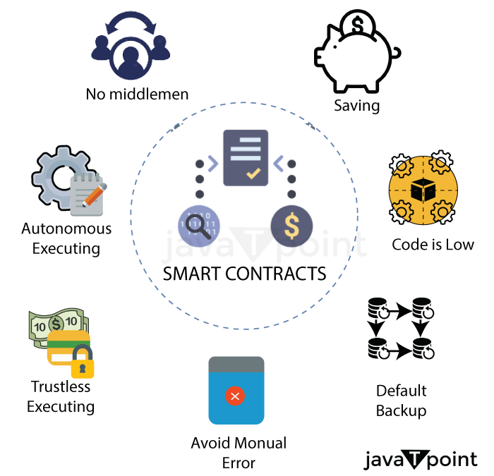

* **Autonomy:** There isn't a requirement to depend on third parties who may be biased or do not have your best interests in mind.
* **Trust:** all of your records are secured on a common database and are accessible to all parties.Documents are cloned multiple times on the blockchain and can never be "lost."Documents are encrypted, rendering them nearly impenetrable to hackers.
* **Speed:** These contracts self-execute, saving you valuable time.
* **Savings:** By eliminating the middlemen, smart contracts offer you money.
* **Precision:** Smart contracts run the exact code specified, guaranteeing that no errors occur.
* **Transparency:** Organisations such as governments could bring greater transparency to their transactions.
* **Use Cases for Smart Contracts:**Smart contracts have been employed in a variety of market areas due to their benefits. The following are some industries that have heavily used smart contracts to expedite commercial transactions. Here are some examples of smart contract applications:
* **Finance and Insurance:** Smart contracts have completely altered traditional financial services. Examples include:
  + **Trade clearing:** simple handling of permissions for various signing parties and safe payment transfer after the trade resolution amount has been calculated.
  + **Insurance settlement:** Insurance businesses use smart contracts to route claims, check for mistakes, and approve the payment transfer workflow. The amount will be paid to the parties according to the policy type when the details have been verified.
  + **Micro-insurance:** micropayments are assessed and transferred using data gathered by IoT devices.
  + **Transparent auditing:** smart contracts use a variety of technologies to retain records, eliminating the possibility of missing details. It also allows stakeholders to participate in the decision-making process.
* **Healthcare:** Smart contracts are additionally finding a home in healthcare by simplifying work processes.
  + **EMR**- It allows physicians and patients to sign it, allowing the transfer of healthcare records following approval.
  + **Medical Research-** allows researchers to make micropayments to patients in order to obtain their medical information and assure their participation.
  + **Track Health-** Today, consumers use health-tracking gadgets and are rewarded when they reach a goal.
* **Media:** Smart contracts backed by blockchain are also being used in the media. Anyone can license media in whatever way they wish. It has boosted the automation of previously manual transactional tasks. Processing is now faster, more precise, and more efficient.
* **Supply Chain:** Smart contracts have primarily been used in the manufacturing and supply chain industry for a number of reasons:
* It secures payment transfers through multi-signature approval.
* Product provenance enables the user to transfer payments after changing custody of bills of lading.

## **Smart Contracts' Limitations and Difficulties**

* **Ease of Correction**- Because the smart contract is constructed on blockchain, it has the same benefits of immutability. It secures smart contracts, but it comes with significant drawbacks. Because you can't reverse them, a single mistake can lead to massive, costly mistakes. Engineers can use De-facto flexibility to make modifications. It enables developers to keep certain codes in distinct agreements in changeable storage.
* **Instances of a Loophole**- when parties trust one another and don't deceive one another benefit from it. However, with intelligent agreements, ensuring that the terms are carried out precisely as stipulated may be difficult. For example, suppose you bought a brand of shoe but received a counterfeit. Smart contracts may not be capable of overcoming such legal difficulties.
* **Third-party:** Smart contracts are believed to eliminate the requirement for third parties, although this is not entirely accurate. Somehow, there is always a reliance on a third party to complete the work via smart contracts.
* **Permanent error :** If there are errors, they are permanent and cannot be corrected.
* **Human element:** They depend on the developer to ensure that the code adheres to the contract's conditions.

## **Conclusion**

Most firms now utilize intelligent agreements to automate processes and save time and money. A smart contract has made the business process more efficient. Because intelligent agreements are constructed on blockchain technology, they have blockchain benefits such as security, tamper-proofing, autonomy, business reasoning, security, and a lot more. We discussed how to use smart contracts in this article.

# **Blockchain and data privacy**

## **What exactly is Blockchain?**

The blockchain, as a secure ledger, organises the increasing number of transactions into a hierarchically growing chain of blocks , with each block guarded by cryptography techniques to ensure the robust integrity of its transaction data. New blocks can only be committed to the global chain of blocks if the decentralised consensus method is successfully completed.

In particular, a block retains the hash value of the whole block itself, which may be viewed as its encryption image, as well as the hash value of the preceding block, serving as a cryptographic connection to the before block in the the distributed ledger.

## **Introduction**

Blockchain has become one amongst the most highly anticipated technological advances in recent years. However, blockchain technology as well as information security laws and regulations have advanced significantly.

Blockchain provides the benefits of decentralisation and distributed global ledger sharing, but it also carries a possibility of data privacy leaks. There is still a wide room for the development of different protection techniques to prevent harmful attackers from stealing the personal information of blockchain users. First, this article examines the chain block design, as well as the Bitcoin data privacy danger. Blockchain is a decentralised data processing technique in which all network participants are responsible for data distribution and storage. With the massive amounts expansion of the blockchain technology in recent years, many countries' energy departments have started using blockchain technologies for smart grids in areas such as trading in energy applications, electric car applications, energy security applications, and microgrid operations. Blockchain technology, when integrated with cryptography, can provide safe real-time metering & communication procedures for smart grids, significantly lowering the high costs of transmission generated by the previous approach. The use of the blockchain in the process of trading electric energy may successfully minimise energy loss while also improving the trading system's real-time performance and security. Without the use of third intermediaries, businesses and consumers can trade power and capital on a peer-to-peer and trustworthy basis.

ADVERTISEMENT

## **Data privacy introduction**

So far, the majority of public interest in blockchain has been on crypto-currencies, particularly Bitcoin, as well as associated financial services like first-time coin offerings (ICOs). Less overtly, but maybe more critically in the long run, significant investment is being made in the creation of a wide range of blockchain applications, ranging from asset registration (including property) to self-executing ('smart') contracts. Despite widespread misunderstanding about what blockchain is or could become, blockchain and other distributed ledger methods (DLTs) have attracted the attention of governments, companies, and individuals, and they have become a focus of interest for lawmakers and regulators around the world.

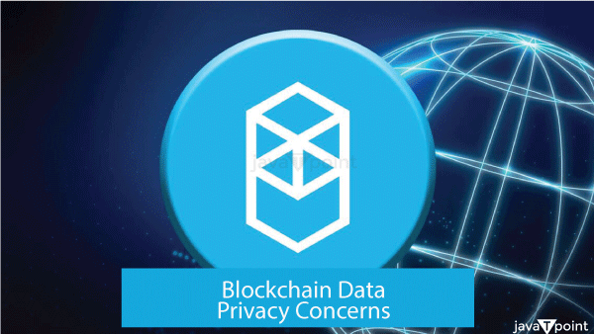

In most applications, transactions are globally disclosed and are not encrypted. If this data involves personal data, such as "medical or financial data," it causes regulatory and legal issues, particularly in Germany. One option is to exclusively store data that is encrypted in the distributed ledger, but this raises another issue: if a key needed to decode specific details is lost, the information may not be restored precisely. In addition, if a key has been taken or publicised, all data in the blockchain is forever decrypted because the data cannot be edited. Blockchain, on the other hand, can help to improve preventive security methods, particularly in terms of identification and access.

## **How blockchain supports data privacy**

In the modern era, where all things are digital and data is king, privacy is now an unavoidable concern. Today's users having little to no influence over how online apps and websites use their data and private data. Whereas this data can be utilised to provide personalised searches and personalised product and service suggestions, it can also lead to fraud and security breaches. Blockchain technology offers a solution! Let us look at some of the ways Blockchain technology works to preserve the confidentiality and safety of users and their data.

ADVERTISEMENT

ADVERTISEMENT

* **Decentralisation and Agreement :** Decentralisation is a crucial component that contributes to the security of Blockchain. Whereas a standard database keeps data in a single location, Blockchain stores data by replicating it to multiple locations, resulting in a distributed ledger. As a result, in order to secure data privacy, Blockchain requires non-traditional procedures.Each exchange on the system is open and is stored on a collection of devices rather than just one computer. Every device connected to a blockchain gets an electronic copy of each transaction that occurs on the blockchain.  
  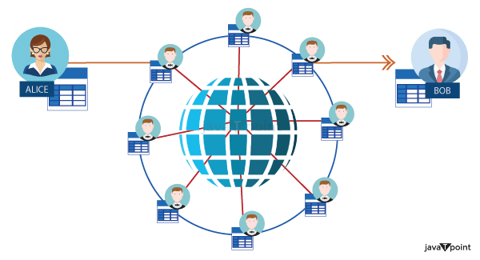  
  This implies that the blockchain is collaboratively run and governed by a community of individuals who depend on the system. Any new block added to the chain by a node in the network is first validated by the Blockchain network's other nodes. The modified blocks are discarded. Only when more than 51% of the computers in the blockchain agree on the new block will it be properly added to the chain. This is referred to as the Majority mechanism.
* **Hashing and Blocks :** As the name implies, blockchain is an ordered sequence or series of blocks. Each one of these blocks is made up of three distinct components, namely,
  + The information or data
  + The hash value of the block
  + The prior block in the chain's hash

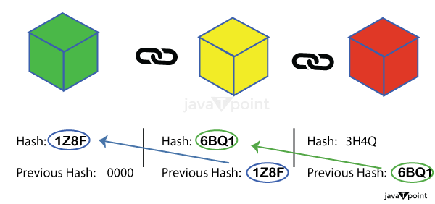  
The information in a block is encrypted and has a unique identity (similar to a fingerprint). This identification is referred to as a Hash. Each block in the chain has responsibility for storing the encryption key of the previous block. This contributes to the Blockchain system's effectiveness and security.The Genesis Block is the initial block in a chain that is unconnected to any earlier block.  
If anything inside the block changes, the hash of the blocks also changes. That means the following block is going to point to an additional hash rather than the one that came preceding it (it no more stores the preceding block's valid hash). As a result, all subsequent blocks in the sequence become invalid. Because of this property, hashes may be used as an effective method for detecting modifications and manipulation in Blockchain data. As a result, the information is protected and tamper-proof.

* **Proof of work on Sample** : Proof work is a process or approach used to slow down the generation of new blocks. As a consequence, if a person interferes with the contents in one block, he or she must recalculate the evidence of work for every other block in the chain. Individuals will find it difficult to tamper without a block as a result of this.  
  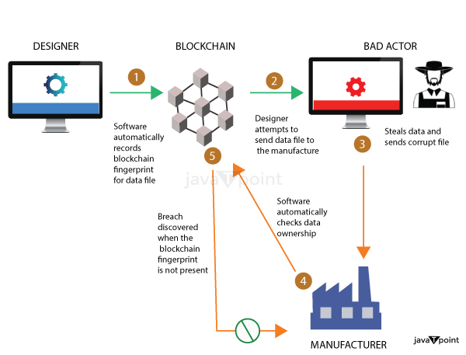  
  Proof of operation and hashing algorithms work together to reduce fraud and hence ensure the integrity and security of data in the network of Blockchain devices.
* **Public Addresses :** Every node in the distributed ledger (computer or other device) has a unique private key and public address. When a node participates in an exchange, it simply communicates its public address to the rest of the world, not the private key. This public name is a random string of digits and letters. When other Blockchain network users see the public location, all they can see is the transaction record and the general address. However, personal and financial data such as the user's name, age, and address remain anonymous. This mechanism ensures that the user's privacy is protected.
* **Encryption and Private Key Control:** Blockchain employs sophisticated encryption algorithms to secure data. Each participant in a blockchain network has a unique cryptographic key pair: a public key and a private key. Data is encrypted using the recipient's public key, ensuring that only the intended recipient can decrypt and access the information. This cryptographic encryption protects sensitive data during transmission and storage, reducing the risk of unauthorized access.  
  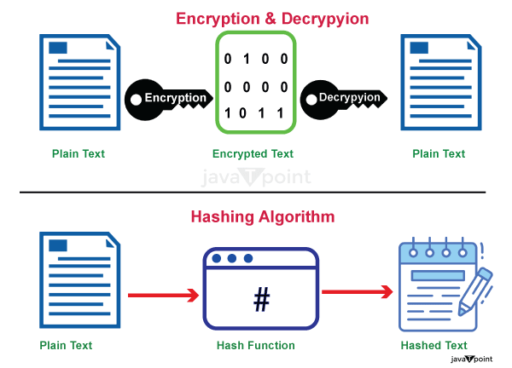  
  The private key, which is securely held by the data owner, grants access to the data stored on the blockchain. This ownership and control over the private key empower individuals and organizations to manage their own data, eliminating the need to trust centralized entities with sensitive information. Users can share selective access to their data by granting temporary or permanent cryptographic permissions, thereby enhancing data privacy and control.
* **Proof of Zero-Knowledge :** Zero Knowing Proof is an excellent method for safeguarding private information in the Blockchain system. This strategy allows a person to demonstrate to other people that a particular assertion is true without revealing any extra information. In an exchange, the prover must demonstrate to the verifier whether a certain value (also referred to to both the provide and the verifier) is accurate and reliable, while eliminating any extraneous information.
  + It's like proving to somebody that you know the secret without actually telling them the secret.
* **Smart Contracts and Permissioned Blockchains:** Smart contracts, self-executing programs running on blockchain networks, provide an additional layer of privacy and control over data. Smart contracts enable predefined rules and conditions to be enforced automatically, eliminating the need for intermediaries. By embedding privacy features within smart contracts, sensitive information can be securely shared and processed without exposing it to unauthorized parties.

In permissioned blockchains, access to the network and data is restricted to trusted participants, enhancing privacy and confidentiality. These private blockchains are particularly useful in enterprise settings, where specific data privacy requirements need to be met. By carefully managing access control and permissions, organizations can ensure that only authorized entities can participate and access sensitive data.

## **Data privacy Threads in blockchain :**

* **Pseudonymity versus Anonymity:** One of the fundamental characteristics of blockchain is the pseudonymous nature of transactions. While users are represented by cryptographic addresses rather than their real identities, the transparency of the blockchain can still enable the linkage of transactions to specific individuals or entities. With the increasing availability of external data sources and sophisticated analysis techniques, the pseudonymous nature of blockchain transactions may be compromised, jeopardizing the privacy of participants.
* **Data Leakage through Off-Chain Activities:** Although blockchain itself provides a secure environment for data storage, certain interactions and activities related to blockchain may occur off-chain. Off-chain data includes information shared through external platforms, communication channels, or smart contracts that interact with external systems. These off-chain activities can potentially expose sensitive data, such as personal details or transactional information, to vulnerabilities outside the blockchain environment. Consequently, the privacy of participants' data becomes dependent on the security measures implemented in these external components.
* **Inadequate Implementation of Privacy Protocols:** While blockchain offers potential solutions for privacy concerns, the implementation of privacy protocols and techniques is not standardized across all blockchain networks. Privacy features such as zero-knowledge proofs, ring signatures, or stealth addresses can enhance confidentiality, but their usage and effectiveness can vary depending on the specific blockchain implementation. Inadequate implementation or misconfiguration of privacy protocols can lead to unintended data exposure, rendering the blockchain susceptible to privacy breaches.
* **Public versus Private Blockchains:** Public blockchains, such as Bitcoin and Ethereum, maintain transparent transaction records visible to anyone in the network. While these blockchains provide strong security guarantees, they inherently sacrifice privacy to achieve decentralization and transparency. On the other hand, private or permissioned blockchains limit access to trusted participants, enabling greater privacy control. However, even in private blockchains, data privacy can be compromised if participants do not adhere to strict access controls or if malicious actors infiltrate the network.
* **Storage of Immutable Data:** The immutability of data recorded on the blockchain, a key feature ensuring data integrity, can also pose challenges to privacy. Once information is written on the blockchain, it cannot be altered or deleted. In cases where personal or sensitive data is inadvertently stored on the blockchain, eradicating that information becomes extremely challenging. This immutability feature conflicts with the "right to be forgotten" principle, which is a crucial aspect of data privacy regulations such as the General Data Protection Regulation (GDPR).

## **Conclusion**

Blockchain technology presents a groundbreaking solution to the challenges of data privacy and security. Through its decentralized structure, immutability, encryption mechanisms, and smart contract capabilities, blockchain offers a robust framework for safeguarding personal and organizational data.

While blockchain technology offers promising solutions to data privacy concerns, it is essential to acknowledge and address the challenges it presents. Striking a balance between transparency and privacy, adopting robust privacy protocols, and ensuring proper implementation of security measures are crucial steps toward enhancing data privacy within blockchain systems. As blockchain evolves and matures, continuous efforts to address these challenges will be necessary to unleash its full potential while safeguarding the privacy rights of individuals and organizations alike.

# **Solana blockchain**

Solana (SOL) represents a currency that was created to be comparable to and better than Ethereum. Anatoly Yakovenko, a software developer, created Solana, which is named after a tiny Southern California coastal community.

Yakovenko suggested this novel cryptocurrency in 2017, Solana will go live in March 2020. Today, SOL is a well-known cryptocurrency, ranking 11th in terms of total market capitalization.

## **What Exactly Is Solana?**



Solana is a type of blockchain that resembles Ethereum so much that it's commonly known as a "Ethereum killer." The SOL token, like Ethereum, can be acquired on the majority of major exchanges. The true value of the token is in completing transactions through the Sol network, which offers distinct features.A proof-of-history consensus technique is used by the Solana blockchain. This approach defines the following block in Solana's chain using timestamps.

To define each block in their chains, many early digital currencies, including Bitcoin and Litecoin, used a proof-of-work mechanism. Proof of work employs a consensus technique in which miners select what their subsequent block will be.

ADVERTISEMENT

However, this proof-of-work mechanism is sluggish and resource-intensive, requiring massive quantities of energy. This is one of the reasons Ethereum switched to a proof-of-stake method, which reduced the usage of energy by 99.9%.

Proof of stake, unlike the previous proof-of-work technique, employs staking to specify the next block. The blockchain holds stalled coins as collateral until validators reach an agreement on the chain's next block.

## **Delegated Evidence of Stake by Solana**

Solana use "a combination of time-tested cryptography methods and novel approaches to address the drawbacks of crypto's first-wave solutions," as stated by Konstantin Anissimov, the chief executive officer of crypto exchange CEX.IO.

The key problem Solana was seeking to tackle was Ethereum's scalability concerns, which were aided by its unique blend of proof of history and delegated proof-of-stake algorithms. Delegated proof-of-stake is an alternative to the more common proof-of-stake method.



For those who need an overview, the proof-of-stake method is a set of transactions that uses a system of validators to generate fresh blocks in a blockchain.

Solana's delegated proof-of-stake method provides consumers with various benefits. According to Christian Hazim, researcher at ETF supplier Global X, the history algorithm provides a layer of protection to the network.

Solana, in essence, addresses two of the three challenges raised by Vitalik Buterin, the co-founder of Ethereum, in his cryptocurrency trilemma of scalability, security, and decentralisation.

Although Buterin first asserted that Ethereum will answer all three components of the trilemma, most experts assume the network would only address two: security and decentralisation.

Solana, on the other hand, aims to address two aspects of the trilemma: safety and capacity. SOL's proof of history mechanism offers the network with unrivalled security. While the Solana platform's computing speed provides for improved scalability.

## **What distinguishes Solana?**

Solana offers exponentially greater speeds for transactions compared to those offered by Ethereum ( Eth ) and Cardano (ADA), at just a little of the cost, according to Anissimov, by using an innovative combination of proof of the past and delegated proof for stake.

Unlike proof on work, which utilises miners to determine the next chain in the chain, or documentation of risk, which employs staked coins to define the block that follows, evidence of history defines blocks in the Solana chain using timestamps.

This novel technique allows blockchain validators to vote for the timestamps of distinct blocks on the chain. This maintains the chain decentralised while also enabling for quicker, more secure calculations.

## **How Does Solana Function?**

Solana employs both proof-of-history and delegate proof-of-stake protocols.

According to Bryan Routledge, an assistant professor many finance at Carnegie Mellon University's Tepper School of Business, Solana is attempting to "process lots of transactions quickly.

"According to Routledge, attempting to execute transactions rapidly frequently necessitates centralization. Visa, for example, requires an enormous number of computers to maintain its processing speed. Bitcoin, on the other hand, "processes transactions very slowly" in order to stay decentralised, according to Routledge.

Because the fundamental goal of the technology known as blockchain is to create decentralised systems, Solana seeks to handle transactions at the speed of a major, centralised firm like Visa while retaining Bitcoin's decentralisation. Because Solana's systems have reduced environmental and monetary costs, this speed allows for greater scalability.

The rapid addition of blocks to Solana's blockchain necessitates extra degrees of protection for the blockchain. Solana's proof of past algorithm come into play here. This algorithm timestamps every record in such a way that the system's security is maintained.

Solana's SOL tokens were then staked and utilized as collateral to conduct network transactions. These transactions range from smart contract validation to employing Solana as a token that is not fungible (NFT) marketplace.

ADVERTISEMENT

ADVERTISEMENT

Degenerate Ape Academy was the first significant NFT venture on the Solana marketplace for digital currencies in August 2021, over a year after Solana was created. Solana's price increased from roughly thirty dollars to seventy-five in the first week of that month.

Solana reached an all-time high of approximately $260 in November 2021, at the peak of the cryptocurrency bull run.

## **What are the distinctions between Solana and Ethereum?**

Both blockchains have supporters and a plethora of apps operating on them. However, Ethereum was the most widely used because it provides a more accessible and complex DApp environment. Certain distinctions between the two cannot be missed. We'll look at the distinctions among these blockchains from 10 different angles.

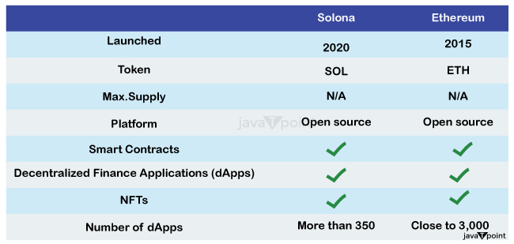

**Process:** Ethereum 1.0 is based on a the power needed consensus process, similar to the one employed by Bitcoin's blockchain. This implies that miners, who utilise their computer capacity to validate transactions on the blockchain and produce new blocks, defend the network. This is the very essence of a decentralised network, and it contributes to boost network security.

**Programming language:** Smart contracts, which operate on decentralised blockchain networks, allow developers to design programmes. Every network node has its own virtual computer, which executes commands as they are recorded to the digital record. The programming languages and virtual machines supported by a smart-contract platform have an impact on smart contract security.

Of obviously, a programming language is crucial since programmers who are more comfortable with it are less likely to make errors. This means that a previous virtual machine may be more reliable and have fewer mistakes than a younger one.

The architecture of Solana is more complex and allows multithreading. It also runs its programmes using the Gulf Stream's transaction forwarding technique rather than mempools.

**Downtimes:** Because Ethereum was the first customizable blockchain network, most of its problems have been ironed out. Although it might become crowded at times, it is never down since it is far more decentralised than other chains. It's one of the reasons Ethereum has failed to scale. The project's goal is for any cryptocurrency user to be able to run an Ether node on whatever hardware is available.

**The expense of the transaction :** This is critical since many individuals despise paying transaction fees. Solana's minimal transaction costs are well-known. Solana has a lower transaction cost than Ethereum. Different blockchains manage block size differently. Some block dimensions are dictated by storage (for example, MB in Bitcoin), whereas others are defined by a gas constraint .

**Transaction speed:** Solana is one of the quickest digital currencies to use when it relates to transaction processing. This is because of network architecture. Ethereum prioritised decentralisation, whereas Solana prioritised throughput.

**Size of the network:** Ether is the largest platform which enables smart contracts. As reported by DeFi Llama, Ethereum's TVL (Total Worth Locked) has risen to $28.61 trillion, while Solana's TVL has remained unchanged at $276.15 million. When it pertains to TVL, the disparity among the two channels is about 200%. As a result, most financial apps choose Ethereum. Solana is only getting started with banks, and it may take some time for it to catch the full extent of Ethereum's massive network size.

**Market capitalization :** Ethereum and Solana both include native currency that are used to pay transaction fees. These are two of the most important currencies in the whole cryptocurrency industry.

As of the beginning of 2022, 1 ETH is worth $1,621, and Ethereum's market valuation is $198.4 billion, with approximately 122.3 million ETH tokens in circulation. Ether is the second most valuable cryptocurrency, after only Bitcoin.

ADVERTISEMENT

ADVERTISEMENT

**The DeFi ecosystem :** Because of its age, Ethereum has a considerably wider and more diversified DeFi ecosystem that Solana. Solana, on the other hand, is making an effort to recruit more developers into its network by adopting a number of marketing methods such as hacking competitions and bug-bounty programmes. These strategies have helped to grow the number of consumers and developers since its beginnings.

**NFTs :** Although Ethereum was not the first protocol to employ non-fungible tokens to produce NFTs that are (Non-Fungible Tokens), it became one of the most influential. Although the trade of NFTs boomed in 2021, NFTs were employed much earlier.

NFTs were introduced in one of the earliest blockchain apps, CryptoKitties. It made headlines in 2017 when the software caused massive congestion on Ethereum.

## **Solana remarkeble Features**

Let's take a look on some of the most intriguing aspects of the distribution system known as Solana. What makes it so quick, and what distinguishes it from other cryptocurrencies.

**Evidence of History (PoH):** When it comes to validating data blocks and records in a decentralised system, all computers have to collaborate on a time. These machines are referred to as nodes. These nodes must constantly interact in order to agree on whenever the building was produced. Furthermore, because not every nodes will have an adequate connection to the internet, the rate at which they deliver Blocks will vary.

**Sealevel:** A word used to explain the fact that Solana validators are not required to validate just one purchase at a time. Rather, they can validate numerous smart contract codes at the same time.

**Scalability and Future Proof:** This brings us to the issue of Solana's Scalability. According to Solana, it is not restricted by ideas or software, but by hardware. So, if processing power doubles in the future, Solana will be able to increase its efficiency.

**Rust programming language :** Solana writes code in the Rust language for programming. This is distinct from Ethereum's usage of the Solidity programming language. Rust is a language with low levels, which implies that it requires more effort to build things, but it is far more powerful that other programming languages.

One disadvantage of Rust is that users cannot just paste existing code from other blockchains into Rust. You must reconstruct and rebuild the code in Rust. Developers that intend to migrate to the Solana system will find it inconvenient. These smart contracts, however, will be stronger than Ethereum.

**Pipelining :** Solana's activities mostly make use of Pipeline technology, which is commonly used to increase transaction speed. To handle a data input stream, the Pipeline system employs numerous consecutive phases, each with its own specialised hardware. That's how it'll appear, similar to a washing machine, only with separate dryer and washer portions.

**Cloudbreak :** One of the most important aspects of Solana is its ability to scale, which is unique to this Cloudbreak technology. Cloudbreak is an horizontal scaling solution that uses an organised database to read and write transaction input effectively. Cloudbreak is also involved in the establishment of hardware and software links.

**Algorithm of Tower Tolerance for Byzantine FaultsIf :** one of the nodes on the blockchain fails or is disrupted in performing its function, the Tower's Byzantine fault tolerance mechanism takes over to guarantee that it does not affect other nodes on the blockchain. Hill Tolerance for Byzantine Faults is a mechanism that allows failed nodes to continue operating despite many operational failures.

**Archivers :** The archivers are requested to affirm that they are routinely storing the needed data by the network, which is done via archiving tiny bits of the state, and they are urged to keep away from consensus meetings. The history of the state has been erasure-coded and fractured.

## **Conclusion**

Using those protocols, systems, and technologies, Solana has evolved into a unique blockchain network with luxurious scalability, safety, and transaction speed capabilities. Solana is fantastic, with sky-high potentials that state and verify it is the ideal suit for Defi applications. It is also manageable, with limited charge alternatives and a short confirmation time, so it aids in the creation of good projects. Solana appears to have a bright career ahead of him. It is introducing more well-known digital applications to its network every day and gaining traction. We hope we managed to explain and comprehend everything about Solana, which how it operates, and its many characteristics.

# **What Is Cardano?**

Cardano is a cryptocurrency and blockchain platform that seeks to provide a safe and scalable framework for the creation of decentralised apps (dApps) and intelligent contracts. Charles Hoskinson, one among the co-founders behind Ethereum, established it, and it was put together by the blockchain study organisation IOHK, which (Input Output Hong Kong).

Cardano stands apart because of its scientific method and concentration on peer-reviewed research. It aspires to develop a stable and sustained blockchain ecosystem by combining academic rigour with cutting-edge technology.

The idea is based on a layered design that isolates the network's settlements layer from the computing layer, providing flexibility and scalability.

Cardano's implementation into the Ouroboros proof-of-stake, or PoS, consensus mechanism is one of its fundamental features, ensuring network security and efficiency while minimising energy usage. It also includes a treasury mechanism that allows the community to fund projects and activities democratically.

ADA is the name of Cardano's native coin. ADA holders may take part in the network's the PoS algorithm by staking the tokens they own to help protect the blockchain & earn rewards.

Cardano's development is driven by a long-term strategy divided into parts. During these phases, crucial features like as the capacity to perform intelligent contracts, the integrating of governance systems, and the construction of a decentralised application platform are implemented.

Cardano's overall mission is to offer a scalable, secure, and long-lasting blockchain architecture that can support a variety of decentralised apps and services while upholding the best standards of academic study and peer-reviewed development.

A decentralised application (dApp) and smart contract development environment that is safe, scalable, and sustainable is what the Cardano blockchain platform and coin project seeks to offer. Charles Hoskinson, another of the Ethereum co-founders, established it, and the blockchain research company IOHK, which (Input Output Hong Kong) developed it.

Cardano is fundamentally a decentralised network that lets users to transmit and receive digital currency in a transparent and safe manner. It makes use of blockchain technology to create a distributed ledger for recording and verifying transactions, doing away with the need for middlemen such banks or financial institutions.

Cardano distinguishes itself via its dedication to peer-reviewed research and scientific methodology. To guarantee the security, dependability, and durability of its blockchain technology, the project focuses a major emphasis on formal procedures and academic rigour. This method of science is intended to give the project legitimacy and serve as a strong basis for its growth.

ADVERTISEMENT

The use of the proof-of-stake (PoS) consensus technique known as Ouroboros is one of Cardano's distinguishing characteristics. Holders of Cardano's native coin, ADA, may take part in the network's agreement process by staked their tokens thanks to this method. Staking is the process of storing a certain quantity of ADA in a digital wallet in order to maintain the security and integrity of the network.

Participants can obtain prizes in the manner of extra ADA in exchange for their efforts.

Cardano is also recognised for its layered design, which divides the system into two independent layers: settlement and computational. Financial reporting and value transfer are handled by the settlement layer, while the smart contracts & dApps are executed by the computational layer.

This separation allows scalability, adaptability, and the possibility of future improvements without interfering with the blockchain's basic operation.

Furthermore, Cardano features a treasury mechanism which enables people to fund projects for development, ideas, and initiatives via a decentralised governance architecture. This guarantees that the ecosystem grows in a decentralised and healthy manner, with all parties having a vote in the growth and financing decisions of the network.

Cardano intends to create a platform that tackles the shortcomings of existing blockchain systems, including scalability, long-term viability and interoperability, while adding rigorous academic research and a driven by community governance approach.

It aims to provide a safe and scalable framework for decentralised applications, hence opening up opportunities for a wide range of real-world use cases throughout sectors.

### **Peer-Reviewed Development and a Scientific Approach:**

Cardano's dedication to scientific research distinguishes it from many other blockchain-based systems. A rigorous and intellectually focused methodology is driving the project's growth, with an emphasis on a peer-re research and official verification. Cardano intends to solve the constraints and issues experienced by current blockchain networks by adding scientific concepts, guaranteeing that the architecture is founded on established methodology and best practises.

### **Ouroboros Consensus Protocol and Layered Architecture:**

The layered architecture of Cardano is a special characteristic that divides the blockchain across two different layers: the payment layer and the computing layer. Financial reporting and value transfer are handled by the settlement layer, while smart contracts and decentralised applications are executed by the computational layer. This split allows scalability, adaptability, and the possibility of future improvements without jeopardising the blockchain's basic functions.

Cardano's Ouroboros consensus system is another important breakthrough. Ouroboros, which is based on a PoS, or proof-of-stake, method, assures network security and efficiency while consuming the least amount of energy.

ADA holders can take part in the PoS agreement procedure by staked their tokens, helping to secure the network and collecting incentives in exchange. This environmentally friendly method is in line with the rising focus for energy conservation in blockchain technology.

### **Governance and funding are decentralised:**

Cardano follows a decentralised governance model, allowing stakeholders can engage in the decision-making process and affect the platform's future evolution.

ADVERTISEMENT

ADVERTISEMENT

The community may propose and finance projects, initiatives, and upgrades through a treasury system, offering a democratic and open approach to resource distribution. This approach gives the Cardano community the ability to drive platform growth and stimulate innovation.

### **Real-World Use Cases and Applications:**

Cardano's adaptability allows up a plethora of real-world applications. Its scalable and secure architecture may be used in a variety of industries, including banking, logistics, healthcare, management of identities, and governance systems.

Cardano's emphasis on interoperability intends to encourage seamless connection with current systems and effective collaboration amongst various industries and stakeholders.

## **Conclusion:**

Cardano marks a huge advancement in blockchain technology development. Its scientific methodology, layered design, and concentration on research that has been peer-reviewed have elevated it to the status of a viable future platform. Cardano has an opportunity to revolutionise industries, stimulate decentralised creativity, and contribute to the general use of blockchain technology as it continues to mature and extend its capabilities.

Cardano, as a platform for blockchain technology, is intended to accommodate a diverse set of decentralised applications (dApps) and application cases from a variety of sectors. Cardano has the following possible applications:

Cardano may be used to build financial applications including remittance services, peer-to-peer financing systems, decentralised exchanges, and stablecoins. Its safe and transparent characteristics helps improve financial transaction efficiency, speed, and cost-effectiveness.

**Supply Chain Management:** Cardano's blockchain's transparency and immutability can aid in the creation of a safer and more effective supply chain ecosystem. Traceability, provenance verification, while real-time tracking of commodities can be enabled, minimising fraud and counterfeiting and boosting accountability.

**Identification and Credentials:** The coin's blockchain may be used for electronic identification solutions, giving people more control around their personal data. It may help with safe and reliable identity verification, accreditation, and credential management, increasing confidence and minimising identity fraud.

**Management and Voting Systems:** Stakeholders are able to engage in decision-making processes thanks to Cardano's decentralised governance paradigm. It may be used to create transparent and secure voting systems, as well as to ensure fair elections, public input upon proposals, and governance procedures for decentralised organisations.

Cardano's development as a scientifically based blockchain platform provides the decentralised ecosystem with a new degree of legitimacy and creativity. Cardano has established itself as a forerunner in the race to determine the next phase of blockchain technology, with an emphasis on research conducted using formal methodologies, and a dedication to environmentally friendly and scalable approaches.

Cardano provides versatility, scalability, and cost-effectiveness by using an architecture of layers and the Ouroboros agreement mechanism, overcoming significant difficulties encountered by current blockchain networks. The platform's decentralised governance approach, in conjunction with its finance system, allows the community to participate fully when making choices and drive the network's growth.

Cardano has a wide range of possible applications, including banking, management of supply chains, healthcare, authentication, and governance systems.

Its capacity to promote interoperability and seamless interaction with current systems increases its value while also opening up new avenues for cooperation and innovation.

ADVERTISEMENT

Cardano's dedication to university research and a peer-re development will create confidence and credibility inside the digital currency community and beyond as it evolves.

Cardano has the ability to revolutionise industries, allow real-world use cases, and pave the path for mainstream adoption of decentralised apps and smart contracts because to its robust foundation and forward-thinking approach.

To summarise, Cardano is a powerful participant in the blockchain arena due to its scientific approach, layered design, sustainable compromise protocol, and community-driven governance.

# **What Is NFT?**

Non-Fungible Tokens (NFTs) are quickly recognised as a ground-breaking technology that is fundamentally altering how we see value, authenticity, and ownership in the digital sphere. NFTs have spawned a wave of creativity and disruption in a variety of industries, ranging from digital artwork and collectibles to video games, music, and beyond.

In the past, it was difficult to establish actual ownership or demonstrate authenticity of digital goods because they could be easily copied.

By using the blockchain system to create distinctive, verifiable, and divisible digital assets, NFTs have overcome this barrier. By making it possible for artists, collectors, and enthusiasts to purchase, sell, and exchange truly unique digital goods, these tokens have expanded their view of the world.

NFTs are the opposite of the concept of fungibility, which is the basis for cryptocurrencies including Bitcoin and Ethereum, because each unit is interchangeable. Every NFT has distinctive qualities that make it unique and irreplaceable, including its metadata, provenance, & ownership history.

A paradigm shift has been brought about by the introduction of NFTs, allowing creators to digitally tokenize their digital works and sell those directly to customers instead of going through conventional middlemen. In order to make money from their work, maintain ownership of their creative works, and engage with their audience in previously unheard-of ways, artists, musicians, and media producers have discovered new channels.

NFTs have also penetrated sectors like music, gaming, virtual property, and even identity verification, going beyond the world of fine art and collectibles. These tokens have revolutionised the idea of digital ownership by allowing users to establish verified digital identities, fans to own exclusive music songs, and players to actually own in-game assets.

The emergence of NFTs was welcomed with delight and excitement, but it has also generated discussion and raised issues. There are concerns regarding sustainability, market speculation, the effects on the environment, and the long-term worth of NFTs. However, it is impossible to ignore an opportunity of NFTs to fundamentally alter how we use and value digital assets.

Non-Fungible Token is referred to as NFT. It is a kind of electronic asset that uses blockchain technology to signify ownership or evidence of validity of a certain good or piece of content. NFTs are distinct and cannot be swapped one-to-one like fungible cryptocurrencies like Ethereum or Bitcoin, which may be exchanged on a similar-for-like basis.

NFTs are becoming more and more popular in the market for fine art and collectibles, but they can also stand in for other types of digital or tangible assets, including music, films, virtual homes, virtual commodities in games, and more. Each NFT is verifiable and tracable thanks to the metadata defining its unique attributes and ownership history.

NFTs are tracked by ownership and past transactions on a blockchain, generally on systems like Ethereum. Transparency, permanence, and the capacity to substantiate ownership and validity are all provided by this. NFTs are available for purchase, sale, and trade on a number of websites that focus on digital art and collectibles.

ADVERTISEMENT

Despite the fact that NFTs have attracted a lot of interest and value recently, opinions regarding their long-term durability and profitability vary. Since the marketplace for NFTs is still developing, it is crucial to thoroughly examine every one of them and its underlying value before making any trades.

### **Recognising NFTs**

NFTs are distinctive digital assets which are created using Ethereum or other blockchain systems. Unlike fungible cryptocurrencies like Bitcoin, which may be swapped like-for-like, NFTs serve as property or proof of validity for a particular product, work of art, or piece of content.

### **Possession and Sincerity**

In the digital sphere, NFTs offer a means of establishing provenance and confirming ownership. Each NFT has metadata that describes its unique qualities and ownership background. Since this data is kept on a blockchain, it is transparent, unchangeable, and authentication is possible.

### **Impact and Application**

Art, antiques and collectible music, gaming, and other industries have all been significantly impacted by NFTs.

**Art:** NFTs have given artists new options to market and sell their digital works directly to collectors, doing away with the need for middlemen. The capacity to demonstrate ownership and authenticity has addressed difficulties with copyright and property rights.

Digital treasures have been brought back to life by NFTs, which let users buy, sell, and exchange one-of-a-kind virtual things like virtual trading cards and virtual properties in video games.

**Music:** NFTs have created new channels for musicians to publish and sell original digital music assets, allowing them to maintain creative control and interact with listeners directly. When music is sold again, NFTs can pay artists recurring royalties.

ADVERTISEMENT

The idea of actual ownership has been introduced to the gaming industry by NFTs, allowing users to own assets within the game and exchange them for those of other players. Because of this, new economies have emerged in virtual worlds.

Non-fungible tokens, or NFTs, have attracted a lot of attention and interest recently. They are distinctive digital assets that may serve as ownership or authenticity evidence for a variety of electronic or physical objects. Here are a few uses for NFTs:

**Digital Art:** The market for digital art is one of the more well-known NFT applications. In order to verify ownership, sell their creations to individual collectors, and get royalties when their work is resold in the future, artists are able to tokenize their digital works as NFTs.

ADVERTISEMENT

Digital collectibles have been produced and traded using NFTs. These could consist of virtual pets, trade cards, uncommon in-game goods, and more. NFTs provide verifiable ownership and scarcity, enabling collectors to purchase, sell, and exchange these rare items.

The ability for gamers to own and exchange in-game assets thanks to NFTs is revolutionising the gaming business. The capacity to move or sell their possessions beyond the game world is provided by the ability for players to acquire special things, virtual people, or real estate as NFTs.

ADVERTISEMENT

ADVERTISEMENT

The ownership of simulated land or assets within simulated universes or metaverses can be represented using NFTs. By allowing people and organisations to purchase, sell, and develop these virtual assets, a market of virtual real estate is established, enabling virtual activities and economies.

**Licencing and Intellectual Property:** NFTs may be used to control intellectual property rights such as music, films, and textual material. Tokenizing content producers' work as NFTs establishes evidence of ownership while also permitting transparent licencing, royalty distribution, and material monetization.

**Event Tickets and Events:** NFTs may be utilised to purchase tickets to events, performances, or special experiences. These tokens can serve as evidence of validity, deter counterfeiting, and facilitate secondary market ticket exchange.

NFTs have been used for charity reasons, allowing the development of one-of-a-kind digital products or experiences that may be auction or sold to generate revenue for certain causes.

**Identification Verification:** NFTs can be used for verifying one's identity and electronic authentication. These tokens may offer secure and secure proof of identity or control of specific characteristics, which can have implications for various sectors such as banking, healthcare, and the management of digital rights. It's important to note that the NFT space continues to be evolving, and fresh applications and utilisation cases are constantly emerging as the technologies and market mature.

While non-fungible tokens (NFTs) are increasing popularity and offer some advantages, they also have several drawbacks and limitations. Following are a few of the major drawbacks of NFTs:

ADVERTISEMENT

**Impact on the Environment:** Many NFTs depend on blockchain-based networks that use energy-intensive consensus processes like as proof-of-work (PoW). The high energy consumption of PoW blockchains like Ethereum has generated worries about their environmental effect, notably in terms currency carbon emissions.

Price Volatility and Speculating in the NFT Market: The NFT market has seen substantial volatility in prices and speculation. NFTs' values can change rapidly, posing a danger to investors and collectors. Price bubbles and abrupt market crashes have been witnessed, potentially resulting in monetary losses for investors.

**Regulation and Standards:** There is presently no comprehensive regulation or industry standards in the NFT field. Legal structures, rights to intellectual property, and consumer protection may be jeopardised as a result. The absence of defined norms and values may lead to market conflicts or fraud.

Concerns about copyright and intellectual property: NFTs may have concerns about intellectual property and copyright rights. An NFT may reflect ownership of a digital object, but it does not always imply possession of the underpinning intellectual property. Additional actions may be required for creators and artists to preserve their rights and guarantee correct licencing and credit of their work.

**Scalability including Network Congestion:** During high demand, several blockchain networks that enable NFTs, including Ethereum, have experienced scalability concerns and network congestion. As a result, transaction fees may be expensive, transaction processing times may be long, and scalability for general acceptance and use may be limited.

**Digital Asset Store and lifespan:** Because NFTs rely mostly on electronic storage infrastructure, the lifespan and availability of these assets is unknown. If the systems that host NFTs fail or if storage techniques become obsolete, digital assets may be lost or become inaccessible.

**Lack of Physical Utility:** While NFTs may symbolise one-of-a-kind digital goods, some opponents say that their intrinsic worth or utility is limited. The value of NFTs is frequently based on subjective criteria such as perceived scarceness or popularity, that may or may not equate to physical utility or practical application.

ADVERTISEMENT

ADVERTISEMENT

**Exclusive Factors:** The electrical current NFT marketplace may be criticised for being exclusive. High transaction costs, the demand of cryptocurrencies for involvement, and the technical expertise required to participate with NFTs can all limit access for those with limited finances or experience with blockchain technology.

It's worth noting that the NFT field is still emerging, and some of these drawbacks can be alleviated over time by technological developments, better regulation, and improved business practises.

# **What Is Web 3.0?**

The Semantic Web or Intelligent Web, commonly referred to as Web 3.0, is the next iteration of the internet which intends to improve how information is arranged, distributed, and accessed.

Web 3.0 goes beyond Web 2.0 by emphasising machine-readable information and intelligent systems, which contrasts with Web 1.0's concentration on static web pages including Web 2.0's introduction of dynamic content and generated by user interactions.

Connected data, artificial intelligence, combined decentralised technology form the basis of Web 3.0. The main idea underlying Web 3.0 is to give computers the ability to comprehend and analyse the enormous quantity of information that is accessible on the internet, enabling them to give consumers more meaningful and customised experiences.

Semantic metadata, which gives data context and meaning, is one of the key technologies powering Web 3.0. This makes it possible for machines to connect and process information more intelligently, which facilitates the discovery, aggregation, and analysis of data from multiple sources. The goal is to build a web of interrelated information that humans as well as machines can use to access, integrate, and analyse data.

In addition to semantic information, Web 3.0 uses machine learning and artificial intelligence to comprehend user preferences and offer more individualised content. Virtual assistants and intelligent agents are becoming increasingly common, guiding users through the immense ocean of information and offering them personalised suggestions and services.

The incorporation of decentralised technology like blockchain is a key component of Web 3.0. Web 3.0 promises to improve security, privacy, & trust in digital transactions and interactions by utilising distributed ledger technology. Users are able to participate in decentralised apps and services directly without the use of middlemen, giving them greater authority over their data.

Significant improvements are anticipated to result from Web 3.0 across a number of industries, including e-commerce, health care, schooling, finance, and more. It has the ability to fundamentally alter how we use technology and information, enabling a more sophisticated and interconnected digital ecology.

Web 3.0 is an evolution towards a more user-centric, intelligent, and interconnected internet where computers and people work together to improve the efficacy and efficiency of online experiences.

The next phase of the internet's development is called Web 3.0, often referred to as the decentralised web or as trust-based web, and it intends to decentralise power, boost privacy, and facilitate peer-to-peer interactions. It is a plan for the web's future that aims to alleviate some of the drawbacks and difficulties of the existing web architecture.

Web 3.0 expands on the ideas of Web 2.0 while also introducing new ideas and technology that promote more user empowerment and information ownership. Blockchain, a decentralised and open ledger that keeps track of interactions and transactions, is one of the core technologies powering Web 3.0.

Blockchain technology enables unreliable and secure transactions, doing away with the need for middlemen in a variety of online activities like data sharing, identity verification, and financial transactions.

Users have greater authority over their data in Web 3.0 and may specify where, how, and with whom their information is shared. This trend towards user-centric management tries to allay worries about data security and privacy, which have been more common in recent years.

Web 3.0 encourages the use of decentralised apps (dApps) and protocol that run on peer-to-peer networks and enable direct user interaction in place of depending on centralised servers and platforms.

The idea of interoperability, which describes the capacity of various systems, platforms, and apps to smoothly connect and exchange data, is another crucial component of Web 3.0. As a result of interoperability, the online ecosystem may become more integrated and linked, allowing information to freely move between various platforms and services, independent of of the underlying technologies.

The incorporation of cutting-edge technology like artificial intelligence, the Internet of Things, and virtual reality (VR) is another attribute of Web 3.0. These technologies can allow novel and immersive experiences for users, automated processes, and the creation of intelligent, autonomous systems when paired with decentralised infrastructure.

It's critical to remember that Web 3.0 remains a notion that is developing, and that its ultimate realisation is a continuous process. To build a more open, decentralised, and user-centric internet, several organisations, platforms, and groups are actively trying to develop and integrate Web 3.0 ideas and technology.

Web 3.0 is the name given to the subsequent iteration of the internet, which intends to improve security and privacy for users and decentralise governance. Smart contracts, decentralised networks, and blockchain are just a few of the technologies it uses. Here are some Web 3.0 application examples:

ADVERTISEMENT

ADVERTISEMENT

**Decentralised Finance (DeFi):** DeFi systems allow for borrowing, lending, and other financial operations without the use of middlemen. To automate and protect transactions, they make use of intelligent agreements on blockchain networks.

**Non-Fungible Tokens (NFTs):** NFTs were distinctive digital assets that can signify ownership of things like works of art, antiques, or virtual properties. Users may build, trade, & sell NFTs using Web 3.0 platforms in a safe and open manner.

Web 3.0 social media platforms that are decentralised are designed to allow users more privacy and control over their data. Users may connect with one another, converse, and exchange material on these networks without relying on centralised platforms since they run on decentralised protocols.

**Decentralised Storage:** Web 3.0 presents technologies for safe data storage across a dispersed network of nodes through the usage of decentralised storage. By ensuring data availability, privacy, and integrity, this strategy lessens dependency on centralised storage providers.

Web 3.0 applications can take use of distributed computing technologies, such as blockchain or other decentralised networks. By combining the processing capacity of several nodes, these platforms allow the execution of complicated computational tasks while assuring efficiency and redundancy.

ADVERTISEMENT

ADVERTISEMENT

**Decentralised markets:** Web 3.0 facilitates the development of decentralised markets, where users may transact directly with one another to purchase and sell products and services without the involvement of middlemen. Smart contracts are used in these markets to automate transactions, check for validity, and maintain buyer and seller confidence.

Web 3.0 intends to give consumers greater authority over their online identities through identity management. People may handle and regulate their personal data using identity management systems that utilise blockchain or decentralised networks, eliminating their dependency on centralised identity suppliers.

Integration of Internet of Things (IoT) Devices: Web 3.0 can help with the decentralised integration of IoT devices. Blockchain technology and smart contracts enable safe data exchange and interaction between IoT devices, preserving user privacy and facilitating frictionless connection.

These represent only a few instances of Web 3.0's possible uses. We may anticipate more creative and decentralised solutions across numerous areas as technology continues to advance.

Although Web 3.0 has an opportunity to lead to substantial breakthroughs, there are also some possible drawbacks and difficulties. Some of them are as follows:

**Complexity:** Web 3.0 innovations can be difficult to comprehend and put into practise, including blockchain and decentralised networks. The high learning curve for consumers and developers may restrict uptake and accessibility.

**Scalability:** Systems built on blockchains, which are frequently essential to Web 3.0, have scalability issues. The number of transactions / second (TPS) may be constrained when additional users join a network, resulting in slower times for transactions and greater expenses.

The development of scaling solutions, including layer-two protocols, is still in its early phases.

Blockchain networks may be energy-intensive, especially those that use proof-of-work (PoW) consensus techniques. The mining and transaction validation processes use a lot of processing power, which leaves a big carbon footprint. More efforts are being made to create consensus processes that use less energy, including proof-of-stake (PoS).

**Governance and Regulation:** Web 3.0's decentralised structure might provide difficulties for governance and regulation. Making decisions and settling conflicts without a centralised authority might be more difficult. Furthermore, the regulatory environment for Web 3.0 apps is still developing, which might be unsettling for consumers and enterprises.

Web 3.0 emphasises privacy and security, but it also introduces new threats in terms of security and privacy. Financial losses may result from smart contract flaws, and as blockchain data cannot be changed, it may be difficult to correct mistakes or delete sensitive information. In addition, Web 3.0's decentralised structure may draw bad actors that attack system weaknesses.

**User Interface:** When using Web 3.0 apps, users are frequently need to manage their passwords and go through complicated interfaces. This may impair the whole user experience and pose a barrier to admission for less technically savvy people. Wider adoption will depend on enhancing user-friendly interfaces and lowering friction.

It's crucial to remember that many of these drawbacks are problems that the Web 3.0 ecosystem's continuing study, development, and innovation may resolve.

An attempt is being made to get beyond these restrictions and build a more user-friendly, adaptable, and ecological Web 3.0 ecosystem as technology progresses.