|  |  |  |  |  |  |  |
| --- | --- | --- | --- | --- | --- | --- |
| Cox regression analysis | | | | | | |
| _t | Haz. Ratio | Std. Err. | z | P>|z| | [95% Conf. Interval] | |
| exposure | .4652658 | .3604926 | -0.99 | 0.323 | .1019017 | 2.124324 |
| 1 year follow-up | | | | | | |

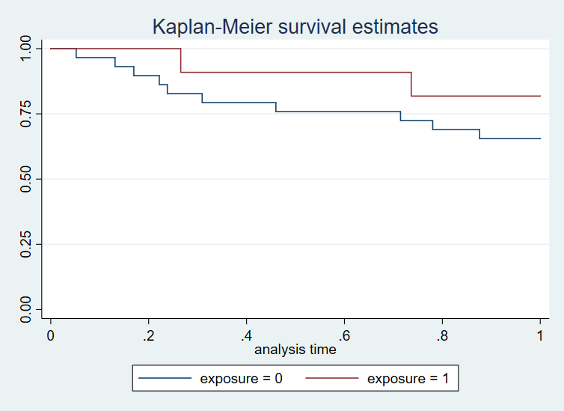

|  |  |  |  |  |  |  |
| --- | --- | --- | --- | --- | --- | --- |
| Cox regression analysis | | | | | | |
| _t | Haz. Ratio | Std. Err. | z | P>|z| | [95% Conf. Interval] | |
| exposure | .8320423 | .3461467 | -0.44 | 0.659 | .3681528 | 1.880454 |
| 2 year follow-up | | | | | | |

