# DACS Online Forms - Mandatory Fields

**1.1.2.3 Register you Interest (CL for Artists)**

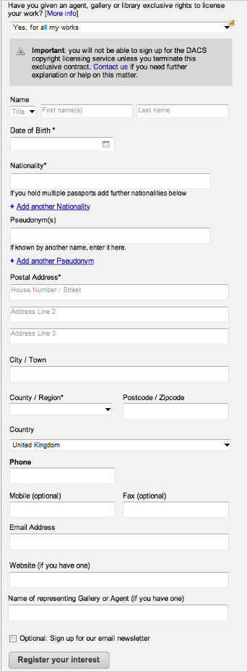

Any forms that have personal details to complete should follow this for the mandatory fields and the order:

Name * - Mandatory

Date of Birth * - Mandatory

Nationality * - Mandatory

Pseudonym – NOT mandatory

Postal Address * (first line only) ie Address Number/ Street – Mandatory

City/Town * - Mandatory

Country/Region – NOT Mandatory

Postcode/Zipcode * - Mandatory

Country * - Mandatory

Phone *- mandatory

Mobile (optional) - NOT Mandatory

Fax (optional) - NOT Mandatory

Email address * - Mandatory

Website (if you have one) – NOT Mandatory

**All forms should follow the above field order for the Your personal details sections, ie**

**1.1.3.3 Apply Online (ARR for Artists)**

Mandatory fields in the Your Personal details section as per personal details highlighted above. In addition,

Additional mandatory fields on this form would be under bank details, depending on the bank account selected

UK Bank Account – all mandatory fields

UK Building Society account –

International Account – IBAN/Swift – mandatory fields

Terms and Conditions – all must be ticked to allow submission of the application form.

**1.1.2.3 Register your Interest (CL for Artists)**

Mandatory fields in the Your Personal details section as per personal details highlighted above. In addition,

Have you given an agent……. A selection must be made

**1.2.3.3 How to Apply for CL( Ben & Heirs)**

Mandatory fields in the Your Personal details section as per personal details highlighted above. In addition,

Additional mandatory fields on this form would be under Details of the Artist’s estate

How would you describe your relationship to the estate – user must make a selection

Has an agent, blah…….. – user must make a selection

Artist’s name * - mandatory

Artist’s date of death – NOT Mandatory

Artist’s nationality * - Mandatory

Artist’s pseudonym – NOT Mandatory

**1.2.4.3 Register your interest (ARR for Ben & Heir)**

Mandatory fields in the Your Personal details section as per personal details highlighted above. In addition,

Additional mandatory fields on this form would be under Details of the Artist’s estate

How would you describe your relationship to the estate – user must make a selection

Has an agent, blah…….. – user must make a selection

Artist’s name * - mandatory

Artist’s date of death – NOT Mandatory

Artist’s nationality * - Mandatory

Artist’s pseudonym – NOT Mandatory

**1.3.2.3.1 Online form (ARR Submit sales details)**

Mandatory fields in the Your Contact details section as per personal details highlighted above. In addition,

Additional mandatory fields on this form would be under Your Sales Information

Item 1 – mandatory fields are:

Sale date*- mandatory

Your reference – NOT mandatory

Artist Name * - mandatory

Artist’s date of birth - NOT mandatory

Artist’s date of death – NOT mandatory

Artist’s nationality * - mandatory

Title of work * - mandatory

Medium - NOT mandatory

Edition number - NOT mandatory

Sale price * - mandatory

**1.4.3 CL Apply Online (customers)**

Mandatory fields in the Contact details section as per personal details highlighted above. In addition,

Product 1 –

Title of the product ……* - mandatory

What type of product….* - mandatory – they must make a selection here

Publishing date – NOT mandatory

Date license needs to be effective from * - mandatory

Everything else is optional

Reproductions –

Artist’s name * - mandatory

Title of work * - mandatory

Everything else is optional