1. Login to AC1
2. Search for account name Nordstrom
   1. TSEE dashboard opens
3. Click phoenix dashboard of user that has all locations. IE: Jamie Langley.
4. Click Reports | Visibility Report
   1. KPI scores matched
5. Hover cursor over graph for most recent date and record score.Compare with KPI for Visibility displayed on Dashboard
   1. Graph is redisplayed for the locations filter
6. Select filter options from Group, Country, State, City, Location and click Apply Filter
   1. Date, score value and number of locations displayed for daily data points
7. Move cursor over Visibility Score History graph
   1. Zoom options window on history graphFrom and To dates changed to match length of Zoom (1 month, 2 months, 6 months, Year to Date, 1 Year, All )
8. Click Zoom options to change windowing.
   1. Graph changes with the sliderFrom and To dates change appropriately.
9. Use window slide below graph and click and drag to change From and To dates
   1. The calendar displays when selecting. Calendars end date cannot go before the start date.
10. Verify the adjusting the calendar changes the reports displayed.
    1. Tool tip opens from right side showing the vendor name, found or not found, and the number of locations.
11. Move cursor over found and not found from Global Sites
    1. List below Sites updates to list locations found or not foundTitle displays vendor name and 'Not found locations' for not found and 'Found locations' for foundList displays pagination, entries per page setup, previous and next buttons and number of entries showing
12. Click Found or Not Found for a vendor from Global Sites  
    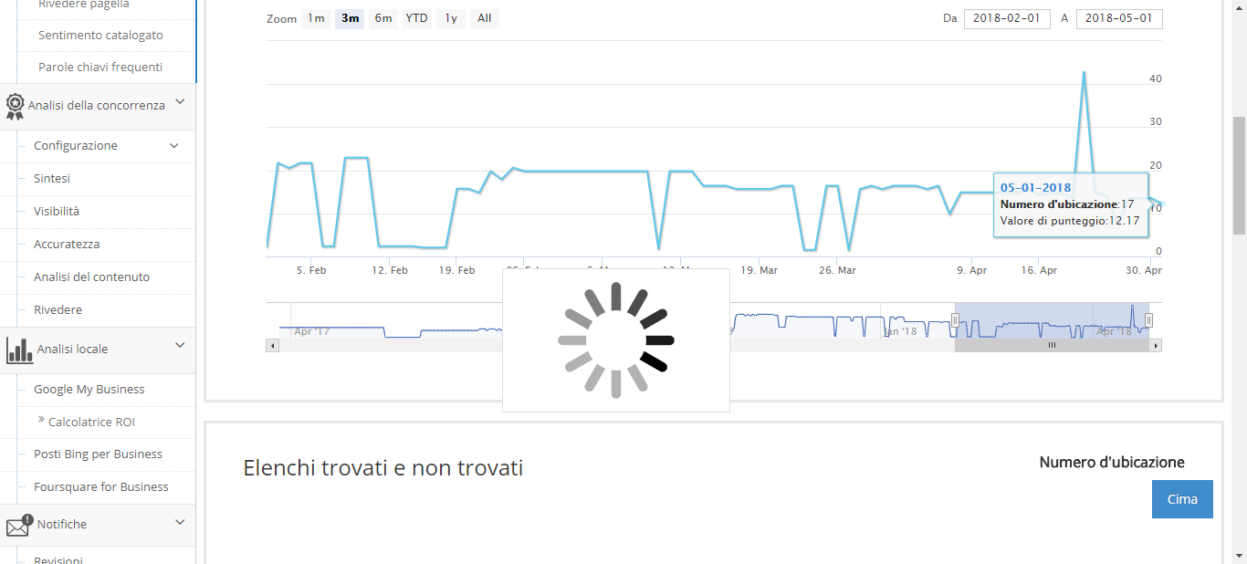  
    1. List below shows locations found or not found for the vendor selectedTitle changes approrpriately for vendor and found or not found locations
13. Click each vendor found & not found
    1. csv is downloaded
14. Click the Export button above the found/not found list
    1. csv contains all locations that were in the list at the time Export was clickedLocation Number, Name, Address, City, St/Prov, Postal Code, Phone, Location and Listing are column headerContent matches list
15. Open export csv
    1. Update URL Listing pop-up opens
16. Click the Update Listing URL next to a location in the list
    1. List below updates to show found locations for vendorfound locations will have a link to a Listing
17. Click on a vendor found location
    1. Vendor listing opens for selected locations in a new tab
18. Click on a Link on the Listing column
19. Close the vendor listing page
    1. Behaves the same as Global Sites but for only Canada
20. Click on found and not found for Canada sites
    1. Behaves the same as Global Sites but for only US
21. Click on found and not found for US sites