* 3. TSEE dashboard opens
  5. KPI scores matched
  6. Graph is redisplayed for the locations filter
  7. Date, score value and number of locations displayed for daily data points
  8. Zoom options window on history graphFrom and To dates changed to match length of Zoom (1 month, 2 months, 6 months, Year to Date, 1 Year, All )
  9. Graph changes with the sliderFrom and To dates change appropriately.
  10. The calendar displays when selecting. Calendars end date cannot go before the start date.
  11. Tool tip opens from right side showing the vendor name, found or not found, and the number of locations.

1. 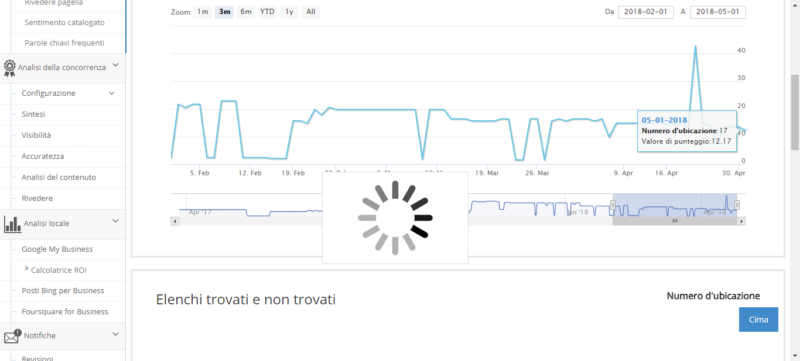  
   1. List below Sites updates to list locations found or not foundTitle displays vendor name and 'Not found locations' for not found and 'Found locations' for foundList displays pagination, entries per page setup, previous and next buttons and number of entries showing
   2. List below shows locations found or not found for the vendor selectedTitle changes approrpriately for vendor and found or not found locations
   3. csv is downloaded
   4. csv contains all locations that were in the list at the time Export was clickedLocation Number, Name, Address, City, St/Prov, Postal Code, Phone, Location and Listing are column headerContent matches list
   5. Update URL Listing pop-up opens
   6. List below updates to show found locations for vendorfound locations will have a link to a Listing
   7. Vendor listing opens for selected locations in a new tab
   9. Behaves the same as Global Sites but for only Canada
   10. Behaves the same as Global Sites but for only US