1. Login to AC1
2. Search for account name Nordstrom
3. Click phoenix dashboard of user that has all locations. IE: Jamie Langley.
   1. TSEE dashboard opens
4. Click Reports | Visibility Report
5. Hover cursor over graph for most recent date and record score.Compare with KPI for Visibility displayed on Dashboard
   1. KPI scores matched
6. Select filter options from Group, Country, State, City, Location and click Apply Filter
   1. Graph is redisplayed for the locations filter
7. Move cursor over Visibility Score History graph
   1. Date, score value and number of locations displayed for daily data points
8. Click Zoom options to change windowing.
   1. Zoom options window on history graphFrom and To dates changed to match length of Zoom (1 month, 2 months, 6 months, Year to Date, 1 Year, All )
9. Use window slide below graph and click and drag to change From and To dates
   1. Graph changes with the sliderFrom and To dates change appropriately.
10. Verify the adjusting the calendar changes the reports displayed.
    1. The calendar displays when selecting. Calendars end date cannot go before the start date.
11. Move cursor over found and not found from Global Sites
    1. Tool tip opens from right side showing the vendor name, found or not found, and the number of locations.
12. Click Found or Not Found for a vendor from Global Sites  
    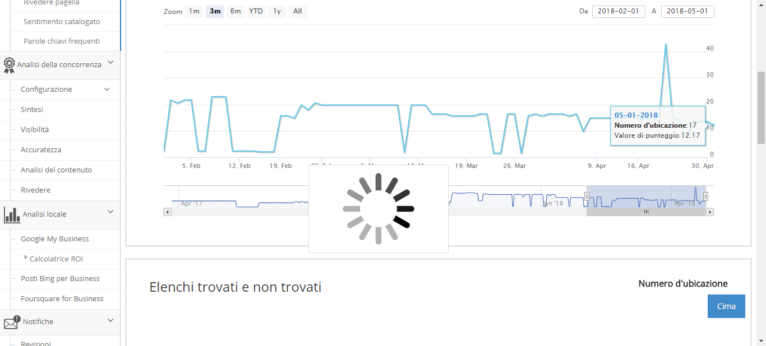  
    1. List below Sites updates to list locations found or not foundTitle displays vendor name and 'Not found locations' for not found and 'Found locations' for foundList displays pagination, entries per page setup, previous and next buttons and number of entries showing
13. Click each vendor found & not found
    1. List below shows locations found or not found for the vendor selectedTitle changes approrpriately for vendor and found or not found locations
14. Click the Export button above the found/not found list
    1. csv is downloaded
15. Open export csv
    1. csv contains all locations that were in the list at the time Export was clickedLocation Number, Name, Address, City, St/Prov, Postal Code, Phone, Location and Listing are column headerContent matches list
16. Click the Update Listing URL next to a location in the list
    1. Update URL Listing pop-up opens
17. Click on a vendor found location
    1. List below updates to show found locations for vendorfound locations will have a link to a Listing
18. Click on a Link on the Listing column
    1. Vendor listing opens for selected locations in a new tab
19. Close the vendor listing page
20. Click on found and not found for Canada sites
    1. Behaves the same as Global Sites but for only Canada
21. Click on found and not found for US sites
    1. Behaves the same as Global Sites but for only US