**VISVESVARAYA TECHNOLOGICAL**

**UNIVERSITY**

**“JnanaSangama”, Belgaum -590014, Karnataka.**



**LAB REPORT**

# on

**Object Oriented Java Programming**

**(23CS3PCOOJ)**

***Submitted by***

**D A Chethan (1BM23CS083) *in partial fulfillment for the award of the degree of***

**BACHELOR OF ENGINEERING**

***in***

**COMPUTER SCIENCE AND ENGINEERING**



**B.M.S. COLLEGE OF ENGINEERING**

**(Autonomous Institution under VTU)**

# BENGALURU-560019

**December-2024**

**B.M.S. College of Engineering,**

**Bull Temple Road, Bangalore 560019**

(Affiliated To Visvesvaraya Technological University, Belgaum)

## Department of Computer Science and Engineering



**CERTIFICATE**

This is to certify that the Lab work entitled “Artificial Intelligence (23CS5PCAIN)” carried out by **D A Chethan (1BM23CS083),** who is bonafide student of **B.M.S. College of**

**Engineering.** It is in partial fulfillment for the award of **Bachelor of Engineering in Computer Science and Engineering** of the Visvesvaraya Technological University, Belgaum. The Lab report has been approved as it satisfies the academic requirements in respect of an Artificial Intelligence (23CS5PCAIN) work prescribed for the said degree.

|  |  |
| --- | --- |
| Lab faculty Incharge Name-Geetha  Assistant Professor  Department of CSE, BMSCE | Dr. Kavitha Sooda  Professor & HOD  Department of CSE, BMSCE |

# Index

|  |  |  |  |
| --- | --- | --- | --- |
| **Sl.**  **No.** | **Date** | **Experiment Title** | **Page No.** |
| 1 | 01/10/2024 | QUADRATIC EQUATION |  |
| 2 | 08/10/2024 | SGPA CALCULATOR |  |
| 3 | 22/10/2024 | ABSTRACT CLASS |  |
| 4 | 15/10/2024 | Book details |  |
| 5 | 29/10/2024 | Bank Details |  |
| 6 | 12/11/2024 | Packages |  |
| 7 | 19/11/2024 | Interface |  |
| 8 | 26/11/2024 | Exception Handling |  |
| 9 | 03/12/2024 | Threads |  |
| 10 | 03/12/2024 | UI |  |

Github Link:

<https://github.com/DAChethan2485/1BM23CS083_OOJ>

**Program 1**

Code:

 import java.util.Scanner;

 public class Quadratic

 {

 public static void main(String[] args)

 {

 int a;

 int b;

 int c;

 Scanner sc = new Scanner(System.in);

 System.out.print("Enter 'a' value: ");

 a= sc.nextInt();

 System.out.print("Enter 'b' value: ");

 b=sc.nextInt();

 System.out.print("Enter 'c' value: ");

 c=sc.nextInt();

 float disc = ((b*b)-4*a*c);

 System.out.println(disc);

 if (a==0)

 {

 System.out.println("Not Quadratic");

 }

 else

 {

 if (disc<0)

 {

 System.out.println("No real roots ");

 }

 else if (disc>0)

 {

 double root1= (-b + Math.sqrt(disc))/(2*a);

 double root2= (-b- Math.sqrt(disc))/(2*a);

 System.out.println("Real roots ");

 System.out.println("Root-1: "+root1);

 System.out.println("Root-2: "+root2);

 }

 else

 {

 double root1=(-b)/(2*a);

 System.out.println("Real and equal");

 System.out.println("Root-1: "+root1);

 System.out.println("Root-2: "+root1);

 }

System.out.println("D A Chethan");

 System.out.println("1BM23CS083");

 }

 }

 }

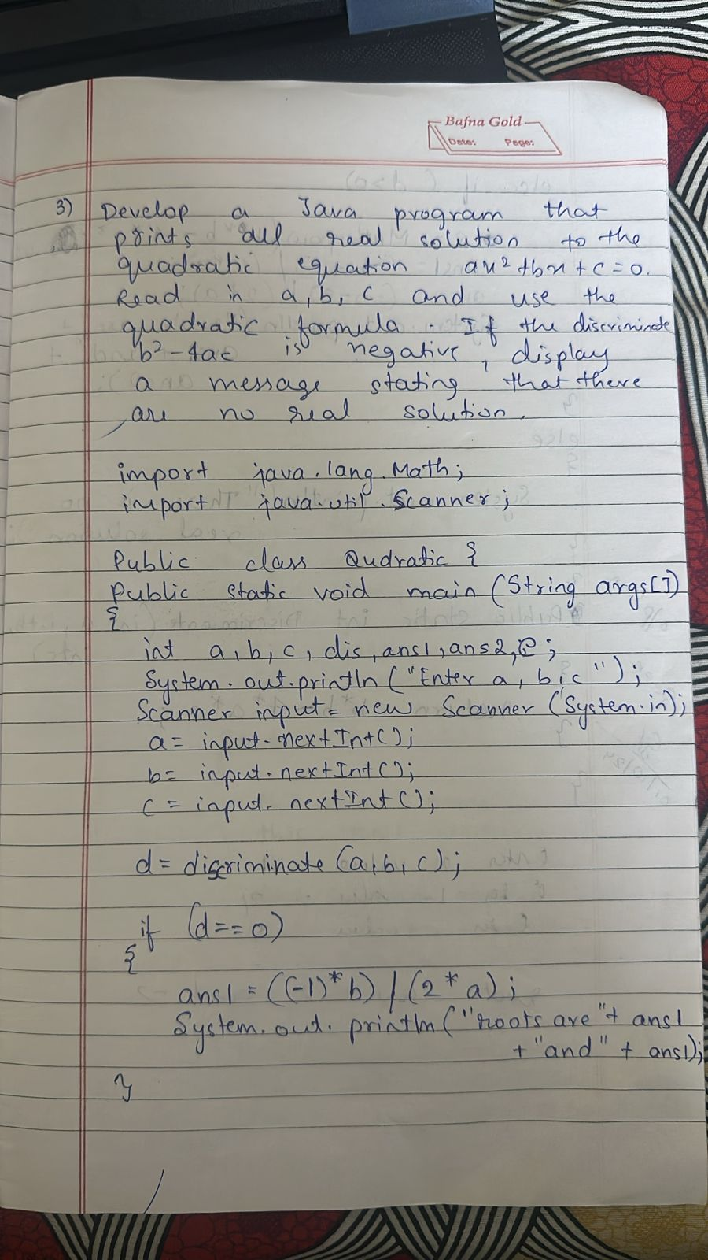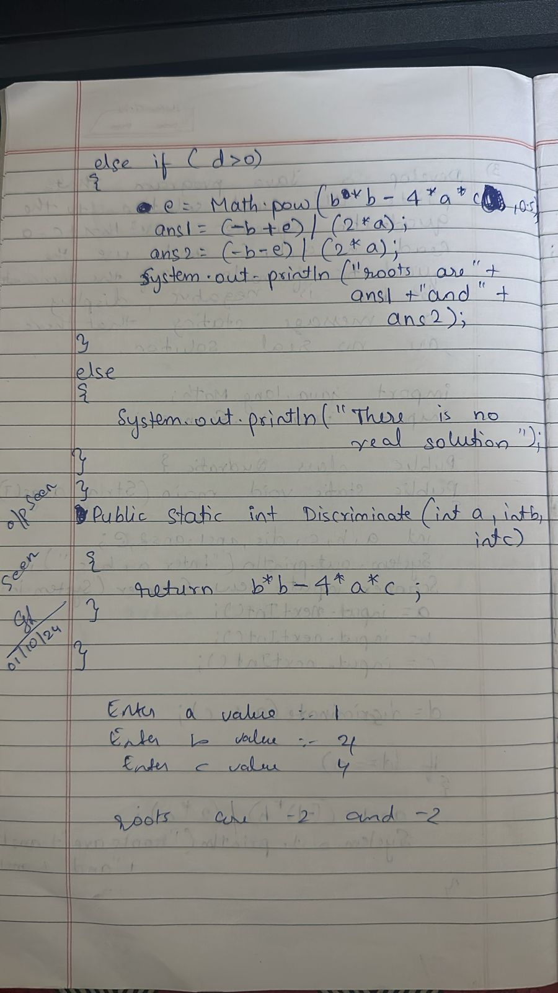

**Program 2**

Code:

import java.util.Scanner;

public class student {

public static void main(String[] args) {

Scanner sc = new Scanner(System.in);

System.out.print("Enter the number of students: ");

int numStudents = sc.nextInt();

sc.nextLine();

String[] names = new String[numStudents];

String[] usns = new String[numStudents];

int[][] creditsArray = new int[numStudents][];

int[][] marksArray = new int[numStudents][];

double[] sgpas = new double[numStudents];

for (int s = 0; s < numStudents; s++) {

System.out.println("Enter details for student " + (s + 1) + ":");

System.out.print("Enter your name: ");

names[s] = sc.nextLine();

System.out.print("Enter your USN: ");

usns[s] = sc.nextLine();

System.out.print("Enter the number of subjects: ");

int numSubjects = sc.nextInt();

int[] credits = new int[numSubjects];

System.out.println("Enter the credits for each subject:");

for (int i = 0; i < numSubjects; i++) {

credits[i] = sc.nextInt();

}

creditsArray[s] = credits;

int[] marks = new int[numSubjects];

System.out.println("Enter the marks for each subject out of 100:");

for (int i = 0; i < numSubjects; i++) {

marks[i] = sc.nextInt();

}

marksArray[s] = marks;

int[] gradePoints = new int[numSubjects];

int[] resultArray = new int[numSubjects];

for (int i = 0; i < numSubjects; i++) {

gradePoints[i] = (marks[i] / 10) + 1;

resultArray[i] = credits[i] * gradePoints[i];

}

int totalCredits = sum(credits);

int totalResult = sum(resultArray);

if (totalCredits > 0) {

sgpas[s] = (double) totalResult / totalCredits;

} else {

sgpas[s] = 0.0;

}

}

System.out.println("\n--- Results ---");

for (int s = 0; s < numStudents; s++) {

System.out.println("Student " + (s + 1) + " (" + names[s] + ", " + usns[s] + "):");

System.out.print("Credits: ");

for (int credit : creditsArray[s]) {

System.out.print(credit + " ");

}

System.out.println();

System.out.print("Marks: ");

for (int mark : marksArray[s]) {

System.out.print(mark + " ");

}

System.out.println();

System.out.println("SGPA: " + sgpas[s]);

System.out.println();

}}

static int sum(int[] array) {

int sum = 0;

for (int value : array) {

sum += value;

}

return sum;

}

}

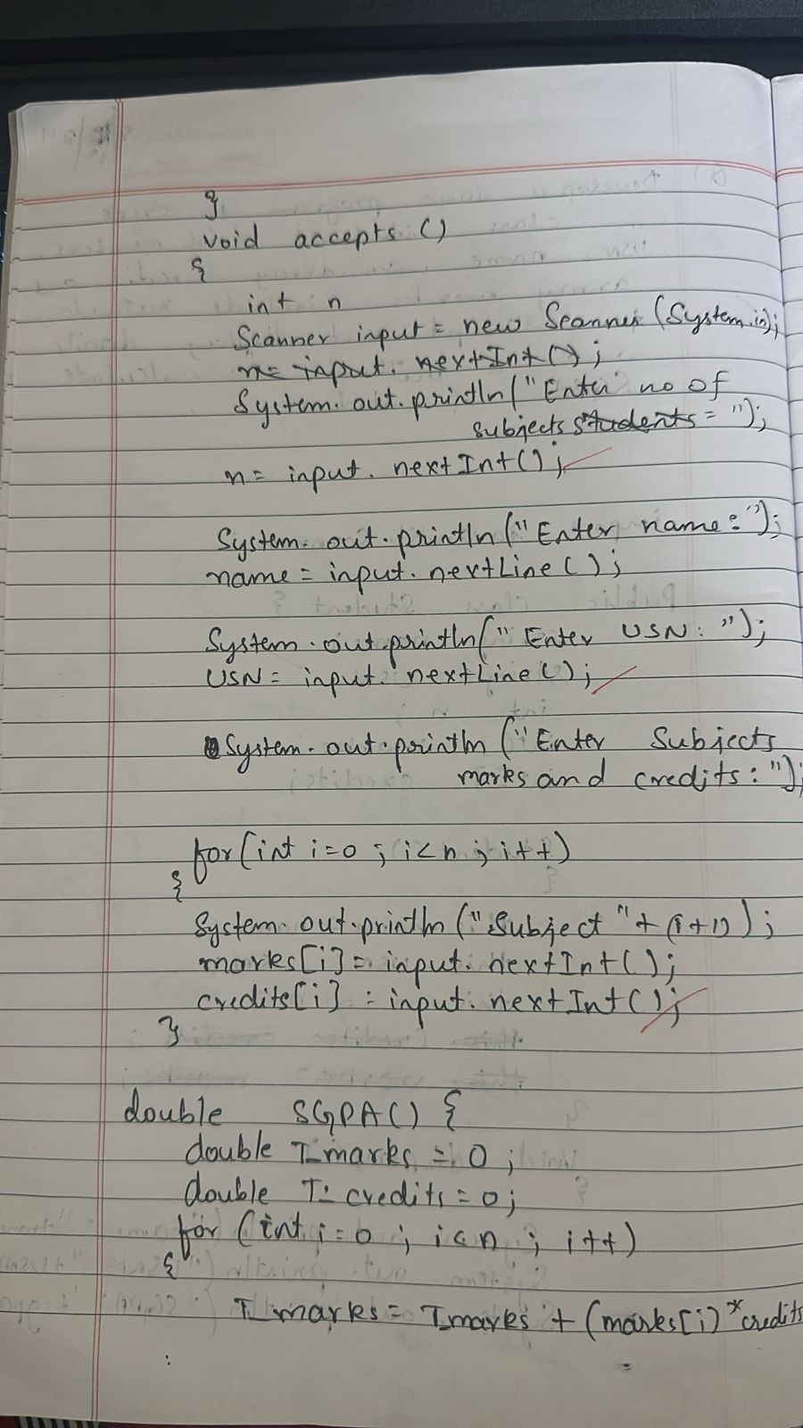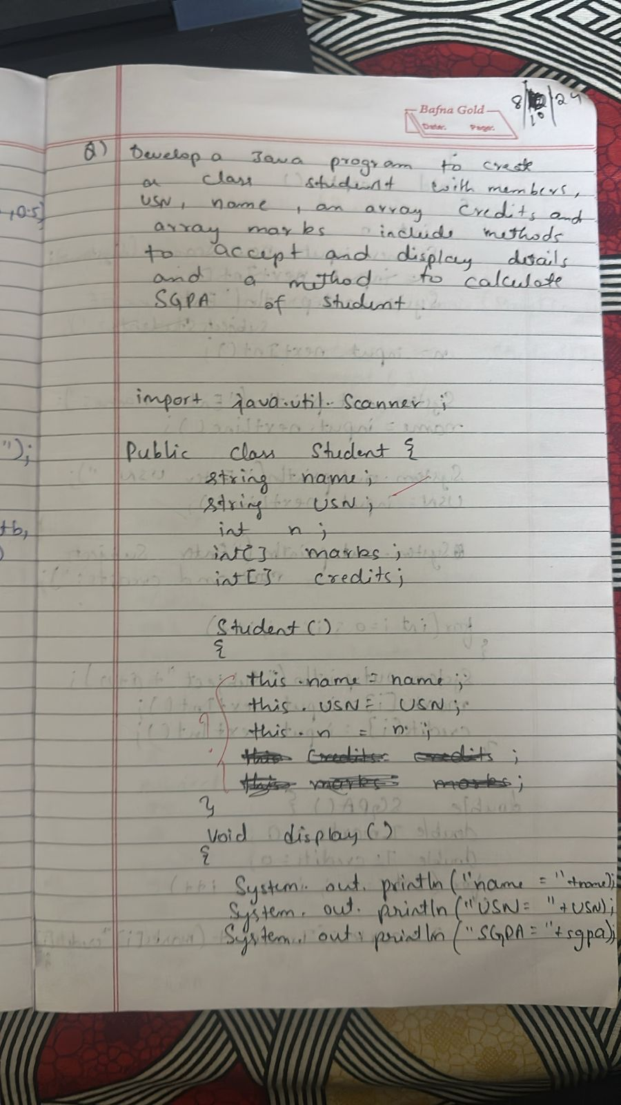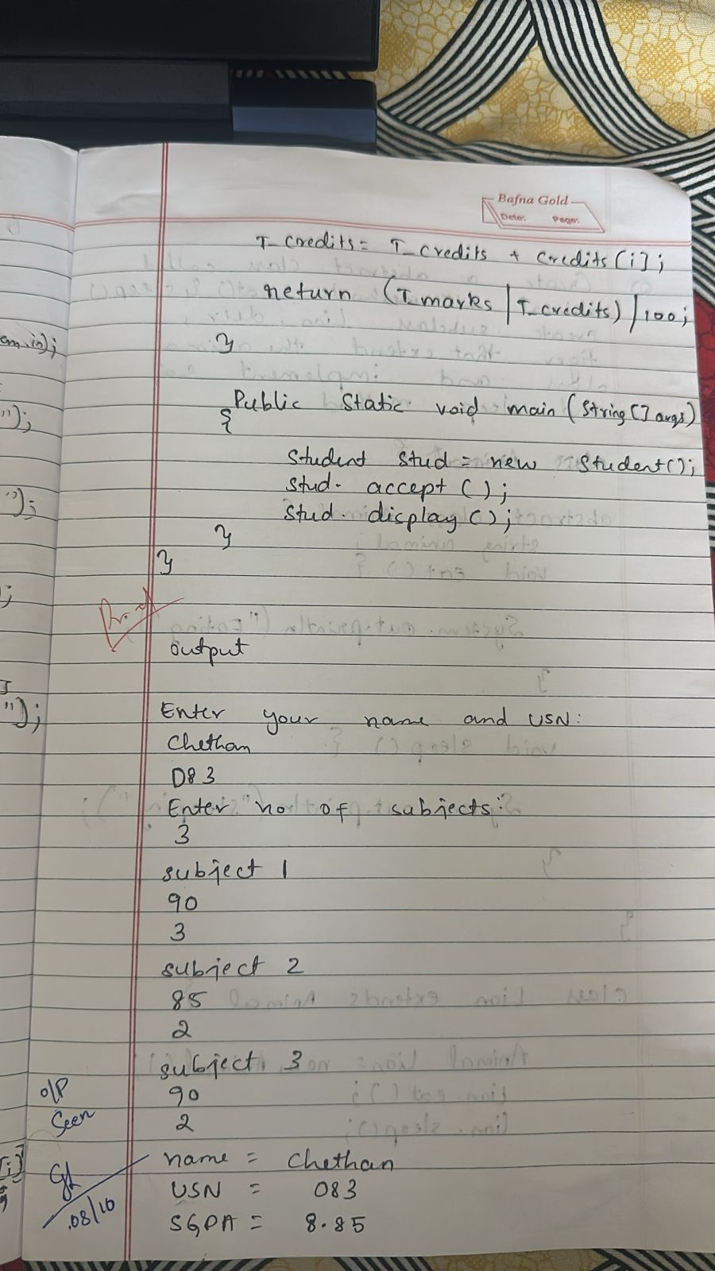

**Program 3**

Code:

import java.util.Scanner;

   abstract class Shape{

    double a,b,result;

    abstract void printArea();

    }

class Rectangle extends Shape{

void printArea(){

System.out.println("Enter l and b of rectangle:");

Scanner s=new Scanner(System.in);

a=s.nextDouble();

b=s.nextDouble();

result=a*b;

System.out.println(result+" sq units");

}

}

class Triangle extends Shape{

void printArea(){

System.out.println("Enter b and h of triangle:");

Scanner s=new Scanner(System.in);

a=s.nextDouble();

b=s.nextDouble();

result=a*b/2;

System.out.println(result+" sq units");

}

}

class Circle extends Shape{

void printArea(){

System.out.println("Enter radius of circle:");

Scanner s=new Scanner(System.in);

a=s.nextDouble();

result=3.142*a*a;

System.out.println(result+" sq units");

}

}

class printArea{

public static void main(String args[]){

    System.out.println("name-D A Chethan");

    System.out.println("usn-1BM23CS083");

Rectangle r=new Rectangle();

Triangle t=new Triangle();

Circle c=new Circle();

r.printArea();

t.printArea();

c.printArea();

}

}

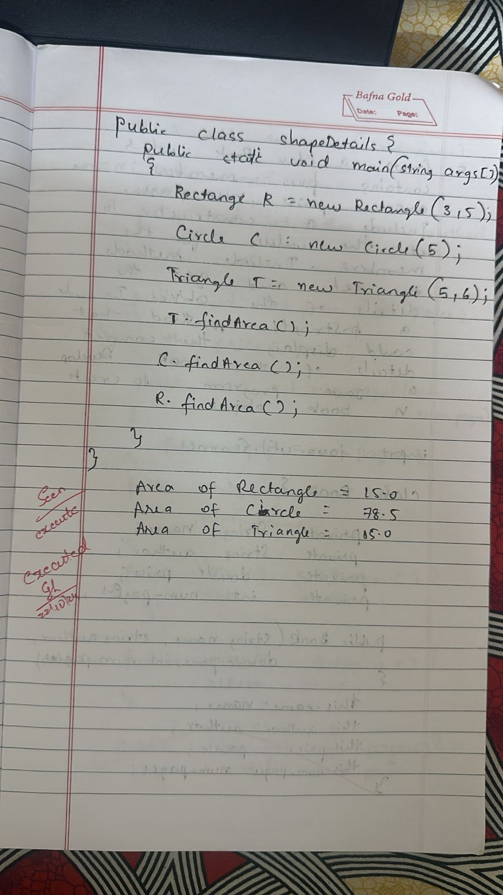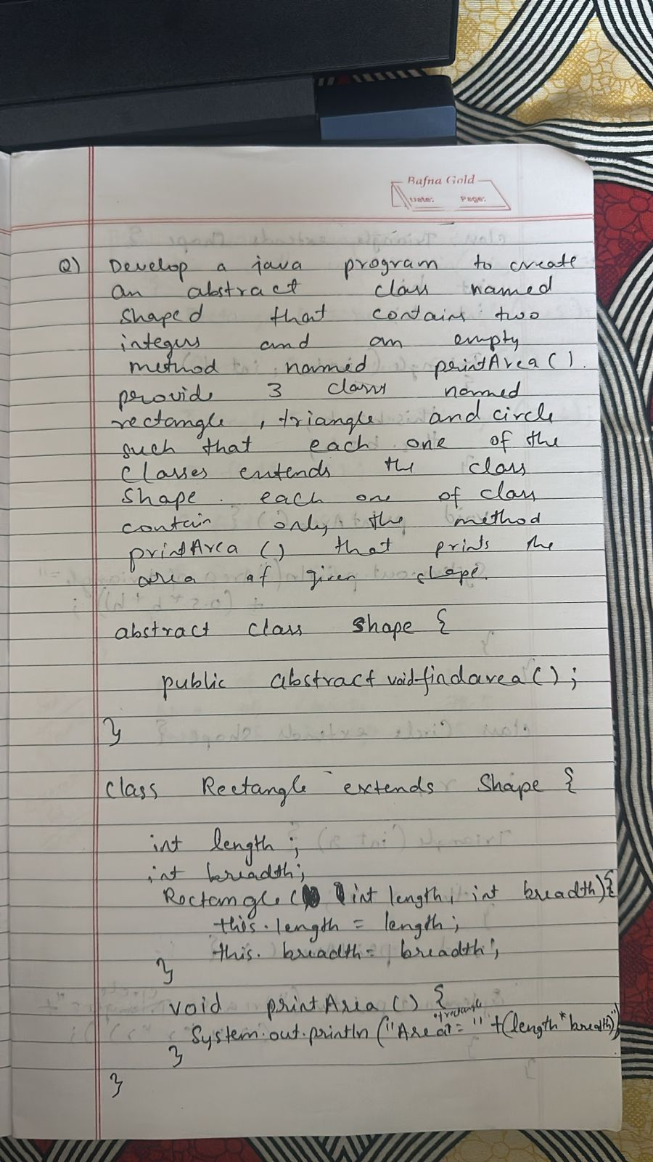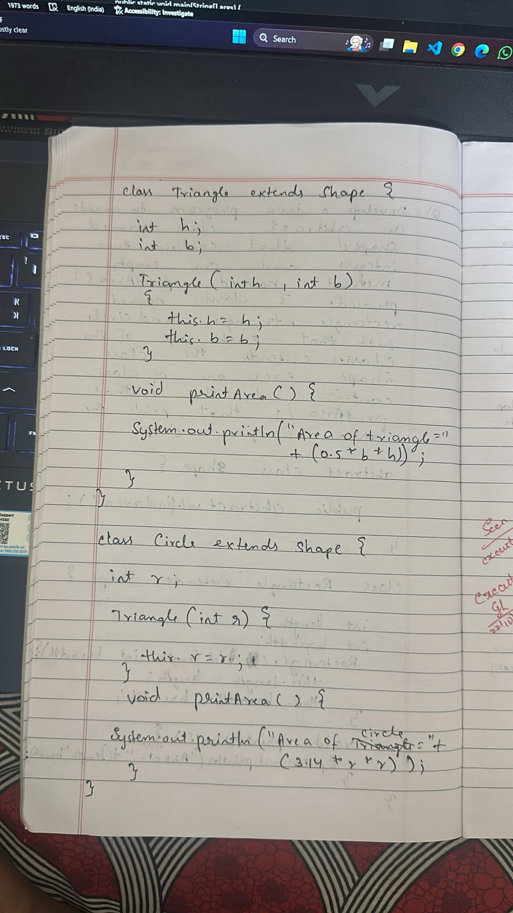

**Program 4**

Code:

import java.util.Scanner;

class Book{

private String name;

private String author;

private int price;

private int numPages;

Book(String name, String author, int price, int numPages){

this.name = name;

this.author = author;

this.price = price;

this.numPages = numPages;}

public String toString(){

String name ,author ,price ,numPages ;

name="Book name: " + this.name + "\n";

author="Author name:" + this.author+"\n";

price = "Price: " +  this.price + "\n";

numPages = "Number of pages: " + this.numPages + "\n";

return name + author + price + numPages;

}}

public class Books{

public static void main(String args[]){

System.out.println("name- D A Chethan");

System.out.println("usn- 1BM23CS083");

String name, author;

int price, numPages;

Scanner sc=new Scanner(System.in);

System.out.print("enter the number of books:");

int n =sc.nextInt();

Book [] books= new Book[n];

for(int i=0;i<n;i++){

System.out.println("enter the name of the "+(i+1)+" Book:");

name =sc.next();

System.out.println("enter the author of the "+(i+1)+" book:");

author= sc.next();

System.out.println("enter the price of the :"+(i+1)+" book:");

price= sc.nextInt();

System.out.println("enter the number of pages of the "+(i+1)+" Book:");

numPages = sc.nextInt();

System.out.println("Result");

books[i]= new Book(name, author, price, numPages);

System.out.println(books[i]);

}

}

}

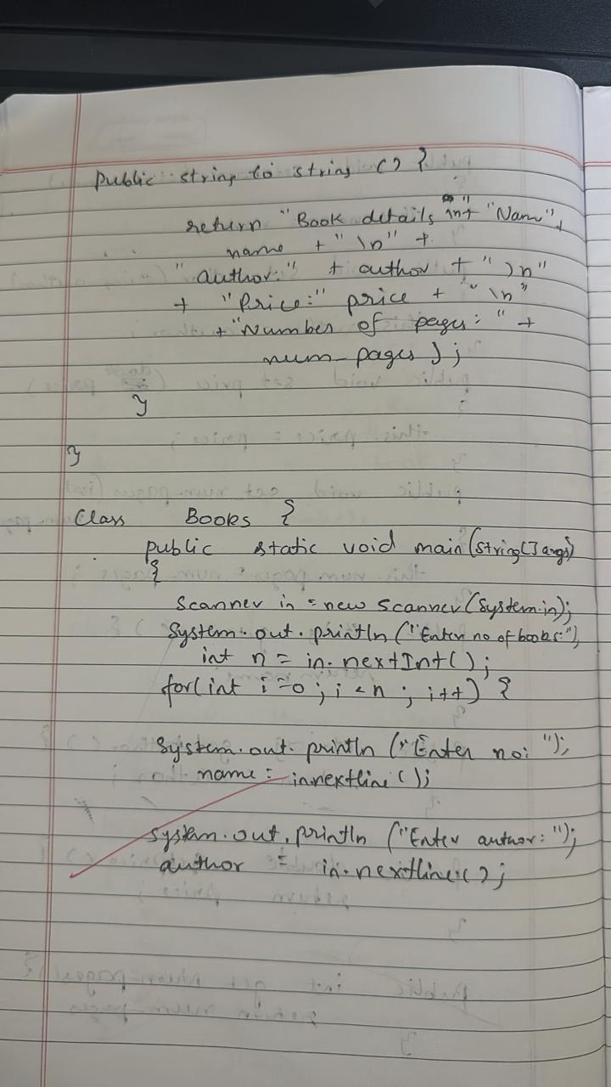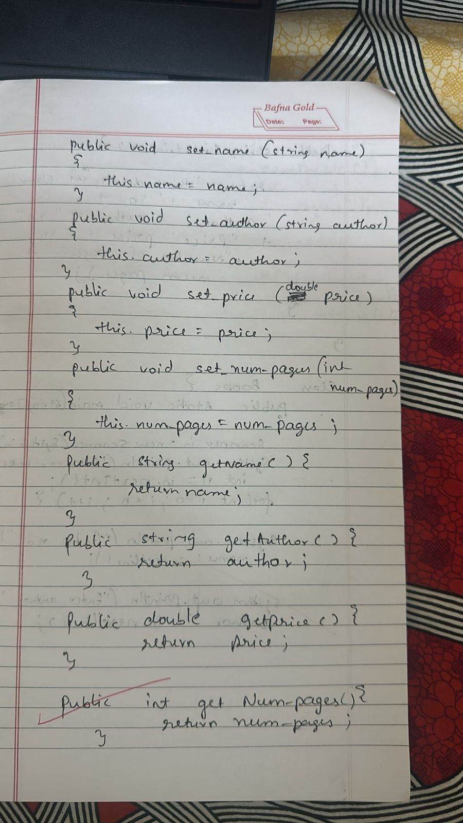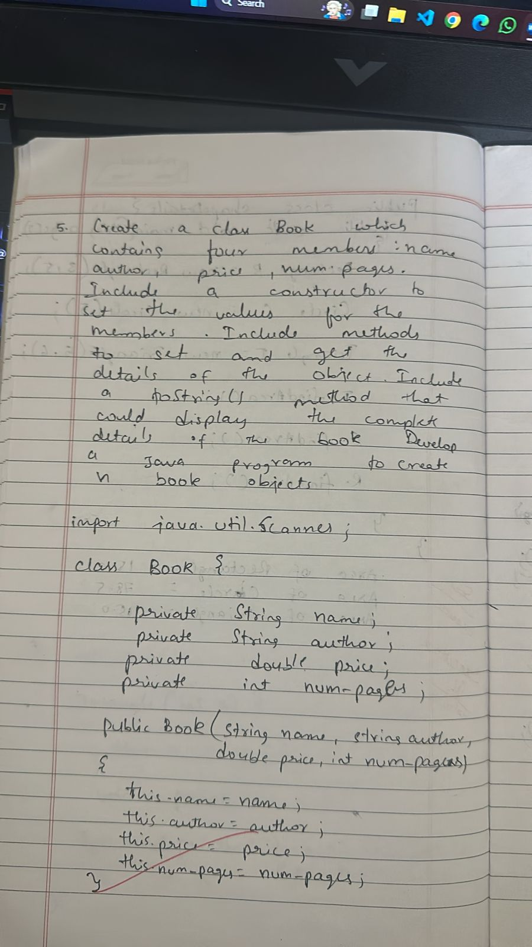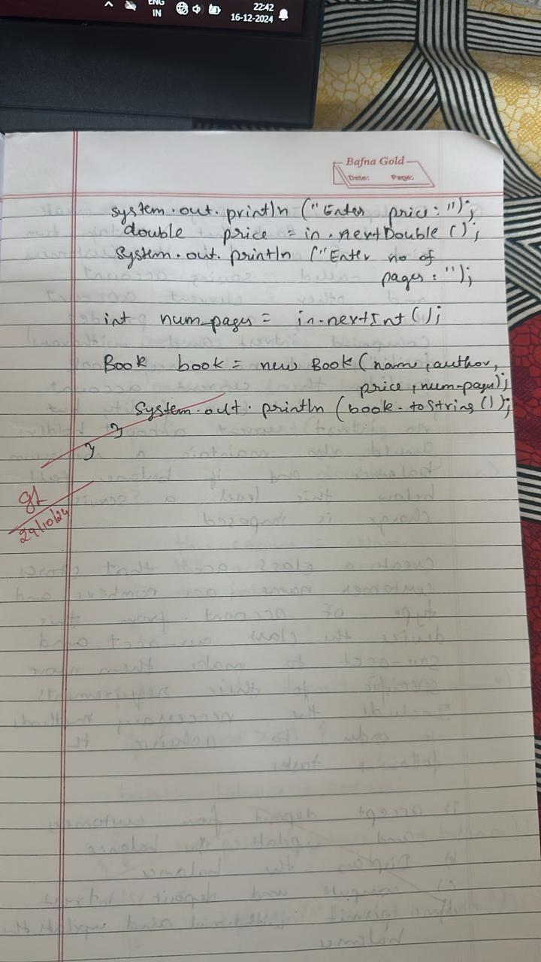

**Program 5**

Code:

import java.util.Scanner;

class PrintInfo {

   static void print() {

        System.out.println("Name:D A Chethan0 ");

        System.out.println("USN: 1BM23CS083");

    }

}

class Account {

    String customerName;

    int accountNumber;

    String accountType;

    double balance;

    Account(String name, int accNumber, String accType) {

        customerName = name;

        accountNumber = accNumber;

        accountType = accType;

        balance = 0;

    }

    public void deposit(double amount) {

        balance += amount;

        System.out.println("Deposited: " + amount + ". Updated balance: " + balance);

    }

    public void displayBalance() {

        System.out.println("Account Balance: " + balance);

    }

    public void withdraw(double amount) {

        System.out.println("This operation is specific to account type.");

    }

}

class SavAccount extends Account {

    double interestRate = 0.04;  // 4% annual interest rate

    SavAccount(String name, int accNumber) {

        super(name, accNumber, "Savings");

    }

    public void computeInterest() {

        double interest = balance * interestRate;

        balance += interest;

        System.out.println("Interest added: " + interest + ". Updated balance: " + balance);

    }

    @Override

    public void withdraw(double amount) {

        if (balance >= amount) {

            balance -= amount;

            System.out.println("Withdrawn: " + amount + ". Updated balance: " + balance);

        } else {

            System.out.println("Insufficient balance.");

        }

    }

}

class CurAccount extends Account {

    double minBalance = 500.0;

    double serviceCharge = 50.0;

    CurAccount(String name, int accNumber) {

        super(name, accNumber, "Current");

    }

    public void checkMinBalance() {

        if (balance < minBalance) {

            balance -= serviceCharge;

            System.out.println("Balance below minimum. Service charge imposed: " + serviceCharge + ". Updated balance: " + balance);

        }

    }

    @Override

    public void withdraw(double amount) {

        if (balance >= amount) {

            balance -= amount;

            System.out.println("Withdrawn: " + amount + ". Updated balance: " + balance);

            checkMinBalance();

        } else {

            System.out.println("Insufficient balance.");

        }

    }

}

public class Bank {

    public static void main(String[] args) {

        PrintInfo.print();

        Scanner sc = new Scanner(System.in);

        System.out.println("Enter customer name:");

        String name=sc.next();

        System.out.println("Enter account number:");

        int accountnumber=sc.nextInt();

        SavAccount savingsAccount = new SavAccount(name, accountnumber);

System.out.println("Enter customer name:");

        String name1=sc.next();

        System.out.println("Enter account number:");

        int accountnumber1=sc.nextInt();

        CurAccount currentAccount = new CurAccount(name1, accountnumber1);

        while (true) {

            System.out.println("\n-----MENU-----");

            System.out.println("1. Deposit\n2. Withdraw\n3. Compute Interest for Savings Account\n4. Display Account Details\n5. Exit");

            System.out.print("Enter your choice: ");

            int choice = sc.nextInt();

            System.out.print("Enter the type of account (saving/current): ");

            String accType = sc.next();

            if (accType.equals("saving")) {

                switch (choice) {

                    case 1:

                        System.out.print("Enter the deposit amount: ");

                        double depositAmount = sc.nextDouble();

                        savingsAccount.deposit(depositAmount);

                        break;

                    case 2:

                        System.out.print("Enter the withdrawal amount: ");

                        double withdrawalAmount = sc.nextDouble();

                        savingsAccount.withdraw(withdrawalAmount);

                        break;

                    case 3:

                        savingsAccount.computeInterest();

                        break;

                    case 4:

                        System.out.println("Customer name: " + savingsAccount.customerName);

                        System.out.println("Account number: " + savingsAccount.accountNumber);

                        System.out.println("Type of Account: " + savingsAccount.accountType);

                        savingsAccount.displayBalance();

                        break;

                    case 5:

                        System.exit(0);

                        break;

                    default:

                        System.out.println("Invalid choice.");

                }

            } else if (accType.equals("current")) {

                switch (choice) {

                    case 1:

                        System.out.print("Enter the deposit amount: ");

                        double depositAmount = sc.nextDouble();

                        currentAccount.deposit(depositAmount);

                        break;

                    case 2:

                        System.out.print("Enter the withdrawal amount: ");

                        double withdrawalAmount = sc.nextDouble();

                        currentAccount.withdraw(withdrawalAmount);

                        break;

                    case 3:

                        System.out.println("Current accounts do not earn interest.");

                        break;

                    case 4:

                        System.out.println("Customer name: " + currentAccount.customerName);

                        System.out.println("Account number: " + currentAccount.accountNumber);

                        System.out.println("Type of Account: " + currentAccount.accountType);

                        currentAccount.displayBalance();

                        break;

                    case 5:

                        System.exit(0);

                        break;

                    default:

                        System.out.println("Invalid choice.");

                }

            } else {

                System.out.println("Invalid account type.");

            }

        }

    }

}

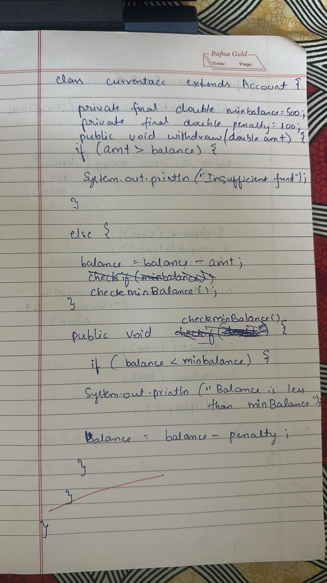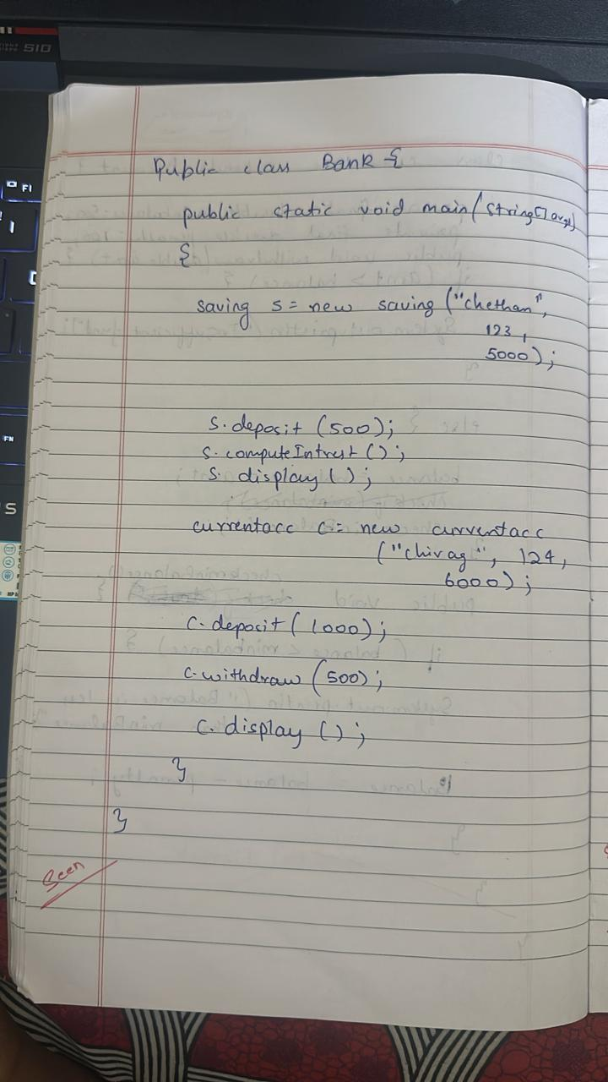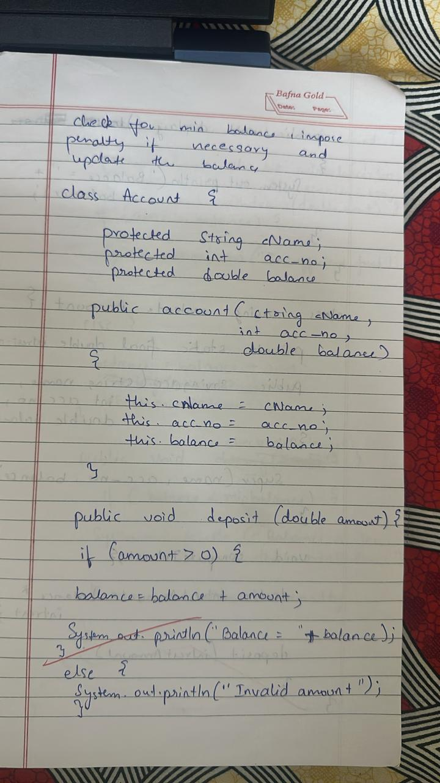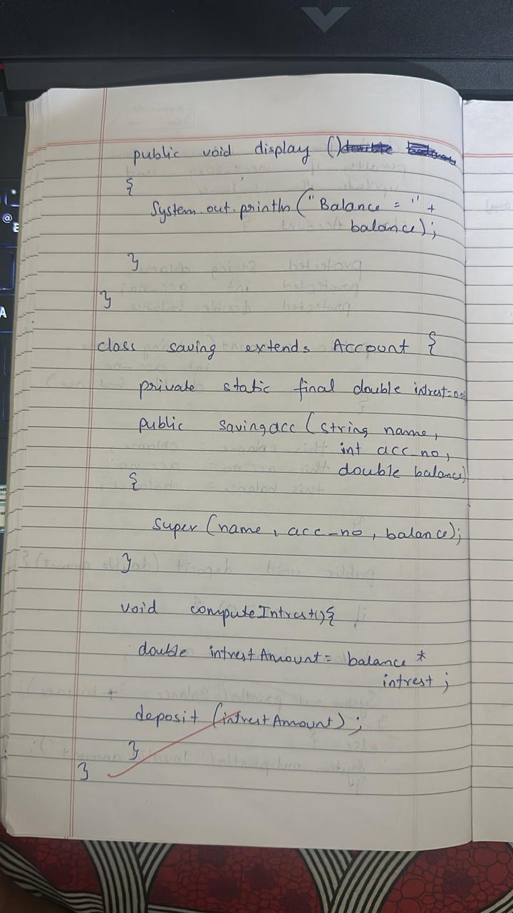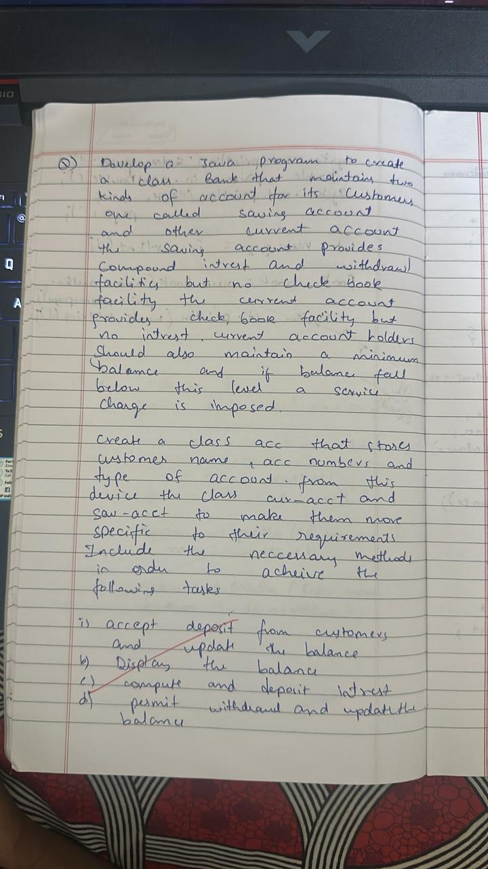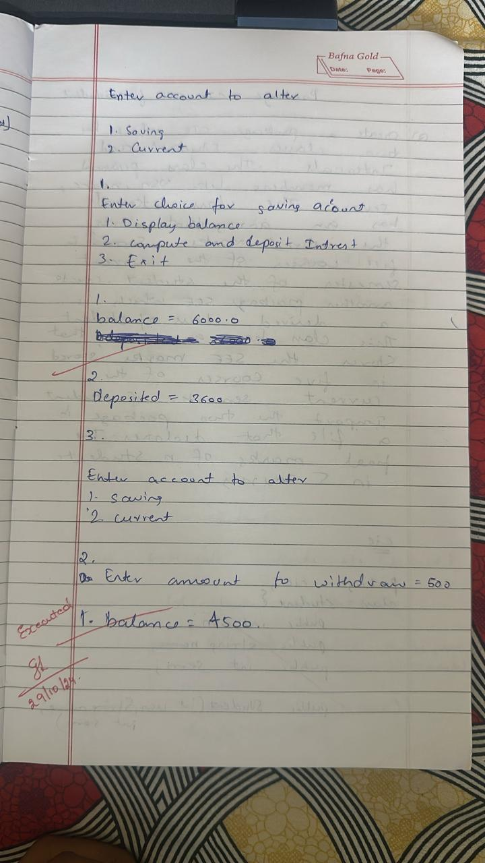

**Program 6**

Code:

//internals

package CIE;

import java.util.Scanner;

public class Internals extends Student {

    int[] cieMarks = new int[5];

    public void inputCIEMarks() {

        Scanner s = new Scanner(System.in);

        System.out.println("Enter CIE marks for 5 subjects:");

        for (int i = 0; i < 5; i++) {

            System.out.print("Subject " + (i + 1) + ": ");

            cieMarks[i] = s.nextInt();

        }

    }

    public int[] getCieMarks() {

        return cieMarks;

    }

}

//student

package CIE;

import java.util.Scanner;

public class Student {

    protected String usn;

    protected String name;

    protected int sem;

    public void inputStudentDetails() {

        Scanner s = new Scanner(System.in);

        System.out.print("Enter USN: ");

        usn = s.nextLine();

        System.out.print("Enter Name: ");

        name = s.nextLine();

        System.out.print("Enter Semester: ");

        sem = s.nextInt();

    }

    public void displayStudentDetails() {

        System.out.println("USN: " + usn);

        System.out.println("Name: " + name);

        System.out.println("Semester: " + sem);

    }

}

//externals

package SEE;

import CIE.Student;

import java.util.Scanner;

public class External extends Student {

    int[] seeMarks = new int[5];

    public void inputSEEMarks() {

        Scanner s = new Scanner(System.in);

        System.out.println("Enter SEE marks for 5 subjects:");

        for (int i = 0; i < 5; i++) {

            System.out.print("Subject " + (i + 1) + ": ");

            seeMarks[i] = s.nextInt();

        }

    }

    public int[] getSeeMarks() {

        return seeMarks;

    }

}

//main

import CIE.Internals;

import SEE.External;

import java.util.Scanner;

public class main {

    public static void main(String[] args) {

        Scanner sc = new Scanner(System.in);

        System.out.print("Enter the number of students: ");

        int numStudents = sc.nextInt();

        sc.nextLine();

        Internals[] cieStudents = new Internals[numStudents];

        External[] seeStudents = new External[numStudents];

        for (int i = 0; i < numStudents; i++) {

            System.out.println("\nEnter details for student " + (i + 1) + ":");

            cieStudents[i] = new Internals();

            cieStudents[i].inputStudentDetails();

            cieStudents[i].inputCIEMarks();

            seeStudents[i] = new External();

            seeStudents[i].inputSEEMarks();

        }

        System.out.println("\nFinal marks for each student:");

        for (int i = 0; i < numStudents; i++) {

            System.out.println("\nDetails for student " + (i + 1) + ":");

            cieStudents[i].displayStudentDetails();

            int[] cieMarks = cieStudents[i].getCieMarks();

            int[] seeMarks = seeStudents[i].getSeeMarks();

            int[] finalMarks = new int[5];

            System.out.println("Final marks in each subject:");

            for (int j = 0; j < 5; j++) {

                finalMarks[j] = cieMarks[j] + seeMarks[j];

                System.out.println("Subject " + (j + 1) + ": " + finalMarks[j]);

            }

        }

        sc.close();

        System.out.println("D A CHETHAN");

        System.out.println("1BM23CS083");

    }

}

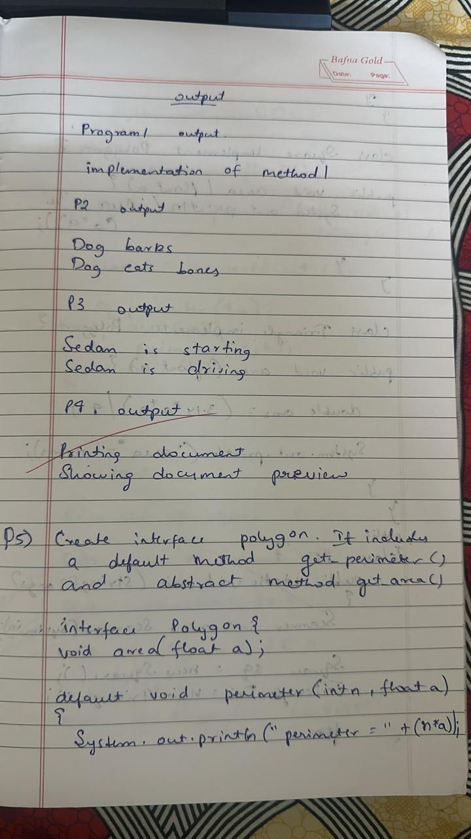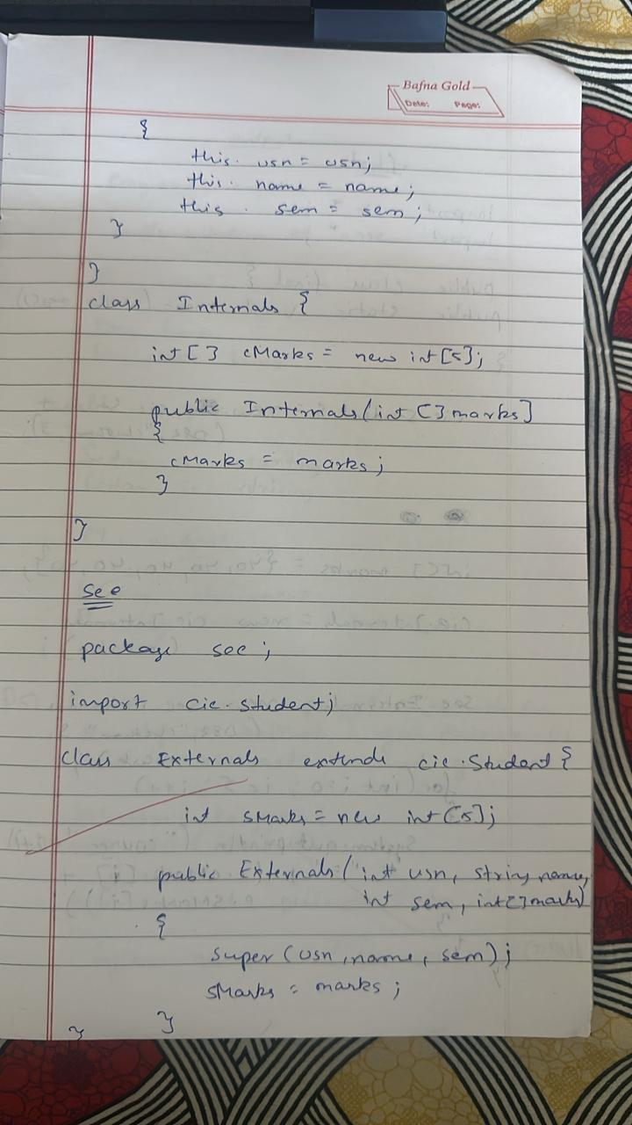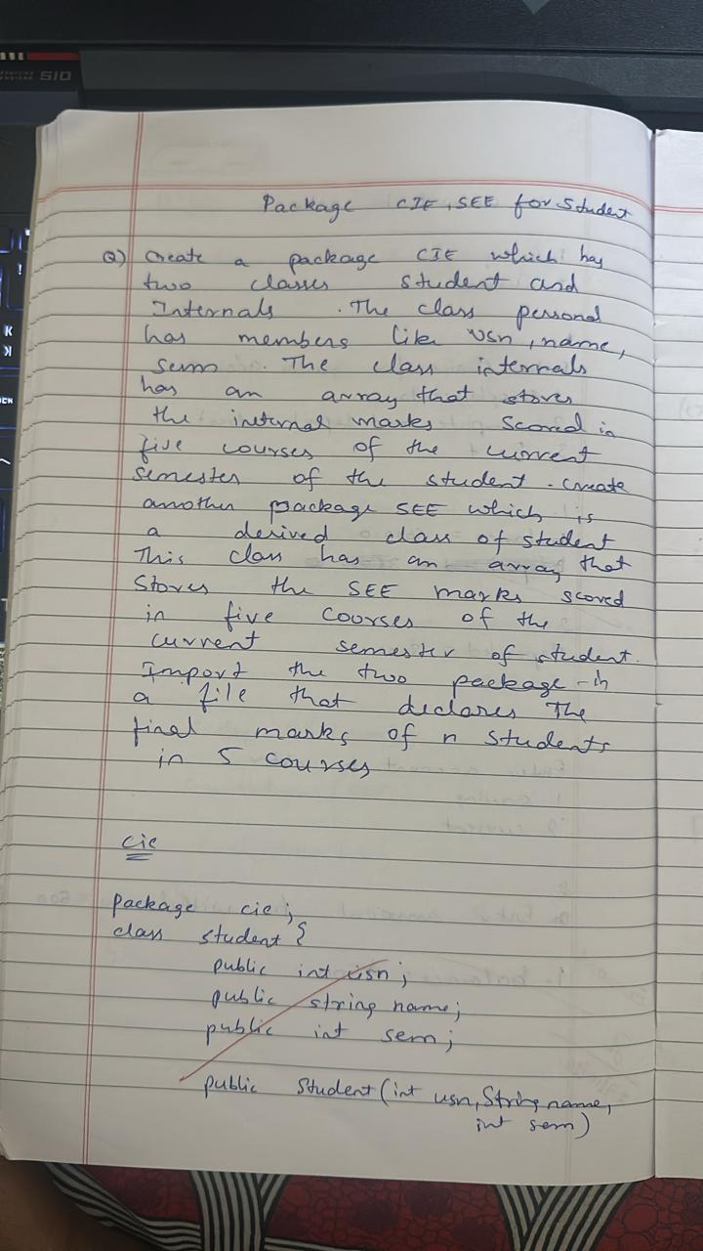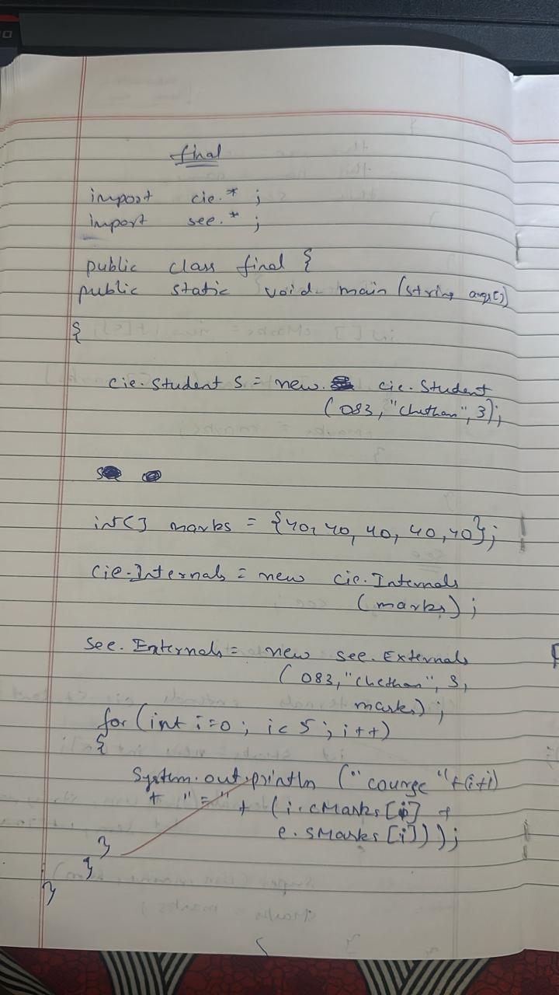

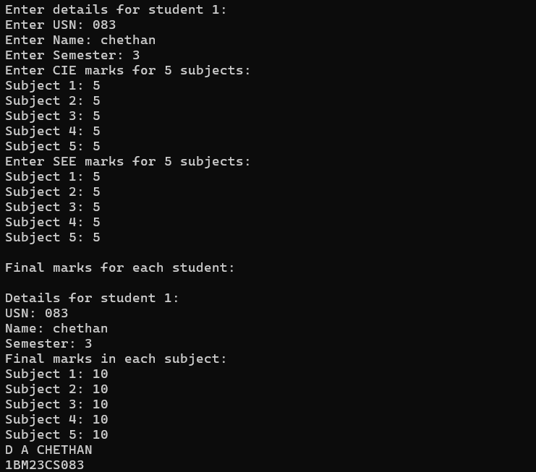

**Program 7**

Code:

import java.util.Scanner;

class WrongAgeException extends Exception {

    public WrongAgeException(String message) {

        super(message);

    }

}

class Father {

    protected int fatherAge;

    public Father(int age) throws WrongAgeException {

        if (age < 0) {

            throw new WrongAgeException("Father's age cannot be negative!");

        }

        this.fatherAge = age;

        System.out.println("Father's age is: " + fatherAge);

    }

}

class Son extends Father {

    private int sonAge;

    public Son(int fatherAge, int sonAge) throws WrongAgeException {

        super(fatherAge);

        if (sonAge < 0) {

            throw new WrongAgeException("Son's age cannot be negative!");

        }

        if (sonAge >= fatherAge) {

            throw new WrongAgeException("Son's age cannot be greater than or equal to father's age!");

        }

        this.sonAge = sonAge;

        System.out.println("Son's age is: " + sonAge);

    }

}

public class ExceptionInInheritance {

    public static void main(String[] args) {

        Scanner scanner = new Scanner(System.in);

        try {

            System.out.print("Enter father's age: ");

            int fatherAge = scanner.nextInt();

            System.out.print("Enter son's age: ");

            int sonAge = scanner.nextInt();

            Son son = new Son(fatherAge, sonAge);

        } catch (WrongAgeException e) {

            System.err.println("Exception: " + e.getMessage());

        } catch (Exception e) {

            System.err.println("Invalid input! Please enter integers.");

        } finally {

            scanner.close();

        }

        System.out.println("D A CHETHAN,1BM23CS083") ;

    }

}

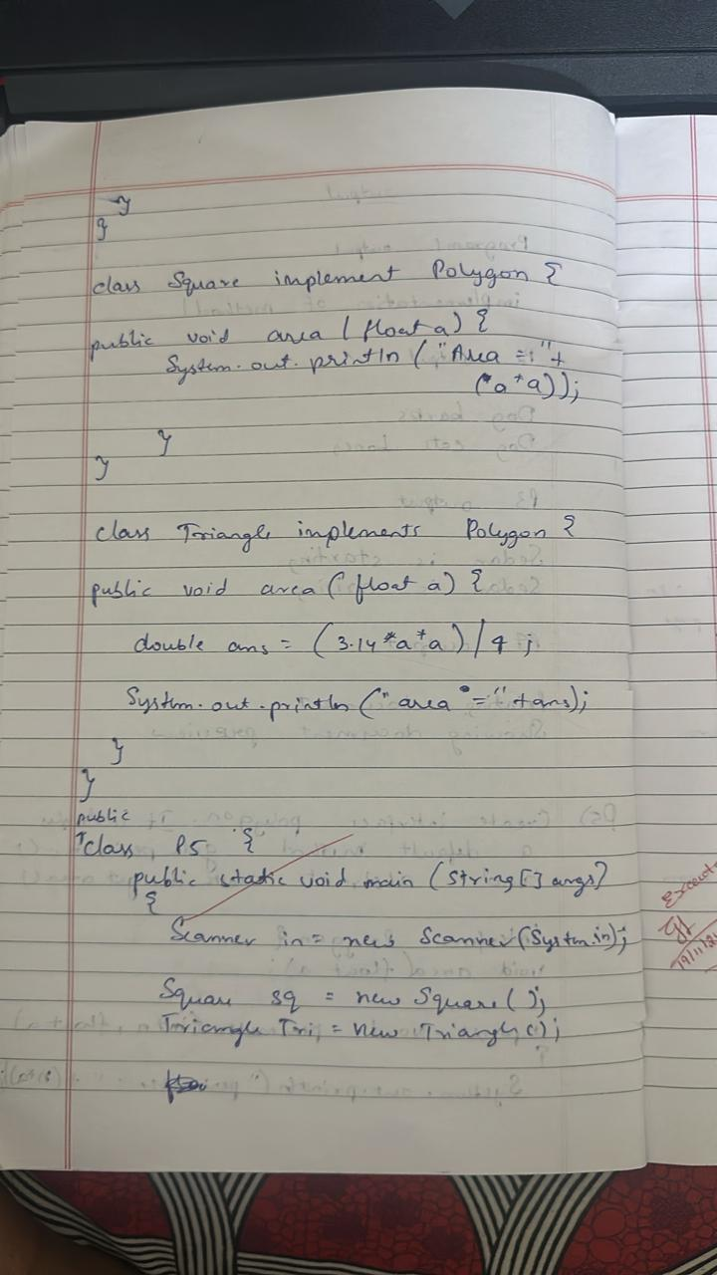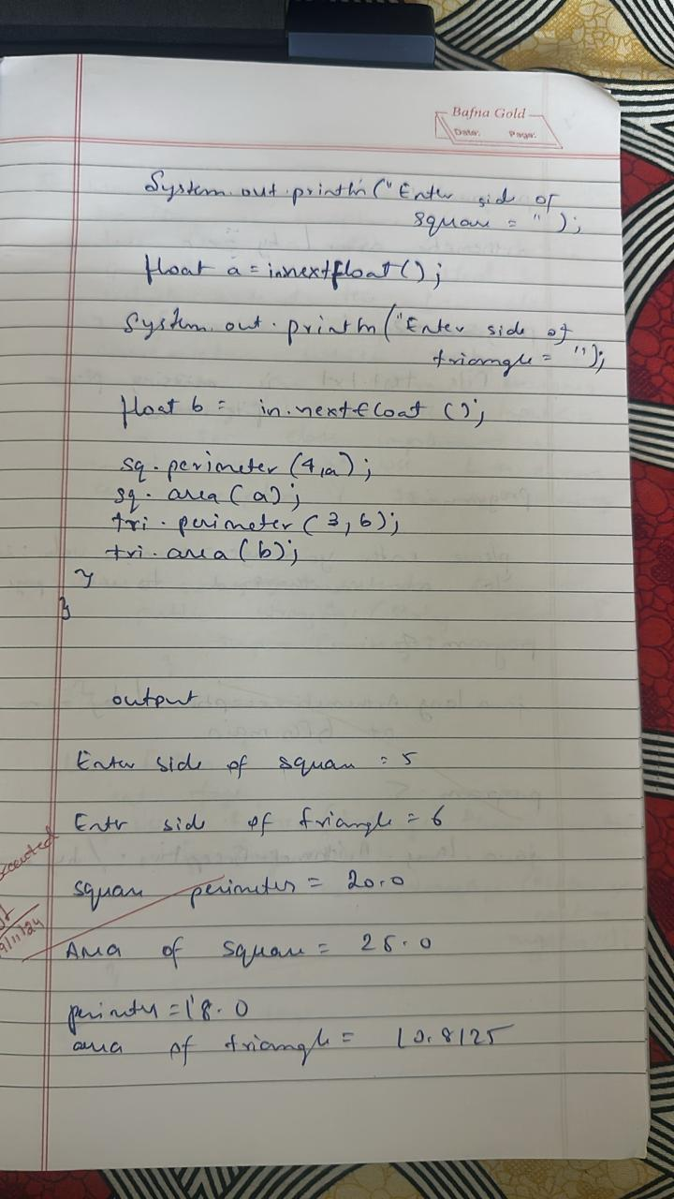

**Program 8**

Code:

import java.util.Scanner;

interface Polygon {

    void area(float a);

    default void perimeter(int n, float l) {

        System.out.println("Perimeter of shape = " + (n * l));

    }

}

class Square implements Polygon {

    public void area(float a) {

        System.out.println("Area of square = " + (a * a));

    }

}

class Triangle implements Polygon {

    public void area(float a) {

    System.out.println("Area of triangle = " + ((1.72 / 4) * (a * a)));

    }

}

public class ip {

    public static void main(String[] args) {

    System.out.println("D A Chethan -1BM23CS083");

    Scanner cin = new Scanner(System.in);

        Square s = new Square();

        Triangle t = new Triangle();

    System.out.println("Enter side of square");

    float ss = cin.nextFloat();

    System.out.println("Enter side of triangle");

    float st = cin.nextFloat();

        s.area(ss);

    t.area(st);

        s.perimeter(4, ss);

        t.perimeter(3, st);

    }

}

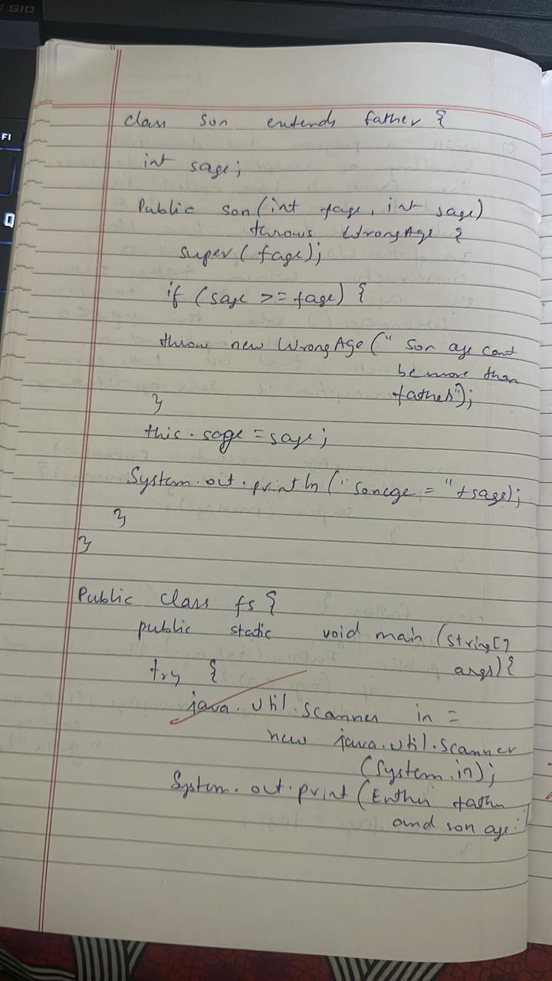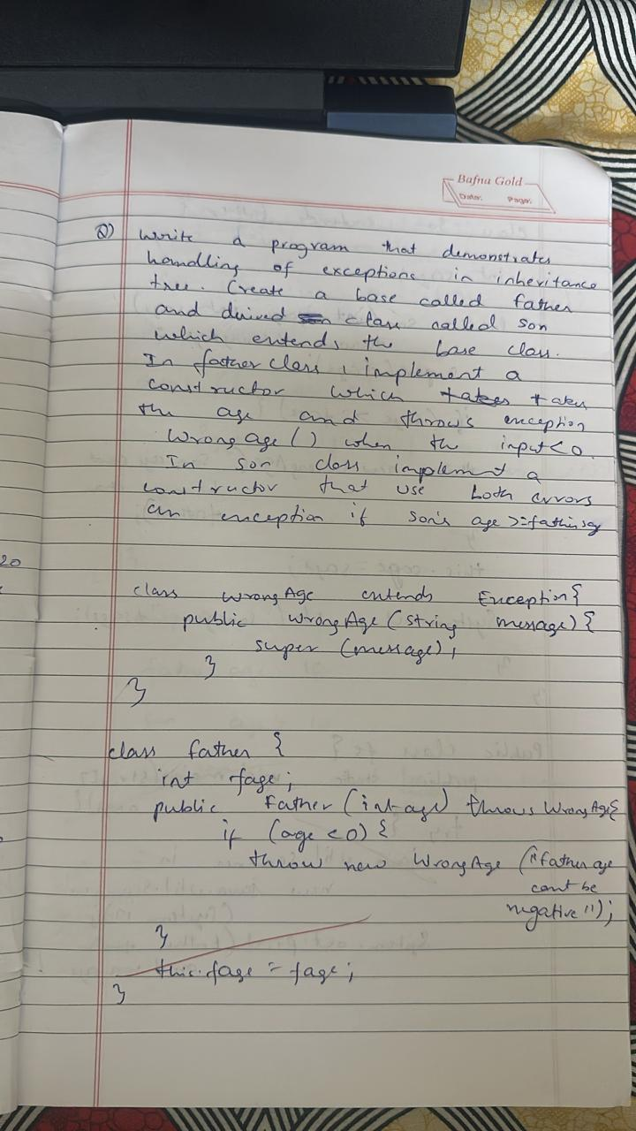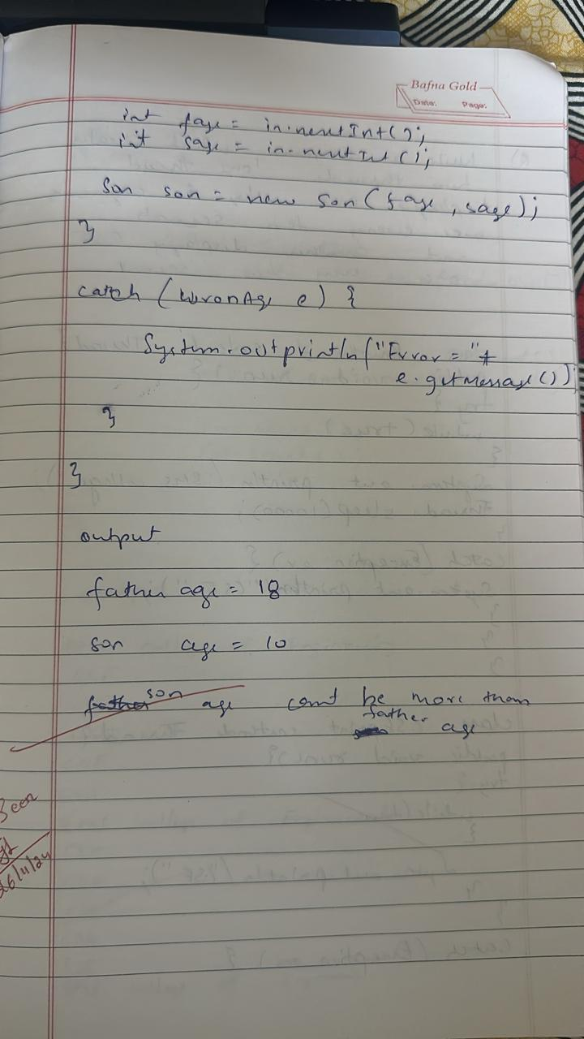

**Program 9**

Code:

class BMSPrinter extends Thread {

    public void run() {

        try {

            while (true) {

                System.out.println("BMS college of engineering");

                Thread.sleep(10000);

        }

        } catch (Exception e) {

            System.out.println(e);

        }

    }

}

class CSEPrinter extends Thread {

    public void run() {

        try {

            while (true) {

                System.out.println("CSE");

                Thread.sleep(2000);             }

        } catch (Exception e) {

            System.out.println(e);

        }

    }

}

public class threads1 {

    public static void main(String[] args) {

        BMSPrinter bmsThread = new BMSPrinter();

        CSEPrinter cseThread = new CSEPrinter();

        bmsThread.start();

        cseThread.start();

    }

}

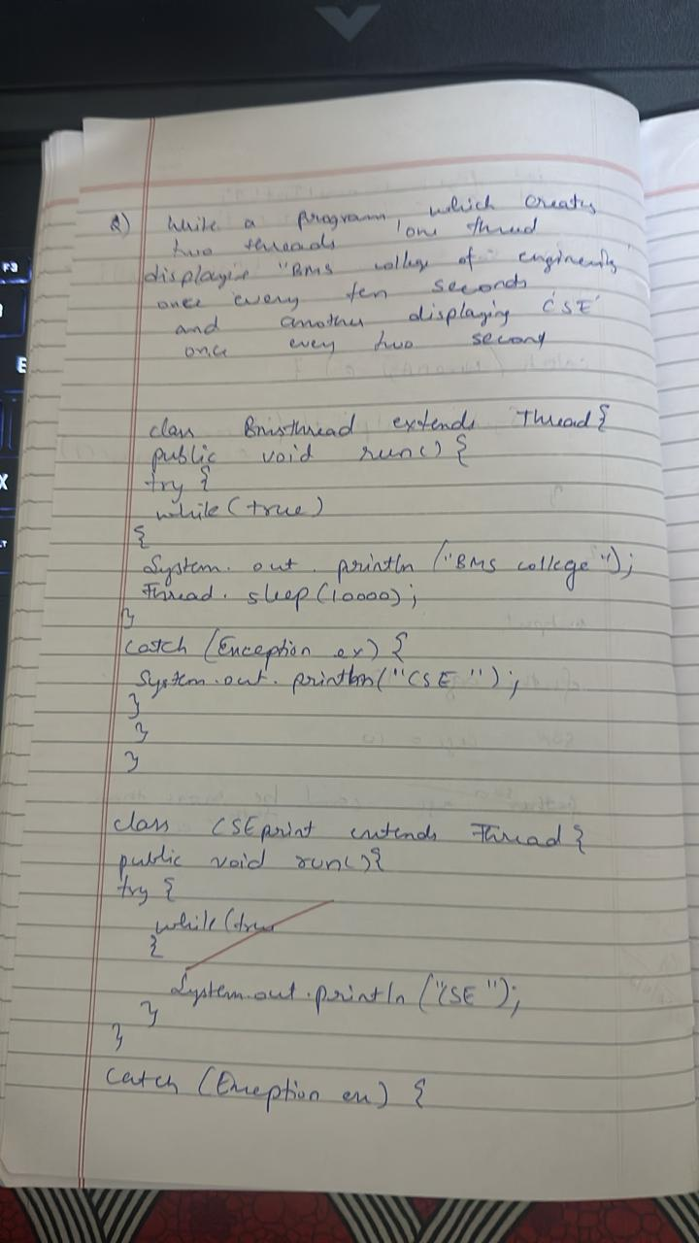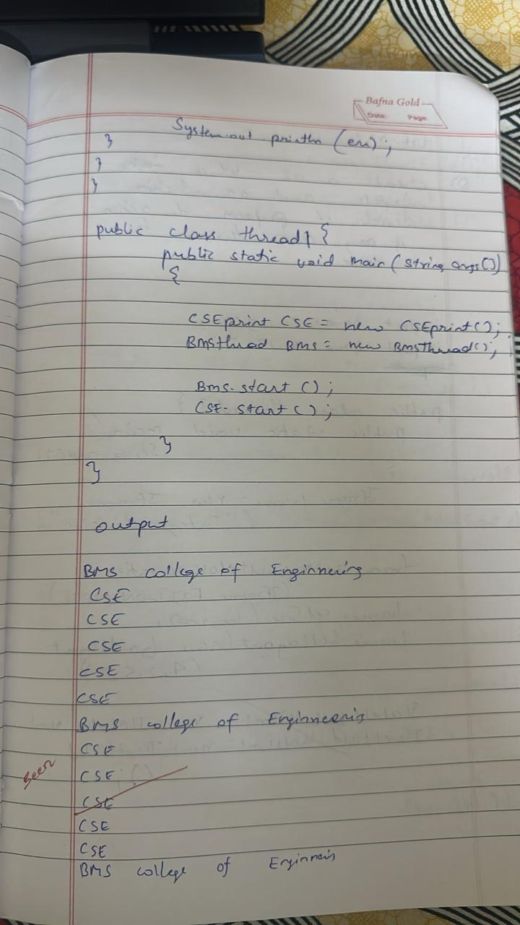

**Program 10**

Code:

import javax.swing.*;

import java.awt.*;

import java.awt.event.*;

class SwingDemo {

    SwingDemo() {

        JFrame jfrm = new JFrame("Divider App");

        jfrm.setSize(275, 150);

        jfrm.setLayout(new FlowLayout());

        jfrm.setDefaultCloseOperation(JFrame.EXIT_ON_CLOSE);

        JLabel jlab = new JLabel("Enter the dividend and divisor:");

        JTextField ajtf = new JTextField(8);

        JTextField bjtf = new JTextField(8);

        JButton button = new JButton("Calculate");

        JLabel err = new JLabel();

        JLabel alab = new JLabel();

        JLabel blab = new JLabel();

        JLabel anslab = new JLabel();

        jfrm.add(err);

        jfrm.add(jlab);

        jfrm.add(ajtf);

        jfrm.add(bjtf);

        jfrm.add(button);

        jfrm.add(alab);

        jfrm.add(blab);

        jfrm.add(anslab);

        button.addActionListener(new ActionListener() {

            public void actionPerformed(ActionEvent evt) {

                try {

                    int a = Integer.parseInt(ajtf.getText());

                    int b = Integer.parseInt(bjtf.getText());

                    int ans = a / b;

                    alab.setText("A = " + a);

                    blab.setText("B = " + b);

                    anslab.setText("Ans = " + ans);

                    err.setText("");

                } catch (NumberFormatException e) {

                    alab.setText("");

                    blab.setText("");

                    anslab.setText("");

                    err.setText("Enter Only Integers!");

                } catch (ArithmeticException e) {

                    alab.setText("");

                    blab.setText("");

                    anslab.setText("");

                    err.setText("B should be NON zero!");

                }

            }

        });

        jfrm.setVisible(true);

    }

    public static void main(String args[]) {

        System.out.println("D A CHETHAN, 1BM23CS083") ;

        SwingUtilities.invokeLater(new Runnable() {

            public void run() {

                new SwingDemo();

            }

        });

    }

}



