✅ Why the Olist dataset is an excellent choice
You accidentally found a gold-standard learning dataset for Data Engineering:
What makes it ideal
- ✔ Real-world complexity (but still manageable)
- ✔ Multiple tables → perfect for joins, transformations, modeling
- ✔ Time-based data → great for incremental loads
- ✔ Business meaning (sales, customers, products, campaigns)
- ✔ Widely used in industry & interviews
This is way more realistic than toy CSVs.
Step 1: Dataset:

1️⃣ SALES — Azure SQL Database
Core transactional data , Use these tables:
Table | Why
orders | Order lifecycle, dates, status
order_items | Sales amount, quantity
payments | Payment value & type
💡 This simulates a production OLTP database perfectly.
📍 Where it lives
- Azure SQL Database
- Linked Service: LS_AZURE_SQL_SALES

2️⃣ CUSTOMERS — REST API (Simulated)
Olist already has customers — BUT for learning purposes, this is actually better:

Option A (recommended for learning)
- Load customers table
- Expose it via:
  - Azure Function or
  - Mock REST (JSON export)
- Consume it as REST source
Fields to extract:
- customer_id
- customer_unique_id
- city
- state
- zip_code
📍 Where it lives
- REST endpoint (simulated)
- Linked Service: LS_REST_CUSTOMERS
💡 This is very realistic — many companies expose internal DBs as APIs.

3️⃣ PRODUCTS — CSV (Blob Storage)
Use these tables:
Table | Why
products | Product attributes
category_translation | Enrichment (EN categories)
Store them as:
- CSV or Parquet
- In Azure Blob Storage
📍 Where it lives
- ADLS GEN2
- Linked Service: LS_BLOB_PRODUCTS

4️⃣ CAMPAIGNS — CSV (Blob Storage)
Olist doesn’t directly give “campaigns”, but this is actually a feature, not a problem.
You have 2 clean options:

Option A (Best for learning)
Create a synthetic campaigns table:
- campaign_id
- campaign_name
- start_date
- end_date
- product_category
- discount_pct
Why this is great:
- In real life, marketing data is external
- You practice business logic joins
📍 Where it lives
- ADLS GEN2
- Linked Service: LS_BLOB_CAMPAIGNS
- 🧠 Final architecture (clean & realistic)
- Sources
│
├── Azure SQL DB (Sales)
│ ├ orders
│ ├ order_items
│ └ payments
│
├── REST API (Customers)
│
├── ADLS GEN2 (Products CSV)
│
└── ADLS GEN2 (Campaigns CSV)
Built an end-to-end Azure data platform using real e-commerce data, integrating SQL, REST APIs, and ADLS gen2 , applying Medallion Architecture, and delivering business-ready Gold tables.
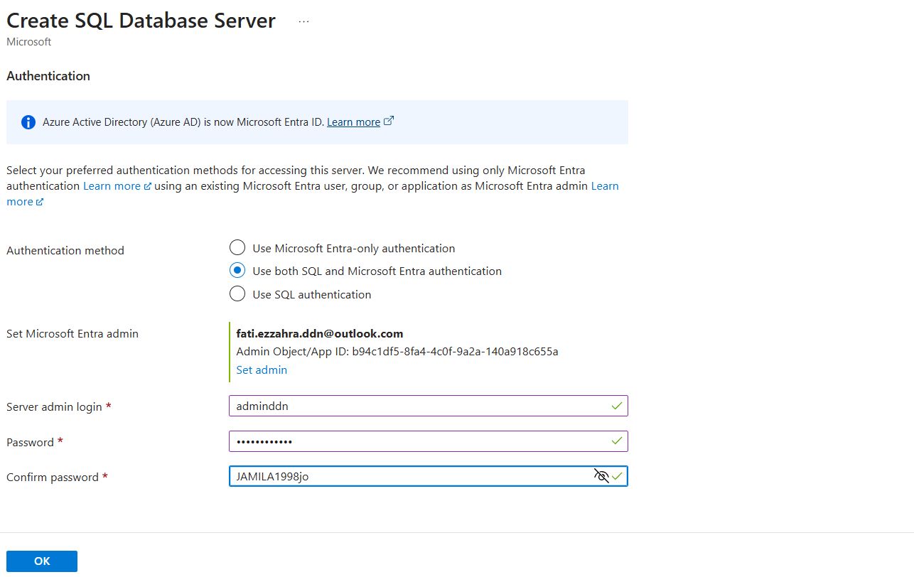
👉 ALL ingested using Synapse Pipelines
2️⃣ ADLS GEN2 – CONTAINERS (VERY IMPORTANT)
You create ONE Storage Account, with 4 containers:
adls-retail-prod
├── landing (optional – raw files exactly as received)
├── bronze (raw but structured)
├── silver (clean & conformed)
└── gold (business-ready)
⚠️ Yes → 4 containers
⚠️ Not 10, not 1
This is industry standard.

3️⃣ BRONZE LAYER (INGESTION)
What happens here?
- NO transformation
- NO joins
- NO business logic
How?
👉 Synapse Pipelines (Copy Activity)
Example pipeline:
PL_INGEST_ALL_SOURCES
Activities:
- Copy_AzureSQL_to_Bronze
- Copy_API_to_Bronze
- Copy_SFTP_to_Bronze
📁 Folder structure:
bronze/
├── sales/
│ └── ingest_date=2026-02-27/
├── customers/
├── products/
├── campaigns/
Format:
- Parquet (preferred)
- JSON allowed
✅ Data lineage preserved
✅ Replay possible

4️⃣ SILVER LAYER (TRANSFORMATION – CORE DATA ENGINEERING)
Tool used:
👉 Synapse Spark Pool (PySpark notebooks)
Notebook examples:
NB_SILVER_SALES
NB_SILVER_CUSTOMERS
NB_SILVER_PRODUCTS
What happens here?
- Schema enforcement
- Deduplication
- Type casting
- CDC handling
- Data quality rules
Example:
df = df.dropDuplicates(["order_id"])
df = df.filter("order_status IS NOT NULL")
📁 Output:
silver/
├── sales/
├── customers/
├── products/
Format:
- Parquet or Delta
⚠️ Silver = clean, but NOT aggregated

5️⃣ GOLD LAYER (DATA WAREHOUSE – STAR SCHEMA)
WHERE is Gold stored?
Two options (real companies use both):
Option | Usage
ADLS Gold | For ML / Spark
Dedicated SQL Pool | For BI
We’ll do Dedicated SQL Pool (classic DE role).

6️⃣ DATA MODELING (THIS IS WHAT INTERVIEWERS LOVE)
⭐ FACT TABLES (3–5 max)
FactSales
FactReturns
FactWebTraffic
Example:
FactSales
- order_id
- customer_key
- product_key
- date_key
- quantity
- revenue

⭐ DIMENSION TABLES (6–8)
DimCustomer
DimProduct
DimDate
DimStore
DimCampaign
DimGeography
✔ Surrogate keys
✔ Slowly Changing Dimension Type 2 (customers)

7️⃣ HOW DATA FLOWS TO GOLD (VERY IMPORTANT)
Step 1 – Spark prepares Gold-ready data
Notebook:
NB_GOLD_FACT_SALES
- Joins Silver tables
- Generates surrogate keys
- Writes to staging tables

Step 2 – Load into Dedicated SQL Pool
Method:
- COPY INTO
- PolyBase
- Or Spark JDBC write
Tables created ONLY in SQL Pool:
CREATE TABLE FactSales (...)
CREATE TABLE DimCustomer (...)
👉 This is your Data Warehouse

8️⃣ ORCHESTRATION (END-TO-END PIPELINE)
Pipeline:
PL_DAILY_ETL
Flow:
Copy → Bronze
↓
Spark → Silver
↓
Spark → Gold prep
↓
Load → SQL Pool
Triggers:
- Daily at 01:00
- Or event-based

9️⃣ CI/CD (REAL ENTERPRISE SETUP)
Inside Synapse:
- Enable Git
- Develop in dev
- Publish → ARM templates
Pipeline:
Dev → Test → Prod
Artifacts deployed:
- Pipelines
- Notebooks
- SQL scripts
- Linked services (parameterized)
⚠️ This is hard → that’s why courses skip it
But this is what senior DEs do.

🔟 CONSUMPTION (BUSINESS)
- Power BI connects to:
  - Dedicated SQL Pool
- DirectQuery or Import
- Semantic model on Gold

🎯 NUMBERS YOU ASKED FOR (EXACT ANSWERS)
Item | Count
ADLS containers | 4
Pipelines | 5–10
Spark notebooks | 10–15
Fact tables | 3–5
Dimension tables | 6–8
SQL Pools | 1 Dedicated
Environments | Dev / Test / Prod

🧠 WHY THIS PROJECT IS PERFECT FOR YOU
- 100% Synapse
- Medallion architecture
- Real enterprise patterns
- Interview-ready
- Matches DP-203 + real job expectations

