**DESIGN THIS FOR DOUBLE THE POWER FOR PROTECTION OF THE PSU ITSELF!!!!!!!!!** (Or at least to 1.5x the maximum wanted power.)

Marker colors on the document:

* Red – to do, very important
* Yellow – to do, less important or on hold
* Green – done

# Power supply to do list

* DC power supply
* 0-35 V (or 30 V at minimum)
* 0-2.5 A, but design for 4 A (except the fuse and current limiting)
* Minimum efficiency of 60%, but the more the better. Try to make it as efficient as possible.
* Protection fuse
* Short-circuit protection for at most 1 A (the less the better, but that at most)
* Maximum current limiting in normal functioning (the current range above)
* Output voltage ripple at most 5% of the output voltage, but ideally 1-2%, or better yet, less than 1%. "For a 5 vdc supply 50mv ripple is an acceptable figure." (Quora). I saw on another answer that for CPU voltages, 1% at mega most, and inferior would be ideal, and I saw too that DC-DC PSUs have 1% of ripple. Check this for various loads.
* The supply must be fast enough to change the current to keep the voltage in case the load changes quickly. | Needs physical testing
* Check what happens in case there’s component failure 🡪 the load must remain safe!
* Implement some sort of oscillations detector to know if the ripple is too big on the output – do it with an Arduino checking the voltage at all times
* Implement a crowbar circuit: shorts the supply line (after the fuse) in case there is some surge in voltage and so protects the rest of the circuit from overvoltage/surges.
* Implement reverse polarity protection on the output
* Overvoltage protection: imagine one or more power diodes gets shorted 🡪 full voltage will appear on the output. As mega soon as that happens the relay must immediately cut the power. Is it…? The regulator still tries to regulate… Think about it.

# Unregulated module

This module is the full-wave rectifier with smoothing capacitor to result in an unregulated DC power supply.

We have 24 VAC max. at the input, which means 34 V pk-pk. The transformer will also have to be 0-12-24 VAC to be possible to switch voltages and, therefore, reduce the power consumption of the power supply. See on Transformer the one chosen (since we need its maximum electrical ratings to know which components to choose).

Thus, a bridge rectifier will be used, and in this case, the full-wave version for more efficacy. Each diode will have to withstand, in this case, 35 V minimum. As it’s good practice to go get at least 50% above of the value, then at minimum we have 42.5 V.

The maximum current of the power supply will be 3 A for both windings (100 VA / 24 VAC = 100/34 = 2.95. 50 VA / 12 VAC = 50 / 17 = 2.95), as per the transformer maximum ratings. But as we’re designing for 4 A, 4+4/2 = 6 A minimum maximum current rating for all power components.

## Fuse

The PSU will have to be able to work with stable 2.95 A max, so 3.15 A should be a good idea. And a slow fuse, for spikes in current not to blow it (shouldn’t be bad either if they happen).

## Transformer

This one seems like a good candidate: <https://adajusa.pt/pt/transformadores-em-fase-unica/12486-transformador-100va-e-230-s-12-24v-ip-00-8445340124863.html>.

* 230 VAC – 0-12-24 VAC
* 100 VA
* 4.17 A RMS

Those voltages translate to 0-17-34 VDC (which is what matters here).

The maximum current after rectification is 50/17 = 2.95 A and 100/34 = 2.95 A (the power gets divided by 2 on each winding. In series it’s 100 VA, but each one is 50 VA).

## Rectifier diodes

Checking, for example, the datasheet of the power diode SR5100 (just to have one as a reference of the values to pay attention to), we see we must pay attention to the following maximum values, being the project values in parenthesis:

* Peak Repetitive Reverse Voltage (34 V)
* Working Peak Reverse Voltage (34 V)
* DC Blocking Voltage (34 V)
* RMS Reverse Voltage (24 V)
* Average Rectifier Forward Current (6 A)
* Non-Repetitive Peak Surge Current (see below)
* Operating and Storage Junction Temperature Range (to be calculated – hint, it’s related to the power dissipated on the cooler and fans of the PSU box, and there are also specifications of ºC/W dissipated on coolers, so that can help knowing the temperature)

Above, we have the Non-Repetitive Peak Surge Current, which we don’t have a value for. There is, however, a formula for that, just below. This is the version for the full-wave rectifier, as that’s the worst case. Formula:

, having assumed Vr = 3 V, just because I’d like to get the PSU to 30 V, so the least ripple the better (knowing it goes at most to 34 V).

So, at most 124 A (theoretically) will be put through the power diodes.

If possible, I’ll get Schottky-barrier diodes (SBDs), because of their 0.2-0.3 V drop, compared to the normal 0.7 V drop – more efficient.

YOU ASSUMED WRONG!!!! SHOULD HAVE CHECKED WITH THE DIODES YOU WERE BUYING!!!!! NTC RESISTOR IS ***MANDATORY***!!!!! THE MAXIMUM OF THE DIODES YOU BOUGHT IS 150 A!!!!!!!!!!

## Capacitor

The formula to calculate its value is:



Supposedly I’d calculate the value for the worst case, which is when one of the bridge branches breaks down (half the frequency). Though, to make this as cheap as possible (and as better functioning as I can, though never ignoring maximum component ratings – this here would just be a just commodity to have it fully functioning with only one branch working), I’ll go for the full-wave case:



Though on Ltspice with 30 V on the output, 13 mF are not enough and so I decided to go to 45 mF.

As I’m calculating for the full-wave case, if one of the branches goes down, a warning must be issued. So I’ll think of some LEDs to do it somehow.

One must also pay attention to the maximum surge current that capacitors can handle. To help reducing it, I will consider using a NTC thermistor, which decreases its resistance with increasing temperature (meaning it will become a short-circuit moments after current passes through it, which warms it up, and hence reduces the peak current through the capacitor).

See how to do this above, and then correct the diode ratings when the current is lowered. Also pay attention that this dissipates near 0.3 * 4^2 = 5 W… Think on something else, or go ahead…

## Automatic relay winding switch

If the PSU has the transformer at its maximum at all times and it’s requested 5 V / 4 A at the output, the power transistor will have to take 25 V of drop, which will result in 25 * 5 = 125 W of dissipated power (wtf).

To reduce the power consumption, something I thought on is that one could use a transformer with multiple windings (which seems is actually used in linear PSUs) and use a rellay to choose which winding to use.

For this, I’ve thought on a little switch circuit that compares the output voltage with a fixed voltage not too far from the 17 V.

### Circuit schematic

### Relays

The one on 12 VAC must be On by default, and the one on 24 VAC must be Off by default. This is because one must be conducting when the circuit starts from 0, while the other cannot not be conducting.

They must be able to carry at least 6 A minimum, use as little current to switch (so that I can ease my life with using an op-amp to provide the current), and at most need 10 V to switch (since from the op-amp, about 15 V will come out, and that will be compared to GND, so 10 V seems a good value not too close to the 15 V switching voltage).

Because when these things switch there’s “infinite” voltage generated due to the coil inside them, one must use a flyback diode so that the maximum voltage drop is low (VD, in this case). I’m not sure it’s really needed, but I don’t really like the idea of infinite voltage on a circuit that’s supposed to handle with 34 VDC max., so… flyback diode. Any diode should suffice, I believe. So will be any that I have in the components box.

### Op-amp

LM358, as suggested on Discord, as opposite to uA741 because seems to outperform the latter (can go to VSS, for example).

### Zener diode

The Zener diode must have a voltage near the primary winding voltage, so that when the output is near that voltage, it switches to the other winding. 15 V seems a good choice. Greater than 15 V will switch the output to the higher winding; less than that will switch back to the lower winding.

### Schmitt trigger

It can’t be as simple as described on the Zener diode section. Can’t just switch based on one voltage. What happens at exactly 15 V then? Or at 14.9-15.1 V? (noise) Instability will happen 🡪 one must use a Schmitt trigger. The formula for the width of the hysteresis is

VSS is 34 V. A good width seems to be around 1.5 V. That’s

So the upper winding will be activated when the voltage rises to 15+1.7=16.7 V, and the lower winding will be activated when the voltage lowers to 15-1.7=13.3 V.

# Regulator module

## Power transistor(s)

The maximum output current is 4 A. Therefore, we need a transistor capable rated for at least 1.5-2x 4 A which gives 6-8 A.

The maximum output voltage is 30 V. This way, we need a transistor capable of handling at least 45-60 V on VCE.

The maximum power on the transistor is , so a transistor capable of handling 180-240 W is needed.  
Or, since that’s “too infinite”, a few transistors in parallel with lower power ratings. This also means that resistors must be added in series with each transistor, all in parallel with each other, to normalize the currents going on each transistor or else one might conduct more than the others and heat up a lot more (components are never exactly equal).

We’re also going with a BJT:  
(From <https://www.eevblog.com/forum/beginners/bjt-vs-mosfet-for-linear-power-supply-output/msg812441/?PHPSESSID=5jcesoeqncrh9mfehrlvegabaq#msg812441>)

I was also told the TO247 is a good package to use.

So I chose the TIP142. And I chose to use 4 of them. That gives 45 W dissipated on each.

## Reference voltage

Initially a Zener was going to be used, but as pointed out to me on Discord, there can be drifts in the Zener voltage depending on the ripple from the unregulated part of the PSU.

So, instead of using a Zener diode, I decided to use the LMV431CZ programmed to output between 1.24 and 30 V with a potentiometer (its recommended range of operation) which is also the minimum and maximum voltages of the PSU.

## Comparator op amp

The op amp must withstand the unregulated supply’s voltage and must output enough current to the power transistors.

Therefore, we need one capable of handling 34 V. The output current from the op amp is the necessary one to make the power transistors output the chosen current. The maximum current is 4 A, so dividing that by the gain of the TIP142 which is very high and I’ll assume 100 (the datasheets say 500-1000 min but that’s with VCE = 4 V, and I don’t know what happens with higher VCE) gives 4/100 = 40 mA – this is the current on the base of the transistors needed.

So, an op amp with current output of 40 mA is needed. I chose the LM6171 which has a maximum output current of 135 mA and maximum VS of 36 V.

## Output voltage divider

*For 1.24 V*

*For 30 V*

*Joining the 2 equations*

With the chosen potentiometer being of 20 kOhm, R11 = 1780 Ohm.

## Current protections

There are at least 2 types of protections: constant current limiting and foldback protection.



The foldback protection is the green one; the constant current limiting is the blue one; the red one is no protection at all.

We could use the foldback one, and initially I was going to use it, but aside from it progressively limiting the circuit current, the short-circuit protection is not complete: with 4 A max, LTspice said 2.8 A would be the short-circuit protection current – not cool. Also, the resistor it requires has a higher value than the constant current limiting protection one, so it steals less voltage from the output (4 V vs 0.9 V after testing on LTspice).

So I tried to think on a solution and arrived at:

There’s the short-circuit protection and the adjustable current limiting one (idea taken from <https://freecircuitdiagram.com/215-variable-adjustable-current-limiter-circuit/>). The first protects when the output is shorted; the second protects whenever the output current tries to go above 2.5 A when on overload.

### Overload protection

The OC protection works by comparing the voltage on R16 and activating Q6 whenever it goes above 0.66 V (the necessary to activate the transistor), again stealing whatever current is necessary to keep the current on 2.5 A at most OR whatever we choose as the maximum – because it can be chosen with RPot1.  
I didn’t want to bother making the calculations, so instead I went by trial and error until the maximum was 2.5 A. Keeping RPot1 at 1 kOhm that resulted in R17 being of 1 kOhm. I also set R16 to be 1 Ohm. The minimum current to limit is given by:

Power rating needed for R16:

So we need at least 24-32 W for R16.

### Short-circuit and general protection

The SC protection works by comparing output voltage to a fraction of the reference voltage.

The relay is by default connected to GND and needs power to connect to Vunreg. The op amp is mounted in the inverting configuration, so it’s by default On and on max current, setting the relay to Vunreg as long as the op amp is working. In case of failure of power to the op amp, it will stop conducting and the relay will protect the load (SC and general protection).

Whenever OUT is lower than Vref/something chosen with a potentiometer (if it’s below the requested it’s an overload and can be allowed (potentiometer), or if it’s very much below it’s a short (which can also be allowed for certain cases, again with the potentiometer)), the op amp will get disabled and will disable the relay and it’ll connect again to GND.

There’s also a pull-up capacitor C5 to push the signal to HIGH on the first run (adds some delay but should be fine. It’s a very small delay). After that, the capacitor will be full and won’t do anything anymore – good, because it’s just there for the first run. This is useful because the circuit begins at 0 V everywhere and in case Vref rises faster than OUT, the SCP will get triggered, right at the beginning which is not too useful. The capacitor overrides whatever output the op amp has and forces the output to be activated. After some small period of time (10 ms according to LTspice) it’ll be full and will have no effect anymore, leaving the output to the comparison between Vref and OUT.

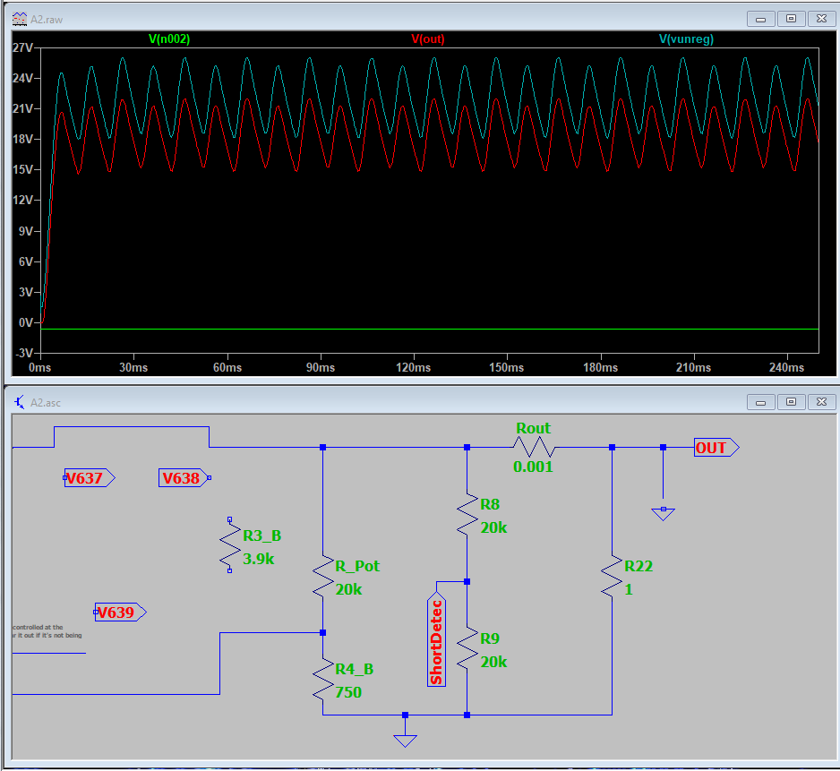

PUT THE LMV431 NEAR THE POWER TRANSISTOR!!!!!

One of the graphs in the datasheet says that the reference current gets lower as temperature increases 🡪 the power transistor is the hottest thing in there.

EDIT: do NOT do this. Vref changes with temperature, so if the PSU is being put at max, it will be hotter inside. Else, will be cooler. Get it as away from heat sources as possible (even if it has to be outside the board or something, connected with wires (or maybe not because of parasitic inductance on the wires and with such small currents that could affect stuff?).

ZKA won’t change. The cathode voltage won’t change because it’s connected to the reference, which also won’t change because the temperature supposedly won’t change (too much? Hopefully at all). The current won’t change either, because this thing is connected to an op-amp, which requires almost no current, and almost or no current changes at all. So none will change, and therefore ZKA won’t change either.

The LM358 has 2.5-5 pF of input capacitance, so from the picture below, the chip will be perfectly stable (0 F almost, meaning no capacitive load – 2nd picture below).

READ THE LAYOUT GUIDELINES OF THE LM358 IN THE DATASHEET!!!!!

Example of guideline:



CHECK WHICH OP-AMP YOU BOUGHT!!!!!!!!!!

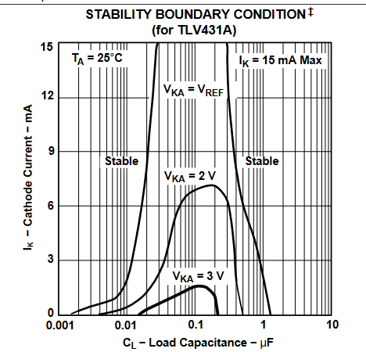

As the LMV431 is functionally equivalent to the TLV431, and the TLV431 datasheet is more complete, I’ve used TLV431 datasheet and its application notes PDF.

See about emitter degeneration technique in BJTs.

Various in parallel for less “You have to keep in mind that semiconductor devices tend to obey the general Arrhenius law, meaning a failure rate ~doubling for every 10°K (or C) increase.”?

<https://www.electronics-tutorial.net/analog-integrated-circuits/schmitt-trigger/non-inverting-schmitt-trigger/>

In the end, check <https://www.instructables.com/10Amp-Linear-Power-Supply/> and see everything he thought of that you didn’t.