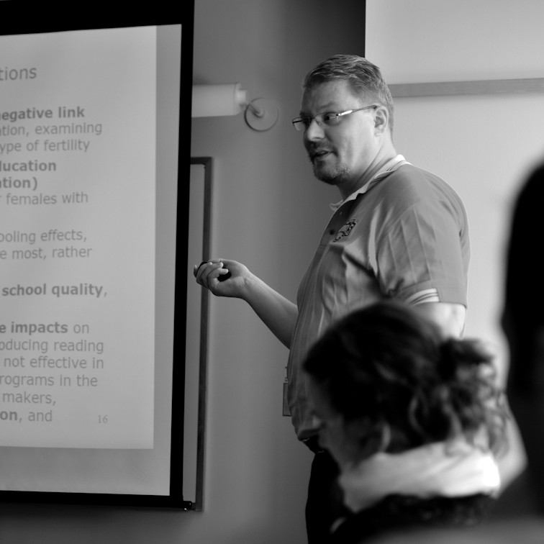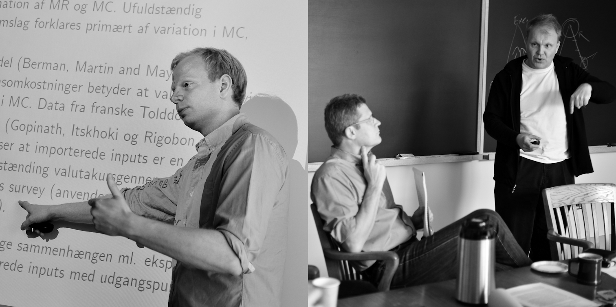

**Danish Academic Economists in North America**

# DAEiNA Meeting 2023

Enclosed is the **conference program for** the 10th annual meeting of Danish Academic Economists in North America (DAEiNA), which will be held on **May 27, 2023** at **Aarhus University in Aarhus, Denmark**.

Participation is open to anyone who has (i) a connection to Denmark and (ii) a past, present, or future interest in doing economic research in North America. To sign up to attend, please register at [https://events.au.dk/daeina2023/registration](https://aarhusbss.conferencemanager.dk/?eventcode=econ) before May 1, 2023.

All meals and activities are paid for by DNRF and AUFF, except the pre-conference dinner on May 26. We are only able to provide funds for lodging to external PhD students this year.

We are looking forward to seeing you in Aarhus.

For more information regarding DAEiNA and our activities, visit our website at  
http:// [www.daeina.net.](http://www.daeina.net/)

**Regards from the DAEiNA Board**

**Torben G. Andersen**, Professor, Kellogg School, Northwestern University

**Mikkel Sølvsten**, Associate Professor, Aarhus University

**Ole Agersnap**, PhD Student, Princeton University

**Morten Ø. Nielsen**, Professor, Aarhus University



**Danish Academic Economists in North America**

**2023 Meeting Program**

(All presentations are 35 mins plus 5 mins discussion)

|  |  |
| --- | --- |
| **Fri, May 26**  **18.00-** | **Networking and dinner** @ Den Rustikke, Mejlgade 20, 8000 Aarhus C |
| **Sat, May 27** |  |
| **09:00-9:45** | **Breakfast, coffee, and arrival**, Fuglesangs Allé 4, Building 2632(L), room 242 |
| **09:45-10.00** | **Welcome address and organizational meeting** |
| **10:00-12:00** | **1st session (chair: Mikkel Sølvsten, Aarhus University)** |
|  | Mikkel Houmark, Aarhus University  *First Among Equals? How Birth Order Shapes Child Development*  Marie Pietraszek, University of Copenhagen  *TBD*  Rasmus Lentz, University of Wisconsin-Madison  *The Anatomy of Sorting - Evidence from Danish Data* |
| **12:00-13:00** | **Lunch** |
| **13:00-15:00** | **2nd session (chair: Bo E. Honoré, Princeton University)** |
|  | Sebastian Roelsgaard, Princeton University  *The Fragility of Sparsity*  Asbjørn Kaufmann, Aarhus University  *Semiparametric Efficiency for Sharp Bounds under Sample Selection*  Jesper Riis-Vestergaard Sørensen, University of Copenhagen  *TBD* |
| **15:00-15:30** | **Coffee break** |
| **15:30-17:30** | **3rd session (chair: Morten Ø. Nielsen, Aarhus University)** |
|  | Frederik Almar, Aarhus University  *Marital Sorting and Inequality: How Educational Categorization Matters*  Ole Agersnap, Princeton University  *TBD*  Marie-Louise Vierø, Aarhus University  *Lost in objective translation: Awareness of unawareness when unknowns are not simply unknowns* |
| **17.30-18.30** | **Break and walk through the Botanical Garden** |
| **18.30-** | **Dinner** @ Restaurant Malt, Bryggerboligen, Ceresbyen 64 |