**Installing Wazuh Agent**

**Prepared by**: Avelino Dahotoy III

**Date**: June 04, 2024

## **Executive Summary**

This document guides IT Specialist in installing the Wazuh Agent for Windows device. Wazuh is an SIEM/XDR tool used to protect organization from security threats.

**Wazuh Agent Deployment:**

Below is a step-by-step guide in installation a Wazuh Agent to an endpoint device.

1. Login to the Wazuh dashboard.
2. Click the arrow down button at the side of Wazuh logo to show the menu.
3. Select the **Agent** option.

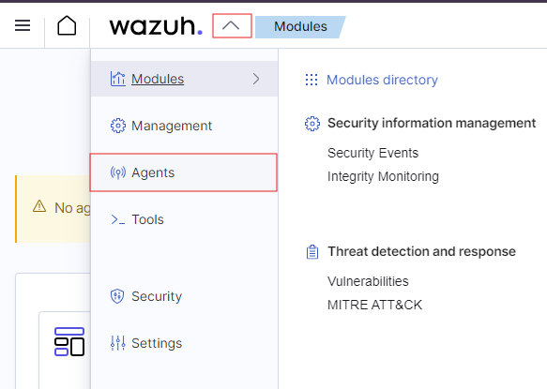

1. Select the system you want to install the agent to.

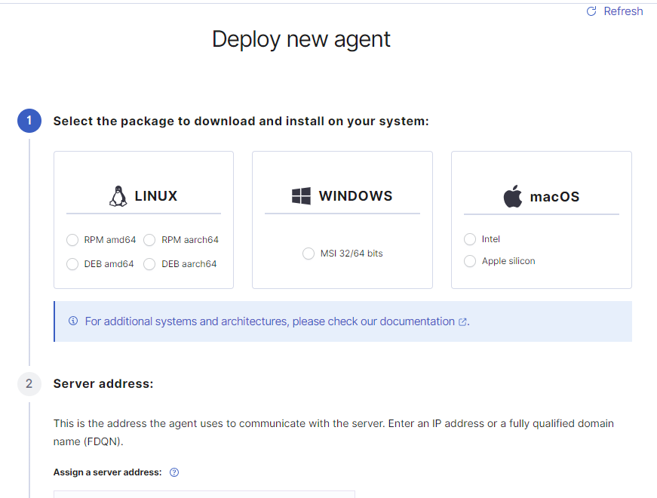

1. Enter the server address in the SERVER ADDRESS field.

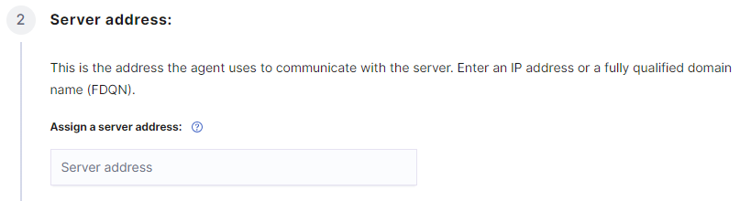

*NOTE: You may enter either the IP address or the domain name of the Wazuh server*.

1. Agent Name Configuration**:** While it is labeled as optional, it is recommended that you provide an **agent name** for identification purposes on the Wazuh server. Follow the specified format for the agentUse the agent name format:

* Format: <username-sytem-devicetype- serialnumber >
* Sample: third-windows-laptop-FW200026

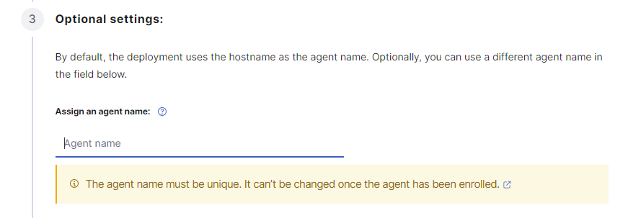

1. A command is automatically generated out of the information to install the wazuh agent using a terminal.

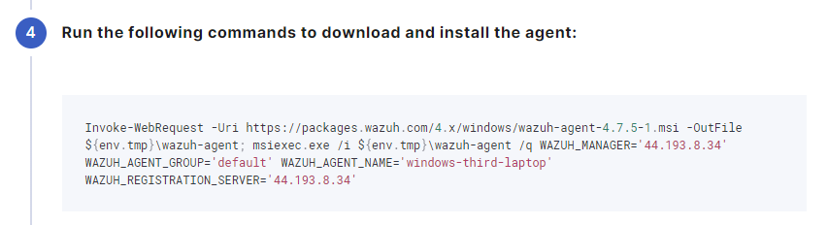

1. Copy this command and then open a **Powershell** terminal for windows or **Shell Bash** for macOS.

**NOTE**: You need to have administrator privileges to run this command successfully.

1. Once you successfully installed the agent, you now need to start the Wazuh Service.

**FOR WINDOWS**: NET START WazuhSvc

**FOR macOS**: sudo /Library/Ossec/bin/wazuh-control start