SE& DevOps: Intro to Git & GitHub

This Lab will introduce the basics of Git and GitHub along with the specific software tools that you will use in this Module. Follow this Lab carefully as the successful use of these tools will be paramount to your success in this module.

Getting Started
In this Lab, you will learn how to use Git and GitHub which are the most popular and widely used Version Control tools available. If you do not currently have a GitHub account, sign up via the link below. If you already have an account, you can use your personal account for this module.
https://github.com/join

Important Information
This Lab documents will contain commands that you should run in the bash terminal. This code will be provided in boxes as shown below:
This is a sample command that fits on one line

This is a much longer sample command that covers multiple lines but should still be copied as a single command

As you can see, some commands will be short and clearly displayed on a single line. This can be copied directly into the Terminal. Other commands, such as the second one, are much longer and do not fit on one line. If you are going to copy and paste these commands make sure to copy all lines and paste as a single command. Each new command is separated by a blank line so that each command is clearly distinguished.
If you are unfamiliar with using the Terminal or Bash it is highly recommended that you complete the following Tutorial:
https://ubuntu.com/tutorials/command-line-for-beginners
This tutorial is written for Ubuntu but as the Terminal we are using (GitBash for Windows or Terminal for MacOS/Linux) also uses Bash, the commands are the same and the tutorial is very relevant. The Virtual Machines you create on AWS will utilise the Ubuntu Operating system and therefore this tutorial will also be useful when interacting with your VMS.

The following Cheat Sheet is also helpful for remembering Bash commands and will be a good point of reference throughout this Module:
https://cheatography.com/davechild/cheat-sheets/linux-command-line/pdf/

Git Basics
For this Lab you will need an AWS EC2 Instance to work on.
- Using the guidance in Lab 1, create a new Instance with the Name ‘Lab 2 Instance’ and connect to it using GitBash.

Ensure you are connected to an EC2 Instance before continuing.

- First, make sure that Git is installed (it should be by default) using the following command:
git --version

The result should be similar to:
git version 2.43.0
But do not worry if the version number is not exact. If you see a message indicating that Git is not installed, it can be installed manually using the following command:
sudo apt-get install git -y

OR use this command
sudo yum install git -y

IMPORTANT NOTE: Please remember that if you are copying/pasting commands containing ‘…’ or “…” that you check these symbols in the terminal. You may have to manually replace them if they cause errors. Sometimes these characters are represented differently by MSWord which results in the Terminal not understanding them.
- Now you can configure Git to use your GitHub credentials using the following commands, replacing the word USERNAME and EMAIL with the details you used when creating your Git account (note the “ ” in the first command but not the second). The final command allows you to check that the first two worked correctly so double check the return information.
git config --global user.name “USERNAME”

git config --global user.email EMAIL

git config --global -l

Git and GitHub Authentication
- Open an internet browser and go to your GitHub account.
Before we can use GitHub with our AWS Instance we have to set up a form of authentication between the Instance and the GitHub website. To do this you will make use of SSH keys which provides authentication in the same way you authenticate your connection to the AWS Instance.
Rather than using a .pem file containing the key, we will generate a new pair of SSH keys directly on the Instance.
The following commands should be run on the AWS Instance.
- First, generate a pair of SSH keys using the command below. You will be prompted for further information when you do this. Read each of the prompts but do not enter any text as we want to use the default option for each prompt. To select the default option simply press ENTER at each prompt to proceed.
ssh-keygen

Or you can type
ssh-keygen -t rsa

When you have completed the above step you should see something similar to the image below in your terminal
Keep pressing Enter on your keyboard until you see something similar to the image below which confirms that the process has been successful.
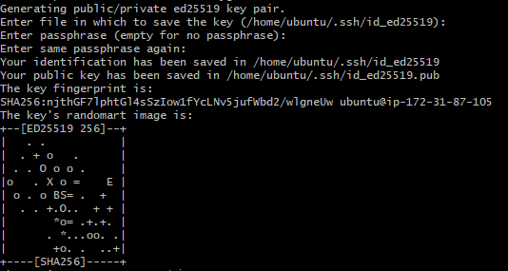
You can see from the image above (and your own terminal) that the Public Key has been stored in the location ‘/home/ubuntu/.ssh/id_******.pub’. SSH Keys always start with the phrase ssh- and end with USERNAME@HOSTNAME which in the case of your AWS Instance will be the same as you see at the start of your command prompt and will be similar to ec2-user@ ip-XXX-XXX-XXX-XXX or ubuntu@ip-XXX-XXX-XXX-XXX where the X indicate the Private IP address of your Instance.
- Use the cat command (which prints the contents of a file to the terminal) to view this Public Key and copy it (including the start and end sections mentioned above) to the box provided below. Note if the number in the filename is different for you then use it instead.
cat ~/.ssh/id_******.pub

My Public SSH Key

- Now log into the GitHub website, click on the Profile icon at the top right and select Settings from the drop-down menu.
- On the left of the Settings page select ‘SSH and GPG Keys’ and then click on the ‘New SSH Key’ button at the top of the screen.
- In the Title field enter something identifiable about the machine you generated the Key on such as ‘Lab 3 Instance’ as you may wish to link multiple devices/Instances later.
- Paste the SSH key from above into the Key field and klick ‘Add SSH Key.’ You may be asked to enter your GitHub password again at this point.

GitHub Basics
Now that you have configured authentication between your Instance and GitHub, we can use GitHub to host a Git repository to store our code and other files.

- Go to the GitHub website and view your repositories. Unless you have used GitHub previously, you should have zero repos at this time.
Click on the New Repository button and you will be taken to a form to complete. Fill out the form as shown below:
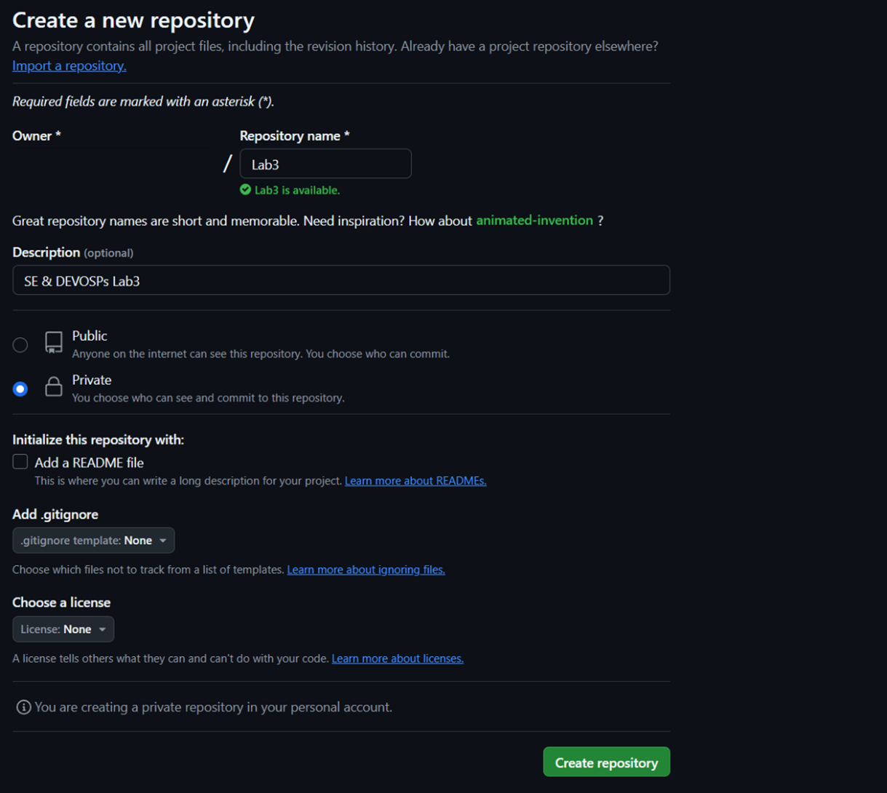
Note that the repository is set to private which means that only people you allow can access your code.
- Now click ‘Create repository’ to complete. When the repository is created you are taken to a new page which provides some good information for getting started.
Ensure that you select SSH and NOT HTTP at the top of this screen as shown below.
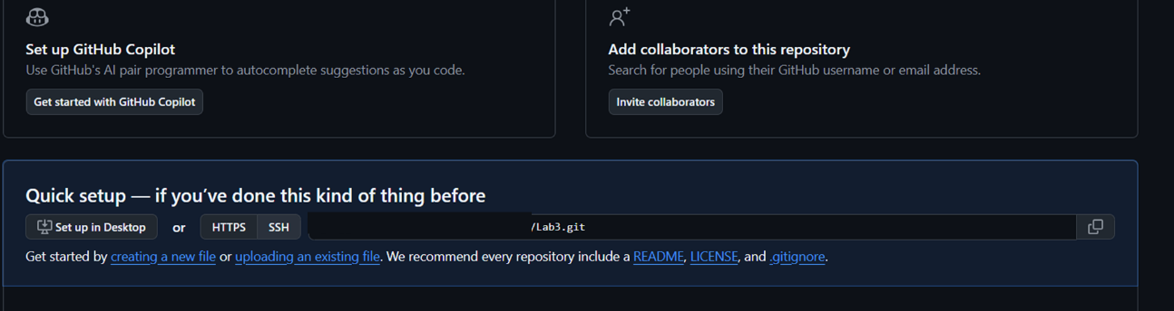

You now have an empty Git Repository on the GitHub website. Now we will see how we can use this as a repository for storing our code.
- Ensuring that you have selected SSH above, copy the link provided that points to your new Git Repository. Now head to your Terminal and run the commands below, replacing the sample link with the one you just copied.
git clone git@github.com:creator_username/Lab3.git

cd Lab3

- When you run the commands above you will see that Git clones the empty repository and creates a folder for this repository with the name you used in Step (a) above. The second command above navigates you into this folder so that you can begin using the repository.
- use the following command which will list all hidden files and directories:
ls -la

Here you will see a folder called “.git” which contains the settings for your repository. You don’t need to interact with this directory but it is helpful to check that it exists to ensure that you are inside a Git repo.
- Before you can do anything with your new repository you will need to create a new file to work with. Use the touch command as shown below to create an empty text file called Lab3.txt:
touch Lab3.txt

You should now be able to see this file in the current directory.
- You can now add this file to your Git repository:
git add Lab3.txt

- Now use the following command to see what Git has done:
git status

This is the staging area. Here you can see the changes you have told Git about. You should see the details on the new file you have just added in the terminal output. These changes are not saved yet and can be undone using the command indicated in the output of the above command.
- To save these changes you need to use the commit command as shown below:
git commit -m ‘initial commit’

Note that with each commit, you must provide a comment or it will be rejected. This is to ensure that your commits are traceable. If you check the staging area again (git status) you should see that it is now empty as your changes have been saved.
- You can see a full list of all of the commits to a repository using the log command:
git log

Here you can see the commit that you have made. Each commit has a unique ID and you can see when the commit was made and by whom. The comment is also provided which will allow you to find commits later as the commit ID is not very useful to humans.
This new file has been successfully committed to the local repository but still only exists on your machine. You can confirm this by going back to the GitHub website and refreshing the page. You will see that there is still no content here despite your commits above.
- in GitBash, edit the file using Nano:
nano Lab3.txt

- Add some text to the file and then save the changes (CTRL+O ENTER) and close it (CTRL+X).

- If you check the staging area (git status) you can see that Git is already aware of the changes you have made but they have not actually been added to the staging area yet as we have to do this manually. git
- Run each of the following commands and be sure to read the output of each so that you understand what is happening:
git add Lab3.txt

git status

git commit -m ‘add some text’

git status

git log

- Check the log (git log) and you should now see two commits to the repository. The second commit is still local at this time and will not appear on you GitHub page.

- Push the changes to the remote repository using the following command:
git push

- View your new document on your GitHub page to confirm that the push has been successful (you will need to refresh the page).

- Try adding some more text to your file and committing and pushing it to your remote repository. Practicing this process now will make the following labs easier for you.
Before proceeding to the next section of the lab, take some time to make, commit and push new changes and files to your github to ensure that you are familiar with the process.
Then use the command ‘cd ..’ to move out of this Git Repo folder before proceeding. At this stage, the pwd command should return /home/ubuntu

PLEASE REMEMBER TO STOP YOUR INSTANCE AT THE END OF THIS LAB SO THAT YOU DO NOT USE UNNECCESARY CREDIT!!

