# Assignment I: microscopic traffic flow modelling & dynamics

In the introductory lecture, we observed an [experiment carried out on a circular road](https://www.youtube.com/watch?v=Suugn-p5C1M). The experiment showed how congestion can arise not just because of road discontinuities (e.g. onramps, intersections, changes in slope, …), but simply due to driver heterogeneity.

In this assignment, you will try to answer the following question:

“Can microscopic simulation replicate the experimental results seen in real life? If so, how?”

You are therefore given a circular road network, not unlike the one from the real-life experiment:

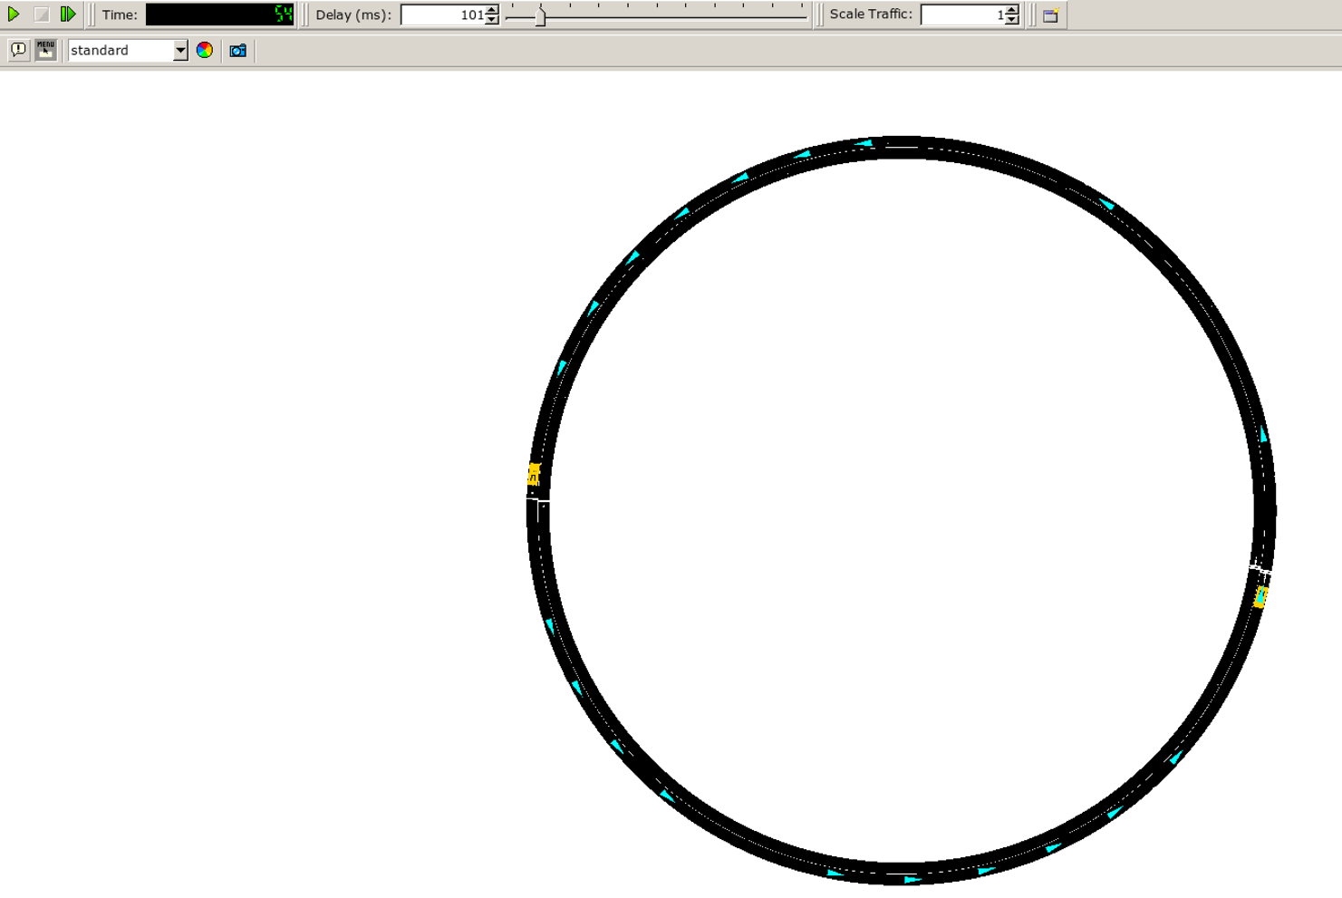

This simulated roadway has the following characteristics:

1. a speed limit of 50km/h
2. a total length of 628m

You will be able to interact with the simulation through a simple web interface, to be installed locally following the instructions in the ‘INSTALL.md’ file, included in this attachment.

Once installation is successful, you will be presented with the following interface:

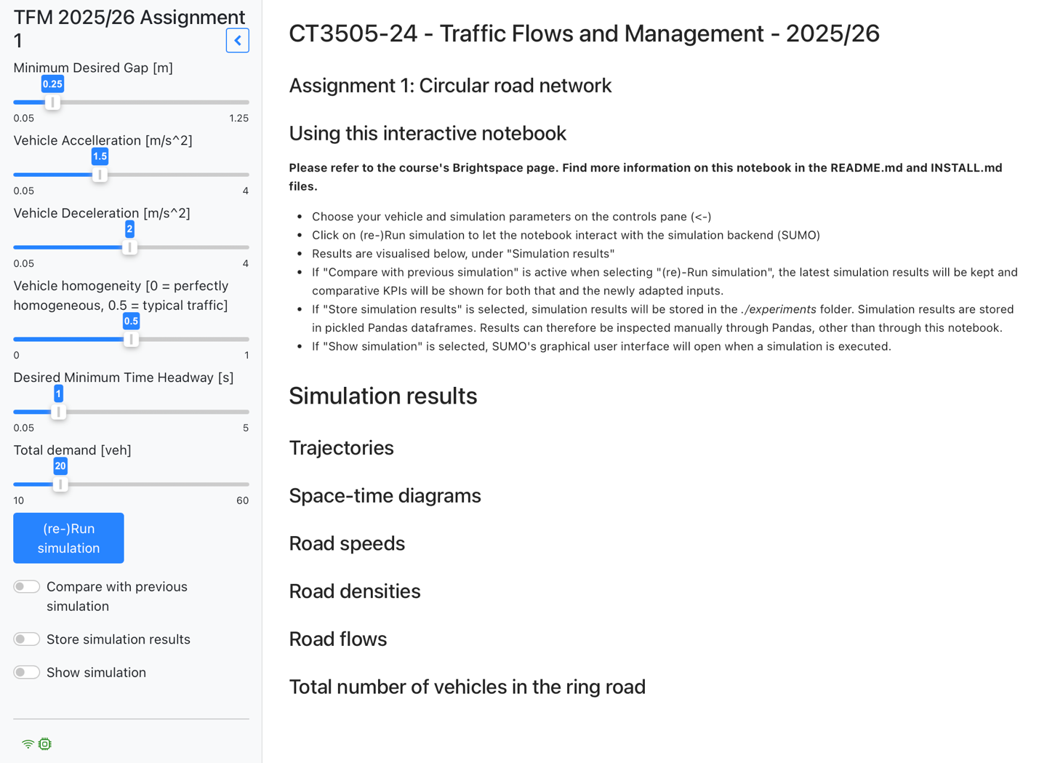

On the left-hand side, you see a few parameters, all related to the Krauß car following model, which we discussed in class. You can also change the total demand (i.e. the number of vehicles that would want to enter the network). You can change these parameters freely, and when clicking on the “Run simulation” button, the SUMO microscopic traffic simulator will run in the background, and provide you with results, as shown in the Figure below (more simulation outputs are not visible here).

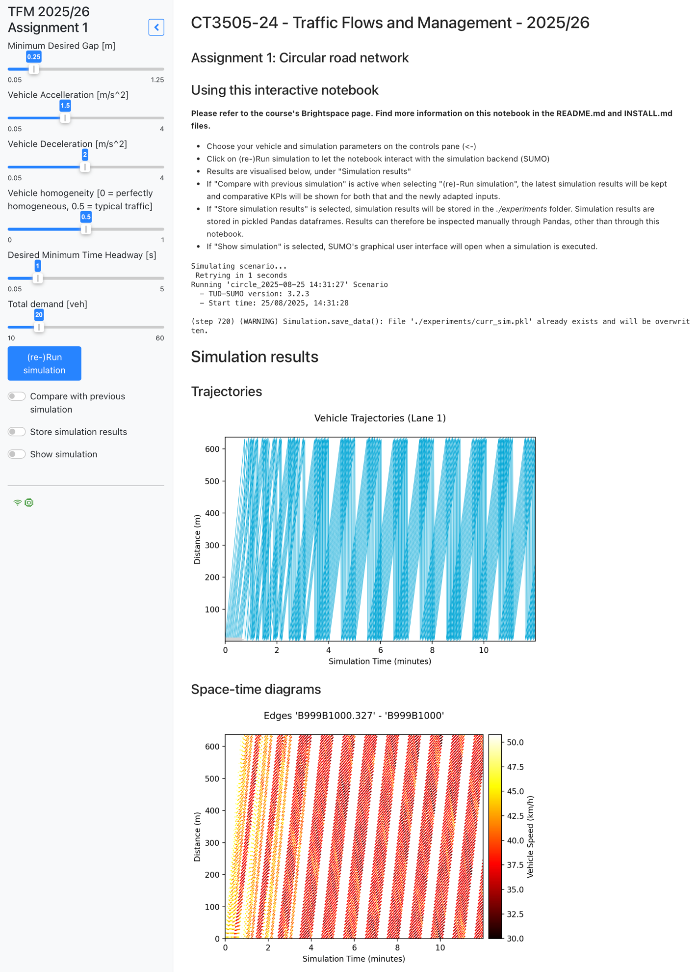

Assignment 1 comprises two tasks:

1. Tune the parameters of the Krauß car-following model, trying to replicate the behavior that was observed in real life, i.e. the appearance of ‘phantom’ jams. You can change one or more parameters; it is recommended that you do so in a structured manner. Try to answer the following questions:
   1. Which parameters led to phantom jams? Which combinations? Which parameters are a necessary condition? Which ones are irrelevant?
   2. What can you observe in the model outputs? How do phantom jams affect space-time diagrams, trajectory plots, …?
   3. How did you choose the parameters and their values? How does this relate to the classroom materials?
2. Given your experimental findings and the road characteristics, draw the flow-density Fundamental Diagram for this circular road. You may use the triangular approximation. Try to answer the following questions:
   1. What are the values for the following key variables? Free-flow speed, capacity, jam density, critical density, maximum back-propagation wave speed?
   2. How does the FD change for changes in the car-following model?

Your results should be presented in Report 1, where you clearly outline the experiments you carried out and your experimental findings. Alongside Report 2, the total page number should not exceed 10 pages, excluding references. Be selective with how you present your findings.

When preparing the report, also refer to the grading rubric!