# Assignment II: traffic flow management: ramp metering

In the lectures we discussed different traffic management strategies, including Ramp Metering. In Assignment I, you work with a circular road scenario, trying to replicate the real-life experiments. In that example, vehicles just “spawn” in the circular road itself – not too realistic! In this assignment, the circular road scenario has been extended, included are now an onramp, for vehicles to merge into the circular road, and an offramp, for vehicles to leave, after a few loops.

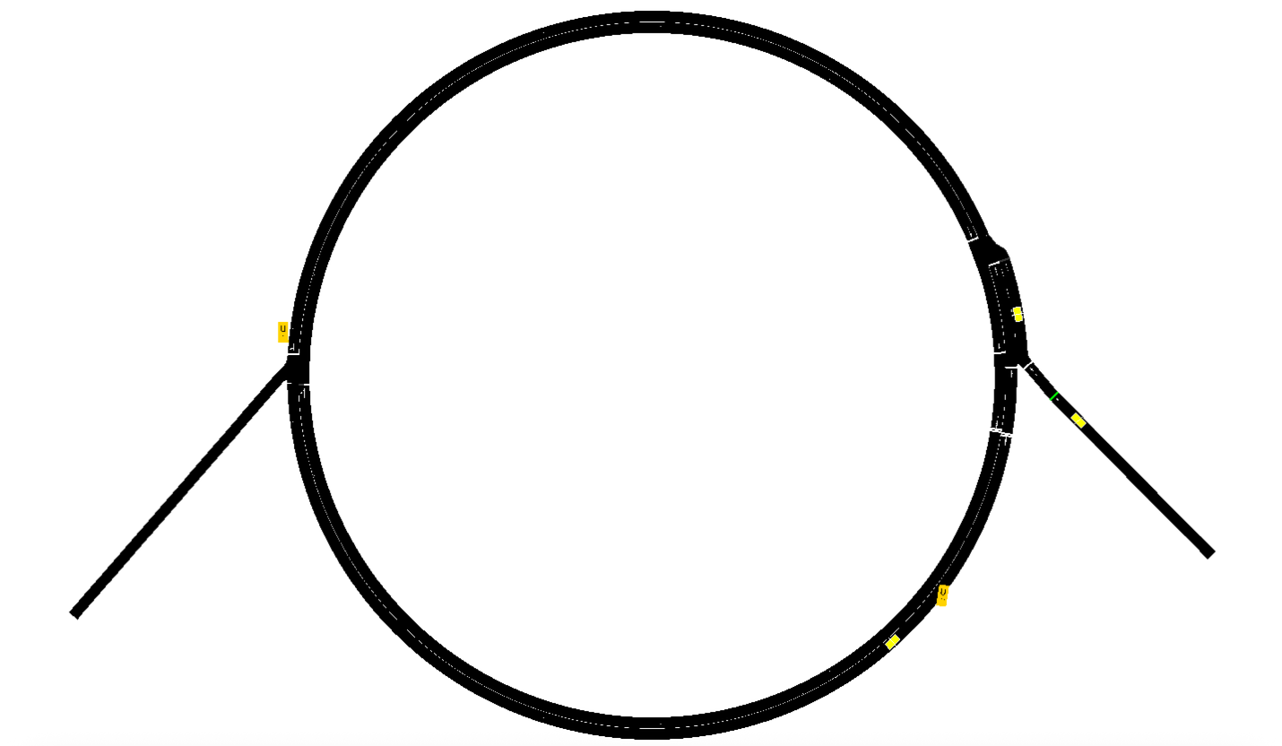

Figure : Ring road with ramps

This simulated roadway has the following characteristics:

1. a speed limit of 50km/h
2. a total length of 628m
3. a section with two lanes at the merging intersection
4. a ramp metering controller installed on the onramp (right hand side)
5. an offramp (left hand side)

A substantial number of vehicles tries to enter the ringway through the onramp; at each round trip, a random amount will leave through the offramp, but many will keep circling. As the simulation progresses, this will lead to substantial congestion:

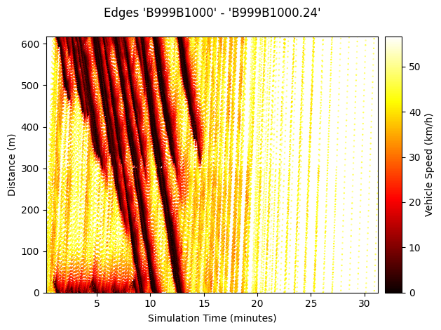

Figure : substantial queueing observed in this space-time diagram when no control is active

For this second assignment, you are tasked with implementing a Ramp Metering algorithm in Python. An example algorithm (on-off) is given in the code (see Figure below), as you will be able to observe, it helps to reduce some of the queueing, but falls short of really clearing up the ringway.

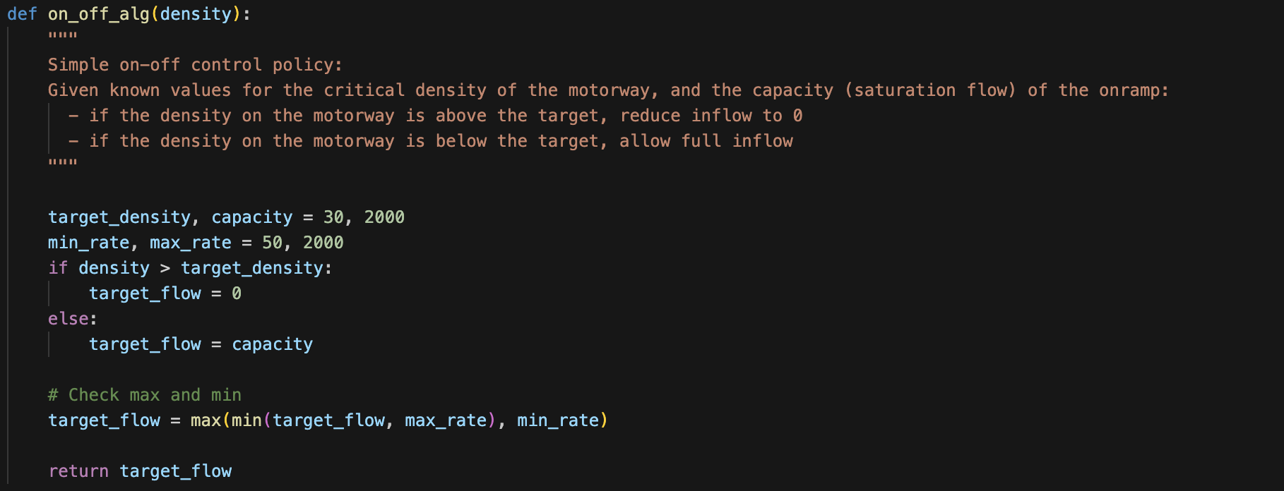

Figure : On/Off control policy (given)

You will be able to interact with the simulation through Visual Studio Code, the simulation is presented to you as a Jupyter notebook.

Assignment 2 comprises one task:

1. Implement a Ramp Metering controller that outperforms the provided On-Off control policy. Try to answer to the following sub-questions:
   1. How do you measure performance in this network? What are your Key Performance Indicators? When do you consider your controller successful?
   2. Which algorithm are you using? Which parameters can you tune? How did you choose the values for these parameters? Which experiments did you carry out?

Your results should be presented in Report 1, where you clearly outline the experiments you carried out and your experimental findings. Alongside Report 1, the total page number should not exceed 10 pages, excluding references. Be selective with how you present your findings.

When preparing the report, also refer to the grading rubric!