UML Diagram Tool

# Introduction

A tool for the reverse engineering of Java object-oriented source code into UML diagrams.

# User Documentation

## Requirements

?

## Installation

?

## Usage

### Loading the project

The first step towards the creation of a diagram is to load your desired project. In order to do that you have to load your project by clicking the menu Project and then Load.

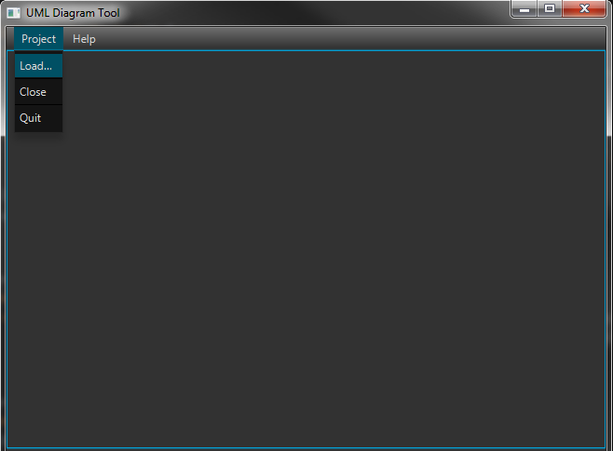

Loading project

### Selecting files

Once you have loaded your project, you must choose the desired files, i.e., the packages or the Java source files, that will be included in the created diagram. To select your files, simply check the corresponding boxes in the project’s tree view.

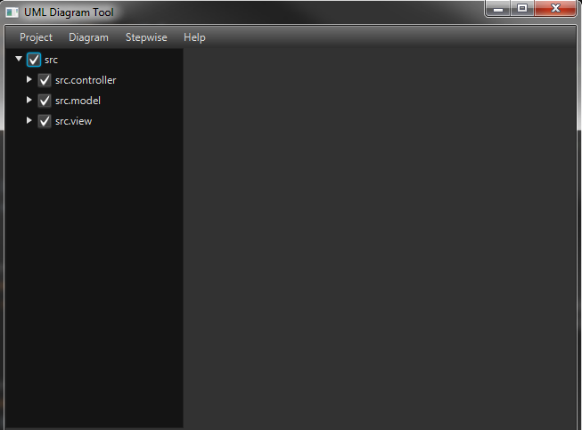

Selecting files

### Creating the diagram

After you have selected your files, you are ready to create your first diagram. There are two ways to create a diagram, the direct way and the stepwise way.

The direct way is very simple, you just need to select the diagram type, i.e., package or class diagram.

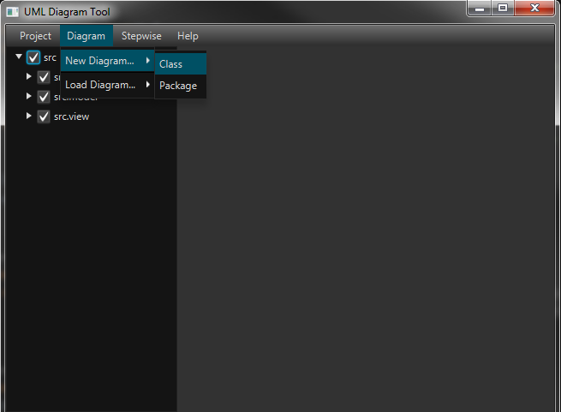 Creating a diagram, the direct way

For the stepwise way, you first need to create a new diagram, then load the desired files and then view the created diagram.

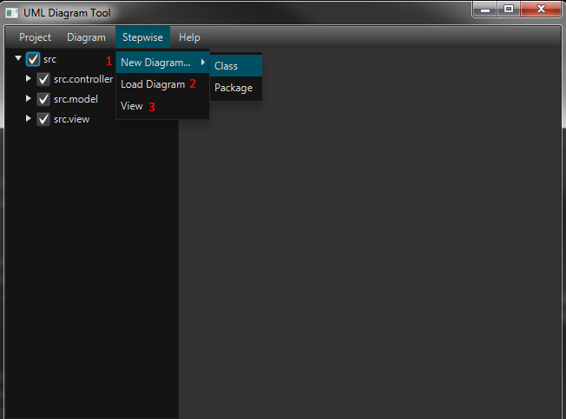

Creating a diagram, the stepwise way

After you have viewed your diagram, you have the option to export your diagram. The available exportations are: GraphML, Image(png) and Text.

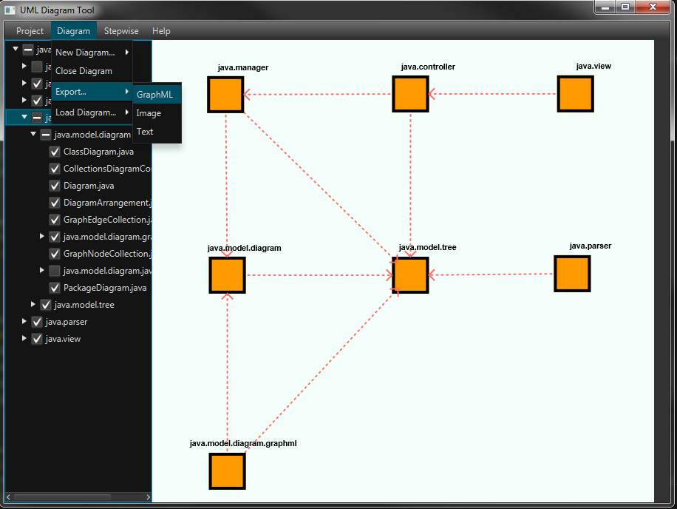

Exporting a diagram

You can view the GraphML file using yEd.

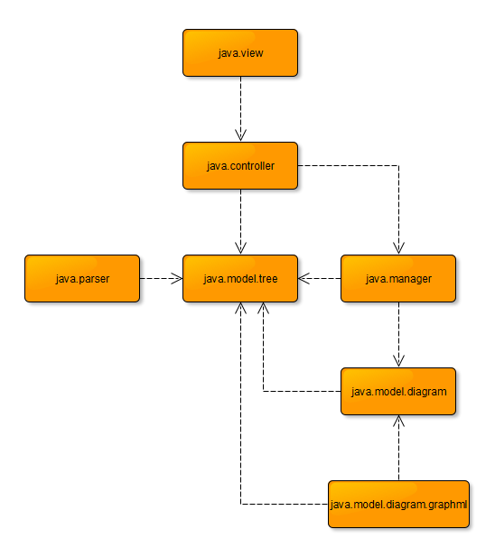

Viewing the diagram via yEd

Another feature after you have viewed your diagram is to choose different files and use the stepwise way to create a new diagram. Instead creating a new diagram, you just need to load the new files and view the new diagram.

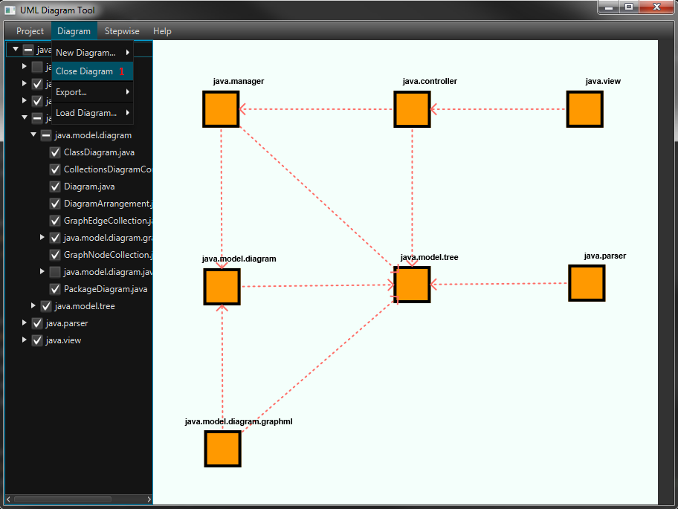

Closing the current diagram

Choose the different files you want to include in the new diagram.

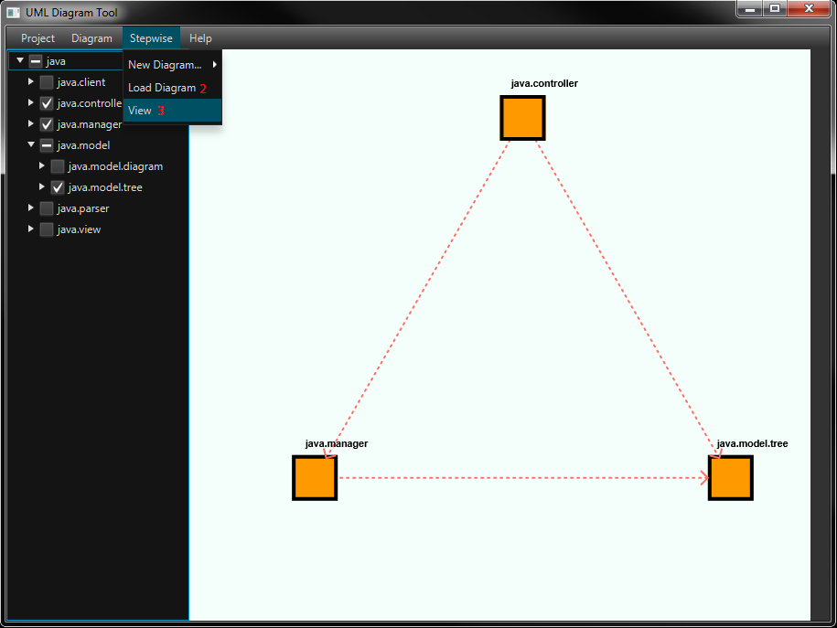

Viewing the new diagram