**Pinax Instruction Manual**

Table of Contents

Information for the tool 2

Query Builder Manual 4

Result Frame 7

# Information for the tool

Here are some basic information for the tool. In this image we see the main window of the tool.

1. In the left panel we can see the names of the registered tables, their columns names, and their data type.
2. In the right panel we have the query builder. Query builder is a bunch of text fields, where the user types the parameters for the sql query. We also have the Run Query button which creates the query and executes it, and the Custom Query button where the user can type any sql query he wants himself.
3. We also have 3 buttons in the upper menu. The first one called Add files is used to register files VIA a file chooser. The Help button opens this instruction manual and the Wipe Data, clears all the registered files from the tool.

# Query Builder Manual

Here are the basic instructions on how to use the query builder provided by the tool.

1. Always add a primary table in the primary table field.
2. When adding parameters, everything should be splitted by a , (comma)

Here we can see in the attributes text field that all the attributes are splitted by a coma. This should be done in all the text fields, in case of multiple parameters.

1. When joining tables, the join filters, table aliases and join types should be in the proper order for the tool to function properly.

Here we see a multiple table join example. We have the primary table 500k, and the 2 tables we want to join it with, 1m and 1_5m. We give them the aliases f for the 500k, o for the 1m and t for the 1_5m. **The first alias in the table alias field is used by the primary table. As we can see in the attributes list and the join filters list, we include the table alias, since the tables contain columns with the same name. This is important to remember. Also note that the primary table is not included in the join table list.**

1. Any special character in the file name is changed to _ (underscore).

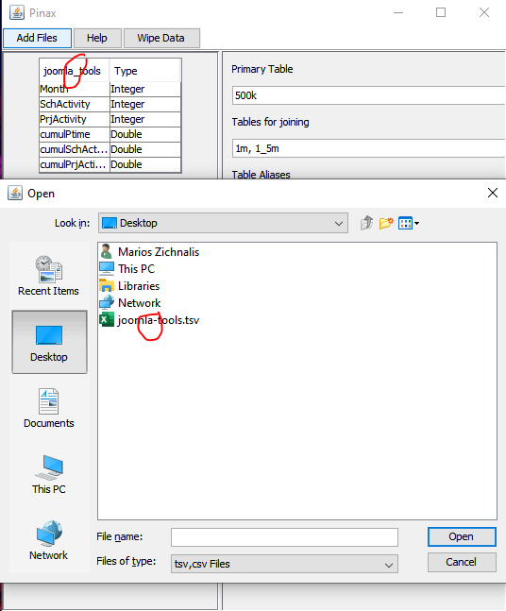

# Result Frame

In the result frame there is the option to save the results as a CSV file. The file is saved in the resources folder of the tool in the folder called saved.

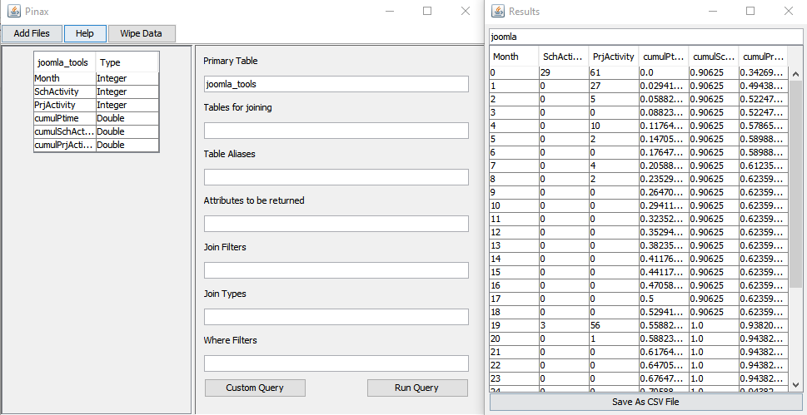

We first have to type the name of the file we want the results to be saved in. This is done in the text field above the results. Here we can see the required name is joomla. After we type a name, we click the Save As CSV File button and the file is created.