To install virtual box and Ubuntu os follow the link given bellow:

https://www.youtube.com/watch?v=x5MhydijWmc

After completing the Ubuntu installation on virtual box.

Open the Ubuntu OS on virtual box.

Goto the terminal or command prompt in ubuntu to install the packages that required for an Computer vision engineering.

You will find the Terminal in desktop
1.In the bottom right you will find Show Application ,click on that.
2.After clicking on that you will search bar at top.
3.Type on that search bar as Terminal, you will find a Terminal.
4.Right click on that Terminal , it will show add to favourites, click on that so it will add on desktop tabs.
5.click on that terminal and install all packages given bellow:

sudo apt update
sudo apt install python3-pip
sudo apt-get install python3-opencv
sudo apt-get install cmake
sudo pip3 install numpy
sudo apt-get install gcc g++
sudo apt-get install libavcodec-dev libavformat-dev libswscale-dev
sudo apt-get install -y libgstreamer-plugins-base1.0-dev
sudo apt-get install -y libgstreamer1.0-dev
sudo apt-get install libgtk-3-dev
sudo apt-get install libpng-dev libjpeg-dev libopenexr-dev libtiff-dev libwebp-dev
sudo pip3 install numpy scipy matplotlib scikit-image scikit-learn ipython
sudo pip3 install opencv-contrib-python
sudo pip3 install tensorflow
sudo apt-get install pyqt5-dev-tools
sudo pip3 install lxml

After completing the installation of all packages given above

you have to clone the label image tool using:
sudo apt install git
git clone https://github.com/tzutalin/labelImg.git

Next you have change the directory to labelImg using :
cd labelImg
make all

Next, You have to run the code using:
python3 labelImg.py

After running python3 labelImg.py , the labeling tool will open like below:
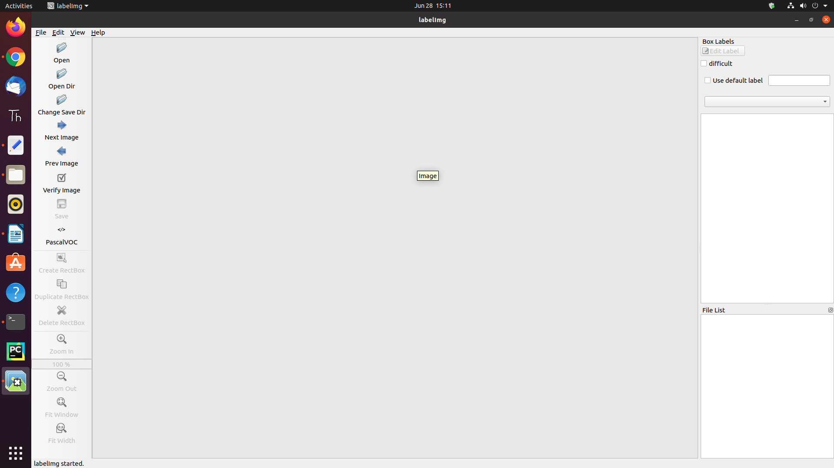

After Tool is opened

Now, you have to convert a videos into frames using python code

So now you have to open Text editor that available on desktop tab or else goto show application at bottom right find on the search bar typing Text Editor

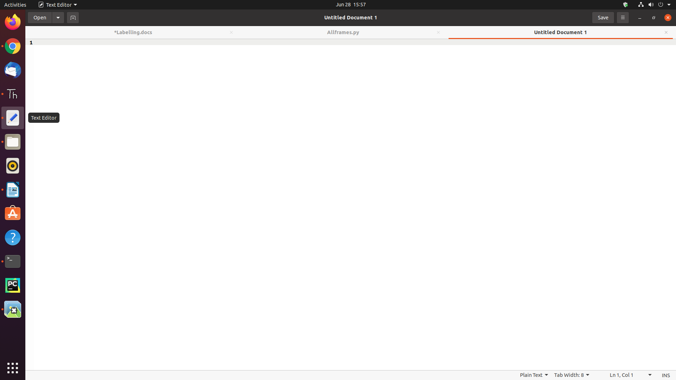

copy the below code and paste it at Text editor
save the code with frames.py which is given below

# Importing all necessary libraries
import cv2
import os

# Read the video from specified path
cam = cv2.VideoCapture("/home/chakri/Documents/Open_cv_tasks/1.mp4")
cam = cv2.VideoCapture("1.mp4")

try:

# creating a folder named data
if not os.path.exists('data'):
os.makedirs('data')

# if not created then raise error
except OSError:
print ('Error: Creating directory of data')

# frame
currentframe = 0

while(True):

# reading from frame
ret,frame = cam.read()

if ret:
# if video is still left continue creating images
name = './data/frame' + str(currentframe) + '.jpg'
print ('Creating...' + name)

# writing the extracted images
cv2.imwrite(name, frame)

# increasing counter so that it will
# show how many frames are created
currentframe += 1

# Release all space and windows once done
cam.release()
cv2.destroyAllWindows()

After saving the code , Goto terminal and run the code with
python3 frames.py

After running the code
Video will convert into frames in a data folder

Now open Label-image tool
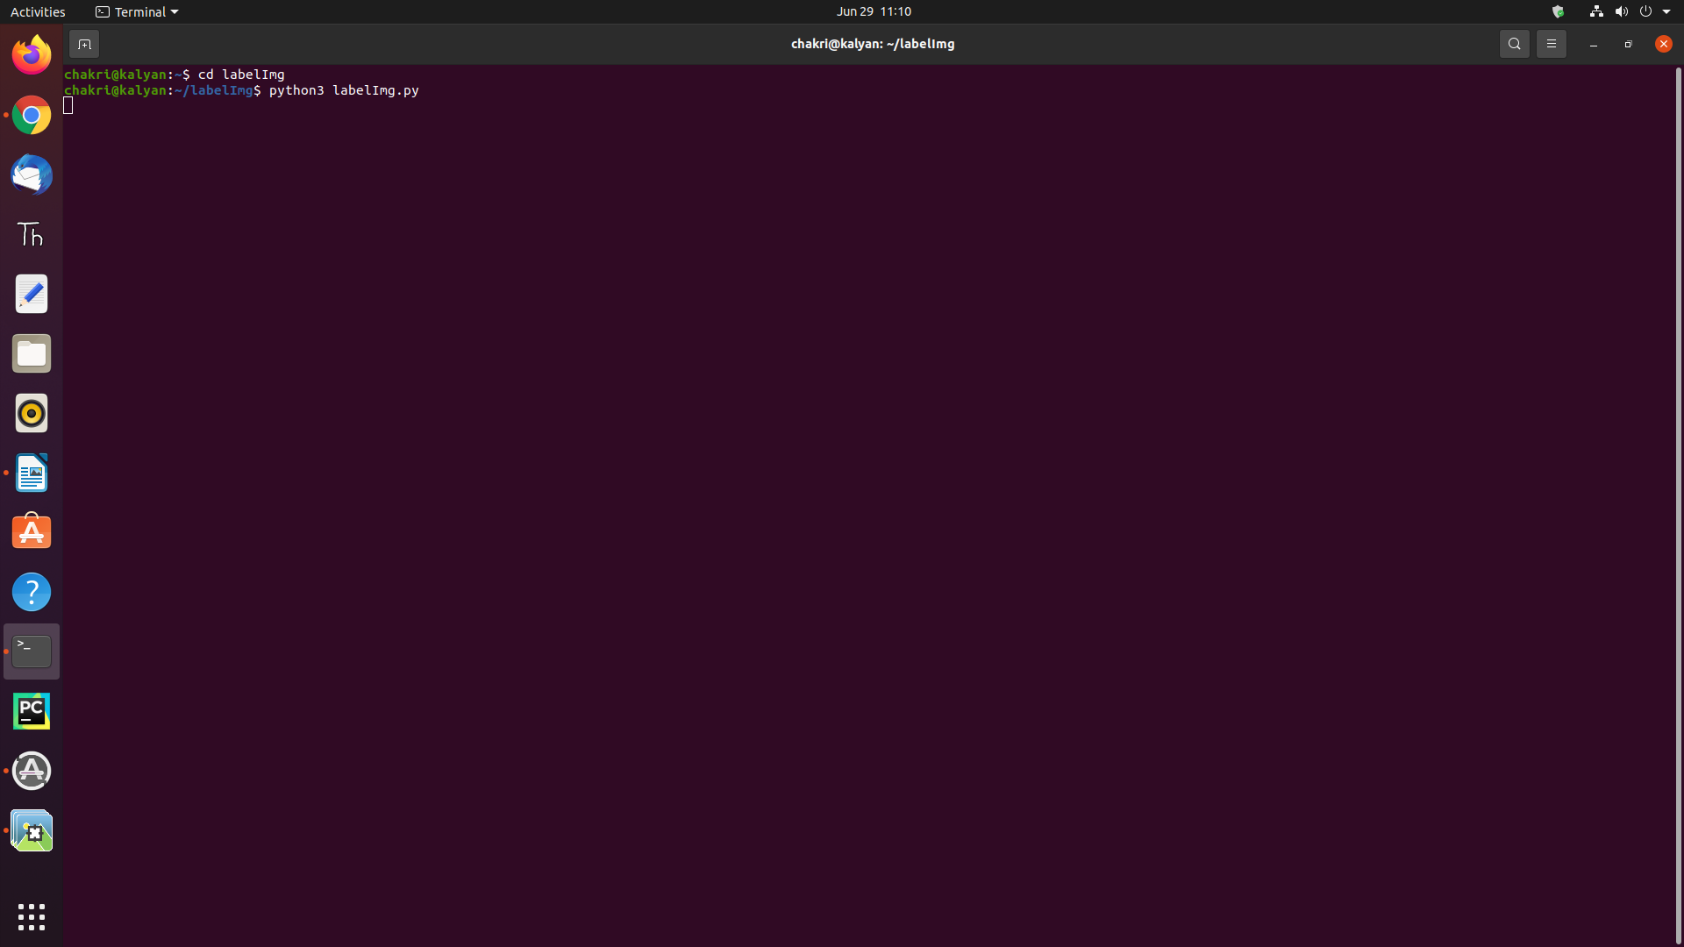

After running the code label-image tool will open

So we converted video into frames

Click on open Direrctory and open the frames of data folder where it is located

After opening the file it looks like this

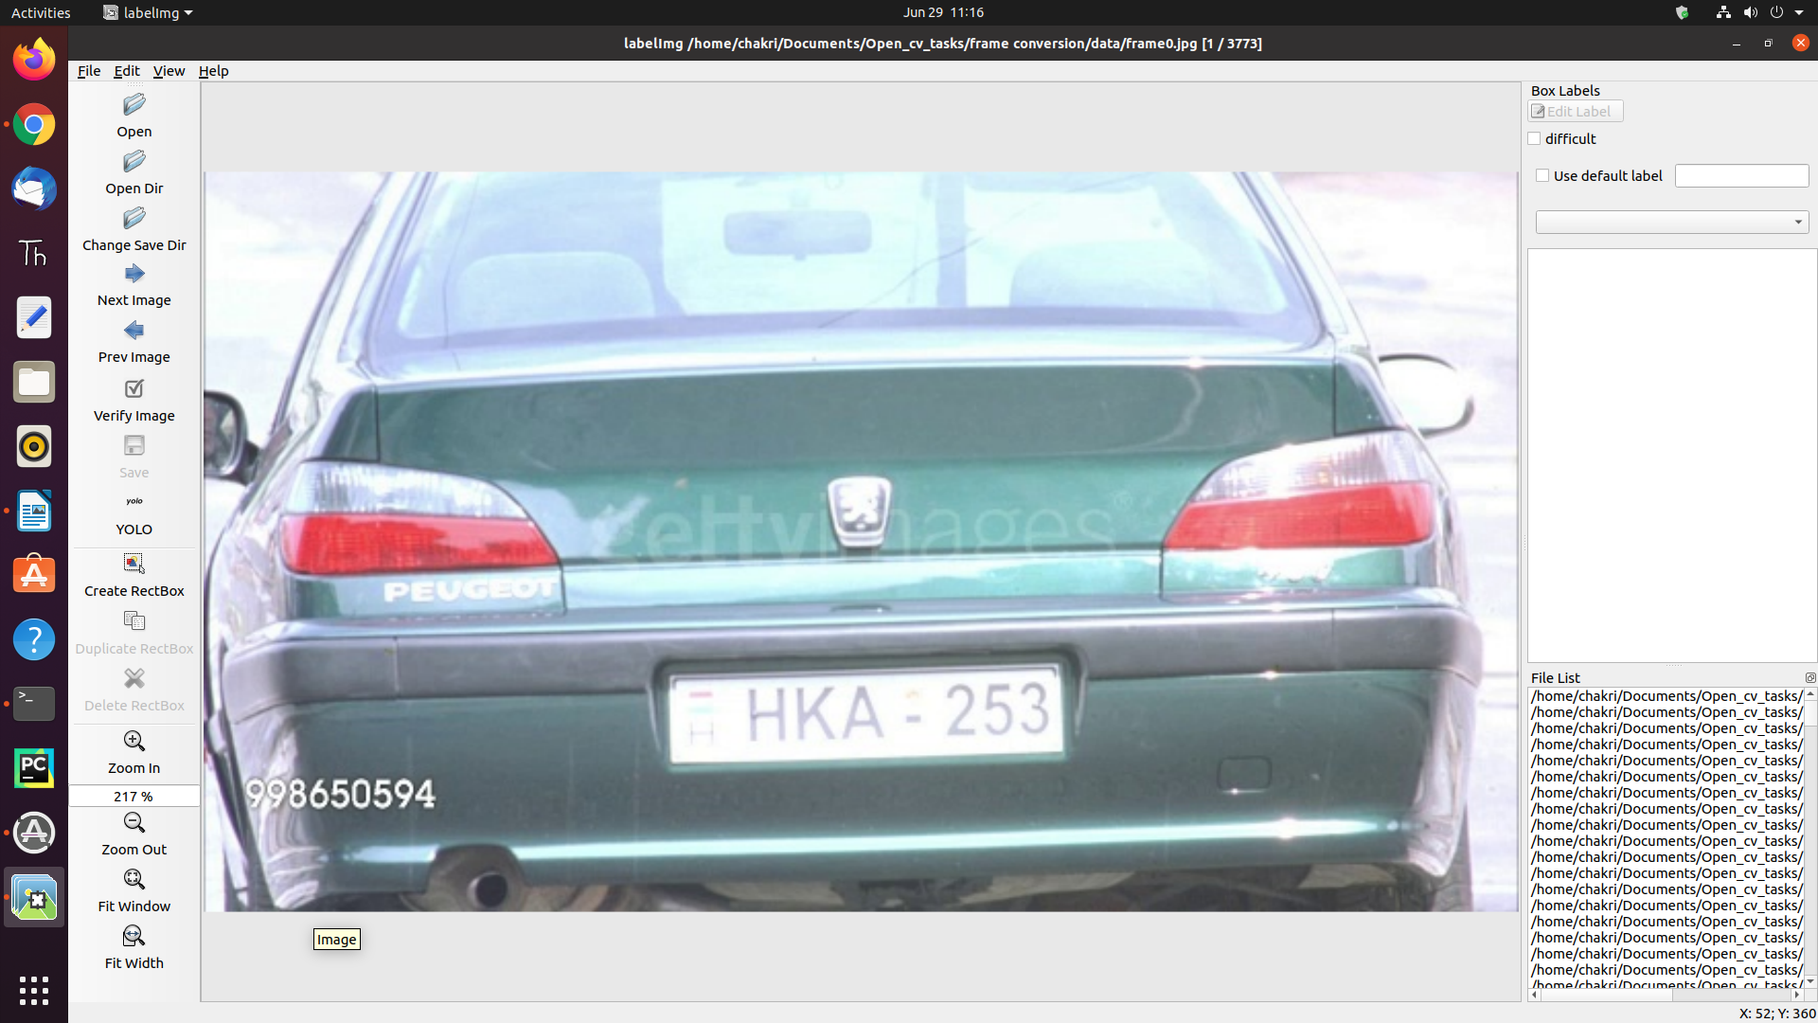

Now you have to change the format into YOLO – You Only Live Once

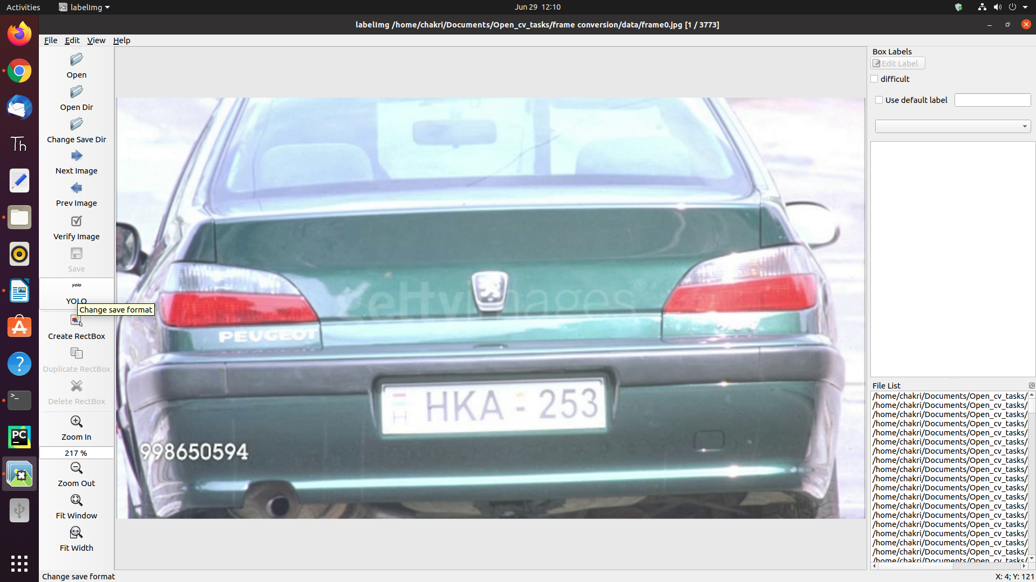

Next click on the Create rectangleBox
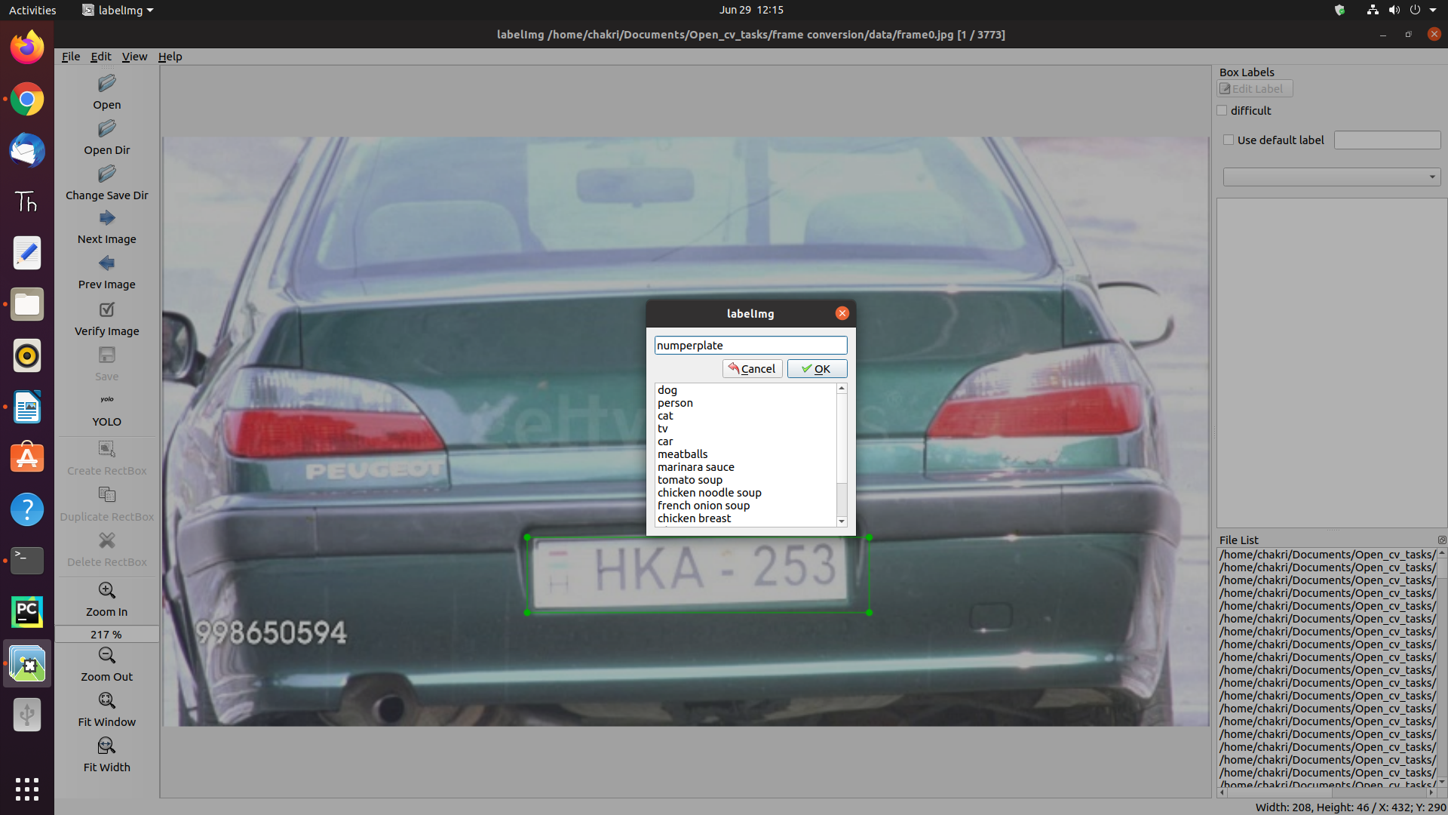
Drag and drop at number plate and save the name with number-plate as shown below:

Now save the file in the same folder with same name present at the folder.
After that click on the Next Image and do the same process for the remaining images.
https://www.programmersought.com/article/41334095772/ -link labelimage installation

