Reporting Document

Last media keywords**Most common words that appears together**(('💔', '😭'), 63)  
(('I', "don't"), 26)  
(('I', '😂'), 26)  
(('❤', '️'), 26)  
(('I', 'know'), 23)  
**Most common words**('I', 253)  
('😂', 68)  
('like', 55)  
('get', 38)  
("I'm", 38)

# All media graphic by time.

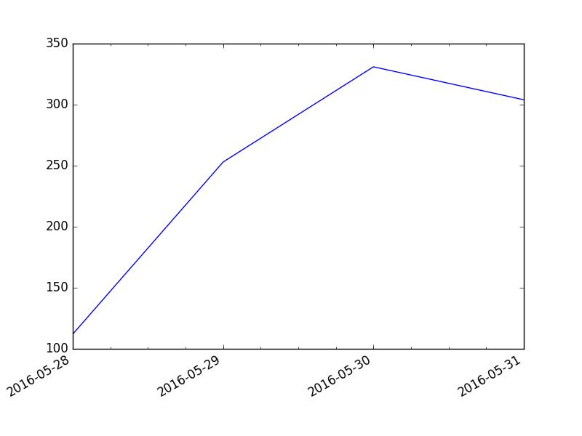

Competitor mediaSorry,there was not enough media by your location....