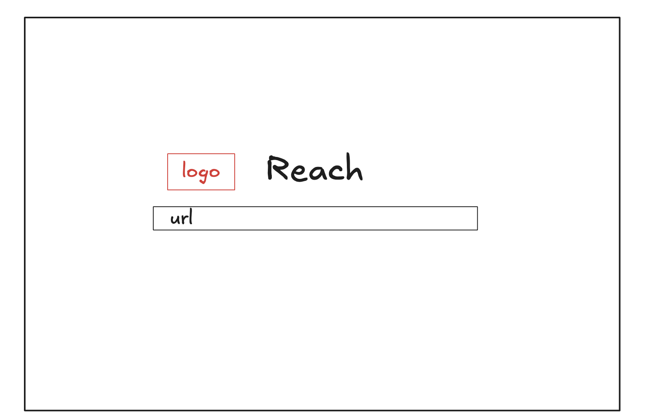

- When they have typed url and hit enter then a new input comes in the center and the url one animates and goes above.
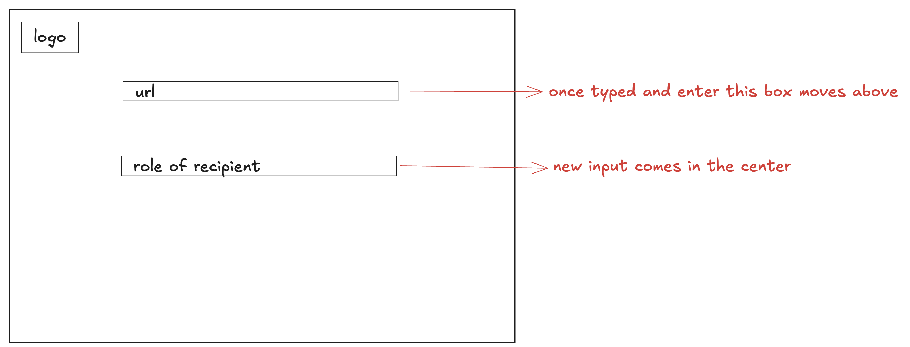

- Again same, when user types and hits enter, new input in center and the rest go up.
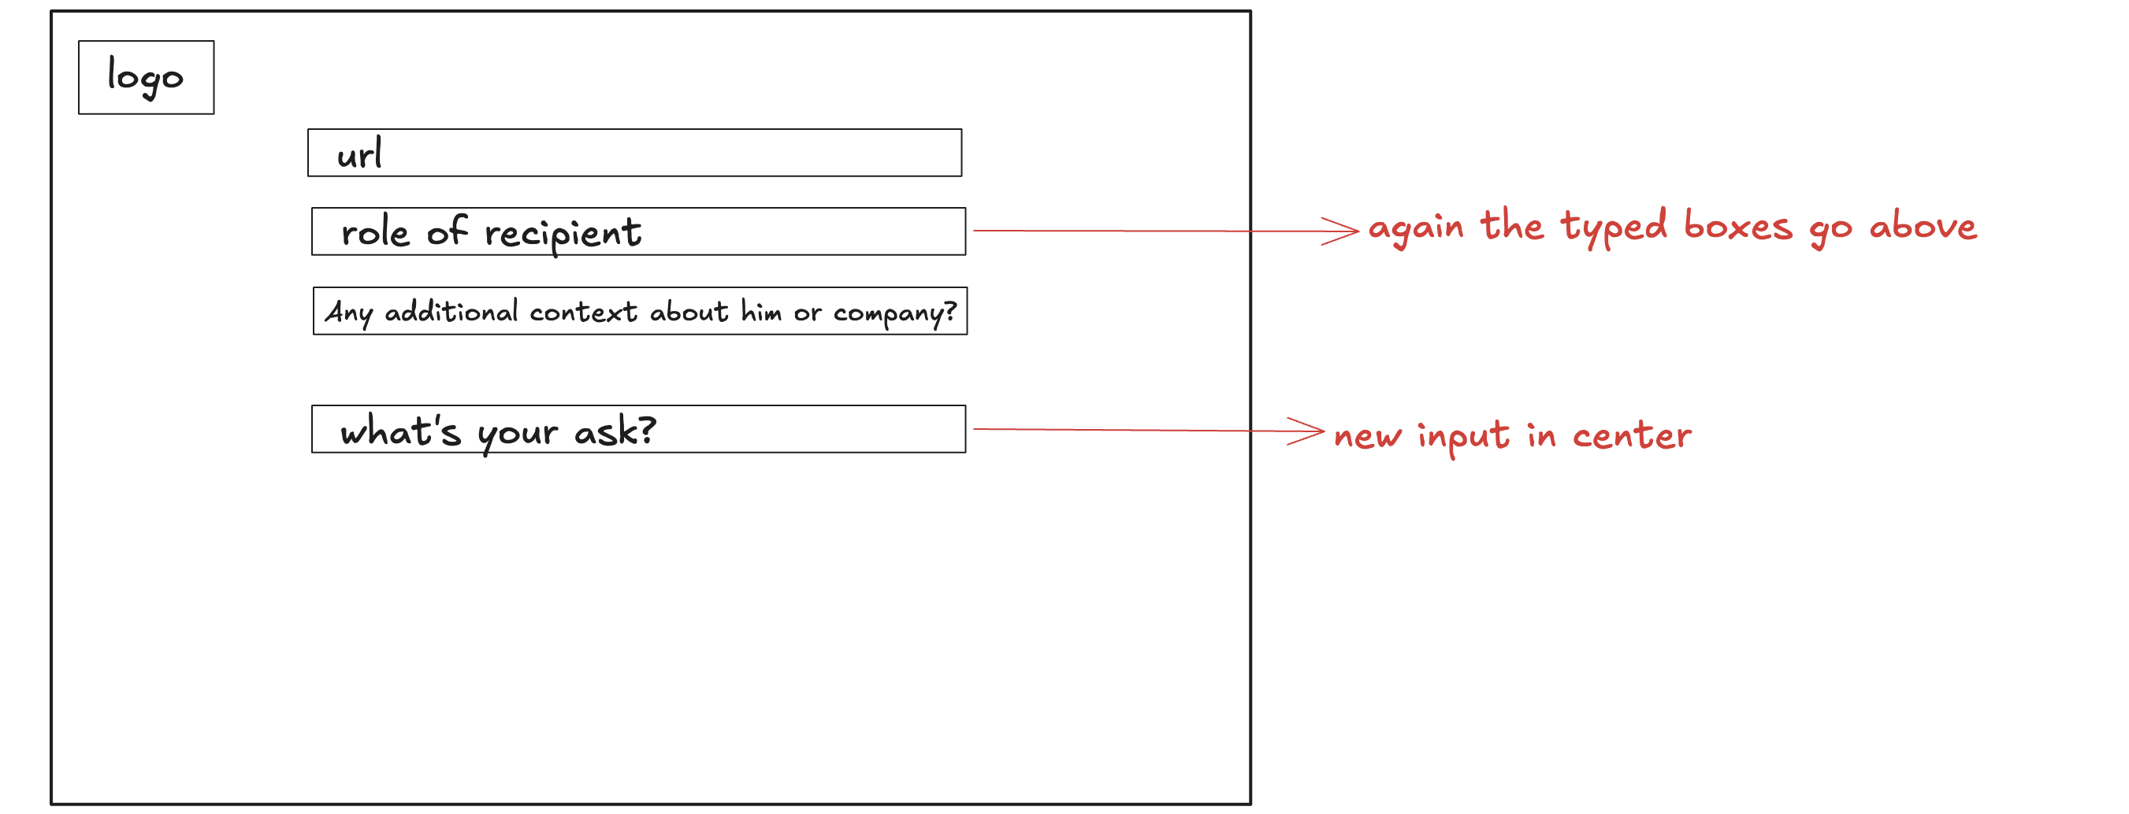

- Finally when every input is completed, all the inputs should stack a bit and go in the top. (still each one should be visible)
