1.
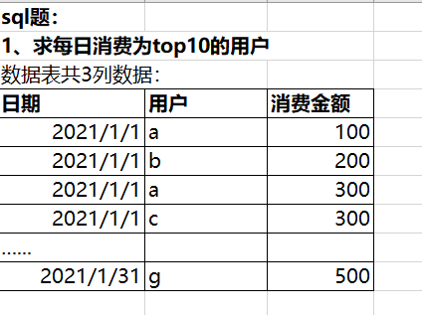

Select 日期，用户
from(
Select * ,row_number() over (partition by 日期order by 金额desc) rank
From(
Select sum(消费金额) 金额 , 用户，日期
From 表1
group by 用户,日期
)t2) t1
Where rank<=10;

2.
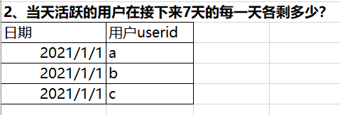
select
log_day '日期',
count(user_id_d0) '当日活跃数量',
count(user_id_d1) '次日留存',
count(user_id_d2) '2日留存',
count(user_id_d3) '3日留存',
count(user_id_d4) '4日留存',
count(user_id_d5) '5日留存',
count(user_id_d6) '6日留存',
count(user_id_d7) '7日留存',
from (
select
distinct 日期,
a.user_id_d0,
b.userid as user_id_d1,
c. userid as user_id_d2,
d. userid as user_id_d3
e. userid as user_id_d4,
f. userid as user_id_d5,
g. userid as user_id_d6,
h. userid as user_id_d7
from
(select
distinct date(日期), userid as user_id_d0
from 表2
group by userid
order by日期) a
left join 表2 b
on b.日期 =date_add(a.日期,interval 1 day) ,a.user_id_d0 = b.userid
left join 表2 c
on c.日期 =date_add(a.日期,interval 2 day) and a.user_id_d0 = c.user id
left join 表2 d
on d.日期 =date_add(a.日期,interval 3 day) and a.user_id_d0 = d.user id
left join 表2 e
on e.日期 =date_add(a.日期,interval 4 day) and a.user_id_d0 = e.user id
left join 表2 f
on f.日期 =date_add(a.日期,interval 5 day) and a.user_id_d0 = f.user id
left join 表2 g
on g.日期 =date_add(a.日期,interval 6 day)
and a.user_id_d0 = g.user id
left join 表2 h
on h.日期 =date_add(a.日期,interval 7 day)
and a.user_id_d0 = h.user id
)
group by 日期;

3.
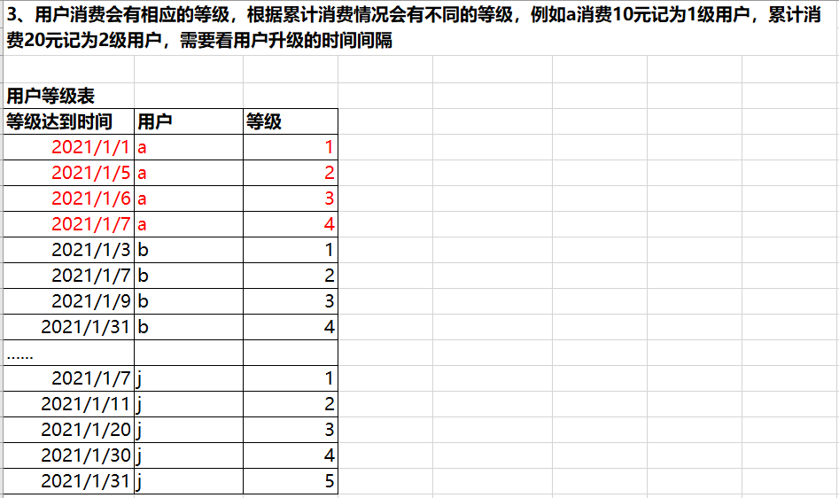

Select 用户,
Sum(case when 等级=1 then 升级间隔 else 0 end) as 等级一升级间隔,
Sum(case when 等级=2 then 升级间隔 else 0 end) as 等级二升级间隔,
Sum(case when 等级=3 then 升级间隔 else 0 end) as 等级三升级间隔,
Sum(case when 等级=4 then 升级间隔 else 0 end) as 等级四升级间隔,
Sum(case when 等级=5 then 升级间隔 else 0 end) as 等级五升级间隔
From (
Select b.用户, datediff(b.等级达到时间,a.等级达到时间) 升级间隔,b.等级
From 用户等级表 a
Inner join 用户等级表 b
On a.用户=b.用户 and b.等级=( a.等级) +1
)t
Group by用户;

