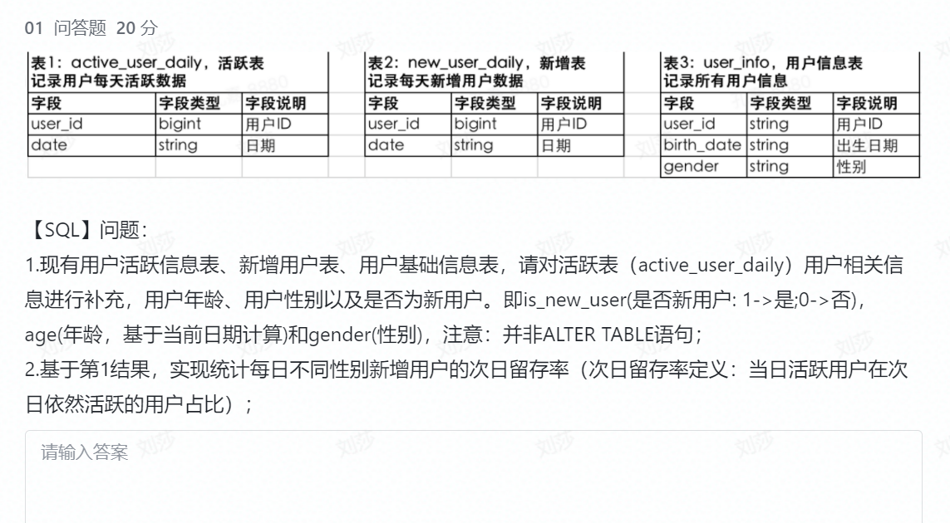
1.
Update active_user_daily a1
Set
age =(Select (date(birth_date)-date(curdate()) from user_info b1
Where b1.user_id=a1.user.id ) ) ),
is_new_user=(select (case when a1.date =b2.curdate() then 1 else 0 end) from new_user_info b2 where b2.user_id=a1.user.id ),
Gender=(select gender from user_info b2 where b2.user_id=a1.user.id );

Update active_user_daily a1
Set
New_date=(select date from user_info b2 where b2.user_id=a1.user.id );

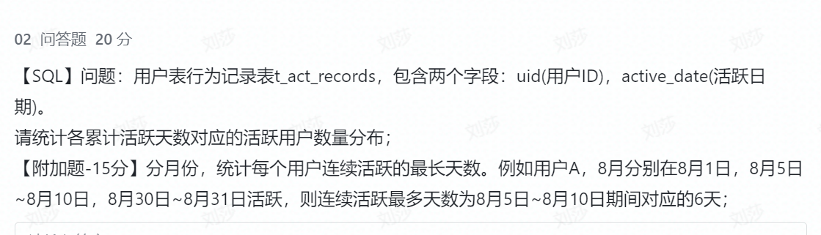
select 累计活跃天数，count（用户） 用户数量
from （Select uid 用户 ,Count ( distinc active_date) 累计活跃天数 from t_act_records group by uid ）
group by 累计活跃天数
;

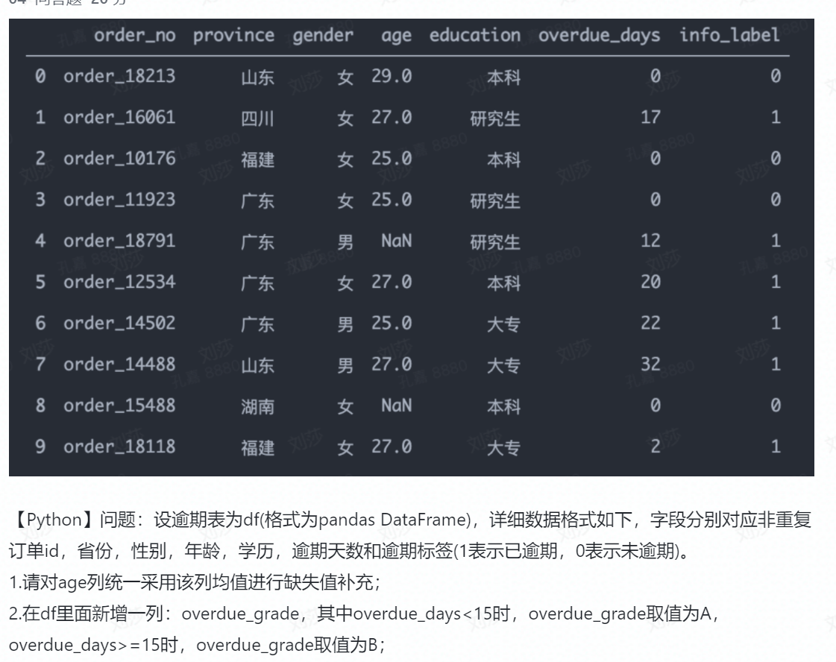
4.1
Import pandas as pd
df[“age”]=df[“age”].apply(lambda x: x if np.isnan(x)==False else df[“age”].mean())
4.2
df[“over_grade”]=df[“overdue_days”].apply(lamda x: A if x<15 else B)

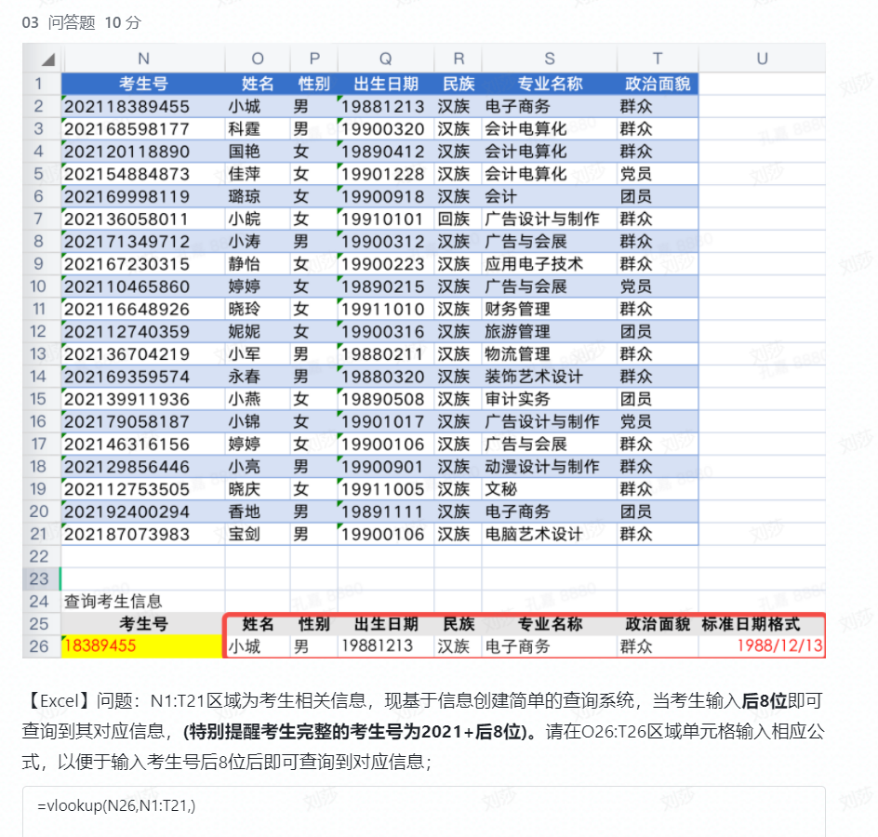
=Vlookup($N26,$N$2:$T$21,match(O$25,$O$1:$T$1,0),1)

