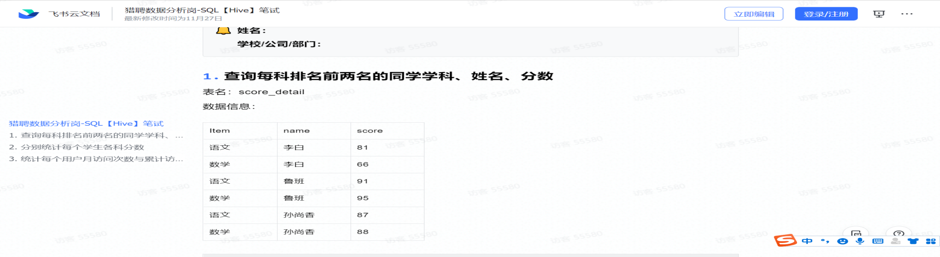

Select name,item,score,RN
from(
Select *,row_number() over (partition by item order by score desc) RN
From score_detail) as t1
Where RN=1 or RN=2;
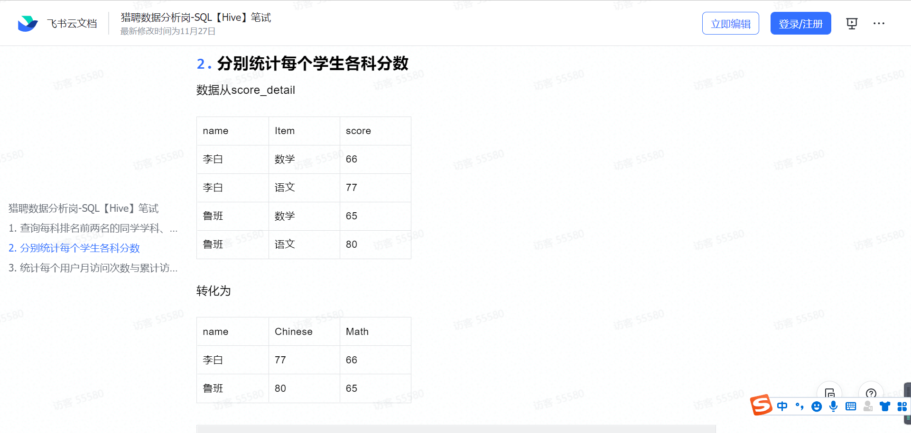

--第二题作答区域--
select name,
sum(case when item='语文' then score else 0 end) as 'Chinese',
sum(case when item='数学' then score else 0 end) as 'Math'
from score_detail
group by name;

数据准备
CREATE TABLE `action` (
`id` int(11) NOT NULL AUTO_INCREMENT,
`userid` char(5) COLLATE utf8_bin NOT NULL,
`visitdate` date DEFAULT NULL,
`visitcount` int(9) DEFAULT NULL,
PRIMARY KEY (`id`) USING BTREE
) ENGINE=InnoDB AUTO_INCREMENT=9 DEFAULT CHARSET=utf8 COLLATE=utf8_bin;

INSERT INTO `lls_test`.`count_user_visit`(`id`, `user_id`, `visit_date`, `visit_count`) VALUES (1, 'u01', '2017-01-21', 5);
INSERT INTO `lls_test`.`count_user_visit`(`id`, `user_id`, `visit_date`, `visit_count`) VALUES (2, 'u01', '2017-01-23', 6);
INSERT INTO `lls_test`.`count_user_visit`(`id`, `user_id`, `visit_date`, `visit_count`) VALUES (3, 'u02', '2017-01-23', 6);
INSERT INTO `lls_test`.`count_user_visit`(`id`, `user_id`, `visit_date`, `visit_count`) VALUES (4, 'u03', '2017-01-22', 8);
INSERT INTO `lls_test`.`count_user_visit`(`id`, `user_id`, `visit_date`, `visit_count`) VALUES (5, 'u04', '2017-01-20', 3);
INSERT INTO `lls_test`.`count_user_visit`(`id`, `user_id`, `visit_date`, `visit_count`) VALUES (6, 'u02', '2017-02-21', 8);
INSERT INTO `lls_test`.`count_user_visit`(`id`, `user_id`, `visit_date`, `visit_count`) VALUES (7, 'u01', '2017-02-22', 4);
INSERT INTO `lls_test`.`count_user_visit`(`id`, `user_id`, `visit_date`, `visit_count`) VALUES (8, 'u01', '2017-02-23', 5);

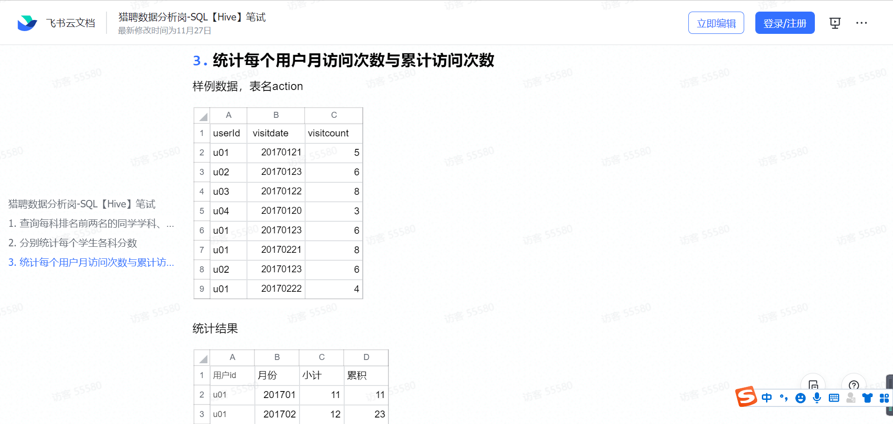

SELECT
a.userid 用户id,
a.yue 月份,
sum( visitcount ) 小计,
(
SELECT
SUM( b.小计 )
FROM
(
SELECT
a.id 用户id,
a.yue 月份,
SUM( vc ) 小计
FROM
( SELECT userid id, visitcount vc, DATE_FORMAT( visitdate, '%Y-%m' ) yue FROM action ) a
GROUP BY
a.id,
a.yue
) b
WHERE
b.月份<= a.yue
AND b.用户id = a.id
) 累积
FROM
( SELECT userid, visitcount, Date_format( visitdate, '%Y-%m' ) yue FROM action ) a
GROUP BY
a.userid,
a.yue;

