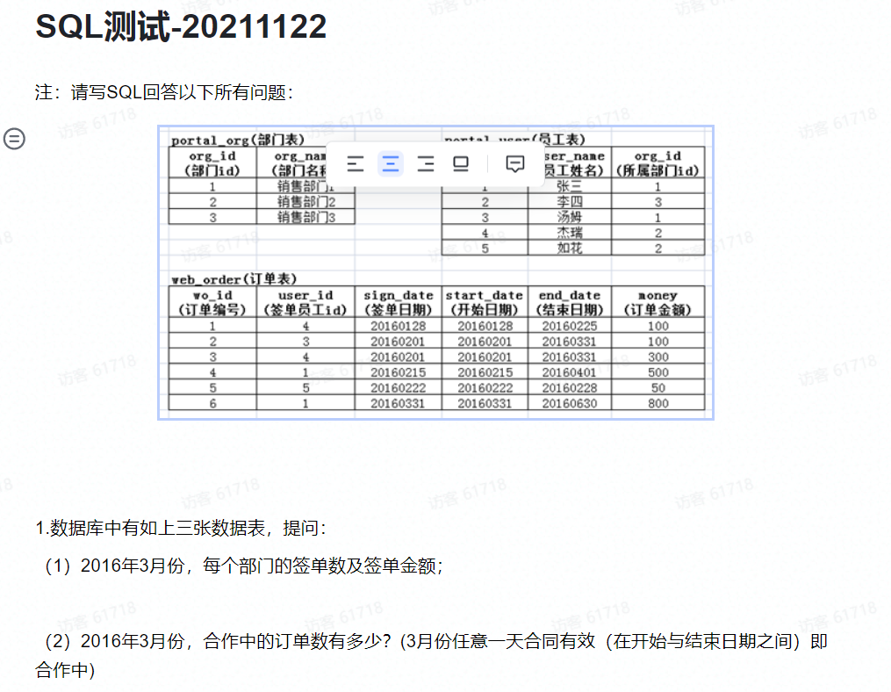
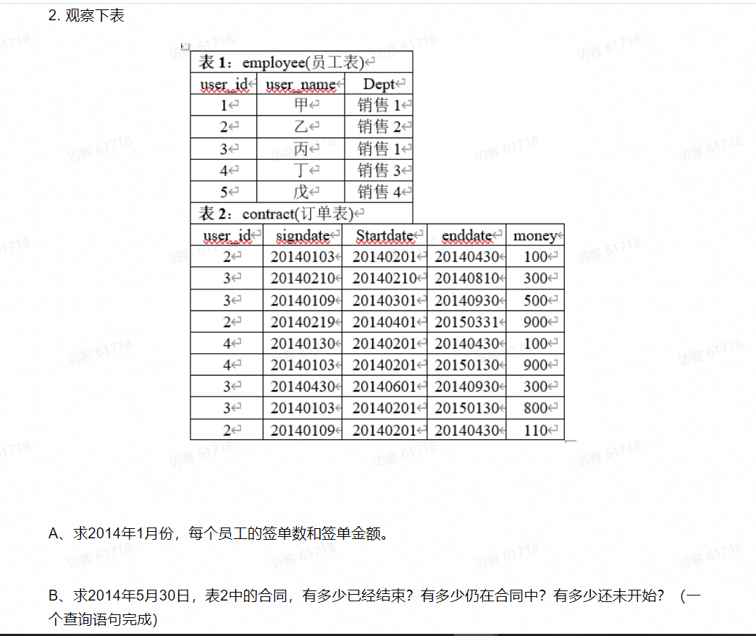
乔答案
1.(1)
Select po. org_name 部门名称, count(sign_date) 签单数 , sum(money) 签单金额
from web_order wo
left join portal_user pu on wo.user_id=pu.user_id
left join portal_org po on wo.org_id=po. org_id
Where sign_date between 20160301 and 20160331
Group by org_id;
1.(2)
Select count(*) 合作中的订单数
From portal_user pu
Inner join portal_org po on pu.org_id=po. org_id
Inner join web_order wo on pu.user_id=wo.user_id
Where start_date between 20160301 and 20160331
or end_date between 20160301 and 20160331;

2.(1)
Select count(*) 签单数,sum(money) 签单金额
From employee e
Inner join contract c on e.user_id=c.user_id
Where signdate between 20140101 and 20140131
Group by user_id;

2.(2)
select
sum(case when Startdate<=20140530 and enddate>=20140530 then 1 else 0 end) 正在进行数,
Sum(case when enddate<=20140530 then 1 else 0 end) 已经结束,
Sum (case when Startdate>20140530 then 1 else 0 end) 还未开始
from contract;

鸭子答案
第一题第一问
Select count(*) 签单数,sum(money) 签单金额
From portal_user a
Inner join portal_org b on a.org_id=b. org_id
Inner join web_order c on a.user_id=c.user_id
Where sign_date between 20160301 and 20160331
group by org_id;
第一题第二问
Select count(*) 合作订单数
From portal_user a
Inner join portal_org b on a.org_id=b. org_id
Inner join web_order c on a.user_id=c.user_id
Where start_date between 20160301 and 20160331
or end_date between 20160301 and 20160331

第二题第一问
Select count(*) 签单数,sum(money) 签单金额
From employee e
Inner join contract c on e.user_id=c.user_id
Where signdate between 20140101 and 20140131
Group by user_id

第二题第二问
select
(Select count(signdate) from contract where Startdate<=20140530 and enddate>=20140530) 正在进行数,
(Select count(signdate) from contract where enddate<=20140530 ) 已经结束,
(Select count(signtdate) from contract where Startdate>20140530) 还未开始
from contract;

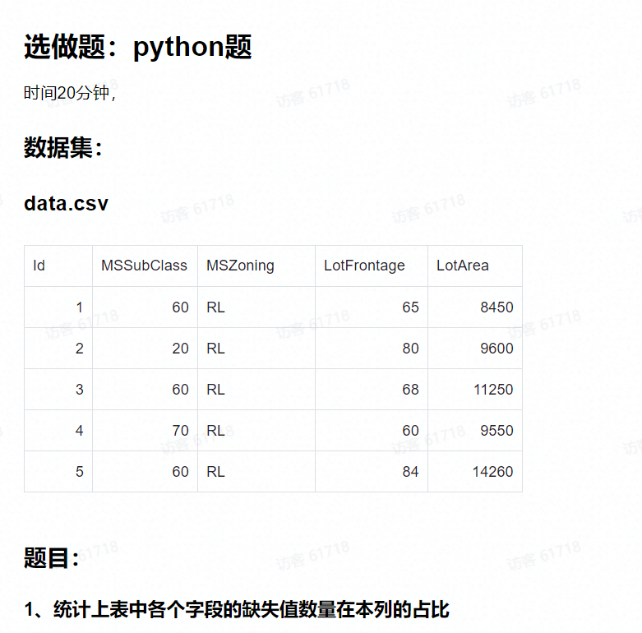

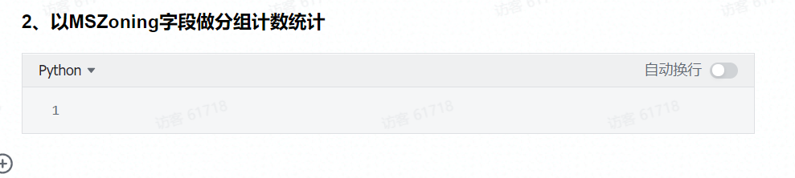

1
import pandas as pd
a=pd.read_csv(‘data.csv’)

def missing_percent(df):
nan_percent = 100*(df.isnull().sum()/len(df))
nan_percent = nan_percent[nan_percent > 0].sort_values()
return nan_percent
print(missing_percent(a))
2
grouped =a.groupby('MSZoning').aggregate(['count'])
grouped

