一、查找每个用户连续登陆的最大天数
use girls
create table user_date(
uid int(20),
login_date date
);
insert into user_date
VALUES(201,'20170101')
,(201,'20170102')
,(202,'20170102')
,(202,'20170103')
,(203,'20170103')
,(201,'20170104')
,(202,'20170104')
,(201,'20170105')
,(202,'20170105')
,(201,'20170106')
,(203,'20170106')
,(203,'20170107');
（1）第一步：按照uid分组，login_date排序，增加一个新字段排名RN
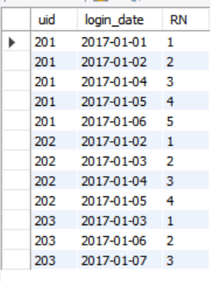
select uid,login_date,
row_number() over (partition by uid order by login_date) RN
from user_date
（2）第二步：在第一步的基础上增加date_diff列，即login_date减去RN
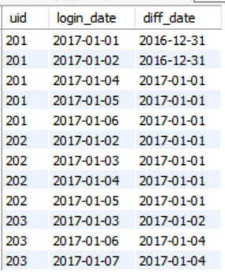
select uid,login_date,date_sub(login_date,interval RN day) as diff_date
from(
select uid,login_date,
row_number() over (partition by uid order by login_date) RN
from user_date) t1
（3）得到每个人在每一天的连续登陆天数
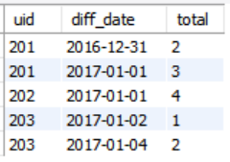
select uid,diff_date,count(1) as total
from(
select uid,login_date,date_sub(login_date,interval RN day) as diff_date
from(
select uid,login_date,
row_number() over (partition by uid order by login_date) RN
from user_date) t1
) t2
group by uid,diff_date

（4）取出最大值
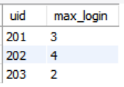
select uid,max(total) as max_login
from(
select uid,diff_date,count(1) as total
from(
select uid,login_date,date_sub(login_date,interval RN day) as diff_date
from(
select uid,login_date,
row_number() over (partition by uid order by login_date) RN
from user_date) t1
) t2
group by uid,diff_date
) t3
group by uid

二、
use girls;
create table student_test_info(
id int(20),
student_id int(20),
student_name varchar(20),
course_id int(20),
course_name varchar(20),
score int(20)
);
insert into student_test_info
values(1,201001,"张黛丝",101,"商务统计",73),
(2,201001,"张黛丝",104,"时间序列分析",67),
(3,201001,"张黛丝",105,"随机过程",52),
(4,201001,"李美妮",104,"时间序列分析",61),
(5,201001,"李美妮",102,"应用回归分析",63),
(6,201001,"孙纳德",101,"商务统计",87),
(7,201001,"孙纳德",107,"计量经济学",82);

(1).编写hive sql语句提取“不偏科的学生”名单。
其中“不偏科的学生”的定义是：该学生选的所有课程中，每一门课程的考试分数均高于该课程的平均分。查询的环境为原生hive2.0
Select student_name,course_name,score,avg_score
From(
Select course_id,avg(score) avg_score
From student_test_info
Group by course_id
) a
inner join student_test_info b on a.course_id=b.course_id
Where score>avg_score;
（2）选出每科排名前2名的同学名字

Select student_name,course_name,score,RN
from(
Select *,dense_rank() over (partition by course_id order by score desc) RN
From student_test_info) as t1
Where RN=1 or RN=2;

