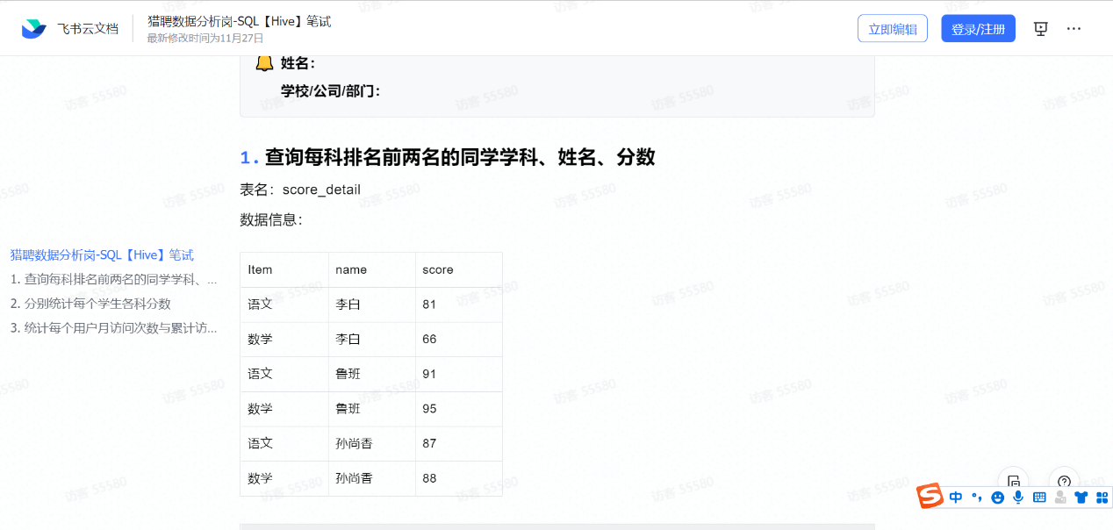
法1
Select name,item,score,RN
from(
Select *,row_number() over (partition by item order by score desc) RN
From score_detail) as t1
Where RN=1 or RN=2;

法2
select score_detail.*
from score_detail s1
where
(select count(1) from score_detail s2
where s2.course = s1.course and s2.score>s1.score)<2

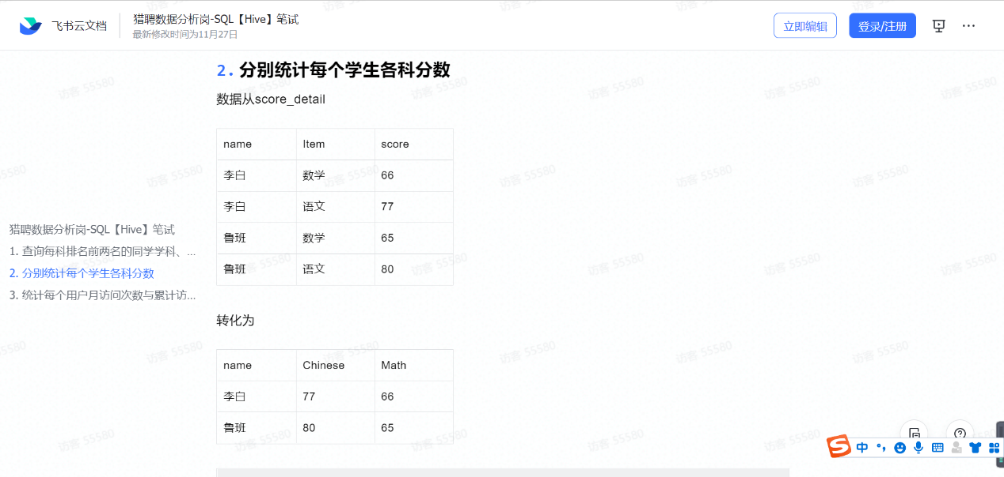

select name,
sum(case when item='语文' then score else 0 end) as 'Chinese',
sum(case when item='数学' then score else 0 end) as 'Math'
from score_detail
group by name;

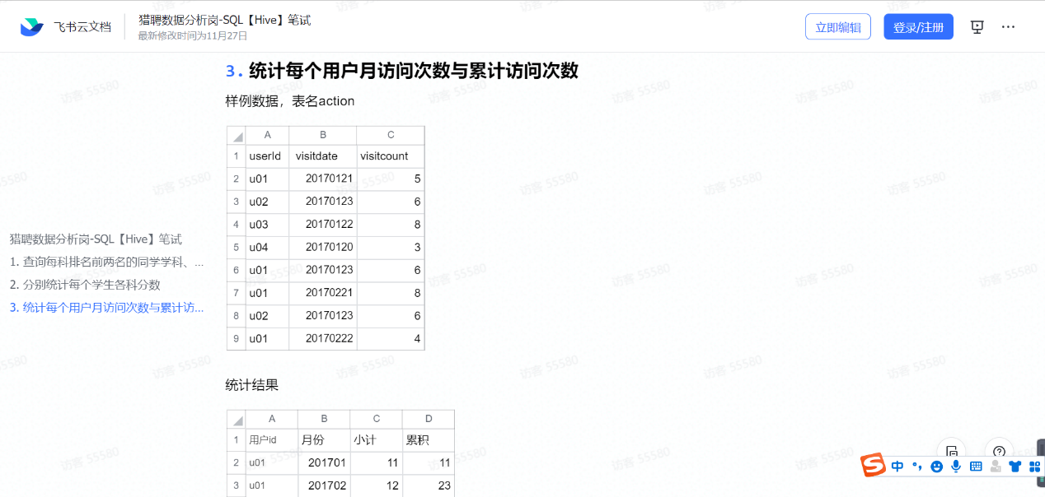

SELECT
a.userid 用户id,
a.yue 月份,
sum( visitcount ) 小计,
(
SELECT
SUM( b.小计 )
FROM
(
SELECT
a.id 用户id,
a.yue 月份,
SUM( vc ) 小计
FROM
( SELECT userid id, visitcount vc, DATE_FORMAT( visitdate, '%Y-%m' ) yue FROM action ) a
GROUP BY
a.id,
a.yue
) b
WHERE
b.yue<= a.yue
AND b.id = a.userid
) 累积
FROM
( SELECT userid, visitcount, Date_format( visitdate, '%Y-%m' ) yue FROM action ) a
GROUP BY
a.userid,
a.yue;

